**COMSATS University Islamabad,   
Abbottabad Campus**

**Project Proposal   
(SCOPE DOCUMENT)**

**for**

**<PROJECT NAME>**  
Version 1.0

***By***

**Student Name 1 CIIT/SP09-BCS-xxx/ATD**

**Student Name 2 CIIT/SP09-BCS-xxx/ATD**

***Supervisor*Supervisor Name**

***Bachelor of Science in Computer Science (20xx-20xx)***

|  |  |  |
| --- | --- | --- |
| **No.** | **Comment** | **Action** |
|  |  |  |
|  |  |  |
|  |  |  |
|  |  |  |
|  |  |  |
|  |  |  |

**SCOPE DOCUMENT REVSION HISTORY**

**Supervisor Signature**

**Date:**

**Table of Contents**

**1.** **Introduction 4**

**2.** **Problem Statement 5**

**3.** **Problem Solution for Proposed System 5**

**4.** **Related System Analysis/Literature Review 5**

**5.** **Advantages/Benefits of Proposed System 5**

**6.** **Scope 6**

**7.** **Modules 6**

7.1 Module 1: Module Name 6

7.2 Module 2: Module Name 6

**8.** **System Limitations/Constraints 6**

**9.** **Software Process Methodology 6**

**10.** **Tools and Technologies 7**

**11.** **Project Stakeholders and Roles 7**

**12.** **Team Members Individual Tasks/Work Division 8**

**13.** **Data Gathering Approach 8**

**14.** **Concepts 8**

**15.** **Gantt chart 9**

**16.** **Mockups 10**

**17.** **Conclusion 11**

**18.** **References 11**

**19.** **Plaragism Report 11**

**Project Category: (**Select all the major domains of proposed project**)**

* **A-**Desktop Application/Information System **B-**Web Application/Web Application based Information System **C-** Problem Solving and Artificial Intelligence ** D-**Simulation and Modeling ** E-** Smartphone Application ** F-** Smartphone Game ** G-** Networks ** H-** Image Processing****Other (specify category) ______________________

**Abstract**

Provide a one to two paragraph summary of your project. The abstract should give an idea of what your project is trying to achieve. Think of your abstract as a condensed version of your whole project. By reading it, the reader should understand the nature of your project. It should be comprehensive, and concise.

**Introduction**

Specify the purpose of this project proposal document along with description detailed background

of the system***.*** (Usually in 10-12 sentences).

**Problem Statement**

**What** problem does your software solve? **Why** you are developing this system? **Does** the same

system already exists? **If yes**, how will a re-implementation aid your learning? **What** skills do you

expect to learn from this project? (Usually in 14-16 sentences)

**Problem Solution for Proposed System**

Briefly explain how your system solves the problems mentioned in the problem statement. (Usually in 14-16 sentences)

**Related System Analysis/Literature Review**

**Write** about the existing/similar systems related to your proposed project. **At least three** existing systems should be discussed.

Don’t use more than 4 sentences for explaining a single system/application.

Briefly explain the related system analysis which help to specify the contribution of the proposed project.

(**Note**: Research based projects may provide literature review instead of related system analysis.)

**Table 1 Related System Analysis with proposed project solution**

|  |  |  |
| --- | --- | --- |
| **Application Name** | **Weakness** | **Proposed Project Solution** |
| The name of related application(s). | Weaknesses may include limited features, low quality functionality and processes. | The way the proposed project mitigates the weaknesses. |

**Advantages/Benefits of Proposed System**

Write down the advantages and benefits of the system you are developing. In other words, you have to mention here advantage of your proposed solution to the existing problem.

(Usually in 5-7 advantages)

**Scope**

Write down the scope of your project in a paragraph. Briefly define the main functionalities of the proposed project. Scope defines the boundaries and range of the proposed solution, that what would be the part of your project and what will be not. Write down in logical flow with consistency.

(Usually in 14-18sentences)

**Modules**

Write down the modules of the proposed project. Don’t forget to mention special/new features. Briefly explain your one module in 6 to 8 sentences.

(Note: Usually 5-6 Modules for 2 student’s projects and 8-9 modules for 3 student’s project)

**Explanation of a Module:** Module is a section of a program that performs a task. Programs consist of [modules](http://www.webopedia.com/TERM/M/module.html), each of which contains one or more routines. The term routine is synonymous with procedure, function, and subroutine.

Example:

*Enterprise resource planning (ERP) software - is comprised of several large modules (for example, finance, supply chain and payroll, etc.), which may be implemented with little or no customization.*

(Briefly explain each module with respect to major functionality in user context)

**Module 1: Module Name**

**Module 2: Module Name**

**System Limitations/Constraints**

Write down the limitations and constraints of the proposed project.

(Usually 2-4 constraints)

**Software Process Methodology**

Write down your software methodology/ software process that will be used for project development. .Also mention why you have chosen this methodology. (Usually 3-5 sentences)

1. You can use Object Oriented Methodology, or Procedural methodology.
2. Choice of methodology will affect choice of tools and technologies
3. Choice of methodology will affect nature of design (SDS)
4. Choice should be made depending on your expertise and your needs e.g. most simulation and device level software can only be programmed in procedural languages.

**Tools and Technologies**

Mention all the hardware/software tools and technologies with version number which will be used in implementation of the project. Write about the APIs, language(s), SDK(s) etc. which you will use for implementation.

Example:

**Table 2Tools and Technologies for Proposed Project**

|  |  |  |  |
| --- | --- | --- | --- |
| **Tools**  **And**  **Technologies** | **Tools** | **Version** | **Rationale** |
| MS Visual Studio | 2015 | IDE |
| MS SQL Server | 2015 | DBMS |
| Adobe Photoshop | CSC 6 | Design Work |
| MS Word | 2015 | Documentation |
| MS Power Point | 2015 | Presentation |
| Pencil | 2.0.5 | Mockups Creation |
| **Technology** | **Version** | **Rationale** |
| C# | 6.0 | Programming language |
| SQL | 2013 | Query Language |
| Html | 5 | Web Development |

**Project Stakeholders and Roles**

Write down the project stakeholders and their roles.

**Table 3Project Stakeholders for Proposed Project**

|  |  |
| --- | --- |
| **Project Sponsor** | All web applications and desktop applications should have real client. Mention your project sponsor.  Default option will be: COMSATS University, Islamabad |
| **Stakeholder** | Mention your stake holders with their roles and responsibilities.  Default option will be:   * Students names * Project Supervisor Name: Mr./Miss … * Final Year Project Committee: Evaluation of project |

**Team Members Individual Tasks/Work Division**

**Table 4Team Member Work Division for Proposed Project**

|  |  |  |
| --- | --- | --- |
| **Student Name** | **Student Registration Number** | **Responsibility/ Modules** |
| Student 1 Name | Student 1 Registration Number | Describe the work division of each  student along with modules  E.g.  Mr. Ali (Module1-Module3)  Augmented reality and Databases tasks. |

**Data Gathering Approach**

Write down information and requirement gathering approaches for proposed project e.g. Interview, Questionnaire etc. (Usually 3-5 sentences)

**Concepts**

Mention the concepts that you will learn while doing the proposed project.

For example: Augmented Reality, Virtual Reality, Algorithms, API’’s Code injection, Closures, VI technique etc.

Not more than 4 sentences for one concept. (Usually 3-5 concepts are briefly mentioned)

Example:

*Concept-1: Concept Name E.g. Augmented Reality (Briefly give the overview of concept with respect to your project)*

**Gantt chart**

Create the Grant Chart and provide estimated start and end dates of all proposed modules/tasks for each team member. Also identify the dependencies (which tasks cannot be started/completed, until the dependent task is completed). Gantt chart can be created using MS Project.

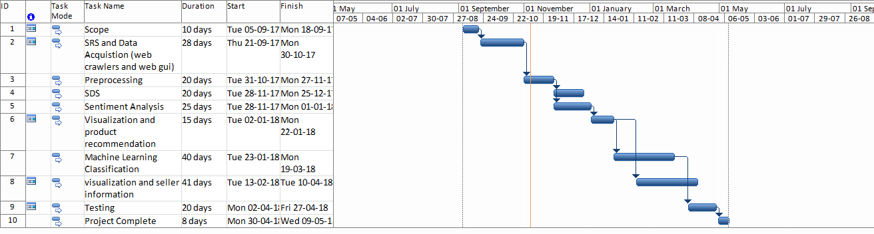

Figure 1Sample Gantt chart

**Mockups**

Insert minimum mockups (Usually 4-6 mockups) which show the major modules mentioned in the scope section of the document. Do not include mockups for Login, Signup, Forgot Password, Contact Us, About Us etc. If the project is a Web or a Smartphone Application, then include at-least three mockups from each part of the project. You can design mockup in any design tool for example pencil tool (<https://pencil.evolus.vn/>) or Balsamiq (<https://balsamiq.com/>)

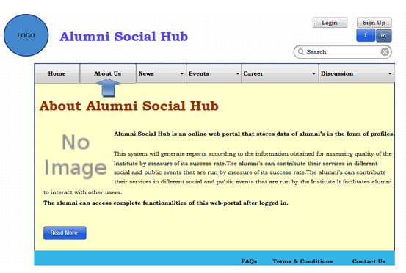

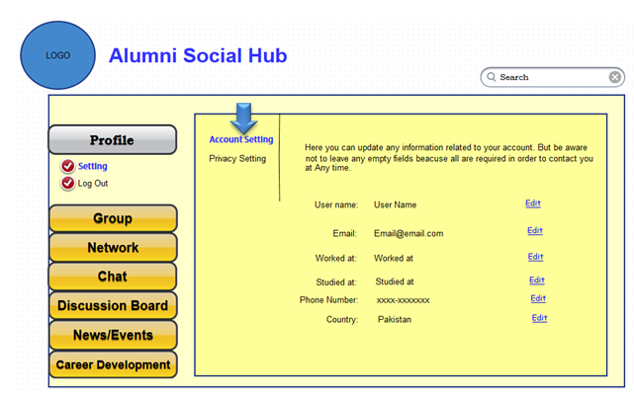

**Conclusion**

Conclude this document. (Usually 4-5 sentences)

**References**

Mention the books, research papers, web links etc.

**Plagiarism Report**

Attach the Plagiarism report of your project scope document from library staff of turnitin tool (http://turnitin.com