**Face Detection and Recognition Student Attendance System**

**Team Members**

**Table of Contents**

**Abstract** ........................................................................................................................................................... 3

1. **Introduction** .................................................................................................................................................... 4
   1. **Project Definition** ....................................................................................................................................... 4
   2. **Project Objectives** ...................................................................................................................................... 4
   3. **Project Specifications** ................................................................................................................................. 4
   4. **Product Architecture and Components** ................................................................................................... 5
      1. ***Functional Diagram***  .............................................................................................................................. 5

***1.4.1*** ***User Interface Image*** .............................................................................................................................. 6

* 1. **Applications** ................................................................................................................................................ 6

1. **Literature Review** ................................................................................................................................................ 7
   1. **Project background** .................................................................................................................................... 7
   2. **Previous Work** ............................................................................................................................................ 7
   3. **Comparative Study** ................................................................................................................................ 133
2. **System Design** .................................................................................................................................................. 133
   1. **Design Constraints** ................................................................................................................................... 13
      1. ***Design Constraint: Engineering Standards*** ....................................................................................... 144
      2. ***Design Constraint: Environmental*** .................................................................................................... 144
      3. ***Design Constraint: Ethical*** ................................................................................................................. 144
   2. **Design Methodology** ............................................................................................................................... 144
   3. **Product Subsystems and Components** ................................................................................................. 144
      1. ***Product Subsystem1: Vision Acquisition*** ........................................................................................... 144
      2. ***Product Subsystem2: Grayscale Conversion*** ...................................................................................... 165
      3. ***Product Subsystem3: Vision Assistant*** ............................................................................................... 165
      4. ***Product Subsystem4: Writing in a Measurement File*** ....................................................................... 176
   4. **Implementation** ...................................................................................................................................... 188
3. **System Testing and Analysis** ........................................................................................................................... 211

**4.2** **Subsystem 2: Vision Acquisition** ........................................................................................................... 211

* 1. **Subsystem 2: Vision Assistant** ............................................................................................................... 221
  2. **Overall Results, Analysis and Discussion** ............................................................................................. 242

1. **Project Management** ....................................................................................................................................... 266
   1. **Project Plan** .......................................................................................................................................... 276
   2. **Contribution of Team Members** ......................................................................................................... 277
   3. **Project Execution Monitoring** ............................................................................................................. 278
   4. **Limitation and Challenges** .................................................................................................................... 278
   5. **Project Bill of Materials and Budget** .................................................................................................... 299
2. **Project Analysis** ............................................................................................................................................... 299
   1. **Life-long Learning** ................................................................................................................................. 299
   2. **Impact of Engineering Solutions** ........................................................................................................... 299
   3. **Contemporary Issues Addressed** ............................................................................................................ 30
3. **Conclusions and Future Recommendations** .................................................................................................... 30
   1. **Conclusions** ............................................................................................................................................... 30
   2. **Future Work and Expected Final Prototype/Results** ............................................................................ 31
   3. **Future Recommendations** ....................................................................................................................... 31
4. **References** .......................................................................................................................................................... 31

#### *Abstract*

Face detection and face recognition are very important technologies these days, furthermore we noticed that they got have a variety of uses such as cellphones, army uses, and some high risk information offices. We decided to make a device that detects and recognize the face as a student attendance system and can be a substitute for the regular paper attendance system and finger print attendance system. The main function in our project is going to be done using LabVIEW because, LabVIEW is a very helpful programming tool in regards of facial uses and very helpful in other uses. Our project is based on a main program in LabVIEW that detects and recognize faces with giving scores and parameters, furthermore the subsystems are an Excel sheet that is integrated with the program, and a messaging device that is for either a message for absent students or to the student’s parents. Components of our project are LabVIEW program as the main system and subsystems, Office Excel sheet to include students names, and a computer (or laptop) to integrate the programs together.

# 1. Introduction

## 1.1 Project Definition

Design of an automatic class attendance system using face detection algorithm of LabVIEW software. The system requires a video capture device and the running LabVIEW algorithm to be implemented successfully. It detects the faces and mark attendance accordingly. This system will prevent unnecessary wastage of time of classes that is usually wasted in form of class roll calls.

## 1.2 Project Objectives

1. Reducing time wastage during conventional class attendance.
2. Utilizing latest trends in machine vision to implement a feasible solution for class attendance system.
3. Automating the whole process so that we have digital environment.
4. Preventing fake roll calls as one to one attendance marking is possible only.
5. Encouraging the use of technology in daily lives.

## 1.3 Project Specifications

1. Uses Pattern Matching algorithm for face detection.
2. Score of minimum 600 required to perfectly match a face.
3. Metric: Camera Resolution.
4. For prototype fixed to 10 users only but scalable design.
5. Requires good lighting condition for better camera capture capability.
6. Attendance sheet is .xlsx format and can be digitally distributed and maintained.

## 1.4 Product Architecture and Components

### 1.4.1 Functional Diagram

FIGURE 1.1: BLOCK DIAGRAM OF THE SYSTEM

The subsystem description is as follows:

**Camera:** The camera is the only hardware component required to capture live video feed of class.

**Vision Acquisition:** This module allows image to be captured by camera into LabVIEW for programming. It includes IMAQ submodules such as IMAQ Create, IMAQdx Open, IMAQdx Grab. They all combine to provide Continuous Acquisition of video feed from camera module.

**Image to Grayscale:** This process is performed using IMAQ ExtractSingleColorPlane VI to convert a 32/16bit image to 8bit image. This is a requirement for our pattern matching algorithm to work completely.

**Pattern Extraction:** This is included in Vision Assistant VI which deals with our face recognition algorithm. Pattern Extraction is feature in which the image inputted features are compared using Pattern Matching Algorithm.

**Feature Extraction:** This feature is used to extract important features out of image. It compares them with templates, saves in database and provides a score of comparison.

**Find Match in database:** Our database has preserved templates or images of students which we aim to recognize and mark attendance. This database can be updated or appended according to requirement. This database is used for comparison with extracted feature of image to confirm a successful hit.

**Update Attendance Sheet.xlsx:** If match is found our algorithm updates the attendance of user corresponding to his/her name in excel file of format .xlsx. If not, the system marks absent in front of his/her name in the same excel file.

### 1.4.1 User Interface Image

This is the front panel of LabVIEW program that the user is going to be using. It shows the attendance sheet with the names of the students, and a live camera of the user in front of the camera.

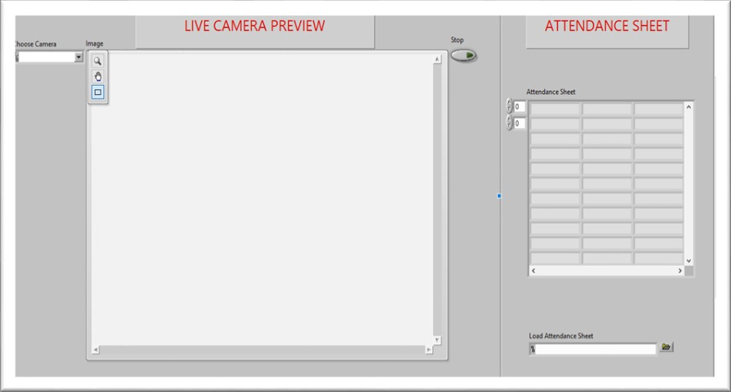

**FIGURE 1.2: FRONT PANEL OF LABVIEW PROGRAM**

## 1.5 Applications

1. Large application in institute attendance system where multiple attendances are carried out for different classes. The attendance will be short timed and reduce manual errors.
2. Large application of computer vision in field of Communication, Biomedical, Automatic Product Inspection.

# 2. Literature Review

## 2.1 Project background

In the face detection and recognition system, the process flow is initiated by being able to detect the facial features from a camera or a picture store in a memory. The algorithm processes the image captured and identifies the number of faces in the image by analyzing from the learned pattern and compare them to filter out the rest. This image processing uses multiple algorithm that takes facial features and compare them with known database.

The motivation behind this project is to simplify the means by which attendance is taken during lectures and how much time it takes. The use of ID cards or manually calling out attendance and writing it down on sheets is not productive and efficient. This system will detect the number of faces on the class and will also identify them from the store database. With the face detection and recognition system in place, it will be easy to tell if a student is actually present in the classroom or not.

## 2.2 Previous Work

**PROJECT # 1**

This is a project done by students as a final year project at Kingston University London in 2018.

The system will be presented an image either via camera or from memory and it must detect the number of faces on it automatically. After identifying faces, the system should crop the faces from the image and store them in memory for image recognition which will be done in the second step. The system should be able to automatically count the number of faces detected on the image.

The second step will be the recognition part where the system will be able to match faces from the stored dataset and compare it to the input data from the first step. A software will be used for this system which automatically sorts out the faces. The software will be inter-active so to facilitate interaction between multiple tasks as required. Because the system has two steps, the second phase of the system will involve the training of images on a dataset that are to be used for recognition.

The system behavior has been explained in the following flowchart

**FIGURE 2.1: BLOCK DIAGRAM OF PREVIOUS PROJECT #1**