- select * from HR.EMPLOYEES where DEPARTMENT_ID < 50;

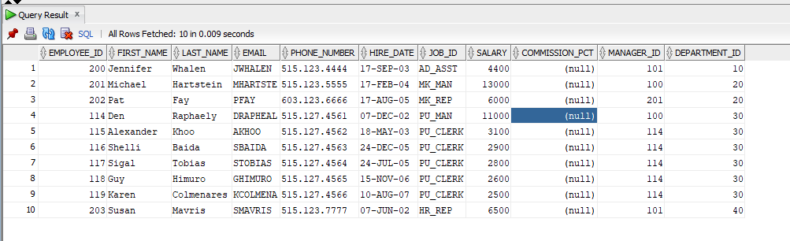

- select * from HR.EMPLOYEES where EMPLOYEE_ID >= 105 and EMPLOYEE_ID <= 115;

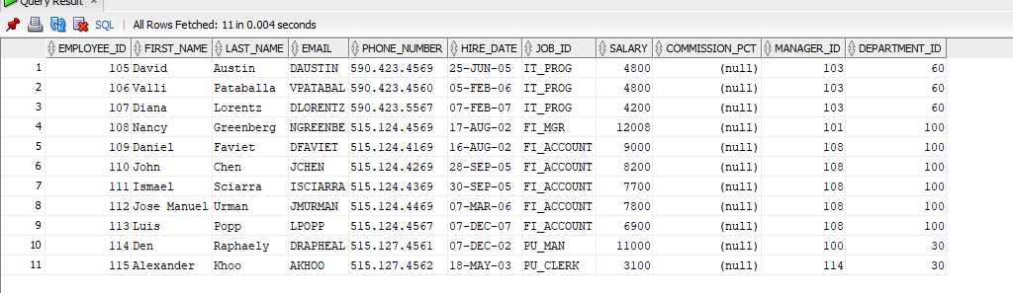

- select * from HR.EMPLOYEES where SALARY = (select salary from hr.employees where employee_id = 103 );
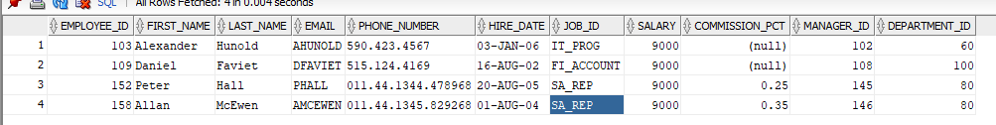

4-select * from HR.EMPLOYEES where FIRST_NAME <> 'Ellen';

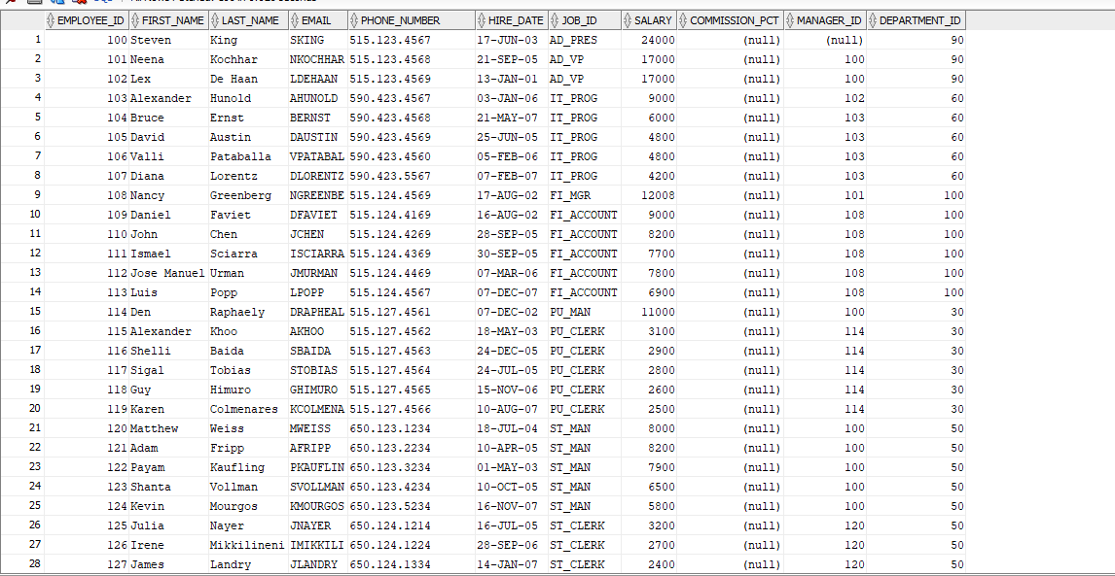

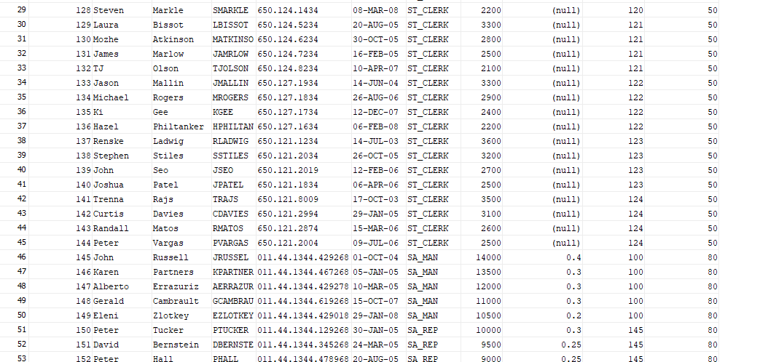

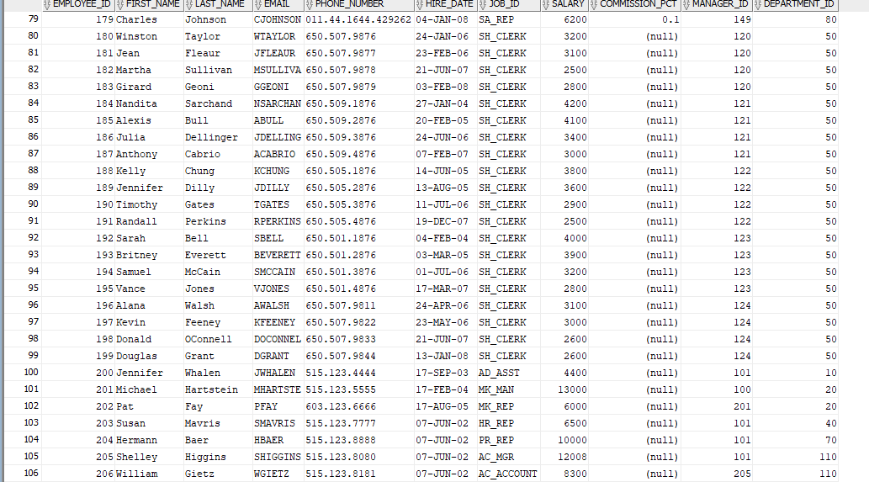

5-select * from HR.EMPLOYEES where salary > 2*3000;

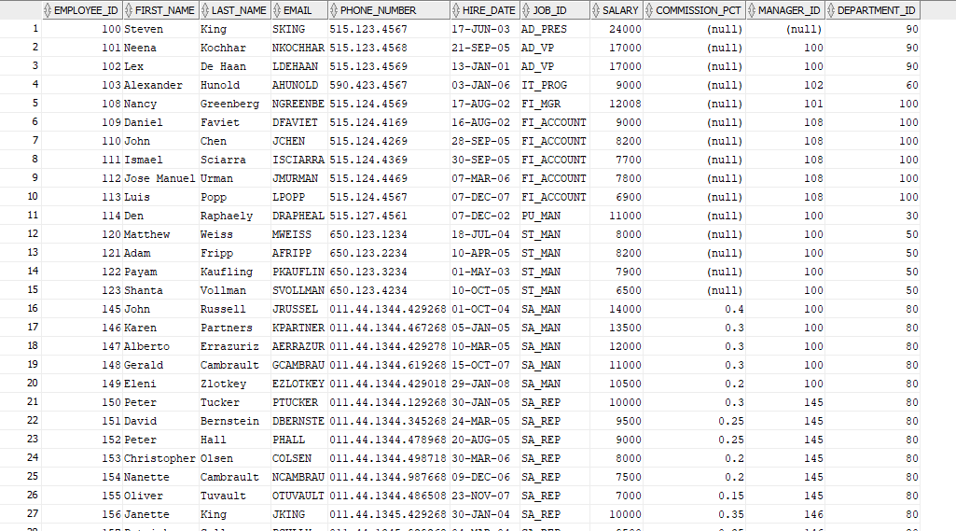

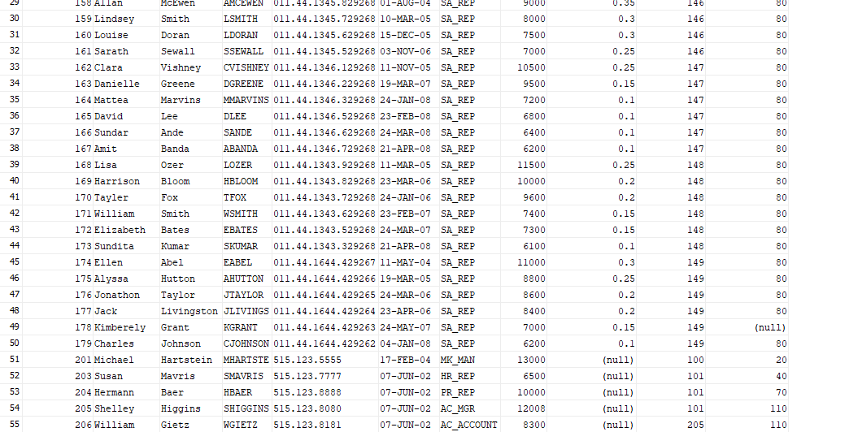

6-select * from HR.EMPLOYEES where EMPLOYEE_ID <= 2000 ;
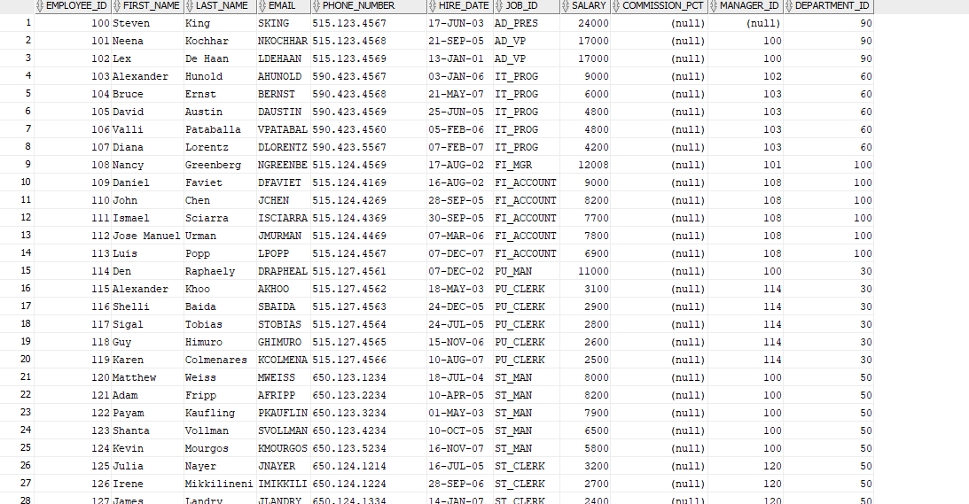

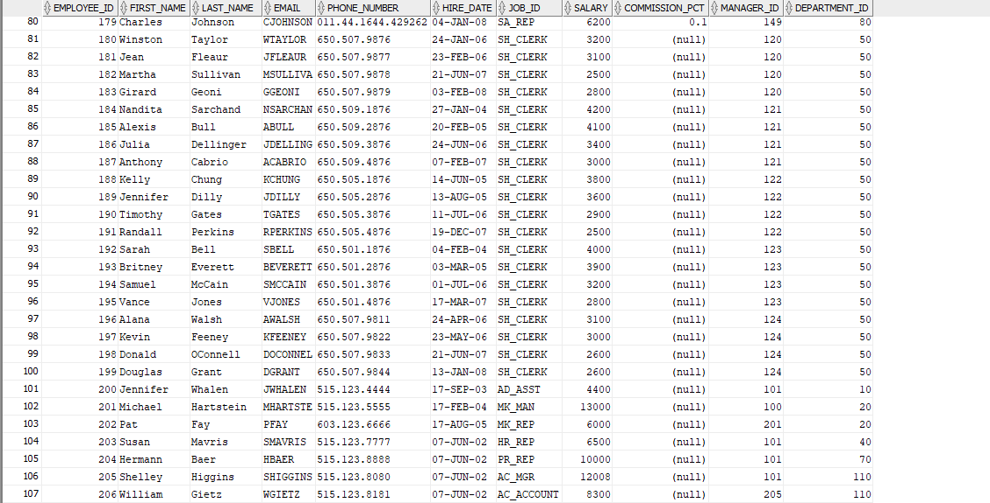

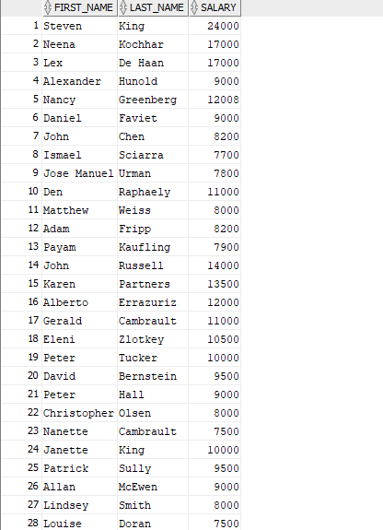

7-select FIRST_NAME
,LAST_NAME
,SALARY
from HR.EMPLOYEES
where salary >7000 ;

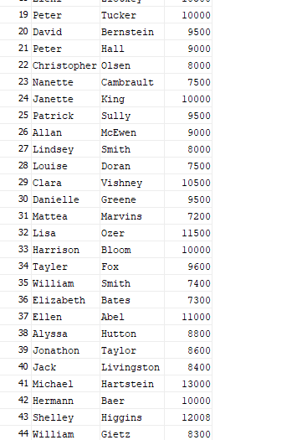

8- select * from HR.EMPLOYEES where EMPLOYEE_ID <> 101 and EMPLOYEE_ID<>102;
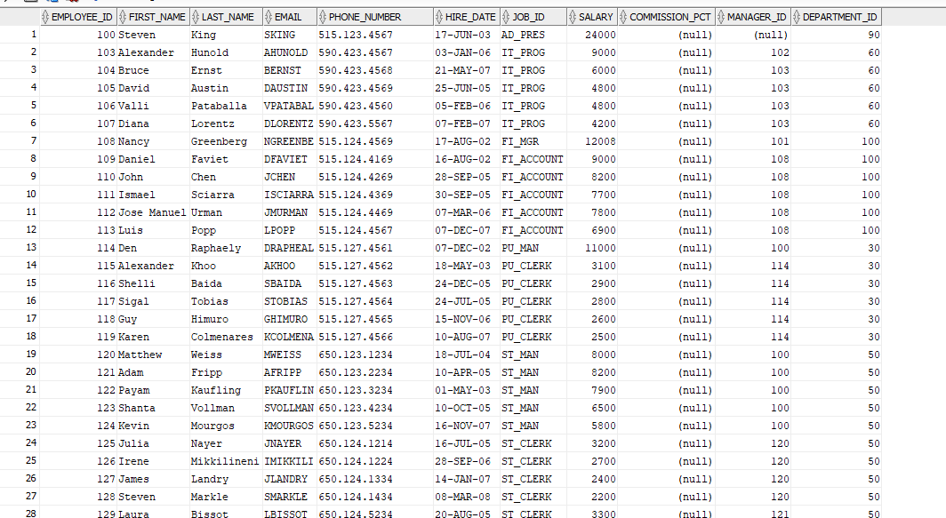
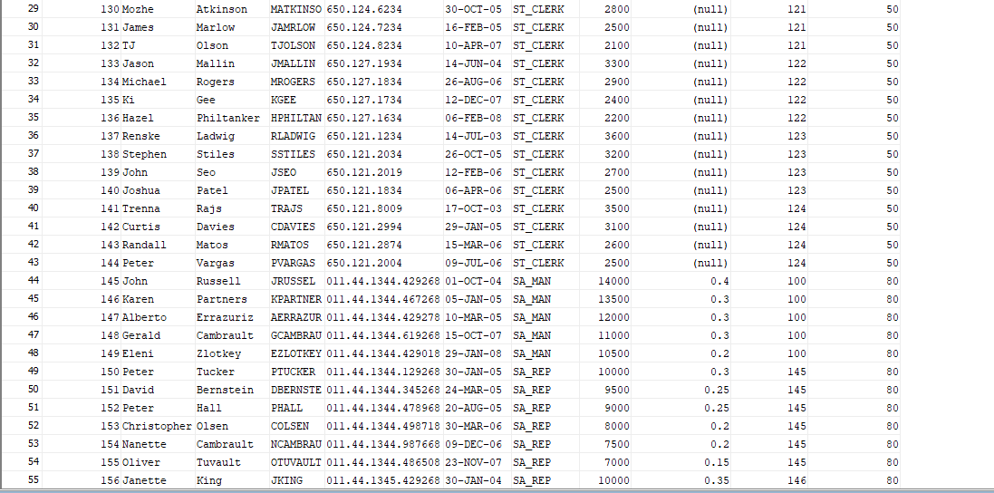

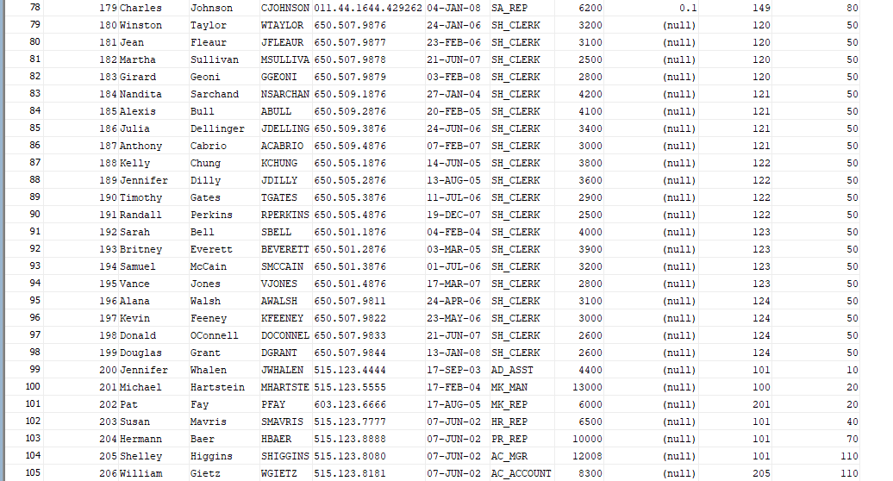

9-select * from HR.EMPLOYEES where FIRST_NAME='John';
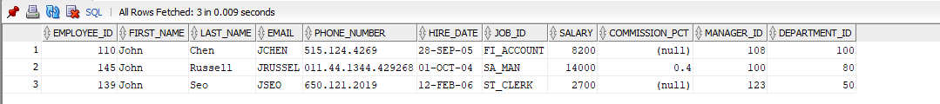

10-select *from HR.EMPLOYEES where SALARY <= 9000;
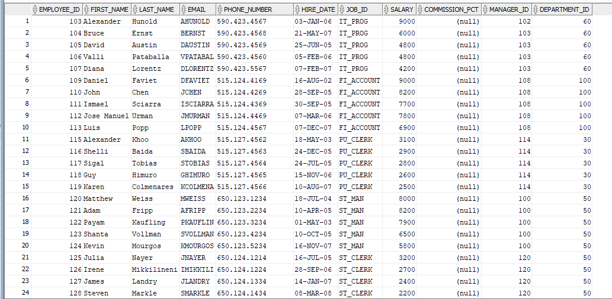
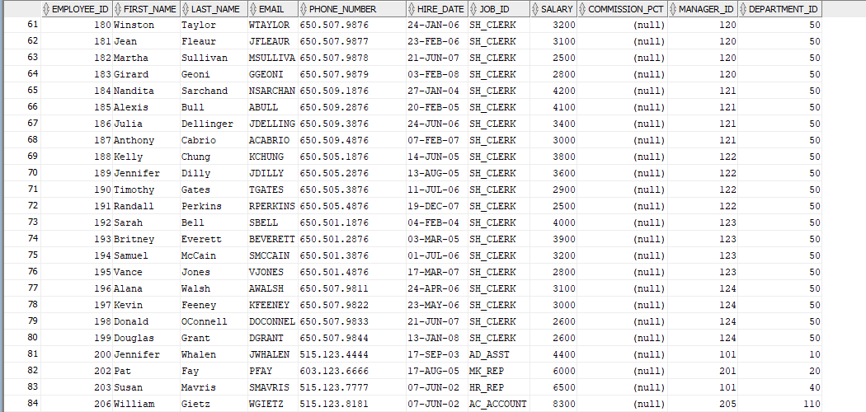
11-select *from HR.EMPLOYEES where employee_id > 100 and EMPLOYEE_ID < 200;
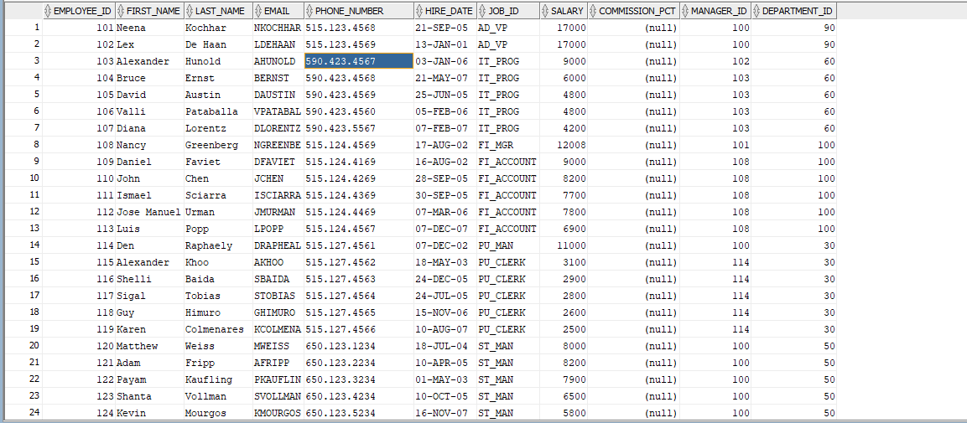
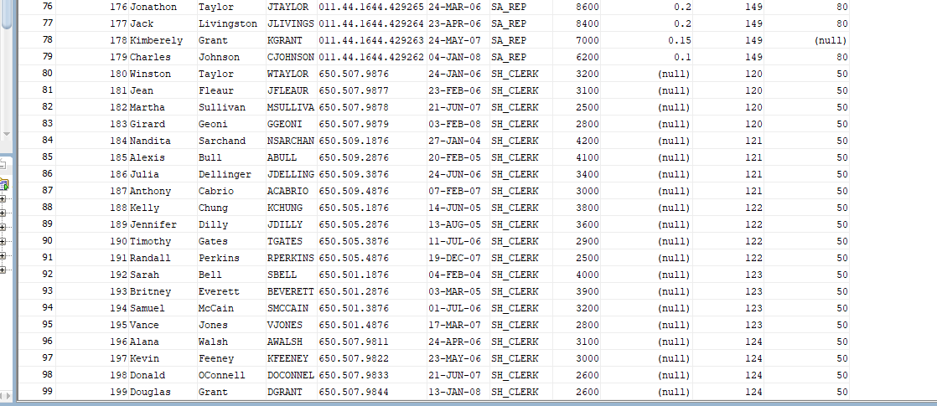

12-select *from HR.EMPLOYEES where SALARY >=5000;
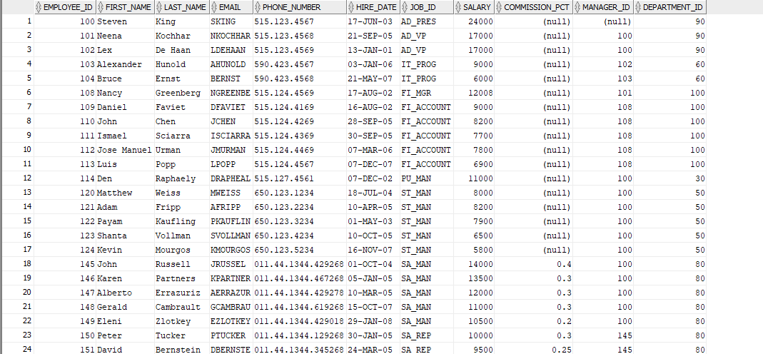

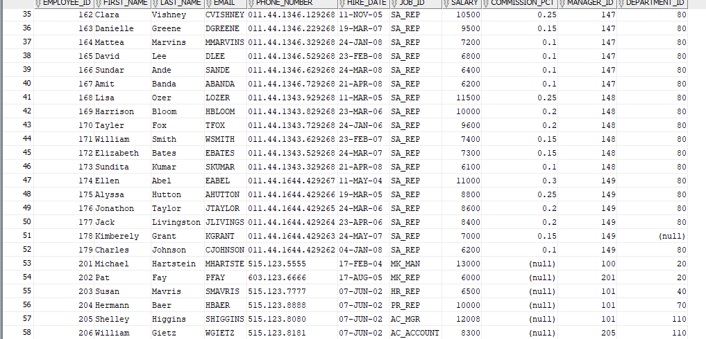

13-select *from HR.EMPLOYEES where first_name = 'Luis';

14-SELECT * FROM HR.EMPLOYEES;
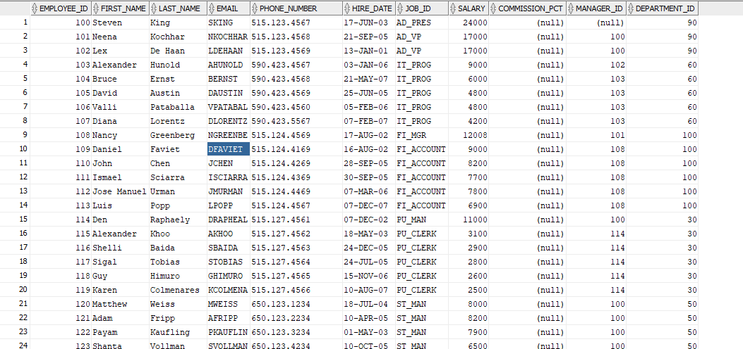

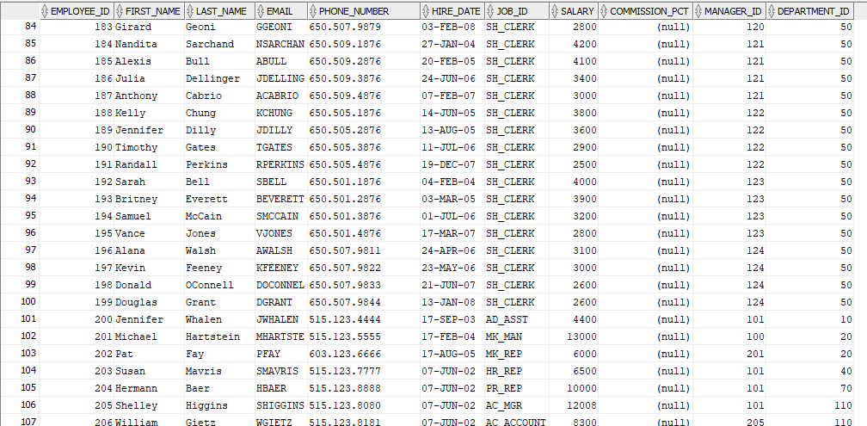

15-select *from HR.EMPLOYEES where SALARY = 2*2500;

