ELEVATE LABS

DEPARTMENT OF DATA SCIENCE & ENGINEERING

A
Internship Project Report On

“STUDENT RESULT PROCESSING SYSTEM (SQL-BASED)”

SUBMITTED IN FULFILLMENT OF THE REQUIREMENT OF
DATA SCIENCE INTERNSHIP @ ELEVATE LABS

GUIDED BY: PREPARED BY:
Elevate Labs Mentor MANSURI MO. UMER

JULY 2025

ELEVATE LABS
www.elevatelabs.in

ABSTRACT

This project titled “Student Result Processing System” is developed as a part of the internship program at Elevate Labs. The goal of this system is to efficiently manage student information, course registration, and academic performance using SQL and relational database design principles.
The system allows administrators to register students and courses, record marks, and automatically compute grades and GPAs. It includes features like ranking students using window functions, handling grade logic through stored procedures, and generating performance views for subjects and students.
This project provides a practical solution for educational institutions to automate the evaluation process and generate detailed academic insights. Tools like MySQL Workbench and GitHub were used for implementation and version control.
The project enhanced our understanding of SQL procedures, normalization, ER modeling, and query optimization techniques—offering a strong foundation in real-world database systems.
INTRODUCTION

The Student Result System is designed to simplify and automate the process of managing student academic data. It acts as a centralized platform that maintains student profiles, course enrollments, exam results, grade calculations, and performance analysis.

In traditional systems, result processing often involves manual effort, spreadsheets, and scattered records, which can lead to errors and inefficiencies. This project introduces a robust, SQL-based relational database that ensures accurate data handling, faster report generation, and easier academic tracking.

The project is built using MySQLWorkBetch, employing concepts such as:

- ER Diagrams for database modelling,
- Primary and Foreign Keys for relational integrity,
- Stored Procedures to automate grade logic,
- Views to represent complex queries clearly, and
- Joins and Window Functions for reporting GPA and student rankings.

This system not only reduces human error but also provides a scalable solution that can be integrated into real-world school or university portals.

OBJECTIVES
The main objective of the Student Result System is to build a structured, error-free academic result processing system that is reliable, fast, and easy to maintain. This system is aimed at helping educational institutions manage and analyze student performance efficiently.

Key Objectives:
- To design a relational database using MySQL that accurately stores student, course, and marks data.
- To automate result calculations, including GPA/CGPA and grade assignments, using stored procedures.
- To maintain student-course relationships via foreign keys and mapping tables.
- To provide quick access to performance data through SQL views and joins.
- To implement ranking functionality using window functions for academic analysis.
- To ensure data integrity and normalization by following best database design practices.
- To present user-friendly outputs for administrators through SQL queries and reports.

SYSTEM DESIGN:
The system design phase involves creating a structured model of the database that outlines how data is stored, related, and accessed. This system follows the Entity-Relationship (ER) model and is implemented using MySQL relational database principles.

1. Entity Relationship Diagram (ERD):
The ER diagram represents the core components of the system and their relationships:
Entities:
- Students
- Courses
- StudentCourses (mapping table)
- Results
- Grades
- Gpa
Relationships:
- A student can enroll in multiple courses (many-to-many, resolved by StudentCourses).
- A course can have many students enrolled.
- Each result links a student to a course with marks and grade.
- Grades are mapped to score ranges.

E-R Diagram for Student Result Processing System:

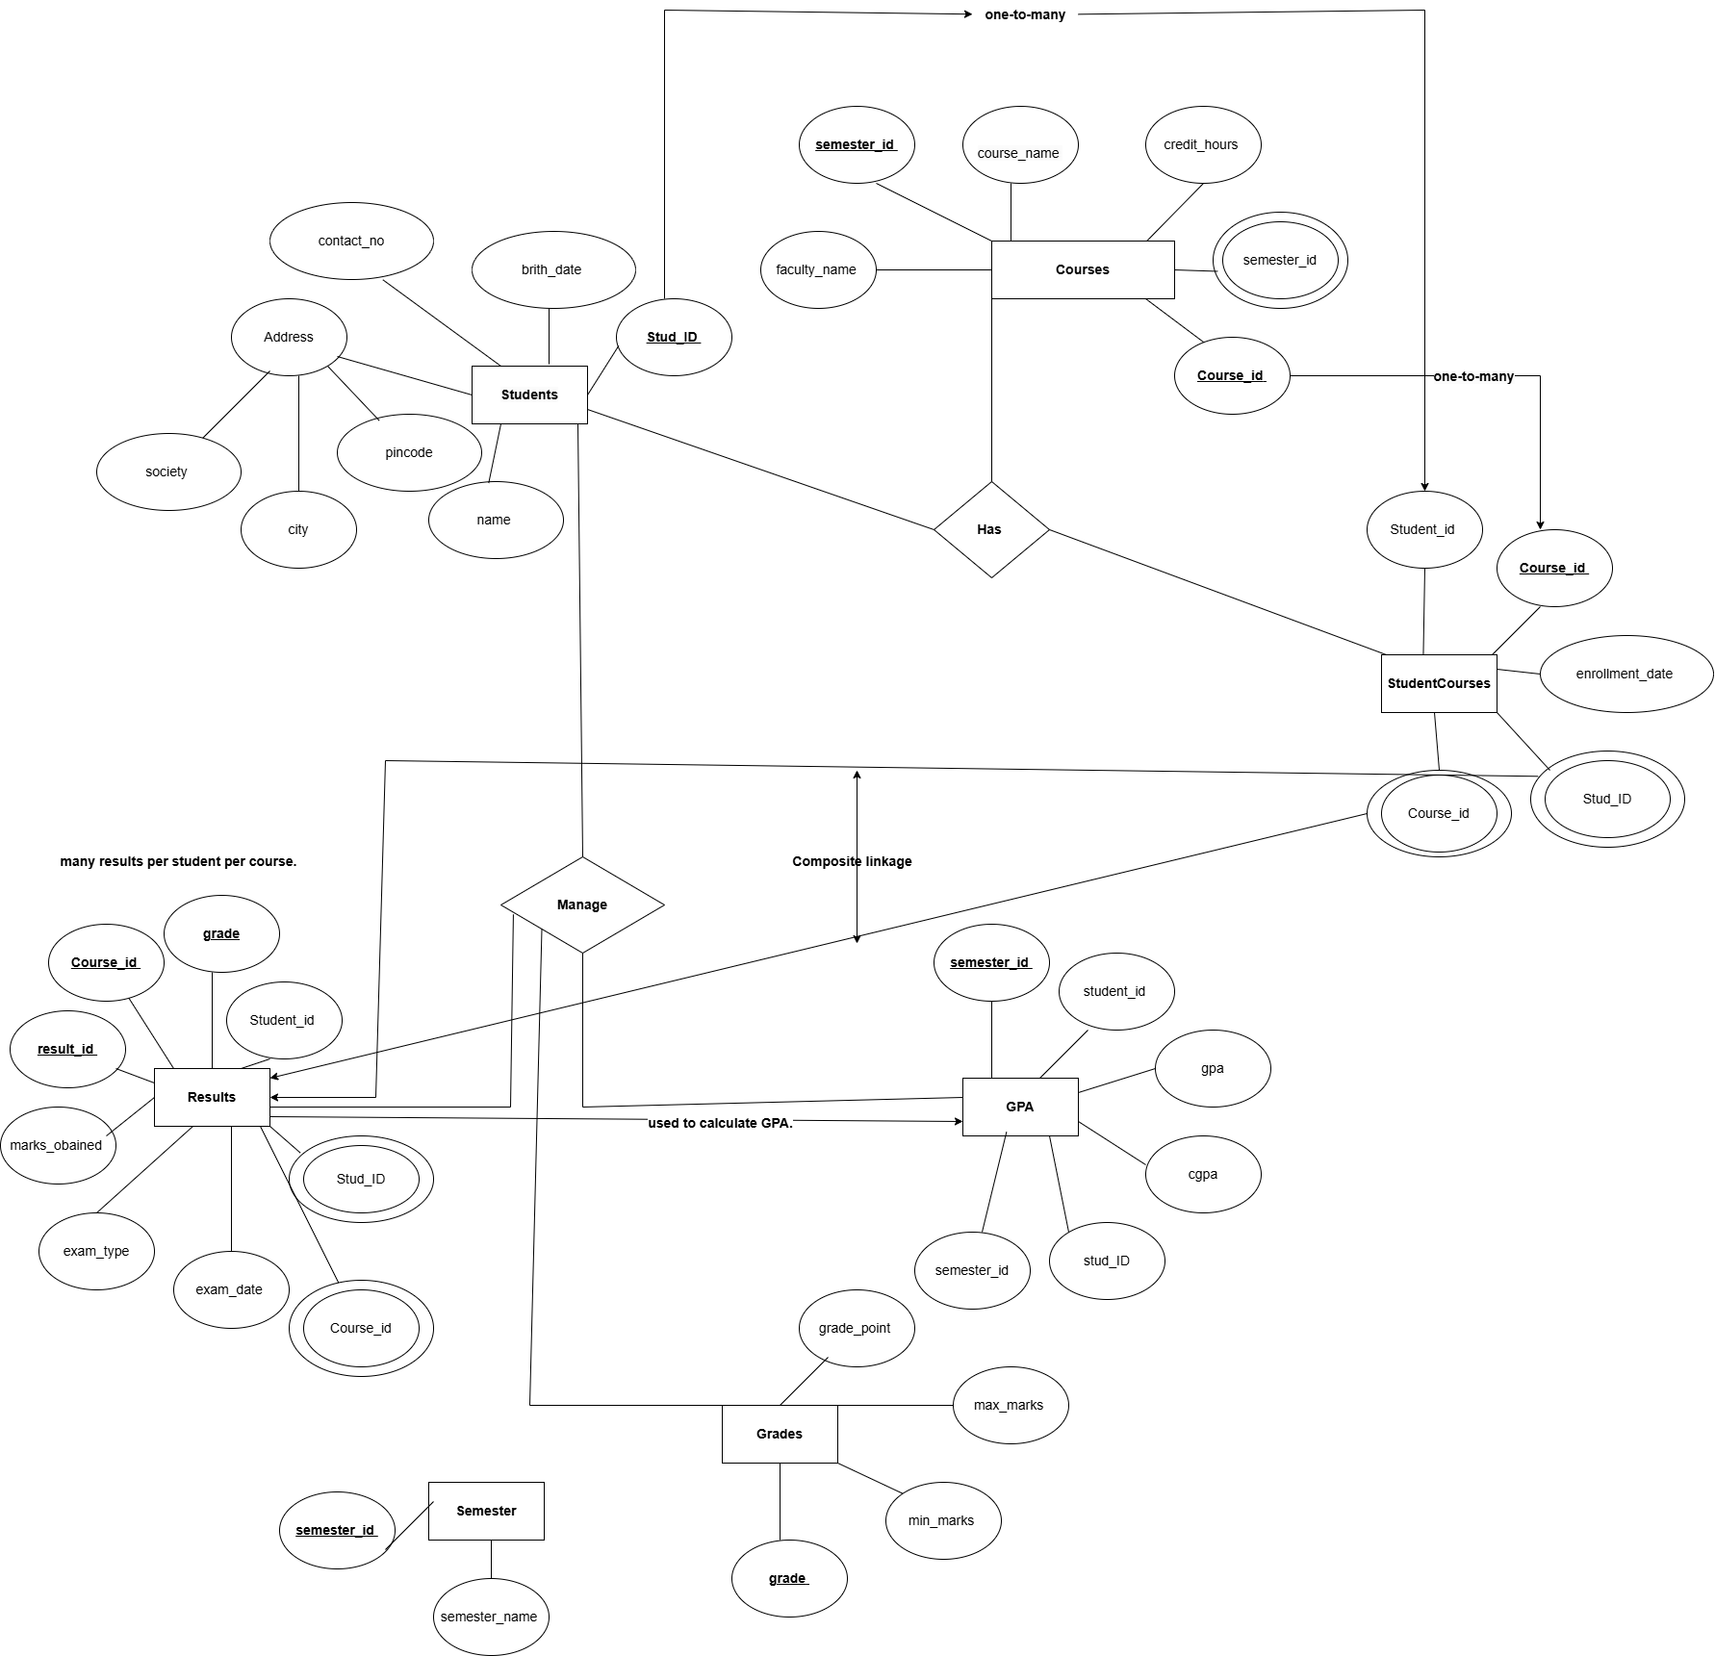

2. Schema Creation (Table Creation):
1. Students Table:
Column Name | Data Type | Key Type | Description
stud_ID | INT | Primary Key | Unique student ID
name | VARCHAR(100) | – | Full name of the student
birth_date | DATE | – | Date of birth
contact_no | VARCHAR(10) | – | Mobile number
society | VARCHAR(100) | – | Society or area name
city | VARCHAR(50) | – | City
pincode | VARCHAR(10) | – | Postal code
2. Courses Table:
Column Name | Data Type | Key Type | Description
course_id | INT | Primary Key | Unique ID for each course
course_name | VARCHAR(100) | – | Course title
credit_hours | INT | – | Number of credit hours
faculty_name | VARCHAR(100) | – | Name of faculty/instructor
semester_id | INT | Foreign Key | Links to Semester.semester_id
3. Semester Table:
Column Name | Data Type | Key Type | Description
semester_id | INT | Primary Key | Unique semester ID
semester_name | VARCHAR(50) | – | Name of semester (e.g., "Sem 1")
4. StudentCourses Table:
Column Name | Data Type | Key Type | Description
student_id | INT | Foreign Key | References Students.stud_ID
course_id | INT | Foreign Key | References Courses.course_id
enrollment_date | DATE | – | Date student enrolled in this course
PRIMARY KEY | – | Composite Key | (student_id, course_id)

5. Results Table:
Column Name | Data Type | Key Type | Description
result_id | INT | Primary Key | Unique result ID
student_id | INT | Foreign Key | References Students.stud_ID
course_id | INT | Foreign Key | References Courses.course_id
marks_obtained | INT | – | Marks scored by the student
grade | VARCHAR(2) | – | Grade (e.g., A, B+, etc.)
exam_type | VARCHAR(50) | – | Midterm / Final
exam_date | DATE | – | Date of the exam

6. Grades Table:

Column Name | Data Type | Key Type | Description
grade | VARCHAR(2) | Primary Key | Grade code (A, B+, etc.)
min_marks | INT | – | Minimum marks for the grade
max_marks | INT | – | Maximum marks for the grade
grade_point | FLOAT | – | Numeric grade point (for GPA)
7. GPA Table:
Column Name | Data Type | Key Type | Description
student_id | INT | Foreign Key | References Students.stud_ID
semester_id | INT | Foreign Key | References Semester.semester_id
gpa | DECIMAL(4,2) | – | GPA for that semester
cgpa | DECIMAL(4,2) | – | Cumulative GPA
PRIMARY KEY | – | Composite Key | (student_id, semester_id)

2. Insert Dummy Data into All Tables: (Screenshot of the data)
1. Student table:
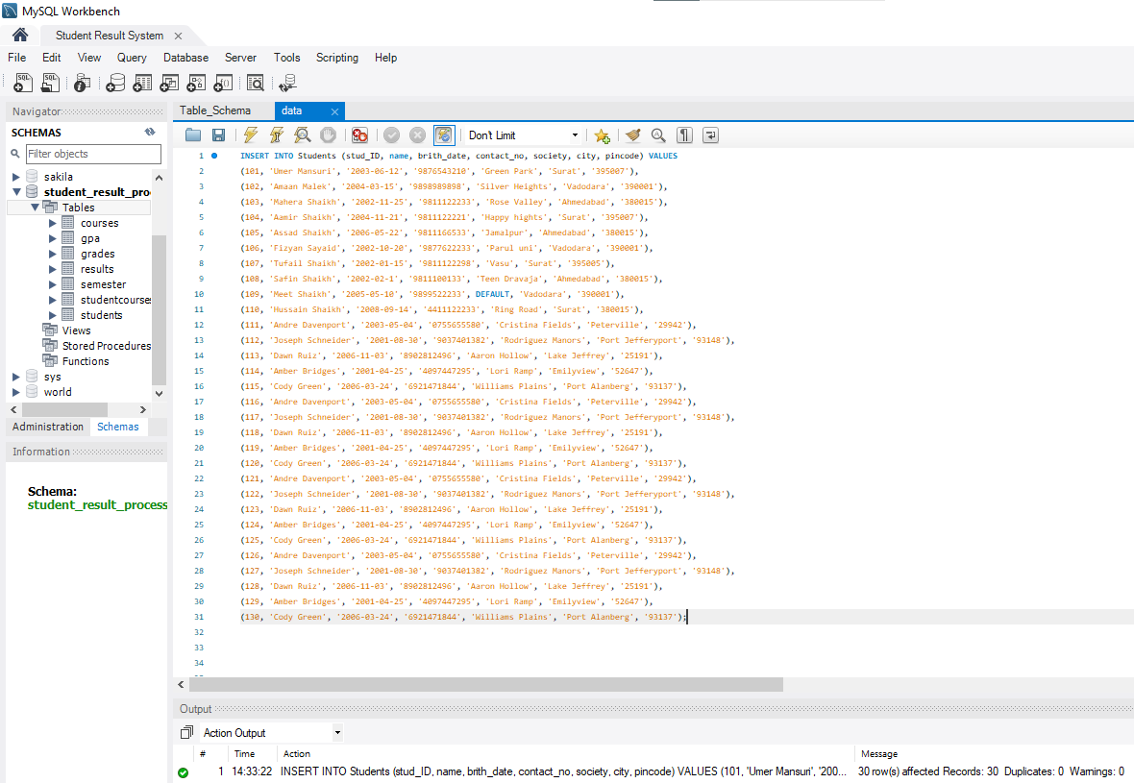
2. Semester table:
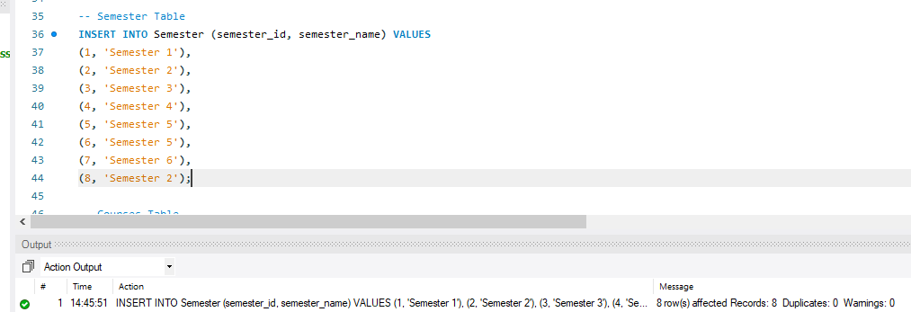

3. Courses table:
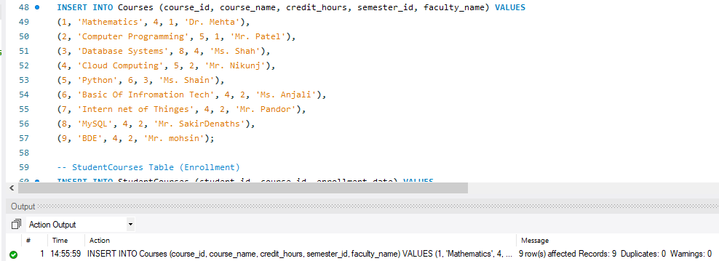
4. StudentCourses table & Grade Table: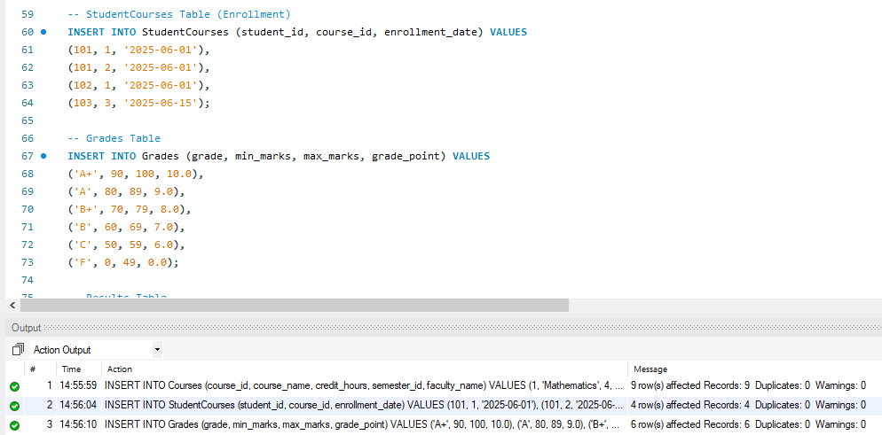

3. ALL ABOUT THE SELECT QUERIES AND SOME OPERATIONS:
1. SELECT Queries & Views next. (Student performance par Subject)

Purpose:
This query is used to analyze individual student performance in each course they are enrolled in.

What the Query Does:
- Retrieves student name, course name, marks obtained, grade, exam type, and exam date.
- Joins the Results, Students, and Courses tables to gather complete details.
- Shows results per subject per student, useful for performance tracking and reports.

Tables Used:
- Results – stores exam results (marks, grade, type, date).
- Students – student basic details.
- Courses – subject/course details.

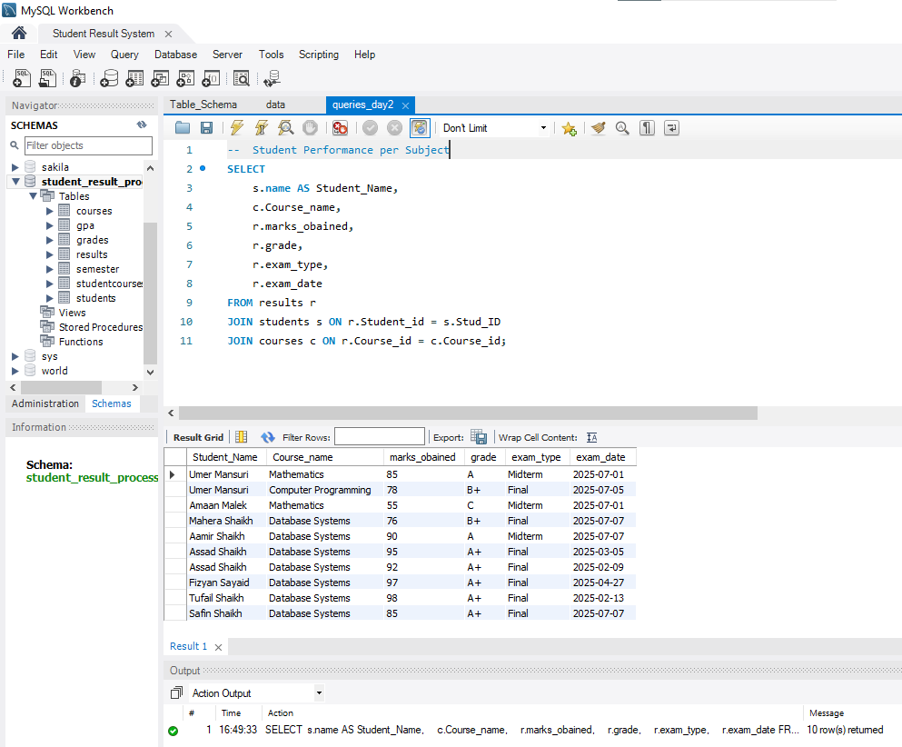

2. Course-Wise Marks:

Purpose:
This query helps analyze how students have performed in each course by calculating:
- Average marks
- Highest marks
- Lowest marks
What the Query Does:
It performs an aggregation using:
- AVG() to find the average marks,
- MIN() to find the lowest marks,
- MAX() to find the highest marks
Grouped by each course to produce summarized performance statistics.

Tables Used:
- results – contains student marks
- courses – contains course details (course name, ID, etc.)
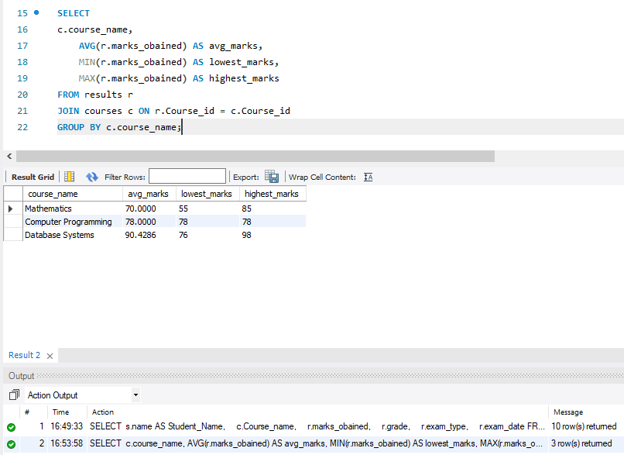

3. Filtered Results by Exam Type:

Purpose:
To retrieve student performance details filtered by a specific exam type (e.g., Midterm, Final). This helps in analysing marks based on different exams.

What the Query Does:
- Selects:
  - Student Name
  - Course Name
  - Exam Type
  - Marks Obtained
- Filters records only where the exam type = 'Midterm'.
- Uses JOIN between:
  - Results (main exam data),
  - Students (to get student name),
  - Courses (to get course name).

Tables Used:
Table | Purpose
Results | Stores exam data, marks, exam type
Students | Provides student details (name, ID)
Courses | Provides course names (linked via ID)

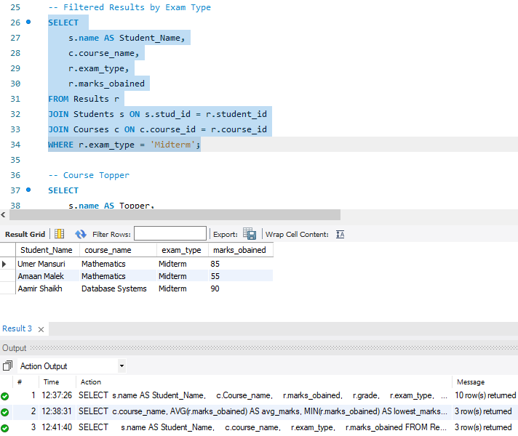

4. Course Topper:

Purpose:
To identify the top-performing student(s) in each course based on the highest marks obtained.

What the Query Does:
- Joins the Results, Students, and Courses tables.
- Uses a sub query to get the maximum marks per course.
- Filters the main results to show only the student(s) who scored those highest marks for each course.
- Returns the name of the student, the course name, and their marks.

Tables Used:
Table Name | Description
Results | Stores marks, grades, exam types, etc.
Students | Contains student personal data
Courses | Details of courses (name, credits, etc.)

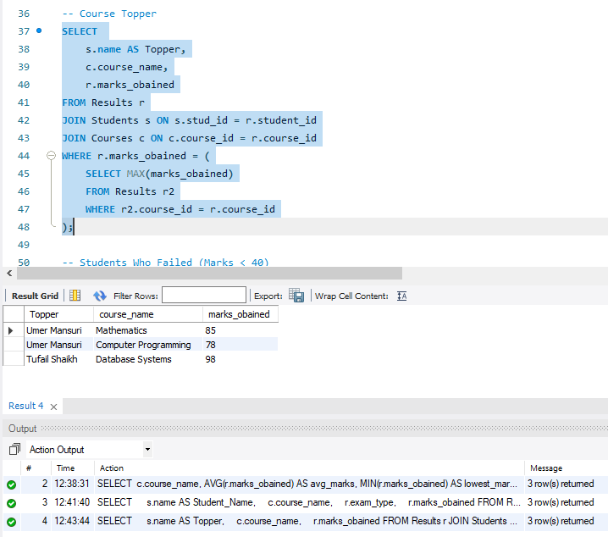

5. Students Who Failed (Marks < 80):

Purpose:
This query is used to identify all students who scored less than 80 marks in any subject. It helps in generating a fail list or tracking students who are underperforming and may need academic support or intervention.

What the Query Does:
- Joins the Results table with the Students and Courses tables to fetch student names and course names.
- Filters the dataset using a WHERE clause to only show records where marks_obtained < 80.
- Returns a list of:
  - Student names
  - Course names
  - Marks obtained (less than 80)

Tables Used:
- Students: Contains student details (e.g., Stud_ID, name)
- Results: Contains marks and exam results (Student_id, Course_id, marks_obtained)
- Courses: Contains course details (Course_id, course_name)

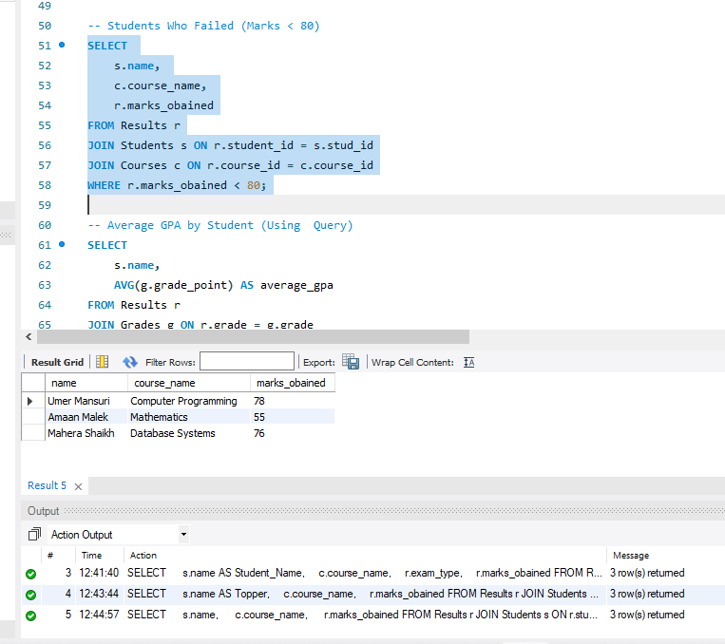
6. Average GPA by Student (Using Query):

Purpose:
To calculate the average GPA of each student based on their grades in various subjects. This helps track the overall academic performance of a student.

What the Query Does:
- It joins the Results, Grades, and Students tables.
- Converts grades like 'A+', 'A', etc. into their respective grade points using the Grades table.
- Averages the grade points for each student using the AVG() function.
- Groups the results by student name to return one GPA per student.

Tables Used:
- Students – to fetch student names.
- Results – to access the student's grades.
- Grades – to map grades to grade points.

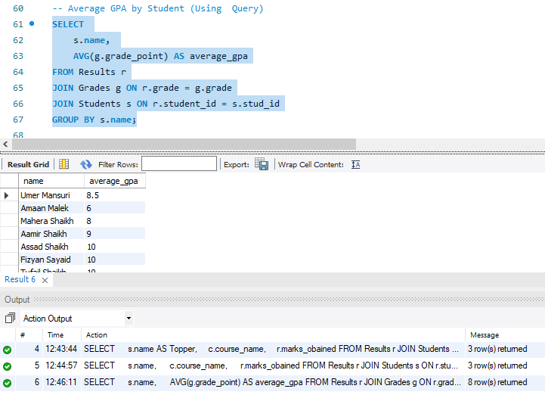

7. Create Views:
1. Create View: Students with Distinction:

Purpose:
To create a view that shows students who scored 75 or more marks in any subject — i.e., students achieving distinction.

What the Query Does:
- Joins the Results table with the Students table based on student_id.
- Filters students whose marks_obtained >= 75.
- Displays their name, marks_obtained, and grade.
- Creates a virtual table (view) named view_distinction_students.

Tables Used:
- Students: To fetch student names.
- Results: To fetch their marks and grades.

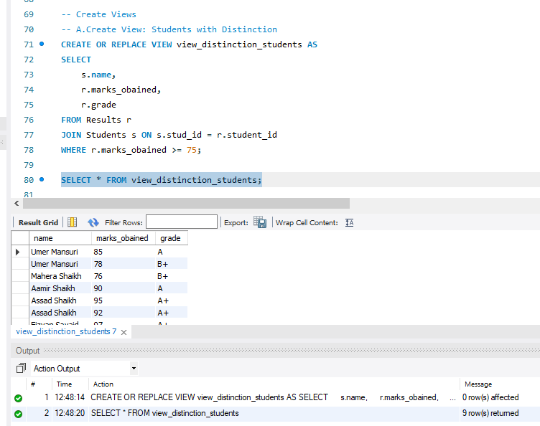

2. View: view_student_results:

Purpose:
To display consolidated student performance by combining data from multiple tables such as students, results, and courses. This view simplifies querying individual student scores, grades, and subjects.

What the Query Does:
- Joins the Students, Results, and Courses tables.
- Retrieves:
  - Student name
  - Course name
  - Marks obtained
  - Grade
  - Exam type
- Saves this result as a view, making it reusable in other reports or queries.

Tables Used:
- Students
- Courses
- Results
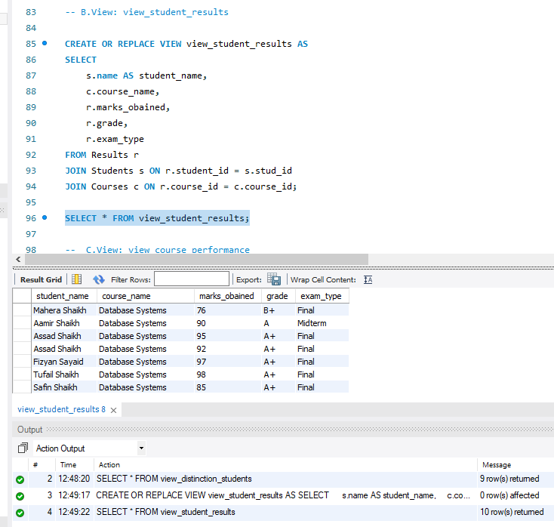

3. View: view_course_performance:

Purpose:
To summarize how each course is performing based on how many students attempted it and what the average score is.

What the Query Does:
- Displays each course name.
- Calculates:
  - Total number of students who attempted the course.
  - Average marks obtained in that course.
- Aggregates results per course using GROUP BY.

Tables Used:
- Courses – for the course name.
- Results – for marks and counting student attempts.
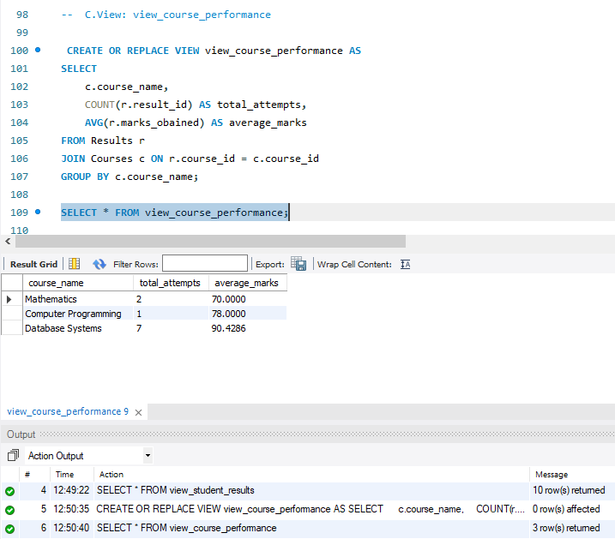

8. Stored Procedure to Calculate Grades and GPA:

Purpose:
This stored procedure is designed to automatically assign grades and calculate GPA for each student based on their marks in the Results table. It eliminates the need for manual grade entry and GPA computation by mapping marks to grade ranges and assigning corresponding grade points.

What the Query Does:
- Iterates through each student’s marks in the Results table.
- Determines the corresponding grade using predefined grade ranges from the Grades table.
- Assigns the grade into the Results table.
- Calculates GPA based on grade points using the Grades mapping.
- Inserts or updates the GPA into the GPA table per student and semester.

Tables Used:
Table Name | Purpose
Results | Stores marks for each student’s course, which are used for grade mapping.
Grades | Contains mapping of mark ranges to grades and their grade points.
GPA | Stores final GPA and CGPA per student per semester.
Students | Reference for student details (used in JOINs or updates if required).

SQL Logic Used:
- CASE conditions to assign grades.
- AVG() aggregation to compute GPA.
- UPDATE or INSERT statements to reflect GPA in the GPA table.
- Optionally includes JOIN between Results and Grades to fetch grade points.

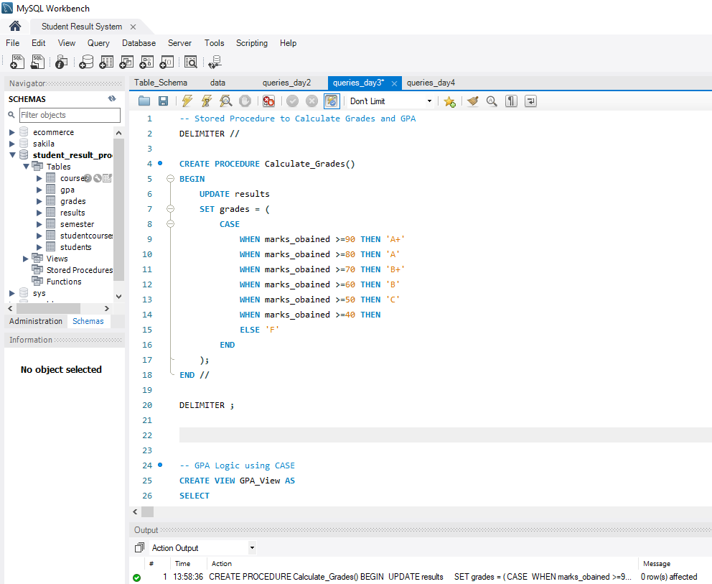
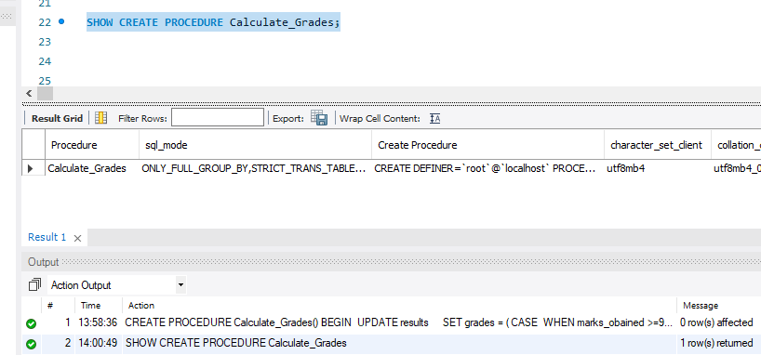

10. GPA Logic using CASE:

Purpose:
To compute GPA for each student based on their grades by assigning numeric grade points using CASE. This helps in converting letter grades (e.g., A+, B, etc.) to numerical GPA values for further analysis like ranking.

What the Query Does:
- Uses a CASE statement inside SELECT to assign grade points:
  - 'A+' → 10, 'A' → 9, 'B+' → 8, etc.
- Averages these grade points per student using AVG(...).
- Groups results by student to get individual GPA.
- Uses ROUND() for formatting the GPA to 2 decimal places.

Tables Used:
- Students: for fetching student names.
- Results: contains marks and grades.
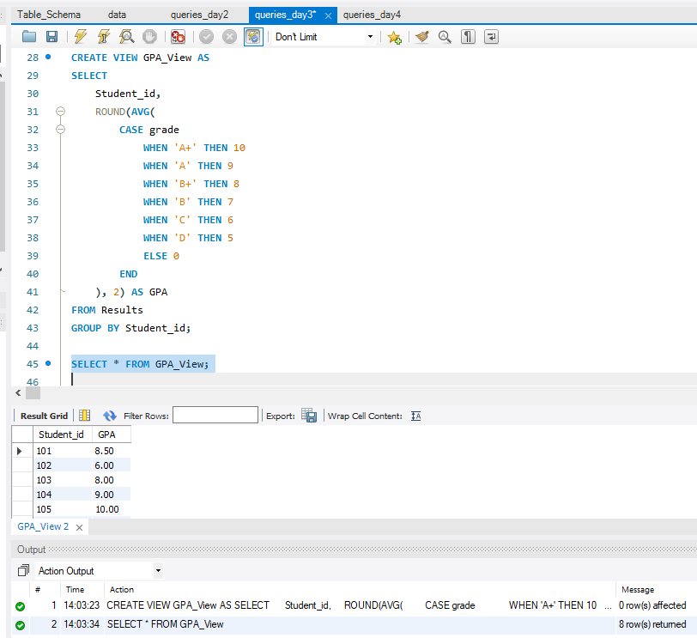

10. Create result_summary View:

Purpose:
To create a consolidated view showing each student’s performance in all enrolled subjects, including the subject name, marks, grade, and exam type. This view simplifies reporting and analysis by providing a unified result set for external queries or display.

What the Query Does:
- Joins the Students, Courses, and Results tables
- Retrieves student name, course name, marks obtained, grade, exam type, and exam date
- Displays a detailed report of each subject-wise result per student
- It is used for reporting or performance dashboards

Tables Used:
Table Name | Purpose
Students | Provides the Stud_ID and name of each student
Courses | Provides Course_id and course_name
Results | Stores marks, grade, and exam data linked via foreign keys

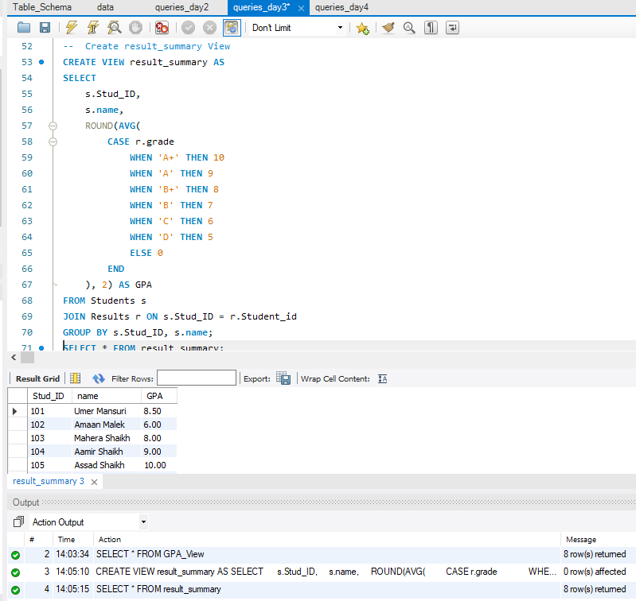

11. GPA Rankings Using RANK():

Description of the Query:
This query calculates the GPA (Grade Point Average) for each student based on letter grades and ranks them in descending order of GPA using the SQL RANK() window function.

Purpose of the Query:
- To compute GPA scores from letter grades.
- To generate a ranking of students based on their GPA.
- To help in identifying top-performing students.
- Useful for academic reporting, awards, scholarships, and performance analysis.

What the Query Does:
- Joins the Students table with the Results table using student IDs.
- Converts letter grades to numeric grade points using a CASE statement.
- Calculates the average grade point (GPA) for each student using AVG().
- Rounds the GPA to 2 decimal places with ROUND().
- Ranks students by GPA in descending order using the RANK() window function.
- Groups results by student ID and name to calculate GPA per student.
Tables Used:
- Students: Contains student data (e.g., Stud_ID, name).
- Results: Contains course results for students (Student_id, grade).

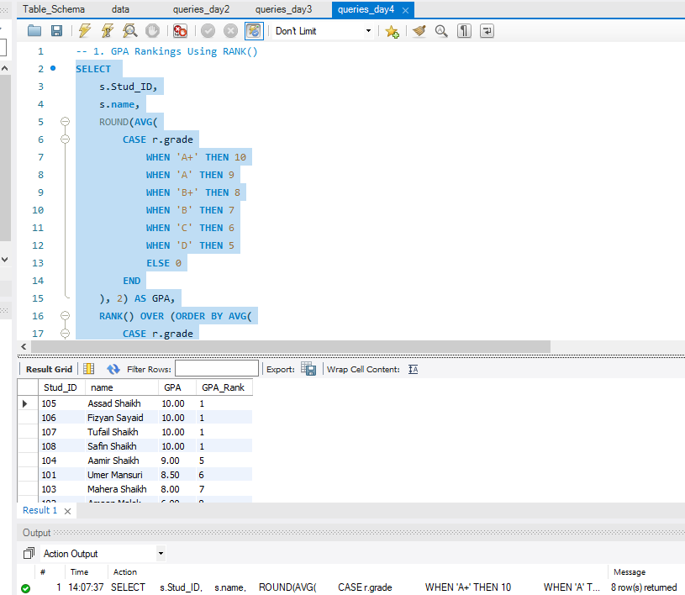
12. Top 3 Students View:

Purpose:
This SQL query creates a view named view_top_3_students that shows the top 3 students based on their GPA, calculated from their grades. It's useful for displaying academic performance rankings in educational systems.

What the Query Does:
- Calculates GPA for each student based on their grades using a weighted average system where:
  - 'A+' = 10
  - 'A' = 9
  - 'B+' = 8
  - Any other grade = 0
- Ranks students using the RANK() window function, ordered by GPA in descending order.
- Filters only the top 3 students using WHERE rank_position <= 3.
- Wraps everything in a view so it can be reused like a table in other queries without writing this logic again.

Tables Used:
- Students Table (s): Fields used: Stud_ID, name,Holds basic student information.
- Results Table (r): Fields used: Student_id, grade,Contains student grades for subjects or exams.
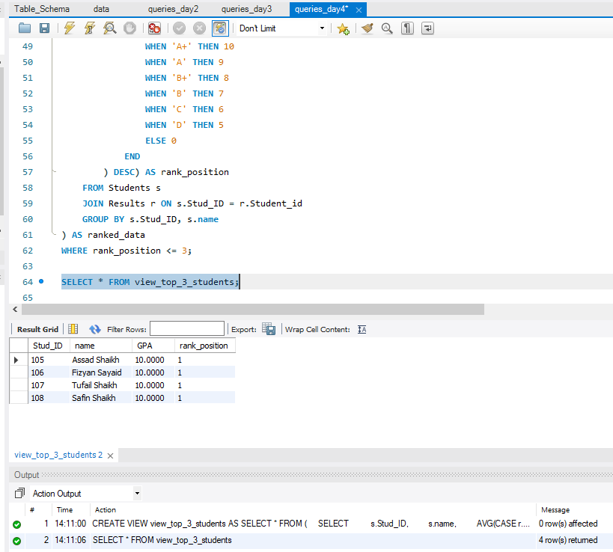
13. Failed Students Report: (NO number of Fail Students)
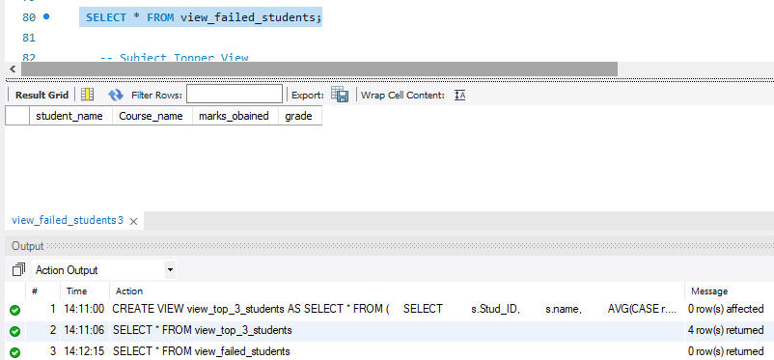
14. Subject Topper View:
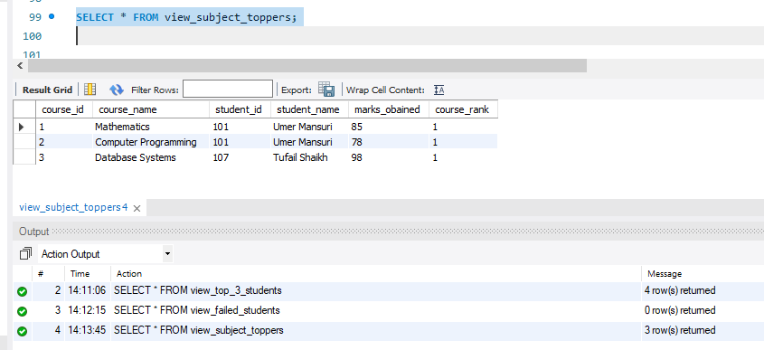

Conclusion
The Student Result System project successfully demonstrates the real-world application of relational database design and SQL programming. Throughout this project, we designed and implemented a normalized database structure that efficiently manages student records, course enrollments, marks, grades, and GPA calculations.
Key features such as stored procedures, views, and advanced SQL queries like JOIN, GROUP BY, and RANK() functions were used to automate core academic operations. This not only ensured data integrity but also optimized reporting and performance analysis.
Additionally, the use of ER diagrams and well-structured schemas helped in understanding the relationships among entities such as students, courses, grades, and exam results. Realistic dummy data further validated the functionality and helped simulate real-time use cases.
Overall, this project has enhanced practical skills in database development using MySQL Workbench and strengthened understanding of business logic, automation, and reporting in SQL-driven systems.

