
BS(SE)

FACULTY OF ENGINEERING SCIENCES AND TECHNOLOGY
Department: Computer Science Program: BS(SE)
COMPUTER VISION

Complex Computing Problem (CCP)
Mapped CLO | SDG | Complex Problem Solving Mapped
CLO3 | 4 & 9 | WP1 (Range of Conflicting Requirements)  WP2 (Depth of Analysis required)  WP3 (Depth of Knowledge required)

GROUP MEMBERS
NAMES ID
SYED MUHAMMAD UMER | 62993
MUHAMMAD SHAH MIR IQBAL | 62602
MUHAMMAD RAMEEL KHAN | 62780
HAFIZ ATEEQ | -

TITLE: Campus Person Identification and Surveillance System

Campus Person Identification and Surveillance System
This report presents a real-time computer vision surveillance system for a university campus. A mobile phone acts as an IP camera while a laptop processes the live stream, detects faces, identifies registered students, logs attendance, and displays analytics through a Streamlit dashboard.

Problem Definition
identity verification at campus gates, laboratories, and classrooms can be slow, inconsistent, and difficult to audit.
The proposed system solves this by converting a low-cost Android phone into a CCTV-like camera source and using Python-based computer vision on a laptop to identify registered students in real time.
The system also handles unknown persons, attendance duplication, searchable records, and department-wise reporting.
• Detect multiple faces in one live frame.
• Recognize registered students and display name, student ID, department, and confidence.
• Mark unknown persons with a red bounding box and capture screenshots for review.
• Store attendance with date, time, and camera source while preventing repeated entries inside a configurable time window.

System Flow
The complete workflow begins from the Android IP camera stream and ends in dashboard visualization and attendance reports.
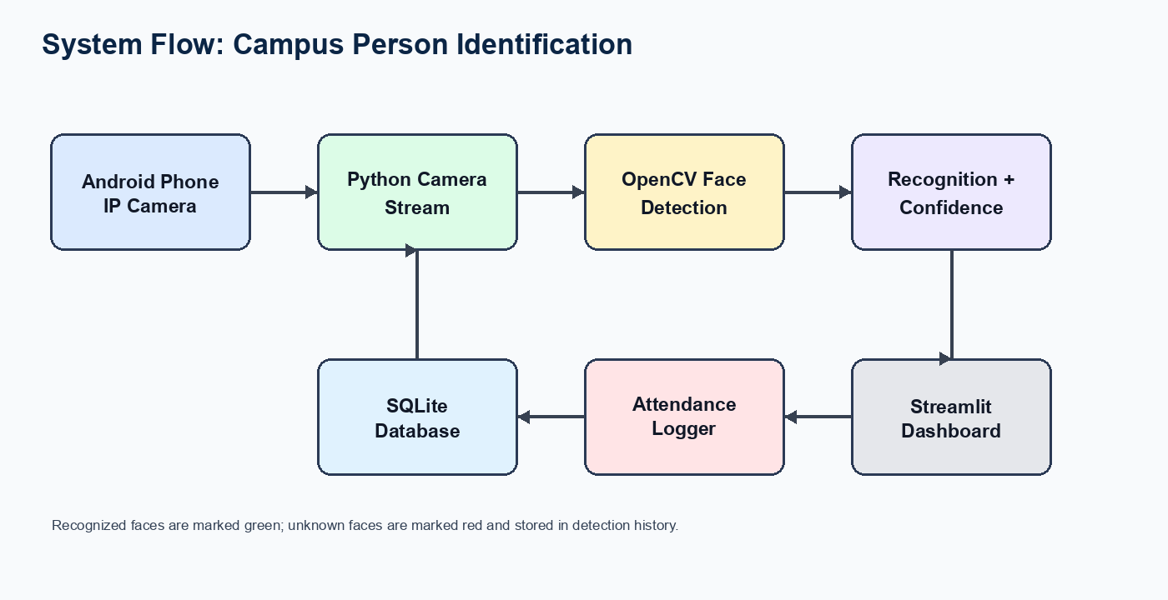
Figure 1: End-to-end system flow from mobile camera to dashboard and attendance database.

System Architecture
The project is modular. Each Python file owns a clear responsibility, making the implementation easier to understand, test, and present.
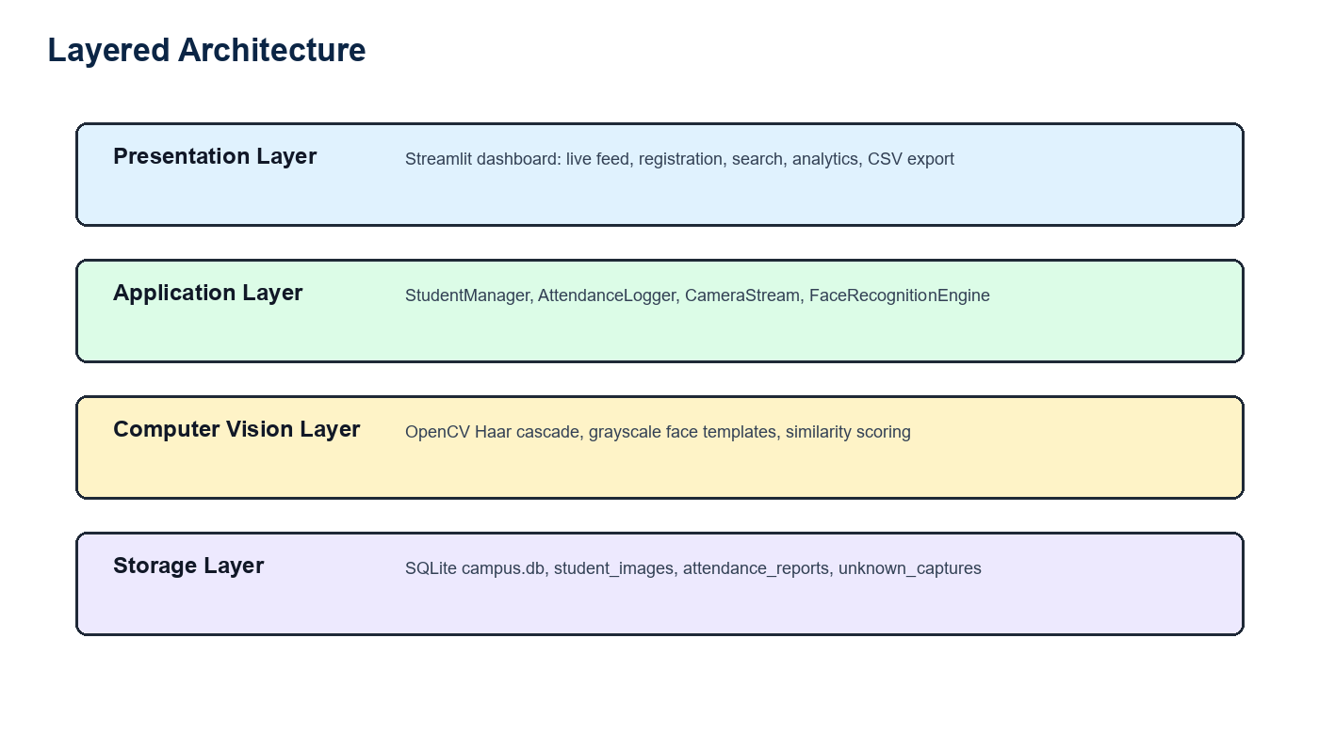
Figure 2: Layered architecture of the surveillance and attendance system.
Component | Description
app.py | Entry point with dependency checks and dashboard launch.
dashboard.py | Streamlit interface for live surveillance, registration, records, analytics, and exports.
camera_stream.py | Connects to webcam, Android IP stream, or IP Webcam snapshot fallback.
face_recognition_engine.py | Detects faces with OpenCV and compares normalized face templates.
student_management.py | Adds, updates, deletes, searches, and loads student encodings.
attendance.py | Logs attendance, blocks duplicates, exports CSV reports, and records detection history.
database.py | Initializes SQLite schema and provides safe query helpers.

Literature Review
Face recognition systems commonly follow a pipeline of image acquisition, face detection, feature extraction, matching, and decision making.
Classical OpenCV approaches use Haar cascade detectors for frontal-face localization. They are lightweight and suitable for CPU-only student projects, but require controlled lighting and camera angles.

Dataset Description
The dataset is created during student registration. Each registered student uploads a clear frontal face image along with full name, student ID, and department.
The system saves original images in the student_images folder and stores a serialized face template in SQLite. Live camera frames from the Android phone form the test stream.
Component | Description
Registered student images | One clear image per student, stored in student_images.
Live stream frames | Frames read from Android IP Webcam, DroidCam, or laptop webcam.
Unknown captures | Screenshots saved when a detected face does not match registered students.
Attendance records | Rows containing student ID, name, department, date, time, and camera source.

Database Design
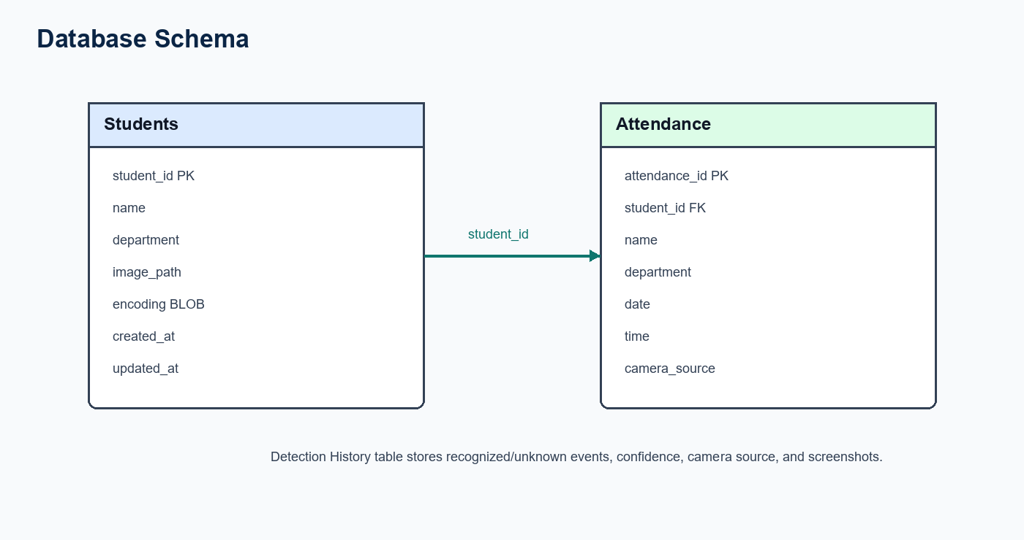
Figure 3: Main database relationship between Students and Attendance tables.

Implementation of algorithms
The algorithm uses OpenCV for detection and recognition. The important implementation stages are listed below.
1. Read frame from webcam, IP camera URL, or IP Webcam snapshot fallback.
2. Convert the frame to grayscale for detection.
3. Detect faces using Haar cascade frontal-face detection.
4. Crop each face, resize to a fixed size, equalize histogram, blur lightly, flatten, and L2-normalize.
5. Compare the live face template with stored student templates using cosine similarity.
6. If similarity is above the recognition threshold, mark the face as recognized; otherwise mark it unknown.
7. Draw bounding boxes, confidence scores, and student details on the live frame.
8. Log attendance only if the student has not been logged within the duplicate-prevention window.

Performance Evaluation
Performance should be evaluated under controlled and real camera conditions. The following metrics are recommended for the course demonstration.
Metric | Evaluation Method | Expected Result
Recognition accuracy | Test registered students against live camera frames. | High when lighting and angle match registration photo.
Unknown detection | Show an unregistered person to the camera. | Red box and unknown screenshot capture.
Attendance duplicate control | Keep same student in frame repeatedly. | Only one attendance row within configured time window.
FPS | Observe live FPS overlay. | Usable on laptop CPU with reduced frame processing.
Dashboard usability | Search, filter, export, and view analytics. | Admin can manage students and attendance without code changes.

Comparative Analysis
Approach | Strength | Limitation | Suitability
OpenCV template matching | Easy install on Python 3.14.3 and CPU friendly. | Less robust to pose and lighting changes. | Best for university demo with controlled images.
face_recognition/dlib | Strong face embeddings and better matching. | Difficult installation on newer Windows Python versions. | Good if Python 3.11 environment is allowed.
Deep learning models | Highest robustness and scalability. | Requires heavier dependencies and more compute. | Best for production extension.

Conclusion
The Campus Person Identification and Surveillance System demonstrates a complete computer vision workflow: student registration, live mobile-camera integration, face detection, student identification, attendance logging, unknown-person capture, and dashboard analytics. The Python 3.14.3 implementation uses OpenCV-only recognition for simple installation and reliable classroom demonstration. Future improvements can include deep-learning embeddings, multi-camera deployment, role-based admin login, and model calibration using larger campus datasets.

Installation and Usage Guide
- Create a virtual environment: python -m venv .venv.
- Activate it: .venv\Scripts\activate.
- Install packages: pip install -r requirements.txt.
- Start dashboard: streamlit run app.py.
- Install IP Webcam on Android and start server.
- Use http://PHONE_IP:8080/video or http://PHONE_IP:8080/shot.jpg in Live Surveillance.
- Register students first, then start surveillance.

