Table of Contents

LectureLens — Architecture Design
Course: CP-670 Android Application Programming Project: LectureLens — Lecture to Notes Companion Date: June 2026 Authors: Daniel Monday-Ogidi, Adeniyi Ridwan Adetunji, Muhammad Umer Amir, Zeeshan Mahmood, Aaron Gullraiz Cecil

1. Overview
LectureLens is an Android application that turns lecture audio into searchable, well-structured notes. The architecture is organized in three layers — Presentation, Domain, and Data — following the Android-recommended MVVM + Clean Architecture pattern. Heavy work (transcription, summarization, embeddings) is delegated to a thin Processing Layer that calls Google cloud services through repository interfaces, so providers can be swapped without touching app logic.
MVP scope: all speech-to-text and notes generation run in the cloud via Google services (Cloud Speech-to-Text + Gemini). An internet connection is required to process a new lecture. Already-processed lectures, transcripts, and notes remain viewable offline because they’re cached locally.
Phase 2 (time permitting): on-device transcription and summarization fallback for offline processing and stronger privacy. The repository interfaces are designed so this slots in without changes to the UI, domain, or data layers.

1.1 Architectural Goals
Goal | How the architecture addresses it
Offline review (MVP) | Local Room DB stores transcripts, summaries, and audio paths so reads never require network. New-lecture processing does require network in the MVP.
Cloud reliability | Both STT and LLM run on Google’s managed services — no on-device model footprint in the MVP.
Provider flexibility | All STT, LLM, and embedding calls go through repository interfaces, so an on-device or alternate provider can be added later without app-logic changes.
Long-lecture support | Background WorkManager jobs run map-reduce summarization in chunks.
Privacy & consent | Audio leaves the device for cloud processing — the user sees an explicit consent prompt before the first upload and a per-lecture indicator afterward.
Testability | Domain layer is pure Java with no Android dependencies; data sources are mockable behind interfaces.

1.2 Technology Stack
The app targets Android 10+ (API 29) and is written in Java using the AndroidX View system (XML layouts + Fragments / Activities), Dagger 2 for dependency injection, Room for local persistence, and WorkManager for background processing. Asynchronous work uses ExecutorService and Guava ListenableFuture (androidx.concurrent:concurrent-futures); reactive UI state is exposed via LiveData. Google Cloud Speech-to-Text handles all transcription and Google Gemini (via the Google AI / Vertex AI Java client) handles all summarization, note generation, and — for the stretch RAG feature — embeddings. There is no on-device transcription or LLM inference in the MVP. Retrofit + OkHttp wrap the REST calls, ExoPlayer handles audio playback, and the MediaRecorder API handles capture. FTS4 (built into SQLite) powers full-text search in the MVP, with an SQLite vector extension reserved for the stretch RAG feature.

2. High-Level Architecture
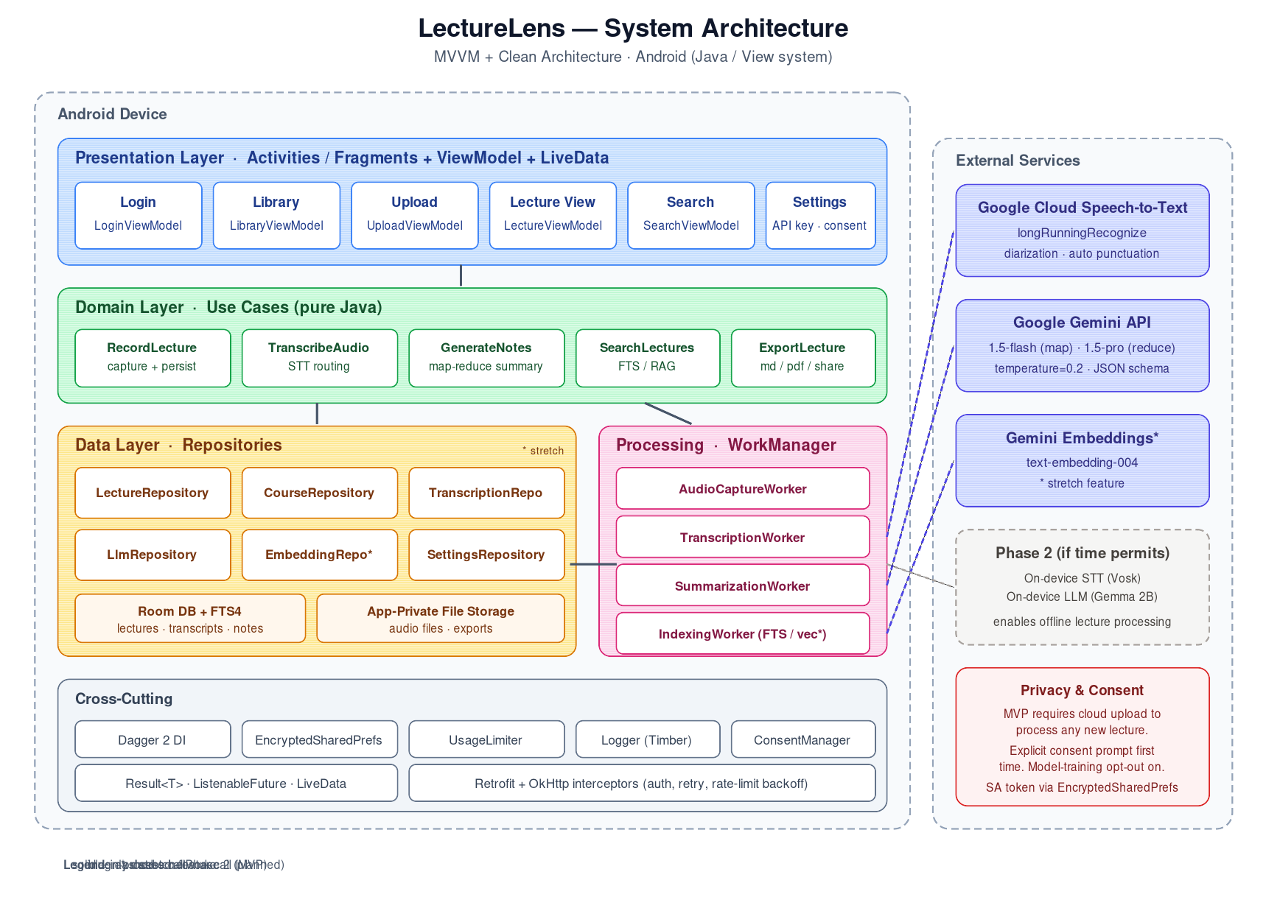
System Architecture
The system is split into four concerns:
Presentation Layer (UI) — Activities / Fragments with XML layouts (Login, Library, Upload, Lecture View, Search) backed by androidx.lifecycle.ViewModel classes that expose LiveData<UiState> to the UI. ViewModels never touch data sources directly; they call use cases. One-shot events (navigation, snackbars) flow through a SingleLiveEvent helper so they aren’t re-emitted on configuration change.
Domain Layer (Use Cases) — Plain Java classes (no Android dependencies) that encapsulate one action each: RecordLectureUseCase, TranscribeAudioUseCase, GenerateNotesUseCase, SearchLecturesUseCase, ExportLectureUseCase. They orchestrate repositories and return ListenableFuture<Result<T>>, which keeps them unit-testable on the JVM.
Data Layer (Repositories) — LectureRepository, CourseRepository, TranscriptionRepository, LlmRepository, EmbeddingRepository. LectureRepository and CourseRepository are backed by Room; TranscriptionRepository, LlmRepository, and EmbeddingRepository are backed by Retrofit clients calling Google services. The interfaces leave room for an on-device implementation in Phase 2. A generic Result<T> class (sealed via Success / Failure subclasses) carries success and error states up the stack.
Processing Layer (Background) — WorkManager workers run the audio → transcript → summary → embeddings pipeline outside the UI lifecycle, so the user can leave the screen while a 90-minute lecture processes.

3. Detailed Component Design

3.1 Presentation Layer
ui/
├── auth/ LoginActivity, LoginViewModel + activity_login.xml
├── library/ LibraryFragment, LibraryViewModel + fragment_library.xml (course/lecture list)
├── upload/ UploadFragment, UploadViewModel + fragment_upload.xml (record/import + progress)
├── lecture/ LectureViewActivity, LectureViewModel + activity_lecture_view.xml (player, transcript, notes)
├── search/ SearchFragment, SearchViewModel + fragment_search.xml (FTS + future RAG)
└── settings/ SettingsActivity + activity_settings.xml (API key, consent, model)
Each ViewModel exposes a single UiState — modeled as an abstract base class with Loading, Success, and Error subclasses — observed by the Fragment / Activity via liveData.observe(getViewLifecycleOwner(), this::render). One-shot events (navigation, snackbars) flow through a SingleLiveEvent<T> helper to avoid re-emission on configuration change.

3.2 Domain Layer
Use cases are the only place business rules live. For example, GenerateNotesUseCase decides whether a transcript is short enough for a single LLM call or needs hierarchical map-reduce. This keeps the rule in one place and out of the ViewModel.
public class GenerateNotesUseCase {
private static final int SINGLE_PASS_LIMIT = 3_000;
private final LlmRepository llm;
private final TranscriptChunker chunker;
private final ListeningExecutorService executor;
@Inject
GenerateNotesUseCase(LlmRepository llm,
TranscriptChunker chunker,
@IoExecutor ListeningExecutorService executor) {
this.llm = llm;
this.chunker = chunker;
this.executor = executor;
}
public ListenableFuture<Result<Notes>> execute(Transcript transcript) {
return executor.submit(() -> {
if (transcript.wordCount() <= SINGLE_PASS_LIMIT) {
return llm.summarize(transcript.text()).get();
} else {
return mapReduceSummarize(transcript);
}
});
}
}

3.3 Data Layer
Room schema (MVP):
Table | Key columns
courses | id, name, color, created_at
lectures | id, course_id (FK), title, date, audio_path, duration_ms, status
transcripts | lecture_id (FK), full_text, language, model_used
transcript_segments | id, lecture_id (FK), start_ms, end_ms, text
notes | lecture_id (FK), summary, key_terms (JSON), action_items (JSON)
transcripts_fts | virtual FTS4 table mirroring transcript text for search
embeddings (stretch) | chunk_id, lecture_id, vector (BLOB), text
status on lectures is an enum (RECORDED, TRANSCRIBING, TRANSCRIBED, SUMMARIZING, READY, FAILED) so the UI can show per-lecture progress on the library screen.
Repository pattern:
public interface TranscriptionRepository {
ListenableFuture<Result<Transcript>> transcribe(File audio, TranscribeOptions options);
}
public class GoogleCloudTranscriptionRepository implements TranscriptionRepository { ... }
// public class OnDeviceTranscriptionRepository implements TranscriptionRepository { ... } // Phase 2
In the MVP, the Dagger 2 graph binds TranscriptionRepository directly to GoogleCloudTranscriptionRepository via an @Binds method in a @Module. A TranscriptionRouter is reserved for Phase 2, when an on-device implementation is added — at that point the router picks the implementation based on user setting and connectivity, and the change is contained in the DI module.

3.4 Processing Layer (Pipeline)
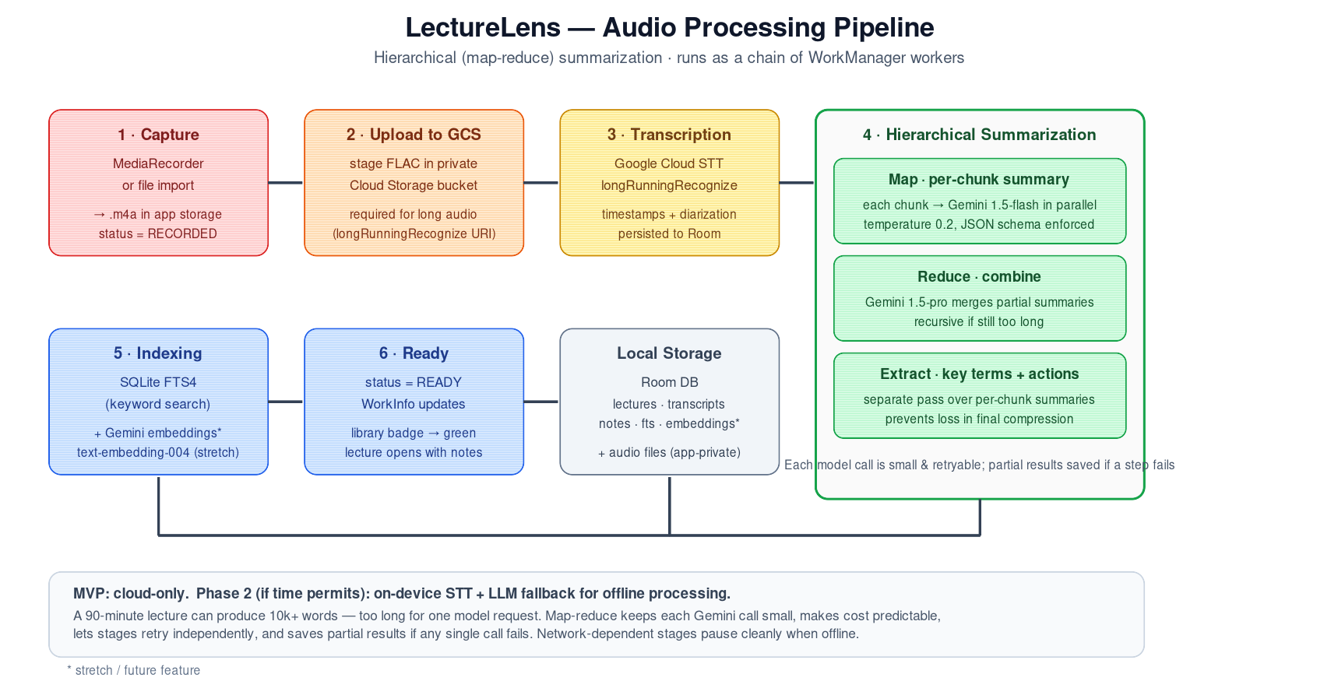
Processing Pipeline
The pipeline runs as a chain of WorkManager workers so each stage is retryable, cancellable, and survives process death.
- AudioCaptureWorker — writes a FLAC/AAC file to app-private storage, inserts a lectures row with status RECORDED.
- TranscriptionWorker — requires network. Uploads the audio to a private Cloud Storage bucket and calls Cloud Speech-to-Text’s longRunningRecognize (which supports lectures up to ~8 hours), polling the returned operation until results land. The response is persisted as timestamped transcript_segments with speaker tags when diarization is enabled.
- SummarizationWorker — requires network. Runs the map-reduce flow against Gemini: each ~3k-token transcript chunk is summarized in parallel by gemini-1.5-flash (map), partial summaries are merged and re-summarized by gemini-1.5-pro (reduce), and a separate extraction pass pulls key terms and action items so they’re not lost in the final compression. Gemini’s structured-output / JSON-schema mode enforces the response shape.
- IndexingWorker — runs locally. Writes transcript text into the transcripts_fts virtual table. Stretch: also computes Gemini embeddings (text-embedding-004) and writes the embeddings table.
Network-dependent workers are enqueued with Constraints.Builder().setRequiredNetworkType(CONNECTED).build(), so if the device is offline the pipeline pauses cleanly and resumes when connectivity returns instead of failing the lecture.
Each worker reports progress via setProgressAsync(), which the ViewModel observes through WorkManager.getWorkInfoByIdLiveData() to drive the upload-screen progress bar.

3.5 External Integrations
Service | Purpose | Phase 2 fallback (time permitting)
Google Cloud Speech-to-Text | Speech-to-text (longRunningRecognize, auto-punctuation, diarization) | Android SpeechRecognizer / Vosk (on-device)
Google Gemini API (gemini-1.5-flash for chunks, gemini-1.5-pro for final reduce) | Summaries, key terms, action items, RAG answers | On-device small LLM (e.g., Gemma 2B via MediaPipe LLM Inference)
Gemini Embeddings API (text-embedding-004) (stretch) | Vector embeddings for semantic search | On-device sentence-transformer (e.g., MiniLM via TFLite)
The “Phase 2 fallback” column is what the repository interfaces enable later — none of it ships in the MVP. The MVP requires network connectivity for any new lecture to be processed.
All external calls go through two Retrofit interfaces — SpeechToTextService and GeminiService — each provided by a Dagger 2 @Module with its own OkHttp client. A single GoogleAuthInterceptor fetches and refreshes the OAuth 2.0 access token (or attaches an API key for the AI Studio Gemini endpoint), and a shared RateLimitInterceptor handles 429/quota backoff. Credentials are stored in EncryptedSharedPreferences; for Cloud Speech-to-Text, the recommended flow is a service-account JSON exchanged for short-lived tokens rather than embedding the raw key in the APK.

4. Key Data Flows

4.1 Recording a New Lecture
User taps record → UploadViewModel.startRecording() → RecordLectureUseCase → MediaRecorder writes to file → on stop, WorkManager.beginWith(transcription).then(summarization).then(indexing).enqueue(). The user can navigate away; the library screen shows the lecture with a live status badge driven by WorkInfo exposed as LiveData.

4.2 Search (MVP)
User types query → SearchViewModel debounces 300 ms (via a Handler posted with postDelayed, cancelled on each new keystroke) → SearchLecturesUseCase calls LectureRepository.search(query) → SQLite FTS4 MATCH query returns hits with snippets → results render with lecture title, timestamp, and matched excerpt. Tapping a result starts LectureViewActivity with the matched timestamp passed as an Intent extra.

4.3 Question Answering (Stretch — RAG)
User asks a question → AskQuestionUseCase → EmbeddingRepository.embed(query) via Gemini text-embedding-004 → vector search over embeddings table returns top-k chunks → chunks + question + system prompt sent to Gemini (gemini-1.5-pro) with low temperature and a JSON response schema → answer rendered with inline citations (lecture name + timestamp) pulled from the retrieved chunks’ metadata. If retrieval confidence is below a threshold, the UI shows “I couldn’t find this in your lectures” instead of letting the model guess.

5. Cross-Cutting Concerns
Error handling. Every repository returns ListenableFuture<Result<T>> where Result<T> is a sealed-style hierarchy (Result.Success<T>, Result.Failure). ViewModels translate errors into user-facing strings via a StringResolver so messages are testable and localizable.
Concurrency. A single @IoExecutor-qualified ListeningExecutorService (backed by a bounded thread pool) handles all I/O and repository work; UI updates are marshalled onto the main thread either through LiveData.postValue() or new Handler(Looper.getMainLooper()). WorkManager workers extend androidx.work.Worker and run on WorkManager’s own executor; cancellation is handled by WorkManager.cancelWorkById() plus checking isStopped() in long loops.
Security & privacy. API keys and the Google Cloud service-account token live in EncryptedSharedPreferences. Audio files are stored in app-private storage (not accessible to other apps). A consent AlertDialog appears the first time a user starts cloud transcription, and a per-lecture indicator shows that audio was uploaded.
Testing. Domain use cases are JVM-unit-tested with JUnit 4 + Mockito; ListenableFuture results are awaited with MoreExecutors.directExecutor() in tests. Repository tests run against an in-memory Room database. Espresso UI tests cover the upload → library → lecture-view happy path. WorkManager has a dedicated test harness (WorkManagerTestInitHelper) for the pipeline workers.
Telemetry. A Logger interface wraps Android’s Log (with Timber as an optional implementation if added later) so logs can be redirected; no PII or audio content is ever logged.

6. Module Structure
A multi-module Gradle setup keeps build times manageable and enforces the layering:
app/ Application class, Dagger graph, navigation
:feature:library Library Fragment + ViewModel
:feature:upload Upload Fragment + ViewModel
:feature:lecture Lecture View Activity + ViewModel
:feature:search Search Fragment + ViewModel
:domain Use cases, domain models (pure Java, no Android deps)
:data Repositories, Room, Retrofit network clients
:processing WorkManager workers, chunking, map-reduce
:core:ui Shared View components, theme, custom Views
:core:common Result type, ListenableFuture helpers, executor providers
The :domain module is plain Java with no Android dependencies, which is what makes the use-case layer trivially unit-testable on a desktop JVM with JUnit + Mockito.

7. Roadmap Mapping to Architecture
Phase | Features | Architectural surface
MVP | Record/import, cloud transcription (Google STT), cloud notes (Gemini), library, FTS search, export, consent UX | Presentation + Domain + Data + Processing — all generation cloud-only
Phase 2 (time permitting) | On-device STT fallback, on-device LLM fallback, long-lecture map-reduce refinements | TranscriptionRouter + on-device implementations of TranscriptionRepository and LlmRepository, settings toggle
Stretch | Semantic search, RAG Q&A, cloud sync | :data:embeddings module, AskQuestionUseCase, optional sync service
The Phase 2 work is purely additive: the MVP ships fully cloud-based, and on-device implementations slot in behind the existing repository interfaces with no changes to ViewModels or use cases. Cloud sync, if added, plugs in the same way.

8. Risks the Architecture Addresses
The biggest risks called out in the proposal — cost overruns, privacy concerns, long-audio limits, connectivity, and vendor lock-in — are all handled at the architecture boundary rather than scattered through the code. Cost limits live in a single UsageLimiter consulted before any cloud call (per-day token and per-minute audio caps for Gemini and Cloud Speech-to-Text respectively). Privacy is addressed by a Google Cloud project under the team’s control with model-training opt-out enabled, plus an explicit per-user consent prompt before the first cloud upload. Long audio uses Cloud Speech-to-Text’s longRunningRecognize operation via a GCS-staged URI, so file-size limits are no longer a blocker. The MVP’s hard network requirement is mitigated by WorkManager constraints (work pauses cleanly until connectivity returns) and by the Phase 2 on-device fallback. Lock-in is mitigated by the repository interfaces — adding on-device, switching to Whisper/GPT, or moving to Claude is a DI-graph change, not an app rewrite.

9. AI Usage
This section documents how AI is used both inside LectureLens and during its development, so reviewers can evaluate it against course academic-integrity policy and so future maintainers understand what is generated vs. authored.

9.1 AI Used Inside the Product
LectureLens is, by design, an AI-powered application. Two Google services do the substantive work:
Capability | Service | Model | Where it appears
Speech-to-text | Google Cloud Speech-to-Text | latest_long recognizer (auto-punctuation, speaker diarization) | TranscriptionWorker (§3.4)
Per-chunk summary (map) | Google Gemini API | gemini-1.5-flash | SummarizationWorker, map stage (§3.4)
Final summary (reduce) | Google Gemini API | gemini-1.5-pro | SummarizationWorker, reduce stage (§3.4)
Key terms + action items | Google Gemini API | gemini-1.5-flash | SummarizationWorker, extraction pass (§3.4)
Question answering (stretch) | Google Gemini API | gemini-1.5-pro | AskQuestionUseCase (§4.3)
Embeddings (stretch) | Google Gemini API | text-embedding-004 | EmbeddingRepository (§4.3)
Guardrails on AI output. Generated content is never presented as ground truth from the lecturer. Specifically:
- Every summary is rendered alongside the source transcript so the user can verify any claim against the recorded audio.
- RAG answers (stretch) always include lecture-name + timestamp citations; tapping a citation opens the relevant transcript section. Low-confidence retrievals show “I couldn’t find this in your lectures” instead of guessing.
- The Gemini system prompt fixes the role as a study-notes assistant and instructs the model to not invent content beyond the supplied transcript. Temperature is set to 0.2 for consistency.
- JSON-schema response mode enforces the output shape, so malformed responses fail fast rather than producing partial UI rendering.
User consent and data handling. Audio leaves the device only after the user accepts an explicit consent prompt. The Google Cloud project is configured with the model-training opt-out enabled on both Speech-to-Text and Gemini, and audio objects in the staging GCS bucket are deleted by TranscriptionWorker immediately after the transcript is persisted. A per-lecture indicator in the UI shows that the audio was processed in the cloud.
Cost and rate-limit handling. A UsageLimiter (see §8) enforces per-day token and per-minute audio caps so a runaway loop cannot drain the team’s quota.

9.2 AI Used During Development
Generative AI assistants (specifically, Anthropic’s Claude) were used by the team to accelerate parts of the design and documentation work. The intent is to be transparent about where AI helped and where the team owns the judgment.
Where AI assistance was used:
- Drafting the structure and prose of this architecture document.
- Generating initial versions of the SVG architecture diagrams and the PlantUML state / activity / sequence diagrams in diagrams/.
- Suggesting boilerplate code patterns (e.g., the ListenableFuture-returning use-case skeleton in §3.2, the Dagger @Module style in §3.5, the Room schema layout in §3.3).
- Drafting comparison tables (e.g., the STT-options table in the proposal, the Phase 2 fallback column in §3.5).
- Editing and re-styling existing diagrams to match academic UML conventions.
Where the team owns the work:
- All requirements, scope, and stakeholder analysis (from the original proposal).
- The decision to use Google Cloud Speech-to-Text and Google Gemini (rather than alternatives).
- The decision to defer on-device processing to Phase 2 and ship a cloud-only MVP.
- The choice of Java + View system + Dagger 2 over Kotlin + Compose + Hilt.
- All review, validation, and final approval of every AI-suggested artifact before it was included in the project.
- The actual implementation of the Android app — production code is written and reviewed by the team. AI-suggested snippets in this document are illustrative; they are not copied verbatim into the codebase without review and adaptation.
Verification practices.
- Every AI-generated code snippet is read line-by-line by at least one team member before commit. Snippets that reference Android APIs are checked against the current AndroidX documentation.
- AI-suggested architectural claims (e.g., “Cloud Speech-to-Text supports up to ~8 hours via longRunningRecognize”) are cross-checked against Google’s official documentation.
- Test code is written by the team, not generated, so the test suite acts as an independent check on the implementation.
What AI was not used for.
- Generating final production code without human review.
- Answering questions on behalf of users inside the app (the only model-facing conversations are summarization and the stretch RAG Q&A — both grounded in the user’s own lectures, not in arbitrary world knowledge).
- Grading, evaluation, or any other use that would conflict with course policy.
If course policy requires per-deliverable AI-use statements, this section should be cited and a short addendum added to each deliverable indicating which subset of the practices above applied.

10. Project Links
Resource | URL
Repository (root) | github.com/umeraamir69/Android-project
Design doc — main branch | LectureLens_Architecture.md @ main
Design doc — feat/pure-java-conversion branch (Kotlin removed) | LectureLens_Architecture.md @ feat/pure-java-conversion
Note for the instructor — repository access. The repository is currently private. To grant access for grading and review, please share your GitHub username with the team and we will add you as a collaborator.

