**TASK 01:**

library(tidyverse)

library(gtrendzR)

M<-gtrends("Machine Learning")

View(M)

data<-M$interest_by_country

ten<-head(data,10)

ten

ten<-head(data,15)

ten<-na.omit(ten)

ten

ggplot(ten) + geom_col(aes(x=location, y=hits))

mliot<-M$interest_over_time

ggplot(mliot,aes(date,hits)) +geom_line(size=1, color="Violet")+geom_point(size=2, color="Blue")+xlab("Year")+ylab("Hits")

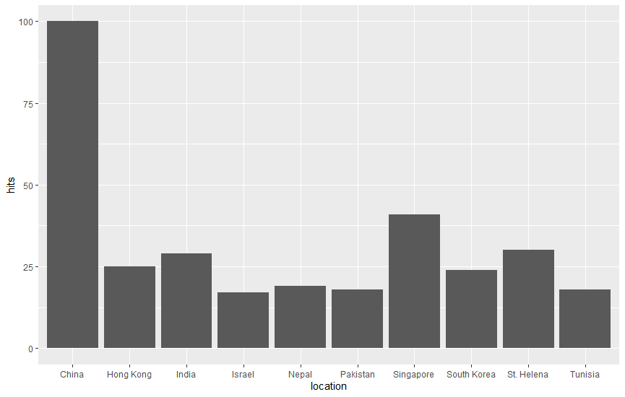

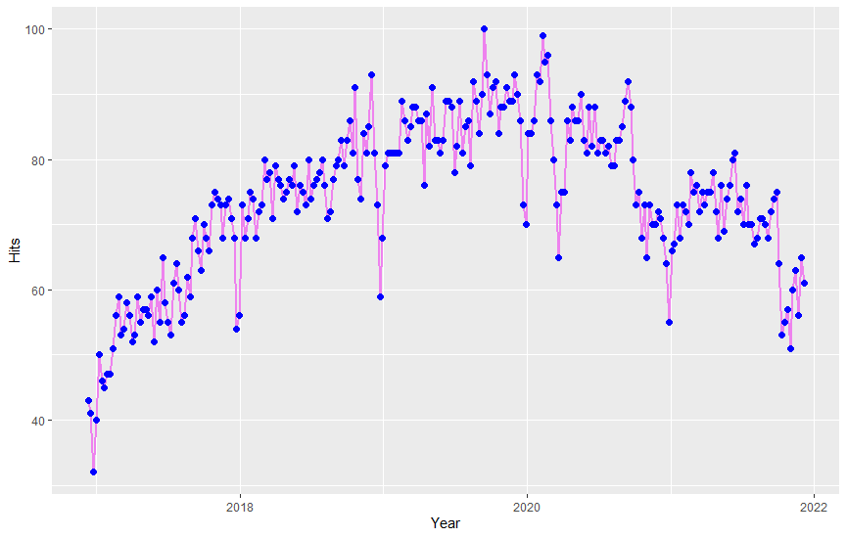

**Conclusion:**

We can see that searches based on “machine learning” on Google started to increase in 2017 and the highest searches were done in 2020 till today. China holds the record of most searches than any other country.