**TASK 04:**

library(ggplot2)

library(tidyverse)

file<-read.csv("uber-raw-data-sep14.csv")

file$Date.Time <- as.POSIXct(file$Date.Time, format="%m/%d/%Y %H:%M:%S", tz="GMT")

file$Dayofweek<-weekdays(as.Date(file$Date.Time))

file$Daynumber<-format(file$Date.Time, format = "%d")

file$Hour<-format(file$Date.Time, format = "%H")

ggplot(file,aes(Daynumber))+geom_bar(width = 0.5, color="Green")+geom_density(aes(x=Daynumber,y=..density..),alpha=0.7)+theme_classic()

ggplot(file,aes(Hour))+geom_bar(width = 0.5, color="Green")+geom_density(aes(x=Hour,y=..density..),alpha=0.7)+theme_classic()

ggplot(file,aes(Dayofweek))+geom_bar(width = 0.5, color="Green")+geom_density(aes(x=Dayofweek,y=..density..),alpha=0.7)+theme_classic()

ggplot(file,aes(Hour,Dayofweek))+geom_bin2d(binwidth = c(0.25, 500))

ggplot(file,aes(Lon,Lat),title(main = "Uber Trip Analysis"),)+geom_point(color="Steel Blue",size=2,alpha=0.8)

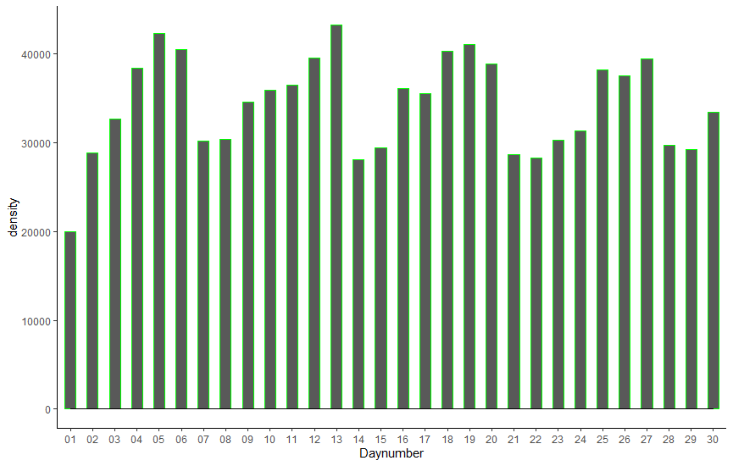

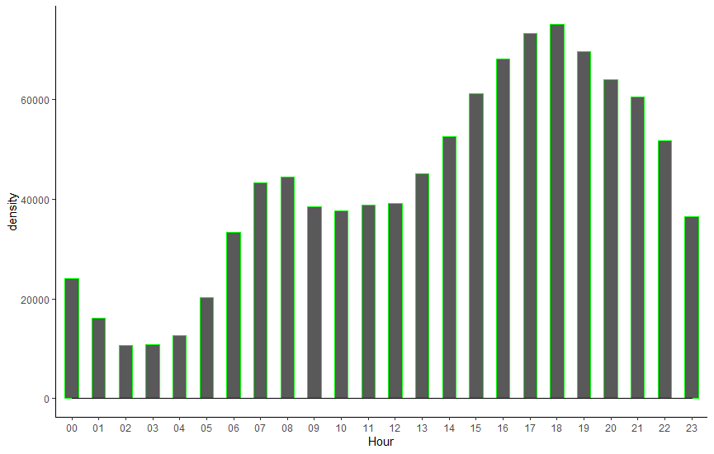

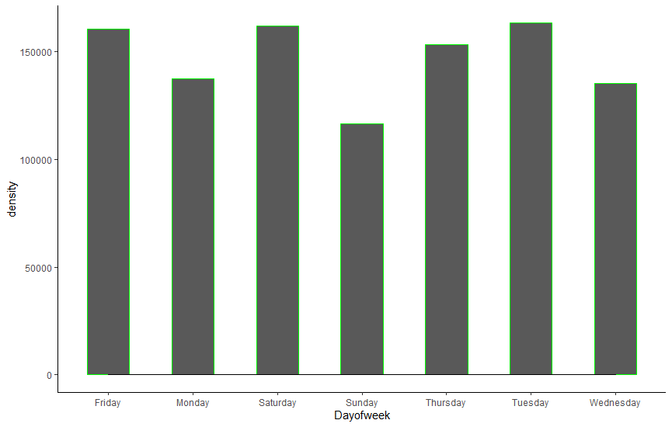

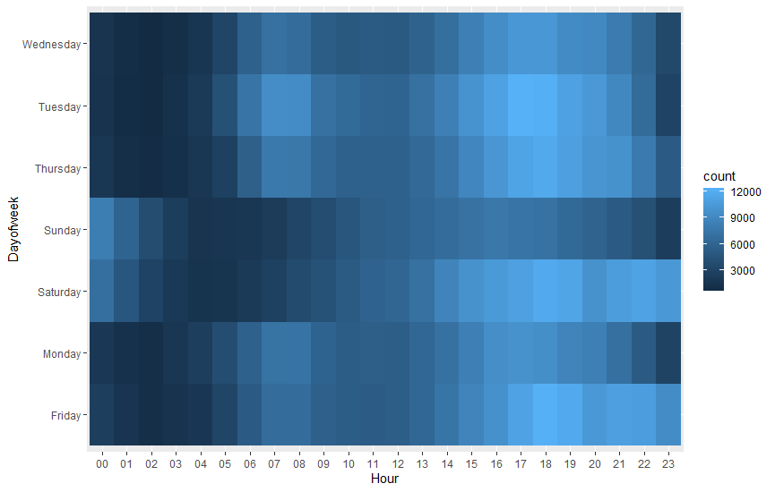

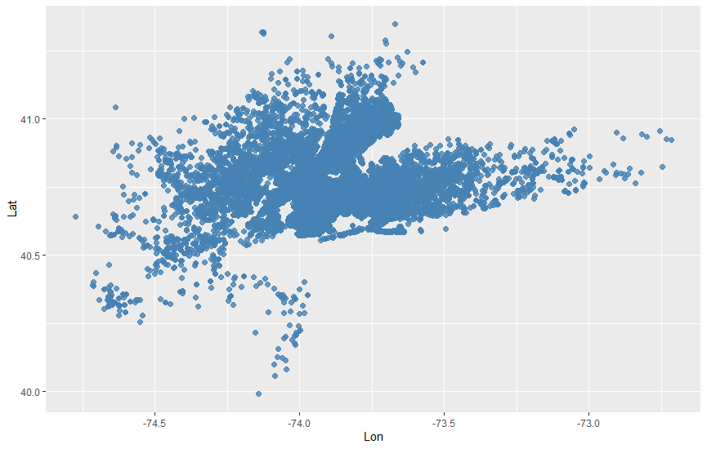

**Conclusion:**

1. Tuesday is the busiest day for Uber
2. On Sunday less number of people use Uber
3. 6 pm is the busiest day for Uber
4. On average a rise in Uber trips start around 5 am.
5. Most of the Uber trips originate near the Manhattan region in New York (searched by coordinates on google map).