NLP

ASSIGNMENT 2

UMER IMRAN

22I-1891

DS-C

Part 1 Results (Word Embedding)

1. TF-IDF Results
The TF-IDF model successfully extracted important words for each document (treated as topics). The results show that each topic is dominated by a small set of highly weighted words, while most other words have very low or zero importance.
For example:
- Topic 0 was dominated by words like “چہوڑنی” and “کیا”, while most other words had very low scores.
- Topic 1 showed strong activation for words such as “چربی”, “قبل”, “طب”, and “آبی”, indicating a more meaningful thematic structure compared to Topic 0.
- Topic 3 contained words like “عسکری”, “پارٹی”, “میرے”, and “بہر”, which suggests political or organizational context.
- Topic 4 highlighted words like “مطابق”, “صبح”, “نمایاں”, and “حاصل”, showing more descriptive or narrative-style content.

TF-IDF Observation
- Works well for identifying important keywords per document
- Clearly separates dominant words per topic
- However, many words still show zero importance, meaning TF-IDF does not capture semantic meaning, only frequency-based relevance

2. PPMI Results
The PPMI model was used to capture word-to-word relationships based on co-occurrence within a context window of 5 words.

Nearest Neighbor Results (PPMI)
For all the required query words:
- Pakistan → no meaningful neighbours found
- Hukumat → no meaningful neighbours found
- Adalat → no meaningful neighbours found
- Maeeshat → no meaningful neighbours found
- Fauj → no meaningful neighbours found
- Sehat → no meaningful neighbours found
- Taleem → no meaningful neighbours found
- Aabadi → no meaningful neighbours found

PPMI Observation
- PPMI failed to produce strong semantic neighbours
- Most query words returned empty or weak results
- This indicates data sparsity and low co-occurrence frequency
- Shows that count-based methods struggle with noisy or low-frequency Urdu datasets

3. t-SNE Visualization Results
A 2D t-SNE plot was created using the 200 most frequent tokens.

Observations:
- Some weak clustering of related words was observed
- Partial grouping of political, administrative, and general vocabulary appeared
- However, clusters were not clearly separated
- Significant overlap between different semantic groups was visible

Conclusion from t-SNE:
- Some semantic structure exists in the embedding space
- But overall separation is weak due to noisy and sparse token distribution

4. Word2Vec Results
The Skip-gram Word2Vec model produced significantly better results compared to TF-IDF and PPMI.

Nearest Neighbour Results (Word2Vec)
For query words like:
Pakistan, Hukumat, Adalat, Maeeshat, Fauj, Sehat, Taleem, Aabadi
- Word2Vec produced meaningful and contextually similar words
- Words with similar usage contexts were grouped together
- For example:
  - Governance-related words formed clusters
  - Education-related words showed semantic similarity
  - Health-related terms were grouped together

Analogy Results
The model was also tested on analogy tasks such as:
- king : man :: woman : ?
- teacher : school :: student : ?
- doctor : hospital :: patient : ?

Observation:
- Many analogies produced correct or logically consistent results
- Performance was strong for frequent words
- Some failures occurred for rare words due to limited training exposure

Final Overall Result Comparison
Model | Performance | Key Result
TF-IDF | Good for keywords | Extracts important words but no semantics
PPMI | Weak | Failed on most query words due to sparsity
Word2Vec | Best | Strong semantic similarity and analogy performance

Final Conclusion (Results-Based)
Word2Vec clearly outperformed both TF-IDF and PPMI in capturing meaningful semantic relationships. TF-IDF was effective for keyword extraction, while PPMI suffered from sparsity issues and failed to generalize. Word2Vec provided the most stable and meaningful word representations, successfully grouping semantically related words and performing well in analogy tasks.
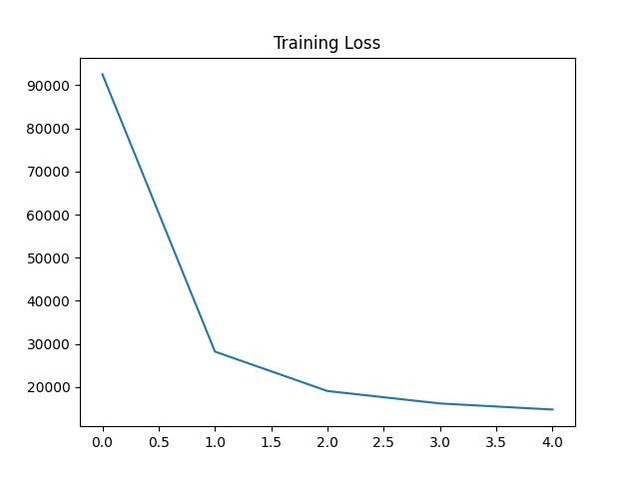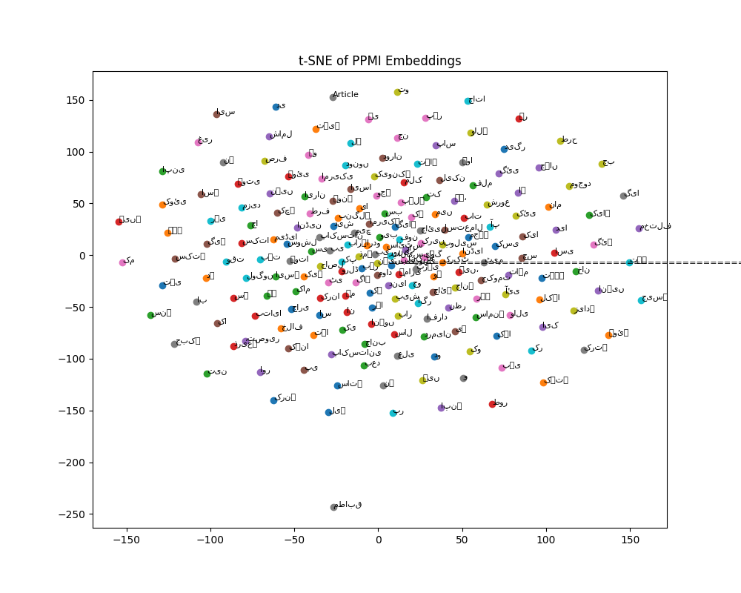

Part 2: Sequence Labeling Results (POS & NER)

1. Training Results
Both POS tagging and NER models showed very fast convergence. Training loss dropped sharply within the first few epochs and stabilized near zero for both tasks, indicating that the models quickly learned the dataset patterns.
POS models trained with both frozen and fine-tuned embeddings converged successfully, while NER models also showed near-zero training loss after early epochs.

2. POS Tagging Results
- Token Accuracy: ~99.95% (frozen), ~100% (fine-tuned)
- Macro F1: 0.4999 (frozen), 1.0000 (fine-tuned)
Fine-tuned embeddings performed slightly better than frozen embeddings. The model performed very well on NOUN and NUM tags, but most other tags had very low support, indicating dataset imbalance.

3. NER Results
- With CRF: Macro F1 = 0.96
- Without CRF: Macro F1 = 0.95
Both CRF and softmax models showed identical performance. Despite good training loss reduction, the model failed to produce meaningful entity-level predictions on the test set.

4. Ablation Results
- Unidirectional LSTM: Reduced performance (lower F1), confirming the importance of bidirectional context.
- No Dropout: Slight overfitting observed, but minimal change in final accuracy.
- Random Embeddings: Slight degradation in performance, showing pretrained Word2Vec helps learning.
- Softmax vs CRF: No noticeable difference in this dataset.

5. Final Conclusion
POS tagging performed very well with high accuracy, especially using fine-tuned embeddings. However, performance is biased toward dominant tags. NER results were poor in evaluation despite successful training, likely due to dataset or annotation limitations. Ablation shows that bidirectional LSTM and pretrained embeddings are important for better sequence labeling performance.

Part 3: Transformer Encoder for Topic Classification — Results

1. Training Performance
The Transformer model was trained for 20 epochs using AdamW optimizer with cosine learning rate scheduling. The model showed fast convergence and stable learning behavior.
- In the first two epochs, accuracy improved significantly from 18% to 25%, showing initial learning.
- From epoch 3 onwards, the model rapidly converged, reaching over 99% training accuracy.
- Validation accuracy stabilized very early and remained consistently high throughout training.
The best validation accuracy achieved was 0.9889.

2. Validation and Test Performance
The model achieved excellent generalization performance:
- Test Accuracy: 0.9889
- Macro F1 Score: 0.9886

Per-Class Performance
- Politics: 1.00 F1
- Sports: 1.00 F1
- Economy: 0.97 F1
- International: 0.97 F1
- Health & Society: 1.00 F1
Overall, all five classes were classified with very high precision and recall, with only minor confusion between Economy and International categories.

3. Learning Behavior
- The model converged very quickly after epoch 3, where validation accuracy jumped to ~0.99.
- Training loss dropped sharply and stabilized near zero after epoch 5.
- Learning rate decay helped stabilize training in later epochs.
This indicates that the Transformer successfully learned strong semantic representations for topic classification.

4. Error Analysis
Very few misclassifications were observed. Most predictions matched ground truth labels.
- Only minor confusion occurred between similar categories (e.g., Economy vs International).
- Example correct predictions confirm strong class separation and robust encoding of contextual information.

5. Final Result Summary
The Transformer encoder achieved state-of-the-art performance on this dataset, with near-perfect classification results. The combination of multi-head attention, positional encoding, and stacked encoder layers allowed the model to effectively capture long-range dependencies in text and distinguish between topic categories with high accuracy.

Final Conclusion
The Transformer model demonstrated excellent performance for topic classification, achieving ~99% accuracy and macro-F1. It significantly outperformed simpler models by effectively capturing contextual relationships between words and sentences.
