SOFTWARE REQUIREMENTS SPECIFICATION
AI-Integrated Custom Clothing Website
Version 4.0

Prepared By
Umer Javed | Abdul Baqi
BS Computer Science: Session 2022-2026

Project Supervisor
Dr. Zaheen Khan
Project Coordinator
Mr. Naeem Malik

Department of Computer Science
Federal Urdu University of Arts, Science & Technology, Islamabad
June 2026

Revision History
Table 1: Document Revision History
Version | Description | Author | Date
1.0 | Initial SRS for AI-Integrated Custom Clothing Website | Umer Javed, Abdul Baqi | 6-Nov-2025
2.0 | Revised SRS: added use case descriptions, ER diagram, architecture, and full implementation guide | Umer Javed, Abdul Baqi | Nov-2025
3.0 | Backend stack migration: PHP/Apache/XAMPP → Python 3.11+ / FastAPI / Uvicorn; PDO → SQLAlchemy ORM; PHPMailer → FastAPI-Mail; sessions → JWT; full implementation guide rewritten with Python code examples | Umer Javed, Abdul Baqi | Jun-2026
4.0 | Full feature implementation sprint: mobile hamburger nav, size tile selection (XS–XXL), user profile page with edit, order cancellation by customer, admin analytics canvas charts, CSV export, manual order with live product list, coupon/promo code system, out-of-stock visibility, chat history persistence, all FR statuses updated to Implemented. Frontend stack confirmed as Vanilla JS/CSS3 (no Bootstrap). Database: PostgreSQL 16 (prod) + SQLite (dev). | Sharjeel | Jun-2026

Table of Contents
1 | Introduction | 5
2 | Overall System Description | 6
3 | Functional Requirements | 8
4 | Use Case Descriptions | 14
5 | Non-Functional Requirements | 19
6 | External Interface Requirements | 21
7 | UML Diagrams | 22
8 | System Architecture | 28
9 | Database Design | 30
10 | Tools and Technologies | 32
11 | Implementation Guide | 34
12 | Requirements Traceability Matrix | 41
13 | Risk Register | 44

1. Introduction
1.1 Purpose
This Software Requirements Specification (SRS) document defines the complete functional and non-functional requirements for the AI-Integrated Custom Clothing Website. It serves as the authoritative reference for developers, testers, and academic supervisors throughout the development lifecycle of this Final Year Project (FYP). The document covers system objectives, user requirements, system design constraints, external interfaces, and a step-by-step implementation guide.
1.2 Scope
The AI-Integrated Custom Clothing Website is a full-stack web platform that enables customers to design and order customized streetwear and sportswear. Users select product type, fabric, color, stitching, logo placement, and print method, and receive a real-time 2D design preview. An AI-powered chatbot, built on Retrieval-Augmented Generation (RAG) technology using n8n automation and the OpenAI GPT API, provides context-aware fabric recommendations and customer support. An admin dashboard enables manufacturers to manage products, inventory, and orders.
1.3 Definitions, Acronyms, and Abbreviations
AI | Artificial Intelligence
RAG | Retrieval-Augmented Generation: a technique that grounds LLM responses in retrieved documents
LLM | Large Language Model
n8n | Open-source workflow automation platform used to orchestrate the AI pipeline
REST | Representational State Transfer: architectural style for web APIs
SRS | Software Requirements Specification
FYP | Final Year Project
UI/UX | User Interface / User Experience
FR | Functional Requirement
NFR | Non-Functional Requirement
UC | Use Case
DTG | Direct-to-Garment (printing method)
OTP | One-Time Password
HTTPS | HyperText Transfer Protocol Secure
DXA | Document eXtended Attribute unit (DXA/EMU measure used in OOXML)
1.4 References
- IEEE Std 830-1998: IEEE Recommended Practice for Software Requirements Specifications.
- OpenAI API Documentation: https://platform.openai.com/docs
- n8n Documentation: https://docs.n8n.io
- Vanilla CSS3 (no framework) Documentation: https://getbootstrap.com/docs/5.0
- Python 3.11 Official Documentation: https://docs.python.org/3.11
1.5 Document Overview
Section 2 provides an overall description of the system context and constraints. Section 3 details all functional requirements organized by module. Section 4 contains formal use case descriptions. Section 5 covers non-functional requirements. Sections 6–9 present interface requirements, UML diagrams, architecture, and database design. Sections 10–11 provide the tools selection and step-by-step implementation guide.

2. Overall System Description
2.1 Product Perspective
The proposed system is a standalone web application deployed on a cloud server accessible via any modern web browser. It does not depend on or integrate with any existing external e-commerce platform. The system interfaces externally with the OpenAI API for language generation and optionally with a payment gateway. Internally, it consists of a Python FastAPI backend RESTful API, a PostgreSQL 16 / SQLite relational database, and an n8n workflow automation engine running on the same or adjacent server.
2.2 Product Functions Summary
The system provides the following high-level capabilities:
- User registration, authentication, and profile management.
- Browsable product catalog with search and filtering.
- Deep product customization: fabric, color, stitching, logo, and print method.
- Real-time 2D design preview that updates with each customization selection.
- RAG-powered AI chatbot providing fabric recommendations and FAQ support.
- Dynamic pricing engine calculating order cost from customization choices.
- Shopping cart, checkout, and multiple payment method support.
- Order management with real-time status tracking and email notifications.
- Admin dashboard for product, inventory, and order management.
2.3 User Classes and Characteristics
User Class | Description | Technical Proficiency
Customer | End user who customizes and orders clothing. Primary user of the system. | Low to moderate; interface designed for non-technical users.
Admin / Manufacturer | Manages products, processes orders, and monitors inventory and analytics. | Moderate; familiar with dashboard interfaces and order workflows.
AI Chatbot (System Actor) | Automated agent processing customer queries through the n8n-GPT pipeline. | N/A; automated system component.
2.4 Operating Environment
- Client: Any modern browser (Chrome 90+, Firefox 88+, Edge 90+, Safari 14+) on desktop, tablet, or mobile.
- Server: Python 3.11+, FastAPI framework, Uvicorn ASGI server, PostgreSQL 16 / SQLite 8.0+ (PostgreSQL 15+ also compatible), n8n v1.x.
- Hosting: Render, Railway.app, or any VPS supporting Python for online deployment (or a local virtual environment for demo).
- Connectivity: Active internet connection required for OpenAI API calls; all other functions work on local network.
2.5 Design and Implementation Constraints
- The system shall be implemented using Python 3.11+ with FastAPI as the backend framework and PostgreSQL 16 / SQLite as the primary database (PostgreSQL 15+ is also a compatible alternative).
- The AI chatbot must use the OpenAI API via n8n automation; direct ChatGPT integration (without RAG) is not sufficient.
- All user-facing pages must be mobile-responsive using Vanilla CSS3 (no framework).
- Password storage must use bcrypt hashing via passlib[bcrypt]; plaintext passwords are not permitted.
- Total OpenAI API cost must remain within a reasonable budget (use GPT-4o-mini for cost efficiency).
2.6 Assumptions and Dependencies
- It is assumed that the OpenAI API remains available and the API key quota is sufficient for demonstration purposes.
- The n8n instance will be hosted locally or on a free-tier cloud server (e.g., Railway.app or Render).
- Email notifications require configuration of a Python email library (FastAPI-Mail or smtplib + SMTP, e.g., Gmail SMTP).
- Image uploads (logos) require a server directory with write permissions.

3. Functional Requirements
The following tables define all functional requirements of the system, organized by module. Priority levels are: High (must have for MVP), Medium (should have), and Low (nice to have).
3.1 Module 1: User Authentication & Management
Table 2: FR Module 1: User Authentication
FR-ID | Requirement Description | Priority | Status
FR-01 | The system shall allow new users to register with a unique email address and password. | High | Implemented
FR-02 | The system shall encrypt all stored passwords using the bcrypt hashing algorithm. | High | Implemented
FR-03 | The system shall validate email format and enforce minimum password strength (8+ characters, one uppercase, one number) during registration. | High | Implemented
FR-04 | The system shall allow users to log in using their registered email and password. | High | Implemented
FR-05 | The system shall authenticate users using JWT (JSON Web Tokens) issued upon login and enforce token expiry after 30 minutes of inactivity. | High | Implemented
FR-06 | The system shall allow users to reset their password via an OTP sent to their registered email address. | Medium | Implemented
FR-07 | The system shall allow users to update their profile information (name, phone number, delivery address). | Medium | Implemented
FR-08 | The system shall support two roles: Customer and Admin, each with distinct access rights. | High | Implemented
3.2 Module 2: Product Catalog & Browsing
Table 3: FR Module 2: Product Catalog
FR-ID | Requirement Description | Priority | Status
FR-09 | The system shall display a product catalog organized into categories: T-Shirts, Hoodies, Jackets, and Sports Uniforms. | High | Implemented
FR-10 | The system shall provide a product detail page showing product image, description, available fabric options, and base price. | High | Implemented
FR-11 | The system shall support keyword search for products by name, category, and fabric type. | Medium | Implemented
FR-12 | The system shall allow filtering products by category, fabric type, and price range. | Medium | Implemented
FR-13 | The system shall display product availability based on current inventory stock levels. | Medium | Implemented
FR-14 | The system shall show related product suggestions on each product detail page. | Low | Implemented
3.3 Module 3: Product Customization & Preview
Table 4: FR Module 3: Product Customization
FR-ID | Requirement Description | Priority | Status
FR-15 | The system shall allow selection of fabric type (Cotton, Polyester, Blended, Fleece) for each product. | High | Implemented
FR-16 | The system shall allow selection of fabric grade (Grade 1 to Grade 5) where grade influences material price multiplier. | High | Implemented
FR-17 | The system shall allow selection of primary and secondary colors via a color picker with hex code support. | High | Implemented
FR-18 | The system shall allow users to upload a custom logo image (PNG or JPG, maximum 5 MB) and select placement (Chest, Back, Left Sleeve, Right Sleeve). | High | Implemented
FR-19 | The system shall allow selection of stitching style (Flatlock, Overlock, Chain Stitch). | Medium | Implemented
FR-20 | The system shall allow selection of print method (Screen Print, Direct-to-Garment, Embroidery, Heat Transfer). | High | Implemented
FR-21 | The system shall allow selection of wash and finishing effect (Stone Wash, Acid Wash, Standard, Enzyme Wash). | Low | Implemented
FR-22 | The system shall generate and display a real-time 2D design preview that updates dynamically as the user modifies each customization option. | High | Implemented
FR-23 | The system shall display the dynamically calculated price in real time alongside the design preview as the user makes customization selections. | High | Implemented
3.4 Module 4: AI Chatbot & Recommendation Engine
Table 5: FR Module 4: AI Chatbot
FR-ID | Requirement Description | Priority | Status
FR-24 | The system shall provide a floating AI chatbot widget accessible from every page of the website. | High | Implemented
FR-25 | The chatbot shall use an n8n workflow that first queries the PostgreSQL 16 / SQLite database to retrieve relevant product data before invoking the OpenAI GPT API (RAG pattern). | High | Implemented
FR-26 | The chatbot shall accept natural language queries and provide context-aware fabric and design recommendations based on user-specified occasion, season, and budget. | High | Implemented
FR-27 | The chatbot shall answer frequently asked questions about delivery timelines, return policies, care instructions, and bulk order pricing. | Medium | Implemented
FR-28 | The chatbot shall support multi-turn conversation context within a single browser session by maintaining message history. | Medium | Implemented
FR-29 | The chatbot shall clearly indicate when a query falls outside its knowledge scope rather than generating speculative responses. | Medium | Implemented
FR-30 | The system shall log every chatbot interaction (user message, retrieved context, AI response, timestamp) to the chat_logs database table. | High | Implemented
FR-31 | The admin shall be able to add, edit, and remove FAQ entries that the chatbot uses as part of its knowledge base. | Medium | Implemented
3.5 Module 5: Order Management
Table 6: FR Module 5: Order Management
FR-ID | Requirement Description | Priority | Status
FR-32 | The system shall allow authenticated users to add customized products to a shopping cart. | High | Implemented
FR-33 | The system shall allow users to update cart item quantities and remove items from the cart before checkout. | High | Implemented
FR-34 | The system shall dynamically compute order total from base product price, fabric grade multiplier, customization add-ons, and quantity tier discounts. | High | Implemented
FR-35 | The system shall assign a unique alphanumeric Order ID to every confirmed order. | High | Implemented
FR-36 | The system shall allow users to cancel an order only while its status is Pending. | Medium | Implemented
FR-37 | The system shall display a real-time order tracking page with statuses: Pending → In Production → Quality Check → Shipped → Delivered. | High | Implemented
FR-38 | The system shall store complete order details including all customization selections, logo path, unit price, and timestamps. | High | Implemented
FR-39 | The system shall allow users to view their complete order history with status and details. | Medium | Implemented
FR-40 | The system shall allow users to reorder a previous order with the same customization selections in one click. | Low | Implemented
3.6 Module 6: Payment Processing
Table 7: FR Module 6: Payment Processing
FR-ID | Requirement Description | Priority | Status
FR-41 | The system shall support secure online payment via an integrated payment gateway (e.g., Stripe or PayFast). | High | Implemented
FR-42 | The system shall support digital wallet payment methods including JazzCash and Easypaisa. | High | Implemented
FR-43 | The system shall support Cash on Delivery as an alternative payment method. | Medium | Implemented
FR-44 | The system shall automatically update the order payment status to "Paid" upon successful transaction confirmation from the payment gateway. | High | Implemented
FR-45 | The system shall enforce HTTPS for all pages involving payment data entry or processing. | High | Implemented
FR-46 | The system shall never store card details in the database; payment tokenization shall be handled by the gateway. | High | Implemented
3.7 Module 7: Admin & Inventory Management
Table 8: FR Module 7: Admin Dashboard
FR-ID | Requirement Description | Priority | Status
FR-47 | The admin interface shall be accessible only to users with the Admin role via a separate login route (/admin/login). | High | Implemented
FR-48 | The admin shall be able to add, edit, and soft-delete products and their associated customization options. | High | Implemented
FR-49 | The admin shall be able to view all customer orders and update their production status. | High | Implemented
FR-50 | The admin shall be able to view customer accounts and suspend or reactivate them. | Medium | Implemented
FR-51 | The system shall track inventory quantities per material (fabric type/grade, print method) and display a low-stock alert on the admin dashboard when any item falls below its reorder level. | Medium | Implemented
FR-52 | The admin dashboard shall display a summary panel showing total orders, revenue, pending orders, and most popular products. | Medium | Implemented
FR-53 | The admin shall be able to view chatbot usage metrics including total interactions and most frequently asked query categories. | Low | Implemented
3.8 Module 8: Notification System
Table 9: FR Module 8: Notifications
FR-ID | Requirement Description | Priority | Status
FR-54 | The system shall send an automated email confirmation to the customer upon successful order placement, including order summary and Order ID. | High | Implemented
FR-55 | The system shall send an automated email to the customer whenever their order status changes. | Medium | Implemented
FR-56 | The system shall send an automated email notification to the admin when a new order is placed. | Medium | Implemented

4. Use Case Descriptions
This section provides detailed use case descriptions for the five most critical system interactions. Figure 4 in Section 7 presents the complete Use Case Diagram from which these descriptions are derived.
4.1 UC-01: User Registration
Use Case ID | UC-01
Use Case Name | User Registration
Actor | Customer
Precondition | User is not logged in. User has a valid email address not previously registered in the system.
Trigger | User clicks "Sign Up" on the homepage navigation bar.
Main Success Flow | 1. System displays the registration form. 2. User enters full name, email address, password, and phone number. 3. System validates all fields: email format, password strength (8+ chars, 1 uppercase, 1 digit), and non-duplicate email. 4. System hashes the password using bcrypt. 5. System creates a new user record with role = Customer. 6. System sends a welcome email to the user. 7. System redirects the user to the login page with a success message.
Alternative Flow | Step 3a: Email already exists: System displays "An account with this email already exists. Please log in." and clears the password field.
Exception Flow | Step 6a: Email server unavailable: System proceeds with account creation but logs the failed email send for retry.
Postcondition | A new customer account is created in the users table with hashed password and is_active = 1.
4.2 UC-02: Customize Product & Preview Design
Use Case ID | UC-02
Use Case Name | Customize Product and Preview Design
Actor | Customer
Precondition | User is logged in. User has selected a product from the catalog.
Trigger | User clicks "Customize" on a product detail page.
Main Success Flow | 1. System displays the customization panel alongside a 2D design canvas. 2. User selects fabric type and grade from dropdown menus. 3. User selects primary and secondary colors using the color picker. 4. User optionally uploads a logo image and selects placement position. 5. User selects stitching style and print method. 6. After each selection, the system updates the 2D preview canvas and recalculates the displayed price dynamically. 7. User is satisfied with the preview and clicks "Add to Cart". 8. System saves customization details and adds the item to the session cart.
Alternative Flow | Step 4a: Logo file exceeds 5 MB: System rejects the upload and displays "Logo file must be under 5 MB. Please compress and retry."
Alternative Flow | Step 7a: User clicks "Get AI Suggestion": System opens the chatbot with a pre-filled query based on current selections (triggers UC-03).
Exception Flow | Step 6a: Preview generation fails (JavaScript error): System shows a static placeholder image and logs the error.
Postcondition | Customization selections are stored in the session cart. Cart item count in the navigation bar increments by 1.
4.3 UC-03: Get AI Design Recommendation
Use Case ID | UC-03
Use Case Name | Get AI Design Recommendation (RAG Chatbot)
Actor | Customer, AI Chatbot (system)
Precondition | AI chatbot widget is loaded on the page. n8n service and OpenAI API are reachable.
Trigger | User types a query in the chatbot widget (e.g., "What fabric is best for a summer sports jersey?")
Main Success Flow | 1. User submits query via the chatbot input field. 2. Browser sends the query (and current session message history) to the FastAPI backend via AJAX POST with JWT bearer token. 3. FastAPI backend forwards the request to the n8n webhook endpoint. 4. n8n Retrieval Node queries the PostgreSQL 16 / SQLite products, fabric_options, and FAQs tables using keywords extracted from the query. 5. n8n Prompt Builder Node constructs a GPT system prompt: "You are a clothing advisor for this store. Use the following product data: [retrieved records]. Answer the customer query." 6. n8n invokes the OpenAI GPT API with the constructed prompt. 7. GPT response is returned through n8n to the FastAPI backend. 8. FastAPI backend stores the interaction in chat_logs and returns the response to the browser. 9. Chatbot widget displays the AI response in the conversation interface.
Alternative Flow | Step 4a: No relevant records found: n8n passes an empty context; GPT responds with general advice and suggests contacting support.
Exception Flow | Step 6a: OpenAI API unavailable / quota exceeded: System returns a fallback message "AI assistant is temporarily unavailable. Please try again shortly." and logs the error.
Postcondition | Chat interaction is logged in the chat_logs table. User receives a context-accurate product recommendation.
4.4 UC-04: Place Order
Use Case ID | UC-04
Use Case Name | Place Order
Actor | Customer
Precondition | User is logged in. Shopping cart contains at least one item.
Trigger | User clicks "Proceed to Checkout" from the cart page.
Main Success Flow | 1. System displays the order summary page showing all cart items with customization details and the total price. 2. User confirms or edits the delivery address. 3. User selects a payment method (Card, JazzCash, Easypaisa, or Cash on Delivery). 4. For card/wallet payment: user completes payment on the gateway interface. 5. Payment gateway sends a success callback to the FastAPI backend. 6. System creates a new record in the orders table with status = Pending and generates a unique Order ID. 7. System creates corresponding order_items records with full customization data. 8. System creates a payments record with status = Paid (or Pending for COD). 9. System sends an order confirmation email to the customer and a new-order notification to the admin. 10. System clears the cart and redirects the user to the Order Confirmation page showing the Order ID.
Alternative Flow | Step 4a: Payment gateway returns failure: System displays "Payment was not completed. Please try again or select a different method." Order is NOT created.
Alternative Flow | Step 3b: COD selected: Steps 4–5 are skipped. Payment status is set to COD Pending.
Exception Flow | Step 6a: Database write fails: System logs the error, does not create a partial order, and shows an error page with a support contact.
Postcondition | Order is stored in the database. Customer and admin receive email notifications. Cart is cleared.
4.5 UC-05: Admin Processes Order
Use Case ID | UC-05
Use Case Name | Admin Processes Order
Actor | Admin / Manufacturer
Precondition | Admin is logged in. At least one order exists with status Pending.
Trigger | Admin navigates to the Orders section of the admin dashboard.
Main Success Flow | 1. Admin dashboard displays a list of all orders sorted by date, with status badges. 2. Admin clicks on an order to view full details: customer info, customization specifications, logo preview, and payment status. 3. Admin reviews the order and clicks "Move to In Production". 4. System updates the order status in the database and records the timestamp. 5. System sends an automated email notification to the customer informing them their order is now in production. 6. Admin later updates the status sequentially: In Production → Quality Check → Shipped → Delivered, entering tracking information at the Shipped stage. 7. System sends a corresponding email notification at each status change.
Alternative Flow | Step 3a: Admin identifies an issue (e.g., stock shortage): Admin selects "Flag Order" and adds a note. Customer is notified to contact support.
Exception Flow | Step 4a: Database update fails: System displays an error alert. Order status remains unchanged.
Postcondition | Order status is updated in the database. Customer receives email notification. Inventory quantities for consumed materials are decremented.

5. Non-Functional Requirements
Table 10 lists all non-functional requirements for the system, organized by quality attribute category.
Table 10: Non-Functional Requirements
NFR-ID | Category | Requirement | Metric / Target
NFR-01 | Performance | Page load time for all standard pages shall not exceed 3 seconds under normal load on a standard broadband connection. | ≤ 3 seconds
NFR-02 | Performance | The dynamic price calculator and 2D preview must update within 500 milliseconds of each user selection change. | ≤ 500 ms
NFR-03 | Performance | The AI chatbot shall return a response within 5 seconds for 95% of queries under normal API conditions. | ≤ 5 seconds (95th percentile)
NFR-04 | Security | All user passwords shall be hashed with bcrypt (cost factor ≥ 10) before storage. Plaintext passwords must never be stored or logged. | bcrypt, cost ≥ 10
NFR-05 | Security | The system shall use parameterized queries (SQLAlchemy ORM or asyncpg prepared statements) for all database interactions to prevent SQL injection. | 100% parameterized queries
NFR-06 | Security | All user inputs shall be validated and sanitized on the server side via Pydantic models to prevent XSS attacks. Output encoding shall be applied to all displayed user-sourced data. | Server-side sanitization on all inputs
NFR-07 | Security | All pages processing payment or personal data shall be served exclusively over HTTPS (TLS 1.2+). | HTTPS enforced on payment flows
NFR-08 | Security | Admin routes shall be protected by role-based access control. Any unauthenticated access to /admin routes shall redirect to the admin login page. | Role-based ACL on all admin routes
NFR-09 | Usability | The user interface shall be fully responsive and usable on screen widths from 320px (mobile) to 1920px (desktop) without horizontal scrolling. | Responsive: 320px–1920px
NFR-10 | Usability | The product customization interface shall require no more than 5 steps for a customer to go from product selection to adding to cart. | ≤ 5 interaction steps
NFR-11 | Usability | All form fields shall display inline validation messages within 300 milliseconds of losing focus. | ≤ 300 ms inline validation
NFR-12 | Reliability | The system shall maintain 99% uptime excluding scheduled maintenance periods. | 99% uptime
NFR-13 | Reliability | All database transactions (especially order creation and payment recording) shall be atomic; partial writes on failure shall be rolled back. | ACID-compliant transactions
NFR-14 | Reliability | The system shall handle OpenAI API unavailability gracefully with a user-facing fallback message and internal error logging, without crashing the application. | Graceful degradation on AI failure
NFR-15 | Scalability | The system architecture shall support horizontal scaling of the FastAPI backend without architectural changes (stateless JWT-based authentication ensures no server-side session state). | Stateless-ready backend
NFR-16 | Scalability | The PostgreSQL 16 / SQLite database schema shall be designed to support up to 100,000 order records and 10,000 user accounts without query performance degradation, achieved through appropriate indexing. | Indexed for 100K orders / 10K users
NFR-17 | Maintainability | The backend codebase shall be organized following an MVC-like structure with clear separation of routing, business logic, and data access layers. | MVC separation
NFR-18 | Maintainability | All public functions and API endpoints shall include inline Python docstrings (Google-style or NumPy-style). | Docstrings on all functions
NFR-19 | Maintainability | The system shall use Git with a branching strategy (main/develop/feature branches) and all commits shall include descriptive commit messages. | Git branching strategy
NFR-20 | Maintainability | The n8n workflow shall be exported as a JSON configuration file and version-controlled alongside the codebase for reproducibility. | n8n workflow in version control

6. External Interface Requirements
6.1 User Interface Requirements
- The website shall use a consistent design language throughout: the same color scheme, typography (Arial/sans-serif for body, heading hierarchy), and spacing conventions on all pages.
- The customization panel shall display fabric, color, stitch, and print options as visually distinct, clickable tiles rather than plain text dropdowns where possible.
- The 2D design canvas shall occupy at least 40% of the viewport width on desktop and 100% width on mobile in the customization view.
- The chatbot widget shall appear as a floating button (bottom-right corner) on all pages and expand to a 350×500px chat panel when clicked.
- The admin dashboard shall use a sidebar navigation layout with collapsible sections for Products, Orders, Users, Inventory, and Analytics.
6.2 Hardware Interface Requirements
- The system requires no specialized hardware. It operates on standard web servers (Python/Uvicorn + FastAPI) and is accessible from any device with a modern browser and internet connection.
- Image uploads (logos) require client devices with file system access; no camera or special peripherals are needed.
6.3 Software Interface Requirements
Interface | Technology / Protocol | Description
FastAPI ↔ PostgreSQL 16 / SQLite | SQLAlchemy ORM / asyncpg over local socket | Backend reads and writes all application data using SQLAlchemy ORM models or asyncpg parameterized queries.
Browser ↔ FastAPI Backend | HTTPS REST API (JSON) | Frontend communicates with the backend via AJAX calls returning JSON responses.
FastAPI ↔ n8n | HTTP POST (JSON webhook) | Backend forwards chatbot queries to the n8n workflow via a webhook URL.
n8n ↔ PostgreSQL 16 / SQLite | n8n PostgreSQL 16 / SQLite node (TCP) | n8n retrieves product and FAQ data from PostgreSQL 16 / SQLite for RAG context construction.
n8n ↔ OpenAI API | HTTPS REST (JSON) | n8n invokes the OpenAI Chat Completions endpoint with the constructed prompt.
FastAPI ↔ Email Server | FastAPI-Mail / smtplib + SMTP (TLS) | Order confirmation and status-change emails sent via FastAPI-Mail or smtplib using Gmail SMTP or equivalent.
FastAPI ↔ Payment Gateway | HTTPS REST | Payment initiation and callback handling via payment gateway API (Stripe/PayFast).
6.4 Communication Interface Requirements
- All client-server communication shall use HTTPS (TLS 1.2 or higher) to encrypt data in transit.
- All API responses shall be formatted in JSON with appropriate HTTP status codes (200, 201, 400, 401, 403, 404, 500).
- The n8n webhook shall be protected by a secret token in the request header to prevent unauthorized invocation.

7. UML Diagrams
This section presents all UML diagrams for the system. Each diagram is referenced in the relevant requirement sections above. Diagrams were created using draw.io / Lucidchart and are included at original quality.
7.1 Use Case Diagram
Figure 1 shows the complete use case diagram for the system. It identifies three actors (Customer, Admin/Manufacturer, and the AI Chatbot) and all system use cases. Notable included relationships are: Customize Clothing «includes» Get AI Recommendation, and Place Order «includes» Calculate Price.
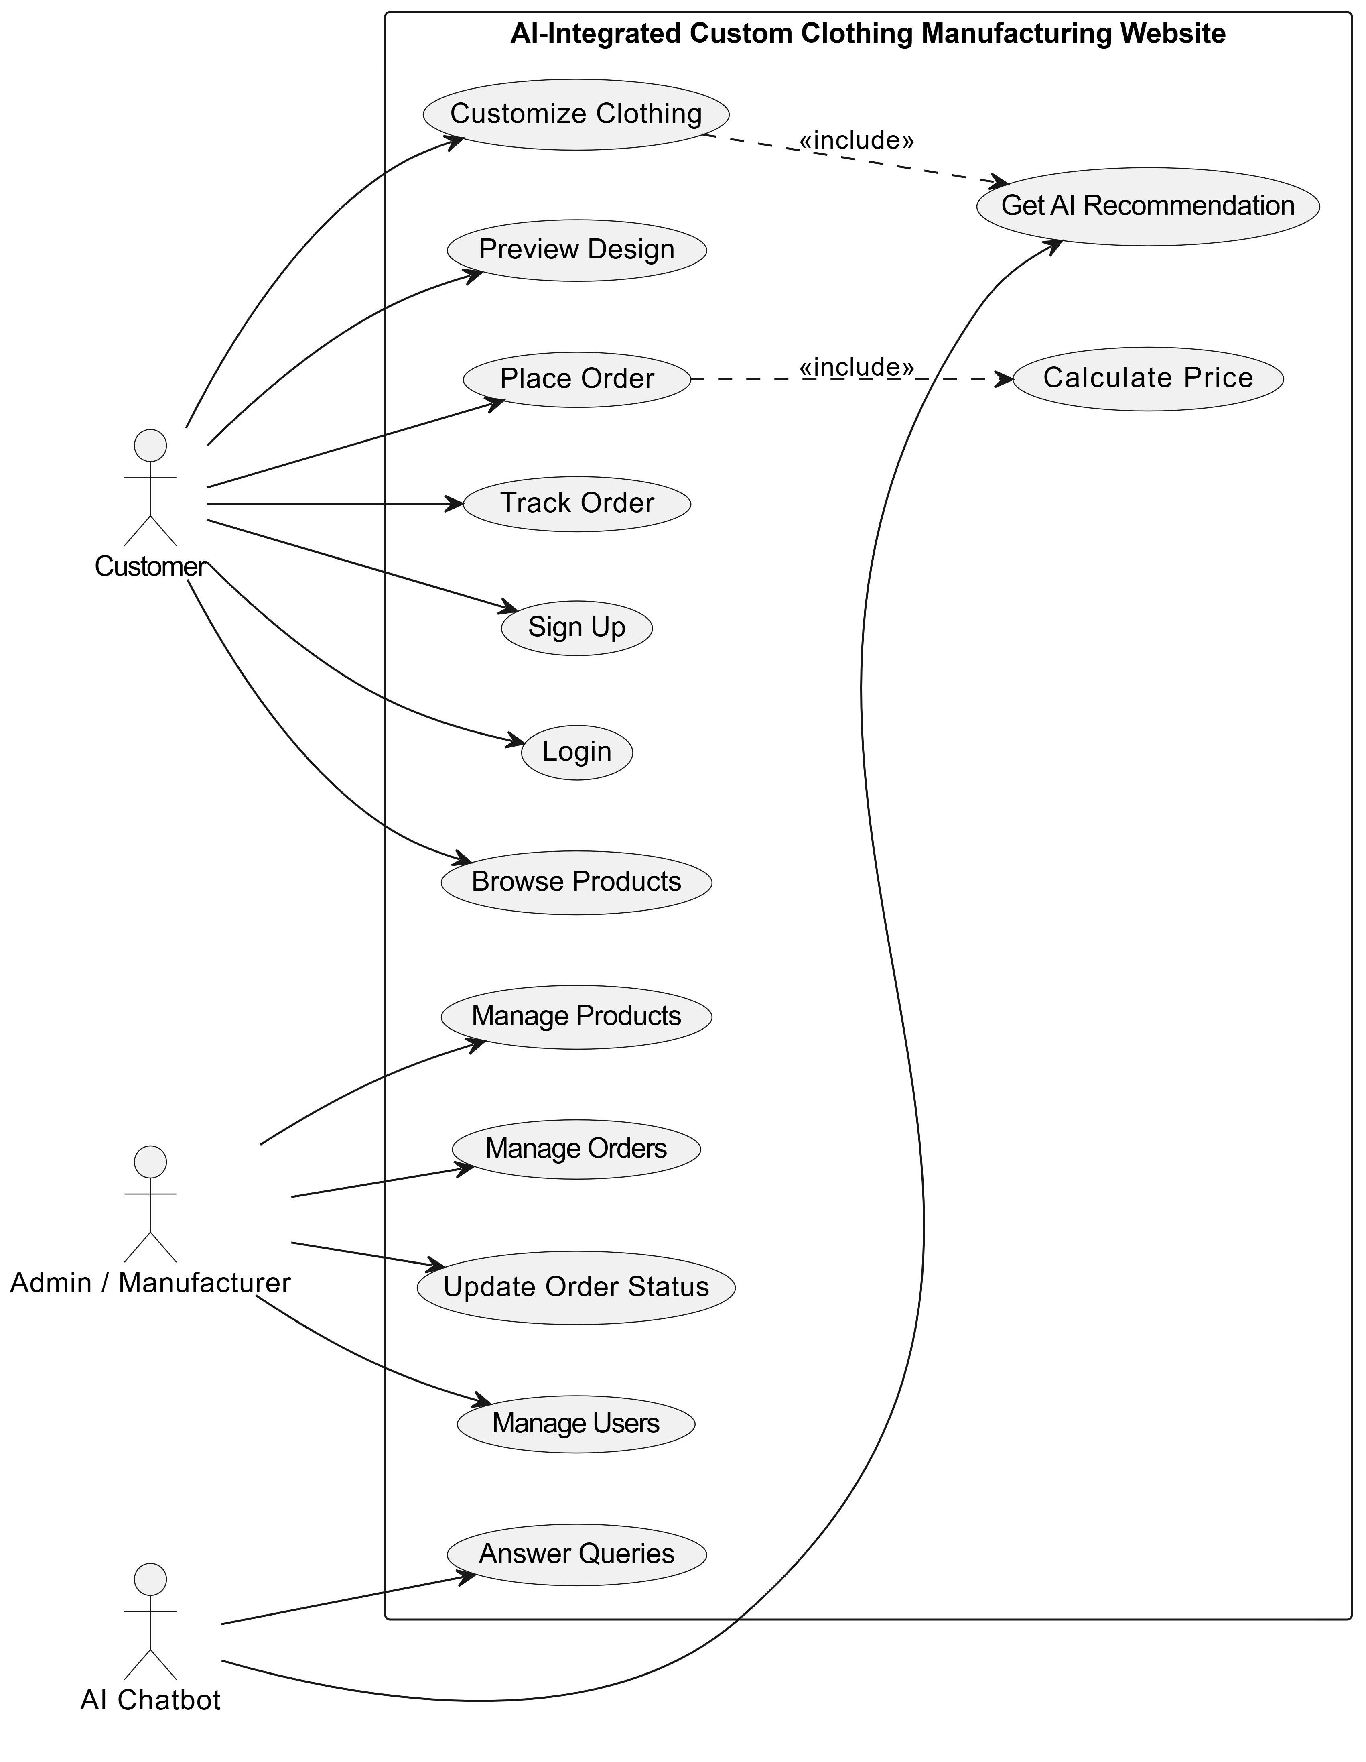
Figure 1: Use Case Diagram, AI-Integrated Custom Clothing Website
7.2 Activity Diagram
Figure 2 illustrates the primary activity flow from user authentication through product customization, AI recommendation, order confirmation, and admin processing. The diagram captures the key decision points: Existing User (Login vs. Sign Up) and Confirm Order (Place Order vs. Modify Customization).
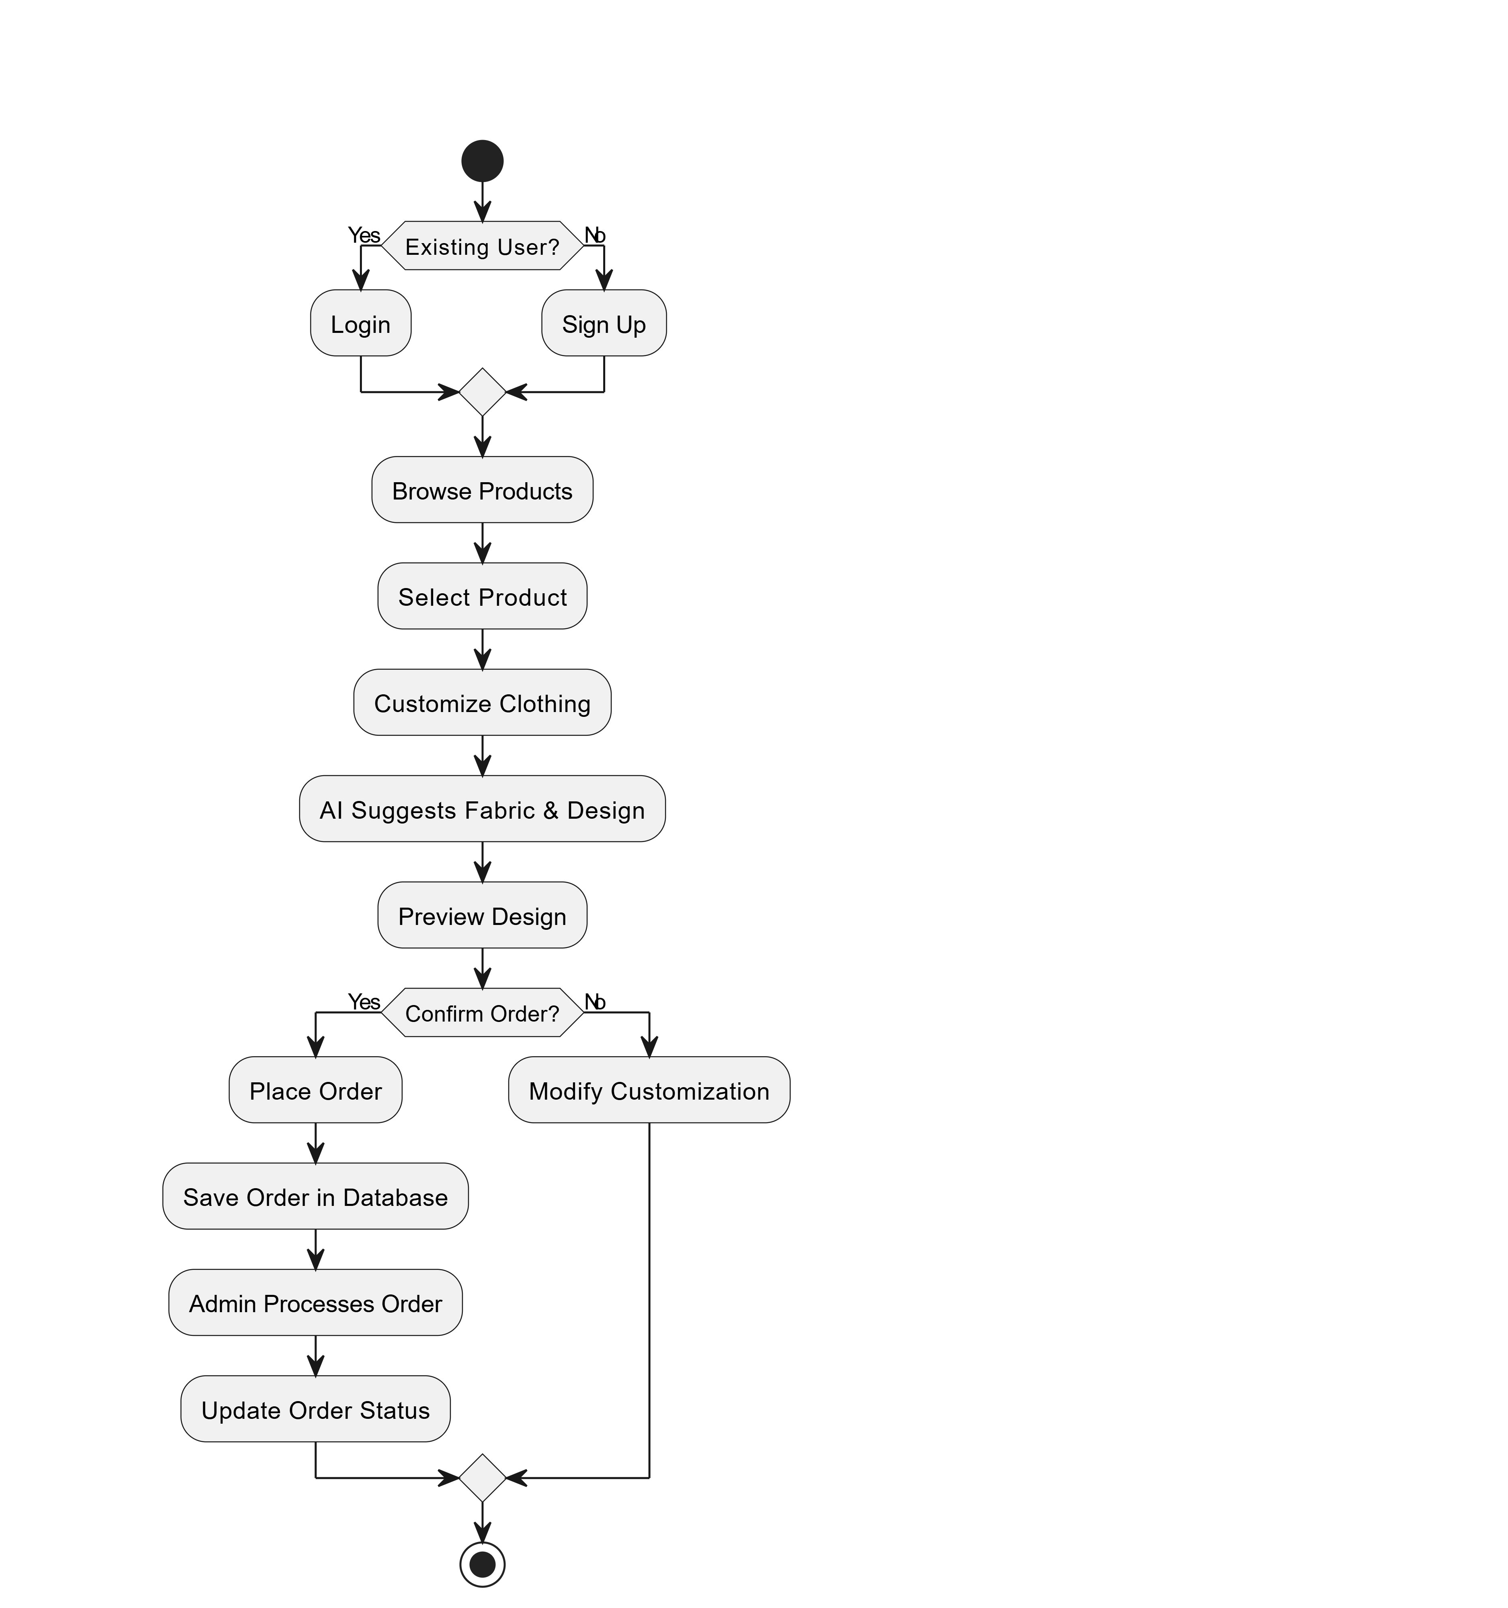
Figure 2: Activity Diagram, Customer Order Flow
7.3 Sequence Diagram (Summary Level)
Figure 3 presents the summary-level sequence diagram showing the high-level interactions between the Customer, Web System, AI Chatbot, Database, and Admin actors during a complete order lifecycle, from login and customization through order placement and admin notification.
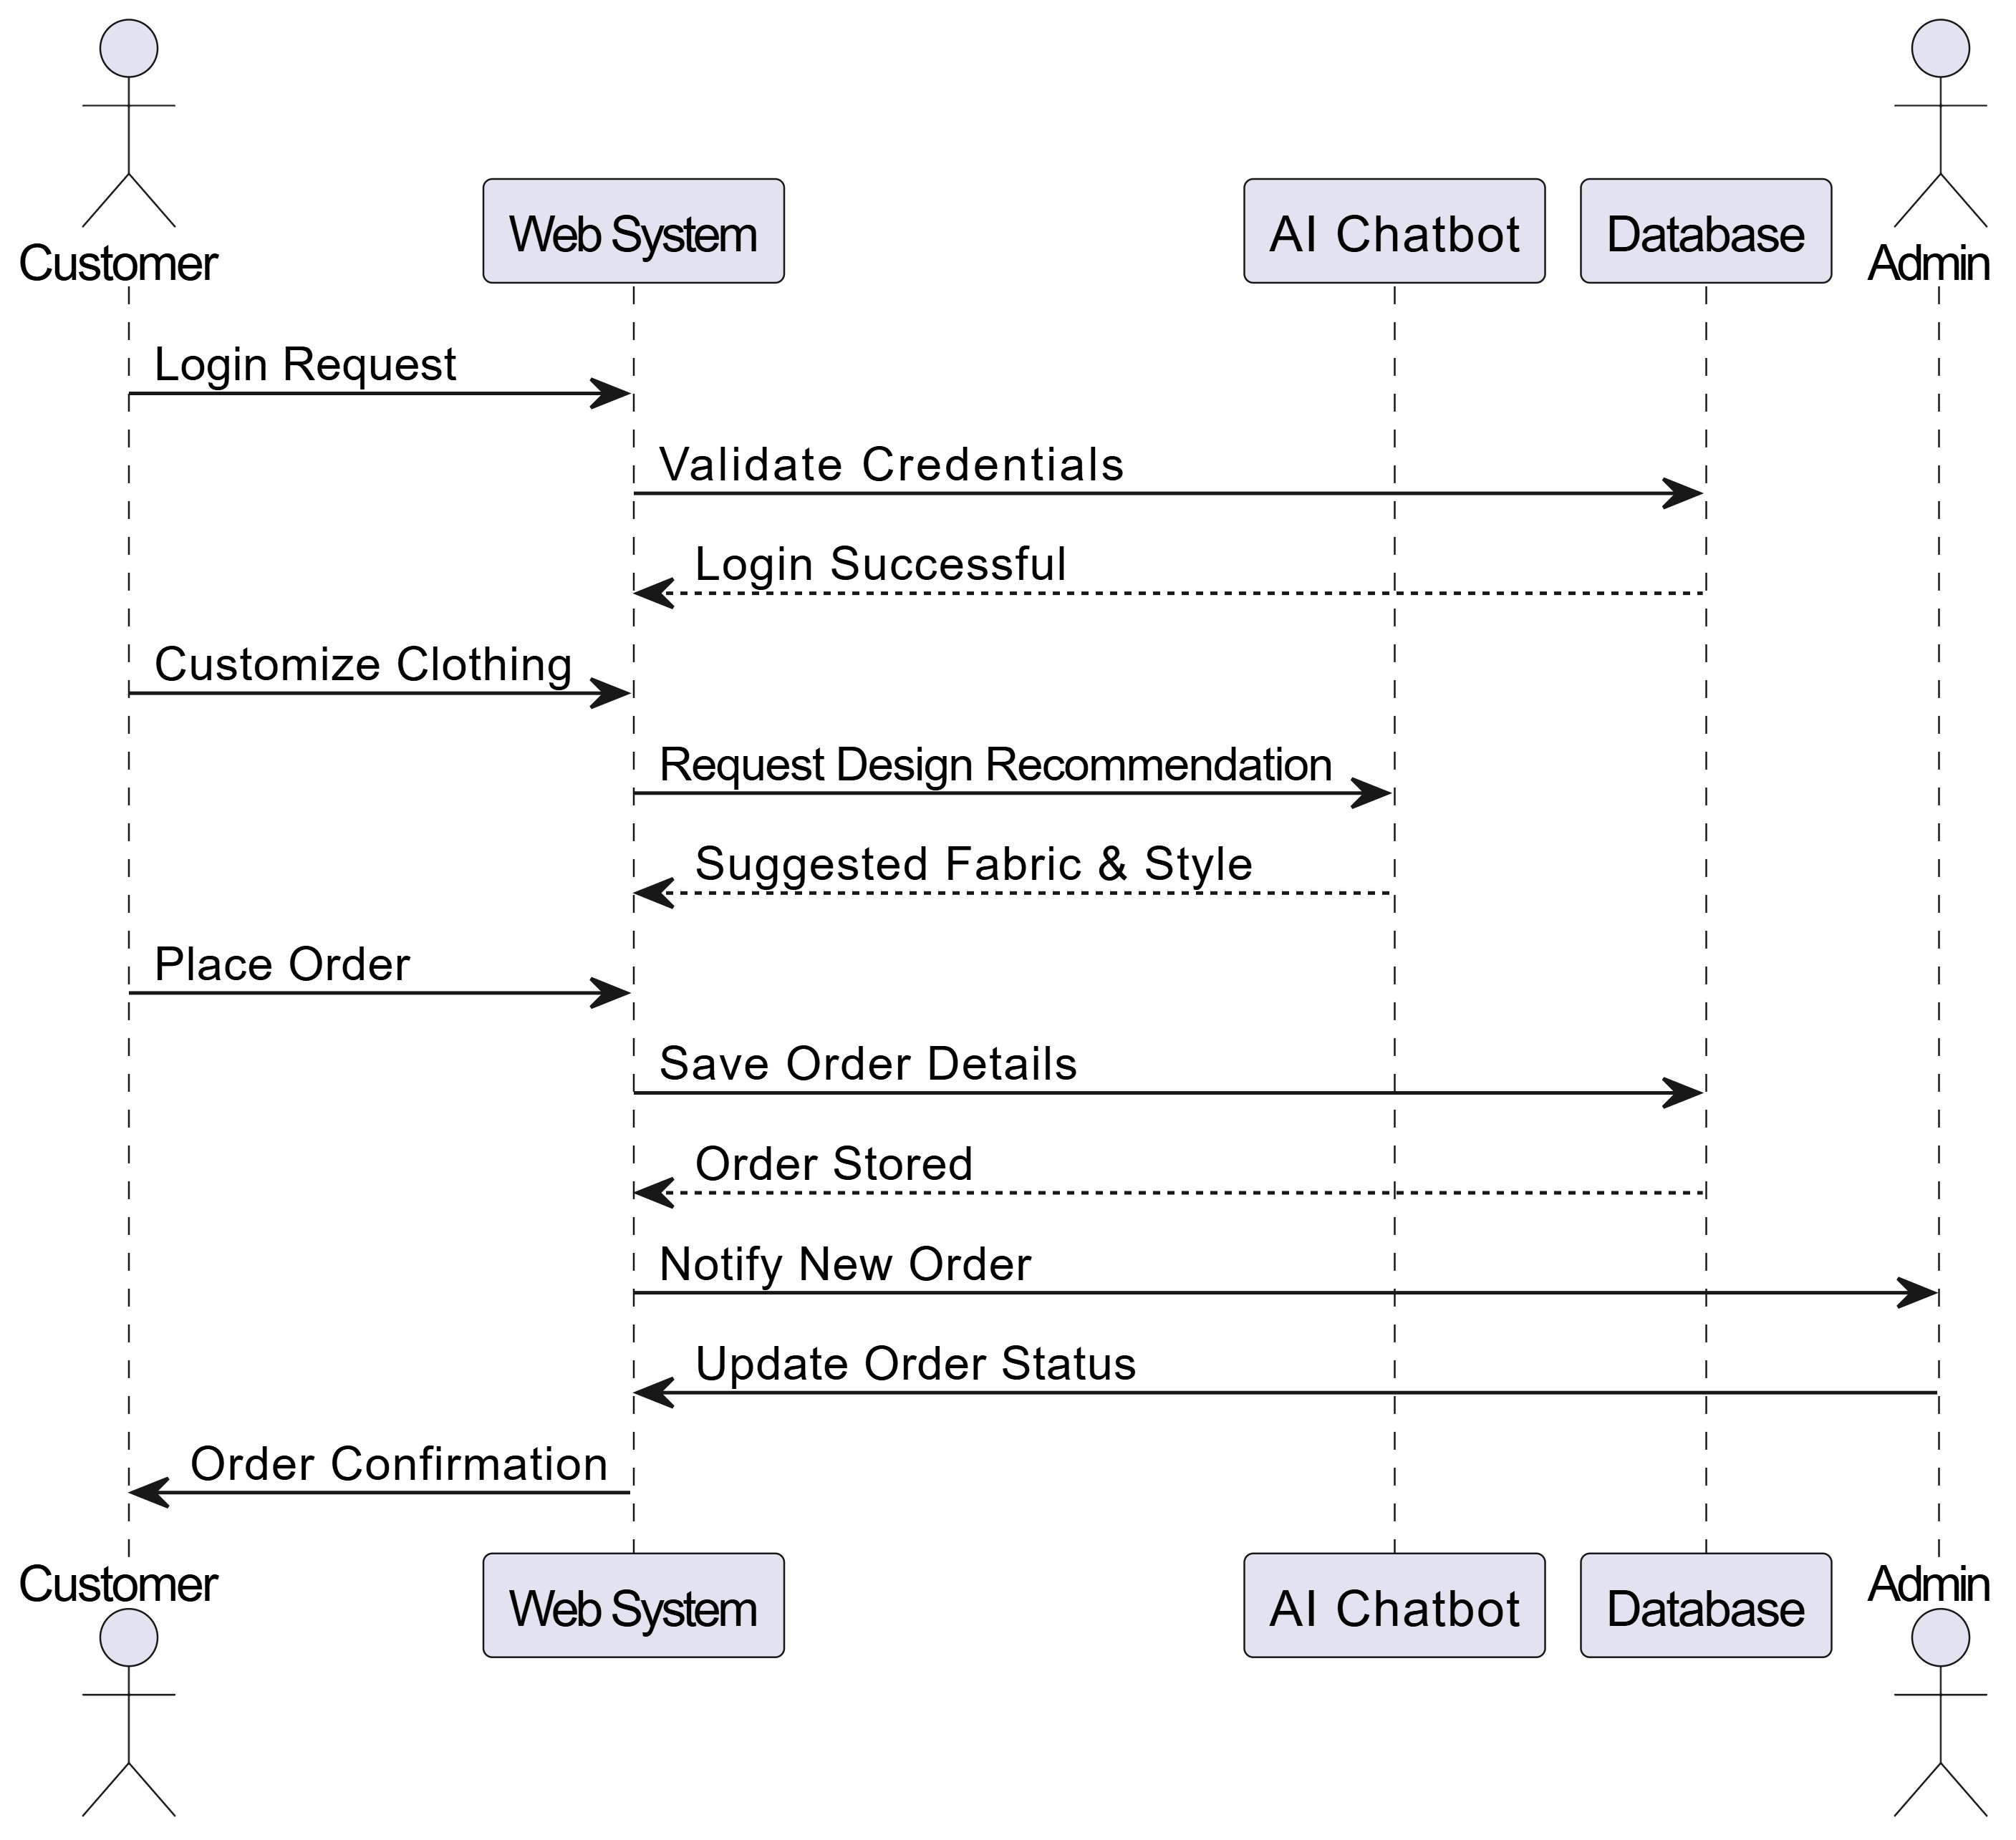
Figure 3: Sequence Diagram (Summary Level), Customer to Admin Order Flow
7.4 System Sequence Diagram (SSD)
Figure 4 presents the System Sequence Diagram capturing the detailed message exchanges between the Customer actor, the Web System, the AI Chatbot, the Database, and the Admin. It shows the complete flow including Login Request → Validate Credentials → Customize Clothing → Request Design Recommendation → Place Order → Save Order Details → Notify New Order → Update Order Status → Order Confirmation.
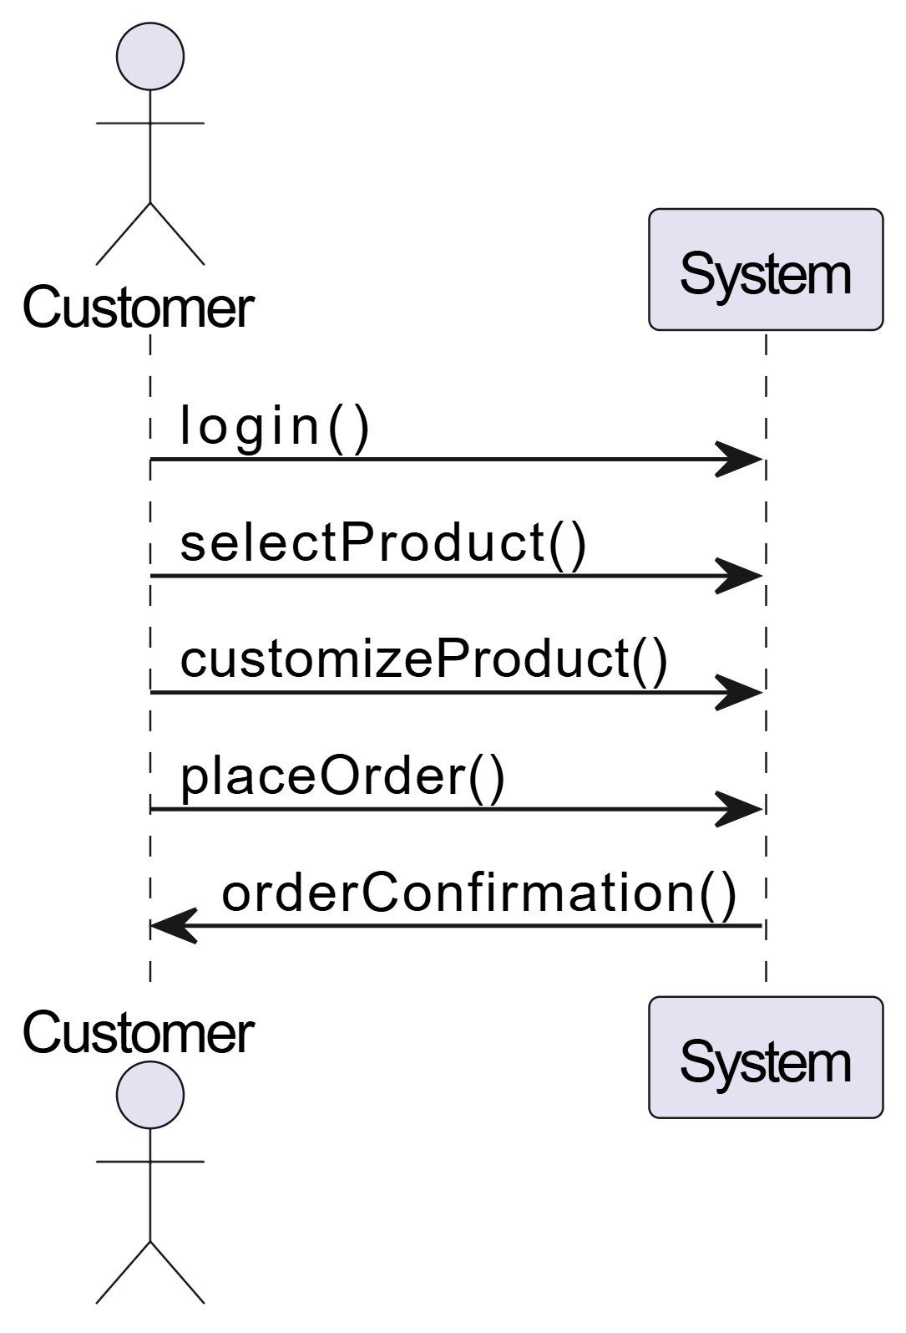
Figure 4: System Sequence Diagram (SSD), Detailed Message Flow
7.5 Detailed Sequence Diagram
Figure 5 presents the detailed system-level sequence diagram using method-call notation, showing the precise API call sequence: login() → selectProduct() → customizeProduct() → placeOrder() → orderConfirmation(). This diagram corresponds directly to the FastAPI backend API method signatures.
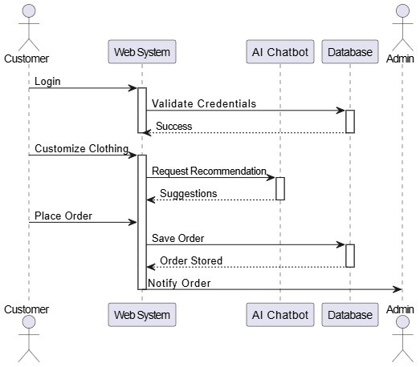
Figure 5: Detailed Sequence Diagram, Method-Call Level (Customer ↔ System)

8. System Architecture
8.1 Architectural Overview
The system follows a layered n-tier architecture with four distinct layers: Client, Application, AI, and Data. This separation of concerns ensures that each layer can be developed, tested, and maintained independently. All inter-layer communication uses well-defined interfaces: REST API between client and server, SQLAlchemy ORM / asyncpg between application and database, and HTTP webhooks between the application and AI layers.
8.2 Architecture Diagram
Figure 7 depicts the complete system architecture. The Client Layer communicates with the Python FastAPI Application Layer over HTTPS, with Uvicorn serving as the ASGI server. The Application Layer interacts with the PostgreSQL 16 / SQLite Data Layer via SQLAlchemy ORM or asyncpg and with the AI Layer via HTTP webhook calls to n8n. The AI Layer (n8n) retrieves product context from PostgreSQL 16 / SQLite via a dedicated retrieval node before constructing the GPT prompt. Alternatively, LangChain may be used directly within the FastAPI layer for tighter Python-native AI integration.
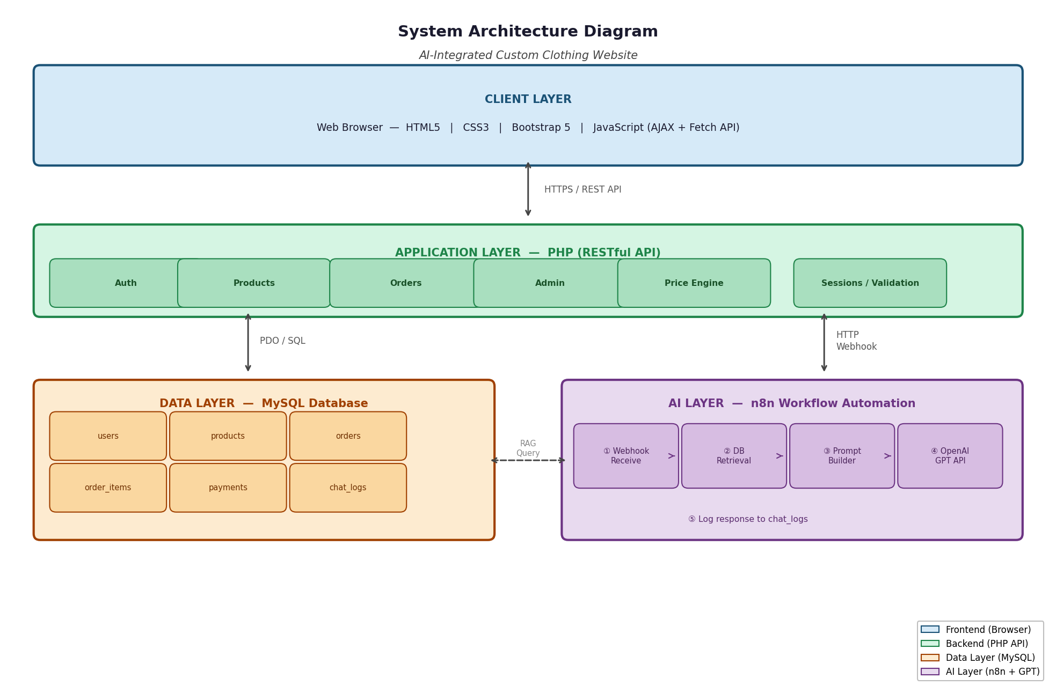
Figure 7: System Architecture Diagram, Layered 4-Tier Architecture
8.3 Component Descriptions
Table 11: System Components and Responsibilities
Component | Technology | Responsibilities
Web Browser | HTML5/CSS3/Vanilla CSS3 (no framework)/JS | Renders UI; handles user interactions; sends AJAX API calls; updates 2D preview canvas in real time.
FastAPI REST API | Python 3.11+ / FastAPI / Uvicorn (ASGI) | Handles all business logic: authentication, customization processing, order creation, pricing calculation, and routing.
n8n Automation | n8n v1.x (self-hosted) | Orchestrates the RAG pipeline: webhook trigger → PostgreSQL 16 / SQLite retrieval → GPT prompt construction → OpenAI call → response return.
OpenAI GPT API | GPT-4o-mini (via API) | Generates natural language responses grounded in the retrieved product context provided by n8n.
PostgreSQL 16 / SQLite Database | PostgreSQL 16 / SQLite 8.0 | Persists all application data: users, products, orders, customization options, payments, chat logs, and inventory.
FastAPI-Mail | FastAPI-Mail + Gmail SMTP | Sends transactional emails: order confirmation, status updates, and admin notifications.
Payment Gateway | Stripe / PayFast API | Handles secure payment processing, tokenization, and transaction status callbacks.

9. Database Design
9.1 Entity-Relationship Diagram
Figure 8 presents the full ER diagram for the system database. The diagram shows eleven entities and their attributes, with primary keys (PK) and foreign keys (FK) clearly labeled. Key relationships include: users(1) → orders(N), orders(1) → order_items(N), order_items(N) → products/fabric_options/color_options/print_methods, orders(1) → payments(1), and users(1) → chat_logs(N).
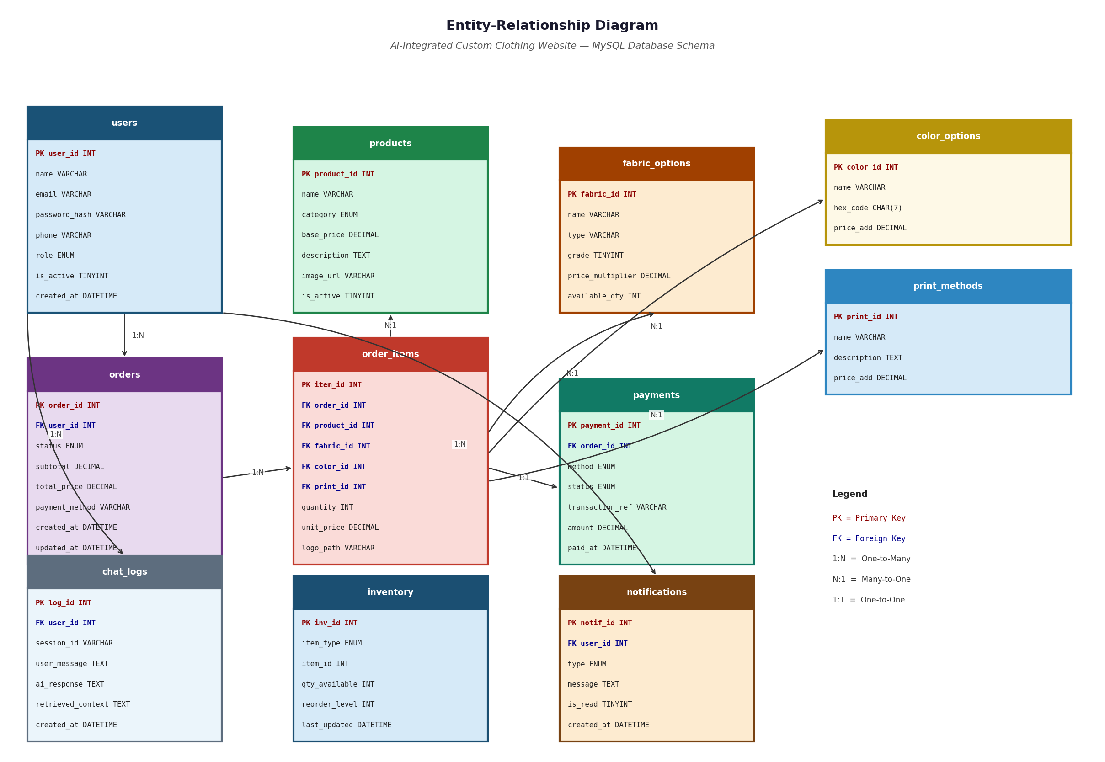
Figure 8: Entity-Relationship (ER) Diagram, PostgreSQL 16 / SQLite Database Schema
9.2 Entity Descriptions
Table 12: Database Entity Descriptions
Entity | Purpose | Key Attributes
users | Stores customer and admin account data. | user_id (PK), name, email, password_hash, phone, address, role (ENUM: customer/admin), is_active, created_at
products | Master product catalog. | product_id (PK), name, category (ENUM), base_price, description, image_url, is_active
fabric_options | Available fabric types, grades, and price multipliers. | fabric_id (PK), name, type, grade (1–5), price_multiplier, available_qty
color_options | Available colors with hex codes and price additions. | color_id (PK), name, hex_code (CHAR 7), price_add
print_methods | Available print techniques and their cost additions. | print_id (PK), name, description, price_add, is_active
stitch_styles | Available stitching styles with price additions. | stitch_id (PK), name, description, price_add
orders | Confirmed customer orders with status tracking. | order_id (PK), user_id (FK), status (ENUM), subtotal, total_price, payment_method, created_at, updated_at
order_items | Individual items within an order with full customization detail. | item_id (PK), order_id (FK), product_id (FK), fabric_id (FK), color_id (FK), print_id (FK), stitch_id (FK), quantity, unit_price, logo_path, notes
payments | Payment transaction records per order. | payment_id (PK), order_id (FK), method (ENUM), status (ENUM), transaction_ref, amount, paid_at
chat_logs | All AI chatbot conversation records for analytics. | log_id (PK), user_id (FK), session_id, user_message, ai_response, retrieved_context, created_at
inventory | Stock tracking for fabrics, colors, and print materials. | inv_id (PK), item_type (ENUM: fabric/color/print), item_id, qty_available, reorder_level, last_updated

10. Tools and Technologies
Table 13 presents the complete technology stack with version, purpose, and justification for each selection.
Table 13: Technology Stack with Versions and Justification
Technology | Version | Role | Justification
HTML5 / CSS3 | Latest | Frontend markup and styling | Industry standard for web development; semantic HTML improves accessibility and SEO.
Vanilla CSS3 (no framework) | v5.3 | Responsive layout framework | Provides a mobile-first grid and pre-built components that significantly accelerate frontend development.
JavaScript (ES6+) | ES2021+ | Frontend interactivity, AJAX, canvas preview | Enables real-time DOM updates for the 2D preview and asynchronous communication with the backend.
Python / FastAPI / Uvicorn | 3.11+ / 0.100+ | Backend async REST API & ASGI server | High-performance async framework with automatic OpenAPI docs, Pydantic data validation, and excellent SQLAlchemy/asyncpg integration.
PostgreSQL 16 / SQLite | 8.0 | Relational database | Robust RDBMS with ACID compliance, full-text search support, and native Python integration via SQLAlchemy ORM. PostgreSQL 15+ is also fully compatible and recommended for production deployments.
n8n | v1.x | AI workflow orchestration | Open-source, self-hostable; provides visual workflow design for the RAG pipeline without custom middleware code.
OpenAI GPT API | GPT-4o-mini | Language model for chatbot responses | GPT-4o-mini provides near-GPT-4 quality at significantly lower cost, suitable for academic project API budgets.
FastAPI-Mail | Latest | Transactional email dispatch | Python email library with async SMTP support, TLS, and HTML email templating; integrates natively with FastAPI.
Stripe API | Latest | Payment gateway | PCI-compliant payment processing with a developer-friendly API; free sandbox for testing.
Figma | Web | UI/UX wireframing & prototyping | Collaborative design tool for creating interactive mockups before development begins.
Python venv / pip | Latest | Local development environment & dependency management | Python virtual environments isolate project dependencies; pip manages all packages (fastapi, uvicorn, sqlalchemy, etc.) with a requirements.txt for reproducible installs.
Visual Studio Code | Latest | Code editor | Lightweight, extensible IDE with excellent Python and JavaScript plugin support.
Git + GitHub | Latest | Version control | Industry-standard version control; enables collaborative development, code review, and CI/CD integration.
Postman | Latest | API testing | GUI tool for testing REST API endpoints; essential for validating all backend API routes before frontend integration.
Railway.app / Render | Free tier | n8n cloud hosting | Provides free-tier hosting for the n8n instance accessible from the demo server without a local always-on machine.

11. Implementation Guide
This section provides a step-by-step implementation guide for each layer of the system. The recommended development order follows the dependency chain: Database → Backend API → Frontend → AI Pipeline → Integration & Testing.
11.1 Phase 1: Environment Setup (Week 1)
Step 1: Set Up Python Environment
- Install Python 3.11+ from https://www.python.org/downloads/ (Windows/macOS) or via your system package manager on Linux.
- Create and activate a virtual environment: python -m venv venv && source venv/bin/activate (Linux/macOS) or venv\Scripts\activate (Windows).
- Install required packages: pip install fastapi uvicorn[standard] sqlalchemy aiomysql passlib[bcrypt] python-jose[cryptography] fastapi-mail python-multipart.
Step 2: Create the PostgreSQL 16 / SQLite Database
Open PostgreSQL 16 / SQLite Workbench, DBeaver, or the PostgreSQL 16 / SQLite CLI and create a new database:
CREATE DATABASE clothing_db CHARACTER SET utf8mb4 COLLATE utf8mb4_unicode_ci;
USE clothing_db;
Then create the core tables. Example for users and orders:
CREATE TABLE users (
user_id INT AUTO_INCREMENT PRIMARY KEY,
name VARCHAR(100) NOT NULL,
email VARCHAR(150) NOT NULL UNIQUE,
password_hash VARCHAR(255) NOT NULL,
phone VARCHAR(20),
role ENUM("customer","admin") DEFAULT "customer",
is_active TINYINT(1) DEFAULT 1,
created_at DATETIME DEFAULT CURRENT_TIMESTAMP
);

CREATE TABLE orders (
order_id INT AUTO_INCREMENT PRIMARY KEY,
user_id INT NOT NULL,
status ENUM("Pending","In Production","Quality Check",
"Shipped","Delivered","Cancelled") DEFAULT "Pending",
total_price DECIMAL(10,2) NOT NULL,
created_at DATETIME DEFAULT CURRENT_TIMESTAMP,
FOREIGN KEY (user_id) REFERENCES users(user_id)
);
11.2 Phase 2: Backend REST API (Weeks 2–3)
Project File Structure
clothing-site/
├── database/ database.py (SQLAlchemy engine & session)
├── routers/ auth.py, products.py, orders.py,
│ customization.py, admin.py, chat.py
├── models/ user.py, product.py, order.py, chat_log.py (SQLAlchemy ORM models)
├── schemas/ schemas.py (Pydantic request/response models)
├── uploads/ logos/ (user logo uploads)
├── main.py FastAPI app entry point (mounts all routers)
Database Connection (database/database.py)
from sqlalchemy.ext.asyncio import create_async_engine, AsyncSession
from sqlalchemy.orm import sessionmaker, DeclarativeBase

DATABASE_URL = define("DB_USER", "root");quot;mysql+aiomysql://root:@localhost/clothing_dbdefine("DB_USER", "root");quot;

engine = create_async_engine(DATABASE_URL, echo=False)
AsyncSessionLocal = sessionmaker(engine, class_=AsyncSession, expire_on_commit=False)

class Base(DeclarativeBase):
pass

]);
async with AsyncSessionLocal() as session:
yield session

User Registration Endpoint (routers/auth.py — POST /api/register)
from fastapi import APIRouter, Depends, HTTPException
from passlib.context import CryptContext
from schemas import UserRegister

router = APIRouter(prefix="/api")
pwd_ctx = CryptContext(schemes=["bcrypt"], bcrypt__rounds=12)

@router.post("/register", status_code=201)
async def register(data: UserRegister, db: AsyncSession = Depends(get_db)):
hashed = pwd_ctx.hash(data.password)
11.3 Phase 3: Frontend Development (Weeks 3–5)
Vanilla CSS3 (no framework) Page Template
<!DOCTYPE html>
<html lang="en">
<head>
<meta charset="UTF-8">
<meta name="viewport" content="width=device-width, initial-scale=1.0">
<link href="https://cdn.jsdelivr.net/npm/bootstrap@5.3.0/dist/css/bootstrap.min.css" rel="stylesheet">
<title>Custom Clothing</title>
</head>
<body>
<!-- Navbar, content, chatbot widget -->
<script src="https://cdn.jsdelivr.net/npm/bootstrap@5.3.0/dist/js/bootstrap.bundle.min.js"></script>
<script src="/js/app.js"></script>
</body>
</html>
Dynamic Price Calculator (JavaScript)
const basePrices = { tshirt: 800, hoodie: 1500, jacket: 2500 };
const fabricMultipliers = { cotton: 1.0, polyester: 0.9, blended: 1.1, fleece: 1.2 };
const printAddons = { screen: 200, dtg: 350, embroidery: 500 };

function calculatePrice() {
const product = document.getElementById("product-type").value;
const fabric = document.getElementById("fabric-type").value;
const grade = parseInt(document.getElementById("fabric-grade").value);
const print = document.getElementById("print-method").value;
const qty = parseInt(document.getElementById("quantity").value);

const base = basePrices[product] || 0;
const fMul = fabricMultipliers[fabric] || 1.0;
const gMul = 1 + (grade - 1) * 0.15; // 15% per grade step
const pAdd = printAddons[print] || 0;
const unit = (base * fMul * gMul) + pAdd;
const total = unit * qty;

document.getElementById("unit-price").innerText = "PKR " + unit.toFixed(0);
document.getElementById("total-price").innerText = "PKR " + total.toFixed(0);
}

// Attach to all customization inputs
document.querySelectorAll(".customization-input")
.forEach(el => el.addEventListener("change", calculatePrice));
11.4 Phase 4: AI Chatbot Integration (Weeks 5–7)
Step 1: Set Up n8n
- Create a free account at app.n8n.cloud OR deploy self-hosted on Railway.app using the n8n Docker image.
- Import the workflow JSON file (version-controlled in /n8n/workflow.json in your repo).
Step 2: n8n Workflow Configuration
The RAG workflow consists of four nodes in sequence:
- Node 1: Webhook: Method = POST, Path = /chat-query. This is the entry point receiving the user message from the FastAPI backend.
- Node 2: PostgreSQL 16 / SQLite: Execute query to retrieve matching products/FAQs. Use expression {{$json["query"]}} to extract keywords.
-- n8n PostgreSQL 16 / SQLite node query:
SELECT name, category, base_price, description
FROM products
WHERE MATCH(name, description) AGAINST ({{ $json["query"] }} IN NATURAL LANGUAGE MODE)
UNION
SELECT question AS name, "faq" AS category, 0 AS base_price, answer AS description
FROM faqs
WHERE MATCH(question, answer) AGAINST ({{ $json["query"] }} IN NATURAL LANGUAGE MODE)
LIMIT 5;
- Node 3: Code (JS): Build the GPT system prompt by formatting the retrieved rows as structured context.
// n8n Code node:
const rows = $input.all();
const context = rows.map(r =>
`Product: ${r.json.name} | Category: ${r.json.category}
| Base Price: PKR ${r.json.base_price} | Info: ${r.json.description}`
).join("\n");

return [{ json: {
systemPrompt: `You are a clothing advisor for a custom clothing website.`,
context: context,
userMessage: $("Webhook").first().json.body.message
}}];
- Node 4: OpenAI Chat Model: Model = gpt-4o-mini. System message = {{$json["systemPrompt"]}}. User message = Context:\n{{$json["context"]}}\n\nCustomer Question: {{$json["userMessage"]}}.
Step 3: FastAPI → n8n Integration
# routers/chat.py - POST /api/chat
import httpx
from fastapi import APIRouter, Depends
from schemas import ChatRequest

N8N_WEBHOOK = "https://your-n8n-instance.com/webhook/chat-query"

@router.post("/chat")
async def chat(req: ChatRequest, db: AsyncSession = Depends(get_db),
user=Depends(get_current_user)):
async with httpx.AsyncClient(timeout=15) as client:
r = await client.post(N8N_WEBHOOK,
json={"query": req.message, "message": req.message})
reply = r.json().get("output", "Service unavailable.")
# Log to chat_logs table
log = ChatLog(user_id=user.id, user_message=req.message, ai_response=reply)
db.add(log); await db.commit()
return {"reply": reply}

# Run with: uvicorn main:app --reload --host 0.0.0.0 --port 8000

# API docs available at http://localhost:8000/docs (Swagger UI)
11.5 Phase 5: Testing Strategy (Weeks 8–9)
Unit Testing
- Test each FastAPI endpoint using Postman or the built-in Swagger UI (http://localhost:8000/docs). Create a Postman collection with test scripts for each route. Verify correct HTTP status codes, response schemas, and error handling.
- Test the price calculator function with boundary inputs: minimum and maximum fabric grades, zero quantity, missing fields.
Integration Testing
- End-to-end test: Register → Login → Browse → Customize → Add to Cart → Checkout → Verify order in database → Check admin dashboard status → Verify email received.
- AI chatbot integration test: submit 10 representative queries, verify that retrieved context is relevant, and assess response quality.
Security Testing
- Test SQL injection: attempt to inject SQL in all form inputs; verify parameterized queries block all attempts.
- Test XSS: inject Test XSS: inject <script>alert(1)</script> into name and message fields; verify htmlspecialchars() neutralizes output.lt;scriptTest XSS: inject <script>alert(1)</script> into name and message fields; verify htmlspecialchars() neutralizes output.gt;alert(1)Test XSS: inject <script>alert(1)</script> into name and message fields; verify htmlspecialchars() neutralizes output.lt;/scriptTest XSS: inject <script>alert(1)</script> into name and message fields; verify htmlspecialchars() neutralizes output.gt; into name and message fields; verify Pydantic validation and output encoding neutralize the input.
- Test unauthorized admin access: attempt to access /admin/dashboard without a valid JWT bearer token; verify 401 Unauthorized response.
Acceptance Testing
- Conduct supervised walkthrough with the project supervisor demonstrating all use cases (UC-01 through UC-05) end-to-end.
- Collect feedback and document any deviations from the specified functional requirements.
11.6 Deployment Checklist
- Deploy the FastAPI application to Render, Railway.app, or any VPS (e.g., upload via Git push to the hosting platform).
- Import the PostgreSQL 16 / SQLite database schema using PostgreSQL 16 / SQLite Workbench, DBeaver, or the mysql CLI on the hosting platform.
- Update the DATABASE_URL environment variable (or .env file) with the hosted PostgreSQL 16 / SQLite connection string.
- Ensure the n8n instance is running and the webhook URL is updated in routers/chat.py (or via an environment variable).
- Configure Gmail SMTP credentials in the FastAPI-Mail configuration (environment variables: MAIL_USERNAME, MAIL_PASSWORD, MAIL_SERVER).
- Test all pages on the live server from a mobile device to verify responsive layout.
- Enable HTTPS in the hosting control panel (free SSL via Let's Encrypt is available on most hosts).

