HACKATON DAY 2: Market Place technical foundation

“ RENTAL E-COMMERCE WEBSITE”

**Basic Requirement for making a e-commerce website:**

System Architecture Overview:

Frontend Pages:

1. Home Page: The main hub showcasing the menu, products, categories, and designs

2. Catalog: A page that displays all clothing items categorized for easy browsing.

3. Product Detail: A detailed view of individual items, including quality and sizing

4. About Us: Information about the brand, its mission, and the team behind it.

5. Contact Page: A form for users to reach out with inquiries or feedback.

6. Cart & Checkout: A user-friendly interface for managing the cart and completing the checkout process.

7. Sign In/Sign Up: Account management pages for user registration and login.

Sanity Backend:

Sanity CMS will manage:

Products: Information about categories, pricing, availability, and customization options.

Customer Data: User profiles, saved addresses, and order histories.

Orders: Real-time updates for order status and delivery progress.

Third-Party API Integrations:

1. **Payment Gateways**: Integration with EasyPaisa JazzCash ,Quickpay,Nayapay for secure online transactions.

2. Food Delivery Services: Integration with delivery partners for seamless logistics and timely delivery.

3. **User Authentication**: OAuth or custom authentication for secure sign-in and sign-up functionality.

4. **Order and Delivery Tracking**: APIs like **Shippo**,**Ali Express** for real-time order updates and delivery tracking.

5. **Maps and Location Services**: Embed Google Maps API to display restaurant locations and delivery zones, assisting with accurate deliveries.

Overall View of the Website:

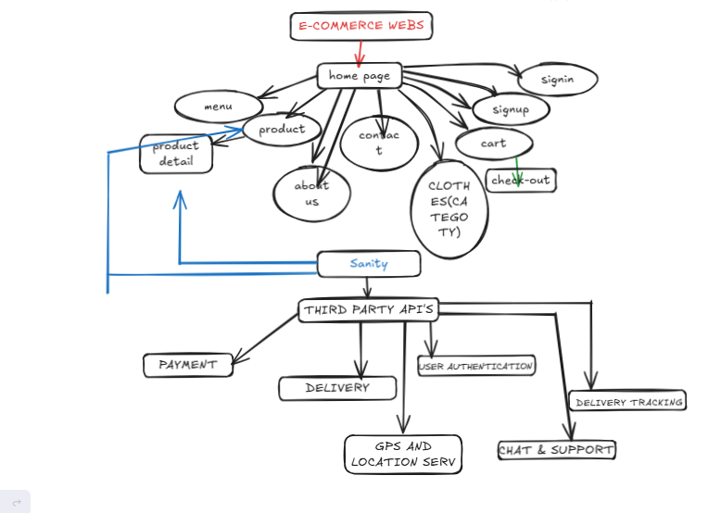

**Technical Roadmap :**

1. Frontend Development:

Milestone 1: Develop the Home Page with Basic Navigation:

. Design the basic layout with a navigation bar and footer.

. Showcase the menu sections, featured products, and blog previews.

. Include clear call-to-action buttons linking to other pages.

**FRONT END REQUIRMENT:**

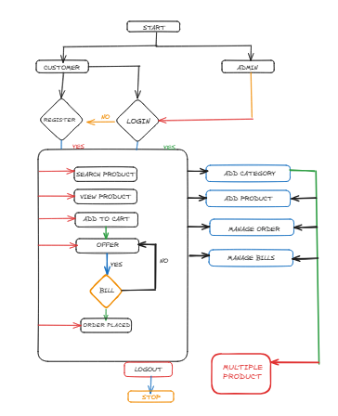

Milestone 2: Build Essential Pages:

Menu Page: Display a list of shopping categories and products with brief details and images.

Product Detail Page: Provide detailed descriptions of each clothing item, including tshirt and shirt with pricing and discount

Cart Page: Allow users to manage items in their cart.

Signup/Signin Page: Enable users to create accounts, log in, and manage profiles.

Milestone 3: Add Dynamic Features:

Main Product Section: Highlight items and their specialties, with reviews and photos.

Contact Page: Set up a contact form for user inquiries and feedback.

2. Backend Development

Milestone 1: Set Up Sanity CMS

Product Management: Create content types for managing clothing products, including categories, pricing, and availability.

Milestone 2: API Integrations

Payment Gateways: Integrate payment systems like EasyPaisa or JazzCash for secure online payments.

Order & Delivery Tracking: Set up real-time tracking for orders using APIs such as Shippo, Ali Express

3. Third-Party API Integration

Step 1: Implement User Authentication

- Enable authentication via **OAuth** or social media logins like Google and Facebook.

Step 2: Integrate Food Delivery Services

- Set up API integrations with food delivery partners to manage logistics and ensure timely deliveries.

- **Step 3: Connect Maps & Location Services for Delivery**

- Implement Google Maps API to display restaurant locations and delivery zones for efficient order processing.

4. Testing & Deployment:

Testing

- Check the website’s responsiveness across different devices and screen sizes.

- Test the functionality of cart, payment processes, and user logins.

- Verify third-party API integrations for payment, tracking, and delivery services.

Deployment

- Deploy the website on platforms like Vercel,Netlify for fast and scalable hosting.

- Perform final checks and bug fixes post-deployment.

Final Deliverable:

- A fully functional, intuitive food website with dynamic features like a magazine, clothes(casual etc) , a shopping cart, secure sign-ins, and third-party API integrations for payment and delivery tracking.

**DESIGN SYSTEM ARCHITECT**

**SYSTEM ARCHITECT OVERVIEW:**

**[FRONT END (NEXT.JS)]**

[SANITY CMS] [PRODUCT DATA API]

[THIRD PARTY APIS] [SHIPMENT TRACKING APIS]

[PAYMENT GATEWAY]