**DOCUMENT:DAY 3 - API INTEGRATION AND DATA MIGRATION**

**“INSTALLATION PROCESS”**

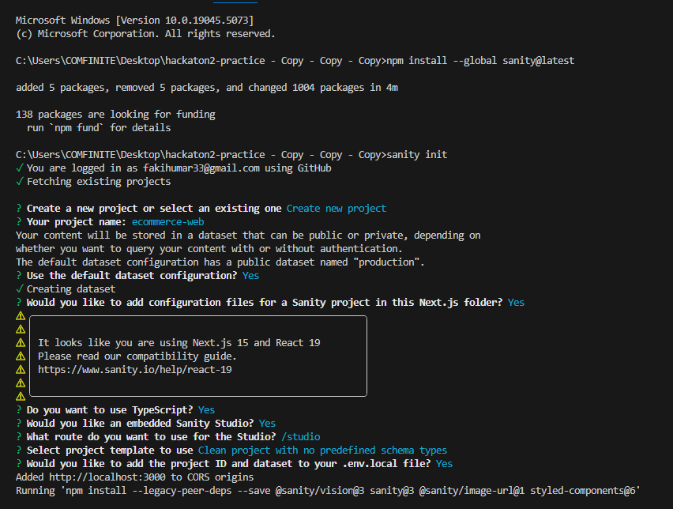

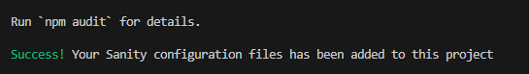

**GROQ QUERY:**

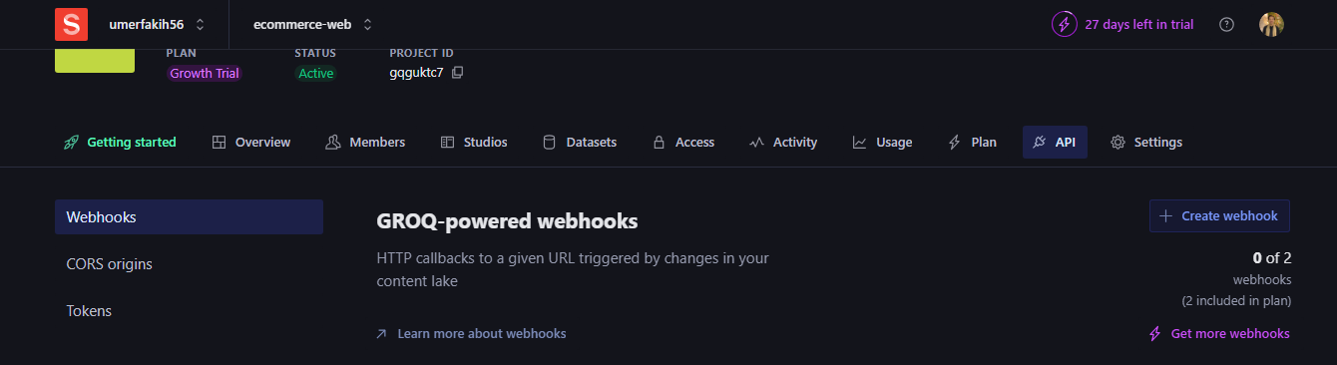

**CORS ORIGINS :**

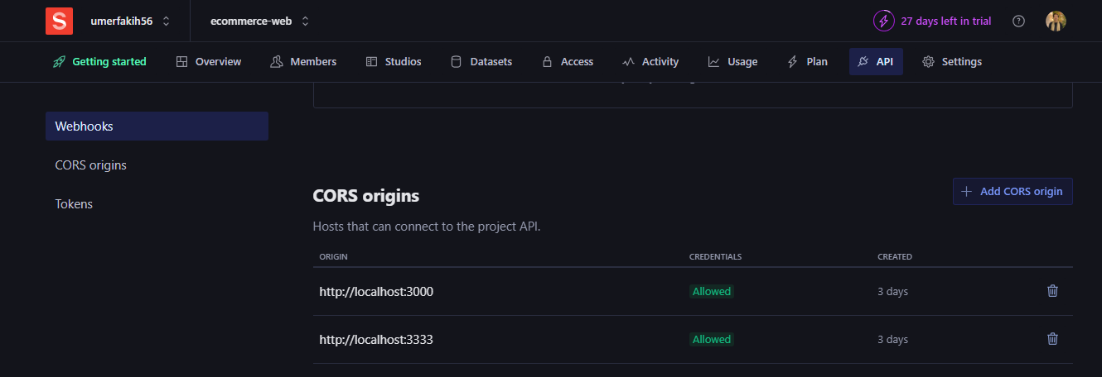

**.GENERATING A TOKEN ON API FOLDER:**

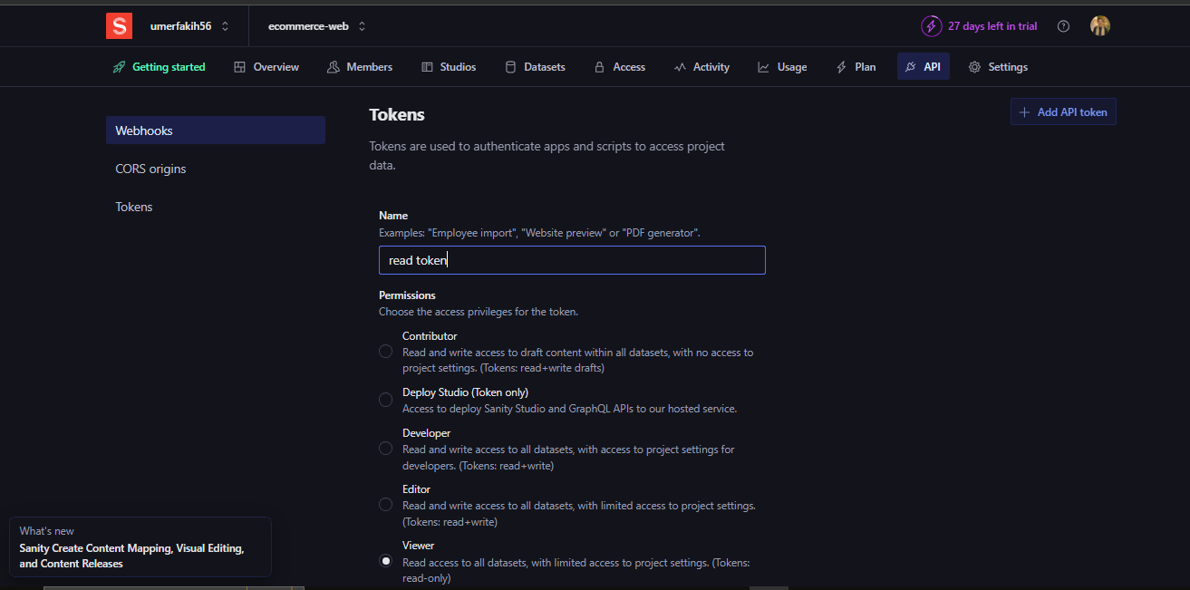

**GENERATED TOKEN:**

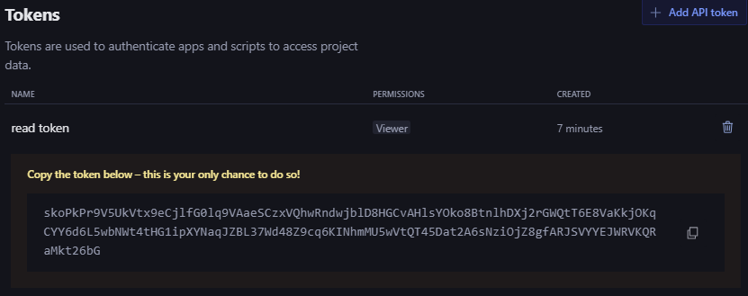

**PRODUCT.TS FILE:**

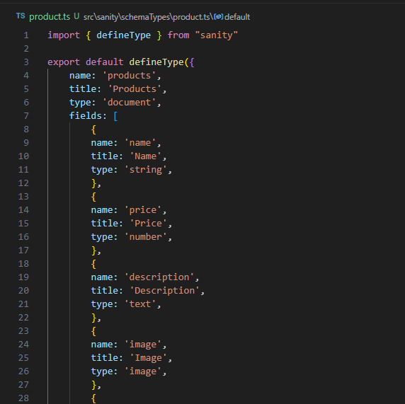**INDEX.TS FILE:**

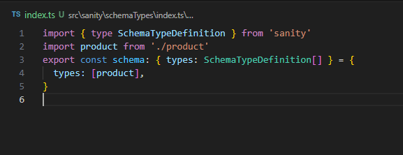

**.make a script folder and add the fie provided**

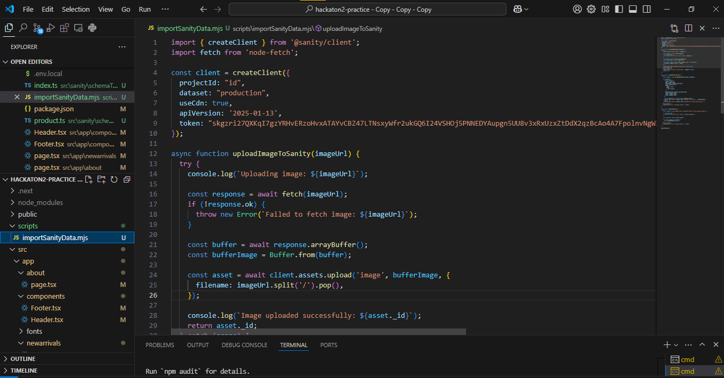

**.ImportSanityData.mjs file**

**.Now I have added my project id and token in the mjs file**

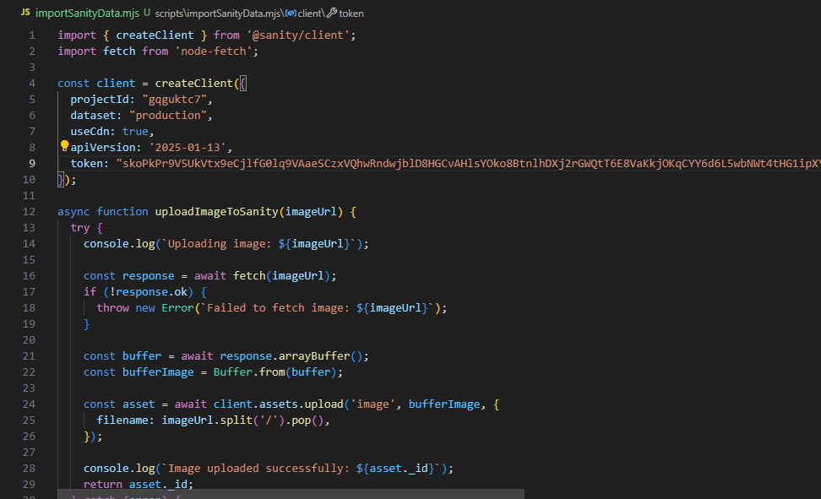

**Package.json file:**

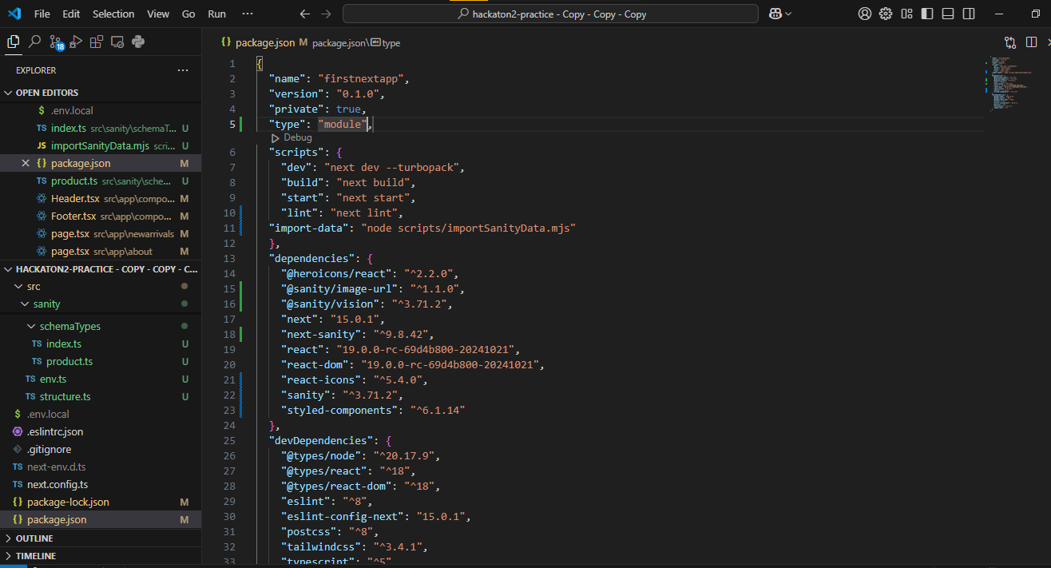

**NPM RUN MIGRATE:**

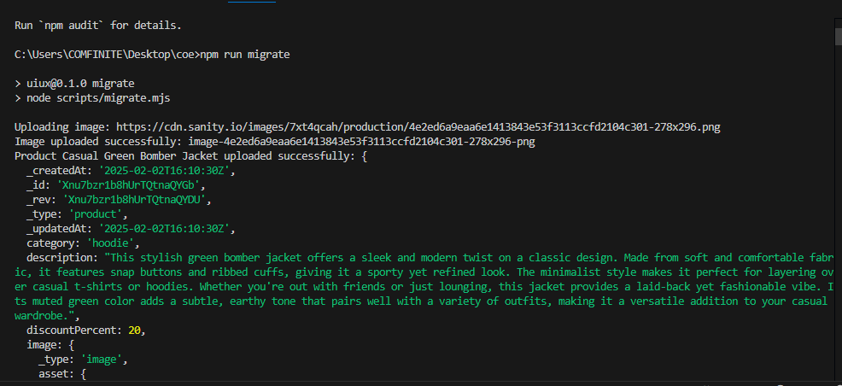

**FETCH DATA TO SEE NO OF ITEMS:**

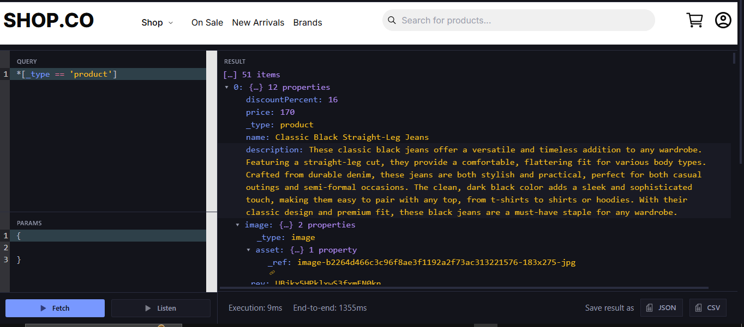

**Screen Interface Product displaying:**

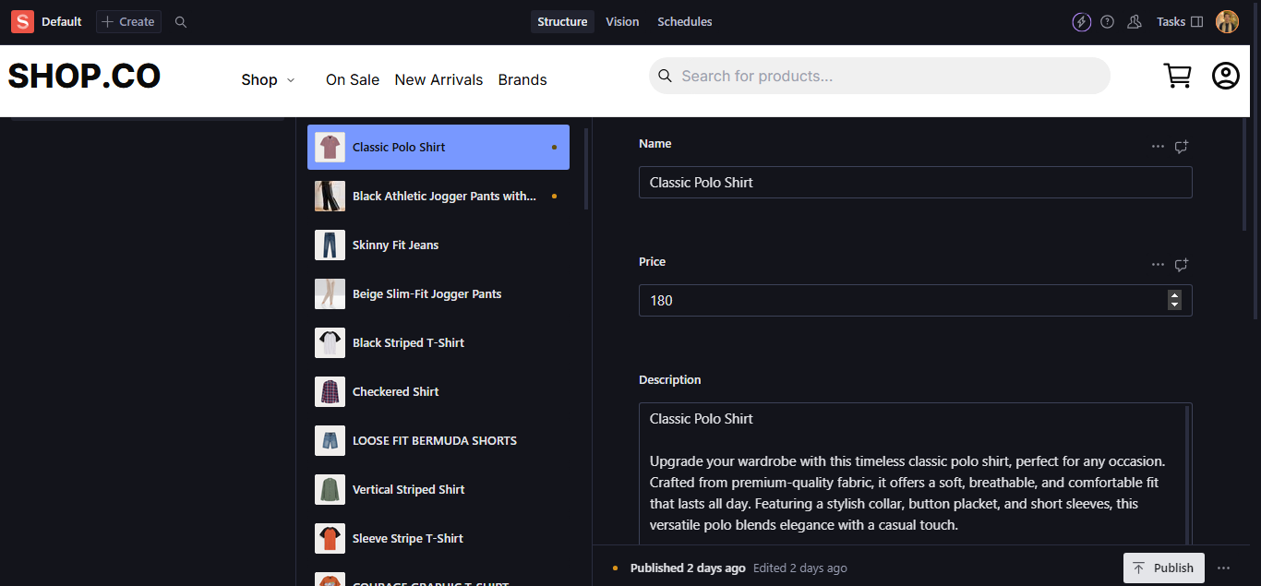

**Product.ts file:**

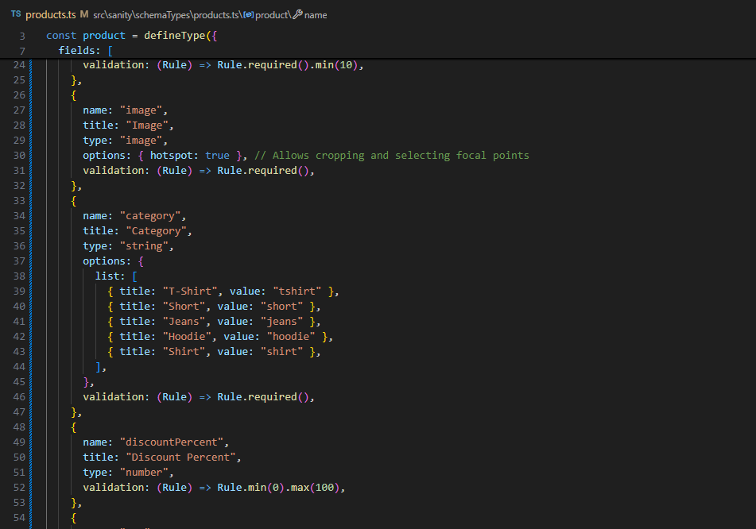

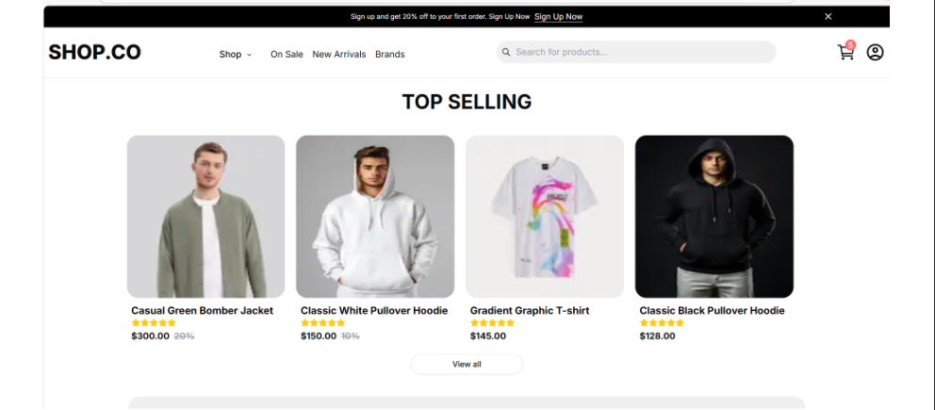

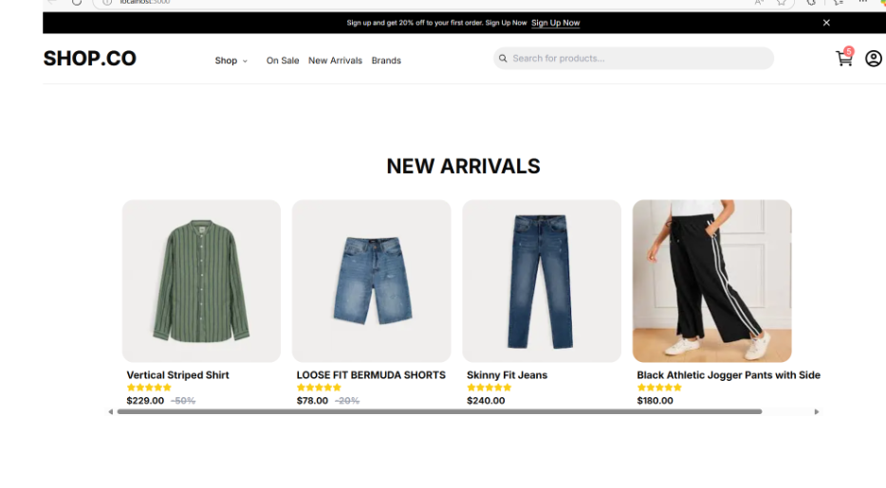

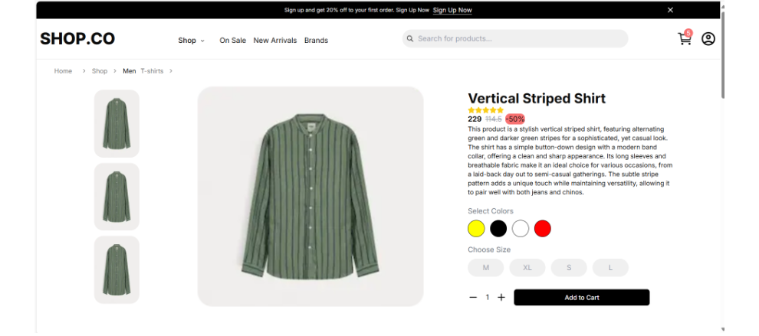

THANKYOU!