- Without fan and window (Gas stove Pm2.5) on Good (26 Jun) and bad airquality day (04 Jul)
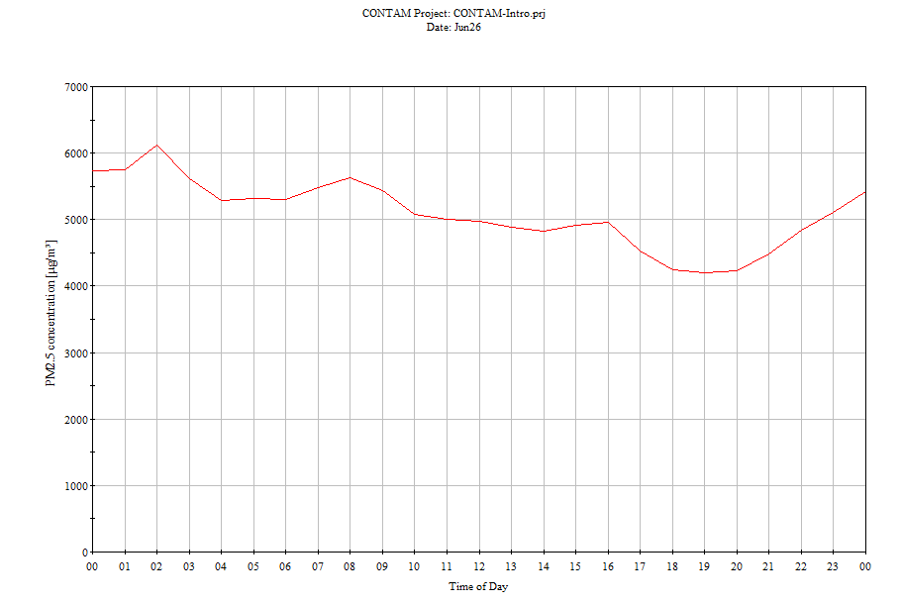
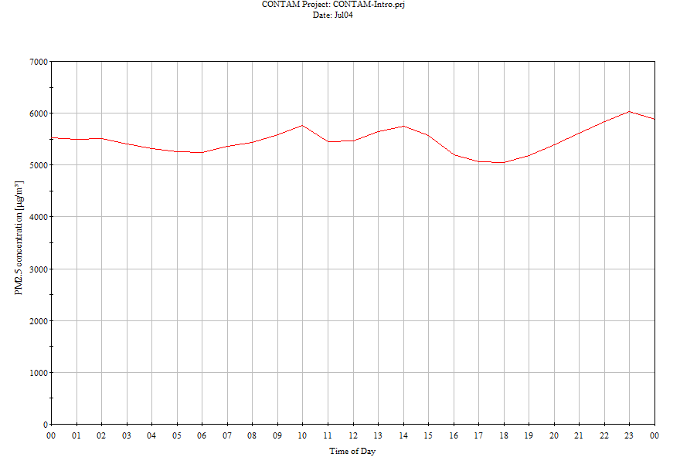

- With fan on and window open (Gas stove Pm2.5) on below outdoor good day and Bad day
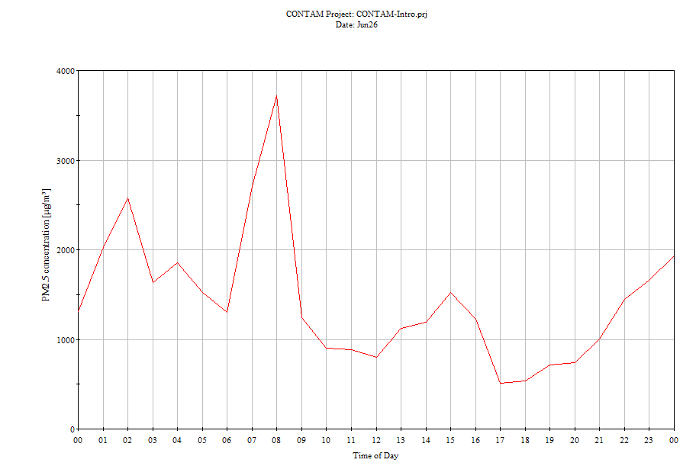
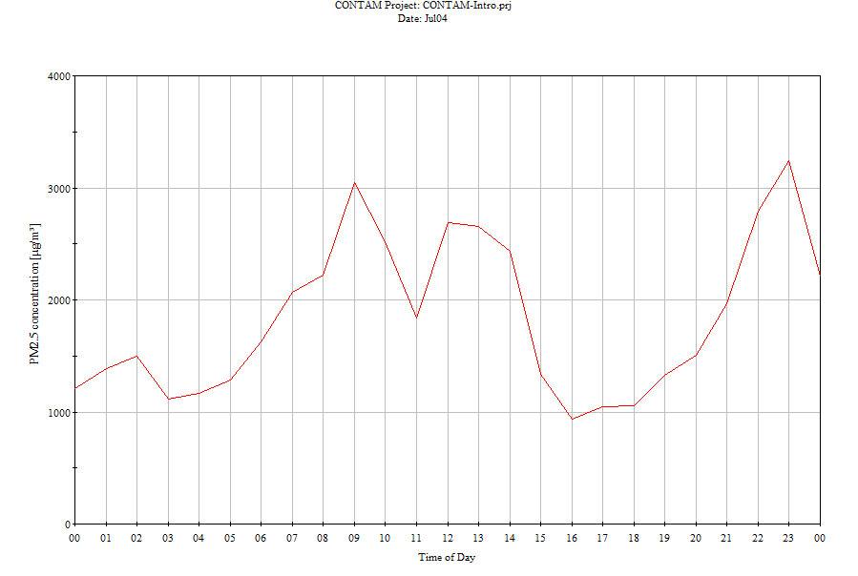
- Without fan and window (Gas stove NO2) on below outdoor bad and good day
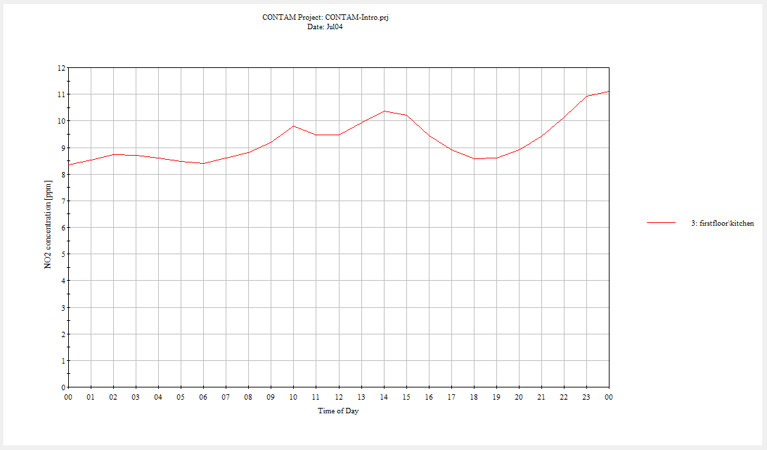

- 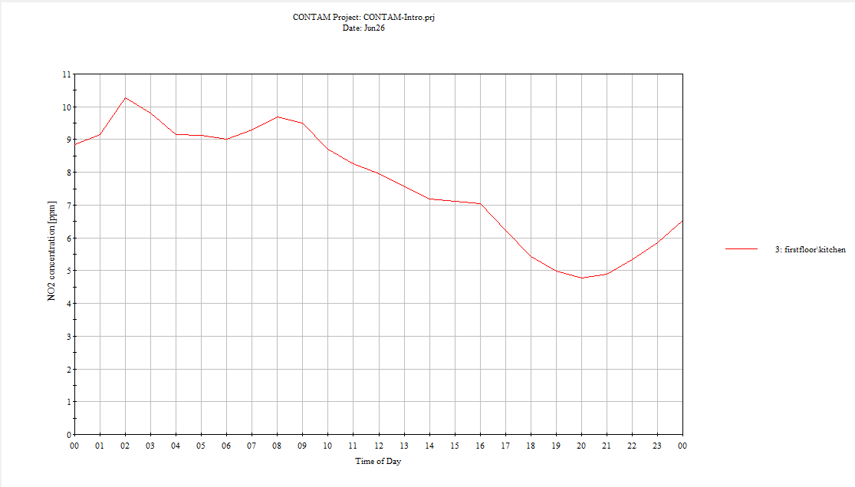

- Fans and window on (Gas stove NO2) on below outdoor bad day and good day

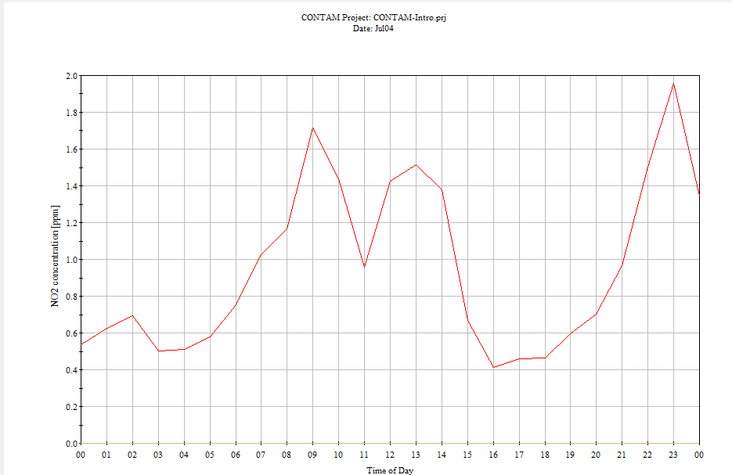
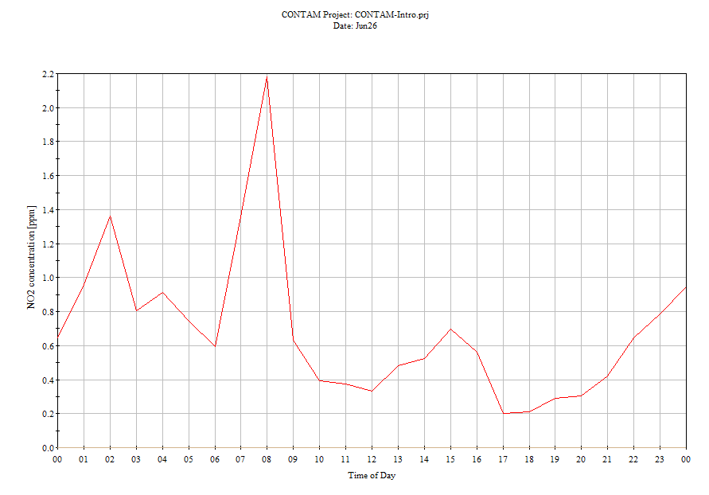
- Fans and window off (Electric stove Pm2.5) on below outdoor bad day and good day
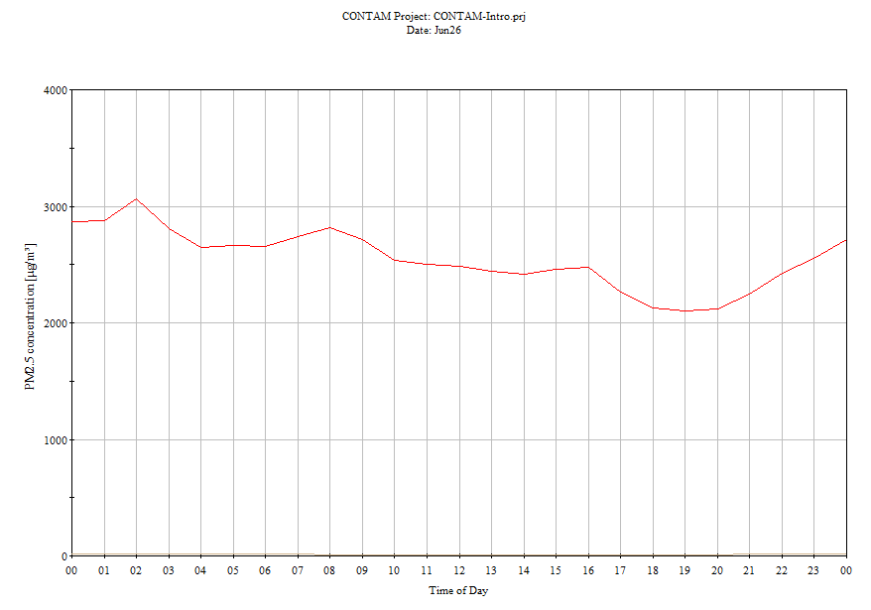

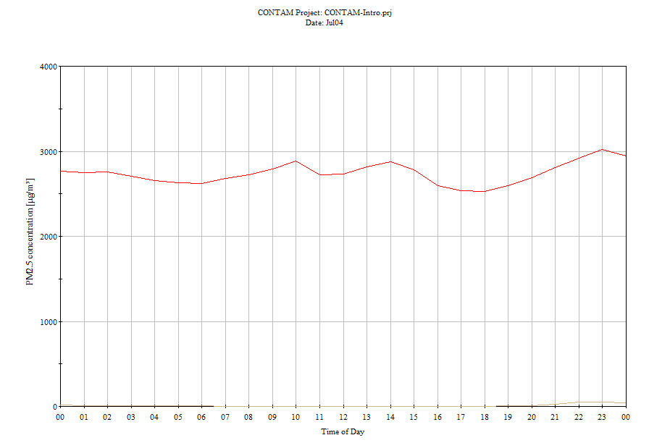

- Fans and window off (Electric stove Pm2.5) on below outdoor bad day and good day
