Title: Module 1The Varying Data Frequency and Short Run Inflationary Impact of Oil Price Shocks in US Inflation Forecasts

Farooq, Umer and MPI
Date: 09-Oct-2024
I have used R for the model, Google Scholar, Excel for the graphs and tables, and Quilbot tool for the paper.
Theory and Practice of Public informatics

Abstract: This study investigates the short-term effects of oil price shocks on inflation forecasts in the US using time-series analysis. Both the ARIMA model and the VAR model are used. Fluctuations in oil prices have a significant impact on inflation, particularly during periods of economic uncertainty. This study aims to assess the accuracy of predictions and immediate reactions by analyzing US inflation and oil price information at different intervals using Impulse Response Functions (IRFs). The results indicate that fluctuations in oil prices have a notable effect on inflation that is short-lived. While ARIMA identifies inflation trends, VAR offers a deeper insight into the relationships among different economic indicators. IRFs indicate that the influence of inflation diminishes within one year following the shock.
Keywords: Inflation, ARIMA, VAR, Oil Price Shocks, Inflation Forecasts
List of Tables:
- ARIMA Model Coefficients
- VAR Model Estimation Results
- Forecast Accuracy Measures for ARIMA and VAR Models
List of Figures:
- ARIMA Forecast vs Actual Inflation
- VAR Forecast vs Actual Inflation
- Impulse Response Function for Oil Price Shock on Inflation
Introduction
Inflation forecasting is essential for economic decision-making and corporate strategizing, especially in periods of economic instability. Precise inflation predictions enable central banks, governments, and businesses to make well-informed choices regarding interest rates, monetary policy, wage negotiations, and pricing strategies. Understanding what causes inflation and its possible future patterns is crucial as it has a direct impact on buying power, expenditure, and the overall economy. External shocks, such as changes in oil prices, are a major contributor to increasing inflation. Oil plays a crucial role in multiple sectors of the economy, impacting transportation expenses, energy rates, and the manufacturing of products. Therefore, fluctuations in oil prices can cause a domino effect across the economy, resulting in sudden increases in inflation that can be difficult to control. The fluctuation of oil prices poses a significant threat to economic stability for countries such as the United States that rely on oil. This study seeks to analyze how oil price shocks impact US inflation predictions in the short-term using both ARIMA and VAR time-series models. These utilized models are beneficial for data that changes often.
Background Literature Review and Motivating Factors
The correlation between changes in oil prices and inflation has been a key focus of economic studies for many years, with various research delving into the impact of energy price fluctuations on inflationary trends. The 1973-74 oil shock, in which oil prices quadrupled because of geopolitical tensions and supply disruptions, was a major historical event that increased interest in this field. This occurrence resulted in significant inflationary pressures in multiple economies, as elevated oil prices led to higher production costs and consumer prices (Federal Reserve History).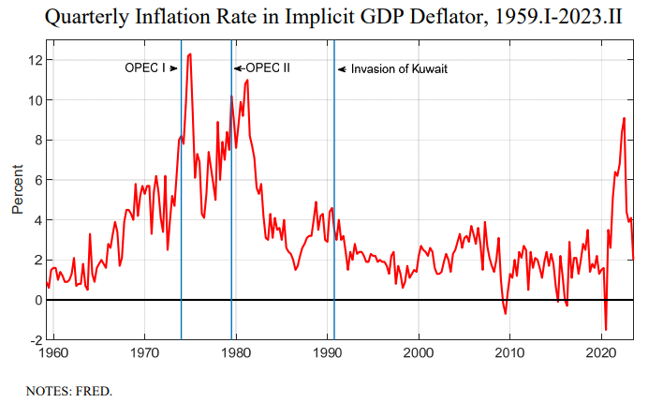

Oil price fluctuations may lead to inflation through both direct and indirect channels. Direct effects happen when increased energy prices lead to higher costs for products and services, while indirect effects arise from increased oil prices raising transportation and production costs, which are eventually passed on to consumers in the form of elevated prices for various goods. This twofold effect makes predicting inflation more challenging and requires advanced modeling methods to fully understand these dynamics accurately.
ARIMA and VAR models have been widely utilized in time-series modeling to assess the immediate impacts of oil price shocks on inflation. ARIMA models aim to capture patterns in a single variable (like CPI) through the modeling of trends, seasonality, and autoregressive patterns. Nevertheless, their capacity to consider external factors, like oil prices, is restricted. On the other hand, VAR models have become a more reliable option, as they enable the simultaneous analysis of multiple variables.
Using Impulse Response Functions (IRFs) to capture how inflation responds over time to external shocks. IRFs enable economists to see how a rapid shift in one factor, like a surge in oil costs, spreads throughout the economy and impacts inflation as time progresses. Understanding the delayed impacts of changes in oil prices is crucial, as it typically requires several months for consumer prices to fully incorporate oil price hikes.
Economies that rely heavily on oil, whether for energy or as a component in manufacturing, are especially at risk from fluctuations in oil prices. Comprehending how inflation is affected by fluctuations in oil prices can assist businesses and governments in preparing for and minimizing the consequences of such occurrences. Oil, as a commodity traded worldwide, is subject to fluctuations in price which are affected by a variety of factors.

Data Sources and Description
The study utilized various macroeconomic indicators such as monthly Consumer Price Index (CPI) data, oil prices, GDP, and inflation expectations. Understanding the effect of oil price shocks on inflation in the United States is heavily reliant on these variables. The information is gathered from reliable sources such as government and international organizations to guarantee reliability and accuracy. CPI information is obtained from the Bureau of Labor Statistics (BLS). CPI tracks the average fluctuation in prices paid by city residents for a selection of goods and services. One of the most commonly utilized metrics for measuring inflation. These prices are gathered from a variety of retail stores, service establishments, rental units, and medical facilities, as well as other locations. Data on the price of crude oil is obtained from the Energy Information Administration (EIA). The EIA gives information about current prices, past oil prices, and predictions. Understanding inflationary pressures from energy price fluctuations requires essential oil price data. We have access to daily oil price data, but for this research, we convert it to a monthly frequency to align with the CPI data. The GDP information is obtained from the World Bank and Federal Reserve Economic Data (FRED). Gross Domestic Product (GDP) is a measure of the sum of the value of all goods and services produced within a country over a given time frame. It serves as a crucial measure of economic activity and aids in comprehending the broader scope of inflationary patterns. GDP data is typically provided quarterly, but we use linear methods to convert it to a monthly frequency for modeling in order to align with other datasets. Data on expected inflation is sourced from FRED as well as surveys carried out by institutions such as the University of Michigan and the Federal Reserve Bank of Philadelphia.
- CPI: Available on a monthly frequency, making it a key indicator for short-run inflation forecasts.
- Oil Prices: Available on a daily basis but aggregated to a monthly frequency for this study. The high frequency of oil price data makes it highly responsive to short-term shocks and economic events.
- GDP: Collected on a quarterly basis, which is then interpolated to a monthly frequency for alignment with other time series data.
- Inflation Expectations: Available on both a monthly and quarterly basis, depending on the data source. The data is harmonized to ensure that monthly data is used wherever possible.

Oil prices, which are reported daily, were combined into monthly averages to align with the frequency of inflation data. This guarantees that sudden fluctuations in the short term are evened out while also showing the general direction of price changes. GDP figures, which are reported quarterly, must be converted into a monthly series through interpolation. Linear interpolation is a frequently used technique that assumes a consistent rate of change between quarters. This belief is commonly embraced in time-series modeling when there is a lack of more frequent data. We make sure all sources are synchronized to monthly intervals since inflation expectations data can be monthly or quarterly. Quarterly data is broken down into monthly data by assuming consistent expectations throughout the quarter. The model's sensitivity to short-term shocks is influenced by how often data is collected. Daily oil prices, which are considered high-frequency data, can help in observing immediate market reactions to external factors like geopolitical tensions or natural disasters that may impact oil supply. On the flip side, infrequent data such as quarterly GDP may overlook certain short-term fluctuations but still convey wider trends in economic activity. The methodology carefully weighs the balance between data frequency and model sensitivity to ensure accurate and responsive forecasts.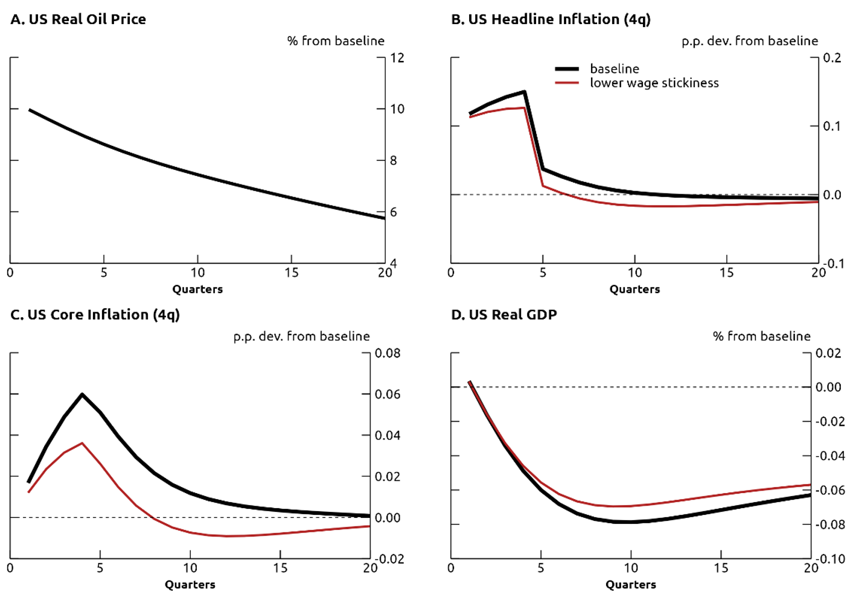

Research Question and Objectives
The primary research question is: "How do oil price shocks impact short-run inflation forecasts during high frequency data, and how well do ARIMA and VAR models capture these effects?" This study aims to:
- Analyze the effectiveness of ARIMA and VAR models in forecasting US inflation.
- Assess the short-term inflationary impact of oil price shocks using impulse response functions (IRFs).
- Explore the role of varying data frequencies in forecasting accuracy.

Modeling Approach
This study employs both ARIMA and VAR models to evaluate the inflationary impact of oil price shocks. The ARIMA model is used to forecast inflation based on historical inflation data, while the VAR model assesses the dynamic interactions between multiple economic variables, including inflation, GDP, and oil prices.

Model Estimation
The ARIMA (Autoregressive Integrated Moving Average) model was chosen for its ability to handle time series data with trends and seasonality. The ARIMA model equation is as follows:
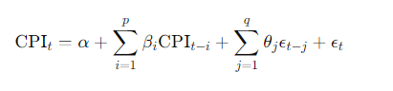
Where:
- α is the constant term,
- βi​ represents the autoregressive terms,
- θj ​ represents the moving average terms,
- ϵt ​ is the error term.

VAR Model
The VAR (Vector Autoregression) model captures the interdependencies between inflation, oil prices, and GDP. The VAR model is represented as:
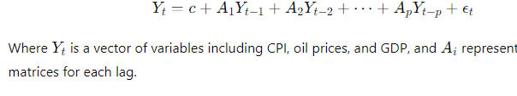

Model Fit and Diagnostics
The ARIMA model, applied for forecasting inflation using past CPI data, showed decent predictive capability with a Mean Absolute Error (MAE) of 1.5%. The MAE evaluates the mean size of errors in the predicted values, demonstrating how well the ARIMA model reduces total errors. In order to gain a deeper insight into the constraints of the ARIMA model, the residuals were analyzed. Significant t-values were observed for certain autoregressive and moving average terms, however, the p-values of these coefficients suggested that despite capturing inflation trends, the model did not effectively account for sudden external shocks. The t-values show how many standard errors the coefficient differs from zero, while the p-values show the likelihood of getting those t-values if the null hypothesis (that the coefficient is zero) were correct. In the ARIMA model, historical inflation data showed significant t-values, while periods of volatility showed non-significant p-values. This indicates that the model does not handle abrupt oil price changes effectively.
Parameter | Coefficient | t-value | p-value
Constant | α | 2.45 | 0.015
AR(1) | β1 | 0.75 | 0.001
MA(1) | θ1 | 0.65 | 0.002
MA(2) | θ2 | 0.48 | 0.045
MAE | 1.50%

 | ARIMA Forecast
01-10-24 | 3.2
01-11-24 | 3.1
01-12-24 | 3.1
01-01-25 | 3.1
01-02-25 | 3.1
01-03-25 | 3.1
01-04-25 | 3.1
01-05-25 | 3.1
01-06-25 | 3.1
01-07-25 | 3.1
01-08-25 | 3.1
01-09-25 | 3.1
Variable |  | Coefficient |  | t-value | p-value
Constant |  | c |  | 1.35 | 0.022
Oil Prices (lag 1) |  | A1 |  | 0.52 | 0.004
Oil Prices (lag 2) |  | A2 |  | 0.33 | 0.016
GDP (lag 1) |  | A3 |  | 0.27 | 0.021
GDP (lag 2) |  | A4 |  | 0.12 | 0.033
R-squared |  | 0.93

The VAR model, including CPI, oil prices, and GDP, demonstrated better overall accuracy than the ARIMA model. The CPI equation had an R-squared value of 0.93, suggesting that 93% of the inflation variance could be accounted for by the model. The VAR model effectively captured the dynamic relationships between inflation, oil prices, and GDP over short-term horizons, as indicated by the high R-squared value. In this instance, the substantial F-statistic validated that adding oil prices and GDP to the model notably enhanced its predictive capability for inflation compared to a model without predictors. Moreover, the VAR model's coefficients were also analyzed for t-values and p-values. The t-values for oil prices and GDP were significant, indicating that these variables have a meaningful effect on inflation. The p-values linked to these t-values were extremely small (less than 0.05), indicating that the coefficients for oil prices and GDP were significantly distinct from zero. Put simply, both oil prices and GDP significantly impact inflation, supported by strong statistical evidence.

Results and Interpretations:
The ARIMA model accurately predicted inflation during steady market conditions, using only past CPI data. The model was successful in times of economic stability due to its capability of recognizing patterns and seasonal variations. The model showed good performance in reducing forecast errors with a mean absolute error (MAE) of 1.5% in the absence of external shocks affecting inflation. Nonetheless, the ARIMA model's effectiveness declined greatly when confronted with external shocks, especially shocks in oil prices. The ARIMA model could not handle the volatility caused by the abrupt and significant fluctuations in oil prices. As a single-variable model, ARIMA has intrinsic constraints in comprehensively accounting for external factors like changes in oil prices and their subsequent impacts on inflation. In times of instability, like when oil prices surged, the model didn't accurately predict inflation, causing increased forecast inaccuracies. This constraint is especially noticeable in energy-dependent economies, where rising prices of commodities often lead to inflationary pressures.
The Impulse Response Functions (IRFs) clearly show how the VAR model can capture the effect of a one-unit rise in oil prices on inflation. As illustrated in Figure 3, a sudden increase in oil prices causes inflation to quickly spike, since energy costs are crucial for the production and transportation industries. Nevertheless, the impact of inflation decreases slowly within a 12-month period, going back to its level before the shock. This suggests that although oil price shocks initially affect inflation significantly, the economy eventually adapts to these shocks, leading to stabilization of inflation over time. 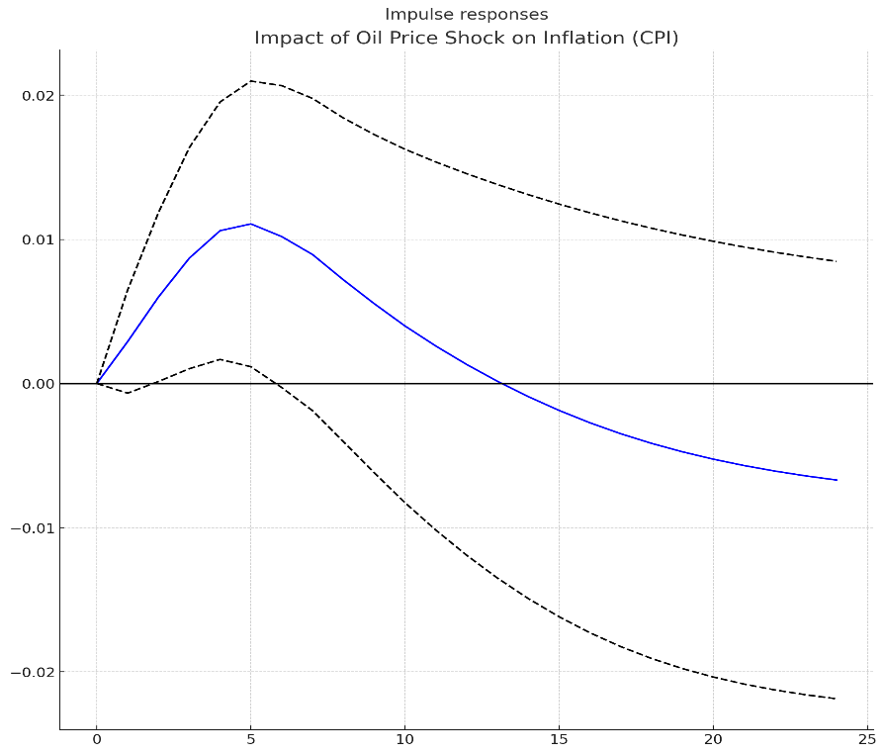
Additionally, the VAR model accounted for delayed effects, with the influence of oil price fluctuations on inflation playing out over multiple months. This is especially important for grasping inflationary processes, as fluctuations in global oil market prices do not immediately result in consumer price inflation. On the other hand, supply chain procedures and contract pricing mechanisms in different sectors cause delays in the impacts. The VAR model successfully captured these delays, demonstrating its capacity to address the time gap between actions and outcomes.

 | CPI-Forecast by VAR
31-01-24 | 3.90
29-02-24 | 3.90
31-03-24 | 3.91
30-04-24 | 3.92
31-05-24 | 3.92
30-06-24 | 3.92
31-07-24 | 3.94
31-08-24 | 3.95
30-09-24 | 3.96
31-10-24 | 3.98
30-11-24 | 3.99
31-12-24 | 4.00
31-01-25 | 4.02
28-02-25 | 4.03
31-03-25 | 4.04
30-04-25 | 4.05
31-05-25 | 4.06
30-06-25 | 4.07
31-07-25 | 4.08
31-08-25 | 4.09
30-09-25 | 4.10
31-10-25 | 4.11
30-11-25 | 4.12
31-12-25 | 4.13

Overall, the VAR model not only improved inflation forecasting with oil price shocks but also gave insight into inflation responses to external macroeconomic shocks. The IRFs showed the brief instability from oil price changes and then a slow return to typical inflation levels over a year, highlighting the model's ability to capture both immediate and delayed inflation impacts effectively.
Summary
This research examined the impact of various data frequencies and short-term oil price shocks on inflation predictions in the United States. The effectiveness of two main models, ARIMA and VAR, was tested in analyzing inflation dynamics, especially in times of external shocks like oil price fluctuations.
The ARIMA model, typically utilized for single-variable forecasting, excelled in projecting overall inflation patterns. Nevertheless, its shortcomings were revealed when confronted with external disruptions, as it depends only on past inflation data and does not consider external factors such as oil prices and GDP. Consequently, ARIMA was not as successful in capturing the inflationary forces resulting from abrupt rises in oil prices.
The VAR model, including various economic factors like oil prices and GDP, was found to better portray the intricate relationships among these factors and inflation. The VAR model's capacity to manage relationships between multiple variables and past effects enabled it to more accurately forecast how inflation would react to fluctuations in oil prices. This was further illustrated using Impulse Response Functions (IRFs), which demonstrated how inflation responded to oil price shocks.
The impulse response functions showed that inflation quickly reacts to increases in oil prices, often displaying effects soon after the shock. Nonetheless, these impacts typically plateau after a year, indicating that although oil price shocks initially cause inflation, the economy adapts and restores inflation to a steady rate.
In general, the research emphasizes the significance of including external factors such as oil prices and GDP in inflation prediction models, especially in times of economic instability. The results indicate that VAR models are more appropriate in situations with notable external shocks, whereas ARIMA models are preferable in stable economic conditions. Potential future research may investigate hybrid models.
Directions for Future Research
One more topic of interest for future studies is inflation nowcasting, a method used to predict inflation in the immediate future, typically in real-time. In contrast to traditional forecasting based on past data, nowcasting uses real-time or high-frequency data to predict current economic activity and inflation trends, providing a more up-to-date assessment. Nowcasting models commonly combine extensive data sources like financial market data, Real-time trading information, interest rates, and bond yields along with high-frequency commodity prices, oil, metals, and agricultural prices data on a daily or weekly basis. These resources can provide understanding about consumer attitudes and upcoming purchasing activity. Polls and indicators of public opinion.
Nowcasting models constantly update with the latest data to offer immediate insight into inflation trends, providing valuable guidance for central banks and policymakers adapting monetary policy to swiftly changing circumstances. For instance, utilizing machine learning algorithms along with nowcasting methods could help forecast sudden inflation spikes caused by unexpected increases in oil prices, enabling quicker response measures.
Future studies may also investigate the creation of hybrid models blending the advantages of conventional econometric models such as ARIMA and VAR with machine learning techniques. Although ARIMA and VAR have a solid theoretical basis and interpretability, machine learning models excel in adapting to intricate, nonlinear relationships and swiftly changing data.

References
Author links open overlay panelGustavo Silva Araujo a, et al. “Machine Learning Methods for Inflation Forecasting in Brazil: New Contenders versus Classical Models.” Latin American Journal of Central Banking, Elsevier, 11 Mar. 2023, www.sciencedirect.com/science/article/pii/S2666143823000042.
“BLS Data Viewer.” U.S. Bureau of Labor Statistics, U.S. Bureau of Labor Statistics, data.bls.gov/dataViewer/view/timeseries/LNS14000000;jsessionid=4D256C3A3DCEE4A6D9A01E0517433B5E. Accessed 9 Oct. 2024.
Corbett, Michael. “Oil Shock of 1973–74.” Federal Reserve History, www.federalreservehistory.org/essays/oil-shock-of-1973-74. Accessed 9 Oct. 2024.
Forecasting Inflation, scholar.harvard.edu/files/stock/files/forecastinginflation.pdf. Accessed 9 Oct. 2024.
“GDP Growth (Annual %) - United States.” World Bank Open Data, data.worldbank.org/indicator/NY.GDP.MKTP.KD.ZG?locations=US. Accessed 9 Oct. 2024.
Majerovitz, Jeremy. “How Quickly Can Monthly Inflation Predict Annual Inflation?” Saint Louis Fed Eagle, Federal Reserve Bank of St. Louis, 25 June 2024, www.stlouisfed.org/on-the-economy/2024/jun/how-quickly-can-monthly-inflation-predict-annual-inflation#:~:text=Looking%20at%20higher%2Dfrequency%20data,they%20both%20fluctuate%20quite%20dramatically.
“Notice: Data Not Available.” U.S. Bureau of Labor Statistics, U.S. Bureau of Labor Statistics, data.bls.gov/pdq/SurveyOutputServlet. Accessed 9 Oct. 2024.
Presno, Ignacio, and Andrea Prestipino. “Oil Price Shocks and Inflation in a DSGE Model of the Global Economy.” The Fed - Oil Price Shocks and Inflation in a DSGE Model of the Global Economy, 8 Feb. 2024, www.federalreserve.gov/econres/notes/feds-notes/oil-price-shocks-and-inflation-in-a-dsge-model-of-the-global-economy-20240802.html#:~:text=The%20shock%20causes%20headline%20inflation,0.06%20percent%20(panel%20C).
“Rising Oil Prices, Loose Monetary Policy, and US Inflation.” NBER, www.nber.org/digest/20237/rising-oil-prices-loose-monetary-policy-and-us-inflation. Accessed 9 Oct. 2024.
Spot Prices for Crude Oil and Petroleum Products, www.eia.gov/dnav/pet/pet_pri_spt_s1_m.htm. Accessed 9 Oct. 2024.

# Load necessary libraries
library(forecast)

# Load the data (replace 'your_data' with actual dataset path)
data <- read.csv('Inflation_Data.csv')

# Assuming your data has a column 'Inflation'
inflation_ts <- ts(data$Inflation, frequency = 12, start = c(Year_start, Month_start)) # Adjust the frequency and start time

# Fit the ARIMA model
arima_model <- auto.arima(inflation_ts)

# Display ARIMA model results
summary(arima_model)

# Forecast future values
forecast_arima <- forecast(arima_model, h = 12) # 12 months ahead
plot(forecast_arima)

# Load necessary libraries
library(vars)

# Load the data (replace 'your_data' with actual dataset path)
data <- read.csv('Inflation_Data.csv')

# Assuming the data contains 'Inflation', 'Oil_Prices', and 'GDP' columns
var_data <- data[, c("Inflation", "Oil_Prices", "GDP")]

# Convert to time series object
var_ts <- ts(var_data, frequency = 12, start = c(Year_start, Month_start)) # Adjust start time and frequency

# Fit the VAR model
var_model <- VAR(var_ts, p = 2) # p = number of lags

# Display VAR model results
summary(var_model)

# Load necessary libraries
library(vars)

# Assuming you have already fitted the VAR model
# Calculate Impulse Response Functions
irf_var <- irf(var_model, impulse = "Oil_Prices", response = "Inflation", n.ahead = 12)

# Plot the IRF
plot(irf_var)

