CS-360 (Fall 2018): Artificial Intelligence Assignment 05 | Adversarial Search Punjab University College of Information Technology, University of the Punjab

Submission Date: Monday-May 14, 2018 10:00 pm
BCSF15M025
Umer Farooq
Consider following tree to answer the questions. |  | 20 Marks
A. | What will be the maximum utility retrieved from the state space? | 2 marks
B. Which state(s) won’t be visited by alpha-beta pruning? |  | 5 marks
C. | If the two agents are rational, which branch will be executed? | 3 marks

- Run the algorithm for alpha-beta pruning on the given tree and determine the values of α and β passed to each

state, please also determine value that each state would return. 10 marks

Assumption

States must be named in Left First, Breadth First order.
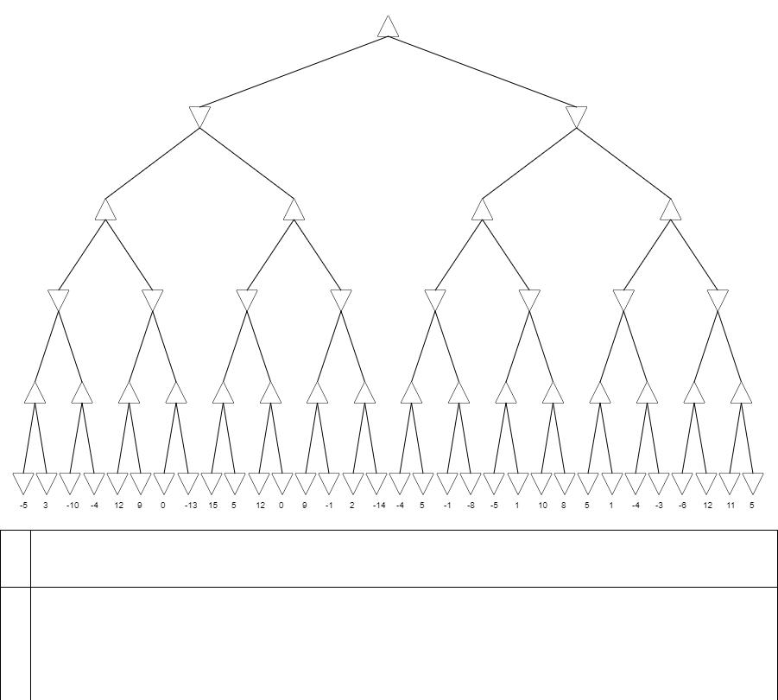

A.

1

B.

S11,S22,S23,S41,S43,S44,S45,S46,S47,S55,S57,S63

C.

S1->S3->S6->S13->S26->S53

D. Provide value of α, β and v for each state in the following table.

Node | α | Β | v | Node | α | β | v
s1 | -inf | +inf | 1 | s33 | 3 | +inf | 3
s2 | -inf | +inf | 0 | s34 | -inf | 3 | -10
s3 | 0 | +inf | 1 | s35 | -10 | 3 | -4
s4 | -inf | +inf | 0 | s36 | -3 | +inf | 12
s5 | -inf | 0 | 12 | s37 | 12 | +inf | 9
s6 | 0 | +inf | 1 | s38 | -3 | +inf | 0
s7 | 0 | 1 | 11 | s39 | 0 | 12 | -13
s8 | -inf | +inf | -4 | s40 | -inf | 0 | 15
s9 | -3 | +inf | 0 | s41 | Pruned | Pruned | Pruned
s10 | -inf | 0 | 12 | s42 | -inf | 0 | 12
s11 | Pruned | Pruned | Pruned | s43 | Pruned | Pruned | Pruned
s12 | 0 | +inf | -1 | s44 | Pruned | Pruned | Pruned
s13 | 0 | +inf | 1 | s45 | Pruned | Pruned | Pruned
s14 | 0 | 1 | -3 | s46 | Pruned | Pruned | Pruned
s15 | 0 | 1 | 11 | s47 | Pruned | Pruned | Pruned
s16 | -inf | +inf | 3 | s48 | 0 | +inf | -4
s17 | -inf | 3 | -4 | s49 | 0 | +inf | 5
s18 | -3 | +inf | 12 | s50 | 0 | 5 | -1
s19 | -3 | 12 | 0 | s51 | 0 | 5 | -8
s20 | -inf | 0 | 15 | s52 | 0 | +inf | -5
s21 | -inf | 0 | 12 | s53 | 0 | +inf | 1
s22 | pruned | Pruned | Pruned | s54 | 0 | 1 | 10
s23 | Pruned | Pruned | Pruned | s55 | Pruned | Pruned | Pruned
s24 | 0 | +inf | 5 | s56 | 0 | 1 | 5
s25 | 0 | 5 | -1 | s57 | Pruned | Pruned | Pruned
s26 | 0 | +inf | 1 | s58 | 0 | 1 | -4
s27 | 0 | 1 | 10 | s59 | 0 | 1 | -3
s28 | 0 | 1 | 5 | s60 | 0 | 1 | -6
s29 | 0 | 1 | -3 | s61 | 0 | 1 | 12
s30 | 0 | 1 | 12 | s62 | 0 | 1 | 11
s31 | 0 | 1 | 11 | s63 | Pruned | pruned | pruned
s32 | -inf | +inf | -5
s

