CS-360 (Fall 2018): Artificial Intelligence Assignment 05 | Adversarial Search Punjab University College of Information Technology, University of the Punjab

Submission Date: Monday-May 14, 2018 10:00 pm

Consider following tree to answer the questions. |  | 20 Marks
A. | What will be the maximum utility retrieved from the state space? | 2 marks
B. Which state(s) won’t be visited by alpha-beta pruning? |  | 5 marks
C. | If the two agents are rational, which branch will be executed? | 3 marks

- Run the algorithm for alpha-beta pruning on the given tree and determine the values of α and β passed to each

state, please also determine value that each state would return. 10 marks

Assumption

States must be named in Left First, Breadth First order.
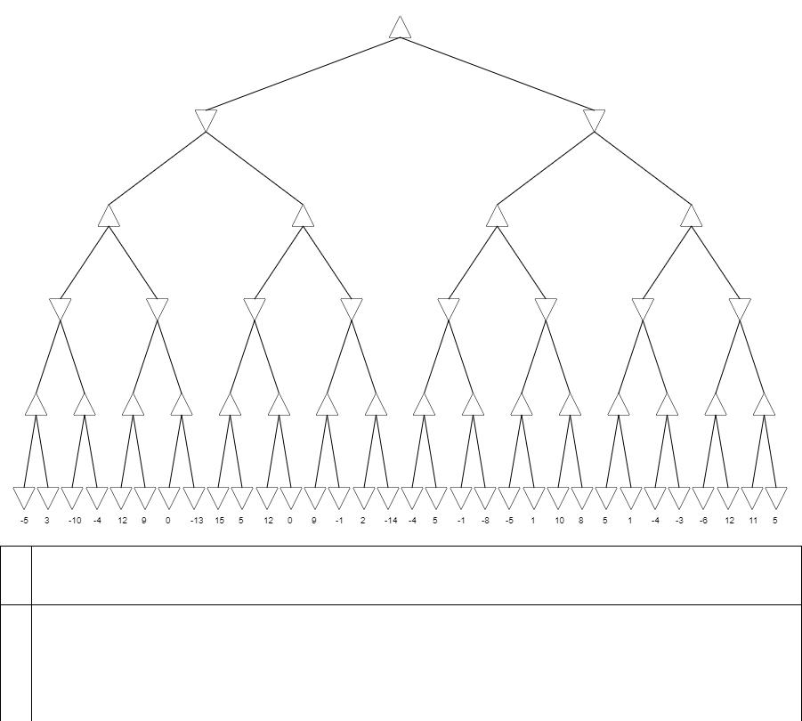

A.

B.

C.

D. Provide value of α, β and v for each state in the following table.

Node | α | β | v | Node | α | β | v
s1 |  |  |  | s33
s2 |  |  |  | s34
s3 |  |  |  | s35
s4 |  |  |  | s36
s5 |  |  |  | s37
s6 |  |  |  | s38
s7 |  |  |  | s39
s8 |  |  |  | s40
s9 |  |  |  | s41
s10 |  |  |  | s42
s11 |  |  |  | s43
s12 |  |  |  | s44
s13 |  |  |  | s45
s14 |  |  |  | s46
s15 |  |  |  | s47
s16 |  |  |  | s48
s17 |  |  |  | s49
s18 |  |  |  | s50
s19 |  |  |  | s51
s20 |  |  |  | s52
s21 |  |  |  | s53
s22 |  |  |  | s54
s23 |  |  |  | s55
s24 |  |  |  | s56
s25 |  |  |  | s57
s26 |  |  |  | s58
s27 |  |  |  | s59
s28 |  |  |  | s60
s29 |  |  |  | s61
s30 |  |  |  | s62
s31 |  |  |  | s63
s32

