 |  | DHA SUFFA UNIVERSITY Off Khayaban-e-Tufail, Phase -VII (Extension), DHA, Karachi - 75500  RESULT INTIMATION |  |  | 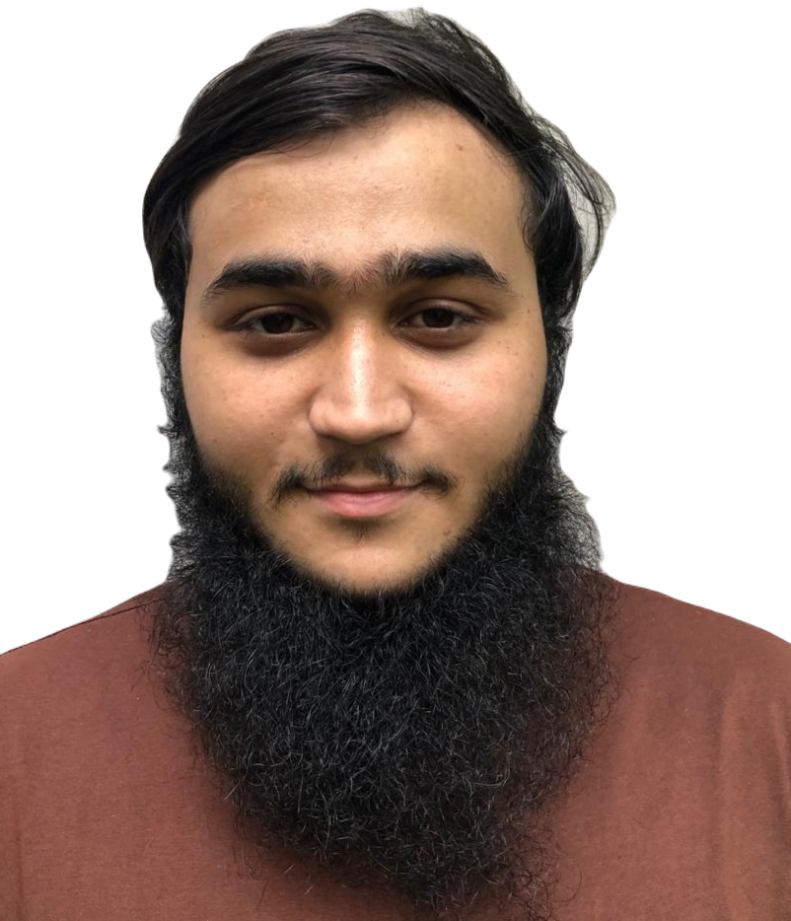
PROGRAM: BACHELOR OF SCIENCE (COMPUTER SCIENCE)
Registration No: | CS241090
Name: | Umer Gul Kaleem |  | Enrolled in the Program: | Fall 2024
Father's Name: | Muhammad Anwer |  | Graduated In: | -
Fall Semester 2024
Course Code | Course Title | Grade | Grade Point | Credit Hours | GP  Earned
CS-1001 | Applications of Information and Communication Technologies | A | 4.00 | 2 | 8.00
CS-1001L | Applications of Information and Communication Technologies L | A- | 3.67 | 1 | 3.67
BS-1101 | Applied Physics | B | 3.00 | 3 | 9.00
BS-1301 | Calculus and Analytical Geometry | B- | 2.67 | 3 | 8.01
HU-1002 | Functional English | B- | 2.67 | 3 | 8.01
HU-2201 | Islamic Studies | A- | 3.67 | 2 | 7.34
CS-1002 | Programming Fundamentals | B+ | 3.33 | 3 | 9.99
CS-1002L | Programming Fundamentals Lab | A- | 3.67 | 1 | 3.67

Status: | Promoted | SGPA: | 3.21 | CGPA: | 3.21
Academic Deficiency: |  |  |  | Promoted
(None / Probation / Relegation / Internship / Withdrawal from the Program)
1. Program Status: |  | Incomplete | 2. Total Credit Hours required to complete the program: | 35 | 3. Credit Hours completed: | 18
4. Final CGPA: | 3.21 out of 4.00 |  | 5. University reserves the right to correct any inadvertent error.
Date of issue: | 1 Mar 2025
Notes:
1. Please check your Name and Father's Name including spellings and report to the Examination Department in case of any error. 2. Discrepancies if any, are to be reported within 7 days of issue of this document.
3. This is a computer generated report and does not need any signature. University reserves the right to correct any inadvertent error. 4. This document is for Campus use only, it is not to be used for any other official purpose.

