**CRYSTAL ONLINE**



FINAL YEAR PROJECT REPORT

Submitted by

Haseeb Akhtar

1421-115142

Submitted to

Munazza Mah Jabeen

Assistant Professor Computer Science

Department of Computer Science

Preston University Islamabad

2019

**ACKNOWLEDGEMENTS**

I am grateful and would like to express my sincere gratitude to my supervisor Mam Munazza Mah Jabeen for her invaluable guidance, continuous encouragement and constant support in making this project possible. I really appreciate her guidance from the initial to the final level that enabled me to develop an understanding of this project thoroughly. Without her advice and assistance, it would be a lot tougher to completion. I also sincerely thanks for the time spent proofreading and correcting my mistakes.

Many thanks to Preston University for providing us the opportunity to explore my capabilities in programming and implementing my ideas to a good use. Having said, that it was all possible because of good staff and great management of Preston University.

Special acknowledgement to all the teachers who have guided me in my life and in my studies without their guidance I wouldn’t have accomplished any of this and also thanks to all the class mates who have pushed me out of my shyness and have helped me in facing my fears.

Also, I would like to acknowledge Simone Memoli CEO of Nero Falco Sicurezza who have accepted my project as their own and also would like to impalement it as their field tool for security assessments.

I wouldn’t end my acknowledgement without saying Thanks to my mentor and my friend Pedro A.K.A r00t-3xp10it who have taught me all I know about coding, love for Linux and Open Source Community.

**DECLARATION**

This Final Year Project is presented in partial fulfillment of the requirements for a Bachelor of Computer Science Degree in Information Technology. It is entirely my own work and has not been submitted to any other University or higher education institution, or for any other academic award in this University. Where use has been made of the work of other people it has been fully acknowledged and fully referenced.

This documentation may be made available within the university Library and may be photocopied or loaned to other libraries for the purpose of consultation.

Haseeb Akhtar

1421-115142

BSCS-Batch 115

**CERTIFICATE**

This is to certify that the project entitled, “Crystal Online" submitted by "Haseeb Akhtar" in partial fulfillment of the requirements for the award of "Bachelor of Computer Science" at the "Preston University Islamabad" is an authentic work carried out by him under my supervision and guidance.

To the best of my knowledge, the matter embodied in the project has not been submitted to any other University / Institute for the award of any Degree or Diploma.

Date: 8th January 2018

Assistant Professor Munazza Mah Jabeen

Department of Computer Science, Preston University

Islamabad. Pakistan

Table of Contents

Chapter 1 8

Software Requirement Specification 8

1.1 Introduction 9

1.2 Purpose 9

1.3 Scope 9

1.4 Definitions, Acronyms and Abbreviations 10

1.5 References 10

1.6 Overview 11

1.7 Functional Requirements 11

1.7.1 Manage User Accounts: 11

1.7.2 Manage Products Category: 12

1.7.3 Manage Products Post: 13

1.7.4 Manage Catalog: 13

1.7.5 Manage Shopping Cart: 14

1.7.6 Manage Shipping 14

1.7.7 Manage Customer Services: 15

1.8 Non-Functional Requirements 16

1.8.1 Security 16

1.8.2 Performance requirements 16

1.8.3 Usability 17

1.8.4 Reliability 17

1.9 Design Constraints 17

1.9.1 User Help 17

1.9.2 User Interfaces 18

1.10 Software Interfaces 18

Conclusion 18

Chapter 2 19

Entity Relationship Diagram 19

Chapter 3 22

Class Diagram 22

Chapter 4 24

Relation Model 24

Chapter 5 35

Testing Module 35

Signup User **Error! Bookmark not defined.**

Login User: 37

Forget Password: 38

Update Account: 39

Deactivate Account: 40

Add Product Category: 41

View/Search Product Category: 42

Update Product Category: 42

Add Post: 44

View/Search Post: 45

Update Post: 46

Deactivate/Activate Post: 47

Add Order: 48

Review Cart/Order: 49

Update Order: 50

Cancel Order: 51

View Order: 52

Chapter 6 53

User Manual 53

6.1 Introduction 54

6.1.1 History 54

6.1.2 Description 54

6.1.3 Computer Requirements 54

6.2 Accessing your website and Admin 55

6.2.1 Accessing your website 55

6.2.2 Admin Area 55

6.2.3 Managers 57

6.2.4 Customers 57

6.2.5 Categories 58

6.2.6 Products 58

6.2.7 Orders 59

6.2.8 Shipments 59

6.3 Front End 60

6.3.1 Home Page 60

6.3.2 Customer Signup 61

6.3.3 Customer Login 62

6.3.4 Customer Profile &Orders 63

6.3.5 Cart 64

# Chapter 1

# Software Requirement Specification

# 1.1 Introduction

This Software Request Specification (SRS) document presents a detailed description of Crystal Online (CO). The purpose of this document is to describe the all the requirements for the system. It represents the requirements analysis that defines the functional and nonfunctional requirements of the CO and its different functionalities. The Intended audience includes all stakeholders in the potential system. These include, but are not necessarily limited to, the following: Administrative staff, Users & Developers.

# 1.2 Purpose

The objective of this software is to minimize the problems that Crystal currently faces regarding their current system and to expand their business towards online system.

So, our purpose is to provide a well-managed and maintained software system which provides the relief to the management of Crystal, as they are interested to get accurate and fast results from this software.

# 1.3 Scope

This system is available on internet for website users. Everyone in the Pakistan can get benefit from this program. This system maintains all the information of Crystal Online e.g. Customer information, product information, sales and shipping details. We improved this system by a surveying plenty of systems that have no such information in a single system that we are providing.

# 1.4 Definitions, Acronyms and Abbreviations

|  |  |
| --- | --- |
| **Term/ Abbreviation** | **Description** |
| CO | Crystal Online |
| RUP | Rational Unified Process |
| DB | Database |
| SQL | Structured Query Language |
| PHP | Hypertext Preprocessor |
| UI | User Interface |

# 1.5 References

|  |  |  |  |
| --- | --- | --- | --- |
|  |  |  | **Website**  [http://www.junaidjamshed.com](http://www.junaidjamshed.com/)[http://www.hub.com](http://www.hub.com/)[http://www.outfitters.com](http://www.outfitters.com/) |
|  |  |  | [www.Outfitters.com](http://www.outfitters.com/)[www.j.crew.com](http://www.j.crew.com/)[www.gamiss.com](http://www.gamiss.com/)[www.Spyder.com](http://www.spyder.com/)  **Books** |

* Applying UML and Patterns 2nd Edition Craig Lawman
* **PHP** and MySQL for Dynamic Web Sites: Visual QuickPort Guide (4th Edition) by Larry Ullman.

# 1.6 Overview

This document contains the requirements of Crystal to automate their system, and to expand their business by selling their products online. All the requirements are firstly gather from our client (owner of Crystal) and then functionalities of system are concluded.

This document is written by following the standards of **RUP**

# 1.7 Functional Requirements

Functional Requirements serves to present the "big picture" of the application. They specifies that what system should do. This section provides detailed technical requirements of the system. This is typically the largest and most important part of this document.

## 1.7.1 Manage User Accounts:

* **Signup User**

**SRS-01.**Customer, operator can create their account by entering First Name, Last Name, Email, Contact number, Password and Confirm Password.

* **Login User**

**SRS-0**User can log in to system by entering email and password.

**SRS-03.**System verifies the email and password from database for user authentication.

* **Forget Password**

**SRS-04.**User can recover his/her password by selecting forget password option and entering his/her email.

**SRS-06.**User can change password after verification of entered email.

* **Change Password**

**SRS-06.**User can change password by entering old Password, new password and confirm new password.

* **View Account**

**SRS-07.**User can view his/her account after logging in to the account.

* **Update Account**

**SRS-08.**User can update personal information like email, contact no, address.

* **Deactivate Account**

**SRS-09.**Admin can deactivate user accounts.

## 1.7.2 Manage Products Category:

* **Add Category**

**SRS-10.** Admin, operator can add categories and sub categories of products.

* **View/ Search Category**

**SRS-11.**User can view/ search categories and sub categories of products.

* **Update Category**

**SRS-1**Admin, operator can update categories and sub categories of products.

* **Deactivate Category**

**SRS-13.**Admin can deactivate categories and sub categories of products.

## 1.7.3 Manage Products Post:

* **Add Post**

**SRS-14** Admin, operator can add posts of products to the system.

* **View/ Search Post**

**SRS-16** User can search product by name.

**SRS-16** User can search products by color and price

**SRS-17** User can view posts of products.

* **Update Post**

**SRS-18**Admin, operator can update posts of products.

* **Deactivate Post**

**SRS-19** Admin, operator can deactivate posts of products.

## 1.7.4 Manage Catalog:

* **Add Catalog**

**SRS-20.**Admin, operator can add catalog for each season.

* **View/ Search Catalog**

**SRS-21.**User can view and search catalog.

* **Update Catalog**

**SRS-2**Admin, operator and operator can update catalog.

* **Deactivate Catalog**

**SRS-23.**Admin, operator can deactivate catalog.

## 1.7.5 Manage Shopping Cart:

* **Add Order**

**SRS-24.**Customer can add his/her order to the shopping cart.

* **Review Cart**

**SRS-26.**Customer can review his/her order in the shopping cart.

* **Update Order**

**SRS-26.**Customer can update his/her order at the shopping cart.

* **Cancel Order**

**SRS-27.**Customer can cancel his/her order from shopping cart.

* **View/ Search Order**

**SRS-28.**Admin/ operator can view orders of customers.

## 1.7.6 Manage Shipping

* **Send Shipping Notification**

**SRS-29.**Admin/ Operator can send shipping notification to customer.

* **Receive Shipping Notification**

**SRS-30.**Customer can get notification about shipment of his/her order via email.

* **View/Search Payment Policy**

**SRS-31.**Customer can view payment method.

* **Add Shipping Policy**

**SRS-3**Admin can add shipping policy of orders.

* **View/Search Shipping Policy**

**SRS-33.**Customer can view shipping policy of orders.

* **Update Shipping Policy**

**SRS-34.**Admin can update shipping policy of orders.

# 1.7.7 Manage Customer Services:

* **Add Delivery Information**

**SRS-36.**Admin can add and update information about delivery time, delivery charges and taxes & duties.

* **View/search Delivery Information**

**SRS-36.**User can view and search delivery information.

* **Update Delivery Information**

**SRS-37.**Admin can update delivery information.

* **Add Size Guide**

**SRS-38.**Admin can add size guide information.

* **View/Search Size Guide**

**SRS-39** User can view/Search size guide information.

* **Update Size Guide**

**SRS-40** Admin can update size guide information.

* **Add Return Policy**

**SRS-41** Admin can add and update return policies of business.

* **View/Search Return Policy**

**SRS-4** User can view return policies of business.

* **Update Return Policy**

**SRS-43** Admin can update return policy of business.

### 1.8 Non-Functional Requirements

Non-functional requirements are more important aspect of any system. They specify the criteria that can be used to judge the operation of a system in particular conditions.

This part of the document contains the detail of non-functional requirements which are mandatory for the system.

## 1.8.1 Security

**User Identification:** User must have a login account to verify themselves.

## 1.8.2 Performance requirements

**User-Interface:** The user interface screen will respond within 5 seconds.

**Response Time:** The system will give response within 3 second after taking output from DB.

## 1.8.3 Usability

**Learnability:** The user documentation and help will be complete. The system should be easy to learn. Operability: The interface actions and elements will be consistent and the system will be customizable to meet specific user needs.

## 1.8.4 Reliability

**Availability:** System will be available 24 hours.

**Accuracy:** System will be completely accurate.

**Correctness:** Our system will meet the specified requirements.

**Errors:** It will be minimum as possible.

# 1.9 Design Constraints

In this project we will use MS Office 2013 and MS Visio 2013 for project documentation, Dreamweaver CS6 for html, CSS and JavaScript, XAMPP server and browsers. We will use windows platform.

## 1.9.1 User Help

A detailed and clearly written user manual along with help brochures will be provided to extract maximum benefit from the system

## 1.9.2 User Interfaces

The user interfaces will be much user friendly because it will be made after discussion with the users of the system. They will be in windows application GUIs, so will be more interactive.

# 1.10 Software Interfaces

* **Windows**

The operating system must be windows 7, 8.1 0r windows 10.

* **Browsers**

User can access the system from all major browsers i.e. (Chrome, IE, Firefox and Safari)

## Conclusion

This SRS document is used to give details regarding the Crystal Online. This document will provide a clear understanding of what is expected in the proposed system. This will give a clear idea on how the software should be developed by the development team for the end users. In this all the functional and nonfunctional requirements are specified in order to get a clear cut idea to develop the system.

# Chapter 2

# Entity Relationship Diagram

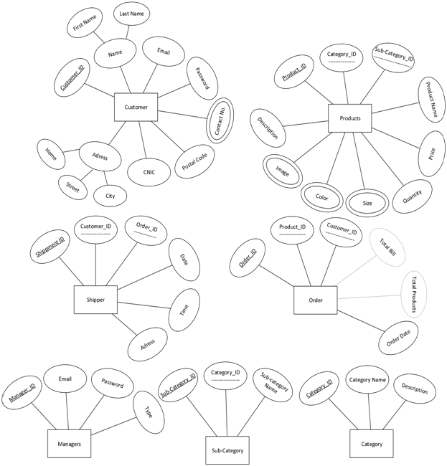

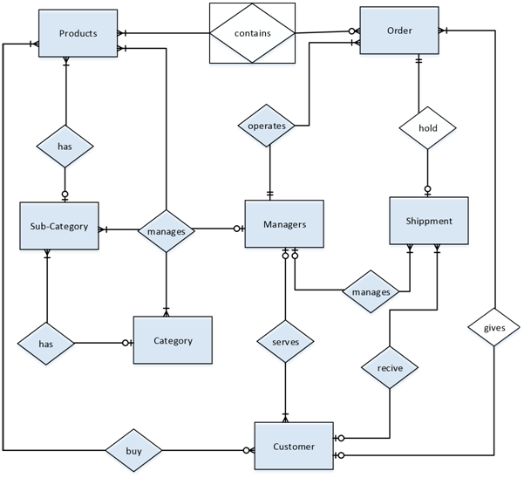

# Chapter 3

# Class Diagram

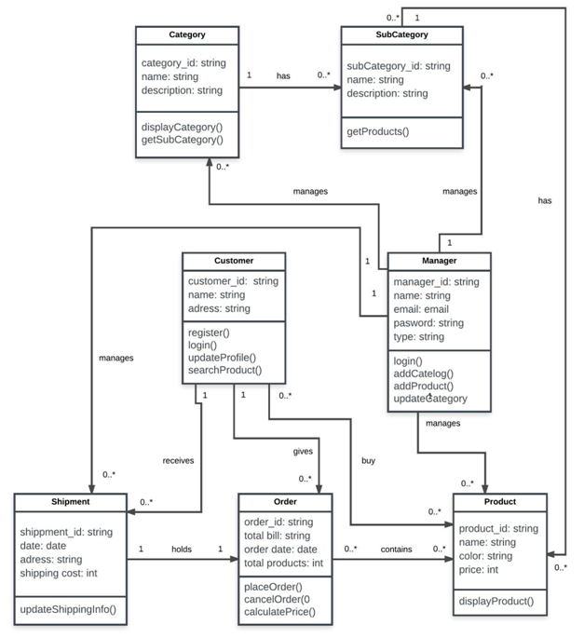

# Chapter 4

# Relation Model

|  |  |
| --- | --- |
| **Table ID** | 01 |
| **Table Name** | Managers |

|  |  |
| --- | --- |
| **Attribute** | **Primary Key Foreign Key Normal Attributes**  Mananger_ID Name  Email  Password Type |

|  |  |
| --- | --- |
| **Table ID** | 02 |
| **Table Name** | Customers |

|  |  |
| --- | --- |
| **Attribute** | **Primary Key Foreign Key Normal Attributes**  Customer ID First_Name  Last_Name  CNIC  Address  Email  Password |

|  |  |
| --- | --- |
| **Table ID** | 03 |
| **Table Name** | Customers_Contacts |

|  |  |
| --- | --- |
| **Attribute** | **Primary Key Foreign Key Normal Attributes**  Customer_ID Contact No. |

|  |  |
| --- | --- |
| **Table ID** | 04 |
| **Table Name** | Category |

|  |  |
| --- | --- |
| **Attribute** | **Primary Key Foreign Key Normal Attributes**  Category_ID Category_Name  Description |

|  |  |
| --- | --- |
| **Table ID** | 05 |
| **Table Name** | Catalogue |

|  |  |
| --- | --- |
| **Attribute** | **Primary Key Foreign Key Normal Attributes**  Sub_Category_ID Category_ID Sub_Category_Name |

|  |  |
| --- | --- |
| **Table ID** | 06 |
| **Table Name** | Products |

|  |  |
| --- | --- |
| **Attribute** | **Primary Key Foreign Key Normal Attributes**  Product_ID Category_ID Product_Name  Sub_Category_ID Price  Quantity  Description |

|  |  |
| --- | --- |
| **Table ID** | 07 |
| **Table Name** | Products_Image_Size |

|  |  |
| --- | --- |
| **Attribute** | **Primary Key Foreign Key Normal Attributes**  Product_ID Image  Size |

|  |  |
| --- | --- |
| **Table ID** | 08 |
| **Table Name** | Order |

|  |  |
| --- | --- |
| **Attribute** | **Primary Key Foreign Key Normal Attributes**  Order_ID Customer_ID Product_Name  Total_Products  Total_Bill  Order_Date |

|  |  |
| --- | --- |
| **Table ID** | 09 |
| **Table Name** | Order_Products |

|  |  |
| --- | --- |
| **Attribute** | **Primary Key Foreign Key Normal Attributes**  Order_ID  Product_ID |

|  |  |
| --- | --- |
| **Table ID** | 10 |
| **Table Name** | Shipment |

|  |  |
| --- | --- |
| **Attribute** | **Primary Key Foreign Key Normal Attributes**  Shipment_ID Customer_ID Address  Order_ID Date  Time |

# Chapter 5

# Testing Module

**Signup User:**

|  |  |
| --- | --- |
| Tc:01 | Signup User |
| Description | This test case is to test the creation of new users. This test case verifies if the signup user is completed successfully or not. This test case will be carried more than one time to verify the process. |
| Priority | High |
| Normal Flow | User request for registration  User enters the account information  User request the system to save information  2. System saves the information in database  3. System displays a user dashboard of successful addition of user in database |
| Preconditions | System should be in running mode  User must enter valid and unregistered email |
| Post-conditions | User account is created and stored with all the provided information in the database. |
| Input Data: | User Name  New Password  Confirm Password |
| Expected Result | Users account created successfully… |
| Actual Result | Users account created successfully… |
| Acceptance | Pass |

### Login User:

|  |  |
| --- | --- |
| TC: 02 | Login User |
| Description | This test case is to test the login of a user. This test case verifies if the user login is completed successfully or not. This test case will be carried more than one time to verify the process. |
| Priority | High |
| Normal Flow | User request the system for login  System compares the user and password  System successfully login the user |
| Preconditions | User is the valid member of the organization |
| Post-conditions | User is successfully logged in |
| Input Data | User Name  Password |
| Expected Result | System displays the user’s dashboard |
| Actual Result | System displays the user’s dashboard |
| Acceptance | Pass |

### Forget Password:

|  |  |
| --- | --- |
| TC: 03 | Forget Password |
| Description | This test case is to test the process of Change Password. This test case verifies if the Change Password is completed successfully or not. This test case will be carried more than one time to verify the process. |
| Priority | High |
| Normal Flow | User request the system to forget password  System requests user email  System checks whether the code has sent to the mail to which the user has provided.  System requests the code  User enters the code system send by an email  System checks whether the entered code is right.  System requests new password and confirm password  User enters the new password and confirm password  System successfully authenticate the user |
| Preconditions | User is the valid member |
| Post-conditions | User successfully change the password |
| Input Data | Code  New Password  Confirm Password |
| Expected Result | Password changed successfully… |
| Actual Result | Password changed successfully… |
| Acceptance | Pass |

### Update Account:

|  |  |
| --- | --- |
| TC: 05 | Update Account |
| Description | This test case describes that how user update his/her account |
| Priority | Medium |
| Normal Flow | User select update account information.  System process the request and allowed to update. .  User updates information like contact number, address, email.  A confirmation message of information successfully updated will show to user. |
| Preconditions | System should be in running mode.  User must be logged in to the system. |
| Post-conditions | Information successfully updated. |
| Input Data | User’s information |
| Expected Result | Password changed successfully |
| Actual Result | Password changed successfully |
| Acceptance | Pass |

### Deactivate Account:

|  |  |
| --- | --- |
| TC: 06 | Deactivate Account |
| Description | This test case describes that how admin will deactivate user’s account. |
| Priority | High |
| Normal Flow | Admin select deactivate user account option.  System process the request and will allowed admin to deactivate user accounts. |
| Preconditions | System should be in running mode.  Admin must be logged in to the system. |
| Post-conditions: | Information successfully updated. |
| Input Data: | User clicked the deactivate button |
| Expected Result | Account deactivated successfully |
| Actual Result | Account deactivated successfully |
| Acceptance | Pass |

### Add Product Category:

|  |  |
| --- | --- |
| TC: 07 | Add Product Category |
| Description | This test case describes that how admin and operator will add product category into the system. |
| Priority | High |
| Normal Flow | Admin added product category by entering category name and type.  System verified the information and shows a confirmation message. |
| Preconditions: | System should be in running mode.  Admin/ operator must be logged in to the system |
| Post-conditions | Category successfully added into the system. |
| Input Data: | User added the required fields |
| Expected Result: | Category added successfully |
| Actual  Result | Category added successfully |
| Acceptance | Pass |

### View/Search Product Category:

|  |  |
| --- | --- |
| TC: 08 | View/Search Category |
| Description | This test case describes that how admin, operator and customer will view product category into the system |
| Priority | High |
| Normal Flow | Admin, operator and customer requested to view category.  System process the request and allowed to view product category. |
| Preconditions | System should be in running mode |
| Post-conditions | Category successfully added into the system. |
| Input Data | User entered category name in search field |
| Expected Result | Category searched successfully |
| ActualResult | Category searched successfully |
| Acceptance | Pass |

### Update Product Category:

|  |  |
| --- | --- |
| TC: 09 | Update Category |
| Description | This test case describes that how admin and operator will update product category into the system |
| Priority | High |
| Normal Flow | Admin/ operator selected update category.  System process the request and allowed to update  Admin and operator updated product category information.  System verified the information and show a confirmation message |
| Preconditions | System should be in running mode.  Admin/ operator must be logged in to the system. |
| Post-conditions | Category successfully added into the system. |
| Input Data | Admin enter the new name of category |
| Expected Result | Category updated successfully |
| ActualResult | Category updated successfully |
| Acceptance | Pass |

### Add Post:

|  |  |
| --- | --- |
| TC: 10 | Add Post |
| Description | This test case describes that how admin and operator added product into the system. |
| Priority | High |
| Normal Flow | Admin added product post by entering snaps of the products.  System verified the information and shows confirmation message. |
| Preconditions: | System should be in running mode.  Admin/ operator must be logged in to the system |
| Post-conditions: | Post successfully added into the system. |
| Input Data: | User entered the required fields |
| Expected Result: | Posts added successfully |
| Actual Result | Posts added successfully |
| Acceptance | Pass |

### View/Search Post:

|  |  |
| --- | --- |
| TC: 11 | View/Search Post |
| Description | This test case describes that how user viewed/ searched post from the system |
| Priority | High |
| Normal Flow | User search/view product by entering category name and type.  System processed the request and post show. |
| Preconditions: | System should be in running mode |
| Post-conditions: | Post successfully Viewed/Searched from the system. |
| Input Data: | User entered product name in search field |
| Expected Result: | Product post searched successfully |
| Actual Result | Product post searched successfully |
| Acceptance | Pass |

### Update Post:

|  |  |
| --- | --- |
| TC: 12 | Update Post |
| Description | This test case describes that how admin, operator updated product post. |
| Priority | High |
| Normal Flow | Admin, operator select update the product post  System process the request and allowed to update  Admin, operator update posts.  System verifies the information and a confirmation message show. |
| Preconditions: | System should be in running mode  Admin/ operator must be logged in to the system. |
| Post-conditions: | Product post was successfully updated. |
| Input Data: | User entered product name in search field |
| Expected Result: | Product post searched successfully |
| Actual Result | Product post searched successfully |
| Acceptance | Pass |

### Deactivate/Activate Post:

|  |  |
| --- | --- |
| TC: 13 | Delete Post |
| Description | This test case describes that how admin, operator activate/deactivate product post. |
| Priority | High |
| Normal Flow | Admin, operator select activate/deactivate the product post  System process the request and allowed to delete  Admin, operators activate/deactivate posts.  System verifies the information and a confirmation message show. |
| Preconditions: | System should be in running mode  Admin/ operator must be logged in to the system. |
| Post-conditions: | Product post was successfully activate/deactivate. |
| Input Data: | Admin operator clicked activate/deactivate button; |
| Expected Result: | Product post activate/deactivate successfully |
| Actual Result | Product post activate/deactivate successfully |
| Acceptance | Pass |

### Add Order:

|  |  |
| --- | --- |
| TC: 14 | Add Order |
| Description | This test case describes that how customer added order in shopping cart |
| Priority | High |
| Normal Flow | Customer selected ads order in the shopping cart.  System processes the request and allowed to add order in shopping cart.  Customer adds order by entering required information.  System verify the information and a confirmation message show |
| Preconditions: | System should be in running mode |
| Post-conditions: | Order successfully added in shopping cart. |
| Input Data: | Customer selected ads order in the shopping cart.  Customers add order by entering required information. |
| Expected Result: | Order added to the shopping cart successfully |
| Actual Result | Order added to the shopping cart successfully. |
| Acceptance | Pass |

### Review Cart/Order:

|  |  |
| --- | --- |
| TC: 15 | Review Cart |
| Description | This test case describes that how customer reviewed his shopping cart |
| Priority | High |
| Normal Flow | Customer select review order.  System process the customer request and allowed review order. |
| Preconditions: | System should be in running mode  Customer must logged in from his account  Customer must gave order before |
| Post-conditions: | Order successfully reviewed. |
| Input Data: | Customer clicked checkout |
| Expected Result: | Order viewed in the shopping cart successfully. |
| Actual Result | Order viewed in the shopping cart successfully. |
| Acceptance | Pass |

### Update Order:

|  |  |
| --- | --- |
| TC: 16 | Update Order |
| Description | This test case describes that how customer update order in shopping cart. |
| Priority | High |
| Normal Flow | Customer select update order in the shopping cart.  System process the request and allowed to update order |
| Preconditions: | System should be in running Mode.  Customer order must be present in the shopping cart. |
| Post-conditions: | Order successfully updated in shopping cart. |
| Input Data: | Customer added new product in the shopping cart.  Customer changed size, color and quantity of added products |
| Expected Result: | Order updated successfully. |
| Actual Result | Order updated successfully. |
| Acceptance | Pass |

### Cancel Order:

|  |  |
| --- | --- |
| TC: 17 | Cancel Order |
| Description | This test case describes that how customer canceled order. |
| Priority | High |
| Normal Flow | Customer selected cancel order from shopping cart.  System will process the request and confirm to cancel order.  A confirmation message of order cancellation will show. |
| Preconditions: | System should be in running Mode.  Customer order must be present in the shopping cart. |
| Post-conditions: | Order will be cancelled successfully. |
| Input Data: | Customer clicked cross button |
| Expected Result: | Order canceled successfully. |
| Actual Result | Order canceled successfully. |
| Acceptance | Pass |

### View Order:

|  |  |
| --- | --- |
| TC: 18 | View Order |
| Description | This test case describes that how administrator operator view orders of customers. |
| Priority | High |
| Normal Flow | Admin, operator and customer select and view orders.  System processes the request and allowed to view orders. |
| Preconditions: | System should be in running mode.  Administrator, operator must be logged into the system. |
| Post-conditions: | Order will be viewed successfully. |
| Input Data: | Customer clicked view cart |
| Expected Result: | Order viewed successfully. |
| Actual Result | Order viewed successfully. |
| Acceptance | Pass |

# Chapter 6

# User Manual

# 6.1 Introduction

## 6.1.1 History

“CRYSTAL ONLNE” is an E-commerce website created for the shop named as crystal. This shopping cart software is designed to get that store up and running with minimum cost and hassle whilst providing a powerful solution to people’s ecommerce needs

This user manual will help to maintain, update and use website easily and quickly. You’ll find detailed screenshots, explanations and instructions on how to manage the website. After you’ve tried it a couple of times, you’ll find it’s easy to use and you may not need this guide any longer, but it is here as a reference.

## 6.1.2 Description

Crystal Online is built using a well-known Platform called PHP.**PHP** (recursive acronym for **PHP**: Hypertext Preprocessor) is a widely-used open source general-purpose scripting language that is especially suited for web development and can be embedded into HTML.

## 6.1.3 Computer Requirements

CO is a light weighted web based application. There are no system restrictions but for better performance, A PC with minimum requirements:

* GHz
* 1 GB RAM (Recommended)
* 40 GB HD

# 6.2 Accessing your website and Admin

### 6.2.1 Accessing your website

You can access your website from:

1. What your customer sees, also known as “The Front End”:

<http://localhost/crysta/>

1. The Admin panel, where you can change your website or add new products: http://localhost/crystal /crystal_admin/

You’ll need to enter your username and password.

### 6.2.2 Admin Area

The Admin area of CO is where you can make changes, add new products, check for orders, and make shipments and anything else related to the website. To access admin side, you require a registered email and a password.

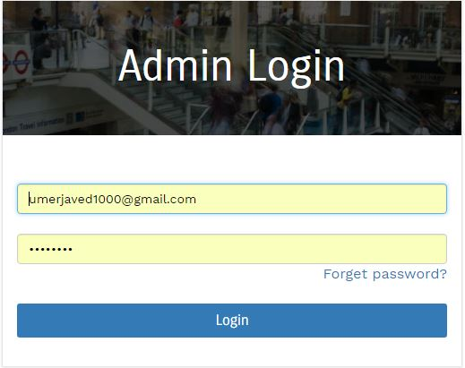

Once admin has logged in, he will see a list of administrative items on the left side of the screen. You can use these to move around the admin section.

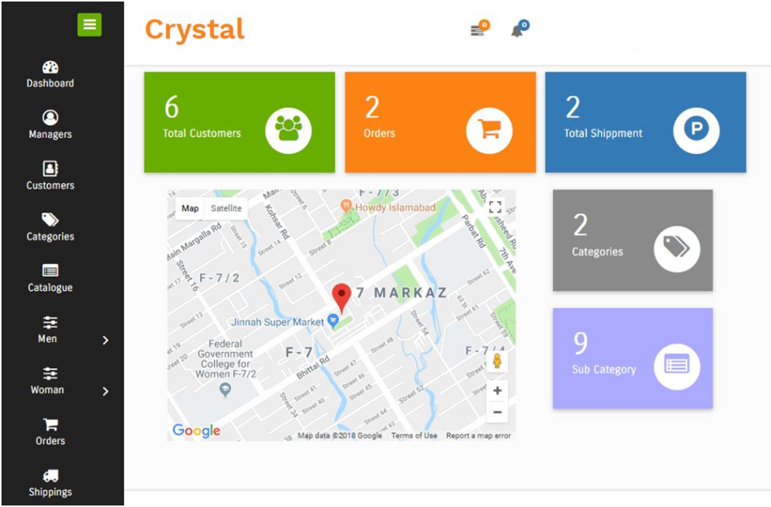

In admin section you can manage,

* Managers
* Customers
* Categories
* Catalogues
* Products
* Orders
* Shipments
* Reports

### 6.2.3 Managers

In this section, you can add new managers (adman’s) who can access and use this admin side of the website.

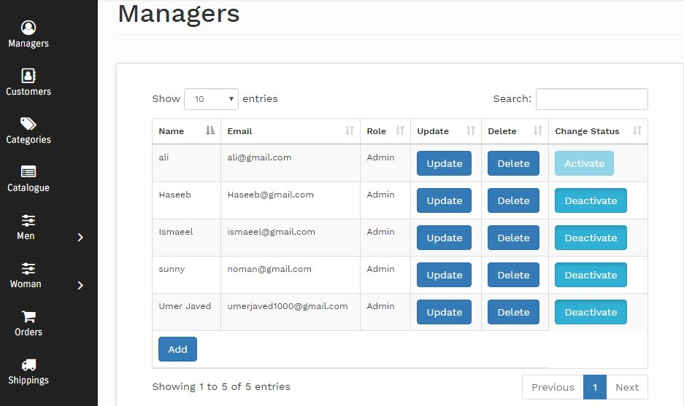

### 6.2.4 Customers

In Customer section, you can view registered customers. You can also activate and deactivate them as per need by clicking activate and deactivate buttons.

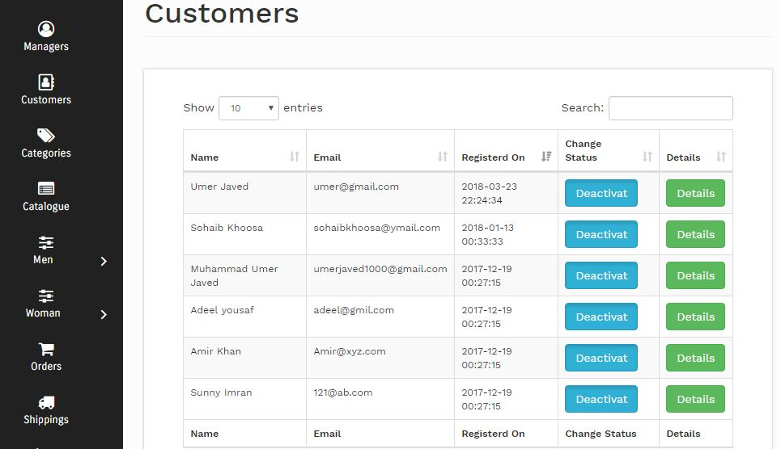

### 6.2.5 Categories

This section provides you to handle the menu items shown in the header of the website (client side).

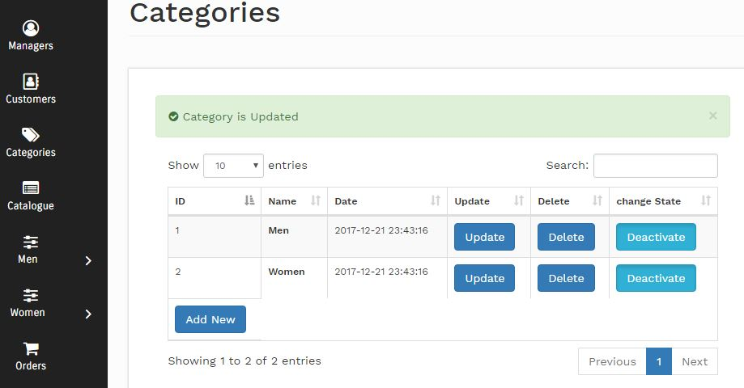

### 6.2.6 Products

This section enables you to view, add, update, activate or deactivate products. This section is very important section in the admin panel. Here is a snapshot of Men category with catalogue of footwear.

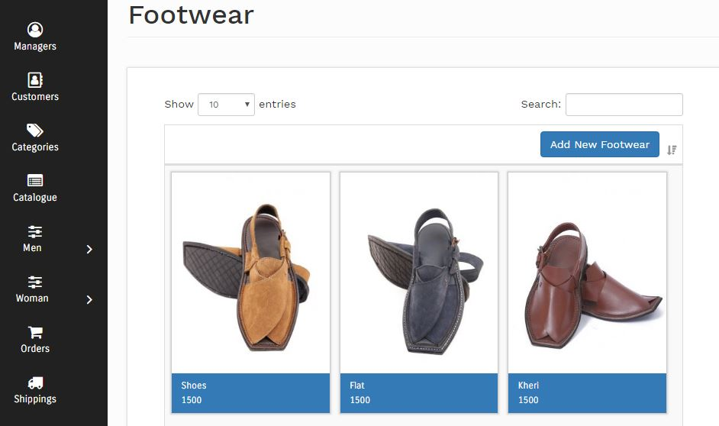

### 6.2.7 Orders

This section allows you to view and manage orders and their details.

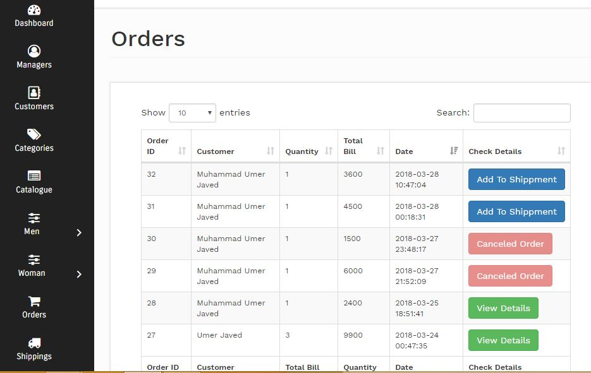

### 6.2.8 Shipments

This section of admin panel provides you to visit shipped orders and their details.

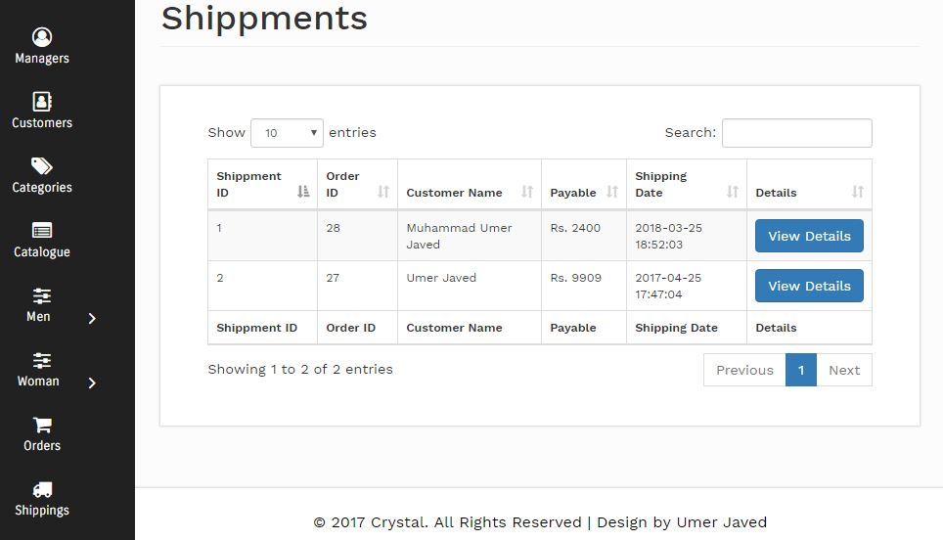

## Front End

Front end of CO is very simple and user friendly. Customer can give order of any product very simply. He can also view track record of his/her orders. He can also cancel his order before its shipment. Once an order is shipped, it cannot be canceled.

Here some snapshots are available of customer end.

### 6.3.1 Home Page

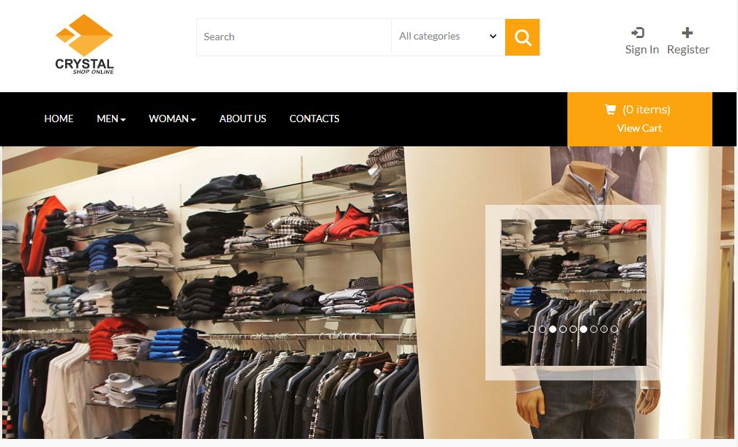

### 6.3.2 Customer Signup

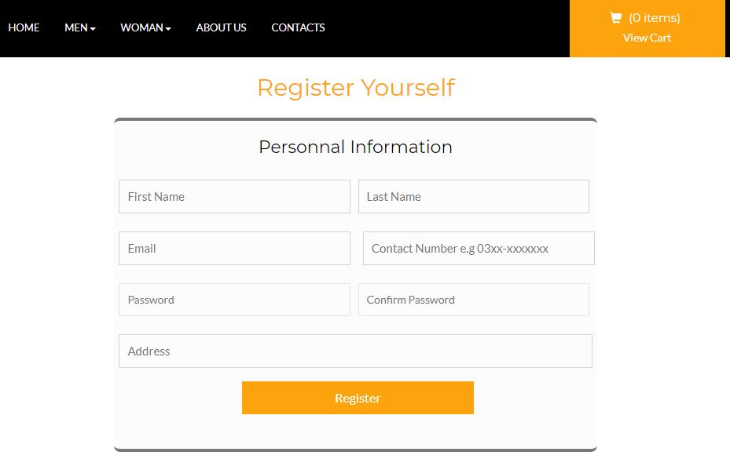

### 6.3.3 Customer Login

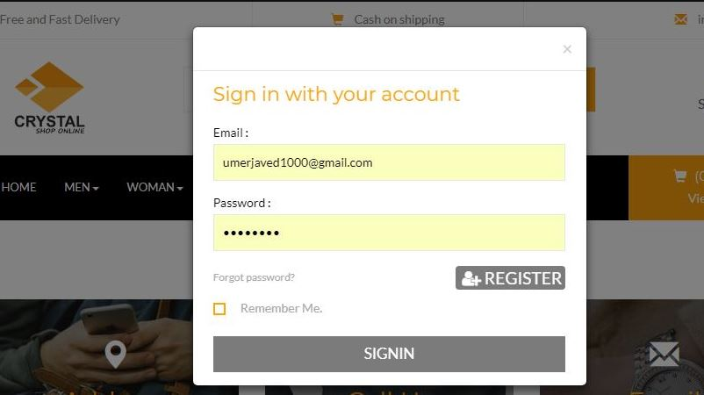

### 6.3.4 Customer Profile &Orders

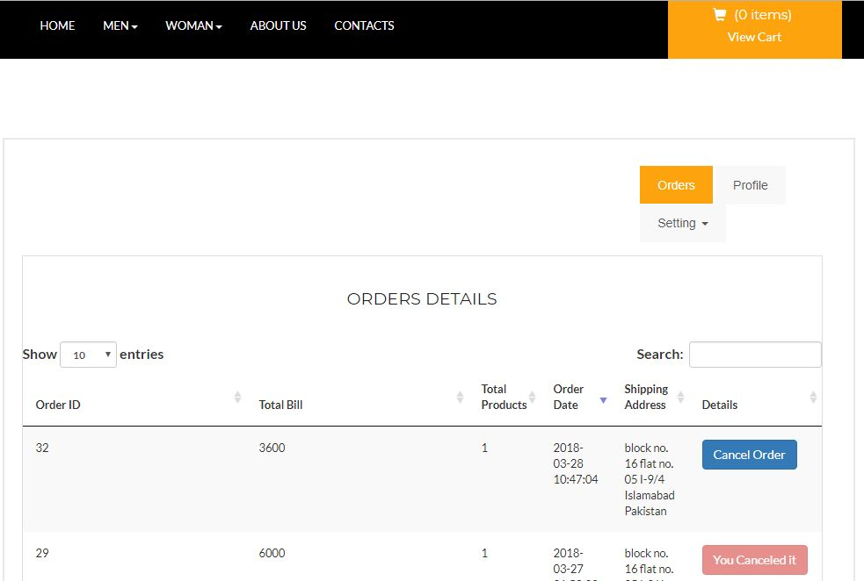

### 6.3.5 Cart

