1. What are the “VENTS” in EC as well as Application. If A8 and A9 are called as Vents, then A8 and A9 have sub-values in them, are they all represent the “VENTS”?

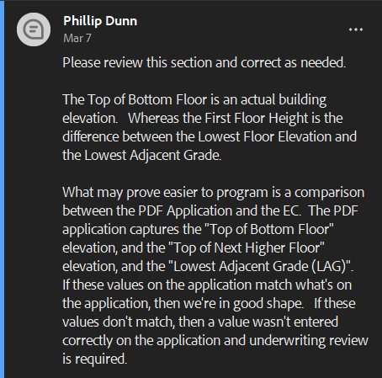

1. We want to know the exact variable names for those in EC. For example, “Top of bottom floor” from EC should be compared to which variable in Application.json. Similarly, all other variables that you want to be compared.
2. 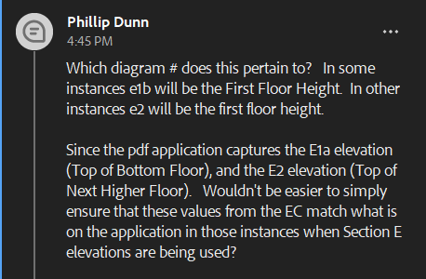Again here. We want to know the exact variables that are relevant to ‘Top of bottom floor’, ‘Top of next higher floor’ variables.