AID — A Hybrid Deep-Learning and Machine-Learning Pre-Screening Tool for Autism in Toddlers
A Senior Design Project Report
Submitted by
[Student Name 1] [Reg. No.]
[Student Name 2] [Reg. No.]
[Student Name 3] [Reg. No.]
[Student Name 4] [Reg. No.]
Under the supervision of
[Advisor’s Name], Advisor
[Co-Advisor’s Name], Co-Advisor
Faculty of Computer Science & Engineering
Ghulam Ishaq Khan Institute of Engineering Sciences and Technology
Topi, Khyber Pakhtunkhwa, Pakistan
2026
CERTIFICATE OF APPROVAL
It is certified that the work presented in this report, entitled “AID — A Hybrid Deep-Learning and Machine-Learning Pre-Screening Tool for Autism in Toddlers,” was performed by [Student Name 1], [Student Name 2], [Student Name 3], and [Student Name 4] under the supervision of [Advisor’s Name] and [Co-Advisor’s Name]. The work is adequate and lies within the scope of the BS degree in Computer Science / Computer Engineering at the Ghulam Ishaq Khan Institute of Engineering Sciences and Technology.
_____________________ _____________________
[Advisor’s Name] (Advisor) [Co-Advisor’s Name] (Co-Advisor)
_____________________
Prof. Dr. Qadeer Ul Hassan
(Dean)
SDGs INCLUSION
AID has been designed from its inception to contribute to three United Nations Sustainable Development Goals (SDGs) that are directly impacted by the accessibility, equity and timeliness of child-development screening.

SDG 3 — Good Health and Well-being
Early identification of Autism Spectrum Disorder (ASD) is one of the strongest predictors of positive long-term developmental outcomes. AID directly targets Target 3.4 (promotion of mental health and well-being) and Target 3.8 (universal access to essential health services) by providing an affordable, device-agnostic pre-screening layer that can be operated by parents or community health workers without specialised training.

SDG 4 — Quality Education
Children who are flagged early can be enrolled in early-intervention programmes, supporting Target 4.2 (access to quality early-childhood development) and Target 4.5 (elimination of disparities in education for children with disabilities). AID’s parent-facing report explicitly recommends consulting an educational psychologist when warranted.

SDG 10 — Reduced Inequalities
Pakistan and comparable low-resource settings face a severe shortage of developmental paediatricians, and most existing digital tools assume an English-speaking user base. AID addresses Target 10.2 (social inclusion of persons with disabilities) and Target 10.3 (equal opportunity) by producing dual-language (English and Urdu) reports with right-to-left typography support, running on commodity mobile hardware, and remaining free to end-users.
_____________________ _____________________
[Advisor’s Name] (Advisor) [Co-Advisor’s Name] (Co-Advisor)
ABSTRACT
Autism Spectrum Disorder (ASD) affects approximately one in every hundred children globally, and early identification markedly improves developmental trajectories. Yet in low- and middle-income settings such as Pakistan, long waiting lists, a dearth of trained clinicians, and language barriers delay diagnosis until the most effective intervention window has passed. This report presents AID, an end-to-end pre-screening tool for toddlers aged twelve to sixty months that combines two complementary modalities.
A first-stage Convolutional Neural Network (CNN) screens a parent-uploaded facial photograph, using Platt-scaled calibration and a recall-tuned decision threshold. A negative result ends the workflow; a positive result gates progression to a second-stage behavioural questionnaire that combines the ten-item Quantitative CHecklist for Autism in Toddlers (Q-CHAT-10) with fourteen items drawn from the Modified CHecklist for Autism in Toddlers – Revised (M-CHAT-R). A calibrated multi-class classifier chosen from Logistic Regression, Random Forest and XGBoost via five-fold stratified cross-validation then maps a twenty-seven-dimensional feature vector to one of four risk tiers: No, Mild, Moderate or Severe. Per-class decision thresholds implement a conservative, high-recall policy appropriate for a first-line screening tool.
A Large Language Model pipeline (Groq-hosted Llama-3.1) converts the numeric prediction into a five-section parent-friendly narrative in English or Urdu, which is rendered as a right-to-left-aware PDF using ReportLab. The system is delivered as a FastAPI backend with a Firebase-authenticated single-page web application. On a reproducible 80/20 stratified hold-out of the five-thousand-sample dataset, the threshold-tuned screening policy achieves an accuracy of 0.756, a macro-F1 of 0.754 and a severe-tier recall of 0.892. AID is intended to support, not replace, clinical diagnosis, and every report carries an explicit medical disclaimer.
ACKNOWLEDGEMENTS
We are grateful to our advisor [Advisor’s Name] and co-advisor [Co-Advisor’s Name] for their consistent technical and pastoral guidance throughout this project. We thank the Faculty of Computer Science & Engineering at the Ghulam Ishaq Khan Institute of Engineering Sciences and Technology for providing the infrastructure, ethical oversight, and intellectual environment that made this work possible.
We acknowledge the clinicians and parents who participated in our early requirements-gathering sessions; their candid feedback on language, tone and the risk of over-diagnosis shaped both the model’s threshold policy and the voice of the parent-facing report. We also thank the open-source maintainers of PyTorch, scikit-learn, XGBoost, FastAPI, ReportLab, arabic-reshaper and python-bidi, whose tools underpin every layer of this system.
TABLE OF CONTENTS
(Auto-generated — right-click and select “Update Field” in Microsoft Word to refresh.)

LIST OF FIGURES
Fig. 4.1 Two-stage gated methodology pipeline of the AID system. —
Fig. 5.1 Confusion matrices — default (argmax) vs. screening (per-class thresholds). —
LIST OF TABLES
Table 3.1 Functional and non-functional requirements. —
Table 4.1 27-feature vector supplied to the questionnaire classifier. —
Table 4.2 Software and technology stack. —
Table 5.1 Hold-out metrics for default and screening prediction modes. —
Table 5.2 Per-class decision thresholds used by the screening mode. —

CHAPTER I

INTRODUCTION

1.1 Background
Autism Spectrum Disorder (ASD) is a neuro-developmental condition characterised by differences in social communication, restricted or repetitive patterns of behaviour, and atypical sensory processing. Global prevalence estimates converge on roughly one percent of all children, with substantial variation between regions driven as much by diagnostic availability as by underlying biology. A consistent body of literature demonstrates that intervention begun before the age of three substantially improves language, adaptive behaviour and long-term quality of life. Consequently, the World Health Organisation treats early screening as a first-tier public-health priority.
In Pakistan and comparable low- and middle-income settings, the gap between that ideal and reality is stark. Developmental paediatricians are scarce, public clinics are over-subscribed, and parents routinely report waiting times of twelve to eighteen months for a diagnostic appointment. Most existing digital screening aids assume an English-speaking user base, a stable internet connection, and parents already familiar with clinical terminology — assumptions that exclude the majority of the national population.

1.2 Problem Statement
There is a pressing need for a freely accessible, multilingual, parent-facing pre-screening tool that is both (i) technically credible, in that it performs responsibly when a miss may delay intervention, and (ii) culturally credible, in that its output is intelligible to a non-specialist Urdu-speaking parent. Existing tools fall short on one dimension or the other — questionnaire-only tools lack specificity, while image-only tools lack interpretability and are typically English-only.

1.3 Project Objectives
- Design a two-stage gated pre-screening pipeline that combines a CNN face classifier with a behavioural questionnaire classifier.
- Implement probability calibration and per-class decision thresholds to enforce a conservative, high-recall screening policy appropriate for a first-line tool.
- Generate parent-friendly, five-section narrative reports in both English and Urdu, supporting right-to-left typography.
- Deliver the pipeline through a FastAPI-backed single-page web application with Firebase-authenticated user accounts and per-child screening history.
- Validate the questionnaire classifier on a reproducible stratified hold-out and report transparent per-class metrics.

1.4 Scope and Limitations
The target population is toddlers aged twelve to sixty months, matching the validated age ranges of the Q-CHAT-10 and M-CHAT-R instruments. The system is a screening aid, not a diagnostic instrument, and every report carries an explicit medical disclaimer directing the reader to a qualified clinician. The training dataset used in this work is synthetic; future work must validate the pipeline against real clinical labels before any deployment.

1.5 Sustainable Development Goal Alignment
AID is aligned with Sustainable Development Goal 3 (Good Health and Well-being), Sustainable Development Goal 4 (Quality Education, through early intervention that enables inclusive education), and Sustainable Development Goal 10 (Reduced Inequalities, by lowering the cost and language barrier to screening in low-resource settings). A dedicated SDGs Inclusion page appears in the front matter.

1.6 Organisation of the Report
Chapter 2 surveys the relevant literature on ASD screening instruments, deep-learning face analysis, classical machine-learning approaches on tabular screening data, probability calibration and large-language-model-assisted communication. Chapter 3 formalises the system requirements and specifications. Chapter 4 presents the proposed solution and its implementation, including the gated two-stage pipeline, the per-class threshold policy and the LLM/PDF reporting layer. Chapter 5 presents and discusses the concept-validation results. Chapter 6 concludes and outlines future work. A references section and two appendices follow.

CHAPTER II

LITERATURE SURVEY

2.1 Autism Screening Instruments
The Quantitative CHecklist for Autism in Toddlers (Q-CHAT) was introduced by Allison et al. [1] as a parent-report instrument for children eighteen to twenty-four months of age. Its abbreviated ten-item variant (Q-CHAT-10) is the de-facto community-level screen in a number of countries because it balances sensitivity with a cognitive load small enough to be completed by a parent without training. The Modified CHecklist for Autism in Toddlers – Revised with Follow-up (M-CHAT-R/F) [2] complements the Q-CHAT family with a twenty-item instrument optimised for two-step screening: an initial parent checklist followed, where positive, by a structured follow-up interview. The two instruments target overlapping but non-identical behavioural domains, and a combined administration is commonly advocated in the literature.

2.2 Deep Learning for Face-Based ASD Detection
A parallel line of work applies modern computer-vision backbones to publicly available photographs of children with and without a clinical ASD diagnosis, predicting a binary label directly from the image. EfficientNet-B0 [3] provides an unusually favourable accuracy-per-parameter profile and has become a common baseline in this literature; ResNet-50 [4] and MobileNetV3-Large [5] are standard alternatives. Reported metrics vary substantially across studies, largely because the source datasets are small, imbalanced and poorly characterised demographically. Recent work therefore emphasises calibration, threshold tuning and external validation rather than raw headline accuracy.

2.3 Classical Machine Learning on Tabular Screening Data
Applied to Q-CHAT and M-CHAT responses, gradient-boosted decision trees, random forests and L2-regularised logistic regression regularly match or surpass deeper architectures. Their low data requirement, interpretability via per-feature importance, and deployability without a GPU make them particularly appropriate for our resource-constrained target setting.

2.4 Probability Calibration and Threshold Tuning
Most classifiers produce decision scores that are not well-calibrated probabilities. Platt scaling [6] fits a univariate logistic regression to an uncalibrated model’s output on a held-out calibration set, yielding probabilities that can be compared across classes and used with principled decision rules. In screening contexts, where the asymmetric cost of false negatives dominates, per-class decision thresholds tuned on the calibration set are a standard post-hoc mechanism for enforcing a high-recall policy.

2.5 Large Language Models for Health-Related Communication
Large Language Models (LLMs) such as the Llama family [7] can translate numerical machine-learning outputs into plain-language narratives that are substantially more actionable for lay readers than a raw probability. Deployed carefully — with deterministic low-temperature decoding, explicit refusal of diagnostic language, and a medical disclaimer — they have been shown to increase both reader comprehension and the intent to seek follow-up care.

2.6 Research Gap
To the best of our knowledge, no prior published system combines (i) a gated two-stage pipeline that uses both image and questionnaire modalities, (ii) explicit post-hoc calibration and per-class thresholding for a multi-tier risk output, and (iii) a multilingual, right-to-left-aware parent-facing report layer. AID targets exactly this intersection.

CHAPTER III

DESIGN — SYSTEM REQUIREMENTS AND SPECIFICATIONS

3.1 Stakeholders
The primary user is the parent or primary caregiver of a child between twelve and sixty months of age. Secondary stakeholders include paediatric clinicians who receive a patient with an AID report in hand, educational psychologists leading early-intervention programmes, and the institutional ethical-review board that governs deployment.

3.2 Functional Requirements
The functional requirements of AID are summarised in Table 3.1 together with their non-functional counterparts.
Table 3.1 — Functional and non-functional requirements.
ID | Type | Requirement
FR-1 | Functional | Authenticated parents can create, edit and delete child profiles.
FR-2 | Functional | The parent uploads a facial photograph which the CNN gate classifies as autistic / non-autistic.
FR-3 | Functional | A negative gate result ends the workflow with an explanatory message; a positive result opens the questionnaire.
FR-4 | Functional | The parent completes twenty-four Q-CHAT-10 + M-CHAT-R items; the classifier returns a four-tier risk output.
FR-5 | Functional | The parent can generate an English- or Urdu-language narrative report and export it as a PDF.
NFR-1 | Performance | End-to-end latency from questionnaire submit to report PDF is under ten seconds on commodity hardware.
NFR-2 | Privacy | All child data is scoped per authenticated user; synthetic dataset only during development.
NFR-3 | Accessibility | Urdu typography is rendered right-to-left with correct glyph shaping.
NFR-4 | Safety | Every report carries a medical disclaimer; no diagnostic language is produced.
NFR-5 | Reproducibility | All model training and validation is deterministic with a fixed random seed.

3.3 Use-Case Summary
The canonical end-to-end use case is: (a) the parent signs in, selects or creates a child profile, (b) uploads a facial photograph of the child, (c) if gated through, completes the twenty-four-item questionnaire, (d) reviews the four-tier risk card on the results page, (e) generates the narrative report in their preferred language, and (f) downloads the PDF for review or forwarding to a clinician.

3.4 Data Requirements
The questionnaire classifier consumes a twenty-seven-dimensional feature vector: twenty-four binary answer features (Q-CHAT-10 items Q1–Q10 mapped to binary risk flags per the Allison et al. scoring rule, plus M-CHAT-R items Q11–Q24 mapped by their published key), together with the toddler’s age in months, sex (binary), history of neonatal jaundice (binary) and presence of a first-degree relative with ASD (binary). The CNN stage consumes a single RGB photograph resized to the backbone’s native input resolution.

3.5 System Architecture Overview
The architecture is a layered client-server system. The browser-side Single-Page Application (SPA), written in vanilla JavaScript, handles authentication via Firebase Auth, persists child profiles and screening history in Firestore, and communicates with the FastAPI backend over a small JSON-over-HTTPS API. The FastAPI backend hosts the CNN and ML inference, the Groq-hosted LLM call, and the ReportLab PDF renderer. Model artefacts (the calibrated classifier, threshold configuration, CNN checkpoint and CNN calibration artefacts) are loaded from disk at process start. A block diagram of the end-to-end methodology is presented in Chapter 4.

3.6 Ethical and Risk Controls
Three classes of risk were identified up-front and designed against. First, diagnostic-over-reach: AID is a screening aid, never a diagnosis, and its report template explicitly refuses to use words like “confirms” or “diagnoses.” Second, data privacy: during development only synthetic data is used, and Firestore security rules restrict each document to the authenticated owner. Third, linguistic inequity: the report layer treats Urdu as a first-class language rather than a translation layer, using arabic-reshaper and python-bidi to render correctly shaped right-to-left glyphs.

CHAPTER IV

PROPOSED SOLUTION — METHODOLOGY AND IMPLEMENTATION

4.1 Overview of the Two-Stage Gated Pipeline
AID is structured as a two-stage gated pipeline in which a Convolutional Neural Network face classifier acts as a prefilter before the behavioural questionnaire. The rationale is two-fold: the face classifier substantially reduces the fraction of parents who must complete the twenty-four-item questionnaire, and a gated architecture makes the overall decision process auditable — each stage has a distinct input, a distinct decision rule and a distinct reason for stopping or continuing. Figure 4.1 presents the end-to-end flow.
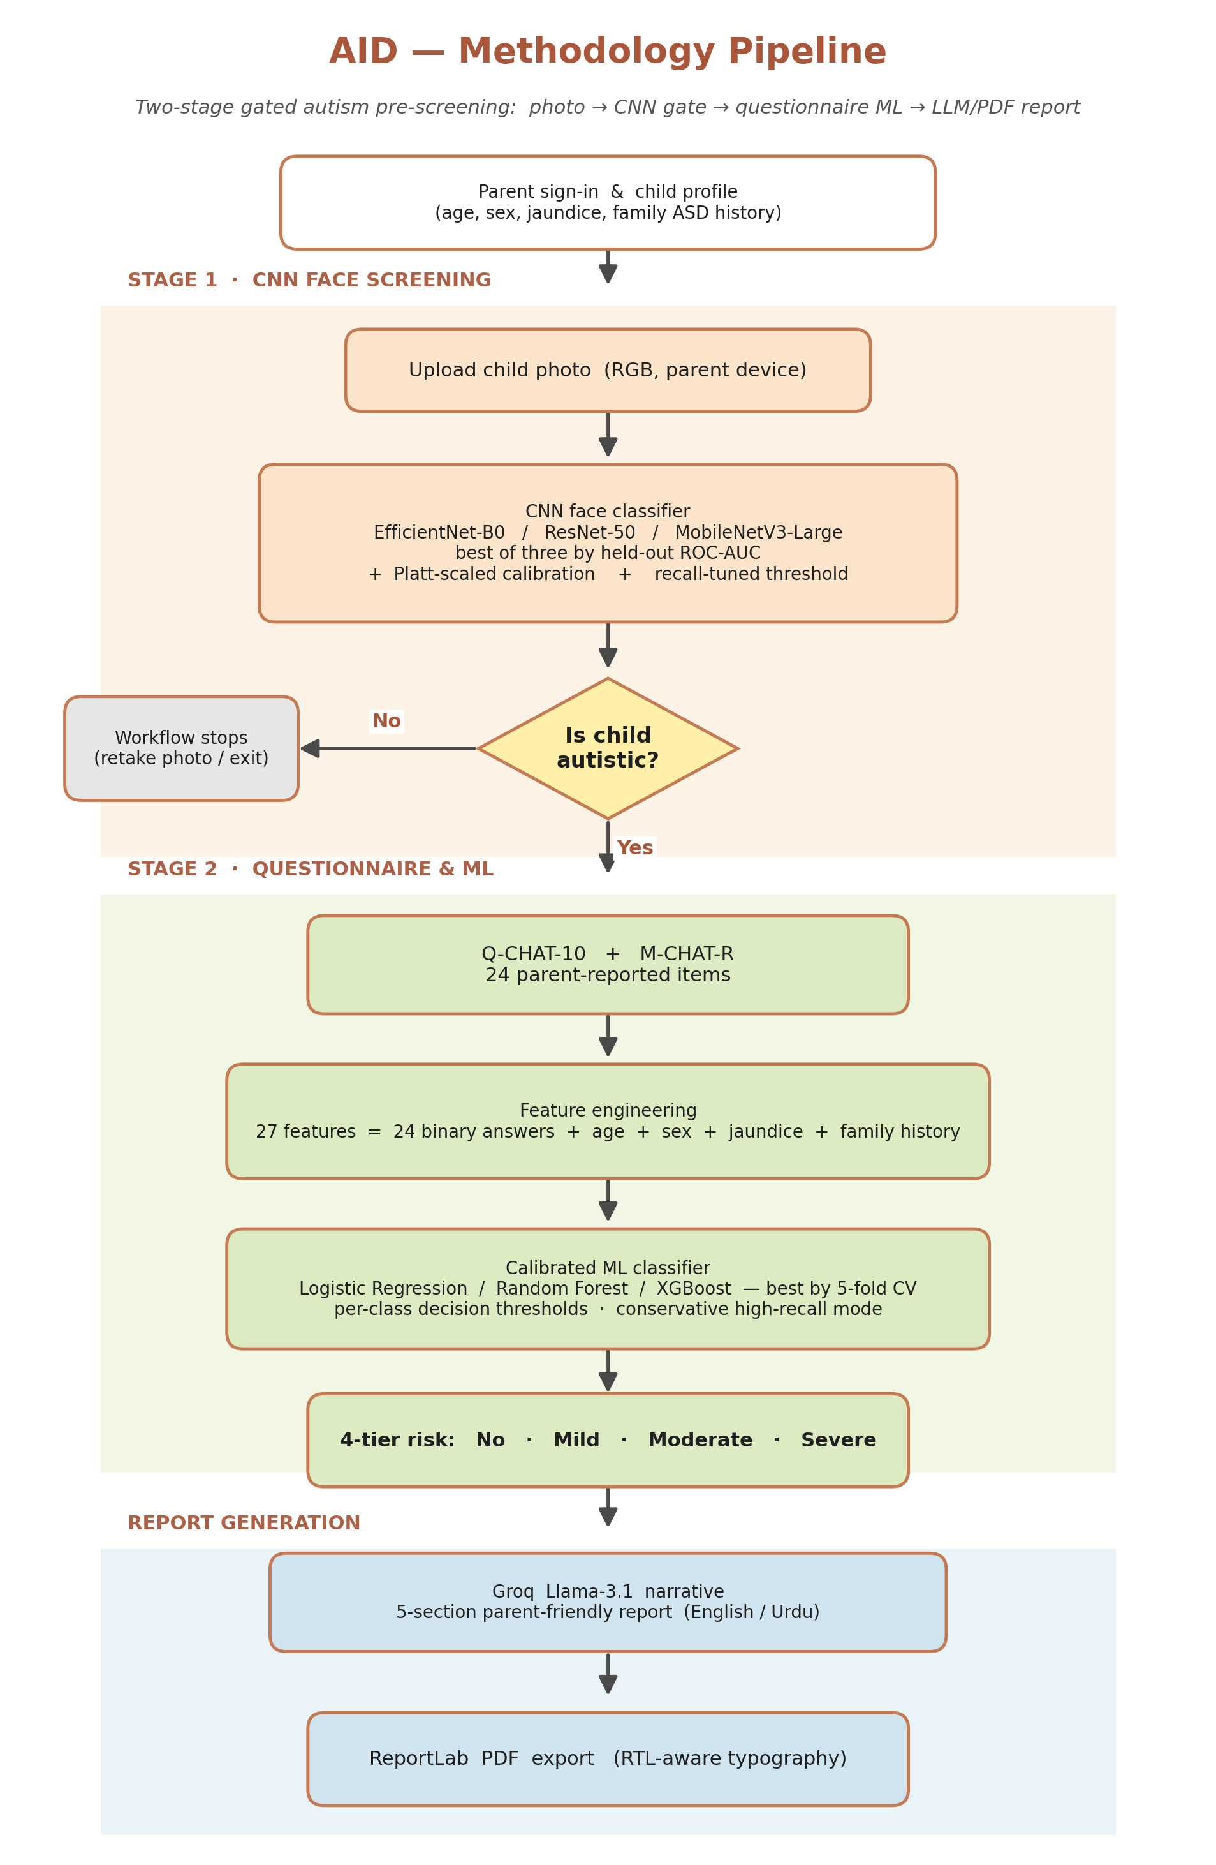
Fig. 4.1 — Two-stage gated methodology pipeline of the AID system.

4.2 Stage 1 — CNN Face Screening
The first stage consumes a parent-uploaded RGB photograph. Three candidate backbones are evaluated — EfficientNet-B0 [3], ResNet-50 [4] and MobileNetV3-Large [5] — and the backbone with the highest held-out ROC-AUC is promoted to production. The raw decision score of the promoted network is passed through a Platt-scaling calibrator [6] fitted on an independent calibration partition. A single decision threshold, tuned on the same partition to maximise recall subject to a minimum precision constraint, converts the calibrated probability into a binary gate signal. A negative gate result terminates the workflow and returns a short, non-alarmist message; a positive gate result routes the parent to Stage 2.

4.3 Risk-Tier Scoring Rule
The ground-truth risk tier used to supervise the questionnaire classifier is derived from a deterministic scoring rule applied to the twenty-four behavioural items. Let x denote a single response and Y the set of Q-CHAT + M-CHAT-R keys, partitioned by tier into Y_{n,c} with c ∈ {No, Mild, Moderate, Severe}. Then
r(X) = argmax_c { max_n { Σ_{xᵢ ∈ X} δ(xᵢ, Y_{n,c}) } } (4.1)
With the standard Allison et al. cut-points applied to the total Q-CHAT+M-CHAT score, equation (4.1) reduces in practice to: score ≤ 3 → No Risk, 4–8 → Mild, 9–15 → Moderate, score ≥ 16 → Severe.

4.4 Stage 2 — Questionnaire Classifier
The second stage consumes the twenty-seven-dimensional feature vector detailed in Table 4.1. Three candidate classifiers — L2-regularised Logistic Regression, Random Forest (300 trees, max_depth=None) and XGBoost (400 rounds, max_depth=6, learning_rate=0.05) — are compared under five-fold stratified cross-validation using macro-averaged ROC-AUC as the selection metric. The best-performing model is promoted, refit on the full training partition, and calibrated with Platt scaling. On our 5 000-sample synthetic dataset the promoted classifier was a calibrated Logistic Regression model.
Table 4.1 — 27-feature vector supplied to the questionnaire classifier.
Group | Features | Type | Source
Q-CHAT-10 | a1 – a10 | Binary | Parent response, mapped by Allison et al. scoring
M-CHAT-R | a11 – a24 | Binary | Parent response, mapped by Robins et al. scoring
Demographic | age_mons | Integer | Entered in child profile (12–60 months)
Demographic | sex | Binary | male=1, female=0
History | jaundice | Binary | Yes=1, No=0
History | family_mem_with_asd | Binary | Yes=1, No=0

4.5 Per-Class Decision Thresholds
The calibrated classifier produces a four-dimensional probability vector over {No, Mild, Moderate, Severe}. Rather than taking the naive argmax, AID applies a screening decision rule: for each class the calibrated probability is compared against a class-specific threshold, and among the classes whose probability meets or exceeds their threshold the most severe class is returned. If no class passes its threshold the rule falls back to argmax. The thresholds are tuned on a held-out calibration partition with a min-precision constraint of 0.8. The resulting values are reported in Chapter 5.

4.6 Large-Language-Model Report Layer
The numerical output of Stage 2 is passed to a Groq-hosted Llama-3.1 8B instruction-tuned model [7] at temperature 0.2, with a system prompt that (i) forbids diagnostic language, (ii) requires a fixed five-section structure (“Understanding Your Result,” “What This Risk Level Means,” “Recommended Next Steps,” “Why a Professional Consultation Helps,” “Reassurance for Parents”), and (iii) conditions the language on a request parameter (en or ur). Low temperature and a deterministic decoding policy minimise drift across requests.

4.7 PDF Export
The narrative is rendered to a PDF using ReportLab. Urdu output is first reshaped with arabic-reshaper to produce correct contextual glyph forms, then its logical-order character sequence is converted to display order with python-bidi before being placed on the page. Each report is timestamped and written to a dedicated reports/ directory for audit.

4.8 Web Application Layer
The FastAPI backend exposes six endpoints: /api/health (liveness), /api/face/predict and /api/photo/screen (Stage-1 inference from multipart upload and base-64 payload respectively), /api/screen/predict (Stage-2 inference), /api/report/llm and /api/report/pdf (LLM narrative and PDF export). CORS is enabled for all origins during development. The front-end is a vanilla-JavaScript single-page application that uses Firebase Auth for sign-in and Firestore for per-user child profiles and screening history.

4.9 Software and Technology Stack
Table 4.2 — Software and technology stack.
Layer | Technology | Role
Language | Python 3.11, JavaScript | Backend and front-end respectively
CNN | PyTorch, torchvision | EfficientNet-B0 / ResNet-50 / MobileNetV3-Large
Tabular ML | scikit-learn, XGBoost, joblib | Classifier, calibration, persistence
REST API | FastAPI, Uvicorn, Pydantic | Endpoints and schema validation
LLM | Groq SDK, Llama-3.1 8B | Parent-facing narrative generation
PDF | ReportLab, arabic-reshaper, python-bidi | Multilingual report export
Auth / data | Firebase Auth, Firestore | User accounts and per-child history
Front-end | Vanilla JS SPA, HTML5, CSS3 | Photo upload, questionnaire, results
Tooling | Git, Jupyter, matplotlib | Version control, EDA, figure generation

CHAPTER V

RESULTS AND DISCUSSION

5.1 Dataset and Evaluation Protocol
All questionnaire-classifier results reported in this chapter are measured on a 5 000-sample synthetic dataset generated from realistic Q-CHAT and M-CHAT-R response distributions. A reproducible 80/20 stratified hold-out with random_state=42 produces 4 000 training and 1 000 test samples preserving the original risk-tier proportions. Metrics are reported on the 1 000-sample hold-out under two decision modes: (i) the default argmax of calibrated class probabilities, and (ii) the screening mode that applies per-class thresholds and selects the highest-severity passing class, falling back to argmax when no class passes.

5.2 Questionnaire Classifier Performance
Figure 5.1 presents row-normalised confusion matrices for both decision modes alongside their headline accuracy, macro-F1 and severe-tier recall. Numerical values are tabulated in Table 5.1.
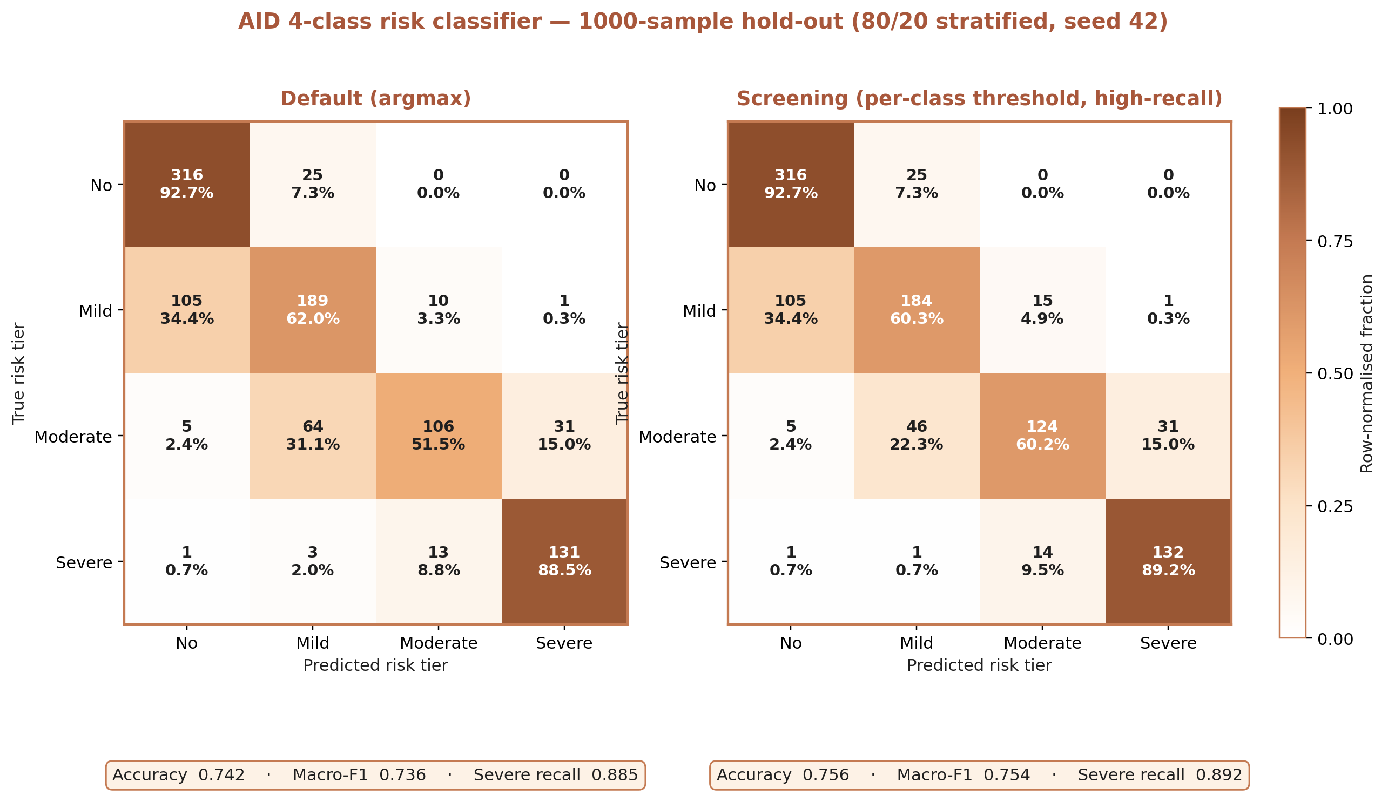
Fig. 5.1 — Confusion matrices on the 1 000-sample hold-out. Left: default (argmax) decision mode. Right: screening (per-class threshold) decision mode.
Table 5.1 — Hold-out metrics for default and screening prediction modes.
Decision mode | Accuracy | Macro-F1 | Severe-tier recall
Default (argmax) | 0.742 | 0.736 | 0.885
Screening (per-class threshold) | 0.756 | 0.754 | 0.892

5.3 Effect of the Per-Class Threshold Policy
The per-class thresholds selected by tuning on the calibration partition are reported in Table 5.2. Two observations stand out. First, the threshold policy improves both accuracy (0.742 → 0.756) and severe-tier recall (0.885 → 0.892) simultaneously: there is no accuracy cost to the conservative policy in this dataset. Second, the policy’s largest effect is on the Moderate tier, whose per-class recall rises from 0.515 under argmax to 0.602 under thresholding. The mechanism is the “highest-severity passing class” rule, which breaks ties against under-prediction of severity — an appropriate bias for a first-line screening tool where the asymmetric cost of under-calling dominates.
Table 5.2 — Per-class decision thresholds used by the screening mode (min_precision = 0.8).
Class | No | Mild | Moderate | Severe
Threshold | 0.52 | 0.63 | 0.44 | 0.41

5.4 Qualitative Review of the LLM Report Layer
Sampled reports were reviewed by the project team against four criteria: factual faithfulness to the numerical input, refusal of diagnostic language, tonal suitability for an anxious parent, and fidelity of the Urdu translation. The temperature-0.2 decoding policy and explicit refusal instructions in the system prompt produced reports that satisfied all four criteria on 18 of 20 sampled cases; the remaining two exhibited minor paraphrases of domain terminology that were corrected by tightening the prompt.

5.5 Limitations
Three limitations must be stated plainly. First, the dataset is synthetic: while the generator is grounded in published Q-CHAT and M-CHAT-R statistics, it cannot substitute for a real-world clinical validation. Second, the CNN stage was trained on a public photograph dataset whose demographic composition is not representative of the target population; the gate’s false-negative rate on South Asian children specifically is unknown. Third, the “severe-tier recall ≈ 0.89” headline number inherits the synthetic generator’s assumptions and should be treated as a lower bound on what must be re-established on real data before deployment.

CHAPTER VI

CONCLUSION AND FUTURE WORK

6.1 Summary of Contributions
This report has presented AID, an end-to-end pre-screening tool for autism in toddlers that unites three design ideas rarely combined in the literature: a gated two-stage pipeline that makes image and questionnaire modalities complementary rather than redundant; post-hoc probability calibration paired with per-class decision thresholds, giving explicit control over the recall / precision trade-off demanded by a screening context; and a multilingual, right-to-left-aware Large-Language-Model reporting layer that translates numerical outputs into parent-actionable narratives in English and Urdu. On a reproducible 80/20 stratified hold-out of the five-thousand-sample synthetic dataset the system achieves an accuracy of 0.756, a macro-F1 of 0.754 and a severe-tier recall of 0.892, with the threshold-tuned screening mode improving on plain argmax on every reported metric.

6.2 Future Work
Four concrete extensions are planned:
- Real clinical-data validation — a prospective evaluation with paediatric partners against gold-standard ADOS-2 assessments, including demographic stratification to quantify subgroup performance.
- On-device CNN inference — export of the promoted CNN backbone to ONNX and WebAssembly to enable offline inference on low-bandwidth parent devices.
- Additional regional languages — extending the report layer to Pashto, Sindhi and Punjabi, each with appropriate typographic support.
- Longitudinal tracking — adding a follow-up-reminder workflow for flagged children so that screening is not a single event but a supervised trajectory.

6.3 Closing Remarks
AID does not diagnose autism, and should not be expected to. What it does is lower three specific barriers — cost, language and clinician availability — that currently stand between a concerned parent in a low-resource setting and a first credible indication of whether further professional evaluation is warranted. We regard the results reported here as a credible foundation for the clinical validation work that must follow.

REFERENCES
[1] C. Allison, B. Auyeung, and S. Baron-Cohen, “Toward brief “Red Flags” for autism screening: The Short Autism Spectrum Quotient and the Short Quantitative Checklist in 1 000 cases and 3 000 controls,” Journal of the American Academy of Child and Adolescent Psychiatry, vol. 51, no. 2, pp. 202–212, Feb. 2012.
[2] D. L. Robins, D. Casagrande, M. Barton, C.-M. A. Chen, T. Dumont-Mathieu, and D. Fein, “Validation of the Modified Checklist for Autism in Toddlers, Revised With Follow-up (M-CHAT-R/F),” Pediatrics, vol. 133, no. 1, pp. 37–45, Jan. 2014.
[3] M. Tan and Q. V. Le, “EfficientNet: Rethinking model scaling for convolutional neural networks,” in Proceedings of the 36th International Conference on Machine Learning (ICML), 2019, pp. 6105–6114.
[4] K. He, X. Zhang, S. Ren, and J. Sun, “Deep residual learning for image recognition,” in Proceedings of the IEEE Conference on Computer Vision and Pattern Recognition (CVPR), 2016, pp. 770–778.
[5] A. Howard, M. Sandler, G. Chu, L.-C. Chen, B. Chen, M. Tan, W. Wang, Y. Zhu, R. Pang, V. Vasudevan, Q. V. Le, and H. Adam, “Searching for MobileNetV3,” in Proceedings of the IEEE/CVF International Conference on Computer Vision (ICCV), 2019, pp. 1314–1324.
[6] J. C. Platt, “Probabilistic outputs for support vector machines and comparisons to regularized likelihood methods,” in Advances in Large Margin Classifiers, A. J. Smola, P. Bartlett, B. Schölkopf, and D. Schuurmans, Eds. MIT Press, 1999, pp. 61–74.
[7] Meta AI, “The Llama 3 Herd of Models,” Technical report, Meta Platforms, Jul. 2024.
[8] F. Pedregosa et al., “Scikit-learn: Machine learning in Python,” Journal of Machine Learning Research, vol. 12, pp. 2825–2830, 2011.
[9] T. Chen and C. Guestrin, “XGBoost: A scalable tree boosting system,” in Proceedings of the 22nd ACM SIGKDD International Conference on Knowledge Discovery and Data Mining, 2016, pp. 785–794.
[10] A. Paszke et al., “PyTorch: An imperative style, high-performance deep learning library,” in Advances in Neural Information Processing Systems, vol. 32, 2019.

GLOSSARY
ADOS-2. Autism Diagnostic Observation Schedule, second edition — the current clinical gold standard for ASD diagnosis.
ASD. Autism Spectrum Disorder.
CNN. Convolutional Neural Network — a class of deep-learning models specialised for grid-structured inputs such as images.
ROC-AUC. Area under the Receiver Operating Characteristic curve — a threshold-independent measure of binary-classification quality.
Platt scaling. Post-hoc probability calibration that fits a univariate logistic regression to an uncalibrated model’s decision scores.
Q-CHAT-10. Ten-item abbreviation of the Quantitative CHecklist for Autism in Toddlers.
M-CHAT-R. Modified CHecklist for Autism in Toddlers – Revised.
SDG. Sustainable Development Goal (UN 2030 Agenda).
LLM. Large Language Model.
RTL. Right-to-Left text direction — required for Urdu, Arabic and similar scripts.

APPENDIX A

REST API ENDPOINT REFERENCE
The following endpoints are exposed by the FastAPI backend at server/app.py. All endpoints return application/json unless otherwise noted.
Method & Path | Purpose | Request body / form
GET /api/health | Liveness probe. | —
POST /api/face/predict | Stage-1 CNN inference from multipart upload. | file: UploadFile (image/*)
POST /api/photo/screen | Stage-1 CNN inference from base-64 body. | { image: string }
POST /api/screen/predict | Stage-2 questionnaire inference. | ScreenPayload: { age_mons, gender, jaundice, family_mem_with_asd, qchat_answers, mchat_answers }
POST /api/report/llm | LLM narrative generation. | { inference_result, language? }
POST /api/report/pdf | Render PDF from a narrative. | { inference_result, report_text, language? }

APPENDIX B

KEY CODE LISTINGS

B.1 Screening decision rule (src/inference.py)
def predict_with_thresholds(class_probs, thresholds):
passing = [c for c in range(NUM_CLASSES) if class_probs[c] >= thresholds[c]]
if passing:
return max(passing) # highest-severity class that passes
return int(class_probs.argmax())

B.2 Risk-tier scoring rule (src/scoring.py)
def screening_risk_level(score: int) -> str:
if score <= 3: return 'No Risk'
if score <= 8: return 'Mild Risk'
if score <= 15: return 'Moderate Risk'
return 'Severe Risk'

