Autism Pre-Screening Tool
Project Report
Faculty of Computer Science and Engineering
Date: April 2026

Abstract
This report presents an AI-assisted autism pre-screening system for early risk estimation in toddlers. The solution combines a photo-based face screening pipeline with Q-CHAT/M-CHAT questionnaire analysis to provide a practical, parent-facing risk assessment workflow.
A FastAPI backend orchestrates image screening, questionnaire inference, risk explanation generation using a large language model, and PDF report creation. The system is designed as a screening aid rather than a diagnostic instrument and includes parent-friendly outputs.

Chapter 1: Introduction
Autism Spectrum Disorder (ASD) screening can benefit from early, accessible, and interpretable digital tools. The project addresses this by implementing a software platform that automates pre-screening workflows while keeping the final decision with healthcare professionals.
Objectives include: (1) collect child information and responses through a simple interface, (2) estimate risk using calibrated machine-learning models, (3) produce understandable narrative guidance for caregivers, and (4) export documentation for consultation support.

Chapter 2: Literature and Background
The design draws from three practical areas: questionnaire-based autism screening, computer-vision screening pipelines, and explainable AI-assisted reporting.
Questionnaire signals are mapped to model features and combined with demographic factors. The project also applies calibration and threshold tuning to improve screening sensitivity in high-risk scenarios.

Chapter 3: System Design
Chapter 3 defines architecture, component boundaries, data flow, and deployment assumptions. The system follows a modular design in which FastAPI serves as the orchestration layer and `src` modules implement domain logic.
Primary modules include face screening (`src/face_screening.py`), questionnaire inference (`src/inference.py`), LLM report generation (`src/llm_report_groq.py`), and report export (`src/pdf_generator.py`).
Figure 1: Overall Architecture
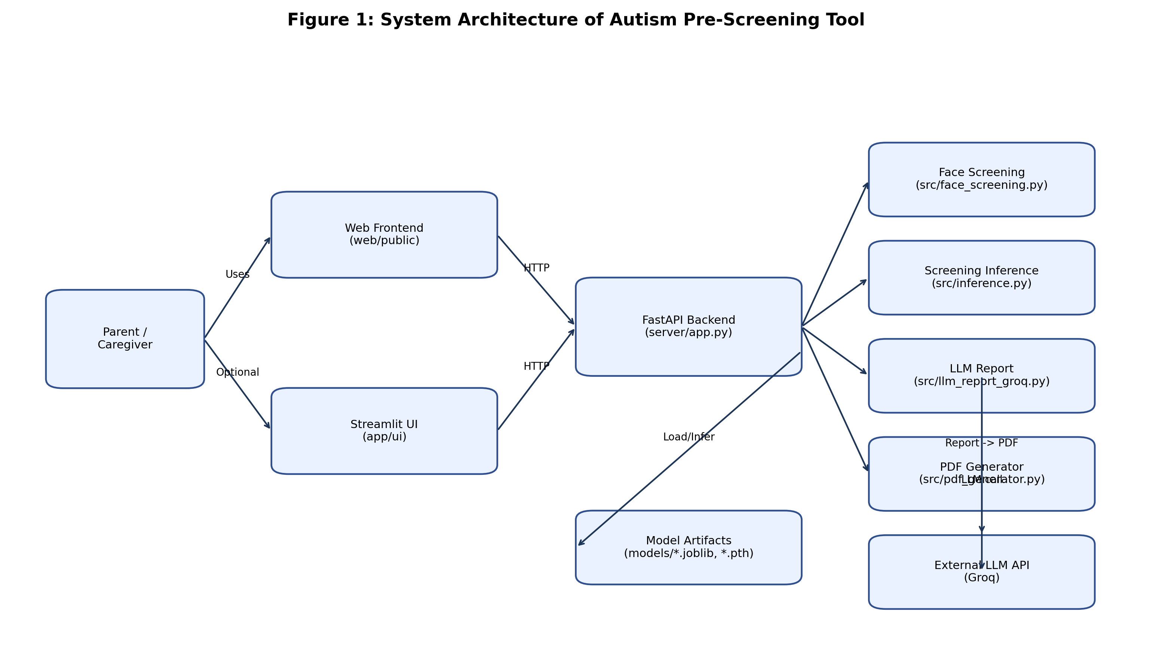

Figure 2: Use Case View
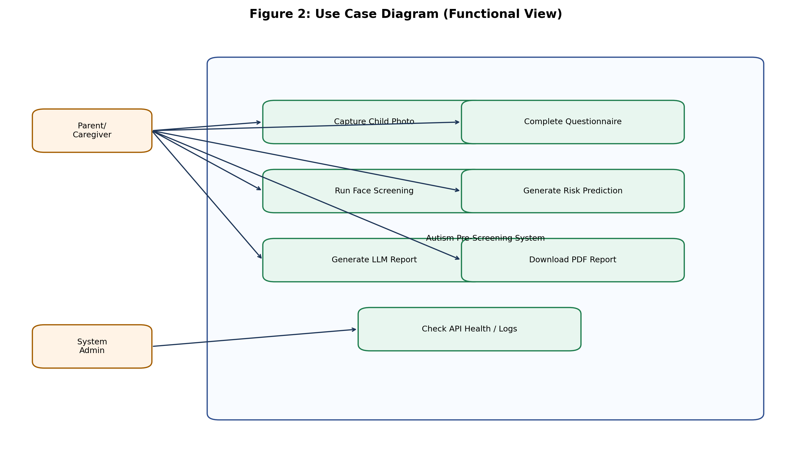

Figure 3: Sequence Diagram
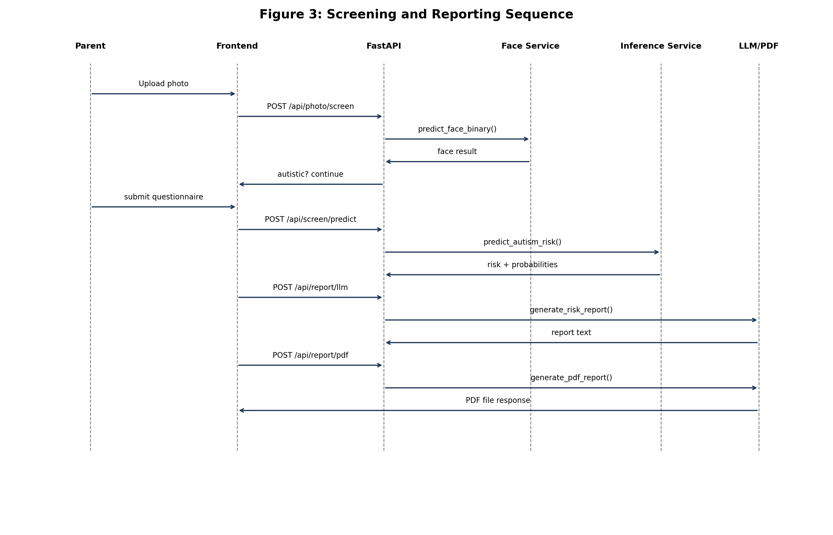

Figure 4: Activity Diagram
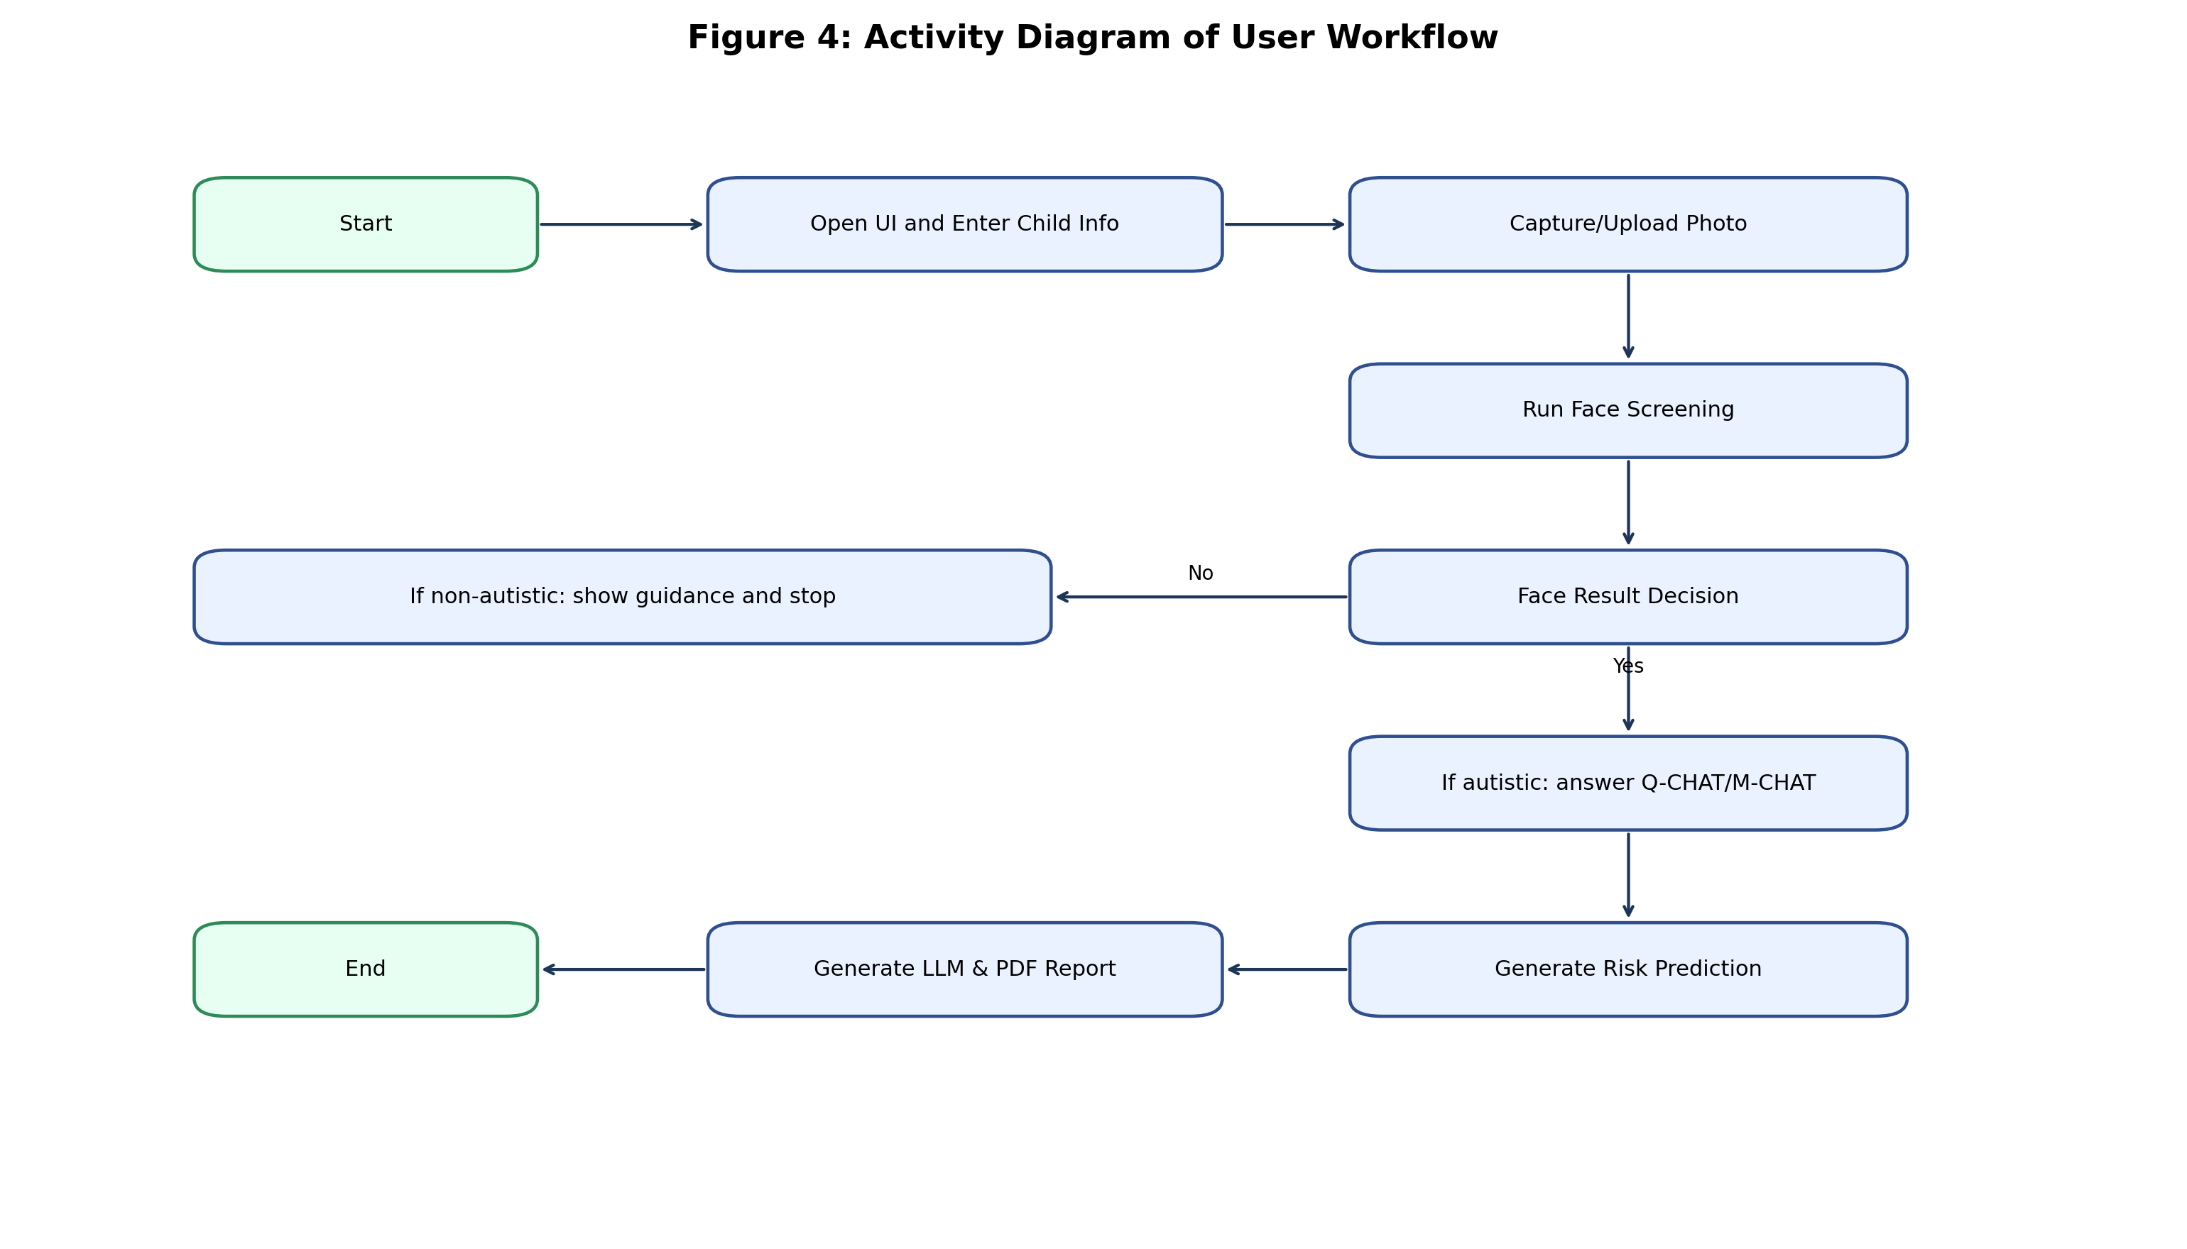

Figure 5: Component Diagram
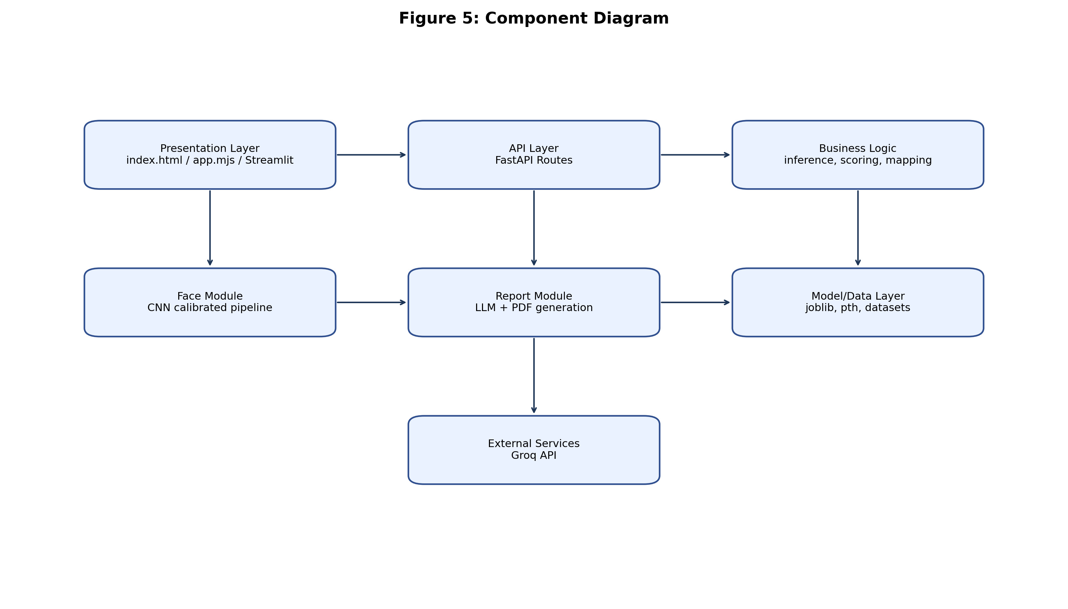

Figure 6: Deployment Diagram
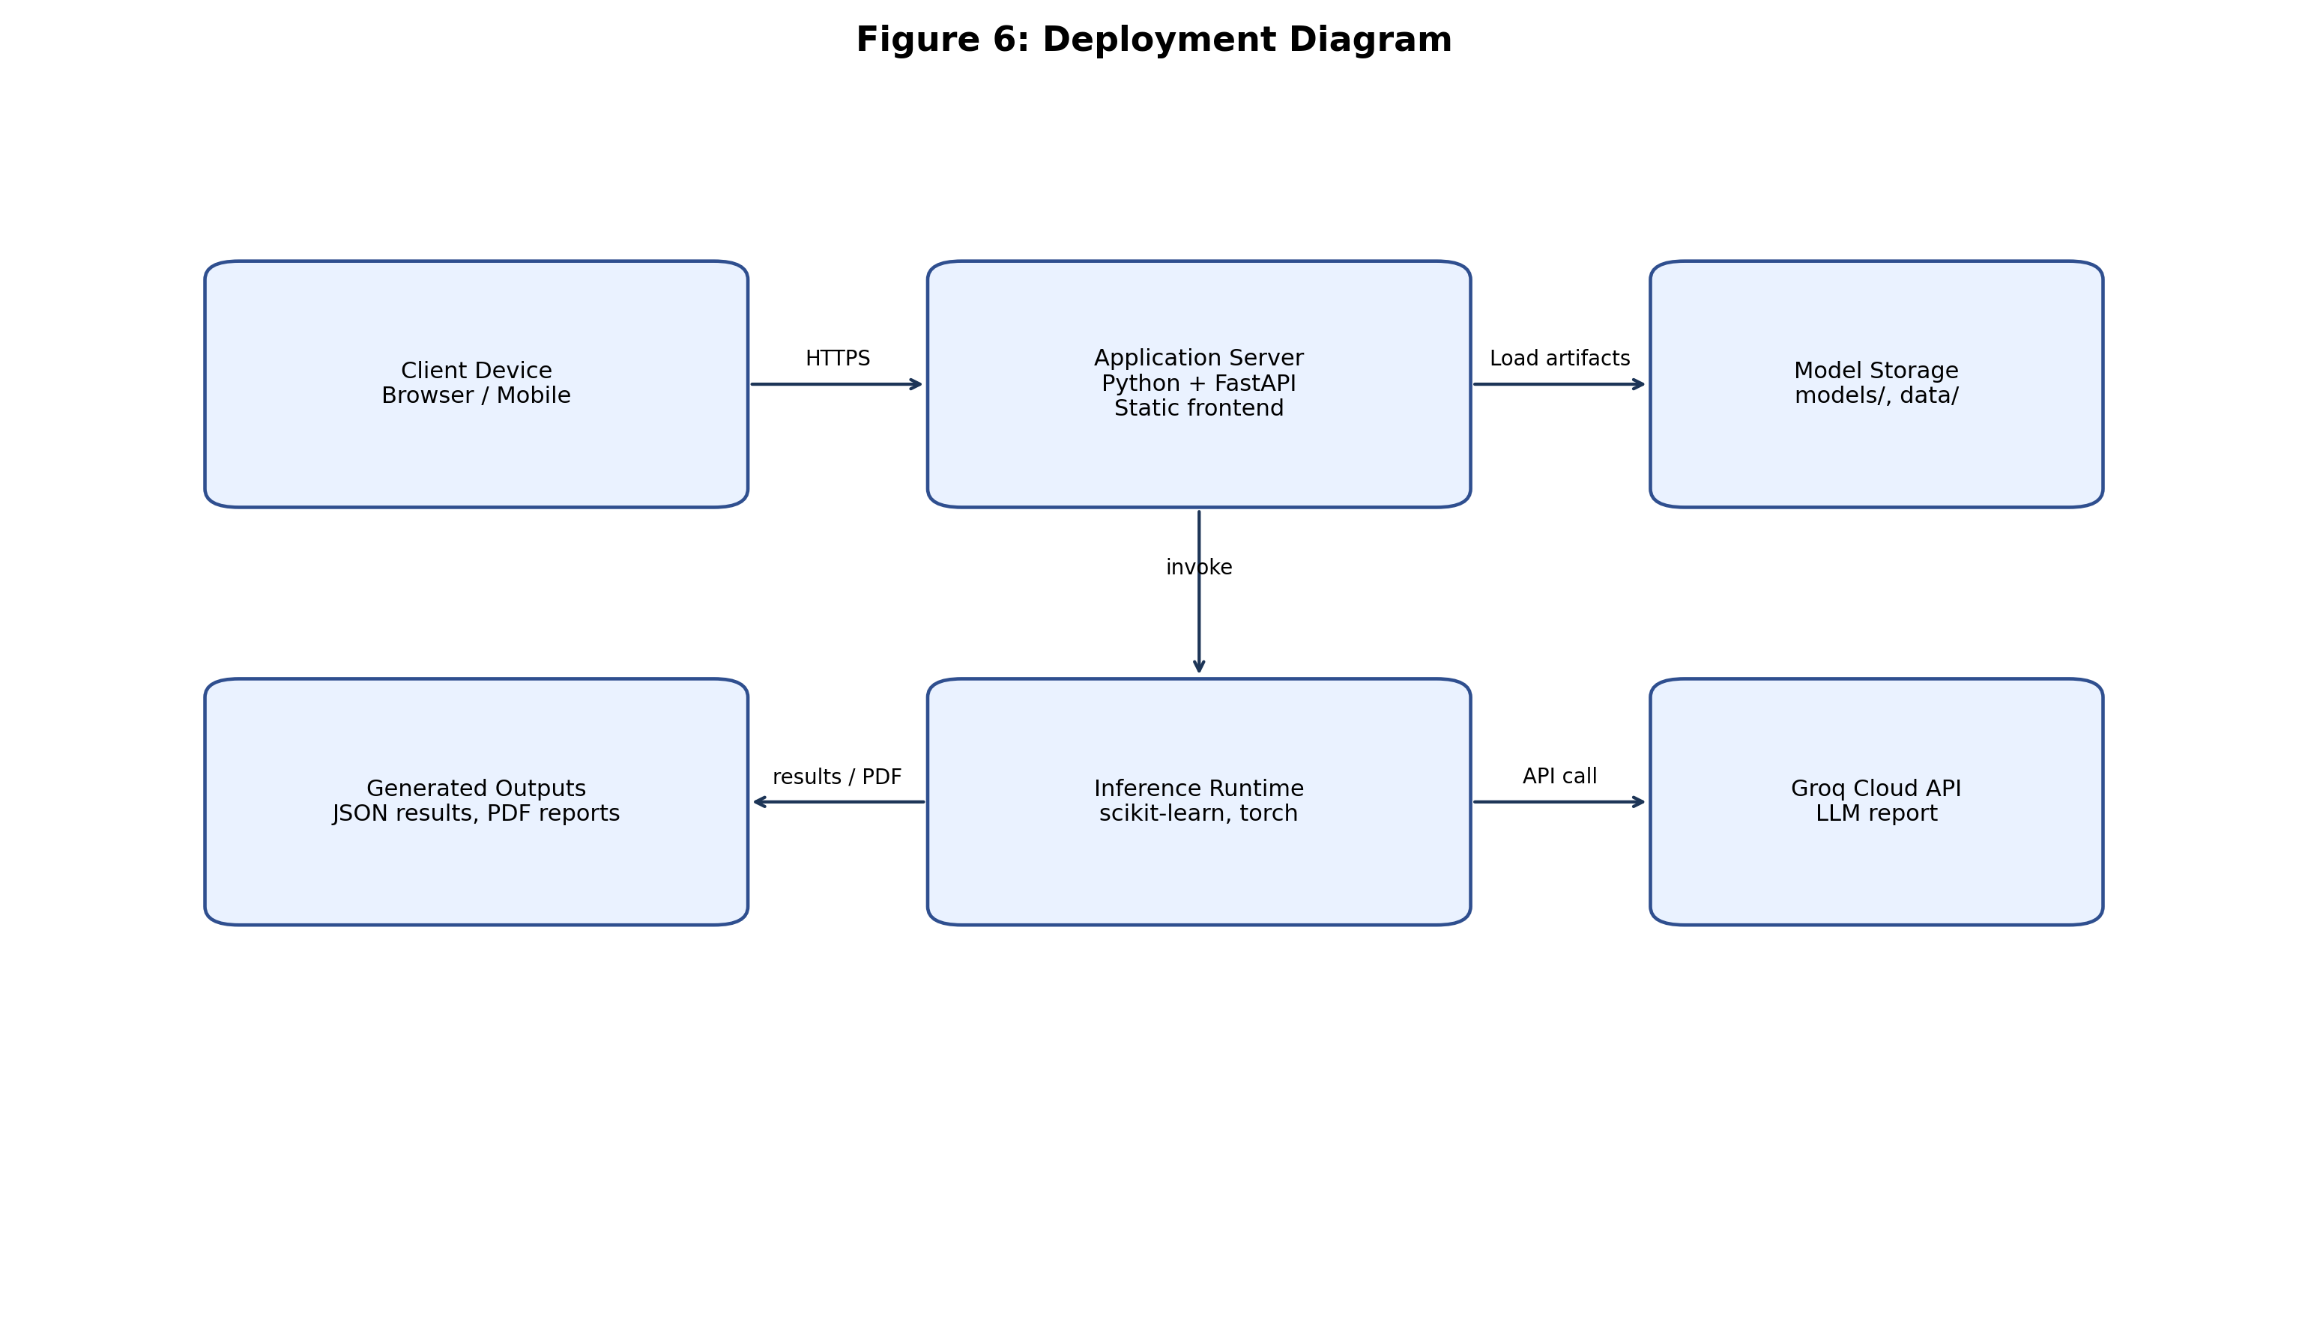

3.1 Model Description
The questionnaire model uses mapped Q-CHAT/M-CHAT answers and demographics to estimate class probabilities across risk levels (No Risk, Mild Risk, Moderate Risk, Severe Risk). A per-class threshold policy supports conservative screening behavior.
The face-screening module uses a calibrated CNN pipeline when artifacts are available and can fall back to a legacy EfficientNet checkpoint.

3.2 Functional Requirements
FR-1: System shall accept photo input and run binary face screening.
FR-2: System shall collect Q-CHAT and M-CHAT responses and return risk prediction.
FR-3: System shall generate parent-friendly narrative risk feedback.
FR-4: System shall generate downloadable PDF report.
FR-5: System shall expose API health endpoint.

3.3 Non-Functional Requirements
NFR-1: Clear and simple user interaction for non-technical caregivers.
NFR-2: Robust input validation and stable API behavior.
NFR-3: Maintainability through modular backend structure.
NFR-4: Reproducibility through explicit model artifact management.

Chapter 4: Proposed Solution and Implementation
The implemented solution provides API endpoints for image screening, questionnaire-based prediction, language-adaptive report generation, and PDF export.
Frontend clients communicate with FastAPI endpoints, and backend services coordinate inference and reporting in a deterministic processing pipeline.

Chapter 5: Results and Discussion
The current implementation is functionally complete for screening workflows and report generation. Script-based tests are available for major modules, though formal CI and automated coverage can be expanded.
Practical strengths include modularity, multilingual report capability, and support for both static-web and Streamlit interfaces.

Chapter 6: Conclusion and Future Work
This project demonstrates a complete autism pre-screening software pipeline that combines computer vision, questionnaire analytics, and narrative reporting.
Future work includes stronger backend authentication, unified frontend standardization, automated test expansion, and longitudinal evaluation with clinically curated datasets.

References
FastAPI Documentation. https://fastapi.tiangolo.com/
scikit-learn Documentation. https://scikit-learn.org/
PyTorch Documentation. https://pytorch.org/docs/
Q-CHAT and M-CHAT screening literature (clinical references to be finalized with supervisor).

