NAME: UMER KHAN
ID: 23K-0798
CN LAB 11
TASK:
ASSIGN VLAN TO PORTS AND THEN INTER VLAN
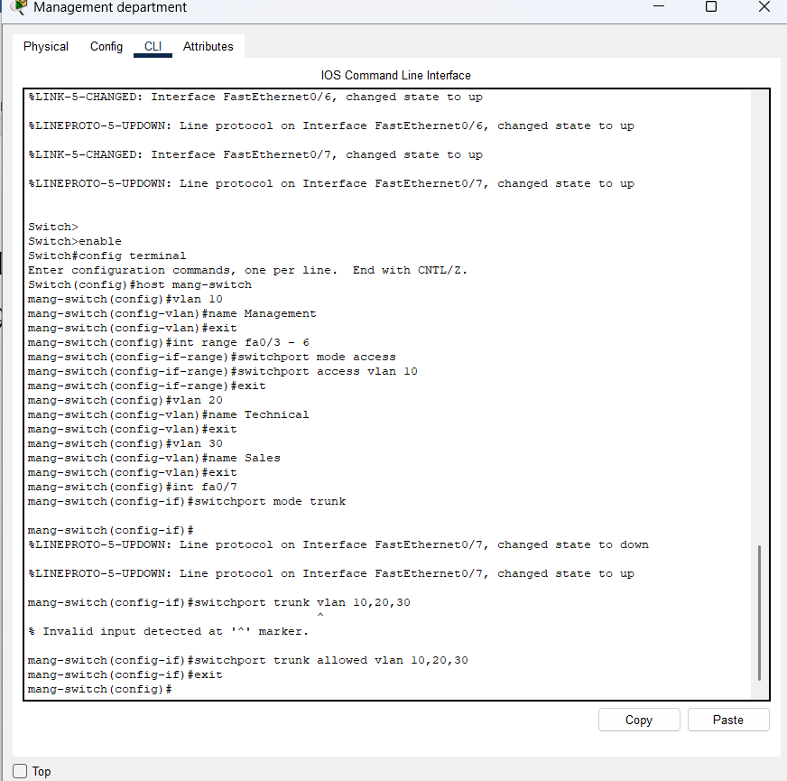
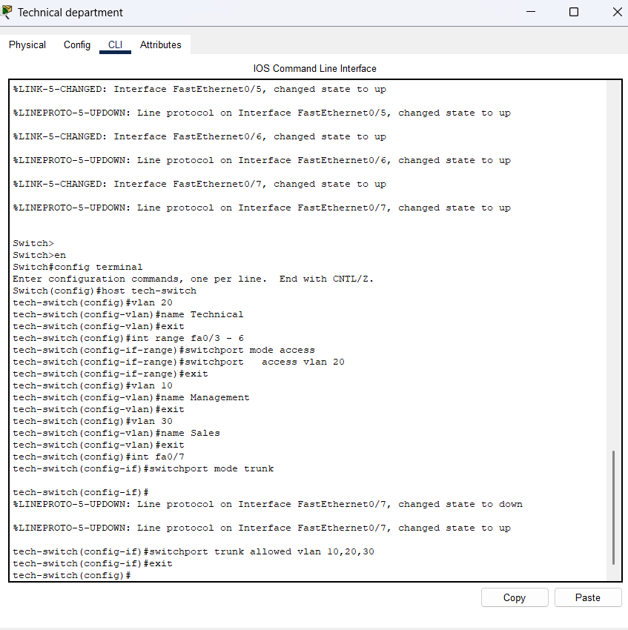
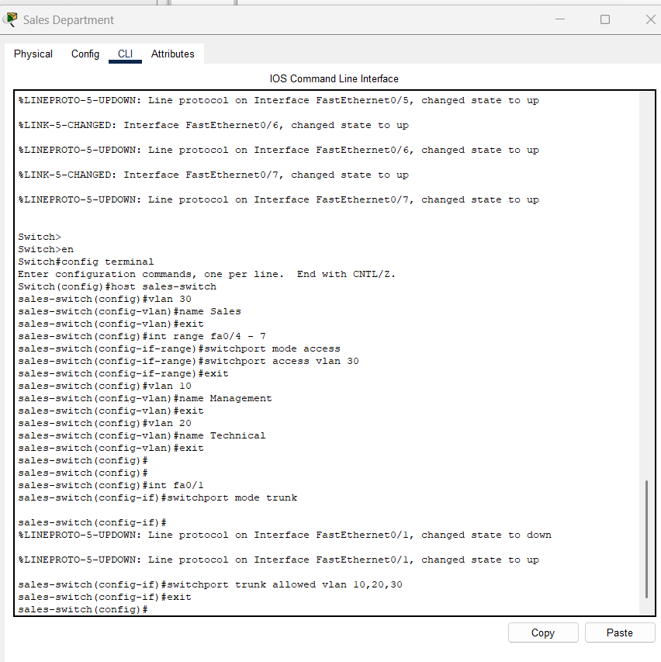
Inter vlan in router
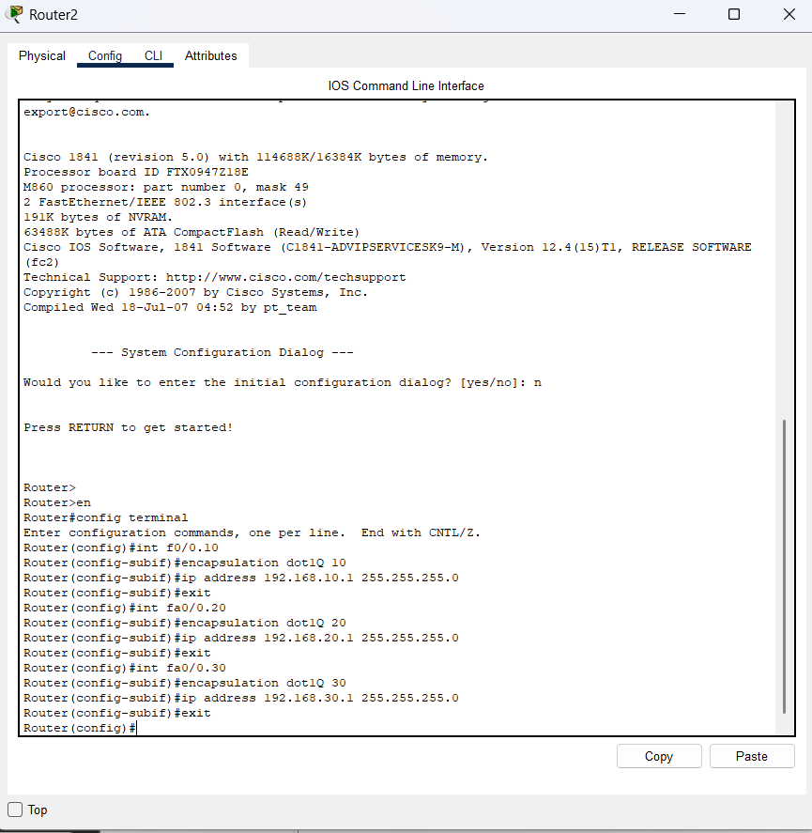

DNS SERVICE AND HTTP
From same pc access all vlans web page
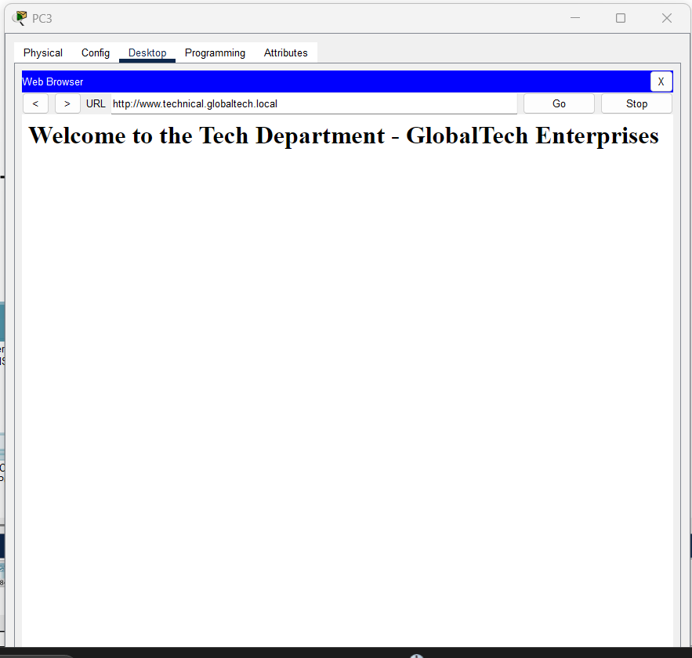
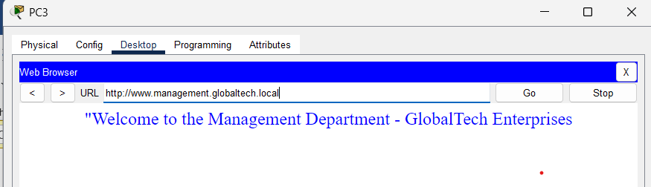
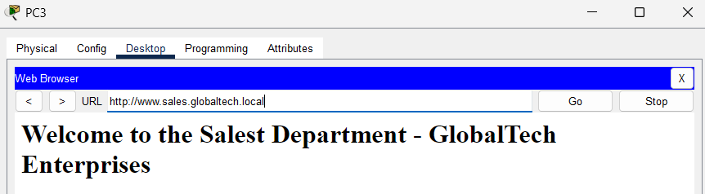

All config in central switch
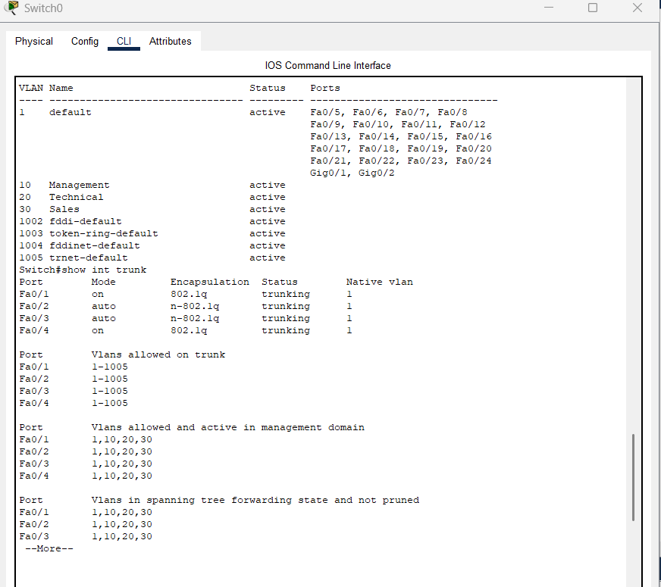
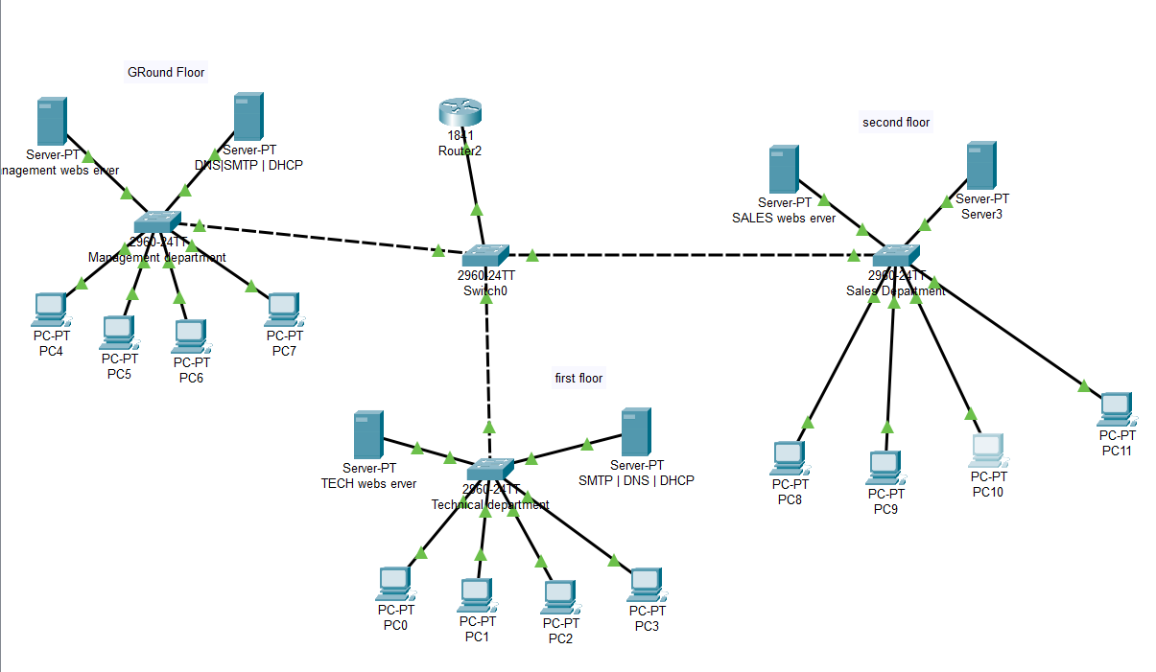
circuit link

