SELECT id, account_id, occurred_at FROM orders;

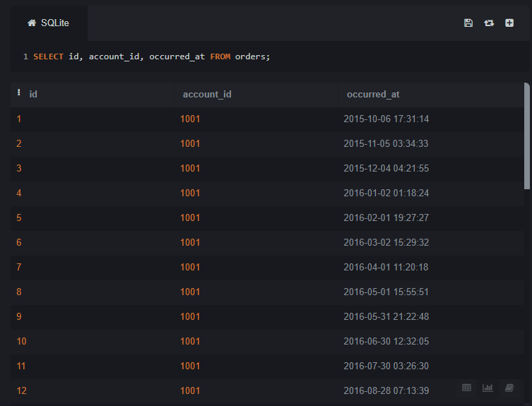

SELECT id, occurred_at, total_amt_usd FROM orders ORDER BY occurred_at LIMIT 10;

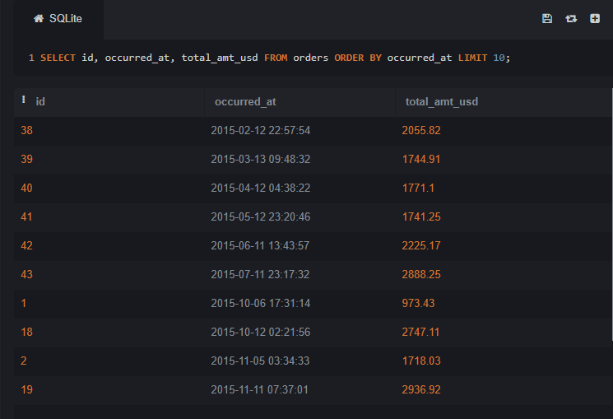

SELECT id, account_id, total_amt_usd FROM orders ORDER BY total_amt_usd DESC LIMIT 5;

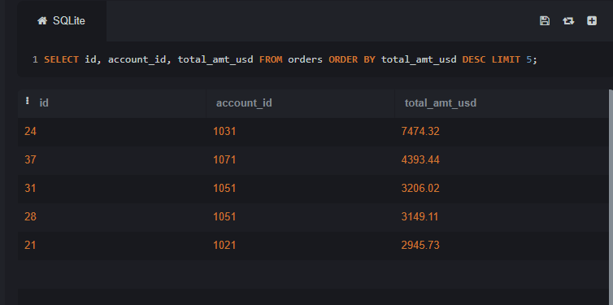

SELECT id, account_id, total FROM orders ORDER BY total LIMIT 20;

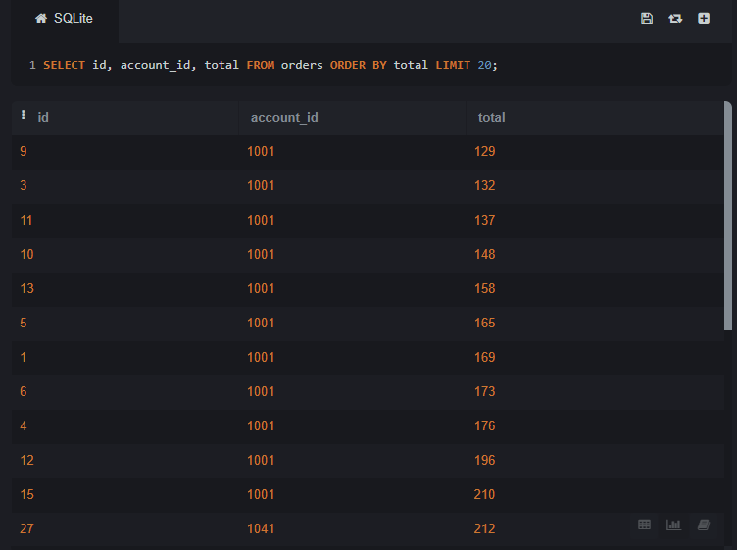

SELECT id, account_id, occurred_at, total_amt_usd FROM

(SELECT *, ROW_NUMBER() OVER (PARTITION BY DATE(occurred_at)

ORDER BY total_amt_usd DESC)

AS row_num FROM orders ) ranked

WHERE row_num <= 5 ORDER BY occurred_at DESC;

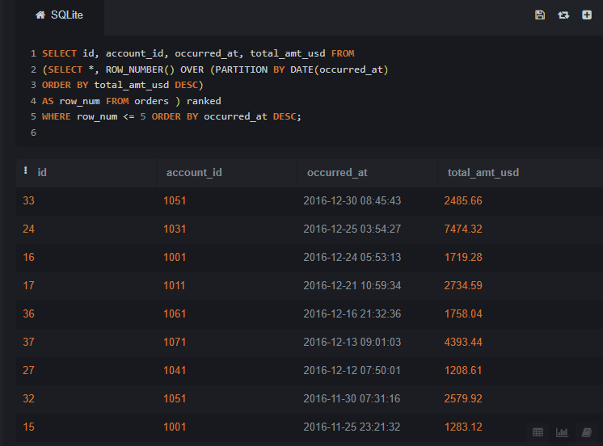

SELECT id, account_id, occurred_at, total_amt_usd

FROM ( SELECT *, ROW_NUMBER() OVER (PARTITION BY DATE(occurred_at) ORDER BY total_amt_usd)

AS row_num

FROM orders ) ranked

WHERE row_num <= 10

ORDER BY occurred_at;

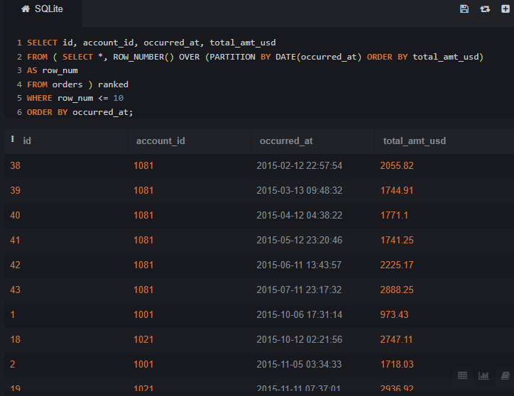

SELECT * FROM orders WHERE gloss_amt_usd >= 1000 LIMIT 5;

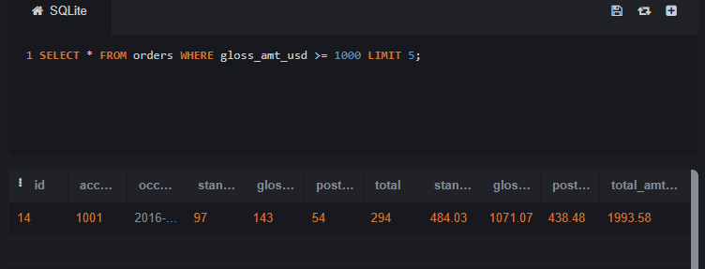

SELECT * FROM orders WHERE total_amt_usd < 500 LIMIT 10;

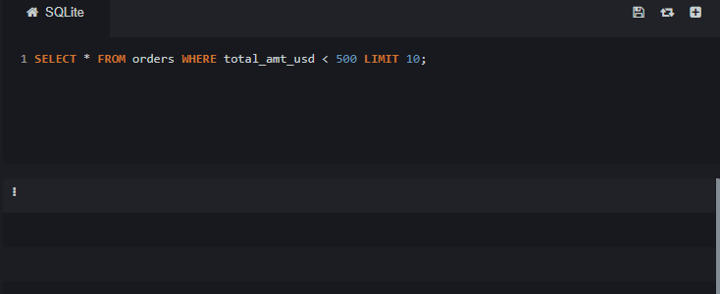

SELECT id, account_id, standard_amt_usd / standard_qty AS unit_price FROM orders LIMIT 10;

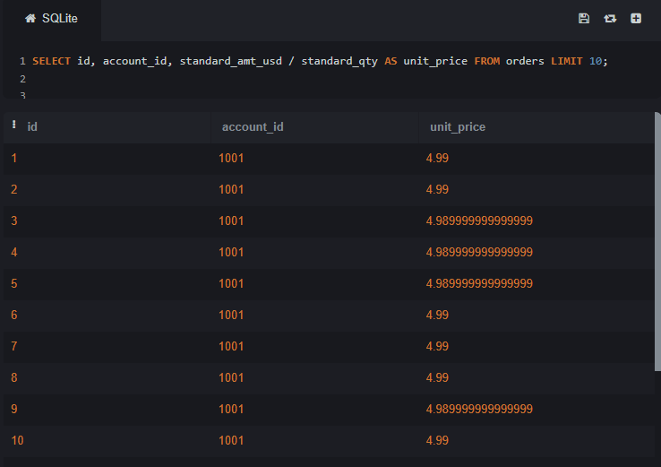

SELECT id, account_id, (poster_amt_usd * 100.0) / NULLIF(total_amt_usd, 0) AS poster_percentage FROM orders;

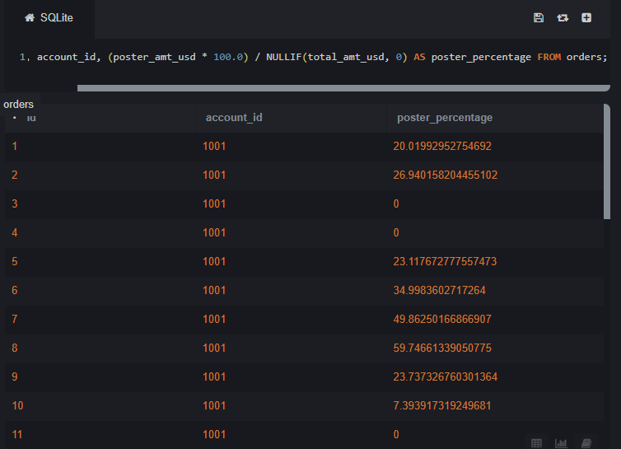

SELECT * FROM accounts WHERE name LIKE 'C%';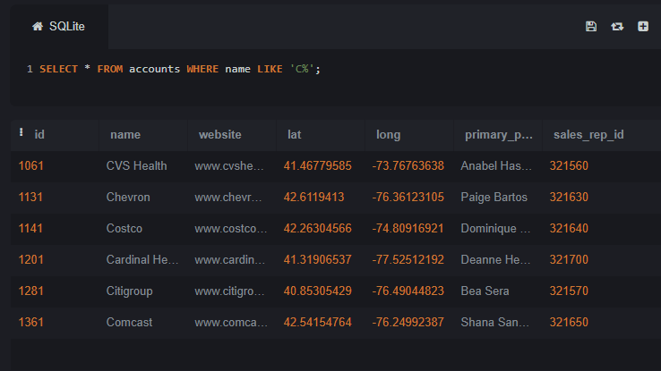

SELECT * FROM accounts WHERE name LIKE '%one%';

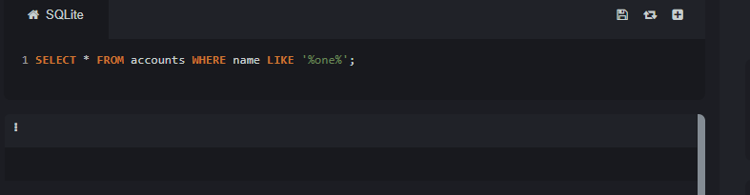

SELECT * FROM accounts WHERE name LIKE '%s';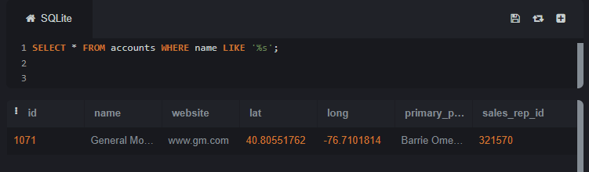

SELECT name, primary_poc, sales_rep_id FROM accounts WHERE name IN ('Walmart', 'Target', 'Nordstrom');

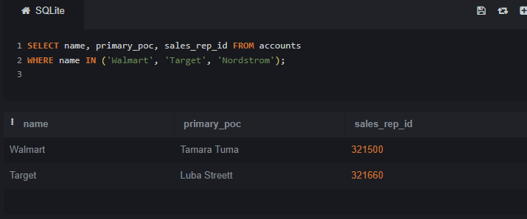

SELECT * FROM web_events WHERE channel IN ('organic', 'adwords');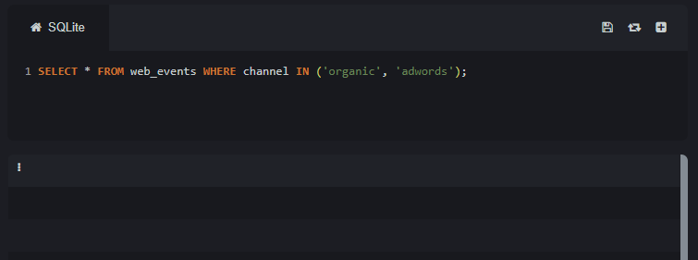

SELECT name, primary_poc, sales_rep_id FROM accounts

WHERE name NOT IN ('Walmart', 'Target', 'Nordstrom');

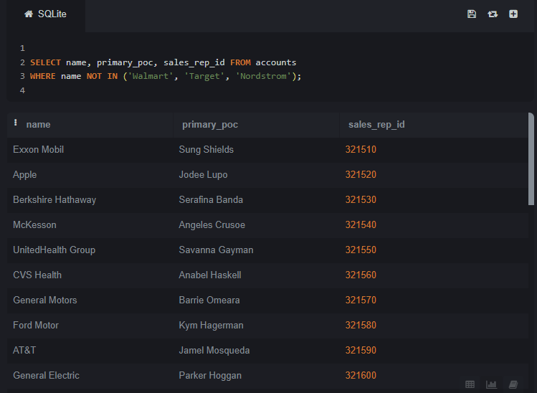

SELECT * FROM web_events

WHERE channel NOT IN ('organic', 'adwords');

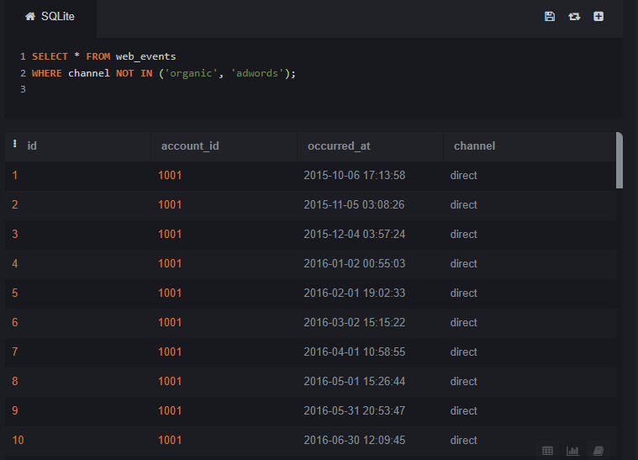

SELECT * FROM accounts WHERE name NOT LIKE 'C%';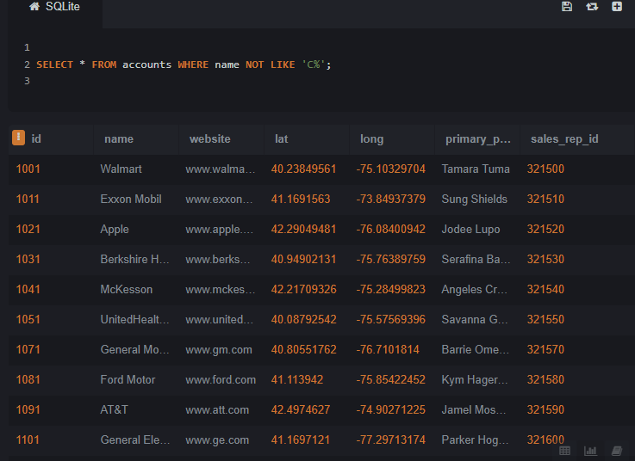

SELECT * FROM acounts WHERE name NOT LIKE '%one%';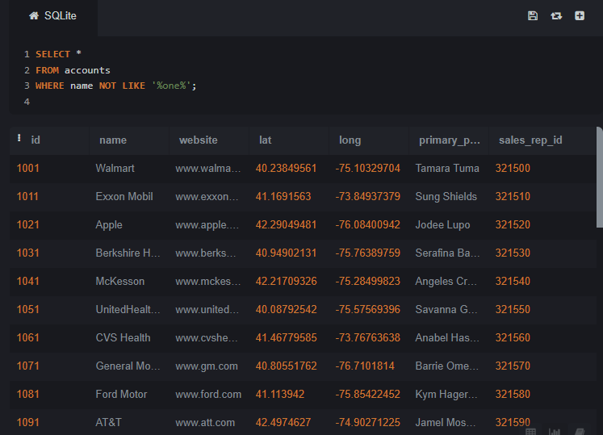

SELECT * FROM accounts WHERE name NOT LIKE '%s';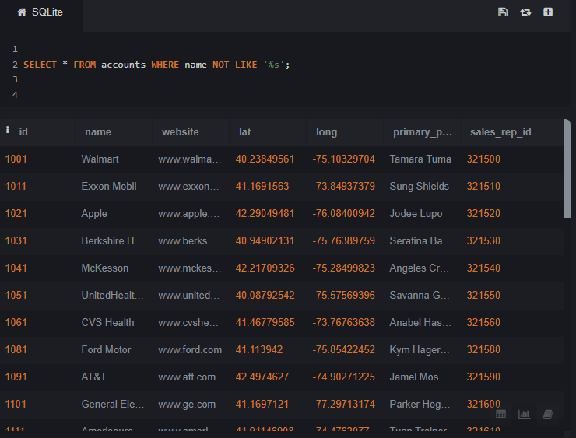

SELECT * FROM orders WHERE standard_qty > 1000 AND poster_qty = 0 AND gloss_qty = 0;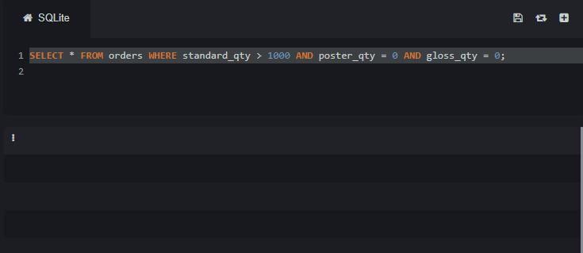

SELECT * FROM accounts WHERE name NOT LIKE 'C%' AND name LIKE '%s';

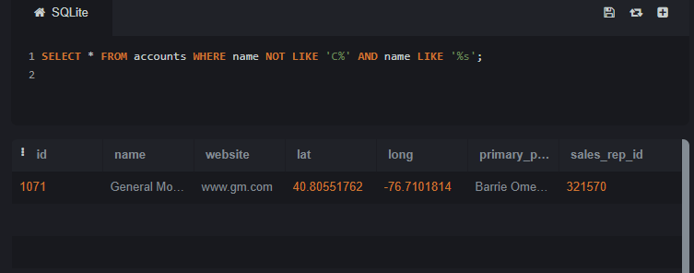

SELECT * FROM web_events WHERE channel IN ('organic', 'adwords') AND DATE(occurred_at) BETWEEN '2016-01-01' AND '2016-12-31' ORDER BY occurred_at DESC;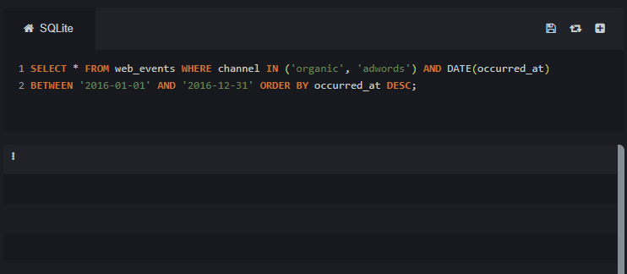

SELECT * FROM orders WHERE standard_qty > 1000 AND poster_qty = 0 AND gloss_qty = 0;

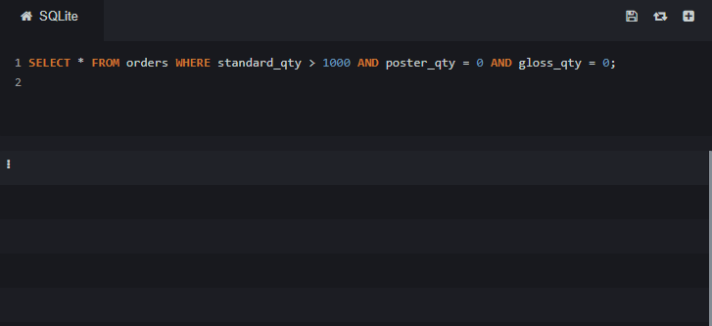

SELECT * FROM accounts WHERE name NOT LIKE 'C%' AND name LIKE '%s';

