|  |
| --- |
|  |
| AP Assignment 1 |
| QUIZER |
|  |
| **Muhammad Umer**  **BSCS5B** |
| **132754** |

|  |
| --- |
|  |

# Introduction

## Objective

The basic objective of the assignment was to solve the problem of generating a digital quiz. Creating a desktop application where a student can attempt a quiz and an instructor can create a quiz.

# Learning

Following were the thing learnt from doing this assignment.

* Making a basic java desktop application
* Use of maven
* Unit Tests
* Profiling
* Concept of Serialization

# Screenshots

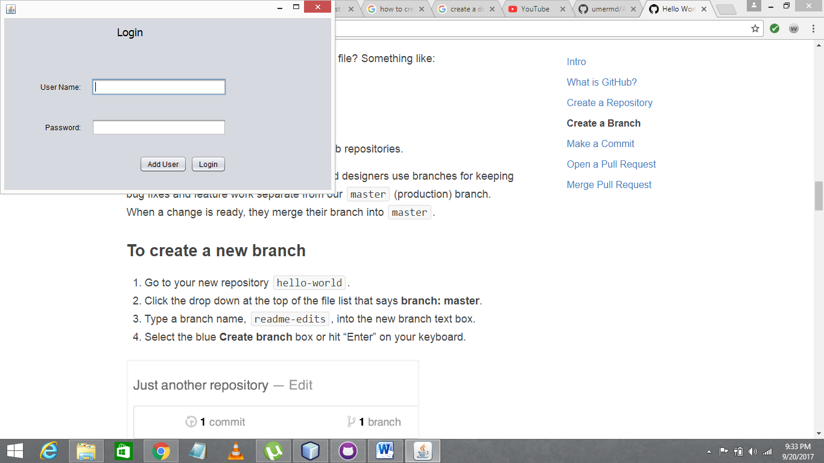

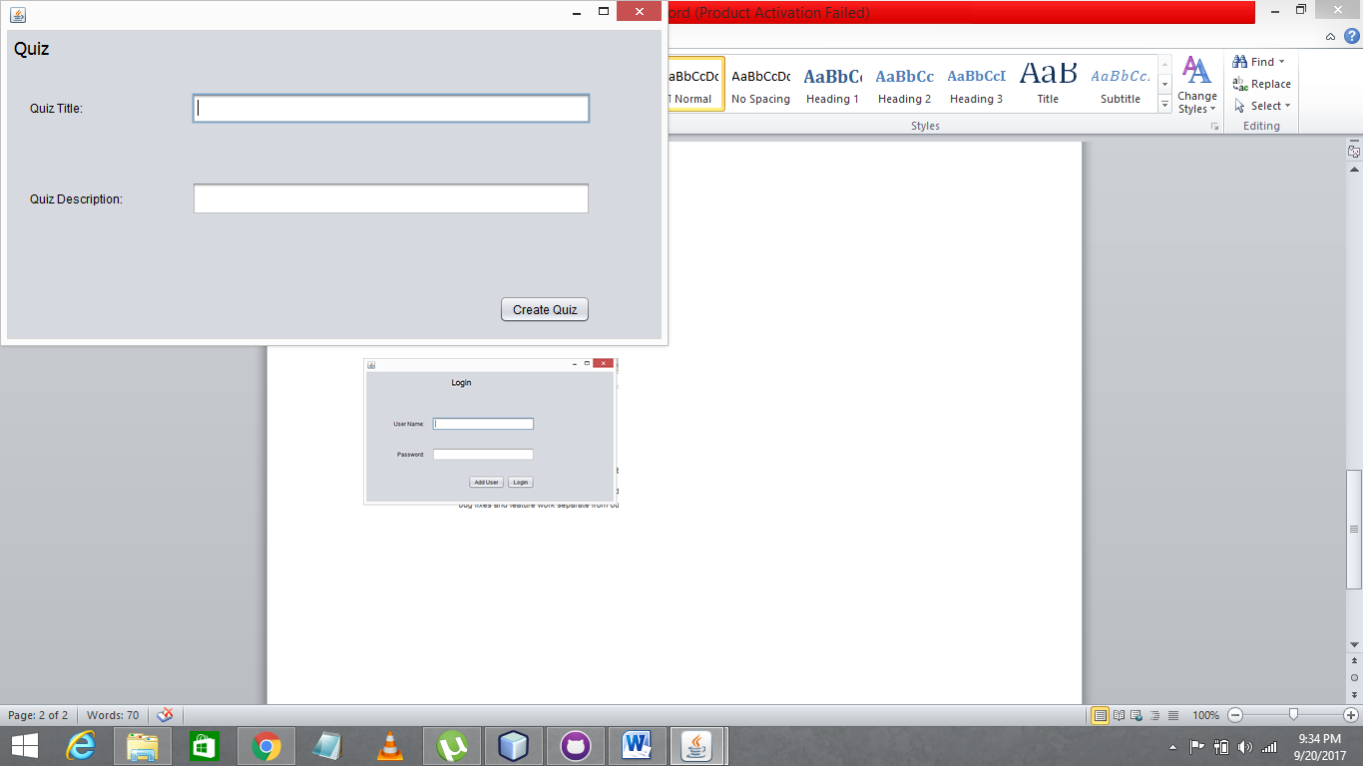

# GitHub

A repository named as Assignment1.

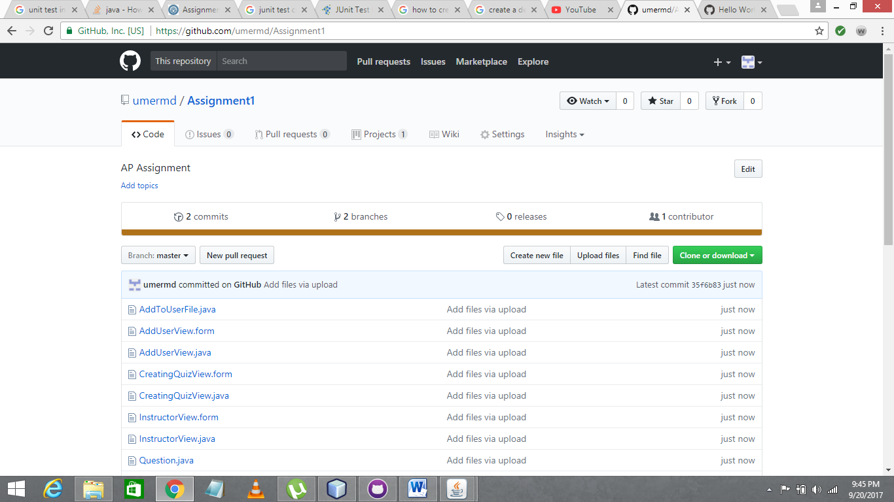

After Committing in Dev Branch.

