**Databases**

**Umer Iqbal x17111854**

**Mark O’Kelly x17742461**

**Muhammad Abu Bakar Sani x17112044**

**Business rules:**

1. A hospital may contain one or many wards. While wards can only be in one hospital.
2. The Beds must be in only ward. While a ward can have zero or many beds.
3. Each ward is controlled by one Ward Sister. Only the Ward Sister can control one or many wards.
4. The Patients must be in one ward only. A ward may have none or many patients present in it.
5. A consultant can visit one or many wards. While a ward may be visited by one or many consultants.
6. A Patient may be treated by one or many consultants. While a consultant may treat one or many patients.
7. A ward may contain one or many nurses. While nurses must be in one and only one ward.
8. A Patient may take one or many types of medicine. While medicine can be taken by zero or many patients.
9. Medicine may dispense in zero or many days. While Day may cater to zero or many medicines taken.
10. Ailment may be present in zero or many Patients. Patients may have one or many ailments.

Diagrams

Conceptual

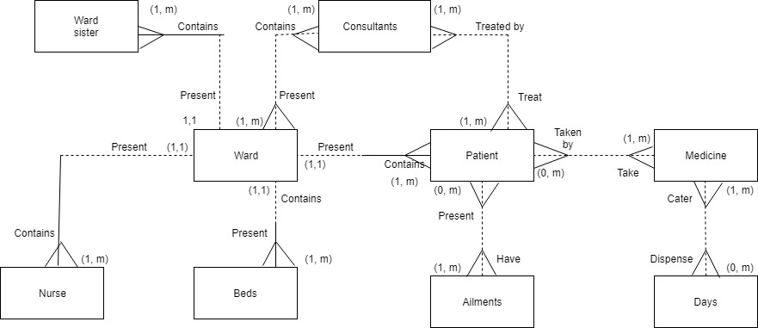

Logical

