Respond & Recommend

POC Objective:
Understand the feedback: Determine whether the feedback is positive, negative.
Check for refund requests: Identify if the customer is requesting a refund or has any related concern.
Generate a response to the customer: Compose a supportive and appropriate reply addressing their feedback, concerns, and recommendations, while maintaining a professional and empathetic tone.
Recommend courses: Suggest relevant courses available on our website based on the customer’s recent interests and interactions.

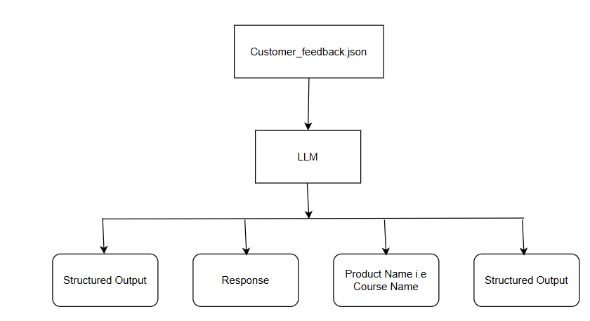

We have a JSON file that contains customer feedbacks
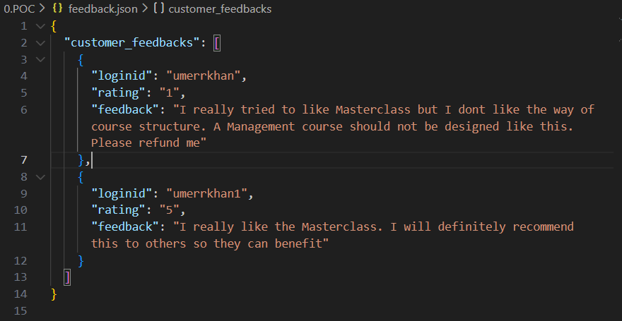
Next, we are connecting with LLM in our case are connecting with Chat GPT. API Key is already stored in the. env environment
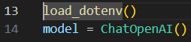

Next, for structured output we have created class

Next, we are sending the feedback that we received from the customer to the model and model will return the structed output

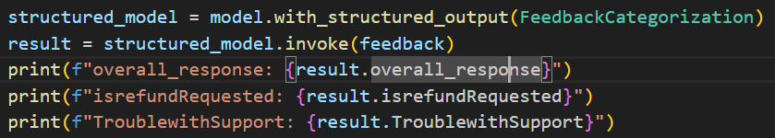

Next, we created three prompts:
- The first prompt is used to generate the response that will be sent back to the customer and to extract the required information.
- The second prompt checks whether the customer is asking about a refund.
- The third prompt identifies whether the customer faced any issues while trying to connect with customer support.
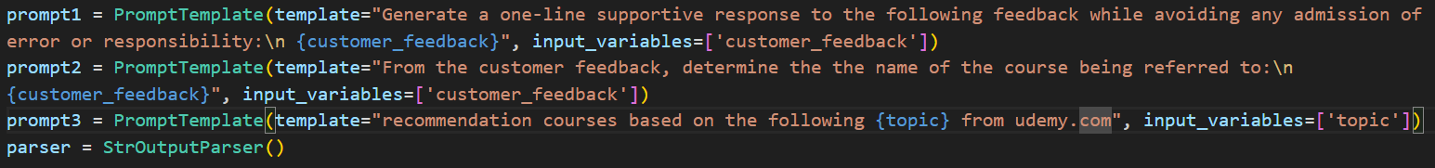

CHAINS – OPTION 1
Next, to achieve faster responses, we execute chains that can run in parallel.
The tasks for generating a supportive response and identifying the course name can be executed concurrently/parallel.
The final task of recommending a course depends on the output of the previous task.
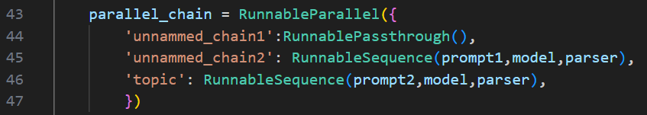
Line 44 is just checking the input
First, we will execute the parallel chain and then we will execute the final task for recommending the course
Finally calling the invoke function to execute the chains
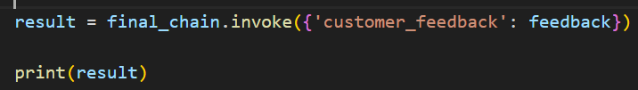

CHAINS OPTION-2
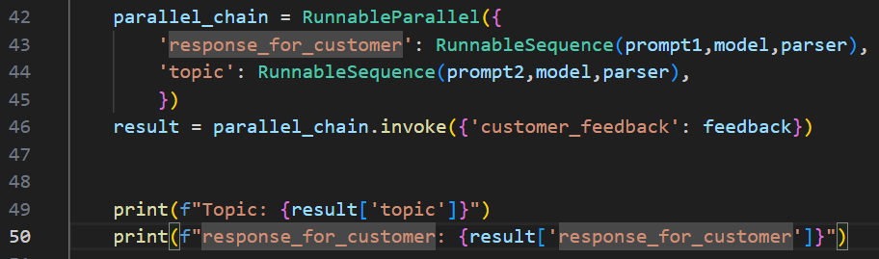

Here we are executing two chains in parallel, One for Generating response for the customer and other to find the topic (course Name)

Next
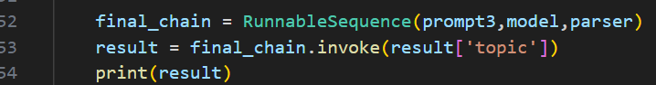
Final chain is for recommending the course.

OUTPUT
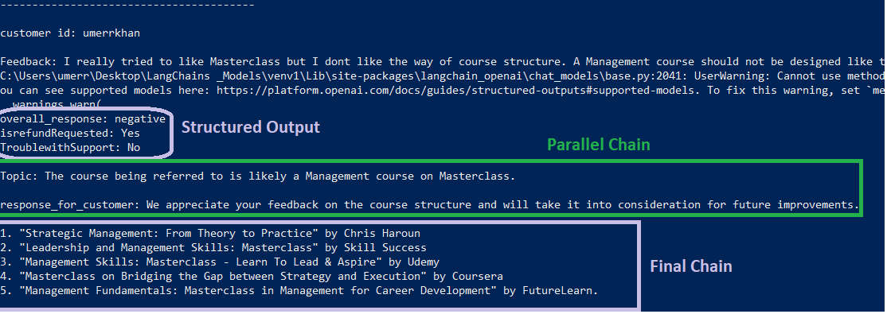

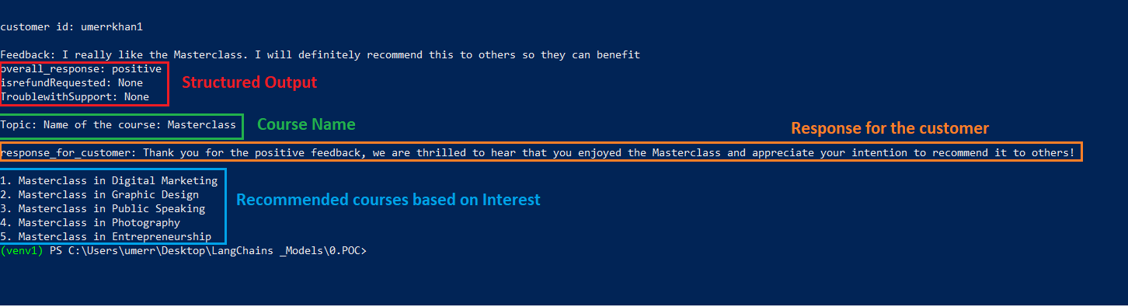
Sequence Chain | Parallel Chain | Final Chain
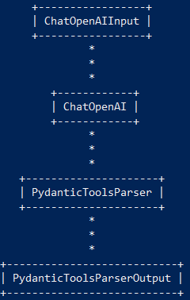 | 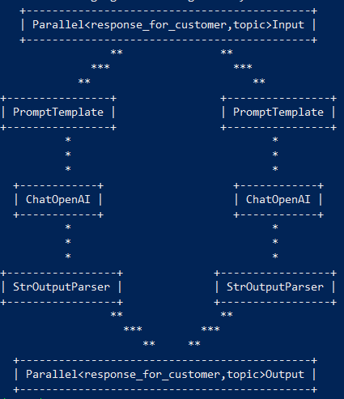 | 