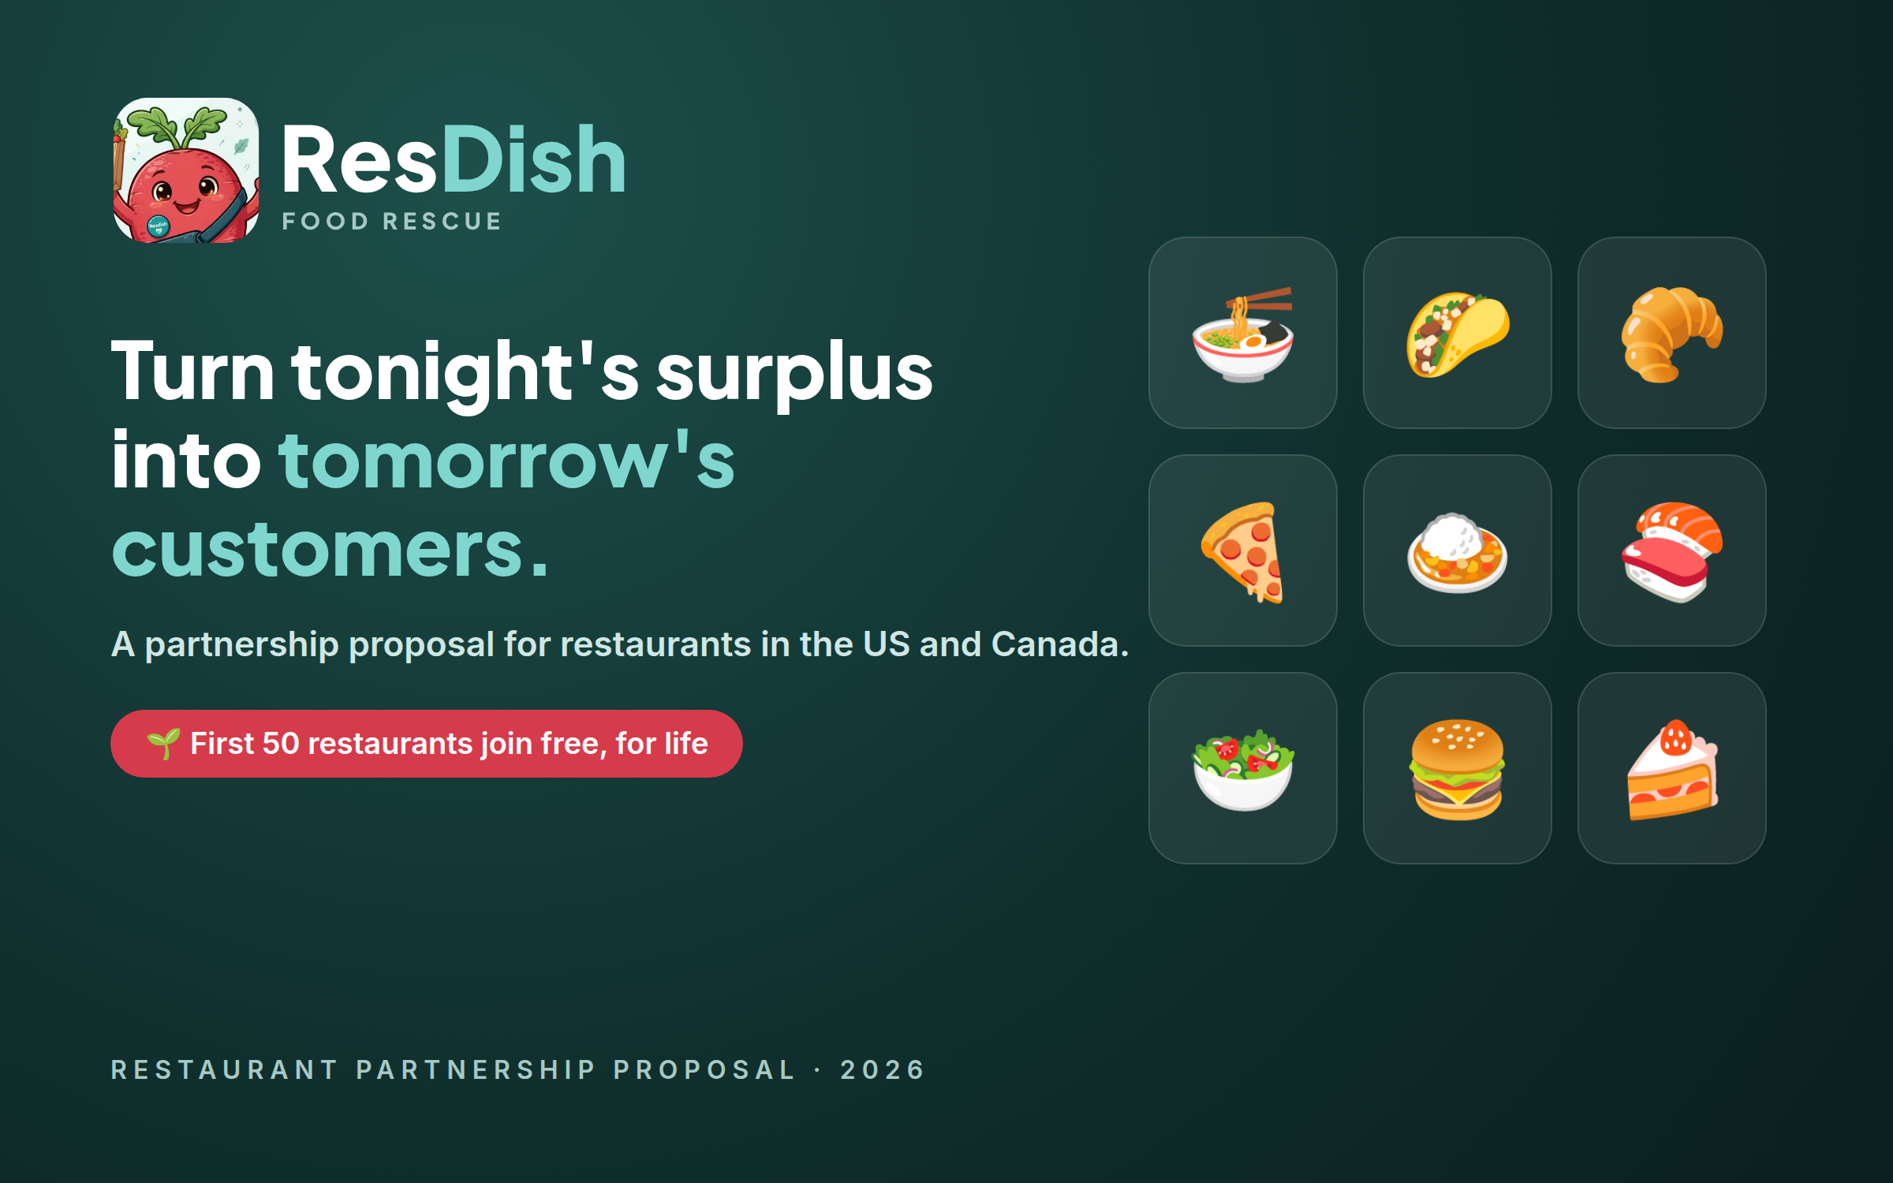
Restaurant Partnership Proposal
Sell your surplus food, win new regulars, and waste less — with no commission on your sales.
Prepared for | ______________________________ (restaurant name)
Prepared by | ResDish Partnerships Team · support@bite-wise.org
Date | October 2026
Offer valid | Founding Partner spots are limited to the first 50 restaurants approved

1. Executive summary
Every restaurant ends up with good food it can't sell: a wrong order, a delivery that never got picked up, the last trays at closing time. Today most of it goes in the bin, along with the money you spent making it. ResDish is a local marketplace where restaurants in greater Seattle post that surplus food at a discount and nearby customers buy it and pick it up, usually within the hour.
We are inviting your restaurant to join as a partner. In short:
- Recover revenue from food you have already paid to make.
- Reach new customers who discover your restaurant through a great deal and come back at full price.
- Keep 100% of your food sales. ResDish charges no commission. Customers pay a small service fee on top.
- Simple pricing: $15 a month, or $150 a year (save $30). The first 50 restaurants approved pay nothing — ever.
- Ready in a day: sign up online, we approve you (usually within one business day), and your counter kiosk is ready on any tablet.

🌱 Founding Partner offer
The first 50 restaurants approved on ResDish become Founding Partners and use the platform free for as long as they remain partners — no subscription fee, no card required, every feature included. Spots are assigned automatically, in order of approval.

Everything included
For your kitchen | For your business
✓ Unlimited offers and menu items  ✓ Discard timers with one-tap extend  ✓ Photos, dietary tags and allergen notes  ✓ Live order bell (dashboard and kiosk) | ✓ Payouts at every pickup via Stripe Connect  ✓ Daily and historical reports (PDF, CSV)  ✓ Invoice number on every payout  ✓ Electronically signed partner agreement

2. The opportunity
Surplus is a normal part of running a kitchen. Orders get made wrong, delivery drivers cancel, customers don't show up, and demand is never perfectly predictable. Each of those meals has already cost you ingredients and labour. Throwing them away turns that cost into a total loss — and it is food that someone nearby would happily buy.
At the same time, many people in the city are looking for good restaurant food at a lower price, and like the idea of rescuing food rather than wasting it. ResDish connects the two, in real time and close to home.

What changes for your restaurant
 | Without ResDish | With ResDish
Wrong or unclaimed orders | Thrown away; full loss | Sold at a discount within the hour
End-of-day surplus | Discarded at closing | Listed with a discard timer; sold before close
New customers | Paid advertising | Customers find you through a deal, then return
Cost | — | $0 (Founding) · $15/month · $150/year; no commission

How it works
Four steps, from a tray of extra food to money in your bank account:
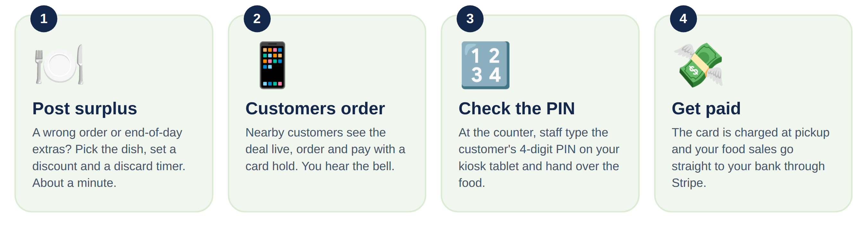

3. What you get
Every plan includes the complete ResDish toolkit. There are no add-ons and no per-order fees for restaurants.

Restaurant dashboard
Post a surplus dish in about a minute: choose it from your menu, set the discount and how long it stays safe to sell (the discard timer). Pause, extend or end an offer at any time. A bell rings for every new order, and daily reports show meals rescued, sales, discounts and taxes, with PDF and CSV export.
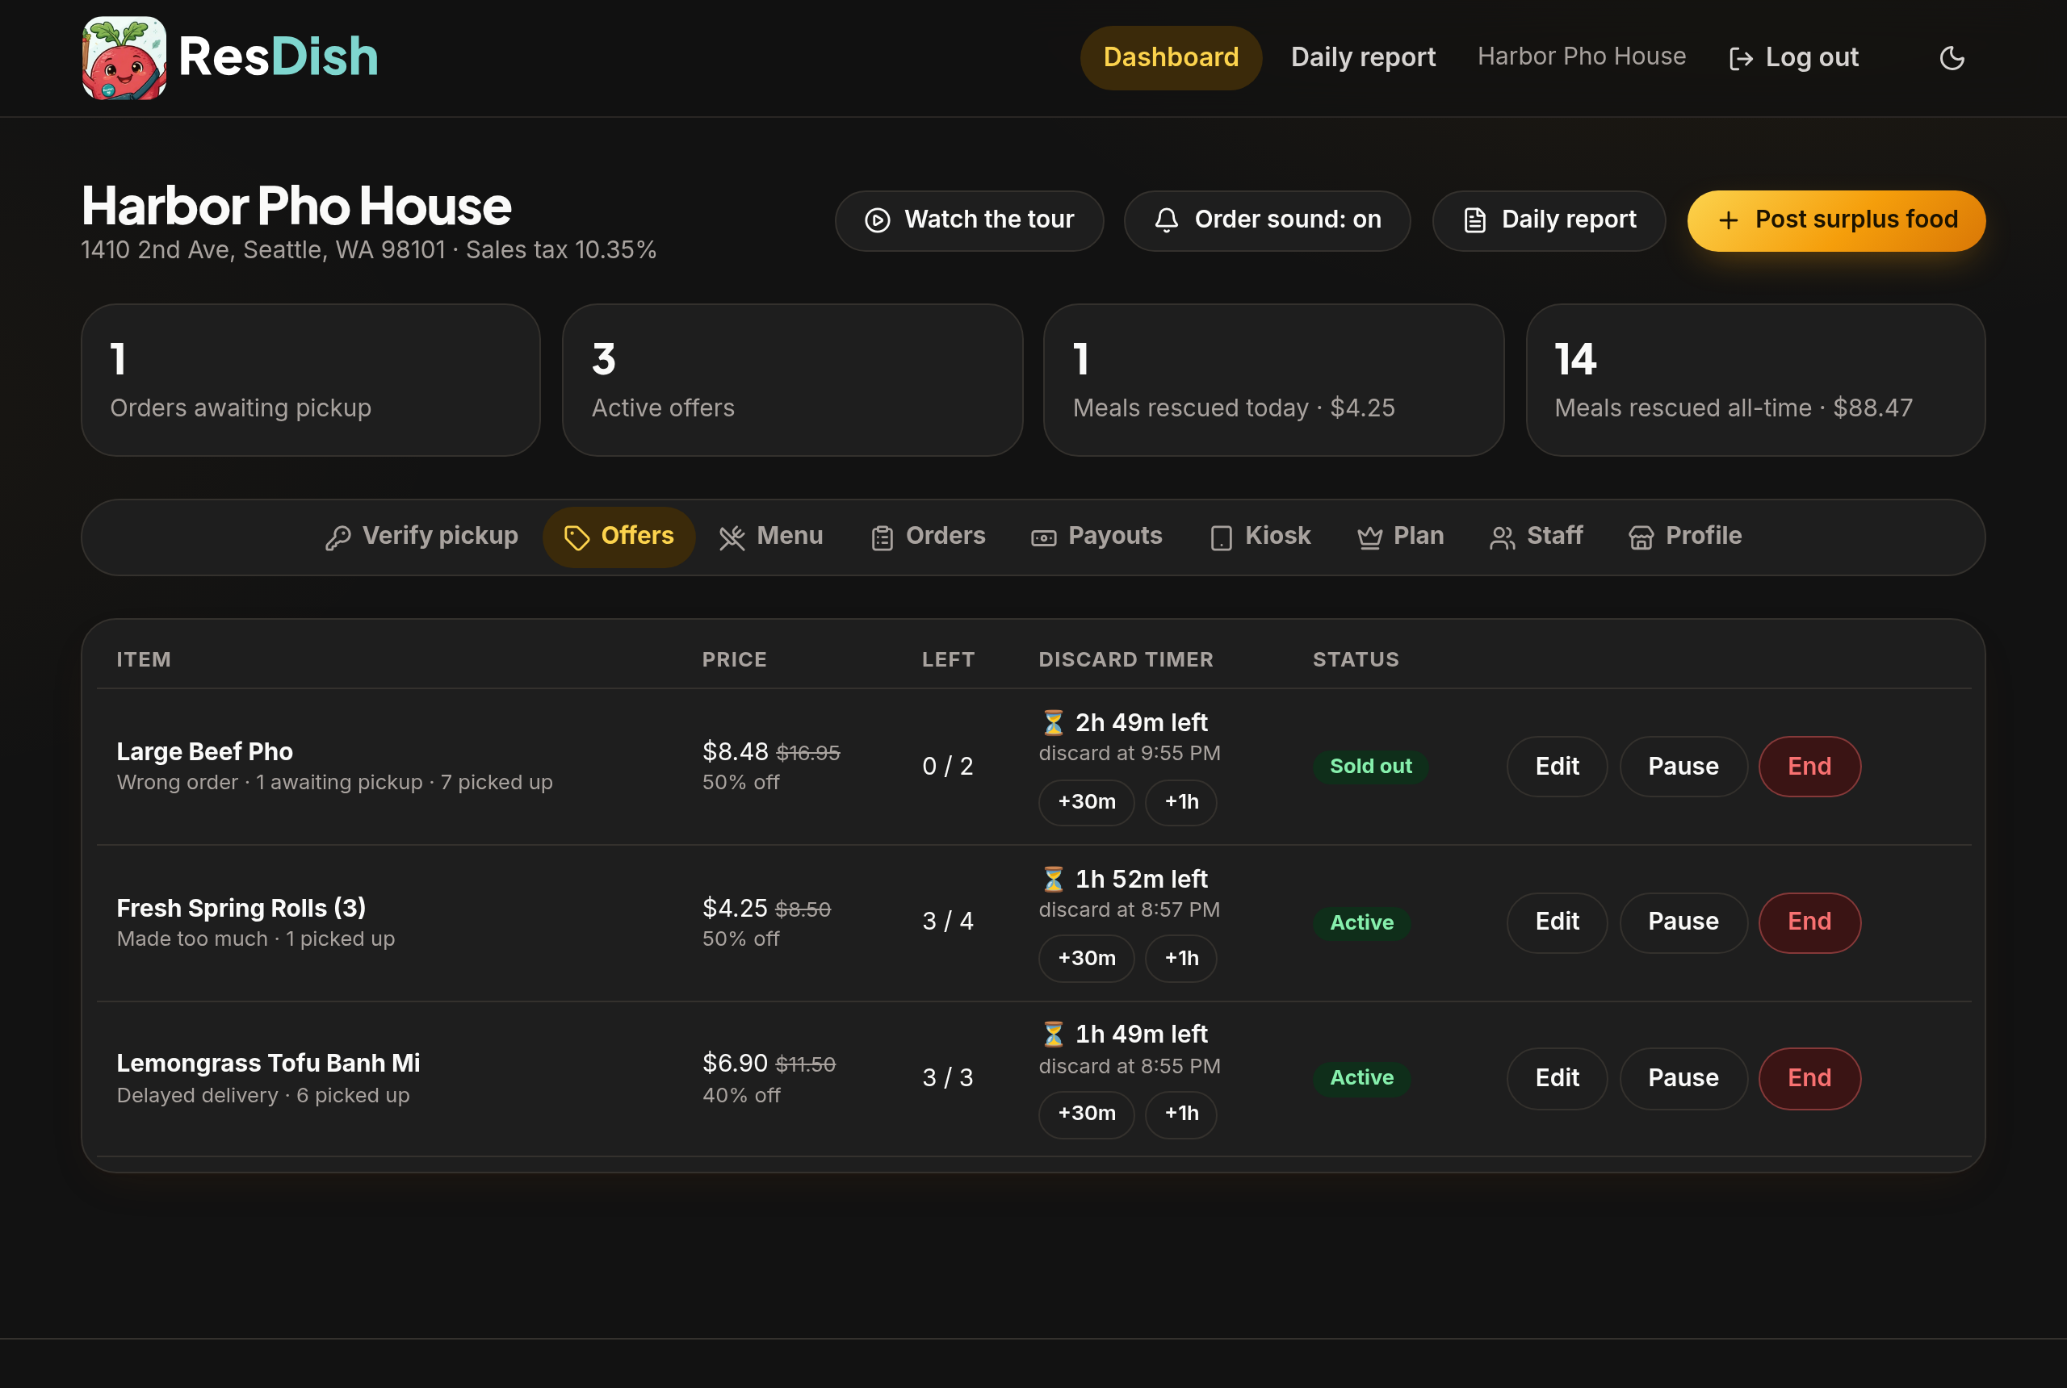
The restaurant dashboard: live offers with their discard timers, orders waiting for pickup and today's results.

Counter kiosk for your tablet
Every approved restaurant gets its own private kiosk link. Open it on any Android tablet or iPad at the counter and add it to the home screen: it runs full-screen like an app. New orders appear with a bell; staff type the customer's 4-digit pickup PIN, check the order, and hand it over. The customer's card is charged at that moment. No staff logins or passwords are needed.
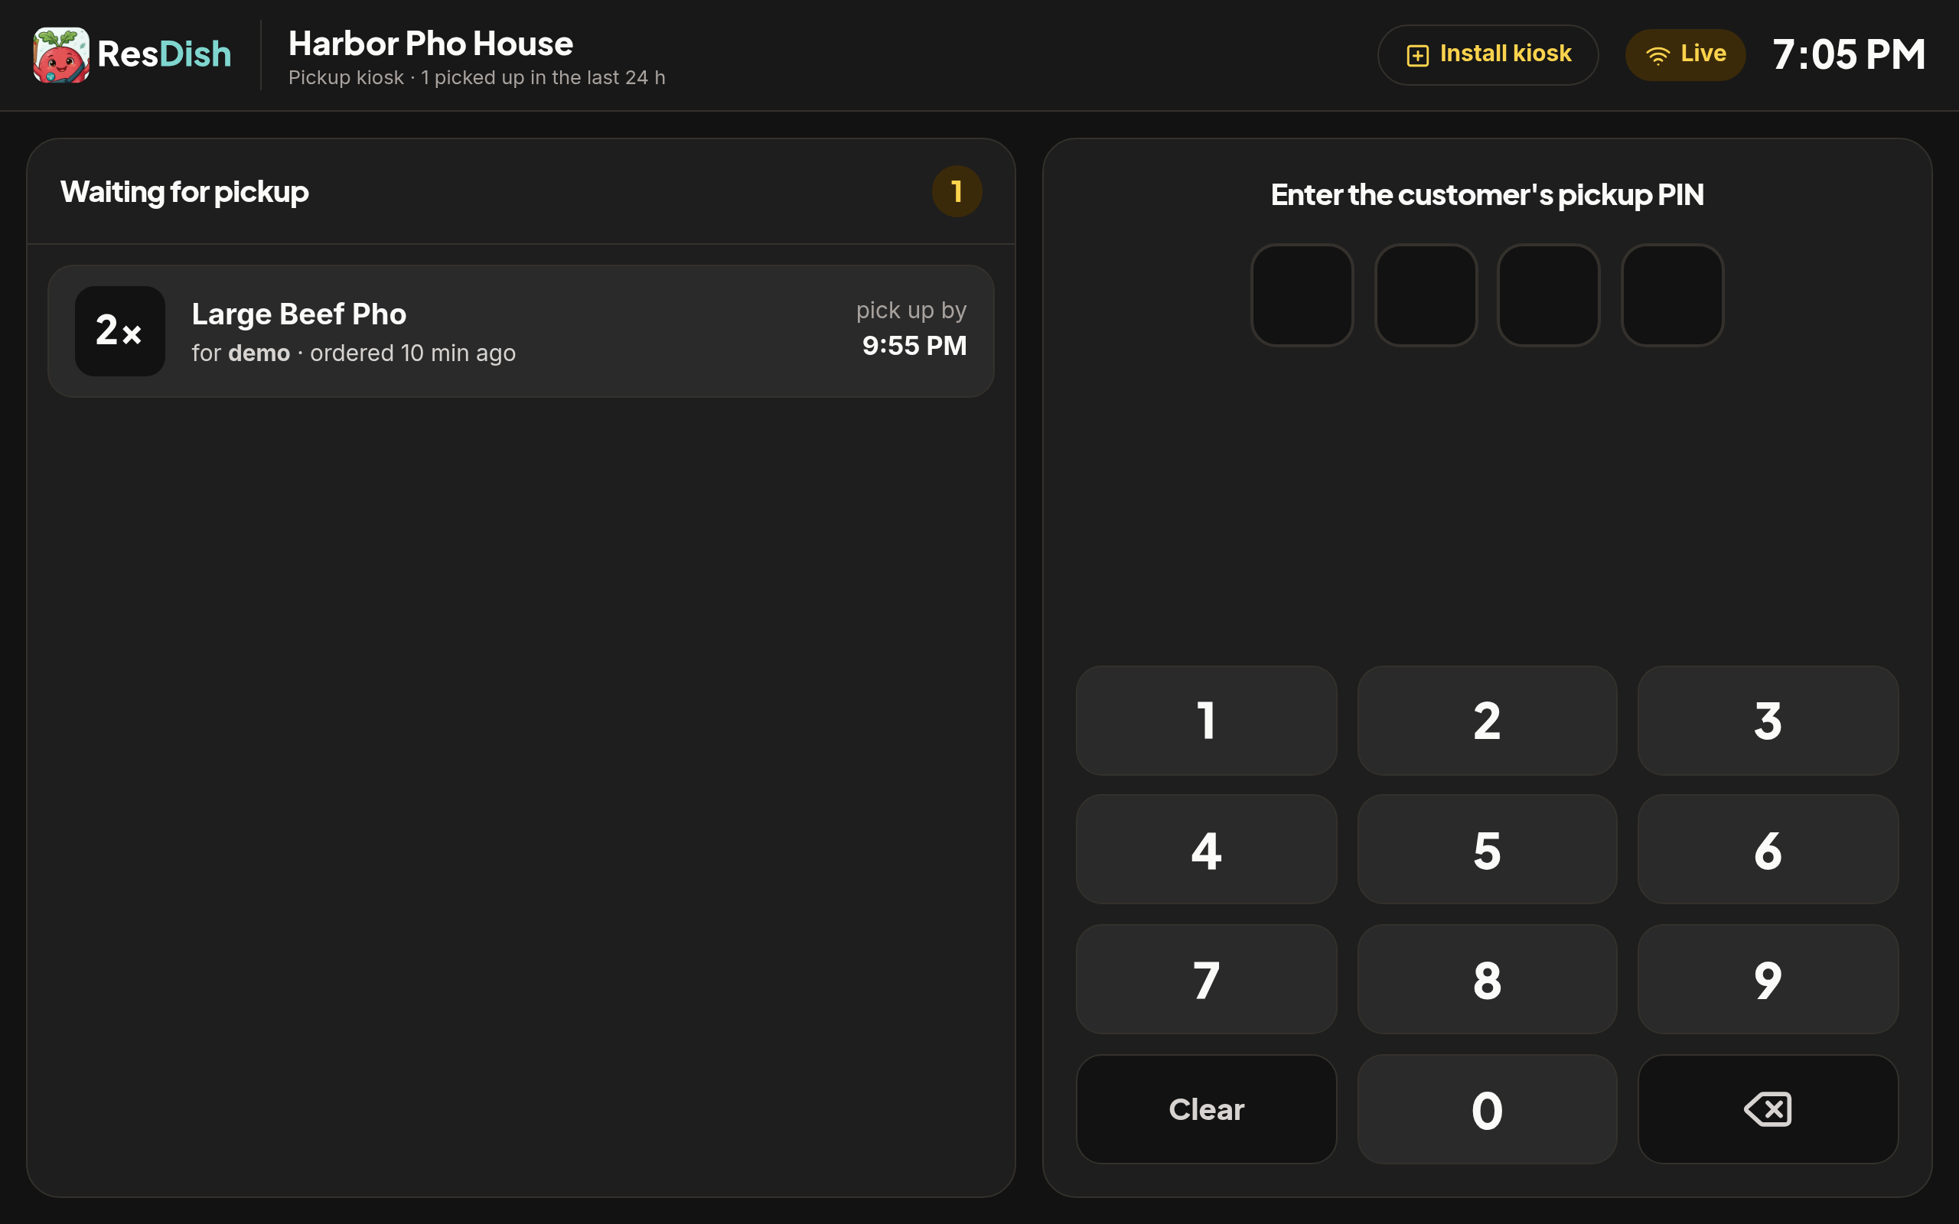
The counter kiosk: orders waiting for pickup on the left, the PIN pad on the right.

What your customers see
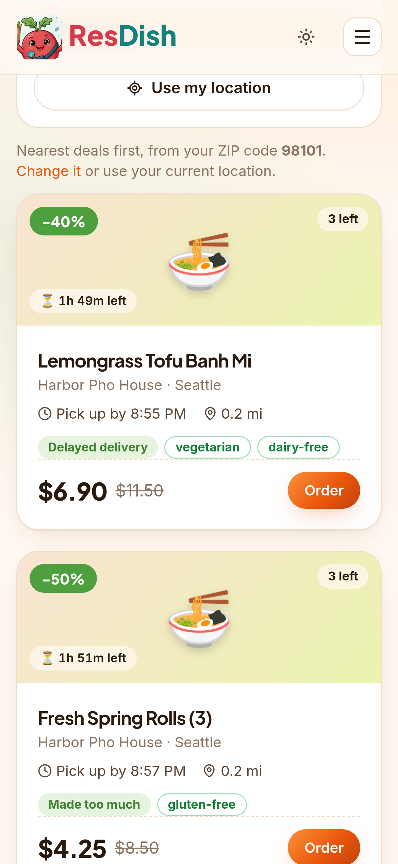  Deals near you, on any phone. | Customers browse live deals on a list or a map, filtered by distance, diet and cuisine. Each listing shows your restaurant's name, the dish, the original and discounted price, how many are left, and the pickup deadline.  - Card hold, not a charge: the customer's card is only charged when your staff confirm the pickup PIN.  - Pickup PIN: every order has its own 4-digit PIN, so the right food goes to the right person.  - No-shows are released automatically after the discard timer, without charging the customer.  - Real people only: sign-up refuses disposable and fake email addresses, and abusive accounts can be suspended or permanently banned.

4. Plans and pricing
One simple fee — and no commission on your food sales, ever. You receive the full discounted price of every meal you sell; the customer pays a separate ResDish service fee on top.
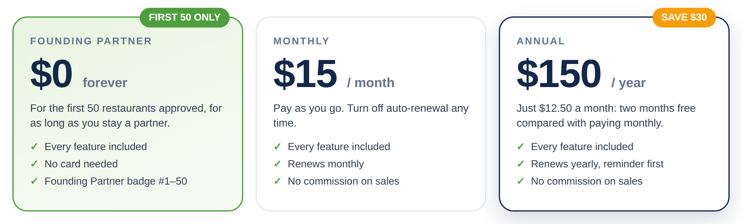
 | Founding Partner | Monthly | Annual
Price | $0 | $15 per month | $150 per year
Who it is for | The first 50 restaurants approved | Any approved restaurant | Any approved restaurant
Saving | Free for life | — | $30 a year vs. monthly ($12.50/month)
Payment | None; no card needed | Card on file, charged monthly in advance | Card on file, charged yearly in advance
Auto-renewal | Nothing to renew | On by default; turn off any time | On by default; reminder emailed a week before
Commission on sales | None | None | None

Auto-renewal, in plain words
- Paid in advance. Your first month or year is charged when you choose a plan, and your offers can go live straight away.
- Renews automatically at the end of each period, charged to your default card on file, so your listings never stop unexpectedly. You get an emailed receipt with an invoice number every time.
- You stay in control. Turn auto-renewal off at any time from the Plan tab of your dashboard; your plan then simply ends on the last day you have paid for. Keep as many cards on file as you like and choose your default, or switch between monthly and annual from your next renewal.
- Annual reminder. Annual plans receive an email reminder about a week before they renew.
- If a payment is declined, your plan becomes delinquent straight away: your offers are paused and you can't post until a payment goes through. We email you and retry your default card automatically, and you can pay at any time from the Plan tab with any card.
- Price changes are announced at least 30 days in advance and only apply from your next renewal.

What a partnership can be worth
An illustrative example (your numbers will differ):
Assumption | Example
Surplus meals sold per day | 5
Average discounted price per meal | $8.00
Days open per month | 30
Food sales recovered per month (paid to you in full) | $1,200
ResDish plan | $15 / month (or $0 as a Founding Partner)
Net recovered per month | ≈ $1,185 – $1,200
Figures are for illustration only and are not a forecast or guarantee of sales.

5. Getting started
Joining takes a few minutes online. Here is what happens:
- Sign up at bite-wise.org with your restaurant details, and accept the Restaurant Partner Agreement electronically.
- Confirm your email. We send a confirmation link; once confirmed, you receive an "application received" email.
- Approval. Our team reviews your application, usually within one business day. Meanwhile you can set up your menu and photos.
- Welcome pack. On approval you receive your welcome email with your electronically signed agreement (PDF), your private kiosk link with Android and iPad buttons, and your plan: Founding Partner if a spot is still open, otherwise a choice of monthly or annual.
- Set up the counter tablet. Open the kiosk link on the tablet and add it to the home screen (one tap on Android; Share → Add to Home Screen on iPad).
- Connect payouts. Link your bank account through Stripe in the Payouts tab, so you are paid at every pickup.
- Post your first surplus dish — and listen for the bell.

Our commitment to you
- Fair, transparent fees: one subscription, no commission, no hidden charges.
- Fast payouts: your share is transferred through Stripe when the customer picks up, with an invoice number for every payout.
- Customer support: we handle customer questions, refunds and platform credit. Credit we give customers is funded by ResDish — you are still paid in full.
- A safe marketplace: PIN-verified pickups, card holds, real-email sign-ups, and the ability to suspend or permanently ban anyone who abuses the platform.

What we ask of partners
- Only list food that is safe to eat throughout its discard timer, prepared and held in line with the Washington Food Code.
- Describe items accurately, including allergens, and use your genuine regular price as the original price.
- Always verify the customer's PIN before handing over food.
- Keep your Stripe account and business licences in good standing.
Partners who break these rules may be suspended for a set number of days or, for serious or repeated issues, permanently removed. The full terms are in the Restaurant Partner Agreement.

6. Frequently asked questions
Do you take a percentage of my sales?
No. You receive the full discounted price of every meal. ResDish earns a service fee paid by the customer, plus the subscription for restaurants that are not Founding Partners.
How do I become a Founding Partner?
Simply sign up. The first 50 restaurants approved are given a Founding Partner spot automatically, and keep it for as long as they remain a partner. No card is needed.
Can I cancel?
Yes. Turn off auto-renewal in the Plan tab at any time; your plan ends at the end of the period you have paid for. Either party may also end the agreement with 14 days' notice.
What equipment do I need?
Any Android tablet or iPad with a web browser for the counter kiosk — or simply the dashboard on a computer or phone. No special hardware or installation.
What if a customer doesn't show up?
The order is released automatically after the discard timer and the customer's card is not charged. You decide whether the food can still be sold.
When do I get paid?
When your staff confirm the pickup PIN, the customer is charged and your share is transferred to your Stripe account, which pays out to your bank on your Stripe schedule.
Who handles complaints and refunds?
ResDish. We share complaints with you before deciding. If we refund as platform credit, ResDish pays for it and you keep your full payment.

7. Next steps
We would love to have your restaurant on ResDish. To join:
- Sign up online at bite-wise.org → "I'm a restaurant". It takes about five minutes.
- Or reply to this proposal and we will help you set up your menu, your first offers and your counter tablet.
- Questions? Email support@bite-wise.org.

Founding Partner spots are limited.
Only the first 50 restaurants approved use ResDish free for life. Sign up today to secure yours.

Expression of interest
This proposal is not a contract. Partnership is governed by the ResDish Restaurant Partner Agreement, which you accept electronically when you sign up. Sign below if you would like us to contact you to get started.
Restaurant
Contact name
Email / phone
Preferred plan | ☐ Founding Partner (if available) ☐ Monthly $15 ☐ Annual $150
______________________________ ______________________________
Restaurant signature & date For ResDish & date

