Name: Shahzeb Umer 21i-0893

Abdullah Tahir 21i-0708

Project:

**CampusBites: Café Management System**

Contents

Functional Requirements of Each Module: 2

1. Staff Management System: 2

Update Staff Information: 2

Remove a staff member: 2

View A list of all staff members: 2

2. Customer Management Module: 2

Add a New Customer: 2

Update Customer Information: 2

View a List of All Customers: 3

3. Inventory Management Module: 3

Add a New Item to the Inventory: 3

Update Item Information: 3

Remove an Item from the Inventory: 3

View a List of All Items in the Inventory: 3

4. Order Management System: 3

Place a New Order for a Customer: 3

View a List of All Orders with Details: 3

5. Menu Management Module: 3

Create a New Menu Item: 3

Update Menu Item Information: 3

Remove a Menu Item: 4

View a List of All Menu Items: 4

6. Transaction Management Module: 4

Record a New Transaction: 4

View Transaction History: 4

Generate Reports on Sales: 4

7. Security Module: 4

User Authentication and Authorization: 4

Role-Based Access Control: 4

ERD: 4

EERD: 5

Relational Schema: 6

Snapshots of Implemented Project: 10

Audit Trail: 15

# Functional Requirements of Each Module:

## Staff Management System:

The system should allow the administrator to add a new staff member by providing the following details: first name, last name, contact information, address, salary, role (cashier, manager, inventory manager), username, and password.

### Update Staff Information:

The system should permit the administrator to update existing staff information, including modifying details such as name, contact details, address, and salary.

### Remove a staff member:

The system should provide the capability to deactivate or remove a staff member from the system while preserving historical data associated with that staff member.

### View A list of all staff members:

The system should display a comprehensive list of all staff members, including their roles, contact information, and historical performance data.

## Customer Management Module:

### Add a New Customer:

Staff members should be able to register new customers, capturing information such as first name, last name, contact details, and loyalty points.

### Update Customer Information:

Staff members should have the capability to modify customer details, including names, contact information, and loyalty points.

### View a List of All Customers:

The system should display a list of all registered customers along with their loyalty points.

## Inventory Management Module:

### Add a New Item to the Inventory:

Staff should be able to add new items to the inventory, providing details such as name, description, quantity, price, category, and unit price.

### Update Item Information:

Staff members should have the capability to modify existing item details, including quantity, price, and other attributes.

### Remove an Item from the Inventory:

The system should allow staff to remove an item from the inventory.

### View a List of All Items in the Inventory:

The system should display a comprehensive list of all items in the inventory, including details like quantity and price.

## Order Management System:

### Place a New Order for a Customer:

Staff members should be able to create new orders for customers, select items from the menu and specify quantities.

### View a List of All Orders with Details:

The system should display a list of all orders with associated details such as order ID, items, quantities, and total price.

## Menu Management Module:

### Create a New Menu Item:

Staff members should be able to add new items to the menu, specifying details such as name, category, description, and price.

### Update Menu Item Information:

Staff should have the capability to modify existing menu items, including details like name, category, description, and price.

### Remove a Menu Item:

The system should allow staff to remove a menu item.

### View a List of All Menu Items:

The system should display a comprehensive list of all items on the menu.

## Transaction Management Module:

## Record a New Transaction:

Staff members should be able to record transactions, capturing details such as payment method, amount, customer ID, and staff ID.

## View Transaction History:

The system should display a history of all transactions, including details like transaction ID, date, payment method, and amount.

### Generate Reports on Sales:

The system should provide the capability to generate reports summarizing sales data, possibly on a daily, weekly, or monthly basis.

## Security Module:

### User Authentication and Authorization:

The system should ensure that only authorized users can access the system through secure authentication methods.

### Role-Based Access Control:

The system should assign specific roles to users (cashier, manager, inventory manager) with corresponding access privileges.

# ERD:

# EERD:

# Relational Schema:

Staff:

CREATE TABLE Staff (

StaffID INT PRIMARY KEY,

FirstName VARCHAR(50) NOT NULL,

LastName VARCHAR(50) NOT NULL,

StContact VARCHAR(100) NOT NULL,

Address VARCHAR(200),

Salary INT,

Role VARCHAR(50) NOT NULL,

Username VARCHAR(100) UNIQUE NOT NULL,

Password VARCHAR(50) NOT NULL

);

* It is 1NF.
* It is in 2NF.
* It is in 3NF.

Costumer:

CREATE TABLE Customer (

CstID INT PRIMARY KEY,

FirstName VARCHAR(50) NOT NULL,

LastName VARCHAR(50) NOT NULL,

CstContact VARCHAR(100),

LoyaltyPoints INT DEFAULT 0

);

* It is 1NF.
* It is in 2NF.
* It is in 3NF.

CREATE TABLE Orders (

OrderID INT PRIMARY KEY,

OrderPrice INT NOT NULL,

OrderDate DATE DEFAULT GETDATE(),

OrderStatus VARCHAR(50) NOT NULL,

CstID INT,

FOREIGN KEY (CstID) REFERENCES Customer(CstID)

);

* It is 1NF.
* It is in 2NF.
* It is in 3NF.

CREATE TABLE Inventory (

InventID INT PRIMARY KEY,

InventName VARCHAR(100) NOT NULL,

InventDescription VARCHAR(255),

Quantity INT NOT NULL,

Category VARCHAR(100),

UnitPrice INT NOT NULL,

Point INT,

InventMgr INT,

FOREIGN KEY (InventMgr) REFERENCES Staff(StaffID)

);

* It is 1NF.
* It is in 2NF.
* It is in 3NF.

CREATE TABLE Inventory (

InventID INT PRIMARY KEY,

InventName VARCHAR(100) NOT NULL,

InventDescription VARCHAR(255),

Quantity INT NOT NULL,

Category VARCHAR(100),

UnitPrice INT NOT NULL,

Point INT,

InventMgr INT,

FOREIGN KEY (InventMgr) REFERENCES Staff(StaffID)

);

* It is 1NF.
* It is in 2NF.
* It is in 3NF.

CREATE TABLE OrderItem (

CstID INT,

OrderID INT,

ItemID INT NOT NULL,

Quantity INT,

ItemPrice INT NOT NULL,

PRIMARY KEY (CstID, OrderID),

FOREIGN KEY (CstID) REFERENCES Customer(CstID),

FOREIGN KEY (OrderID) REFERENCES Orders(OrderID),

FOREIGN KEY (ItemID) REFERENCES Inventory(InventID)

);

* It is 1NF.
* It is in 2NF.
* It is in 3NF.

CREATE TABLE Transactions (

TransID INT PRIMARY KEY,

TransDate DATE DEFAULT GETDATE(),

PaymentMethod VARCHAR(50) NOT NULL,

Amount INT NOT NULL,

CstID INT,

CashierID INT,

OrderID INT,

FOREIGN KEY (CstID) REFERENCES Customer(CstID),

FOREIGN KEY (CashierID) REFERENCES Staff(StaffID),

FOREIGN KEY (OrderID) REFERENCES Orders(OrderID)

);

* It is 1NF.
* It is in 2NF.
* It is in 3NF.

CREATE TABLE Menu (

MenuItemID INT PRIMARY KEY,

InventID INT,

MenuMgr INT NOT NULL,

FOREIGN KEY (MenuMgr) REFERENCES Staff(StaffID),

FOREIGN KEY (InventID) REFERENCES Inventory(InventID)

);

* It is 1NF.
* It is in 2NF.
* It is in 3NF.

# Snapshots of Implemented Project:

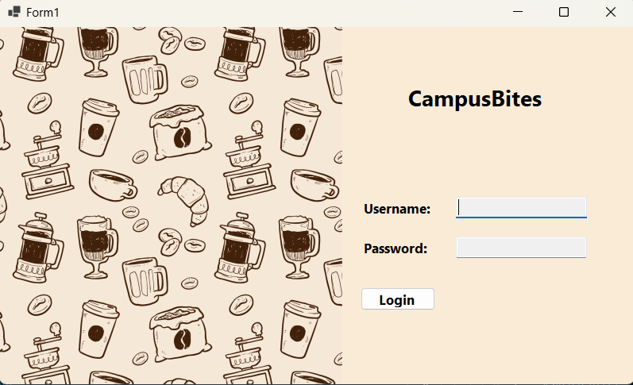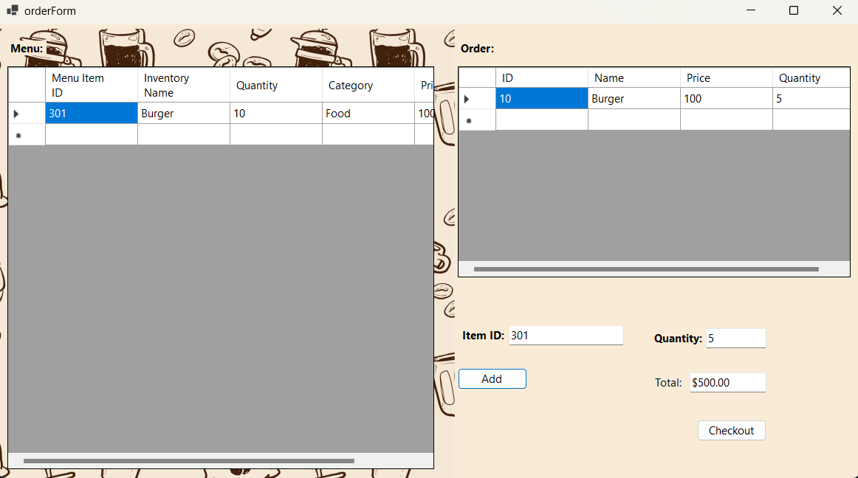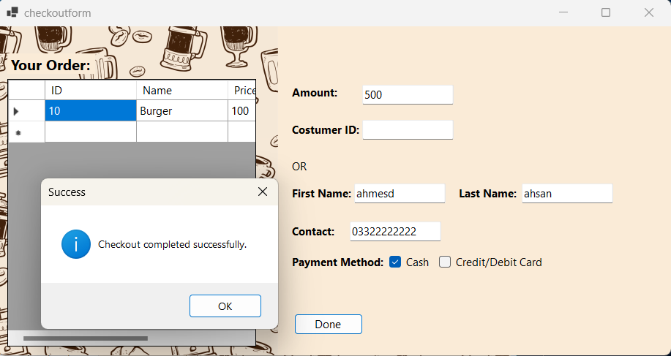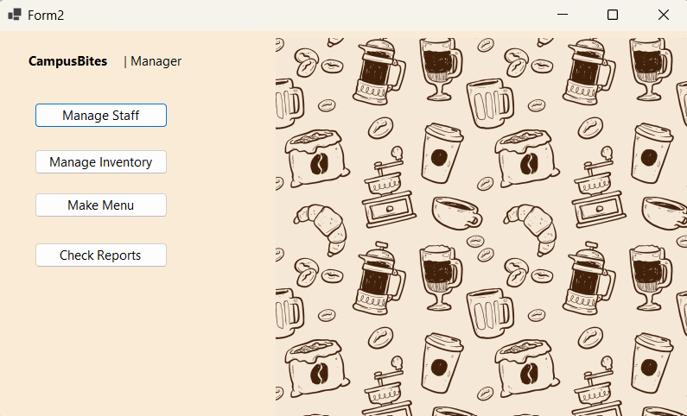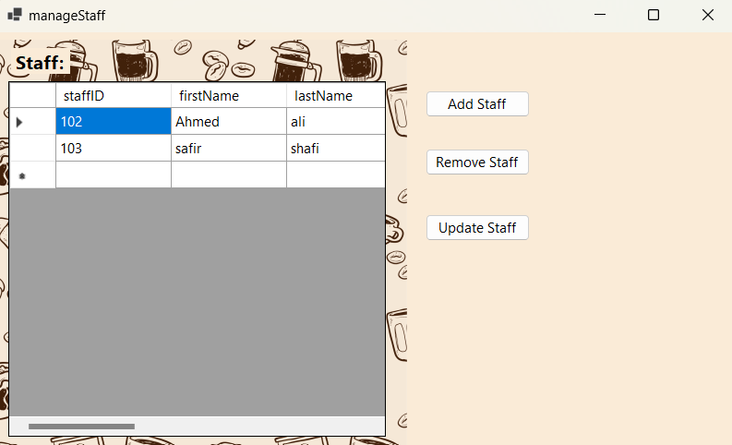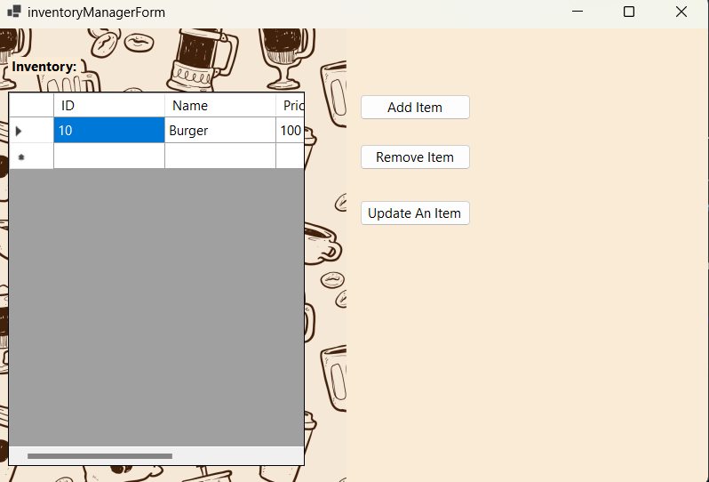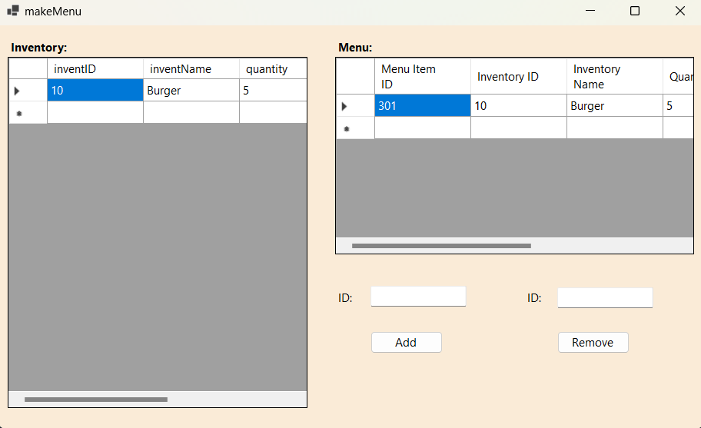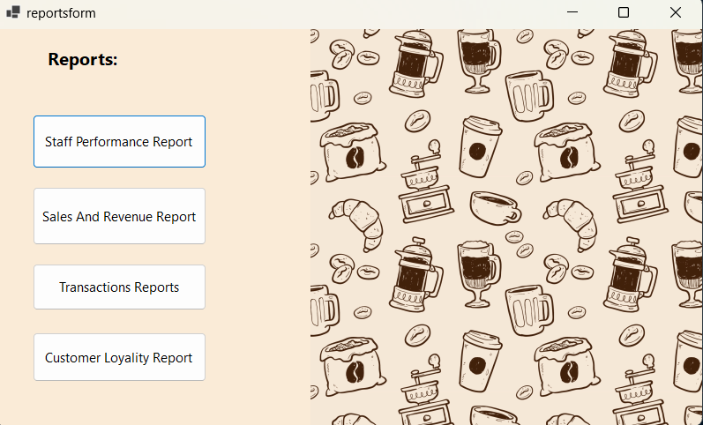

# Audit Trail:

We made the audit trail for our project by implementing a Trigger on every table which is doing insertion in one table Audit Trail.