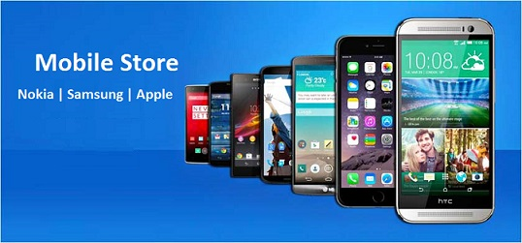

**Mobile Store** is the top Mobile provider company around the world. There are more than five different mobiles in the mobile store. The mobile store company wants to develop a desktop application using C sharp and Filing to maintain the records of Customer purchasing mobile. They also provide given below sample data for assistance in application development.

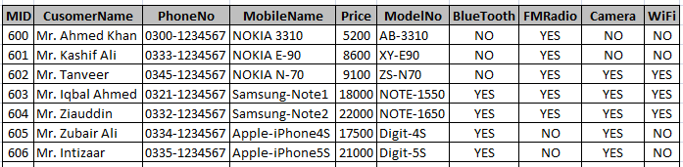

**Develop GUI for following given requirements:**

1. New Customer data must be inserted according to sample data.
2. New ID must be generated of each Customer.
3. Customer data must be searchable on the basis of Name and Phone No.
4. The record of Customer data must be deleted after confirmation of Yes/No message box on the double click event of Data Grid View on the basis of ID.
5. Separate GUI for the update of Customer data on the basis of ID.
6. Use of standard Tool box controls (MDI with child forms, Menus, Date Time Picker, Combo Box, Text Box, Labels, Radio buttons, Check box, Grid view, Picture box and other tools) are highly important.
7. Good colors and images can be used to develop GUI to attract Users.
8. Proper Login and New User Creation is required. Proper word documentation is must.