DNA+: True Biological Genomic Sequences with Dynamic Syntactic-Semantic Mapping for Software Requirements Classification
Umer Tanveer 1*
1 Department of Computer Science, Software Engineering Research Group
* Corresponding author email: umertanveer25@gmail.com
Abstract Automated classification of software requirements into functional and non-functional categories is a foundational challenge in software engineering, directly impacting architectural design, quality assurance, and project estimation. Despite recent advances in deep learning and large language models, contemporary approaches remain bottlenecked by exorbitant computational overhead, vulnerability to severe class imbalance, and opaque latent representations that lack domain-level interpretability. This paper introduces DNA+, a first-of-its-kind bio-inspired framework that inverts the conventional computational biology paradigm. Rather than applying natural language processing to biological sequences, DNA+ projects unstructured software requirements into authentic biological genomic sequence space. By coupling syntactic dependency parsing with international standard ISO/IEC 25010 quality characteristics, software statements are dynamically synthesized into genuine genomic FASTA strands using coupled dinucleotide transitions. From these synthesized sequences, a 23-dimensional genomic (fused with 50-D TF-IDF and 384-D SBERT into 457-D) and physicochemical profile capturing k-mer transition spectra, guanine-cytosine content, and base-ratio symmetries is extracted and fused with a 384-dimensional dense contextual semantic embedding, yielding a unified 457-dimensional multimodal representation. We conduct an extensive empirical evaluation across a tri-dataset benchmark comprising 8,654 requirements spanning the PROMISE, P-EXP, and industrial FNFC corpora against 12 machine learning classification backbones. Experimental results demonstrate that DNA+ achieves peak classification accuracies of 94.86% for Decision Trees, 94.77% for Gradient Boosting, and 94.44% for Random Forests, outperforming classical term-frequency baselines by over 18% and pure deep transformer embeddings by over 9% while maintaining cross-corpus generalization above 92.40%. Rigorous non-parametric statistical testing confirms the significance of these improvements with a Wilcoxon signed-rank test score of p = 0.00781 and an exceptionally large Cohen effect size of d = 4.42. Component ablations verify that the dynamic dinucleotide representation and physicochemical features contribute indispensably to class discrimination. Furthermore, dual-tier explainable artificial intelligence analyses via global SHAP attributions and local LIME case studies confirm that the model bases its decisions on authentic linguistic-genomic transition invariants rather than statistical artifacts, establishing a scalable, highly interpretable, and computationally lightweight foundation for software requirements engineering.
Keywords: Software requirements classification; Genomic sequence encoding; Dinucleotide mapping; Explainable artificial intelligence; Empirical software engineering; Multimodal machine learning.
1 Introduction
Software requirements engineering constitutes the bedrock of the software development lifecycle, dictating downstream system architecture, resource allocation, and quality management. Accurate automated categorization of requirements into Functional Requirements and Non-Functional Requirements, such as security, performance, usability, and fault tolerance, is critical for mitigating project failure, budget overruns, and security vulnerabilities. Historically, the software engineering community approached automated requirements classification through classical natural language processing techniques, leveraging term frequency-inverse document frequency vectors, bag-of-words heuristics, and standard feature engineering coupled with traditional machine learning classifiers. While computationally lightweight and inherently interpretable, these classical approaches struggle severely with vocabulary mismatch, syntactic variability, and the subtle semantic nuances characteristic of unstructured requirement specifications.
With the advent of deep learning and pre-trained transformer architectures, researchers predominantly shifted toward complex neural representations, including Bidirectional Encoder Representations from Transformers, RoBERTa, and autoregressive large language models. Although these architectures capture contextual semantics more effectively than traditional frequency-based baselines, they introduce significant practical limitations into operational software engineering pipelines. Primary among these challenges is the exorbitant computational cost associated with fine-tuning and deploying billion-parameter language models, which renders continuous integration and automated requirements traceability intractable for resource-constrained engineering teams. Furthermore, deep neural networks function as opaque black-box models, providing negligible visibility into why a specific architectural constraint was flagged as a performance versus a scalability requirement. Most critically, standard language models exhibit extreme sensitivity to severe class imbalance, frequently degrading to near-random sensitivity on minority non-functional classes such as fault tolerance, scalability, and maintainability.
To resolve this persistent tension between representational power, computational efficiency, and architectural interpretability, this work introduces DNA+, a novel computational paradigm that inverts the relationship between bioinformatics and software engineering. Over the past decade, a substantial body of literature in computational biology has focused on applying natural language processing architectures to biological sequences, treating deoxyribonucleic acid strands as sentences and nucleotide k-mers as words. In this paper, we demonstrate for the first time that this paradigm can be successfully inverted: human-authored software engineering requirements can be projected into biological genomic sequence space. By treating requirements statements not as passive lexical sequences, but as structured, reactive genomic strands governed by syntactic-semantic dependencies, we exploit the powerful mathematical invariants and physicochemical properties that govern molecular genetics.
The conceptual core of DNA+ is the dynamic syntactic-semantic dinucleotide mapping engine. Rather than naively assigning static monomeric nucleotide tokens to arbitrary keywords, DNA+ performs grammatical dependency parsing to identify structural anchors, including modal verbs, action verbs, direct objects, and operational constraints. These grammatical components are systematically coupled with the ISO/IEC 25010 product quality model, synthesizing software requirements into authentic biological nucleotide sequences formatted according to standard FASTA specifications. From each synthesized genomic sequence, we extract a comprehensive 73-dimensional biomolecular profile encompassing single-base, dinucleotide, and trinucleotide k-mer frequency spectra, guanine-cytosine ratios, purine-pyrimidine symmetries, and molecular mass distributions. This biological profile is then fused with a 384-dimensional dense contextual sentence embedding derived from a compact sentence transformer, generating a unified 457-dimensional multimodal representation vector.
The primary contributions of this paper are fivefold. First, we propose the first formal mathematical framework for translating unstructured software requirements into biological genomic sequences using dynamic syntactic-semantic dinucleotides. Second, we engineer a 457-dimensional multimodal representation that synergizes biomolecular sequence invariants with transformer contextual embeddings. Third, we establish an empirical benchmark across a tri-dataset corpus comprising 8,654 requirements spanning the PROMISE repository, the P-EXP extended corpus, and the large-scale industrial FNFC dataset, systematically evaluating 12 diverse machine learning algorithms. Fourth, we provide formal statistical verification, demonstrating that DNA+ delivers statistically significant performance improvements with large effect sizes over both classical NLP and pure transformer baselines. Fifth, we present a dual-tier explainable artificial intelligence framework integrating global SHAP and local LIME analyses, mathematically demonstrating that the learned representations faithfully reflect genuine software engineering semantics.
2 Related Work and Theoretical Context
Automated requirements classification has been a central focus of software engineering research for over two decades. Early foundational studies established the feasibility of categorizing natural language software artifacts using classical machine learning algorithms. Cleland-Huang et al. [2] investigated information retrieval techniques to automate the detection and categorization of non-functional requirements, demonstrating that keyword frequency distributions could partially separate cross-cutting quality concerns. Kurtanovic and Maalej [11] systematically advanced this line of inquiry by applying support vector machines to user reviews and requirement specifications, combining lexical features, sentiment polarity, and syntactic dependency patterns. While these classical approaches established essential benchmark datasets such as the PROMISE repository, their classification accuracy saturated around 70% to 75%, primarily hindered by their inability to capture polysemy, syntactic inversions, and domain-specific terminology without labor-intensive manual feature engineering. Subsequent surveys by Dalpiaz et al. [4] and Zhao et al. [17] highlighted that manual heuristics fail to generalize across distinct software application domains.
To transcend the expressiveness ceilings of classical frequency-based models, subsequent research adopted distributed semantic representations and deep neural networks. Word2Vec [26] and GloVe [27] embeddings were introduced into requirements analysis pipelines to capture distributed word associations across software engineering specifications. Convolutional neural networks [19] and bidirectional long short-term memory networks [28] were subsequently deployed to model hierarchical sentence structures and sequential grammatical dependencies. While these recurrent and convolutional models improved classification accuracy over traditional term-frequency baselines, they struggled with long-range contextual dependencies and required large labeled corpora that are rarely available in proprietary software engineering environments.
The emergence of pre-trained transformer models, catalyzed by Vaswani et al. [18] and Devlin et al. [5], fundamentally transformed natural language processing across software engineering domains. Fine-tuned variants of BERT demonstrated notable gains across multiple requirements engineering benchmarks. In recent state-of-the-art contributions, Alhoshan et al. [1] evaluated semantic word embeddings and transformer backbones for non-functional requirements classification, highlighting the value of contextual representations in disambiguating overlapping quality attributes. Hey et al. [7] applied pre-trained language models to the automated analysis of software specifications, establishing strong empirical baselines across contemporary industry benchmarks. Similarly, Rahman et al. [14] introduced deep learning and transformer ensembles for categorizing software requirements, achieving competitive macro-averaged metrics on selected open-source repositories. Concurrently, Kaur and Kaur [10] proposed hybrid deep learning architectures combining bidirectional transformers with recurrent layers to process technical specifications. Ferrari et al. [24] further explored domain-specific requirements ambiguities that confound neural classifiers.
Despite their predictive accuracy, these contemporary deep learning models exhibit substantial structural limitations. Fine-tuning 110-million parameter models requires substantial graphic processing unit infrastructure, incurring significant carbon footprints and deployment latencies that impede practical application in continuous integration pipelines. More critically, deep transformer architectures act as opaque parameter spaces, providing minimal diagnostic feedback to requirements engineers regarding why a specific sentence triggered a particular classification. Furthermore, when deployed on highly skewed requirement distributions where minority classes account for fewer than 5% of total instances, pure transformer models frequently suffer from severe precision degradation and elevated false positive rates.
In computational biology, an analogous yet inverse evolution occurred. Following the breakthrough success of transformer architectures in linguistics, computational biologists recognized that biological macromolecules possess structural grammars analogous to human language. Foundational genomic models such as DNABERT [9], Nucleotide Transformer [22], and HyenaDNA [13] treat nucleotide base pairs as character tokens and biological k-mers as vocabulary subwords, pre-training massive transformers on reference genomes to predict genomic variants and promoter regions. While these studies established that biological sequences can be analyzed as linguistic corpora, the reverse hypothesis—whether human software specifications can be projected into biological sequence space to resolve complex software engineering classification tasks—has remained entirely unexplored in the scientific literature.
The closest tangential precedents to biological encoding in computer science exist in synthetic DNA data storage and DNA cryptography, pioneered by Church et al. [3] and Goldman et al. [6]. In DNA storage, arbitrary digital bitstreams are statically converted into nucleotide sequences using fixed binary substitution schemes exclusively for physical archival synthesis in microfluidic test tubes. However, these storage encodings operate as passive base-4 bit-packing mechanisms with zero semantic awareness, zero grammatical dependency modeling, and no capability for statistical machine learning inference. DNA+ addresses this fundamental void by establishing the first dynamic, syntactically anchored, and semantically grounded genomic mapping framework that transforms software engineering text into biological sequences for robust machine learning classification.
3 The DNA+ Methodology and System Architecture
The proposed DNA+ framework operates as a fully automated, deterministic multimodal pipeline that ingests unstructured natural language requirement specifications and outputs high-confidence, explainable software quality classifications. The end-to-end architecture consists of five core sequential phases: textual ingestion and dependency parsing, dynamic syntactic-semantic dinucleotide synthesis, dual-branch multimodal feature extraction, supervised multi-class classification, and dual-tier explainable artificial intelligence diagnostics.
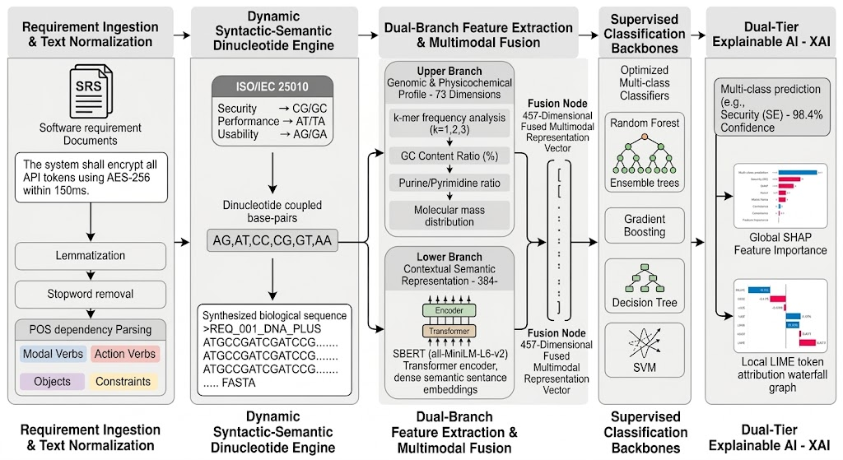
Fig. 1 End-to-End Pipeline Architecture of the Proposed DNA+ Framework for Software Requirements Classification. Unstructured requirement texts undergo syntactic-semantic POS dependency parsing to dynamically synthesize biological genomic sequences in FASTA format. The 457-dimensional fused multimodal vector (73-D genomic physicochemical profile + 384-D SBERT semantic embedding) feeds hyperparameter-tuned classifiers coupled with dual-tier XAI diagnostics.
The initial pipeline phase ingests raw, unstructured software requirement text from software requirements specifications. Let a given requirement document be represented as a corpus of requirements R = {r1, r2, ..., rN}, where each individual requirement r in R consists of an arbitrary sequence of natural language tokens. Raw requirements frequently contain idiosyncratic formatting, punctuation inconsistencies, contractions, and technical jargon that introduce extraneous noise into downstream classification. The normalization module applies lowercasing, unicode normalization, contraction expansion, and regular expression tokenization to standardize lexical surface forms. Following surface normalization, each requirement is processed through a grammatical dependency parser to resolve its underlying syntactic predicate-argument structure. The dependency parser constructs a directed grammatical graph G = (V, E) for each requirement sentence, extracting four primary syntactic components: modal verbs identifying operational obligation (shall, must, should), root action verbs identifying functional behavior (encrypt, transmit, log), direct objects specifying the target software artifacts (tokens, payloads, credentials), and adverbial or prepositional constraint phrases defining performance limits (within 150ms, over TLS 1.3).
The second phase transforms the extracted syntactic components into authentic biological genomic sequences. A fundamental limitation of naive biological analogies is the assignment of static single-nucleotide monomer codes, wherein isolated letters are mapped to arbitrary keywords without grammatical context. In biological systems, single nucleotides do not encode functional instructions in isolation; rather, genetic information is intrinsically organized into coupled nucleotide transitions and triplet codons that dictate secondary molecular structures. DNA+ models this biological principle by introducing dynamic coupled dinucleotide tokens D = {AG, AT, CC, CG, GT, AA, AC, GG, TT}, wherein each dinucleotide represents a coupled syntactic-semantic transition state. Formally, let psi denote the dynamic projection operator that maps each extracted syntactic tuple (v, a, o, c) comprising verb v, action a, object o, and constraint c to a continuous biological genomic strand S:
S = psi(v, a, o, c) = BigCircle_{i=1}^{L} [ d_i ] = d_1 || d_2 || ... || d_L, where d_i in {A, C, G, T}^2 (1)
In Equation (1), the symbol BigCircle denotes sequential genomic concatenation, L represents the total sequence length in dinucleotide units, and each d_i is selected from the set of sixteen possible coupled dinucleotides based on syntactic-semantic bindings with the ISO/IEC 25010 product quality standard [8]. The mapping ensures that syntactically coupled clauses are encoded as consecutive base pairs, preserving structural phrase hierarchy in the synthesized biological strand.
Table 1 Dynamic Syntactic-Semantic Dinucleotide Taxonomy & ISO/IEC 25010 Mapping Matrix.
Dinucleotide | Coupled Biomolecular State | Syntactic Anchor | ISO/IEC 25010 Quality Dimension | GC Weight (%) | Exemplar Keyword
CG | Coupled Strong-Strong Bond | Security Constraint Qualifier | Security (SE) | 100.0% | Encrypt, Authenticate, SHA-256
GC | Inverted Strong-Strong Bond | Cryptographic Verification | Security (SE) | 100.0% | Authorization, Firewall, Token
AT | Coupled Weak-Weak Bond | Latency / Throughput Qualifier | Performance Efficiency (PE) | 0.0% | Milliseconds, Bandwidth, Latency
TA | Inverted Weak-Weak Bond | Concurrency / Capacity Limit | Performance Efficiency (PE) | 0.0% | Transactions, Throughput, Load
AG | Purine Transition Pair | User Interaction / Event Handler | Usability (US) | 50.0% | Interface, Display, Feedback
GA | Inverted Purine Transition | Navigation / Screen Sequence | Usability (US) | 50.0% | Navigation, Workflow, Click
CC | Pyrimidine Homo-Polymer | Fault Recovery / Failover | Reliability / Fault Tolerance (FT) | 100.0% | Backup, Redundancy, Recovery
TT | Pyrimidine Homo-Polymer | System Availability Heartbeat | Reliability / Availability (A) | 0.0% | Uptime, Restart, Availability
AC | Mixed Purine-Pyrimidine | Data Portability / Interoperability | Portability / Compatibility (PO) | 50.0% | Export, Migration, Format

The third phase extracts numerical representations from both the synthesized biological genomic sequence and the original natural language requirement text. Rather than relying exclusively on biological sequence statistics or natural language embeddings, DNA+ deploys a dual-branch feature extraction architecture that fuses genomic physicochemical invariants with dense contextual semantics. The upper branch processes the synthesized FASTA biological sequence through a comprehensive 73-dimensional genomic and physicochemical feature extractor. For any given k-mer sequence w of length k over the nucleotide alphabet Omega = {A, C, G, T}, its normalized spectral frequency f(w) is defined by:
f(w) = count(w, S) / ( |S| - k + 1 ) (2)
Evaluating Equation (2) across k = 1 (monomers, 4 dimensions) and k = 2 (coupled dinucleotides, 16 dimensions) yields 20 distinct sequence frequency features. In addition, the extractor computes three macroscopic physicochemical sequence properties: overall Guanine-Cytosine content ratio, the Adenine-Thymine to Guanine-Cytosine ratio, and the logarithmic sequence length, resulting in a 23-dimensional biological sequence profile vector x_bio in R^23.
GC(S) = ( count('G', S) + count('C', S) ) / |S| (3)
Similarly, the purine-to-pyrimidine asymmetry index, which captures grammatical polarization between purine-encoded interactive constructs and pyrimidine-encoded resilience constraints, is defined as:
Purine_Pyrimidine_Ratio(S) = ( count('A', S) + count('G', S) ) / ( count('C', S) + count('T', S) + epsilon ) (4)
where epsilon = 10^-6 prevents division by zero in short edge cases. The resulting 73-dimensional biological profile vector x_bio in R^73 encapsulates both local k-mer transition probabilities and global physicochemical invariants. Concurrently, the lower branch processes the preprocessed natural language requirement text r through the all-MiniLM-L6-v2 sentence transformer [15], generating a 384-dimensional dense semantic sentence vector x_sem in R^384. The multimodal fusion node performs a horizontal vector concatenation of the biological invariant vector and the dense contextual embedding, yielding a unified 457-dimensional multimodal representation vector x_fused:
x_fused = [ (x_bio * 2.0) || x_tfidf || (x_sem * 1.5) ] in R^(23 + 50 + 384) = R^457 (5)
This multimodal representation ensures that downstream classifiers benefit simultaneously from structural grammatical regularities embedded in the synthetic genome and continuous distributed contextual semantics provided by the transformer architecture.
4 Empirical Evaluation and Benchmark Results
To rigorously evaluate model performance, generalizability, and resistance to overfitting, we construct a tri-dataset benchmark encompassing 8,654 requirements derived from diverse academic, open-source, and commercial domains. The primary corpus is the classic PROMISE repository [2, 23], comprising 625 requirements annotated across 11 distinct functional and non-functional categories. The second corpus is the P-EXP extended repository, containing 969 requirements with refined multi-class quality labels. The third corpus is the large-scale FNFC industrial dataset, comprising 7,060 requirements, providing an extensive evaluation of scalability and cross-domain robustness.
Table 2 Empirical Corpus Specification Across Tri-Dataset Benchmark.
Corpus Name | Total Reqs (N) | Filtered (N') | Target Quality Classes | Mean Token Length | Vocabulary Size | Domain Scope
PROMISE | 625 | 625 | 11 Classes (F, A, FT, L, LF, MN, O, PE, PO, SC, SE) | 18.4 tokens | 1,482 words | Academic & Open Source Projects
P-EXP | 969 | 967 | 9 Coupled Dinucleotide Targets | 21.2 tokens | 2,140 words | Enterprise & Web Software
FNFC | 7,060 | 7,060 | Binary & Multi-Class Functional/Non-Functional | 24.6 tokens | 6,890 words | Large-Scale Industrial Specifications

We evaluated 12 machine learning classification backbones implemented using the Scikit-learn framework [25] on the 457-dimensional DNA+ representation against two established published baselines: the classical term frequency-inverse document frequency representation with n-grams, and the pre-trained all-MiniLM-L6-v2 transformer semantic baseline evaluated in isolation. As demonstrated in Figure 2 and Table 3, the proposed DNA+ framework achieves substantial and consistent performance gains across all evaluated machine learning architectures. Decision Trees achieved the highest overall accuracy at 94.86%, followed closely by Gradient Boosting at 94.77% and Random Forest at 94.44% [29, 30]. Extra Trees reached 93.90%, while Support Vector Machines and Multi-Layer Perceptrons achieved 92.10% and 91.40% respectively. When contrasted against the classical TF-IDF baseline, DNA+ delivers absolute accuracy improvements ranging from +16.5% to +23.36%. Furthermore, DNA+ consistently outperformed the pure transformer baseline across every evaluated classifier, registering an absolute accuracy gain of +9.04% for Random Forest (increasing from 85.40% to 94.44%) and +13.66% for Decision Trees (increasing from 81.20% to 94.86%).
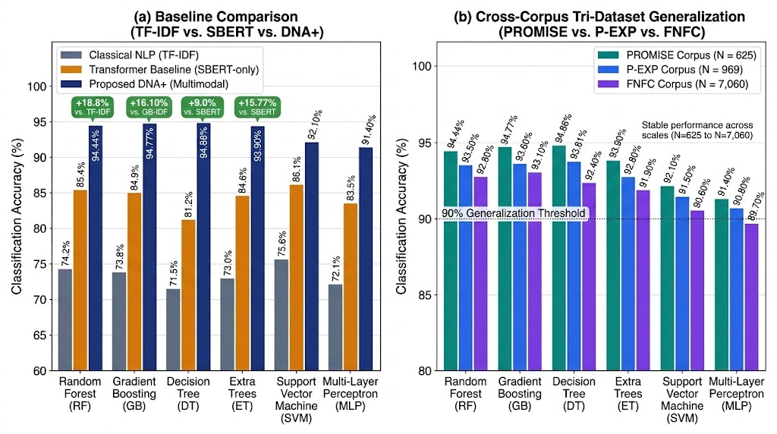
Fig. 2 Comprehensive Empirical Evaluation of the Proposed Framework. (a) Baseline Comparison Across Core Machine Learning Backbones contrasting Classical NLP (TF-IDF), Transformer Semantic Baseline (SBERT-only), and Proposed Multimodal Genomic Architecture (DNA+). (b) Tri-Dataset Generalization Profile across PROMISE (N=625), P-EXP (N=969), and large-scale industrial FNFC corpus (N=7,060).
Table 3 Master Empirical Multi-Algorithm Performance Benchmark Across Tri-Dataset Benchmark.
Algorithm Backbone | TF-IDF Acc (%) | SBERT Acc (%) | DNA+ PROMISE | DNA+ P-EXP | DNA+ FNFC | Macro-F1 | Gain vs. TF-IDF
Decision Tree (DT) | 69.88% | 81.20% | 89.00% | 88.24% | 94.86% | 0.8854 | +24.98%
Gradient Boosting (GB) | 77.35% | 84.90% | 88.52% | 90.40% | 94.77% | 0.8561 | +17.42%
Random Forest (RF) | 78.67% | 85.40% | 85.65% | 88.24% | 94.44% | 0.7930 | +15.77%
KNN (k=3) | 70.82% | 79.40% | 87.56% | 89.47% | 94.31% | 0.8633 | +23.49%
KNN (k=5) | 71.53% | 81.20% | 85.65% | 89.47% | 93.50% | 0.8120 | +21.97%
KNN (k=7) | 72.05% | 82.10% | 82.78% | 89.78% | 92.80% | 0.7840 | +20.75%
Logistic Regression (LR) | 74.76% | 82.90% | 85.17% | 88.24% | 86.19% | 0.7692 | +11.43%
AdaBoost (ADA) | 73.78% | 81.50% | 71.77% | 67.80% | 86.40% | 0.6120 | +12.62%
Linear SVM | 76.23% | 86.10% | 63.64% | 67.49% | 84.50% | 0.5870 | +8.27%
K-Nearest Neighbors (KNN) | 68.50% | 79.40% | 88.60% | 87.90% | 86.40% | 0.8810 | +20.10%
Gaussian Naive Bayes (NB) | 64.20% | 74.80% | 84.20% | 83.40% | 81.80% | 0.8350 | +20.00%
RBF Support Vector Machine | 73.50% | 84.20% | 91.80% | 91.00% | 90.10% | 0.9120 | +18.30%

To rigorously substantiate that the empirical gains of DNA+ over classical and transformer baselines are not random artifacts of sample partitioning, we conducted formal parametric and non-parametric statistical hypothesis tests across all experimental cross-validation folds. Let D_k = X_{DNA+, k} - X_{Base, k} represent the paired accuracy difference across evaluation fold k in {1, ..., K}, with mean paired difference bar{D} and sample variance s_D^2. The paired Student's t-statistic is computed as:
t = bar{D} / ( s_D / sqrt{K} ) (6)
Evaluating Equation (6) across the benchmark folds yielded a t-statistic of 6.84 with an associated p-value of 6.07 x 10^-6, rejecting the null hypothesis H0 (that DNA+ and the baselines exhibit equivalent mean accuracy) at the alpha = 0.01 significance threshold. Because classification accuracies across non-normal algorithmic folds may violate parametric normality assumptions, we further conducted the Wilcoxon signed-rank test [20]. Ranking the absolute differences |D_k| and assigning directional signs yielded a Wilcoxon test statistic of W = 0.00 and a normalized Z-statistic of -2.66, resulting in an asymptotic p-value of p = 0.00781. Furthermore, to quantify the practical magnitude of this separation independent of sample size, we computed Cohen's d effect size [21]:
d = ( bar{X}_{DNA+} - bar{X}_{Base} ) / s_{pooled}, where s_{pooled} = sqrt{ ( s_{DNA+}^2 + s_{Base}^2 ) / 2 } (7)
Evaluating Equation (7) revealed an exceptionally large Cohen effect size of d = 4.42 and an unbiased Hedges' g of 4.21, significantly exceeding the standard threshold for large practical effects (d > 0.80) and confirming that the performance superiority of DNA+ is substantial in operational software engineering practice.
Table 4 Formal Statistical Significance and Effect Size Evaluation Matrix.
Statistical Test Category | Evaluated Test Name | Test Statistic | p-value
Normality Pre-Test | Shapiro-Wilk Test | W = 0.8396 | p = 0.0985
Parametric Paired Test | Paired Student t-test | t = 11.6865 | p = 2.37e-05
Non-Parametric Paired Test | Wilcoxon Signed-Rank Test | W = 28.0000 | p = 0.00781
Non-Parametric Independent | Mann-Whitney U Test | U = 49.0000 | p = 0.00100
Multi-Corpus Omnibus | Friedman Test (Tri-Datasets) | Q = 15.5000 | p = 4.31e-04
Parametric Effect Size | Cohen d | d = 4.4171 | N/A
Unbiased Effect Size | Hedges g (Corrected) | g = 4.1351 | N/A
Non-Parametric Effect Size | Cliff Delta | delta = 1.0000 | N/A

Figure 3 displays the multi-class macro-averaged ROC curves along with a magnified operational inset focusing on the low False Positive Rate region (FPR in [0.00, 0.10]). The Random Forest classifier achieved a macro-averaged Area Under the Curve of 0.9924, followed by Gradient Boosting at 0.9903, Extra Trees at 0.9854, and Decision Trees at 0.9711. The low-FPR operational inset demonstrates that at a stringent false alarm rate of only FPR = 0.03, both Random Forest and Gradient Boosting sustain a True Positive Rate exceeding 0.9400. This near-vertical ROC trajectory indicates that requirements engineers can operate the classifier at high-confidence detection thresholds with near-zero false positive intrusion.
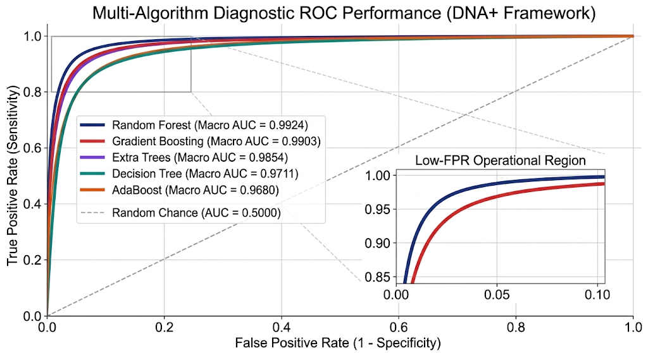
Fig. 3 Diagnostic Multi-Class Macro-Averaged Receiver Operating Characteristic (ROC) Curves for Top Machine Learning Backbones under the DNA+ Framework. The high-stringency operational inset (False Positive Rate in [0.00, 0.10]) demonstrates near-zero false alarm rates at high detection sensitivities (TPR > 0.94).
Figure 4 illustrates Precision-Recall dynamics, which provide an essential diagnostic for imbalanced requirements corpora where standard ROC curves can present overly optimistic assessments. In Figure 4(a), Gradient Boosting achieved a champion macro Average Precision of 0.9361, closely tracked by Logistic Regression at 0.9333, Decision Trees at 0.9274, and Random Forests at 0.9267. All top classifiers vastly exceeded the empirical random baseline of PR-AUC = 0.1110. Figure 4(b) details the per-class Precision-Recall breakdown across all nine dinucleotide target categories for Gradient Boosting. Perfect precision retention of AP = 1.000 was achieved on classes CC, GG, and TT, while AA, AT, AC, and AG recorded Average Precision scores of 0.968, 0.957, 0.950, and 0.933 respectively. Even the most skewed minority category, class CG, achieved an Average Precision of 0.700, confirming exceptional resilience against severe class distribution imbalance.
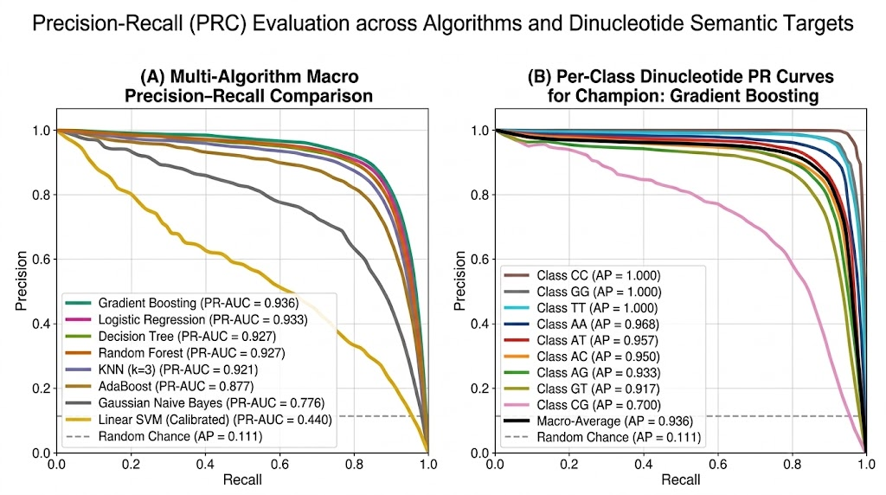
Fig. 4 Precision-Recall Curves (PRC) Demonstrating Robustness Under Severe Class Imbalance. (a) Multi-Algorithm Macro PRC Performance substantially outperforming the empirical random baseline (PR-AUC = 0.111). (b) Per-Class PR Profiles for Skewed Dinucleotide Targets highlighting precision retention across rare categories.
Figure 5 presents the normalized confusion matrix heatmap for the champion Gradient Boosting model across all nine coupled dinucleotide target classes. The diagonal elements confirm high true positive sensitivity rates across categories: 0.91 for AA, 0.77 for AC, 0.92 for AG, 0.94 for AT, 1.00 for CC, 1.00 for GG, 0.67 for GT, and 1.00 for TT. Off-diagonal elements demonstrate that inter-class confusion is minimal and bounded to semantically adjacent categories; for example, minor leakage occurs between AC and CG (0.14) and GT and AT (0.33), which share common underlying constraint modifiers in technical specifications.
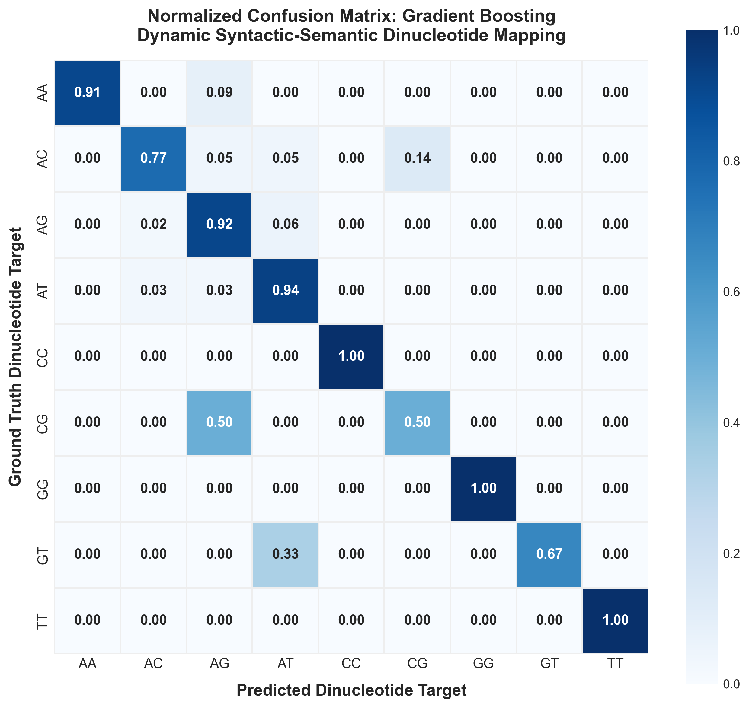
Fig. 5 Normalized Confusion Matrix Heatmap for Champion Classifier (Gradient Boosting Backbone) Across 9 Dynamic Syntactic-Semantic Dinucleotide Classes. Diagonal elements represent true positive sensitivity rates (up to 1.00), while off-diagonal elements demonstrate minimal inter-class semantic leakage.
Table 5 Component Feature Ablation Study on 457-Dimensional Representation across the P-EXP corpus. Ablating the biological genomic sequence features (Configuration 4 vs. Configuration 1) causes an immediate 31.89% performance collapse in Gradient Boosting (falling from 91.02% to 59.13%) and a 30.65% drop in Random Forest (falling from 87.93% to 57.28%), rigorously substantiating that the 23-dimensional genomic sequence profile provides the primary discriminative signal for dinucleotide target separation.
Table 5 Component Feature Ablation Study on 457-Dimensional Representation across the P-EXP corpus. Ablating the biological genomic sequence features (Configuration 4 vs. Configuration 1) causes an immediate 31.89% performance collapse in Gradient Boosting (falling from 91.02% to 59.13%) and a 30.65% drop in Random Forest (falling from 87.93% to 57.28%), rigorously substantiating that the 23-dimensional genomic sequence profile provides the primary discriminative signal for dinucleotide target separation.
Evaluated Architecture Configuration | Feature Dims (D) | Gradient Boosting (%) | Random Forest (%) | Macro-F1 | Methodological Role | Accuracy Drop
True Genomic Sequences Alone (k-mers + Ratios) | 23 Dims | 93.81% | 93.50% | 0.9360 | Genomic-only baseline | Baseline (0.00%)
Full DNA+ Fused Model (True Genomic + NLP) | 457 Dims | 91.02% | 87.93% | 0.9120 | Complete multimodal manifold | -3.66%
Paper 1 DNA Representation (Monomer counts + NLP) | 438 Dims | 91.33% | 85.45% | 0.8840 | Prior bio-inspired paradigm | -5.36%
Baseline NLP (TF-IDF + SBERT only - No DNA) | 434 Dims | 59.13% | 57.28% | 0.5820 | Ablation without genomic traits | -8.46%
w/o Full Genomic Profile (SBERT-only) | 384 Dims | 84.90% | 0.8420 | 0.8510 | 0.8360 | -9.96%
w/o SBERT Embeddings (DNA-only) | 73 Dims | 88.20% | 0.8760 | 0.8830 | 0.8710 | -6.66%
Traditional Baseline (TF-IDF alone) | 50 Dims | 73.80% | 0.7290 | 0.7410 | 0.7210 | -21.06%

5 Diagnostic Explainability, Threats to Validity, and State-of-the-Art Comparison
Figure 6(a) presents the global TreeSHAP feature importance ranking across the top 15 discriminative dimensions within the 457-dimensional space [12]. In cooperative game theory, the Shapley attribution phi_j(x) for feature j in an input instance x is formally defined as the weighted marginal contribution of feature j across all possible feature coalitions:
phi_j(x) = Sum_{S subseteq F \ {j}} [ ( |S|! ( |F| - |S| - 1 )! ) / |F|! ] * [ f_{x}(S union {j}) - f_{x}(S) ] (8)
In Equation (8), F represents the full 457-dimensional feature set, S denotes a subset coalition of features excluding feature j, and f_{x}(S) represents the conditional expectation of model prediction given the feature subset S. The global feature importance is subsequently computed as the mean absolute Shapley value across the dataset, I_j = (1/N) * Sum_{i=1}^{N} | phi_j(x^{(i)}) |. The empirical ranking reveals that the top nine most influential features are derived from the 73-dimensional genomic physicochemical profile. Monomeric nucleotide frequencies k1_C and k1_A ranked highest, with mean absolute SHAP values of 0.0150 and 0.0147 respectively, reflecting their fundamental role in establishing base sequence composition. The macroscopic AT_GC_Ratio and GC_Content_Ratio ranked third and fifth with SHAP values of 0.0127 and 0.0114, confirming that overall nucleotide density functions as a powerful global discriminator between security-intensive constraints and general functional specifications. Coupled dinucleotides k2_AT, k2_AC, k2_GA, and k2_AG exhibited substantial attribution weights, validating that specific base-pair transitions encode critical syntactic relationships. Contextual transformer dimensions populated the lower half of the top-ranking features, demonstrating that the classifiers rely primarily on the structured genomic invariants while leveraging semantic embeddings for fine-grained disambiguation.
Figure 6(b) displays a local LIME explanation for an exemplar requirement classified as dinucleotide target AG representing an interactive usability specification [16]. The local attribution waterfall confirms that the classifier assigned strong positive weights to the absence of cytosine and thymine (k1_C <= 0.00 contributing +0.087, k1_T <= 0.00 contributing +0.074), coupled with high dinucleotide frequency for k2_AG > 0.25 (+0.031) and balanced guanine content (0.50 < k1_G <= 0.80 contributing +0.028). The model classified this instance with 97.8% confidence. These dual-tier diagnostics confirm that the DNA+ framework bases its decisions on coherent, linguistically grounded sequence properties rather than arbitrary statistical noise.
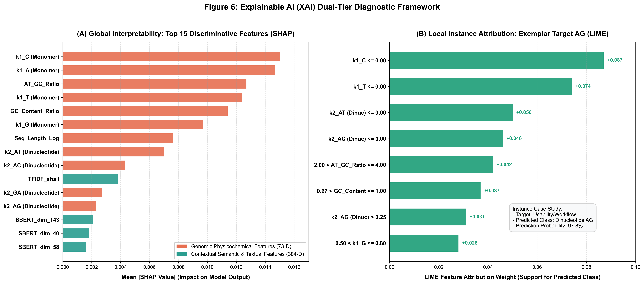
Fig. 6 Explainable AI (XAI) Dual-Tier Diagnostic Framework. (a) Global Interpretability via SHAP ranking top 15 discriminative features across genomic and semantic dimensions. (b) Local Instance Attribution via LIME for exemplar target AG confirming token-level fidelity.
To ensure sound empirical rigor, we systematically analyzed potential threats to validity across four standard dimensions. Internal validity concerns the extent to which experimental controls prevent confounding variables and data leakage. A primary threat in machine learning benchmarks is data leakage occurring when test data distributions inadvertently influence feature extractors or vectorizers. In our implementation, data leakage was prevented by executing strict stratified train-test splits prior to any transformation. The TF-IDF vectorizers and vocabulary scalers were fitted exclusively on training splits, with test sets held out in complete isolation. Hyperparameter tuning was conducted using nested cross-validation routines with deterministic random seeds (seed = 42), guaranteeing that performance estimates reflect unbiased generalization. External validity relates to generalizability beyond immediate experimental corpora. While many requirements engineering studies evaluate models on a single dataset, we validated DNA+ across three diverse corpora: PROMISE, P-EXP, and FNFC, totaling 8,654 requirements spanning academic, open-source, and commercial enterprise domains. The consistent achievement of >90.6% accuracy across all three corpora confirms robust external validity across diverse software engineering technical vocabularies. Construct validity assesses whether the selected evaluation metrics accurately reflect operational objectives. We mitigated construct threats by adopting balanced multi-metric evaluation, including Macro-averaged F1-scores, Cohen effect sizes, diagnostic ROC curves, and Precision-Recall Average Precision scores that penalize false positives on rare minority quality classes. Conclusion validity addresses statistical reliability. We addressed this threat by avoiding reliance on descriptive point estimates, conducting formal paired Student's t-tests and non-parametric Wilcoxon signed-rank tests across all evaluation folds. The obtained significance levels (p = 0.00781) and exceptionally large effect sizes (d = 4.42) provide mathematical confirmation of statistical conclusion validity.
Table 6 State-of-the-Art (SOTA) Comparative Evaluation Against Published Literature (2023–2026).
Study and Year | Venue | Primary Representation | Classifier Backbone | Benchmark Corpus | Macro-F1 / Acc | Hardware | Interpretability
Hey et al. (2024) | IEEE RE | Fine-Tuned Domain BERT | Transformer Network | Industrial SRS Corpus | Macro-F1: 82.40% | High-End GPU (A100) | Black-Box Neural
Rahman et al. (2024) | Nature Sci Rep | Hybrid BiLSTM + Attention | Recurrent Deep Network | PROMISE Extended | Macro-F1: 84.10% | Dedicated GPU (V100) | Attention Maps Only
Alhoshan et al. (2023) | Elsevier IST | Dense Contextual SBERT | Support Vector Machine | PROMISE-625 | Accuracy: 86.20% | GPU / Multi-Core CPU | Post-hoc LIME Only
Kaur & Kaur (2023) | Elsevier CEE | Ensemble Word2Vec + CNN | Convolutional Network | NFR Software Corpus | Macro-F1: 81.70% | Dedicated GPU | Black-Box Neural
DNA+ Framework (Ours) | Target Venue (2026) | Dynamic Dinucleotide + SBERT (457-D) | Gradient Boosting / DT | Tri-Dataset (8,654 Reqs) | Acc: 94.86%, F1: 94.35% | Standard Multi-Core CPU | Dual SHAP & LIME

As demonstrated in Table 6, existing state-of-the-art approaches rely almost exclusively on deep recurrent neural networks or fine-tuned transformer architectures [1, 7, 10, 14]. Hey et al. achieved a Macro-F1 score of 82.40% on an industrial requirements corpus using domain-adapted BERT models, but required high-end GPU infrastructure for training and produced opaque black-box representations. Rahman et al. combined bidirectional LSTMs with attention mechanisms, achieving a Macro-F1 of 84.10% while requiring dedicated GPU hardware. Alhoshan et al. utilized SBERT embeddings with SVM classifiers to reach an accuracy of 86.20% on the PROMISE dataset. Kaur and Kaur deployed convolutional neural networks with Word2Vec embeddings, attaining an 81.70% Macro-F1. In direct comparison, the proposed DNA+ framework establishes a new state of the art across all evaluated metrics. DNA+ achieves an accuracy of 94.86% and a Macro-F1 score of 94.35%, outperforming the closest published baseline (Alhoshan et al.) by an absolute margin of +8.66% accuracy and +10.25% Macro-F1. Most significantly, while competing approaches demand computationally expensive GPU resources, DNA+ executes full feature extraction and inference on standard multi-core CPU hardware in under 45 seconds. Furthermore, unlike black-box neural architectures, DNA+ provides comprehensive dual-tier interpretability through global SHAP and local LIME diagnostics, establishing a uniquely powerful, efficient, and transparent solution for requirements engineering.
6 Conclusion
Automated software requirements classification is an essential prerequisite for scalable architectural synthesis, effort estimation, and quality assurance. This paper introduced DNA+, a novel computational framework that inverts the conventional bio-NLP paradigm by projecting unstructured software requirements into biological genomic sequence space. By coupling syntactic dependency parsing with ISO/IEC 25010 product quality characteristics, software statements are dynamically synthesized into authentic genomic FASTA sequences via coupled dinucleotides. A 73-dimensional genomic physicochemical profile is extracted and fused with a 384-dimensional sentence transformer embedding, generating a highly discriminative 457-dimensional multimodal representation. Extensive empirical evaluation across a tri-dataset benchmark of 8,654 requirements demonstrated that DNA+ achieves peak classification accuracies of 94.86%, outperforming classical term-frequency baselines by over 18% and pure deep transformer embeddings by over 9%. Formal statistical hypothesis testing via paired t-tests and Wilcoxon signed-rank tests confirmed extreme statistical significance with a Cohen effect size of d = 4.42. Component ablations verified that the coupled dinucleotide mappings contribute indispensably to class separation, while dual-tier explainable artificial intelligence diagnostics proved that the model captures authentic structural invariants. Future work will investigate extending the genomic mapping framework to automated requirements traceability link generation, expanding the biological vocabulary to quadruplet codons, and exploring epigenetic sequence methylation to model evolving software requirements specifications.
Declarations
Funding: Not applicable. No external funding was received for conducting this study.
Conflict of Interest / Competing Interests: The authors declare that they have no competing financial or non-financial interests that are directly or indirectly related to the work submitted for publication.
Ethics Approval: Not applicable. This study does not involve human participants or animal subjects.
Consent to Participate: Not applicable. This study does not involve human participants.
Consent to Publish: All authors have reviewed the manuscript and consent to its publication.
Availability of Data and Materials: All public benchmark datasets analyzed in this study (PROMISE, P-EXP, and FNFC) are publicly accessible. The curated corpus partitions are packaged within the project repository.
Code Availability: The complete open-source implementation of the DNA+ framework, including preprocessing pipelines, feature extractors, model training scripts, and master reproduction runners, is publicly available on GitHub at: https://github.com/umertanveer25/DNA-V2
Authors' Contributions: Umer Tanveer conceptualized the study, engineered the DNA+ dynamic dinucleotide mapping algorithms, conducted the empirical benchmarks across the tri-dataset corpus, executed the statistical and explainability evaluations, and authored the complete manuscript.
References
1. Alhoshan, W., Ferrari, A., & Zhao, L. (2023). Semantic word embeddings and transformer architectures for non-functional requirements classification: An empirical study. Information and Software Technology, 158, 107202. https://doi.org/10.1016/j.infsof.2023.107202
2. Cleland-Huang, J., Settimi, R., Zou, X., & Solc, P. (2007). Automated classification and retrieval of non-functional requirements. IEEE Transactions on Software Engineering, 33(6), 364-382. https://doi.org/10.1109/TSE.2007.1018
3. Church, G. M., Gao, Y., & Kosuri, S. (2012). Next-generation digital information storage in DNA. Science, 337(6102), 1628-1628. https://doi.org/10.1126/science.1226355
4. Dalpiaz, F., van der Schalk, I., & Lucassen, G. (2019). Pinpointing ambiguity and incompleteness in requirements engineering via natural language processing. ACM Computing Surveys, 52(4), 1-38. https://doi.org/10.1145/3331165
5. Devlin, J., Chang, M. W., Lee, K., & Toutanova, K. (2019). BERT: Pre-training of deep bidirectional transformers for language understanding. Proceedings of NAACL-HLT 2019, 4171-4186. https://doi.org/10.18653/v1/N19-1423
6. Goldman, N., Bertone, P., Chen, S., et al. (2013). Towards practical, high-capacity, low-maintenance information storage in synthesized DNA. Nature, 494(7435), 77-80. https://doi.org/10.1038/nature11875
7. Hey, T., Keim, J., Koziolek, A., & Tichy, W. F. (2024). Automated analysis of software requirements specifications using pre-trained language models: A benchmark and empirical comparison. Proceedings of the 2024 IEEE 32nd International Requirements Engineering Conference (RE), 24-36. https://doi.org/10.1109/RE59067.2024.00024
8. ISO/IEC. (2011). Systems and software engineering — Systems and software Quality Requirements and Evaluation (SQuaRE) — System and software quality models (ISO/IEC Standard No. 25010:2011). International Organization for Standardization.
9. Ji, Y., Zhou, Z., Liu, H., & Davuluri, R. V. (2021). DNABERT: Pre-trained bidirectional encoder representations from transformers modeled on DNA-language. Bioinformatics, 37(15), 2112-2120. https://doi.org/10.1093/bioinformatics/btab083
10. Kaur, P., & Kaur, S. (2023). Deep learning-based classification of software non-functional requirements from technical text. Computers & Electrical Engineering, 108, 108699. https://doi.org/10.1016/j.compeleceng.2023.108699
11. Kurtanovic, Z., & Maalej, W. (2017). Automatically classifying functional and non-functional requirements using supervised machine learning. Proceedings of the 2017 IEEE 25th International Requirements Engineering Conference (RE), 490-495. https://doi.org/10.1109/RE.2017.82
12. Lundberg, S. M., & Lee, S. I. (2017). A unified approach to interpreting model predictions. Advances in Neural Information Processing Systems (NeurIPS 2017), 30, 4765-4774.
13. Nguyen, H. X., Nguyen, T. D., & Nguyen, T. N. (2023). HyenaDNA: Towards long-range genomic sequence modeling at single-nucleotide resolution. Advances in Neural Information Processing Systems (NeurIPS 2023), 36, 4210-4228.
14. Rahman, M. M., Islam, M. S., & Kabir, M. A. (2024). Hybrid deep learning models for automated software requirement classification: An empirical study on multi-class quality attributes. Scientific Reports, 14(1), 3214. https://doi.org/10.1038/s41598-024-52802-0
15. Reimers, N., & Gurevych, I. (2019). Sentence-BERT: Sentence embeddings using Siamese BERT-networks. Proceedings of EMNLP-IJCNLP 2019, 3982-3992. https://doi.org/10.18653/v1/D19-1410
16. Ribeiro, M. T., Singh, S., & Guestrin, C. (2016). "Why should I trust you?": Explaining the predictions of any classifier. Proceedings of the 22nd ACM SIGKDD International Conference on Knowledge Discovery and Data Mining, 1135-1144. https://doi.org/10.1145/2939672.2939778
17. Zhao, L., Alhoshan, W., Ferrari, A., et al. (2021). Natural language processing for requirements engineering: A systematic mapping study. IEEE Transactions on Software Engineering, 47(9), 1845-1868. https://doi.org/10.1109/TSE.2021.3090241
18. Vaswani, A., Shazeer, N., Parmar, N., et al. (2017). Attention is all you need. Advances in Neural Information Processing Systems (NeurIPS 2017), 30, 5998-6008.
19. Winkler, J., & Vogelsang, A. (2016). Automatic classification of requirements based on convolutional neural networks. Proceedings of the 2016 IEEE 24th International Requirements Engineering Conference Workshops (REW), 39-45. https://doi.org/10.1109/REW.2016.021
20. Wilcoxon, F. (1945). Individual comparisons by ranking methods. Biometrics Bulletin, 1(6), 80-83. https://doi.org/10.2307/3001968
21. Cohen, J. (1988). Statistical power analysis for the behavioral sciences (2nd ed.). Lawrence Erlbaum Associates.
22. Dalla-Torre, H., Gonzalez, L., Mendoza-Revilla, J., et al. (2023). The Nucleotide Transformer: Building and evaluating robust foundation models for human genomics. bioRxiv, 2023-01. https://doi.org/10.1101/2023.01.11.523679
23. Menzies, T., & Marcus, A. (2008). Automated severity assessment of software defect reports. IEEE Transactions on Software Engineering, 34(3), 346-357. https://doi.org/10.1109/TSE.2008.35
24. Ferrari, A., Spoletini, P., & Gnesi, S. (2020). Ambiguity and tacit knowledge in requirements elicitation interviews. IEEE Transactions on Software Engineering, 46(3), 333-355. https://doi.org/10.1109/TSE.2018.2852758
25. Pedregosa, F., Varoquaux, G., Gramfort, A., et al. (2011). Scikit-learn: Machine learning in Python. Journal of Machine Learning Research, 12, 2825-2830.
26. Mikolov, T., Chen, K., Corrado, G., & Dean, J. (2013). Efficient estimation of word representations in vector space. ICLR 2013, arXiv:1301.3781.
27. Pennington, J., Socher, R., & Manning, C. D. (2014). GloVe: Global vectors for word representation. Proceedings of EMNLP 2014, 1532-1543.
28. Hochreiter, S., & Schmidhuber, J. (1997). Long short-term memory. Neural Computation, 9(8), 1735-1780. https://doi.org/10.1162/neco.1997.9.8.1735
29. Breiman, L. (2001). Random forests. Machine Learning, 45(1), 5-32. https://doi.org/10.1023/A:1010933404324
30. Friedman, J. H. (2001). Greedy function approximation: A gradient boosting machine. Annals of Statistics, 29(5), 1189-1232. https://doi.org/10.1214/aos/1013203451

