Umer waleed

D18124701

Web development 2

Project Umer’s Library

1. Index.php

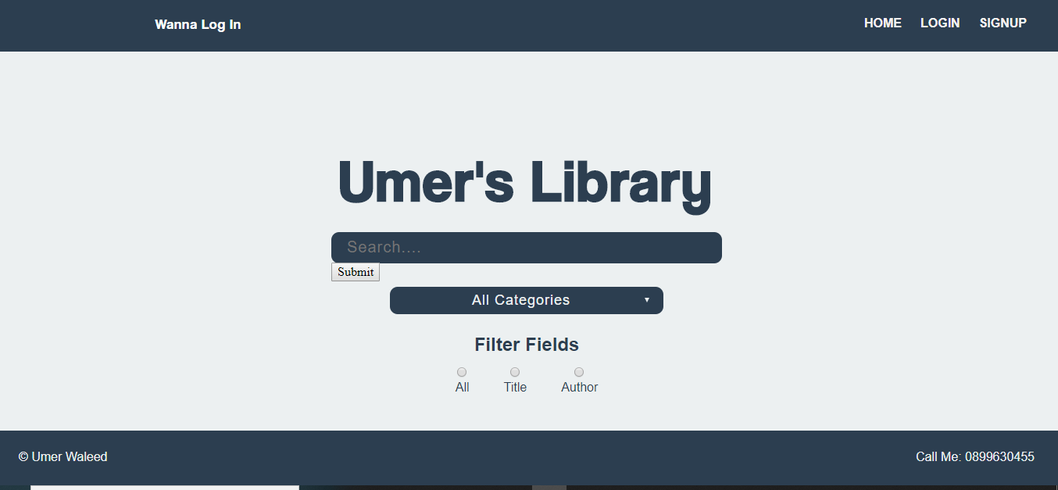

This is the index page of my website also home page of website it will offer user a nav bar with the help of that they can register there self in the library database and in nav bar link to my login page is also given to user with the help of that exixtance user can also login into his account or her account then in main section I have created my own libratry logo it will print the logo in the middle of the page and then there are two search bars they are connected to the one submit button if user will enter the button it will perfom the action and go to the search.php

---------------------------------------------------------------------------------------------------------------------------

Code of index.php

<?php

session_start();

include 'dbh.php';

?>

<!DOCTYPE html>

<html lang="en">

<head>

<meta charset="utf-8">

<meta name="viewport" content="width=device-width, initial-scale=1.0">

<link rel="stylesheet" href="normalize.css">

<link rel="stylesheet" href="style.css">

<title>Umer's Library</title>

</head>

<body>

<div class="page-wrap">

<header>

<div class="container">

<?php

if(isset($_SESSION['username']))

{

echo '<div class="float_left">

<p class="top_heading"><sapn id="top">WellCome</sapn</p>

</div>';

}

else

{

echo '<div class="float_left">

<p class="top_heading"><sapn id="top">Wanna Log In</sapn</p>

</div>';

}

?>

<nav>

<ul>

<li><a href="index.php"><span>HOME</span></a></li>

<li><a href="Login.php"><span>LOGIN</span></a></li>

<li><a href="signup.php"><span>SIGNUP</span></a></li>

</ul>

</nav>

</div>

</header>

<main>

<div class="container">

<form action="search.php" method="GET">

<h1>Umer's Library</h1>

<div class="search_engine">

<div class="search_bar">

<div class="search_box">

<input type="text" name="search" placeholder="Search....">

<button style="background:black; broder:0px;" type="submit" name="submit-search"><img src="magnifying-glass.png" alt="search-icon" height="25" width="25"></button>

</div>

</div>

</div>

<div class="search_filter">

<div class="categories_section">

<div class="category-dropdown">

<select name="category">

<option class="options" value="" selected>All Categories</option>

<option class="options" value="1">Health</option>

<option class="options" value="2">Business</option>

<option class="options" value="3">Biography</option>

<option class="options" value="4">Technology </option>

</select>

</div>

</div>

<div class="search-by_section">

<h2>Filter Fields</h2>

<div class="filter_options">

<div class="radio-button_group">

<input type="radio" name="search-by" value="All" id="radio-1">

<label for="radio-1">All</label>

</div>

<div class="radio-button_group">

<input type="radio" name="search-by" value="Title" id="radio-2">

<label for="radio-2">Title</label>

</div>

<div class="radio-button_group">

<input type="radio" name="search-by" value="Author" id="radio-3">

<label for="radio-3">Author</label>

</div>

</div>

</div>

</div>

</form>

</div>

</main>

</div>

<footer>

<div class="container">

<p class="footer-left">&copy; Umer Waleed</p>

<p class="footer-right">Call Me: 0899630455</p>

</div>

</footer>

</body>

</html>

---------------------------------------------------------------------------------------------------------------------------

1. Dbh.php

This is the file I included in every file because this is the connection file for my database I have put the connection in to variable called $conn dollar sign is the way to define the variable in php my database connection is in localhost /root/ /librarydb this is we can make our code more efficient because we are not using or AKA DRY don’t repeat yourself

---------------------------------------------------------------------------------------------------------------------------

Code of Dbh.php

<?php

$server = 'localhost';

$username = 'root';

$password = '';

$database = 'librarydb';

$conn = mysqli_connect($server,$username,$password,$database);

?>

---------------------------------------------------------------------------------------------------------------------------

1. Login.php

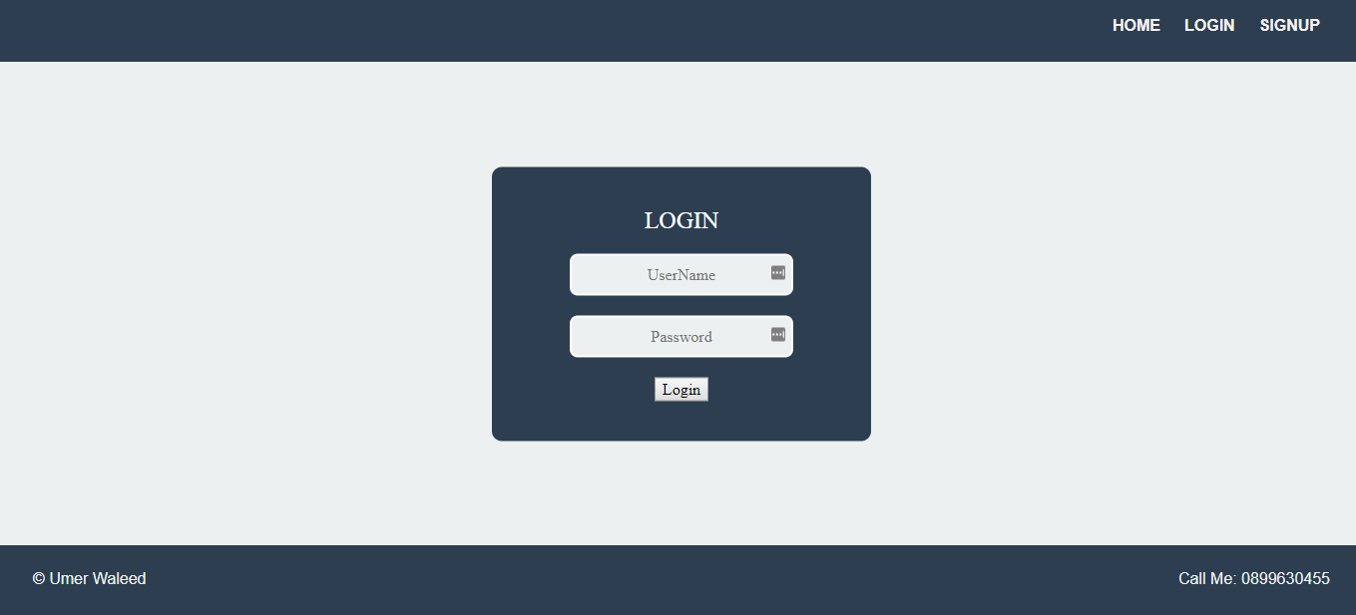

Basically this page wil be able to access from the nav bar of some other pages this will provide user two input fields where user is going to put there username or email address and then inlast user is going to click the button by using php code I am saving that data in some variables and then performing the security checks It has the same header and footer as rest of the file

---------------------------------------------------------------------------------------------------------------------------

Code of

<?php

session_start();

include 'dbh.php';

?>

<!DOCTYPE html>

<html lang="en">

<head>

<meta charset="utf-8">

<meta name="viewport" content="width=device-width, initial-scale=1.0">

<link rel="stylesheet" href="normalize.css">

<link rel="stylesheet" href="style.css">

<title>Umer's Library</title>

</head>

<body>

<div class="page-wrap">

<header>

<div class="container">

<?php

if(isset($_SESSION['username']))

{

echo '<form action="logout.inc.php" method="POST">

<button type="submit" name="logout-submit">Logout</button>

</form>';

echo'<nav>

<ul>

<li><a href="login_index.php"><span>HOME</span></a></li>

</ul>

</nav>';

}

else

{

echo'<nav>

<ul>

<li><a href="index.php"><span>HOME</span></a></li>

<li><a href="Login.php"><span>LOGIN</span></a></li>

<li><a href="signup.php"><span>SIGNUP</span></a></li>

</ul>

</nav>';

}

?>

</div>

</header>

<main>

<div class="container">

<?php

if(isset($_SESSION['username']))

{

echo'<h1>wellcome to your </h1>';

}

else

{

echo '<form action="login.inc.php" method="POST" class="login_box">

<h2>Login</h2>

<input class="login_input" type="text" name="mailuid" placeholder="UserName">

<input class="login_input" type="password" name="password" placeholder="Password">

<button type="submit" name="login-submit">Login</button>

</form>';

}

?>

</div>

</main>

</div>

<footer>

<div class="container">

<p class="footer-left">&copy; Umer Waleed</p>

<p class="footer-right">Call Me: 0899630455</p>

</div>

</footer>

</body>

</html>

---------------------------------------------------------------------------------------------------------------------------

1. Login_index

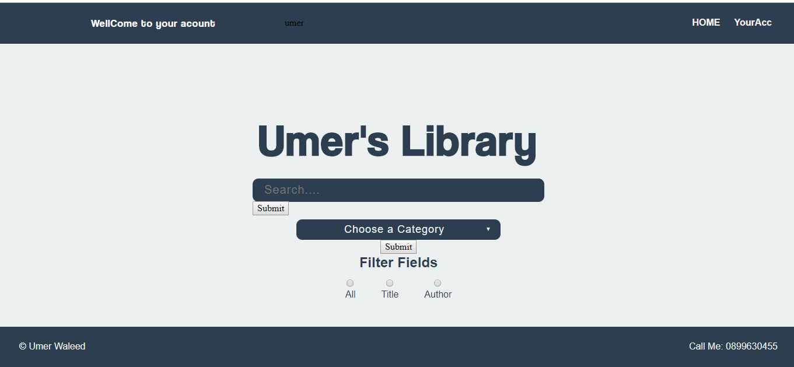

This is the page is the same as index.php but I have make this index page for the user who are in his or her account I have removed some variable from the nav bar as user is already log in so no point giving the option again and same with the sigh up thing

---------------------------------------------------------------------------------------------------------------------------

Code of login_index.php

<?php

session_start();

include 'dbh.php';

?>

<!DOCTYPE html>

<html lang="en">

<head>

<meta charset="utf-8">

<meta name="viewport" content="width=device-width, initial-scale=1.0">

<link rel="stylesheet" href="normalize.css">

<link rel="stylesheet" href="style.css">

<title>Umer's Library</title>

</head>

<body>

<div class="page-wrap">

<header>

<div class="container">

<?php

if(isset($_SESSION['username']))

{

if(isset($_SESSION['firstname']))

{

echo '<div class="float_left">

<p class="top_heading"><sapn id="top">WellCome to your acount</sapn</p>

</div>';

echo $_SESSION['firstname'];

}

}

else

{

echo '<div class="float_left">

<p class="top_heading"><sapn id="top">Wanna Log In</sapn</p>

</div>';

}

?>

<nav>

<ul>

<li><a href="login_index.php"><span>HOME</span></a></li>

<li><a href="Login.php"><span>YourAcc</span></a></li>

</ul>

</nav>

</div>

</header>

<main>

<div class="container">

<form action="login_search.php" method="GET">

<h1>Umer's Library</h1>

<div class="search_engine">

<div class="search_bar">

<div class="search_box">

<input type="text" name="search" placeholder="Search....">

</div>

<div class="submit_search">

<button type="submit" name="submit-search">Submit</button>

</div>

</div>

</div>

<div class="search_filter">

<div class="categories_section">

<div class="category-dropdown">

<select name="category">

<option class="options" value="">All Categories</option>

<option class="options" value="1">Health</option>

<option class="options" value="2">Business</option>

<option class="options" value="3">Biography</option>

<option class="options" value="4">Technology </option>

</select>

</div>

</div>

<div class="search-by_section">

<h2>Filter Fields</h2>

<div class="filter_options">

<div class="radio-button_group">

<input type="radio" name="search-by" value="All" id="radio-1">

<label for="radio-1">All</label>

</div>

<div class="radio-button_group">

<input type="radio" name="search-by" value="Title" id="radio-2">

<label for="radio-2">Title</label>

</div>

<div class="radio-button_group">

<input type="radio" name="search-by" value="Author" id="radio-3">

<label for="radio-3">Author</label>

</div>

</div>

</div>

</div>

</form>

</div>

</main>

</div>

<footer>

<div class="container">

<p class="footer-left">&copy; Umer Waleed</p>

<p class="footer-right">Call Me: 0899630455</p>

</div>

</footer>

</body>

</html>

---------------------------------------------------------------------------------------------------------------------------

1. Login_search.php

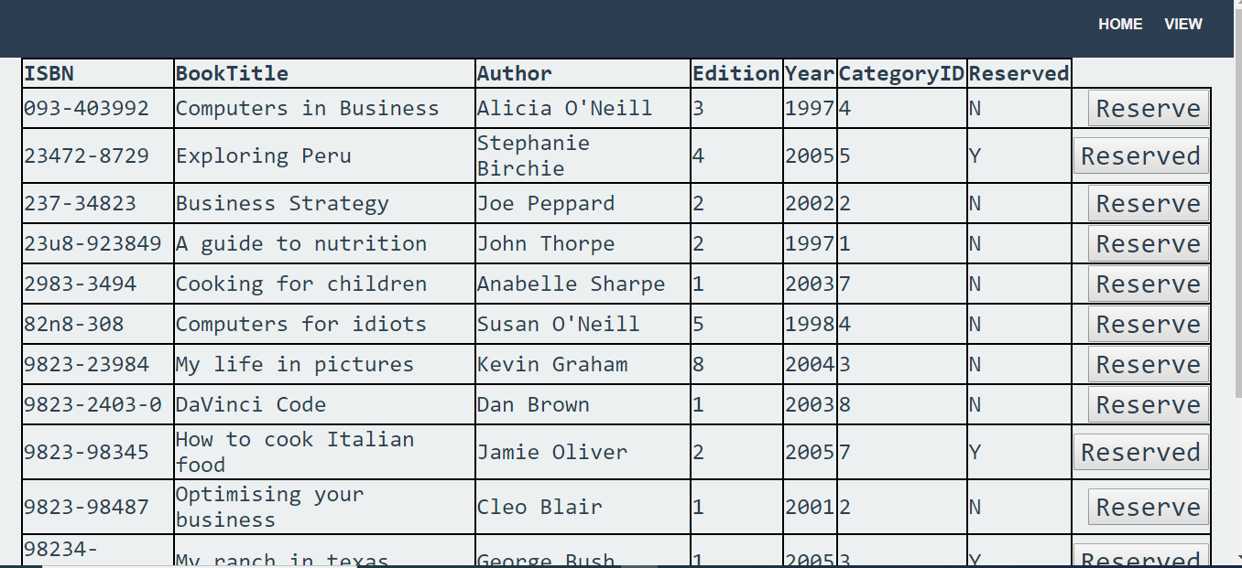

Once user is in the account they are no more using the search file because the whole purpose of account is to give user option to reserved the book and when user does the reservation part in database there is a table with the name of reservation and record of the book and username will supposed to be saved over there if the button is pressed

---------------------------------------------------------------------------------------------------------------------------

Code of login_search.php

<?php

include 'dbh.php';

?>

<!DOCTYPE html>

<html lang="en">

<head>

<meta charset="utf-8">

<meta name="viewport" content="width=device-width, initial-scale=1.0">

<link rel="stylesheet" href="normalize.css">

<link rel="stylesheet" href="style.css">

<title>Umer's Library</title>

</head>

<body>

<div class="page-wrap">

<header>

<div class="container">

<nav>

<ul>

<li><a href="login_index.php"><span>HOME</span></a></li>

<li><a href="viewreserve.php"><span>VIEW</span></a></li>

</ul>

</nav>

</div>

</header>

<main>

<div class="container">

<table id="resulttablelogin">

<tr>

<th>ISBN</th>

<th>BookTitle</th>

<th>Author</th>

<th>Edition</th>

<th>Year</th>

<th>CategoryID</th>

<th>Reserved</th>

</tr>

<?php

if(isset($_GET['submit-search']))

{

$search = mysqli_real_escape_string($conn,$_GET['search']);

$cid = mysqli_real_escape_string($conn,$_GET['category']);

$sql = "select * from books where (BookTitle like '%$search%' or Author like '%$search%') AND (CategoryID LIKE '%$cid%') ";

$result = mysqli_query($conn,$sql);

$quaryresult = mysqli_num_rows($result);

if($quaryresult > 0)

{

while($row = mysqli_fetch_assoc($result))

{

$isbn = $row['ISBN'];

$state = $row['Reserved'];

echo "<tr>

<td>".$row['ISBN']."<span></td>

<td>".$row['BookTitle']."</td>

<td>".$row['Author']."</td>

<td>".$row['Edition']."</td>

<td>".$row['Year']."</td>

<td>".$row['CategoryID']."</td>

<td>".$row['Reserved']."</td>";

if($row['Reserved']=='N')

{

?>

<form action="reserve.php" method="post"><td colspan=7><button name="enter" class="seperate" value="<?php echo $isbn ?>">Reserve</button></td></tr></form>

<?php

}

else

{

echo'<div><td colspan=7><button class="seperate">Reserved</button></td></tr></div>';

}

}

}

else

{

echo"no results found";

}

}

?>

</table>

</div>

</main>

</div>

<footer>

<div class="container">

<p class="footer-left">&copy; Umer Waleed</p>

<p class="footer-right">Call Me: 0899630455</p>

</div>

</footer>

</body>

</html>

---------------------------------------------------------------------------------------------------------------------------

1. Login.inc.php

This is the file which is working which has the actual beckend pragramme fir the user login the actual thing it is doing that when user input the data in login file this file will save the data of those two variable in$username and $passwrod then it will through the query in data base checking if there is any row exist in my data base with same username if so then it will check the user enter password with the password saved in my data base if both are the same then user will be able to access the account

---------------------------------------------------------------------------------------------------------------------------

Code of login.inc.php

<?php

if(isset($_POST['login-submit']))

{

include 'dbh.php';

$mainuid = $_POST['mailuid'];

$password = $_POST['password'];

if(empty($mainuid)||empty($password))

{

header("Location:index.php?error=emptyfields");

exit();

}

else

{

$sql = "select * from users where UserName=? or Email=?;";

$stmt = mysqli_stmt_init($conn);

if(!mysqli_stmt_prepare($stmt,$sql))

{

header("Location:index.php?error=sqlerror");

exit();

}

else

{

mysqli_stmt_bind_param($stmt,"ss",$mainuid,$mainuid);

mysqli_stmt_execute($stmt);

$result = mysqli_stmt_get_result($stmt);

if($row = mysqli_fetch_assoc($result))

{

if($password == $row['Password'])

{

$pwdcheck = true;

session_start();

$_SESSION['username'] = $row['UserName'];

$_SESSION['password'] = $row['Password'];

$_SESSION['firstname']= $row['FirstName'];

echo $_SESSION['firstname'];

header("Location:login_index.php?login=success");

exit();

}

else

{

$pwdcheck =false;

header("Location:login.php?error=wronguser");

exit();

}

echo $pwdcheck;

#$pwdcheck = password_verify($password,$row['Password']);

#$pwdcheck = $r

}

else

{

header("Location:index.php?error=nouser");

exit();

}

}

}

}

else

{

header("Location:index.php");

exit();

}

?>

---------------------------------------------------------------------------------------------------------------------------

1. Logout .incphp

This is file only access when the logout button is pressed this option is givin to user in login file but when user is in the account the file won’t show the form instead it will show the button to logout when it is pressed the file will open which will close the sesion() and destroy all the session veriables

---------------------------------------------------------------------------------------------------------------------------

Code of logout.inc.php

<?php

session_start();

session_unset();

session_destroy();

header("Location: index.php");

?>

---------------------------------------------------------------------------------------------------------------------------

1. Normalize.css

This file is prepared by someone else I found this online and used this is nothing but some css for the body it is not like bootstap

---------------------------------------------------------------------------------------------------------------------------

Code of normalize.css

/*! normalize.css v8.0.1 | MIT License | github.com/necolas/normalize.css */

/* Document

========================================================================== */

/**

* 1. Correct the line height in all browsers.

* 2. Prevent adjustments of font size after orientation changes in iOS.

*/

html {

line-height: 1.15; /* 1 */

-webkit-text-size-adjust: 100%; /* 2 */

}

/* Sections

========================================================================== */

/**

* Remove the margin in all browsers.

*/

body {

margin: 0;

}

/**

* Render the `main` element consistently in IE.

*/

main {

display: block;

}

/**

* Correct the font size and margin on `h1` elements within `section` and

* `article` contexts in Chrome, Firefox, and Safari.

*/

h1 {

font-size: 2em;

margin: 0.67em 0;

}

/* Grouping content

========================================================================== */

/**

* 1. Add the correct box sizing in Firefox.

* 2. Show the overflow in Edge and IE.

*/

hr {

box-sizing: content-box; /* 1 */

height: 0; /* 1 */

overflow: visible; /* 2 */

}

/**

* 1. Correct the inheritance and scaling of font size in all browsers.

* 2. Correct the odd `em` font sizing in all browsers.

*/

pre {

font-family: monospace, monospace; /* 1 */

font-size: 1em; /* 2 */

}

/* Text-level semantics

========================================================================== */

/**

* Remove the gray background on active links in IE 10.

*/

a {

background-color: transparent;

}

/**

* 1. Remove the bottom border in Chrome 57-

* 2. Add the correct text decoration in Chrome, Edge, IE, Opera, and Safari.

*/

abbr[title] {

border-bottom: none; /* 1 */

text-decoration: underline; /* 2 */

text-decoration: underline dotted; /* 2 */

}

/**

* Add the correct font weight in Chrome, Edge, and Safari.

*/

b,

strong {

font-weight: bolder;

}

/**

* 1. Correct the inheritance and scaling of font size in all browsers.

* 2. Correct the odd `em` font sizing in all browsers.

*/

code,

kbd,

samp {

font-family: monospace, monospace; /* 1 */

font-size: 1em; /* 2 */

}

/**

* Add the correct font size in all browsers.

*/

small {

font-size: 80%;

}

/**

* Prevent `sub` and `sup` elements from affecting the line height in

* all browsers.

*/

sub,

sup {

font-size: 75%;

line-height: 0;

position: relative;

vertical-align: baseline;

}

sub {

bottom: -0.25em;

}

sup {

top: -0.5em;

}

/* Embedded content

========================================================================== */

/**

* Remove the border on images inside links in IE 10.

*/

img {

border-style: none;

}

/* Forms

========================================================================== */

/**

* 1. Change the font styles in all browsers.

* 2. Remove the margin in Firefox and Safari.

*/

button,

input,

optgroup,

select,

textarea {

font-family: inherit; /* 1 */

font-size: 100%; /* 1 */

line-height: 1.15; /* 1 */

margin: 0; /* 2 */

}

/**

* Show the overflow in IE.

* 1. Show the overflow in Edge.

*/

button,

input { /* 1 */

overflow: visible;

}

/**

* Remove the inheritance of text transform in Edge, Firefox, and IE.

* 1. Remove the inheritance of text transform in Firefox.

*/

button,

select { /* 1 */

text-transform: none;

}

/**

* Correct the inability to style clickable types in iOS and Safari.

*/

button,

[type="button"],

[type="reset"],

[type="submit"] {

-webkit-appearance: button;

}

/**

* Remove the inner border and padding in Firefox.

*/

button::-moz-focus-inner,

[type="button"]::-moz-focus-inner,

[type="reset"]::-moz-focus-inner,

[type="submit"]::-moz-focus-inner {

border-style: none;

padding: 0;

}

/**

* Restore the focus styles unset by the previous rule.

*/

button:-moz-focusring,

[type="button"]:-moz-focusring,

[type="reset"]:-moz-focusring,

[type="submit"]:-moz-focusring {

outline: 1px dotted ButtonText;

}

/**

* Correct the padding in Firefox.

*/

fieldset {

padding: 0.35em 0.75em 0.625em;

}

/**

* 1. Correct the text wrapping in Edge and IE.

* 2. Correct the color inheritance from `fieldset` elements in IE.

* 3. Remove the padding so developers are not caught out when they zero out

* `fieldset` elements in all browsers.

*/

legend {

box-sizing: border-box; /* 1 */

color: inherit; /* 2 */

display: table; /* 1 */

max-width: 100%; /* 1 */

padding: 0; /* 3 */

white-space: normal; /* 1 */

}

/**

* Add the correct vertical alignment in Chrome, Firefox, and Opera.

*/

progress {

vertical-align: baseline;

}

/**

* Remove the default vertical scrollbar in IE 10+.

*/

textarea {

overflow: auto;

}

/**

* 1. Add the correct box sizing in IE 10.

* 2. Remove the padding in IE 10.

*/

[type="checkbox"],

[type="radio"] {

box-sizing: border-box; /* 1 */

padding: 0; /* 2 */

}

/**

* Correct the cursor style of increment and decrement buttons in Chrome.

*/

[type="number"]::-webkit-inner-spin-button,

[type="number"]::-webkit-outer-spin-button {

height: auto;

}

/**

* 1. Correct the odd appearance in Chrome and Safari.

* 2. Correct the outline style in Safari.

*/

[type="search"] {

-webkit-appearance: textfield; /* 1 */

outline-offset: -2px; /* 2 */

}

/**

* Remove the inner padding in Chrome and Safari on macOS.

*/

[type="search"]::-webkit-search-decoration {

-webkit-appearance: none;

}

/**

* 1. Correct the inability to style clickable types in iOS and Safari.

* 2. Change font properties to `inherit` in Safari.

*/

::-webkit-file-upload-button {

-webkit-appearance: button; /* 1 */

font: inherit; /* 2 */

}

/* Interactive

========================================================================== */

/*

* Add the correct display in Edge, IE 10+, and Firefox.

*/

details {

display: block;

}

/*

* Add the correct display in all browsers.

*/

summary {

display: list-item;

}

/* Misc

========================================================================== */

/**

* Add the correct display in IE 10+.

*/

template {

display: none;

}

/**

* Add the correct display in IE 10.

*/

[hidden] {

display: none;

}

---------------------------------------------------------------------------------------------------------------------------

1. Reserve.php

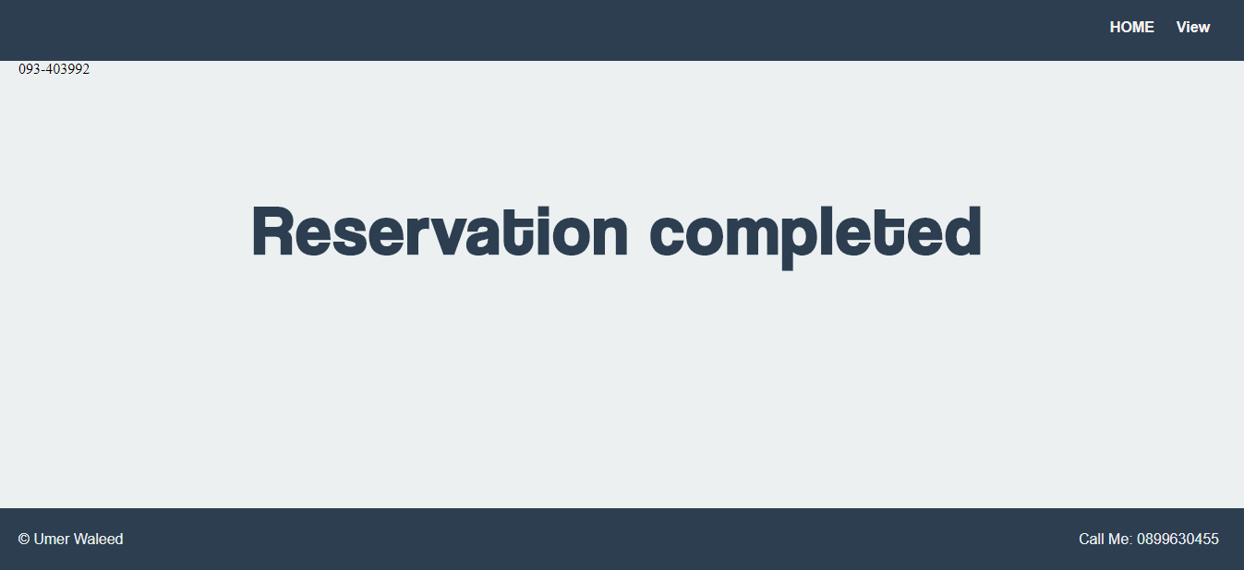

This file will be open when user is inside his or account and want to reserved something in when table in login_search will be printed over there in each row there will be button to reserved the book if its is not reserved if user click the button action will bring data means isbn number of particular row in reserve and with simple query we will put that data in reservation table in our database

---------------------------------------------------------------------------------------------------------------------------

Code of reserve.php

<?php

session_start();

include 'dbh.php';

?>

<!DOCTYPE html>

<html lang="en">

<head>

<meta charset="utf-8">

<meta name="viewport" content="width=device-width, initial-scale=1.0">

<link rel="stylesheet" href="normalize.css">

<link rel="stylesheet" href="style.css">

<title>Umer's Library</title>

</head>

<body>

<div class="page-wrap">

<header>

<div class="container">

<nav>

<ul>

<li><a href="login_index.php"><span>HOME</span></a></li>

<li><a href="viewreserve.php"><span>View</span></a></li>

</ul>

</nav>

</div>

</header>

<main>

<div class="container">

<?php

if(isset($_POST['enter']))

{

echo $_POST['enter'];

$isbn = $_POST['enter'];

$user = $_SESSION['username'];

$date = date("d-m-Y");

$do = "update books set Reserved = 'Y' where ISBN = '$isbn'";

$insert = "insert into reservations values ('$isbn','$user', $date)";

mysqli_query($conn, $do);

mysqli_query($conn, $insert);

echo'<h1>Reservation completed</h1>';

}

else

{

echo 'shit';

}

?>

</div>

</main>

</div>

<footer>

<div class="container">

<p class="footer-left">&copy; Umer Waleed</p>

<p class="footer-right">Call Me: 0899630455</p>

</div>

</footer>

</body>

</html>

---------------------------------------------------------------------------------------------------------------------------

1. Search.php

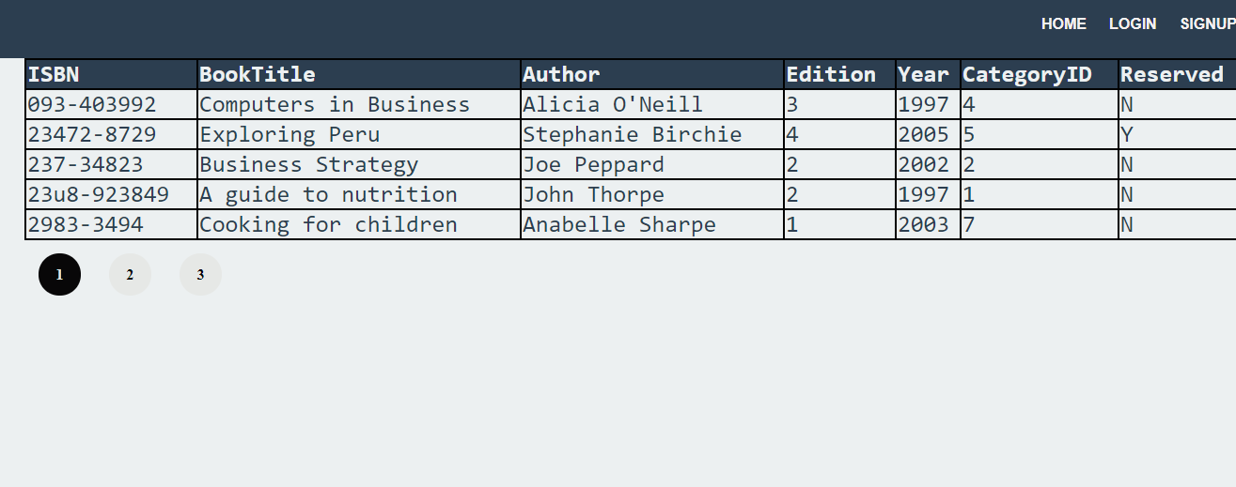

This file is same as login_search.php but this time instead of we are using this when user is not register user in out website it is for random person they can serach for the book but they can not reserve it

---------------------------------------------------------------------------------------------------------------------------

Code of search.php

<?php

include 'dbh.php';

?>

<!DOCTYPE html>

<html lang="en">

<head>

<meta charset="utf-8">

<meta name="viewport" content="width=device-width, initial-scale=1.0">

<link rel="stylesheet" href="normalize.css">

<link rel="stylesheet" href="style.css">

<title>Umer's Library</title>

</head>

<body>

<div class="page-wrap">

<header>

<div class="container">

<nav>

<ul>

<li><a href="index.php"><span>HOME</span></a></li>

<li><a href="Login.php"><span>LOGIN</span></a></li>

<li><a href="signup.php"><span>SIGNUP</span></a></li>

</ul>

</nav>

</div>

</header>

<main>

<div class="container">

<table id="resulttable">

<tr>

<th>ISBN</th>

<th>BookTitle</th>

<th>Author</th>

<th>Edition</th>

<th>Year</th>

<th>CategoryID</th>

<th>Reserved</th>

</tr>

<?php

if(isset($_GET['submit-search']))

{

$search = mysqli_real_escape_string($conn,$_GET['search']);

$cid = mysqli_real_escape_string($conn,$_GET['category']);

echo $cid;

$sql = "select * from books where (BookTitle like '%$search%' or Author like '%$search%') AND (CategoryID LIKE '%$cid%') ";

$result = mysqli_query($conn,$sql);

$no_of_results = mysqli_num_rows($result);

if (!isset($_GET['page'])) {

$page_no = 1;

} else {

$page_no = $_GET['page'];

}

$results_per_page = 5;

$this_page_first_result = ($page_no-1)*$results_per_page;

$number_of_pages = ceil($no_of_results/$results_per_page);

$sql = "select * from books where (BookTitle like '%$search%' or Author like '%$search%') AND (CategoryID LIKE '%$cid%') LIMIT " . $this_page_first_result . "," . $results_per_page;

$result = mysqli_query($conn,$sql);

$no_of_results = mysqli_num_rows($result);

if($no_of_results > 0)

{

while($row = mysqli_fetch_assoc($result))

{

echo "<tr>

<td>".$row['ISBN']."</td>

<td>".$row['BookTitle']."</td>

<td>".$row['Author']."</td>

<td>".$row['Edition']."</td>

<td>".$row['Year']."</td>

<td>".$row['CategoryID']."</td>

<td>".$row['Reserved']."</td>

<tr>";

}

}

else

{

echo"no results found";

}

}

?>

</table>

<?php

for ($page=1; $page <= $number_of_pages ; $page++) {

if ($page==$page_no)

{

echo '<div style="width:45px; height:45px; background-color:#2c3e50; margin-top:15px; margin-left:15px; margin-right:15px; align-items:center; text-align:center; position:relative; display:inline-block; border:2px solid black;"><span style="color:#ecf0f1; line-height:45px; font-weight:bold; user-select:none;">' . $page . '</span></div>';

}

else

{

echo '<a href="' . $_SERVER['PHP_SELF'] . '?search=' . urlencode($_GET['search']) . '&submit-search='.urlencode($_GET['submit-search']). '&category='.urlencode($_GET['category']). '&page='. $page .' "><div style="width:45px; height:45px; background-color:#ecf0f1; margin-top:15px; margin-left:15px; margin-right:15px; align-items:center; text-align:center; position:relative; display:inline-block; "><span style="color:#2c3e50; line-height:45px; font-weight:bold; user-select:none;">' . $page . '</span></div></a>';

}

}?>

</div>

</main>

</div>

<footer>

<div class="container">

<p class="footer-left">&copy; Umer Waleed</p>

<p class="footer-right">Call Me: 0899630455</p>

</div>

</footer>

</body>

</html>

---------------------------------------------------------------------------------------------------------------------------

1. Signup.php

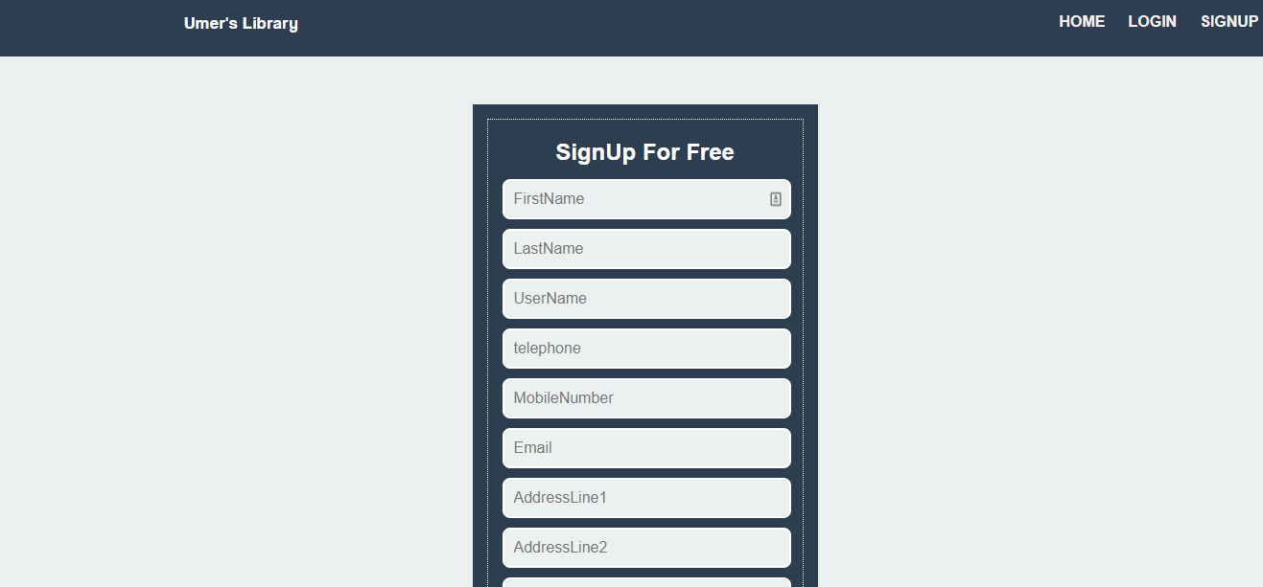

This is the file which has the front end code of my website it has in total this sigh up page is in the nav bar of login and index.php the user has to enter the data which will in the input fields then I am retrieving this data into some other variables and performing some task

---------------------------------------------------------------------------------------------------------------------------

Code of signup.php

<?php

include 'dbh.php';

session_start();

?>

<!DOCTYPE html>

<html lang="en">

<head>

<meta charset="utf-8">

<meta name="viewport" content="width=device-width, initial-scale=1.0">

<link rel="stylesheet" href="normalize.css">

<link rel="stylesheet" href="style.css">

<title>Umer's Library</title>

</head>

<body>

<div class="page-wrap">

<header>

<div class="container">

<div class="float_left">

<p class="top_heading">Umer's Library</p>

</div>

<nav>

<ul>

<li><a href="index.php"><span>HOME</span></a></li>

<li><a href="Login.php"><span>LOGIN</span></a></li>

<li><a href="signup.php"><span>SIGNUP</span></a></li>

</ul>

</nav>

</div>

</header>

<main>

<div class="container">

<div class="wrap">

<form action="signup.inc.php" method="POST" class="signup">

<h2>SignUp For Free</h2>

<?php

if (isset($_GET['error'])) {

if ($_GET['error'] == "emptyfields") {

echo '<div style="padding: 20px; border-radius: 24px; margin-bottom: 30px; text-align:center; "><span style="font-family: Arial; font-size: 18px; color:red;">Pls enter all fields</span></div>';

}

}

?>

<input type="text" name="firstname" placeholder="FirstName">

<input type="text" name="lastname" placeholder="LastName">

<input type="text" name="username" placeholder="UserName">

<input type="number" name="telephone" placeholder="telephone">

<input type="number" name="mnumber" placeholder="MobileNumber">

<input type="email" name="email" placeholder="Email">

<input type="text" name="addressline1" placeholder="AddressLine1">

<input type="text" name="addressline2" placeholder="AddressLine2">

<input type="text" name="city" placeholder="City">

<input type="password" name="password" placeholder="password">

<input type="password" name="confirmpassword" placeholder="Enter_Password_Again">

<br>

<br>

<input type="radio" name="male" value="male"><span class="signupradiobtn">Male</span>

<input type="radio" name="female" value="female"><span class="signupradiobtn">Female</span>

<br>

<br>

<input type="checkbox"><span class="signupradiobtn">Agree Terms and Conditions</span>

<br>

<button type="submit" name="submit-search">Submit</button>

</form>

</div>

</div>

</main>

</div>

<footer>

<div class="container">

<p class="footer-left">&copy; Umer Waleed</p>

<p class="footer-right">Call Me: 0899630455</p>

</div>

</footer>

</body>

</html>

---------------------------------------------------------------------------------------------------------------------------

1. Signup.inc.php

This is the backend programe file which will be open once user enters the button of signup al the data is collected into php variables I have done some validation just to check that whether the data in the variable is not empty or not according to the constraints I have kept it in my database if every thing goes well after all the validation user will get the msg of successful signup and in database there will be record created for the new user.

---------------------------------------------------------------------------------------------------------------------------

Code of signup.inc.php

<?php

include 'dbh.php';

if(isset($_POST['submit-search']))

{

$firstname = $_POST['firstname'];

$lastname = $_POST['lastname'];

$username = $_POST['username'];

$telephone = $_POST['telephone'];

$mobilenumber = $_POST['mnumber'];

$email = $_POST['email'];

$addressline1 = $_POST['addressline1'];

$addressline2 = $_POST['addressline2'];

$city = $_POST['city'];

$password = $_POST['password'];

$confirmpassword = $_POST['confirmpassword'];

if(empty($firstname)||empty($lastname)||empty($username)||empty($mobilenumber)||empty($email)||empty($addressline1)||empty($addressline2)||empty($city)||empty($password)||empty($confirmpassword))

{

$message = "empty fields";

header("Location: signup.php?error=emptyfields");

exit();

}

elseif(!filter_var($email,FILTER_VALIDATE_EMAIL)&&!preg_match("/^[a-zA-Z0-9]*$/",$username))

{

echo"email and username error";

header("Location: signup.php");

exit();

}

elseif(!filter_var($email,FILTER_VALIDATE_EMAIL))

{

echo"not correct email";

header("Location: signup.php");

exit();

}

elseif(!preg_match("/^[a-zA-Z0-9]*$/",$username))

{

echo"username nod correct";

header("Location: signup.php");

exit();

}

elseif($password != $confirmpassword)

{

echo "passwrod not same";

header("Location: signup.php");

exit();

}

else

{

$sql = "select UserName from users where UserName=?";

$stmt = mysqli_stmt_init($conn);

if(!mysqli_stmt_prepare($stmt,$sql))

{

echo"Sql Error";

}

else

{

mysqli_stmt_bind_param($stmt,"s",$username);

mysqli_stmt_execute($stmt);

mysqli_stmt_store_result($stmt);

$result_check = mysqli_stmt_num_rows($stmt);

if($result_check > 0)

{

echo "username already taken";

}

else

{

$sql = "insert into users (FirstName,Surname,UserName,Telephone,MobileNumber,Email,AddressLine1,AddressLine2,City,Password) values(?,?,?,?,?,?,?,?,?,?)";

$stmt = mysqli_stmt_init($conn);

if(!mysqli_stmt_prepare($stmt,$sql))

{

echo"Sql Error";

exit();

}

else

{

$hasedpwd = password_hash($password,PASSWORD_DEFAULT);

mysqli_stmt_bind_param($stmt,"sssiisssss",$firstname,$lastname,$username,$telephone,$mobilenumber,$email,$addressline1,$addressline2,$city,$password,);

mysqli_stmt_execute($stmt);

echo"sighup successfull";

header("Location: index.php?error=emptyfields");

exit();

}

}

}

}

#mysqli_stmt_close($stmt);

mysqli_close($conn);

}

---------------------------------------------------------------------------------------------------------------------------

1. Viewreserve.php

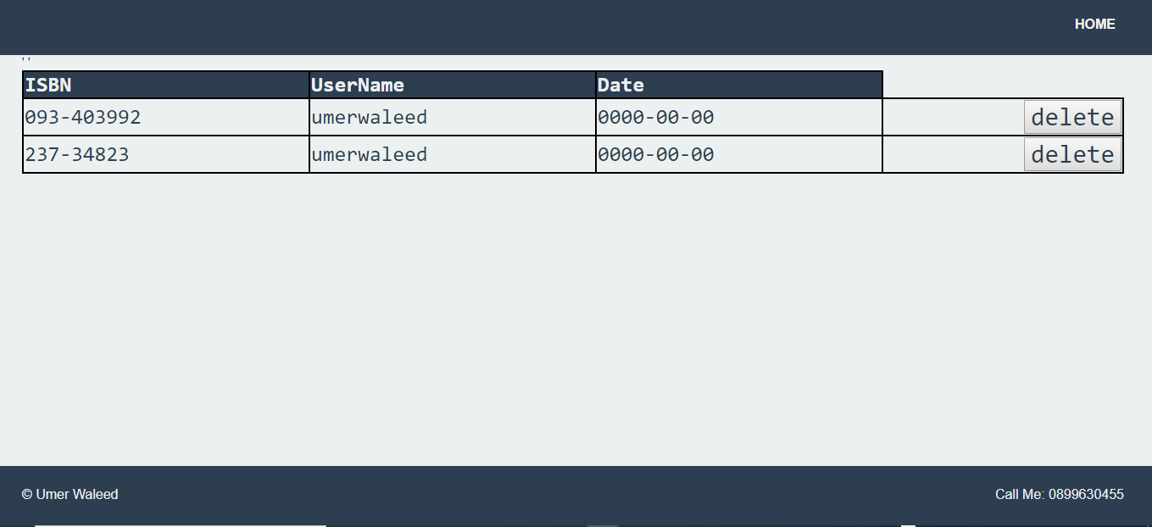

Once user has successfully reserved the book message will be there successful reservation and there will be option to view the data of books that you have reserved already there will be option to delete the reserve book ass well once user click that button the book is not reserved by that user anymore

---------------------------------------------------------------------------------------------------------------------------

Code of viewreserve.php

<?php

session_start();

include 'dbh.php';

?>

<!DOCTYPE html>

<html lang="en">

<head>

<meta charset="utf-8">

<meta name="viewport" content="width=device-width, initial-scale=1.0">

<link rel="stylesheet" href="normalize.css">

<link rel="stylesheet" href="style.css">

<title>Umer's Library</title>

</head>

<body>

<div class="page-wrap">

<header>

<div class="container">

<nav>

<ul>

<li><a href="login_index.php"><span>HOME</span></a></li>

</ul>

</nav>

</div>

</header>

<main>

<div class="container">

<table id="resulttable">

<tr>

<th>ISBN</th>

<th>UserName</th>

<th>Date</th>

</tr>

<?php

$sql = "select * from reservations";

$result = mysqli_query($conn,$sql);

$quaryresult = mysqli_num_rows($result);

if($quaryresult > 0)

{

while($row = mysqli_fetch_assoc($result))

{

$isbn = $row['ISBN'];

echo "<tr>

<td>".$row['ISBN']."</td>

<td>".$row['UserName']."</td>

<td>".$row['ReservedDate']."</td>";

?>

<form method="POST"><td colspan=7><button name="delete" class="seperate" value="<?php echo $isbn ?>">delete</button></td></tr></form>'

<?php

}

}

else

{

echo"no records found";

}

if(isset($_POST['delete']))

{

$isbn = $_POST['delete'];

$delete = "delete from reservations where ISBN = '$isbn'";

$undo = "update books set Reserved = 'N' where ISBN = '$isbn'";

mysqli_query($conn, $delete);

mysqli_query($conn, $undo);

}

?>

</table>

</div>

</main>

</div>

<footer>

<div class="container">

<p class="footer-left">&copy; Umer Waleed</p>

<p class="footer-right">Call Me: 0899630455</p>

</div>

</footer>

</body>

</html>

---------------------------------------------------------------------------------------------------------------------------