**Umesh Roka Magar**

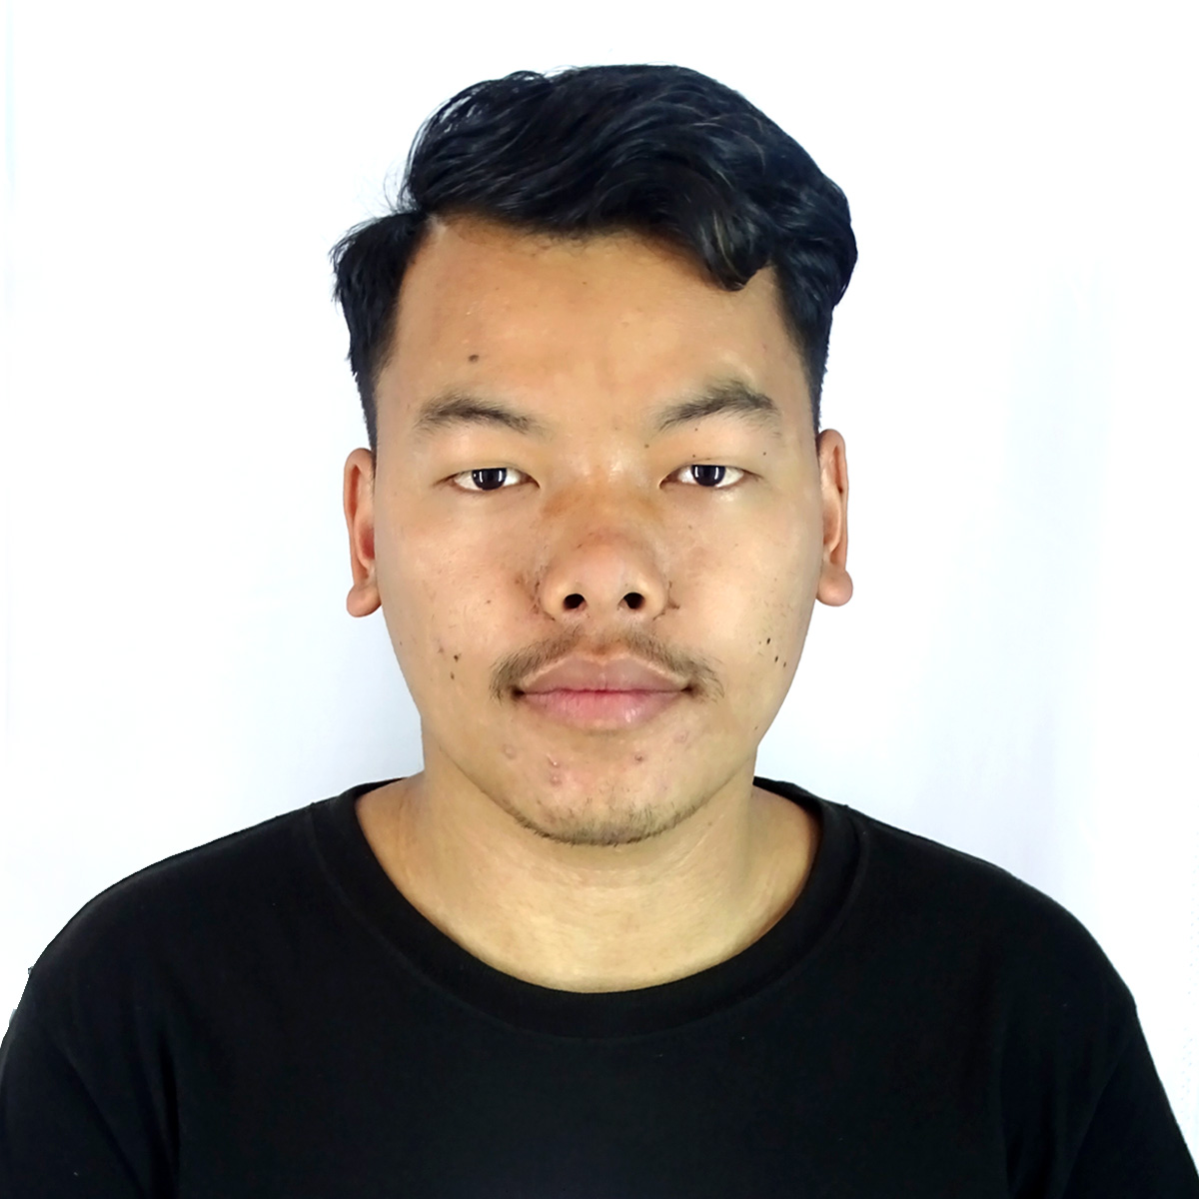

* **Email:** [umeshmagar764@gmail.com](mailto:umeshmagar764@gmail.com)
* **Phone:** 9841144826
* **Linked-In:**
* **GitHub:**

**Summary:**

Enthusiastic and motivated junior full stack developer with a foundational understanding of the MERN stack. Eager to leverage skills in JavaScript,MongoDB, Express.js, React, and Node.js to contribute to dynamic development teams and build impactful web application. Quick learner with a passion for technology and a commitment to continuous improvement.

**Skills:**

* **Languages:** HTML5,CSS3,JavaScript
* **Front-End:** React.js, Redux ,Tailwind, Bootstrap, Material-UI.
* **Back-End:** Node.js, Express.js, RESTful APIs.
* **Database:** MongoDB, Mongoose
* **Version Control:** Git, GitHub
* **Tools & Platforms:** Visual Studio Code, Postman, npm
* **Soft Skills:** Problem-Solving, Communication, Teamwork,Adaptability.

**Projects:**

**Personal Portfolio Website**

* **Description:** Developed a personal portfolio website to showcase projects and Skills
* **Technologies:** React, Tailwind, GitHub pages
* **Responsibilities:**
* Designed and implemented a responsive layout using

React and Tailwind.

* Integrated GitHub API to display project repositories dynamically.

**Education:**

* **Diploma in Information Technology**
* **College Name:** Rolpa Polytechnic Institute
* **Location:** Nepal,Rolpa Municipality -1 Mewang
* **Duration:** 2020 -2024

**Certification:**

* **MERN stack course:** Mindrisers Institute of Technology

**Additional Information:**

* **Language:** Fluent in English, Nepali
* **Hobbies:** Codding, playing football, Listening Music, Watching Tech related videos and Implementing it on project