TL Draft

Aim:
* To showcase a disaggregated BNG gateway on cloud environment(see illustration).
* Propose standardized APIs/Messaging between access protocol entities and Subscriber manager.
* * Showcase NATs messaging wrt to protocol entities and Subscriber manager.

Caveats:
* Data plane is not being looked at now, this will be left to the OVS/DPU.
* Delays towards protocol side need to be considered.

Assumptions:
* Protocol messages reach the protocol entities directly, not through ODL.
* ODL is programmed with OF rules for forwarding DHCP, PPPOE or other protocols to daemon instances directly.
* Subscriber Authentication is through radius for now. Diameter can also be used, need to check if there is a client for the same that can be integrated. Subscriber manager will be configured for IP pool and policy info through SDN, this is something that will take e design effort.

Subscriber manager:
* AAA authentication functionality. Accounting needs more thought, because data does not hit the protocol entity.
* IP allocation? Will be taken up later in phase2.
* Subscriber database(external, eg: ETCD)
* Policy control? We do not plan to demonstrate any services in this phase.

NATS messaging:
* Standard APIs/messages defined for communication between entities.
* Entities will register for message subscriptions from NATS server.
* New protocol entities to used these standard APIs/messages to be able to communicate with subscriber manager.
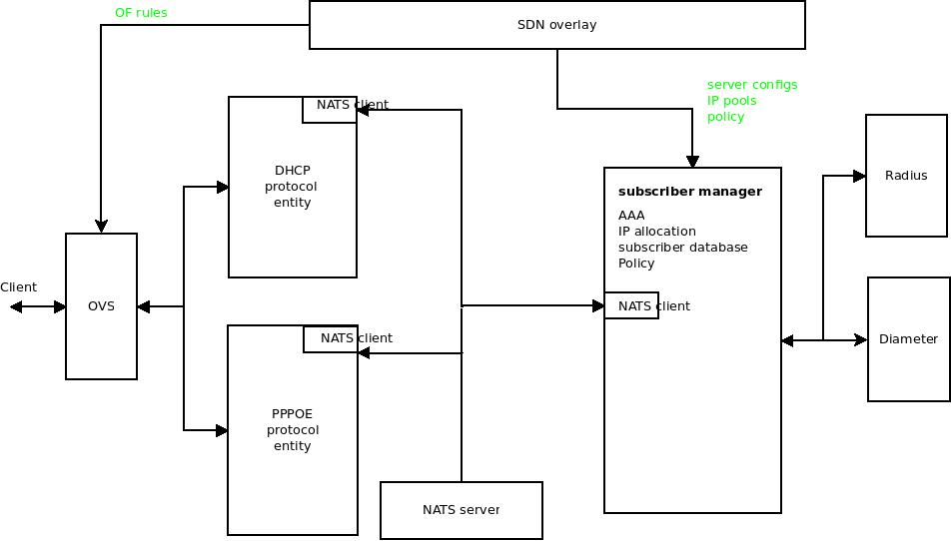

Subscriber manager APIs/messages over NATs:
Authentication:
AUTH+info for authentication as per protocols + IP allocation yes/no + key
RESP+ key +message OK or error + IP allocation info
IP allocation:
GETIP+key
SETIP+key+OK/error+IP allocation info
Teardown:
REL+Key

Note: Key is something the protocol entity provides, which subscriber manager will send back for response match.
