1. Retrieve the total number of orders placed.

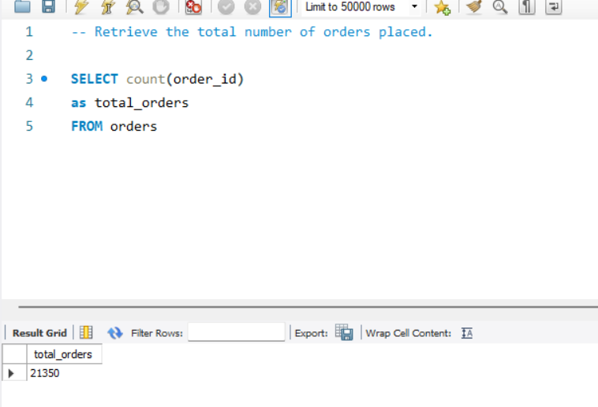

1. -- Display the price of pizza by pizza name.

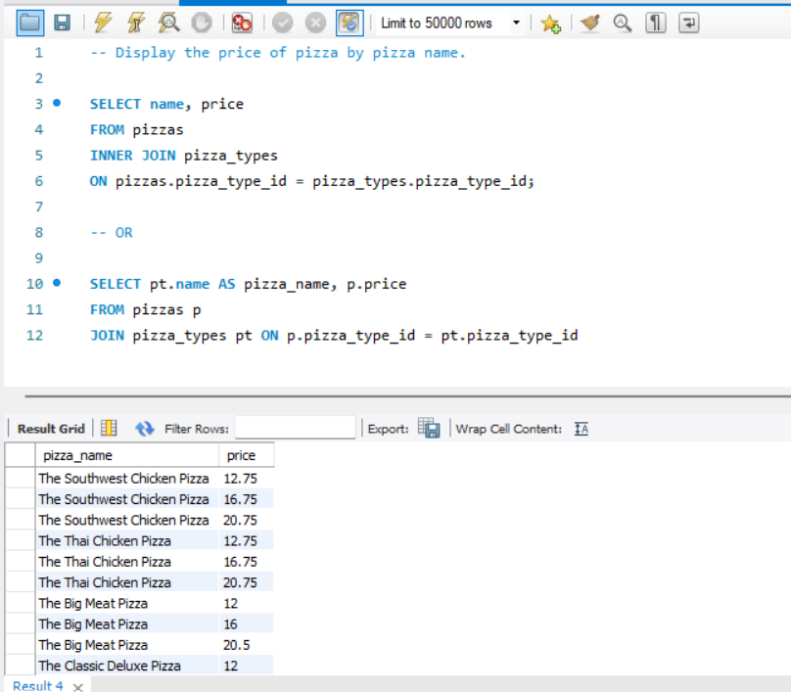

1. Calculate the total revenue generated from pizza sales.

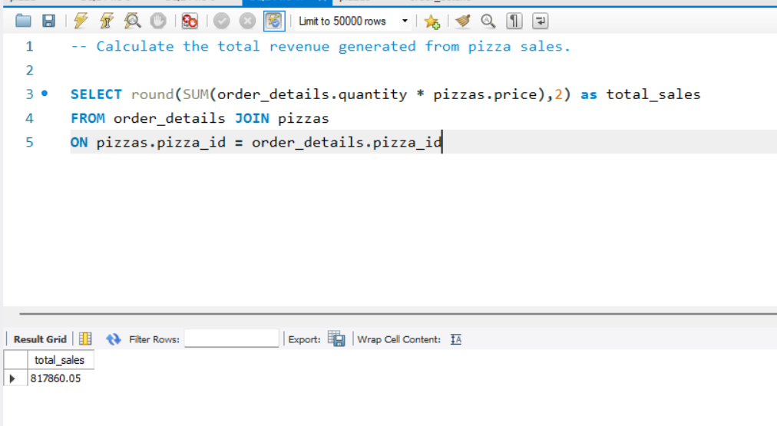

1. Identify the highest-priced pizza.

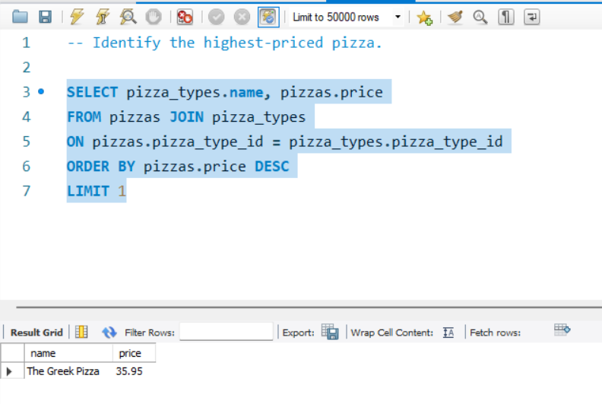

1. List the top 5 most ordered pizza types along with their quantities.

