Report on “ski_data” data analysis capstone work:
Problem Statement:

The purpose of this data science project is to come up with a pricing model for ski resort tickets in our market segment. Big Mountain suspects it may not be maximizing its returns, relative to its position in the market. It also does not have a strong sense of what facilities matter most to visitors, particularly which ones they're most likely to pay more for.
This project aims to build a predictive model for ticket price based on a number of facilities, or properties, boasted by resorts (at the resorts). This model will be used to provide guidance for Big Mountain's pricing and future facility investment plans.

After wrangling with the data, we have 277 rows and 25 columns left. By plotting a graph, we can see the relationship between AdultWeekday or AdultWeekend is linear (i.e. the higher the value of AdultWeekday, the higher the value of AdultWeekend.) Therefore, we can drop one of the prices. Since AdultWeekend has the least missing value of the two, we choose to drop the AdultWeekday.

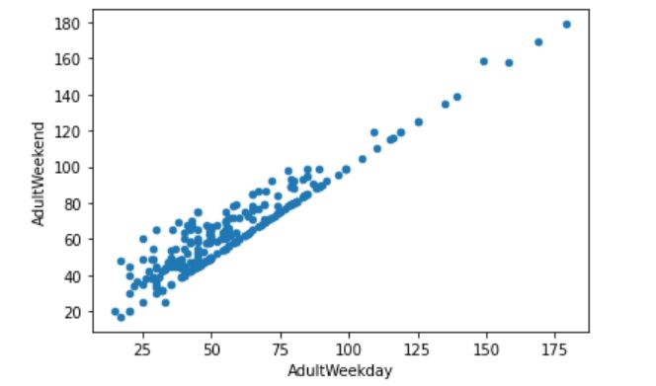

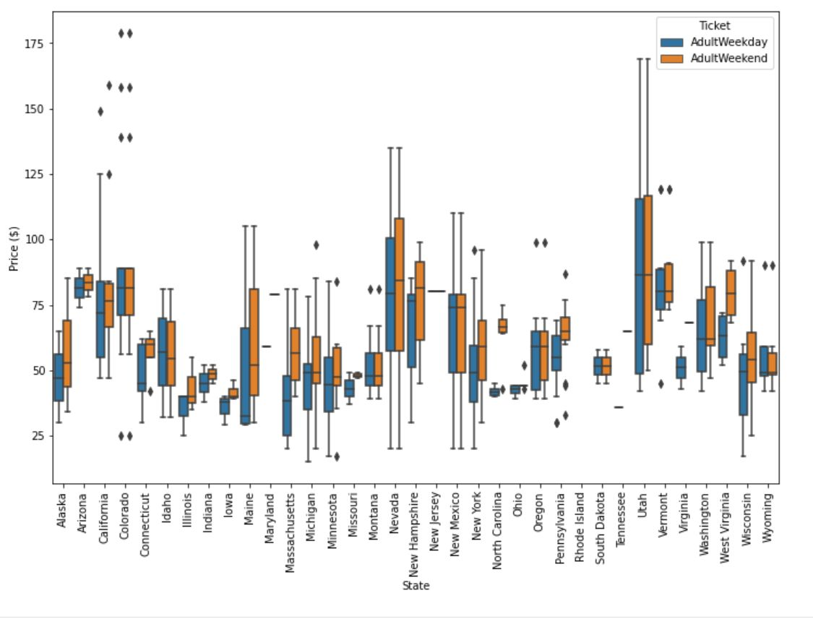

Figure1 : ski_data's scatterplot with 'AdultWeekday' ticket prices on the x-axis and 'AdultWeekend' ticket prices on the y-axis

Figure 2: seaborn boxplot of the ticket price with 'state' on the x-axis, 'Price' as the y-value,

A couple of observations can be made. Firstly, there is a clear line where weekend and weekday prices are equal. Weekend prices being higher than weekday prices seem restricted to sub $100 resorts. But the boxplot earlier that the distribution for weekday and weekend prices in Montana seemed equal.

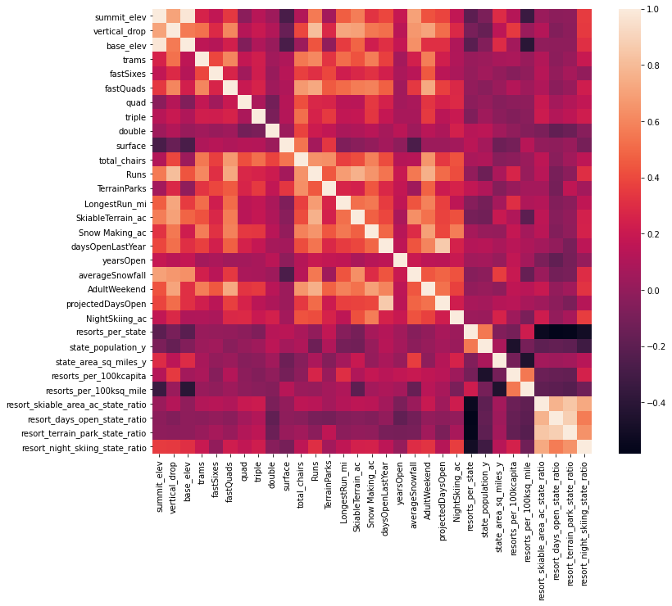
Figure3: Heat map showing high level relationship between the features in the ski_data. Color level is the ticket price.

Ticket price analysis: “fastQuads”, “Runs” and “Snow Making_ac” appear as features of importance. Visitors value more guaranteed snow. Of the new features,”resort_night_skiing_state_ratio” seems the most correlated with ticket price. If this is true, then perhaps seizing a greater share of night skiing capacity is positive for the price a resort can charge. “Runs”, “total_chairs” is quite well correlated with ticket price. People seem to put more value in guaranteed snow cover rather than more variable terrain area.The vertical drop seems to be a selling point that raises ticket prices as well.

