Sheldon1 – Reversing

Open with “gdb”

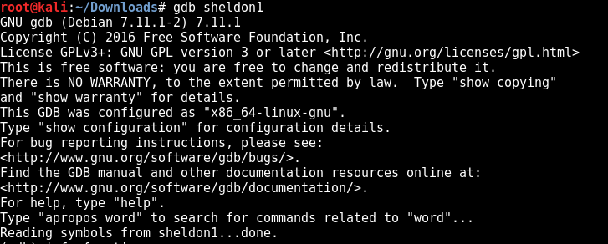

Get information of the functions

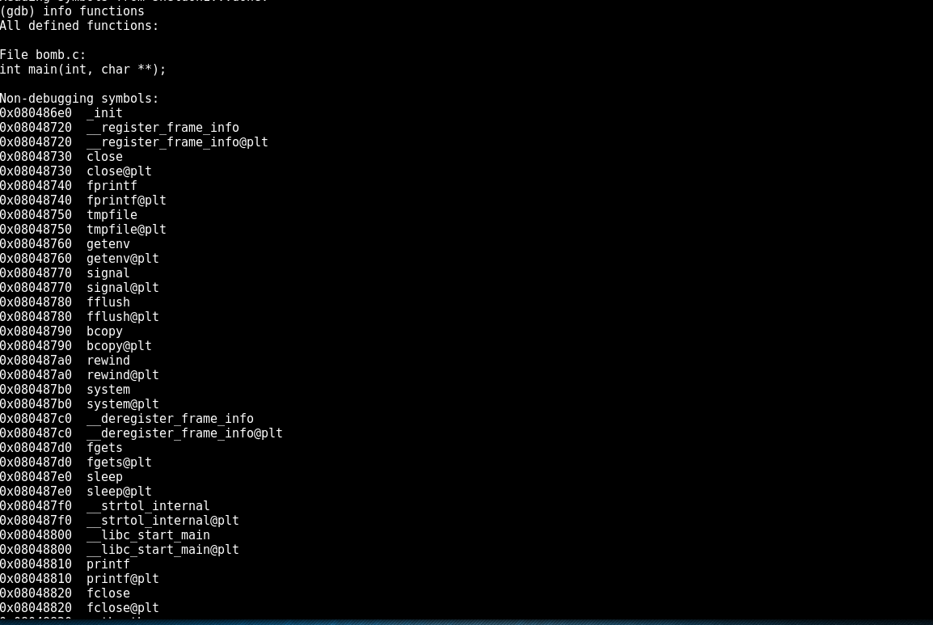

Add a breakpoint in “phase_1” function



Run the file

--Currently getting an permission denied error need to check