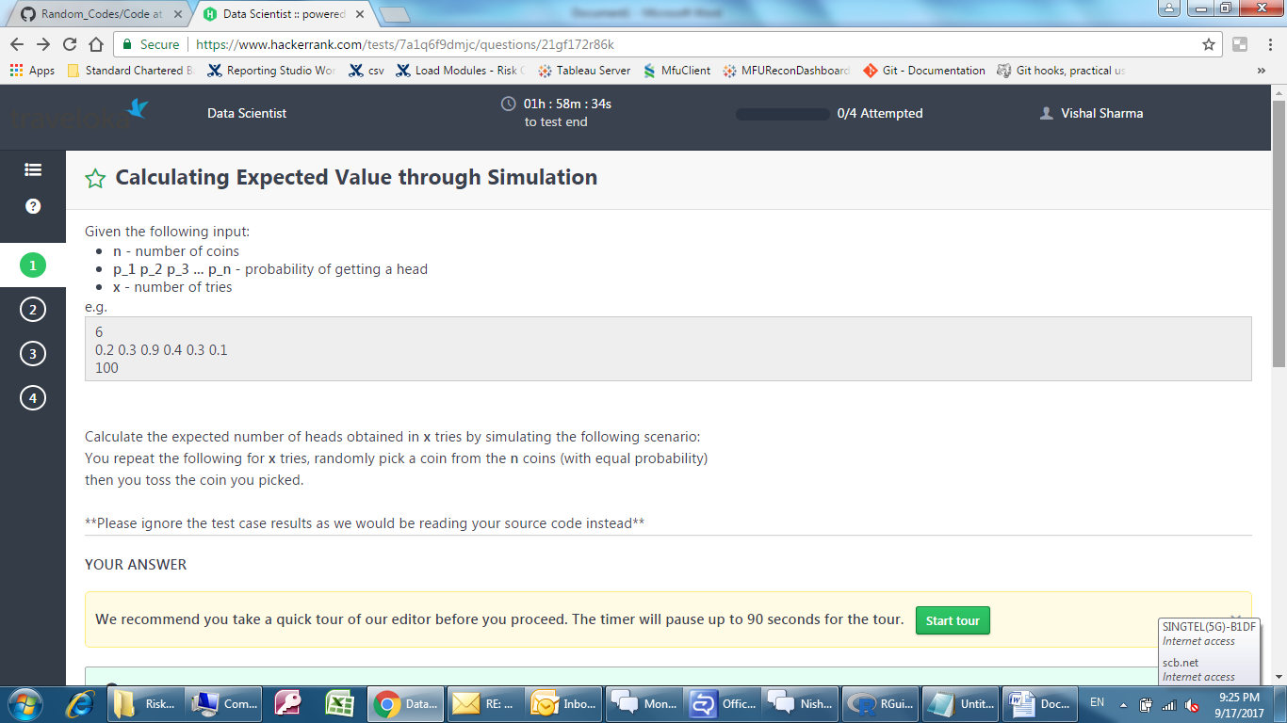

http://pi3.sites.sheffield.ac.uk/tutorials/week-9

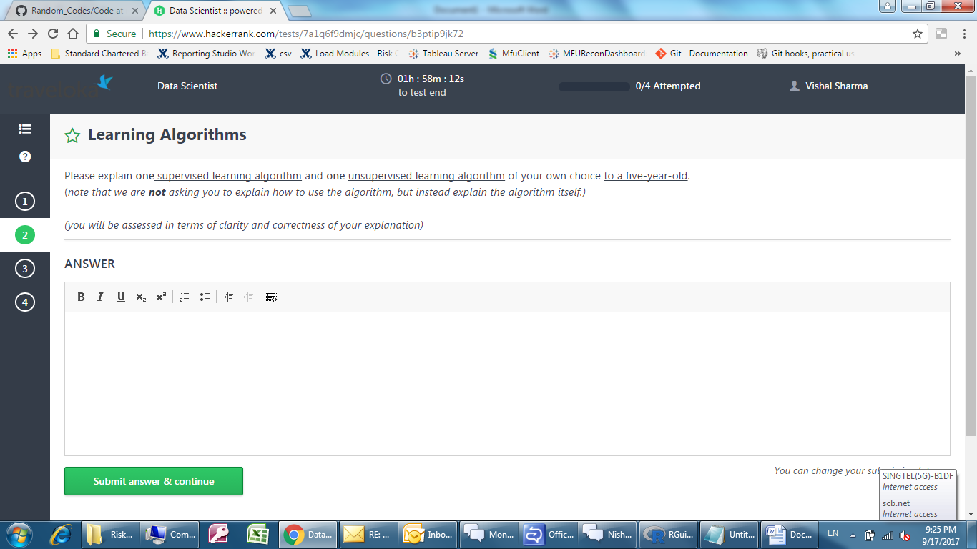

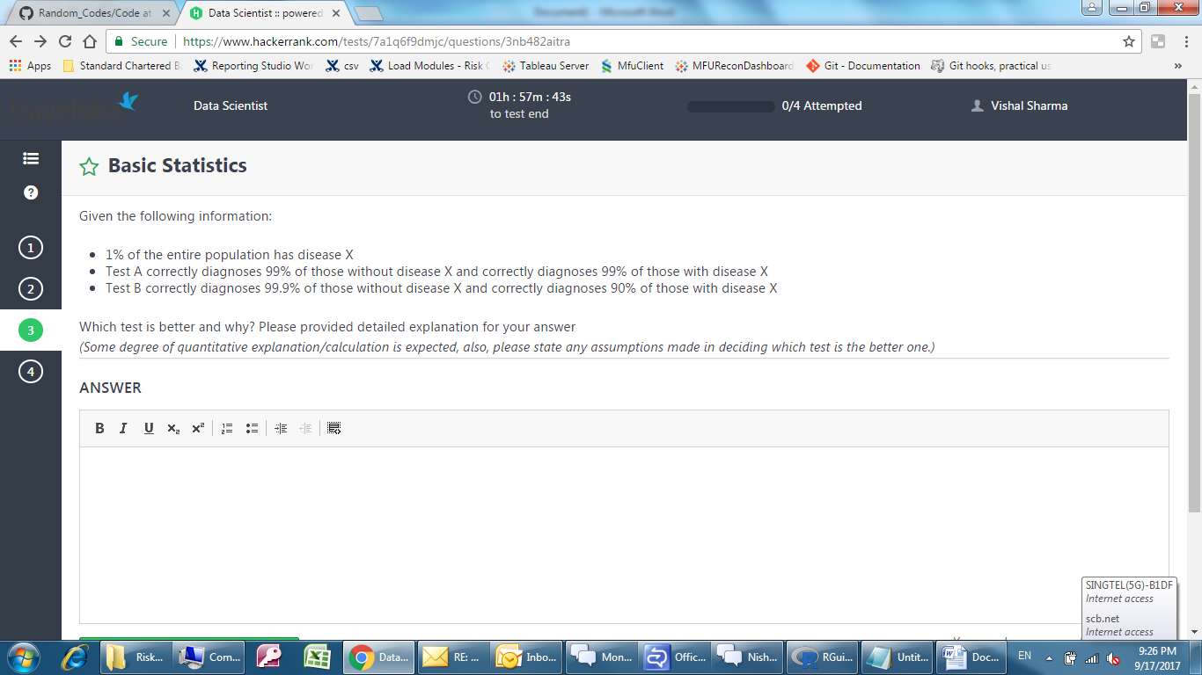

http://sphweb.bumc.bu.edu/otlt/mph-modules/bs/bs704_probability/bs704_probability6.html

