Facebook Integration

Step 1: Install the Facebook SDK for iOS

Download the facebook SDK 3.1.1 from below mention link and install the package. The default install location is ~/Documents/FacebookSDK.

Link : http://developers.facebook.com/ios/downloads/

Step 1: Create a Facebook App

You will need a Facebook App ID before you create a new project with the SDK.

Create a new app on the Facebook App Dashboard please find below link for same and enter your app's basic information.

Link : https://developers.facebook.com/apps/

Step 3: Configure a Facebook SDK in Xcode Project

In Xcode, create a new project, and select 'Single View Application' as shown below.

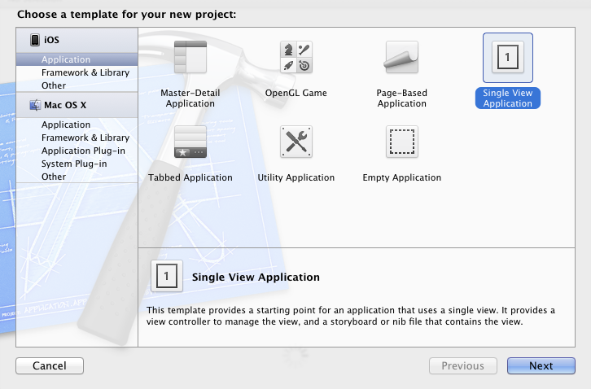

Provide a name and identifier as required:
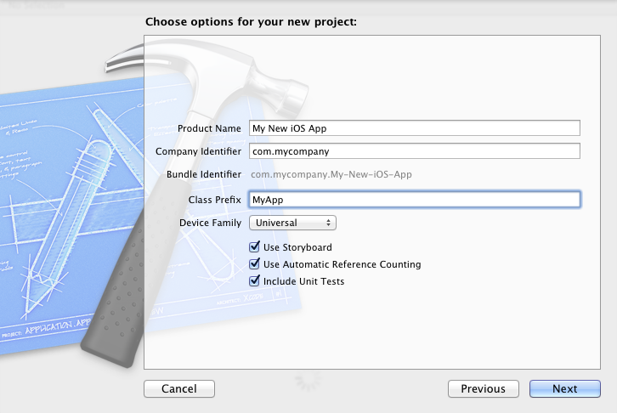

Adding SDK & framework dependencies

Add the Facebook SDK for iOS Framework by dragging the FacebookSDK.framework folder from the SDK installation folder into the Frameworks section of your Project Navigator.

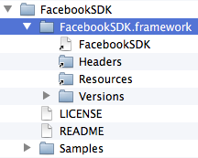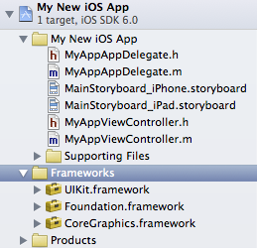

Add the Facebook SDK for iOS resource bundle by dragging the FacebookSDKResources.bundle and FBUserSettingsViewResources bundle file from the FacebookSDK.framework/Resources folder into the Frameworks section of your Project Navigator.

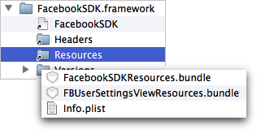

The SDK relies on three other frameworks (AdSupport, Accounts and Social) to use the Facebook features built into iOS6. To add these, go to the 'Linked Frameworks and Libraries' section of the target's Summary pane, and click the 'plus' button to add them:

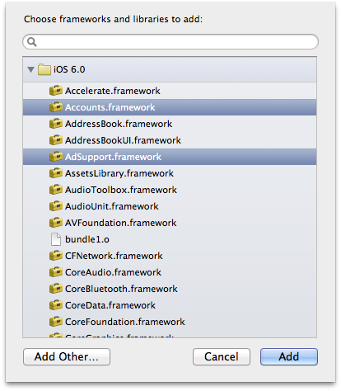

Note: You should use the 'Optional' flag for iOS6-specific frameworks if you would like your app to also build for older versions of the operating systems.

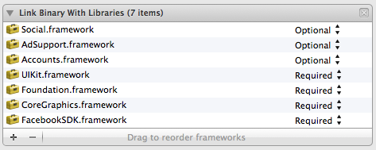

Once done, your Project Navigator should look something like this:

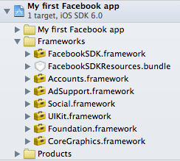

Adding SQLite

Next you need to add the ''-lsqlite3.0'' SQL library to the list of build dependencies in the Build Settings pane:

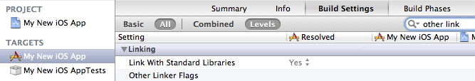

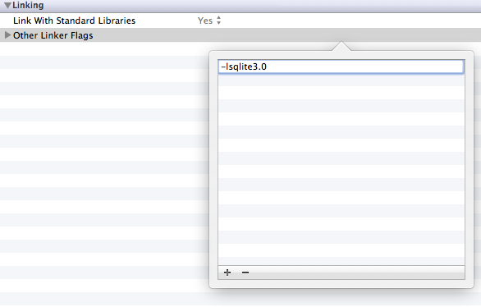

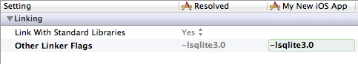

Adding your Facebook App ID

Finally, you need to place the Facebook app ID in two places in your application's main .plist file. Create a key called FacebookAppID with a string value, and add the app ID there:

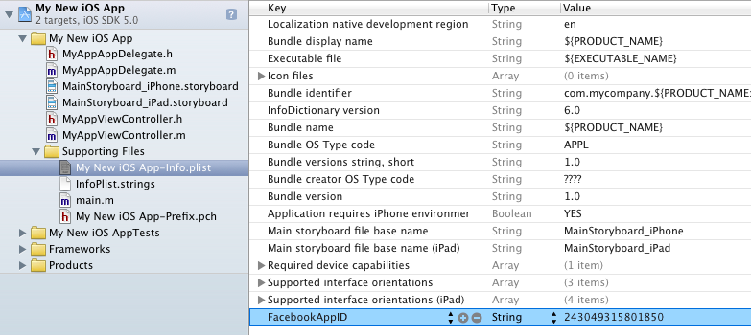

Also, create an array key called URL types with a single array sub-item called URL Schemes. Give this a single item with your app ID prefixed with fb:

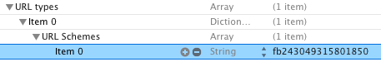

(This is used to ensure the application will receive the callback URL of the web-based OAuth flow.)

Step 4: Open facebook login screen in app

Download FacebookIntegration project from SVN. Please find below SVN link for same. You can refer entire FacebookIntegration project for Open facebook login screen, Get login user information, Share/Publish text on user wall, Share
SVN Link:

*Note: Copy piece of code from below, which is mentioned “Copy and Paste in your project”

Please modify and create below mentioned project file.

1. app delegate file

Open up the app delegate implementation file and include the Facebook SDK:

######## Copy and Paste in your project ########

#import <FacebookSDK/FacebookSDK.h>

######## Copy and Paste in your project ########

The flow back to your app may be interrupted (for ex: if the user clicks the Home button if authenticating via the Facebook for iOS app). If this happens, the Facebook SDK can take care of any cleanup that may include starting a fresh session. To enable this, in the applicationDidBecomeActive: delegate method call the active session's handleDidBecomeActive method:

######## Copy and Paste in your project ########

[FBSession.activeSession handleDidBecomeActive];

######## Copy and Paste in your project ########

You should also take care of closing the session if the app is about to terminate. Do this by adding the following code to the user applicationWillTerminate: app delegate method:

######## Copy and Paste in your project ########

[FBSession.activeSession close];

######## Copy and Paste in your project ########

2. ViewController file

Place Facebook Login button on ViewController and action below mentioned method for same

######## Copy and Paste in your project ########

-(IBAction) showLoginView
{
SCViewController *scView = [[SCViewController alloc] initWithNibName:@"SCViewController" bundle:nil];
[self.navigationController pushViewController:scView animated:YES];
}

######## Copy and Paste in your project ########

ViewController screen will look like as below:
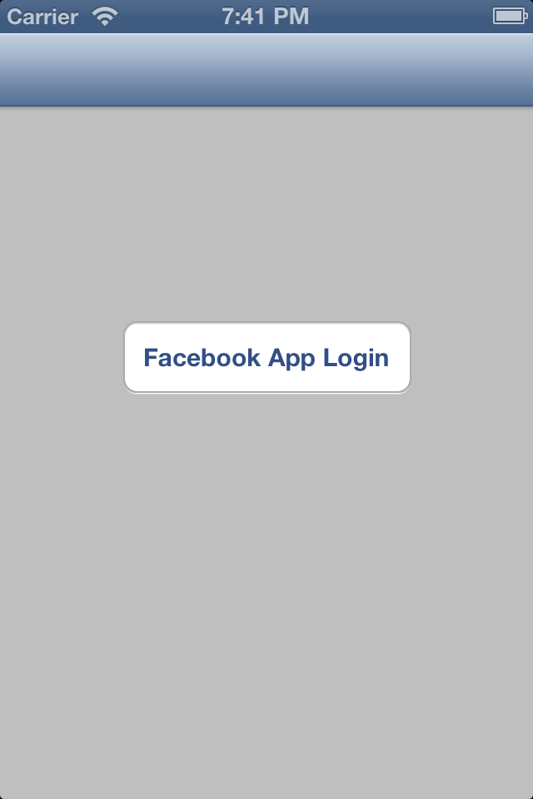

3. SCViewController file

Create new SCViewController file with UIViewController type. Open up the SCViewController header file and include the Facebook SDK:

######## Copy and Paste in your project ########

#import <FacebookSDK/FacebookSDK.h>
//Replace with your Facebook application App ID
#define FaceBookAppID @"257555804283473"

######## Copy and Paste in your project ########

For opening FaceBook login screen, copy below mentioned code from ViewDidLoad method of SCViewController.m and paste in your project file.

######## Copy and Paste in your project ########

NSArray *permissions = [NSArray arrayWithObjects:@"user_photos", @"publish_actions", @"user_videos",@"publish_stream",@"offline_access",@"user_checkins",@"friends_checkins",@"email",@"user_location" ,nil];

FBSession *fbSession = [[FBSession alloc] initWithAppID:FaceBookAppID permissions:permissions urlSchemeSuffix:nil tokenCacheStrategy:nil];

[FBSession setActiveSession:fbSession];

[fbSession openWithBehavior:FBSessionLoginBehaviorForcingWebView completionHandler:^(FBSession *session, FBSessionState status,NSError *error)
{
switch (status) {
case FBSessionStateOpen:
if (!error) {

//Get User Information
[self getUserInfo];

}
break;
case FBSessionStateClosed:
NSLog(@"Close");
case FBSessionStateClosedLoginFailed:

[FBSession.activeSession closeAndClearTokenInformation];

if(error)
{
ViewController *viewObj = [[ViewController alloc] init];
[self.navigationController pushViewController:viewObj animated:YES];
}

break;
default:
break;
}

}];

######## Copy and Paste in your project ########

Add GetUserInfo method for fetch facebook login user information. In user dictionary we will get login user information.

######## Copy and Paste in your project ########

#pragma mark - Get User Information

-(void) getUserInfo
{
[[FBRequest requestForMe] startWithCompletionHandler:^(FBRequestConnection *connection,
NSDictionary<FBGraphUser> *user,
NSError *error) {
if (!error) {

NSLog(@”User Infromation ====%@”, user)

}else { NSLog(@"Found Error === %@", error); [errLbl setHidden:NO]; }
}];
}

######## Copy and Paste in your project ########

Step 4: Share/Publish text on user wall

For share text on user wall, include “ShareViewController” file in your project and do some XIB IBOutlet connection with ShareViewController and SCViewController as per FacebookIntegration project.

Step 5: Share image on user wall

For share image on user wall, copy below mentioned method from “SCViewController.m” and paste in your project.

######## Copy and Paste in your project ########

#pragma mark - Publish Image on FaceBook Wall

- (IBAction) postImageToFacebook
{
UIImage *imgSource = [UIImage imageNamed:@"pic.jpg"];
NSString *strMessage = @"This is the photo caption";
NSMutableDictionary* photosParams = [NSMutableDictionary dictionaryWithObjectsAndKeys:
imgSource,@"source",
strMessage,@"message",
nil];
[FBRequestConnection startWithGraphPath:@"me/photos" parameters:photosParams HTTPMethod:@"POST" completionHandler:^(FBRequestConnection *connection, id result, NSError *error) {
NSString *alertText;
if (error) {
alertText = [NSString stringWithFormat:
@"error: domain = %@, code = %d",
error.domain, error.code];
} else {
alertText = [NSString stringWithFormat:
@"Posted action, id: %@",
[result objectForKey:@"id"]];
}
// Show the result in an alert
[[[UIAlertView alloc] initWithTitle:@"Result"
message:alertText
delegate:self
cancelButtonTitle:@"OK!"
otherButtonTitles:nil]
show];
}];

}

######## Copy and Paste in your project ########

