Text To Speech in iOS (OpenEars Framework)

Step 1: Install the OpenEars Freamwork

Download the OpenEars freamwork from below mention link.

Link: www.politepix.com/wp-content/uploads/OpenEarsDistribution.tar.bz2

Inside your downloaded distribution there is folder called “Frameworks”. Drag the “Freamworks” folder into your app project in XCode.

Step 2: Configure a OpenEars Framework in Xcode Project

In Xcode, create a new project, and select 'Single View Application' as shown below.

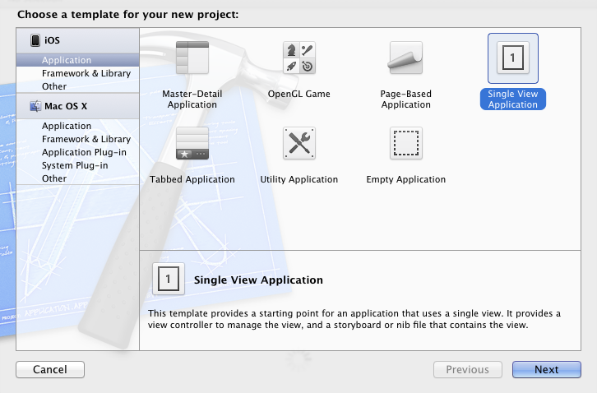

Provide a name and identifier as required:
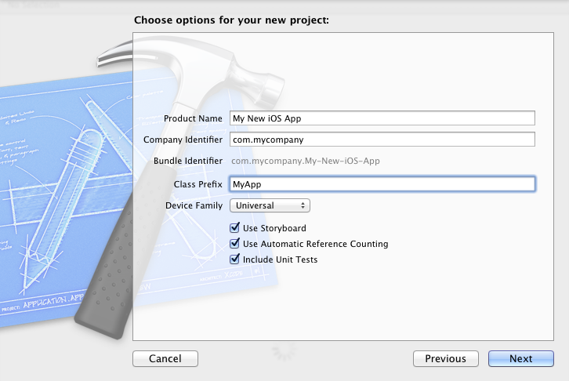

Adding SDK & framework dependencies

Add the iOS frameworks AudioToolBox and AVFoundation in your project.

To use FliteController, you need to have at least one Flite voice added to your project. When you added the "framework" folder of OpenEars to your app, you already imported a voice called Slt, so these instructions will use the Slt voice. You can get eight more free voices in OpenEarsExtras, available at https://bitbucket.org/Politepix/openearsextras

Add the following lines to your header (the .h file). Under the imports at the very top:

######## Copy and Paste in your project ########

#import <Slt/Slt.h>
#import <OpenEars/FliteController.h>

######## Copy and Paste in your project ########

In the middle part where instance variables go:

######## Copy and Paste in your project ########

FliteController *fliteController;
Slt *slt;

@property (strong, nonatomic) FliteController *fliteController;
@property (strong, nonatomic) Slt *slt;

######## Copy and Paste in your project ########

Add the following to your implementation (the .m file): Under the @implementation keyword at the top:

######## Copy and Paste in your project ########

@synthesize fliteController;
@synthesize slt;

######## Copy and Paste in your project ########

Among the other methods of the class, add these lazy accessor methods for confident memory management of the object:

- (FliteController *)fliteController {

if (fliteController == nil) {
fliteController = [[FliteController alloc] init];
}
return fliteController;
}
- (Slt *)slt {
if (slt == nil) {
slt = [[Slt alloc] init];
}
return slt;
}

######## Copy and Paste in your project ########

In the method where you want to call speech (to test this out, add it to your viewDidLoad method), add the following method call:

######## Copy and Paste in your project ########

[self.fliteController say:@"A short statement" withVoice:self.slt];

######## Copy and Paste in your project ########

