Twitter Integration

Step 1: Install the Twitter SDK for iOS

Download the DETweetComposeViewController twitter SDK from below mentioned link

Link: https://github.com/doubleencore/DETweetComposeViewController

OR

Also you can download from SVN, please refer below mentioned link for same.

SVN Link:

Step 2: Create a Twitter App

You will need a Twitter Consumer Key and Consumer Secret before you create a new project with the SDK.

Create a new app on the Twitter App Dashboard please find below link for same and enter your app's basic information.

Link : https://dev.twitter.com/

Make sure your app's Access is set to 'Read and Write' and a Callback URL is defined. Both of these configurations can be found under the Settings of your Twitter app.

Step 3: Configure a Twitter SDK in Xcode Project

In Xcode, create a new project, and select 'Single View Application' as shown below.

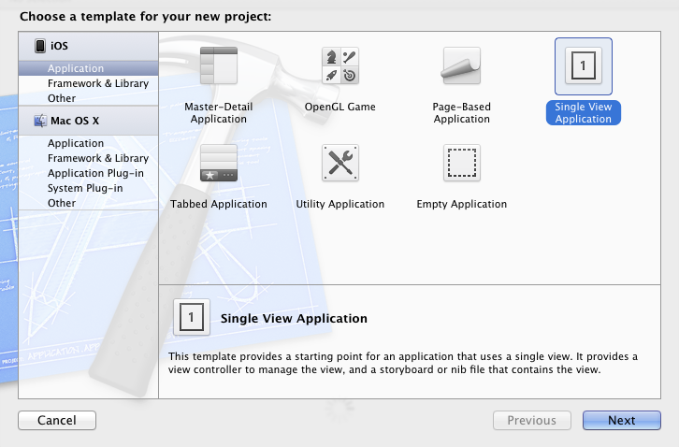

Provide a name and identifier as required:
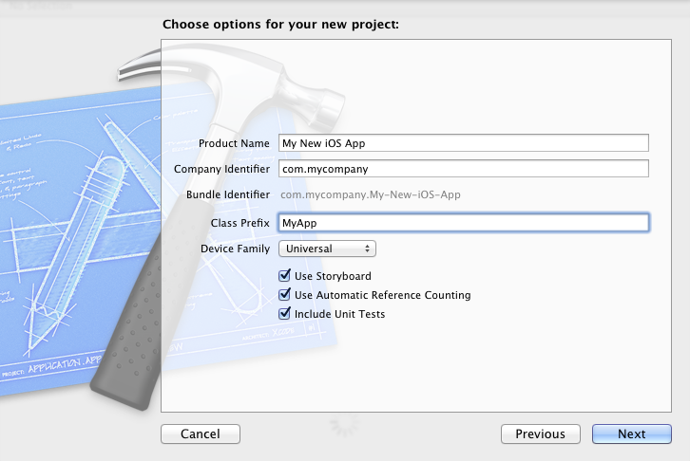

Adding SDK & framework dependencies

Add all the files from the DETweetComposeViewController/DETweetComposeViewController folder to your project.

From DETweetComposeViewController/DETweeter/unofficial-twitter-sdk/unoffical-twitter-sdk, add the following to a group in your project named unoffical-twitter-sdk:

- JSON/
- OAuth/
- tclose.png
- ticon.png
- TwitterDialog.h
- TwitterDialog.m

Link your project against the follwoing frameworks:

- Accounts.framework
- Twitter.framework.

Adding your Twitter Consumer Key and Consumer Secret

Set your Twitter OAuth Consumer Key and Consumer Secret in OAuthConsumerCredentials.h in your project, you will find this file in unoffical-twitter-sdk/OAuth.

Step 4: Twitter Integration: Tweet Message

*Note: Copy piece of code from below, which is mentioned “Copy and Paste in your project”

I have created Twitter Integration Example. You can download example code from below mentioned SVN link

SVN Link:

Please refer same downloaded example code for integrating Twitter in your project. Please open downloaded example code and follow below mentioned steps

1. ViewController file

Open up the ViewController implementation file and include the Twitter SDK:

######## Copy and Paste in your project ########

#import "DETweetComposeViewController.h"

#pragma mark - Tweet Images on twitter

-(IBAction) tweetImage
{

DETweetComposeViewController *tcvc = [[DETweetComposeViewController alloc] init];
[tcvc addImage:[UIImage imageNamed:@"Profile-Pic.jpg"]];
self.modalPresentationStyle = UIModalPresentationCurrentContext;
[self presentModalViewController:tcvc animated:YES];
}
######## Copy and Paste in your project ########

Step 5: Twitter Integration: Tweet Images

Open up the ViewController implementation file and include the below mentioned code:

######## Copy and Paste in your project ########

-(IBAction) tweetImage
{
DETweetComposeViewController *tcvc = [[DETweetComposeViewController alloc] init];
[tcvc addImage:[UIImage imageNamed:@"Profile-Pic.jpg"]];
self.modalPresentationStyle = UIModalPresentationCurrentContext;
[self presentModalViewController:tcvc animated:YES];
}

######## Copy and Paste in your project ########

Step 5: Twitter Integration: Get User Information

Open up the ViewController implementation file and include the below mentioned code:

######## Copy and Paste in your project ########

-(IBAction) getUserInfo
{
NSUserDefaults *userDefault = [NSUserDefaults standardUserDefaults];
NSString *url = [NSString stringWithFormat:@"https://api.twitter.com/1/users/show.json?screen_name=%@&include_entities=true", [userDefault stringForKey:@"screen_name"]];

connObj = [[connectionController alloc] init];
connObj.delegate = self;
[connObj startXMLParsing:url];

}
-(void) parseResponseResult:(id) result
{
NSDictionary *userList = result;
NSLog(@"userList === %@", userList);
}

######## Copy and Paste in your project ########

add “connectionController.h” and “connectionController.m” in your project and include “connectionController.h” file in your project implementation file.

