1. Docker Hub Image link for all 3 microservice

: - <https://hub.docker.com/repository/docker/umeshk301290/userdetails/tags?page=1>(docker pull umeshk301290/userdetails:v1)

:- <https://hub.docker.com/repository/docker/umeshk301290/orderdetails/tags?page=1>(docker pull umeshk301290/orderdetails:v1)

:<https://hub.docker.com/repository/docker/umeshk301290/aggregatedetails/tags?page=1>(docker pull umeshk301290/aggregatedetails:v1)

1. Github link for microservice :-

<https://github.com/umeshk301290/MicroServiceUserService>

<https://github.com/umeshk301290/MicroServiceOrderService>

<https://github.com/umeshk301290/MicroServiceAggregateService>

Screenshots : -

1. Screenshot of all running deployments :-

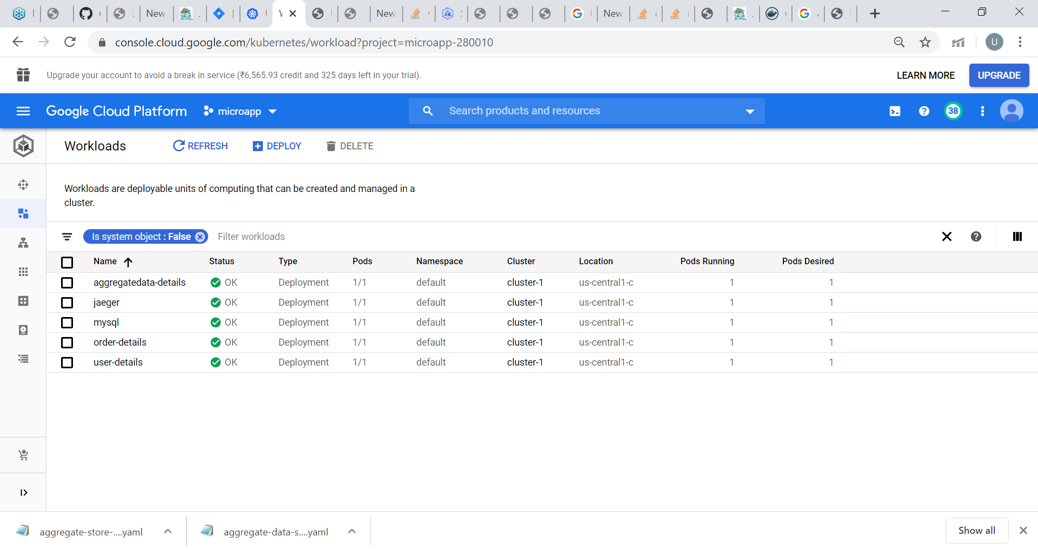

1. Screenshot of all running services with internal and external IP:-

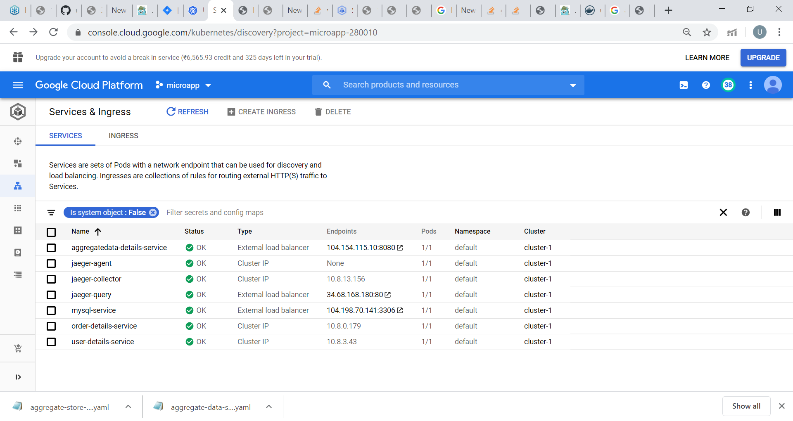

1. Screenshot of persistence volume claim:-

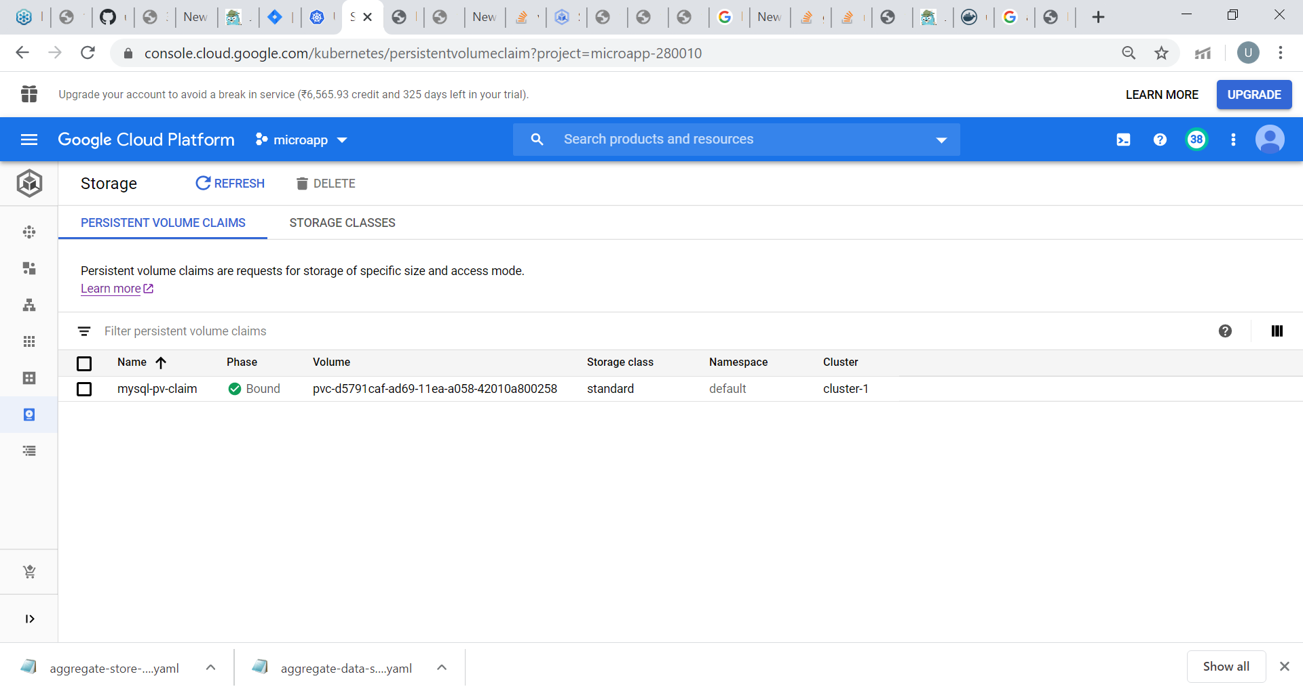

Mysql Db associated with Persistence volume claim

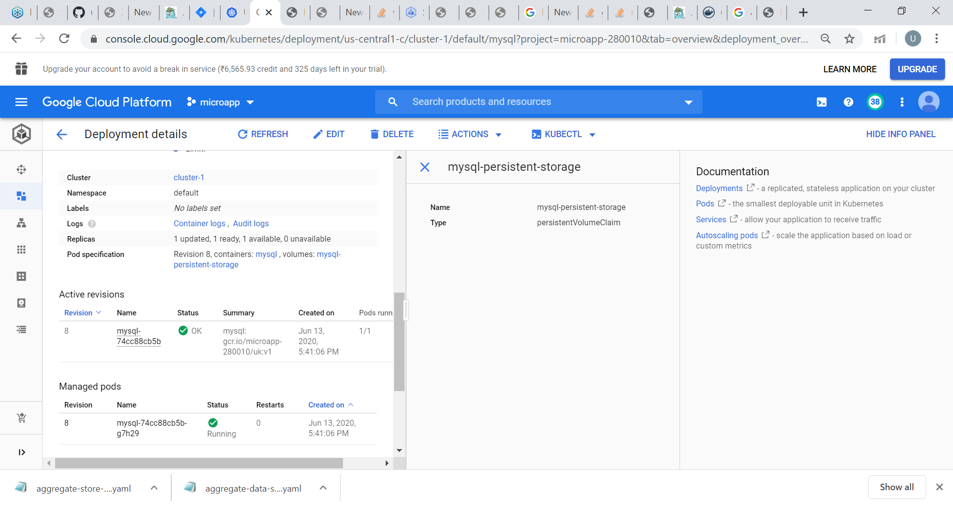

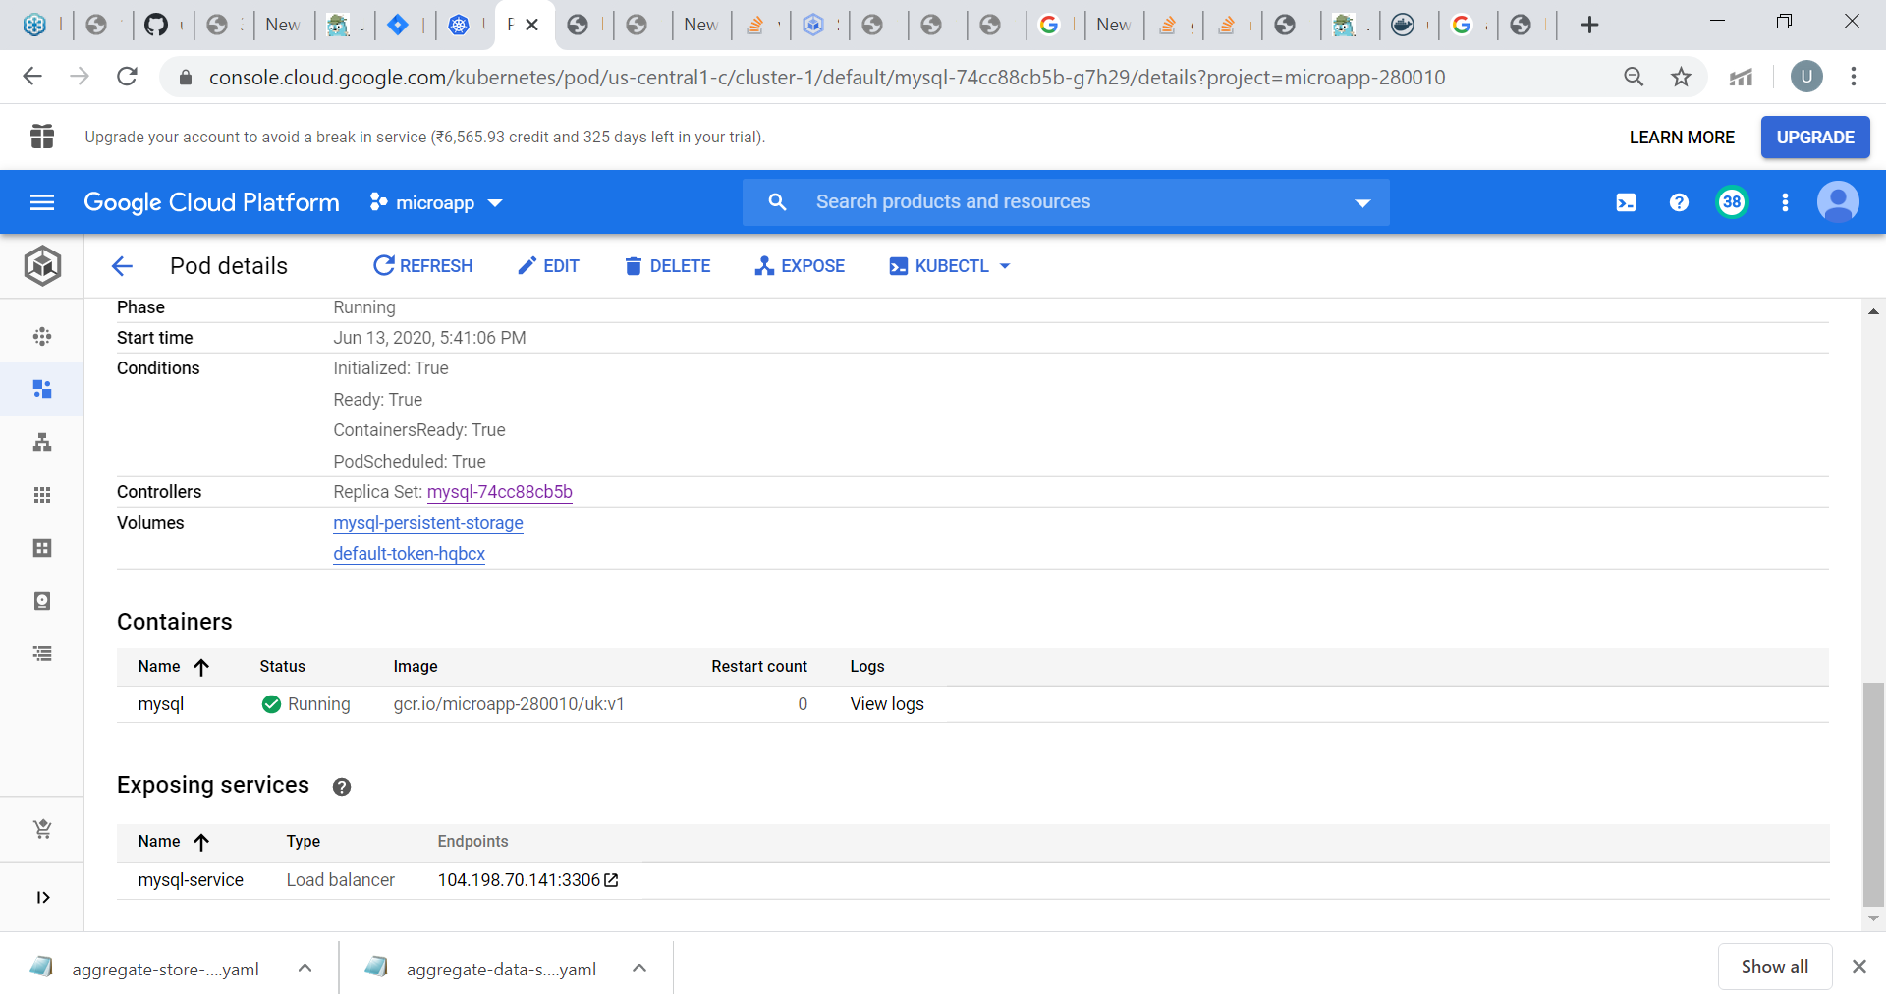

1. Screenshot of Secret Generated : -

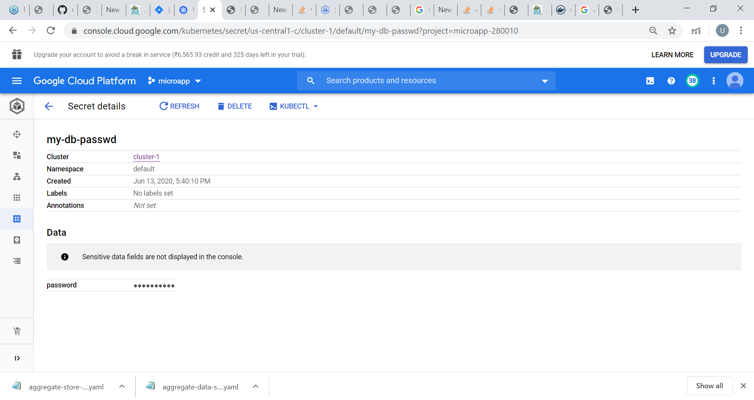

Secret associated with mysql root password :-

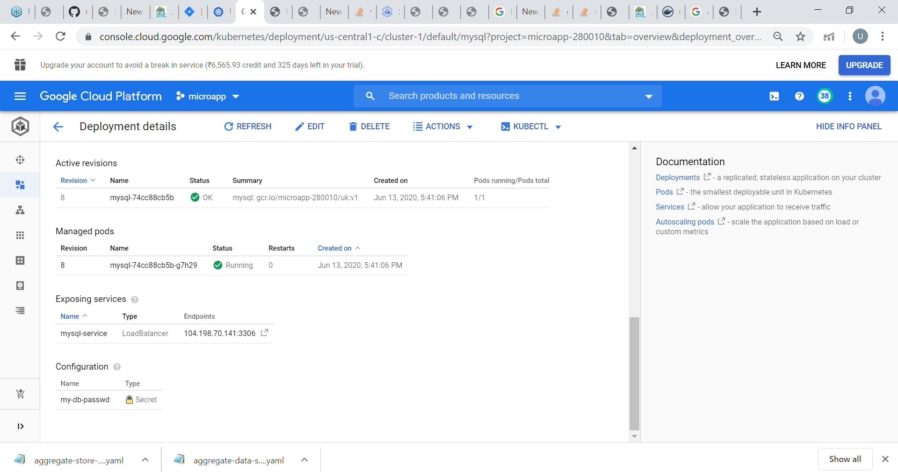

1. Screenshot of Aggregator service with external endpoints :-

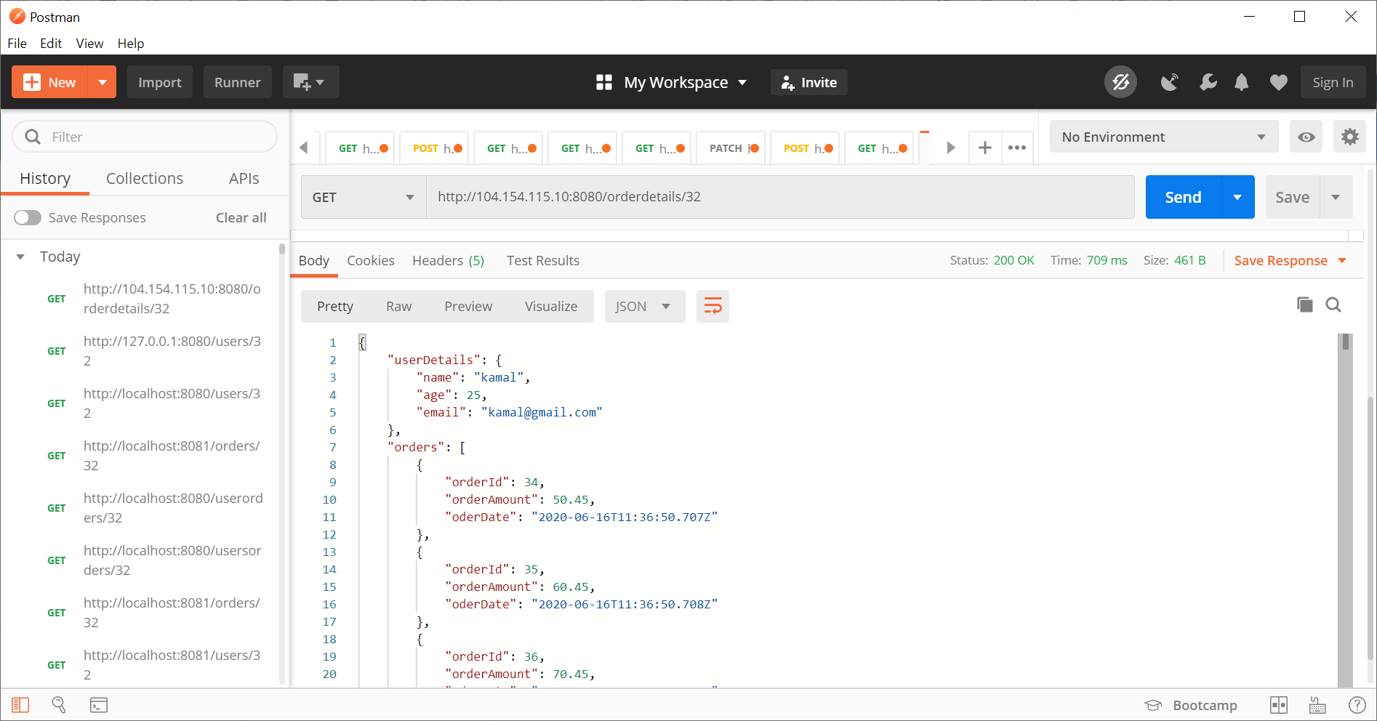

1. Screenshot of trace data on jaeger :-

