Islington College



Final Year Project

CCXXXX

**Interim Report**

**“Think Renting”**

**Submitted By:** **Submitted To:**

Anmol Chalise Mr. Rabin Regmi

14046933

L3C5

Date: xxxxxxxxx

**Abstract**

The business-to-consumer aspect of electronic commerce (e-commerce) is the most visible business use of the World Wide Web. The project will be known as the Think Renting. This project deals with developing an e-commerce website for renting products online. It provides the user with a catalog of different products available for rent.

This report contains the introduction, background, methodology, analysis of current scenario, development tools and progress. Problems of the current system of the product rental management had been analyzes and from that, requirement analysis had been made. On the analyzing part Presentation and comparison of some well-established website development methods had been made and this comparison aims to show the advantages and disadvantages of these methods. This can be vital in order to exploit their strong points and avoid similar mistakes in the methodology that will be finally applied for the development of the website. Another part of the report aims to present the methodology that will be followed throughout the project.

**Table of Contents**

**1.** **Introduction** 5

**1.1 Project Introduction** 5

**1.2 Problem domain** 5

**1.3 Project as a solution** 7

**1.4 Aims and Objectives** 8

**1.4.1 Project Objectives** 8

**1.4.2 Personal Objectives:** 8

**1.5 Structure of Report** 9

**2.** **Background** 9

**2.1 Literature Review** 9

**2.2 Architectures** 10

**2.2.1 How does the web app look and feel to use** 10

**2.3 Current scenario** 10

**2.3.1 Renting system** 10

**2.3.2 Nepal: Rental income taxes (%).** 10

**2.3.3 Growth of rental industry** 11

**2.3.4 Why web based system?** 12

**2.4 Similar system** 12

**2.4.1 Rentoid** 12

**2.4.2 Zilok** 15

**2.4.3 GrabOnRent** 16

**2.5 Analysis of Similar Systems:** 18

**3** **Proposed method, tools and techniques.** 19

**3.1 DSDM (Dynamic System Development Method)** 20

**3.1.1 Why Dynamic System Development Method not chosen.** 21

**3.2 Evolutionary Prototype** 21

**3.2.1 Why Evolutionary prototyping not chosen.** 21

**3.3** **Rational unified prototype** 22

**3.3.1** **Why RUP has been chosen.** 22

**3.3.2** **Stages of RUP.** 22

**4) Initial gantt chart** 23

**5) Progress** 24

**6 Project Plan (final gantt chart)** 26

**3.6 Work Breakdown Structure** 30

**Table of figure**

Figure 1: Gross Domestic Product (GDP) of South Asia (tradingeconomics, 2016) 6

Figure 2: Nepal GDP annual growth rate (Statistics, 2016) 6

Figure 3: Rental income tax – Nepal Compare to other continent (Guide, 2016) 11

Figure 4: Rentroid page 12

Figure 5: Details of the product 13

Figure 6: Zilok Product Page 14

Figure 7: Rentstuff Home page 15

Figure 8: Rentstuff Product Renting Page 16

Figure 9: Dynamic System Development Method 18

Figure 10: Evolutionary Prototype Methodology 19

Figure 11: Rational Unified Prototype 20

Figure 12: Project Plan Gantt Chart 37

# **4) Initial gantt chart**

]

========================

# **5) Progress**

* As for the methodologies for the ‘Think Renting’ application ration[}}}}}}}l unified process (RUP) is selected. RUP consists of the inception, elaboration, construction and transition phase where the project planning is done in the inception phase. Here the table is provided to show the progress of the system is followed.

|  |  |  |  |  |  |
| --- | --- | --- | --- | --- | --- |
| **Task Name** | **Duration** | **Start** | **Finish** | **Predecessors** | **Task completion** |
| **Think Renting** | **184 days** | **Sun 9/18/16** | **Mon 3/20/17** |  |  |
| **Initiation** | **4 days** | **Sun 9/18/16** | **Wed 9/21/16** |  |  |
| **Topic** | **4 days** | **Sun 9/18/16** | **Wed 9/21/16** |  | Completed |
| Project Research | 3 days | Sun 9/18/16 | Tue 9/20/16 |  | Completed |
| Finalization of the topic | 1 day | Wed 9/21/16 | Wed 9/21/16 | 3 | Completed |
| **First Iteration** | **131 days** | **Thu 11/10/16** | **Mon 3/20/17** |  |  |
| Survey | 2 days | Thu 11/10/16 | Fri 11/11/16 | 4 | Completed |
| Requirement Gathering | 1 day | Sat 11/12/16 | Sat 11/12/16 | 6 | Completed |
| Requirement Analysis | 2 days | Sun 11/13/16 | Mon 11/14/16 | 7 | Completed |
| Problem domain | 1 day | Tue 11/15/16 | Tue 11/15/16 | 8 | Completed |
| SRS Preparation | 1 day | Wed 11/16/16 | Wed 11/16/16 | 9 | Completed |
| Review of SRS | 1 day | Thu 11/17/16 | Thu 11/17/16 | 10 | Completed |
| Aims and objectives of the Project | 1 day | Fri 11/18/16 | Fri 11/18/16 | 11 | Completed |
| Work breakdown structure | 2 days | Fri 11/18/16 | Sat 11/19/16 | 11 | Completed |
| Gantt Chart | 2 days | Sun 11/20/16 | Mon 11/21/16 | 13 | Completed |
| **Design** | **38 days** | **Tue 11/22/16** | **Thu 12/29/16** |  |  |
| **Wireframe** | **31 days** | **Tue 11/22/16** | **Thu 12/22/16** | **14** | Completed |
| Version 1.0 | 16 days | Tue 11/22/16 | Wed 12/7/16 |  | Completed |
| Wireframe Version 1.0 Review | 1 day | Thu 12/8/16 | Thu 12/8/16 | 17 | Completed |
| Version 2.0 | 13 days | Fri 12/9/16 | Wed 12/21/16 | 18 | Not Completed |
| Wireframe Version 2.0 Review | 1 day | Thu 12/22/16 | Thu 12/22/16 | 19 | Not Completed |
| WBS | 1 day | Fri 12/23/16 | Fri 12/23/16 | 20 | Completed |
| Gantt Chart | 2 days | Sat 12/24/16 | Sun 12/25/16 | 21 | Completed |
| Use Case Diagram | 3 days | Mon 12/26/16 | Wed 12/28/16 | 22 | Completed |
| Review Interim Report | 1 day | Thu 12/29/16 | Thu 12/29/16 | 23 | Not Completed |
| **Development** | **15 days** | **Sun 1/15/17** | **Sun 1/29/17** |  | Not Completed |
| **Development** | **15 days** | **Sun 1/15/17** | **Sun 1/29/17** |  | Not Completed |
| Front End | 4 days | Sun 1/15/17 | Wed 1/18/17 |  | Not Completed |
| Back End | 4 days | Thu 1/19/17 | Sun 1/22/17 | 27 | Not Completed |
| **Testing** | **5 days** | **Mon 1/23/17** | **Fri 1/27/17** | **28** | Not Completed |
| Black Box testing | 3 days | Mon 1/23/17 | Wed 1/25/17 |  | Not Completed |
| White Box Testing | 2 days | Thu 1/26/17 | Fri 1/27/17 | 30 | Not Completed |
| **Implementation** | **2 days** | **Sat 1/28/17** | **Sun 1/29/17** | **31** | Not Completed |
| Module Deploy | 1 day | Sat 1/28/17 | Sat 1/28/17 |  | Not Completed |
| Review | 1 day | Sun 1/29/17 | Sun 1/29/17 | 33 | Not Completed |
| Iteration 1 Complete | 0 days | Sun 1/29/17 | Sun 1/29/17 | 34 | Not Completed |
| Survey2 | 1 day | Mon 1/30/17 | Mon 1/30/17 | 35 | Not Completed |
| **Second Iteration** | **47 days** | **Tue 1/31/17** | **Sat 3/18/17** | **36** | Not Completed |

# **6 Project Plan (final gantt chart)**

To complete every project some structure must be breakdown. For completion of this project following works are breakdown.

|  |  |  |  |  |
| --- | --- | --- | --- | --- |
| **Task Name** | **Duration** | **Start** | **Finish** | **Predecessors** |
| **Think Renting** | **184 days** | **Sun 9/18/16** | **Mon 3/20/17** |  |
| **Initiation** | **4 days** | **Sun 9/18/16** | **Wed 9/21/16** |  |
| **Topic** | **4 days** | **Sun 9/18/16** | **Wed 9/21/16** |  |
| Project Research | 3 days | Sun 9/18/16 | Tue 9/20/16 |  |
| Finalization of the topic | 1 day | Wed 9/21/16 | Wed 9/21/16 | 3 |
| **First Iteration** | **131 days** | **Thu 11/10/16** | **Mon 3/20/17** |  |
| Survey | 2 days | Thu 11/10/16 | Fri 11/11/16 | 4 |
| Requirement Gathering | 1 day | Sat 11/12/16 | Sat 11/12/16 | 6 |
| Requirement Analysis | 2 days | Sun 11/13/16 | Mon 11/14/16 | 7 |
| Problem domain | 1 day | Tue 11/15/16 | Tue 11/15/16 | 8 |
| SRS Preparation | 1 day | Wed 11/16/16 | Wed 11/16/16 | 9 |
| Review of SRS | 1 day | Thu 11/17/16 | Thu 11/17/16 | 10 |
| Aims and objectives of the Project | 1 day | Fri 11/18/16 | Fri 11/18/16 | 11 |
| Work breakdown structure | 2 days | Fri 11/18/16 | Sat 11/19/16 | 11 |
| Gantt Chart | 2 days | Sun 11/20/16 | Mon 11/21/16 | 13 |
| **Design** | **38 days** | **Tue 11/22/16** | **Thu 12/29/16** |  |
| **Wireframe** | **31 days** | **Tue 11/22/16** | **Thu 12/22/16** | **14** |
| Version 1.0 | 16 days | Tue 11/22/16 | Wed 12/7/16 |  |
| Wireframe Version 1.0 Review | 1 day | Thu 12/8/16 | Thu 12/8/16 | 17 |
| Version 2.0 | 13 days | Fri 12/9/16 | Wed 12/21/16 | 18 |
| Wireframe Version 2.0 Review | 1 day | Thu 12/22/16 | Thu 12/22/16 | 19 |
| WBS | 1 day | Fri 12/23/16 | Fri 12/23/16 | 20 |
| Gantt Chart | 2 days | Sat 12/24/16 | Sun 12/25/16 | 21 |
| Use Case Diagram | 3 days | Mon 12/26/16 | Wed 12/28/16 | 22 |
| Review Interim Report | 1 day | Thu 12/29/16 | Thu 12/29/16 | 23 |
| **Development** | **15 days** | **Sun 1/15/17** | **Sun 1/29/17** |  |
| **Development** | **15 days** | **Sun 1/15/17** | **Sun 1/29/17** |  |
| Front End | 4 days | Sun 1/15/17 | Wed 1/18/17 |  |
| Back End | 4 days | Thu 1/19/17 | Sun 1/22/17 | 27 |
| **Testing** | **5 days** | **Mon 1/23/17** | **Fri 1/27/17** | **28** |
| Black Box testing | 3 days | Mon 1/23/17 | Wed 1/25/17 |  |
| White Box Testing | 2 days | Thu 1/26/17 | Fri 1/27/17 | 30 |
| **Implementation** | **2 days** | **Sat 1/28/17** | **Sun 1/29/17** | **31** |
| Module Deploy | 1 day | Sat 1/28/17 | Sat 1/28/17 |  |
| Review | 1 day | Sun 1/29/17 | Sun 1/29/17 | 33 |
| Iteration 1 Complete | 0 days | Sun 1/29/17 | Sun 1/29/17 | 34 |
| Survey2 | 1 day | Mon 1/30/17 | Mon 1/30/17 | 35 |
| **Second Iteration** | **47 days** | **Tue 1/31/17** | **Sat 3/18/17** | **36** |
| Requirement Analysis | 2 days | Tue 1/31/17 | Wed 2/1/17 |  |
| Problem domain | 1 day | Thu 2/2/17 | Thu 2/2/17 | 38 |
| SRS | 1 day | Fri 2/3/17 | Fri 2/3/17 | 39 |
| **Design** | **32 days** | **Sat 2/4/17** | **Tue 3/7/17** |  |
| Wireframe | 30 days | Sat 2/4/17 | Sun 3/5/17 | 40 |
| Use Case Diagram | 2 days | Mon 3/6/17 | Tue 3/7/17 | 42 |
| **Development** | **11 days** | **Wed 3/8/17** | **Sat 3/18/17** |  |
| **Development** | **11 days** | **Wed 3/8/17** | **Sat 3/18/17** |  |
| Front End | 2 days | Wed 3/8/17 | Thu 3/9/17 | 43 |
| Back End | 2 days | Fri 3/10/17 | Sat 3/11/17 | 46 |
| **Testing** | **5 days** | **Sun 3/12/17** | **Thu 3/16/17** |  |
| Black Box testing | 3 days | Sun 3/12/17 | Tue 3/14/17 | 47 |
| White Box Testing | 2 days | Wed 3/15/17 | Thu 3/16/17 | 49 |
| **Implementation** | **2 days** | **Fri 3/17/17** | **Sat 3/18/17** |  |
| Module Deploy | 1 day | Fri 3/17/17 | Fri 3/17/17 | 50 |
| Review | 1 day | Sat 3/18/17 | Sat 3/18/17 | 52 |
| Second Iteration Complete | 0 days | Sat 3/18/17 | Sat 3/18/17 | 53 |
| **Closure** | **2 days** | **Sun 3/19/17** | **Mon 3/20/17** |  |
| User Manual | 1 day | Sun 3/19/17 | Sun 3/19/17 | 54 |
| Complete System Release | 1 day | Mon 3/20/17 | Mon 3/20/17 | 56 |

Gantt chart

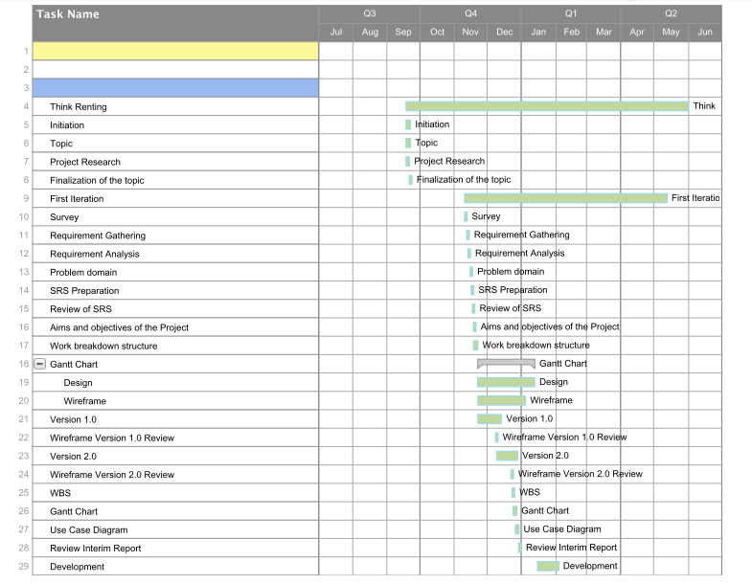

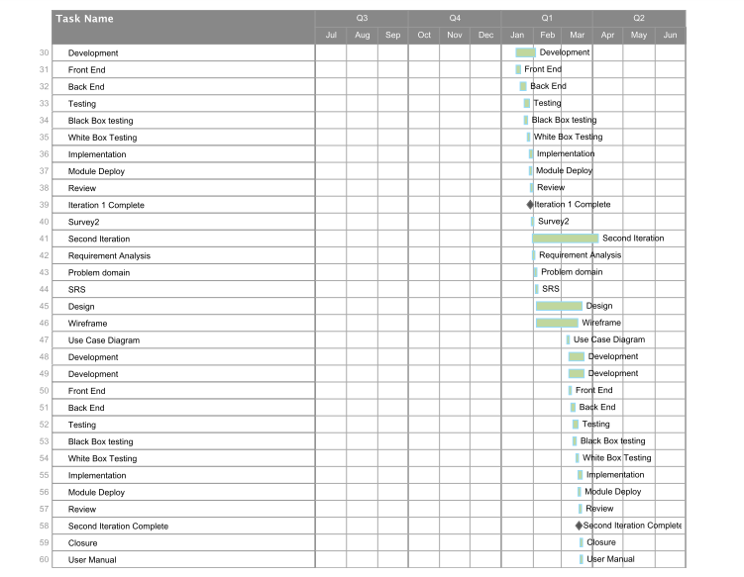

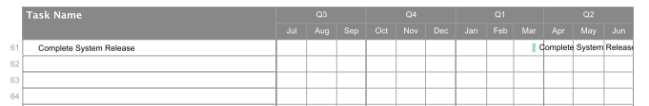

## **3.6 Work Breakdown Structure**

Requirement Gathering

Coding

Testing

Think Renting System

Prepare Reader

Scan Passport

Fix Error

Find Error

Reader System

Maintainance

Black Box Test

Review system

Start Coding

Design System

Use Tools

Design

Conduct interview

Consider Design Tool

Learn to use

Prepare interview

Find Error and Fix

Reader System

Find Error and Fix

Reader System

White Box Test