APPENDIX
  - MATLAB CODES

- Basic Convotion Algorithm :
Column Inheritance:
Without image:
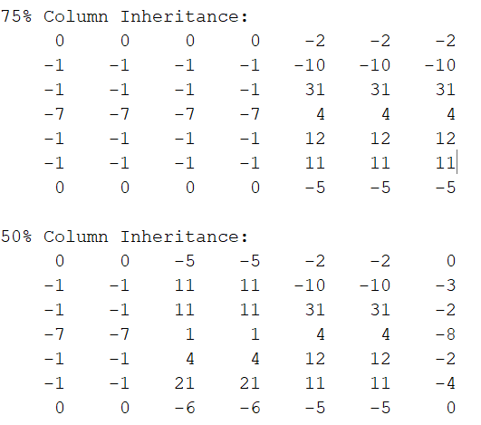
A = [1 5 8 2 3;1 5 4 9 2;7 4 3 6 8;1 4 5 6 2;1 6 4 5 4];
kernel = [0 -1 0;-1 5 -1;0 -1 0];
A1 = conv2(A, kernel);
A275p = A1; A250p = A1; A225p = A1;
for i = 1:7
for j = 1:7
% 75% Inheritance along columns
if mod(j, 4) == 0

A275p(i, j) = A1(i, j - 3);
elseif mod(j, 4) == 2
A275p(i, j) = A1(i, j - 1);
elseif mod(j, 4) == 3
A275p(i, j) = A1(i, j - 2);
end
% 50% Inheritance along columns
if mod(j, 2) == 0
A250p(i, j) = A1(i, j - 1);
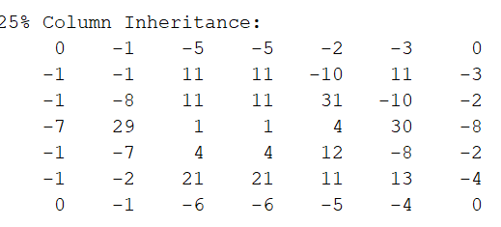
end
% 25% Inheritance along columns
if mod(j, 4) == 0
A225p(i, j) = A1(i, j - 1); end end end
disp('75% Column Inheritance:');
disp(A275p);
disp('50% Column Inheritance:');
disp(A250p);
disp('25% Column Inheritance:');
disp(A225p);

With image:

img = imread('D:/rose.jpeg');
if size(img, 3) == 3
img = rgb2gray(img);
end
A = double(img);
kernel = [1 1 1;1 1 1;1 1 1];
kernel=kernel/sum(kernel(:));
A1 = conv2(A, kernel, 'full');
A2_75 = A1;
A2_50 = A1;
A2_25 = A1;
[rows, cols] = size(A1);
for i = 1:rows
for j = 1:cols
if mod(j, 4) == 0 && j - 3 > 0
A2_75(i, j) = A1(i, j - 3);
elseif mod(j, 4) == 2 && j - 1 > 0
A2_75(i, j) = A1(i, j - 1);
elseif mod(j, 4) == 3 && j - 2 > 0
A2_75(i, j) = A1(i, j - 2);
end

Row Inheritance:
Without image:
A = [1 5 8 2 3;1 5 4 9 2;7 4 3 6 8;1 4 5 6 2;1 6 4 5 4]; kernel = [0 -1 0;-1 5 -1;0 -1 0];
A1 = conv2(A, kernel);
A275p = A1; A250p = A1; A225p = A1;
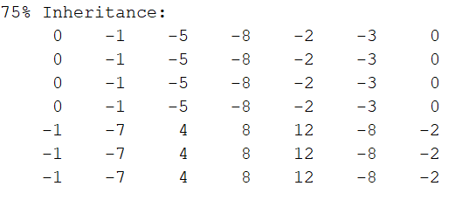
for i = 1:7
for j = 1:7
% 75% row Inheritance
if mod(i, 4) == 0
A275p(i, j) = A1(i - 3, j);
elseif mod(i, 4) == 2
A275p(i, j) = A1(i - 1, j);
elseif mod(i, 4) == 3
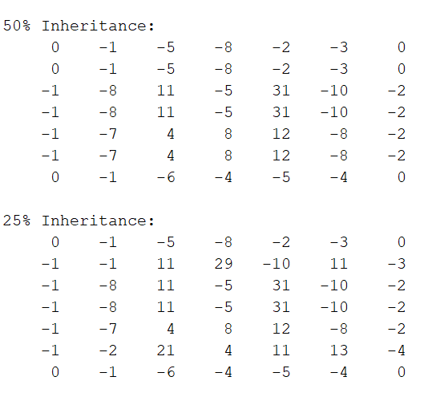
A275p(i, j) = A1(i - 2, j);
end
% 50% row Inheritance
if mod(i, 2) == 0
A250p(i, j) = A1(i - 1, j);
end
% 25% row Inheritance
if mod(i, 4) == 0
A225p(i, j) = A1(i - 1, j);end end end
disp('75% Inheritance:’); disp(A275p);
disp('50% Inheritance:’); disp(A250p);
disp('25% Inheritance:’); disp(A225p);

With image:
img = imread('D:/rose.jpeg');
if size(img, 3) == 3
img = rgb2gray(img);
end
A = double(img);
kernel = [1 1 1; 1 1 1; 1 1 1];
kernel = kernel / sum(kernel(:));
A1 = conv2(A, kernel, 'full');
A2_75 = A1;
A2_50 = A1;
A2_25 = A1;
[rows, cols] = size(A1);
for i = 1:rows
for j = 1:cols
% 75% Row Inheritance
if mod(i, 4) == 0 && i - 3 > 0
A2_75(i, j) = A1(i - 3, j);
elseif mod(i, 4) == 2 && i - 1 > 0
A2_75(i, j) = A1(i - 1, j);
elseif mod(i, 4) == 3 && i - 2 > 0
A2_75(i, j) = A1(i - 2, j);
End
% 50% Row Inheritance
if mod(i, 2) == 0 && i - 1 > 0
A2_50(i, j) = A1(i - 1, j);
end
% 25% Row Inheritance
if mod(i, 4) == 0 && i - 1 > 0
A2_25(i, j) = A1(i - 1, j);
end
end
end
figure;
sgtitle("Algorithm 1- Row Inheritance");
subplot(2,2,1); imshow(uint8(A1)); title('Original Convolution');
subplot(2,2,2); imshow(uint8(A2_75)); title('75% Row Inheritance');
subplot(2,2,3); imshow(uint8(A2_50)); title('50% Row Inheritance');
subplot(2,2,4); imshow(uint8(A2_25)); title('25% Row Inheritance');
Crossing Inheritance:
Without image:
clc; clear; close all;
A = [1 5 8 2 3;1 5 4 9 2;7 4 3 6 8;1 4 5 6 2;1 6 4 5 4];
kernel = [1 1 1;1 1 1;1 1 1];
kernel=kernel/sum(kernel(:));
A1 = conv2(A, kernel);
A25 = A1;
A50 = A1;
A75 = A1;
[rows, cols] = size(A1);
for i = 2:rows
for j = 2:cols
%% 25% CROSS INHERITANCE
if mod(i, 2) == 0 && mod(j, 2) == 0
A25(i,j) = (A1(i-1,j) + A1(i,j-1))/2;
end
%%50% CROSS INHERITANCE
if mod(i+j,2)==0
A50(i,j) = (A1(i-1,j) + A1(i,j-1))/2;
end
%% 75% CROSS INHERITANCE
if mod(i, 2) == 0 && mod(j, 2) ~= 0
A75(i,j) = A1(i-1,j); % inherit from top
elseif mod(i, 2) ~= 0 && mod(j, 2) == 0
A75(i,j) = A1(i,j-1); % inherit from left
elseif mod(i,2)==0 && mod(j,2)==0
A75(i,j) = (A1(i-1,j) + A1(i,j-1))/2; % average
end
end
end
disp('75% Inheritance:'); disp(A75);
disp('50% Inheritance:'); disp(A50);
disp('25% Inheritance:'); disp(A25);

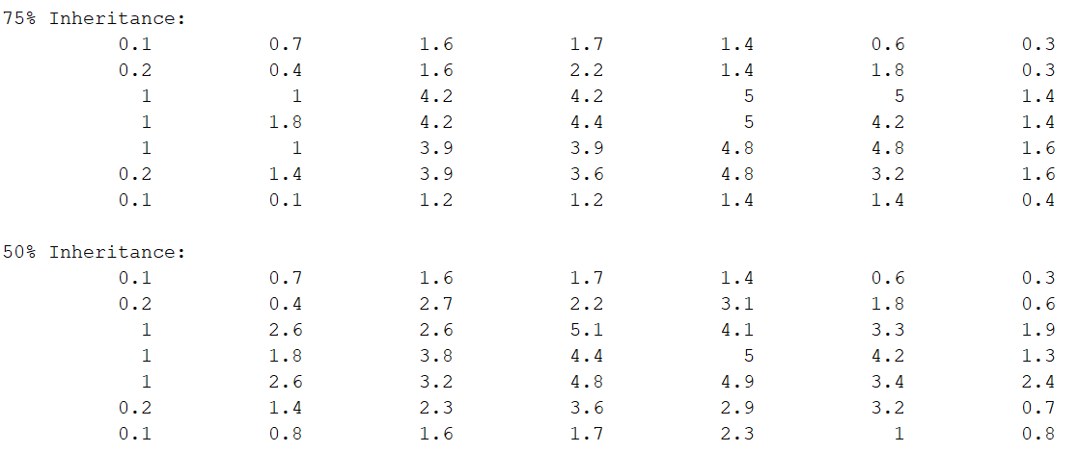
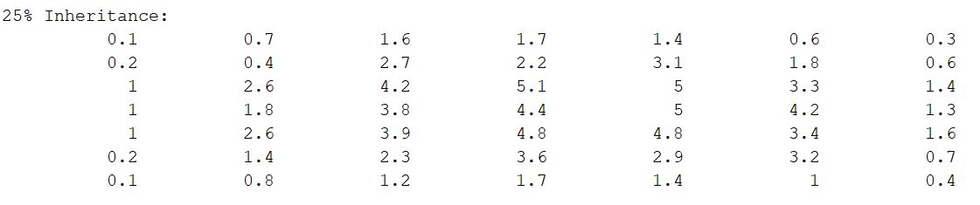
With image:
clc; clear; close all;
img = imread('D:/lena_gray.bmp');
img = double(img);
kernel = [1 1 1;1 1 1;1 1 1];
kernel=kernel/sum(kernel(:));
A1 = conv2(img, kernel);
A25 = A1;
A50 = A1;
A75 = A1;
[rows, cols] = size(A1);
for i = 2:rows
for j = 2:cols
%% 25% CROSS INHERITANCE
if mod(i, 2) == 0 && mod(j, 2) == 0
A25(i,j) = (A1(i-1,j) + A1(i,j-1))/2;
end
%%50% CROSS INHERITANCE
if mod(i+j,2)==0
A50(i,j) = (A1(i-1,j) + A1(i,j-1))/2;
End

- Matrix Rebuild Algorithm:
Without image:
clc; clear all; close all;
%% Input 3x3 Matrices
a = [1 2 0;1 1 3;0 2 2];
b = [0 2 1;0 3 2;1 1 0];
c = [1 2 1;0 1 3;3 3 2];
%% Patch Extraction Using Overlapping IDX Mapping
IDX = [1 4 2 5;4 7 5 8;2 5 3 6;5 8 6 9];
d = a(IDX)'; % Channel R
f = b(IDX)'; % Channel G
e = c(IDX)'; % Channel B
disp('Extracted Patch Matrix d :'); disp(d);
disp('Extracted Patch Matrix f :'); disp(f);
disp('Extracted Patch Matrix e :'); disp(e);
%% Input Features Matrix g (Each row is a flattened patch)
g = horzcat(d, f, e);
disp('Input Features Matrix g:'); disp(g);
%% Kernel Matrices (flattened)
k1 = [1 1; 2 2]; k2 = [1 1; 1 1]; k3 = [0 1; 1 0];
% Flatten each kernel in raster order and stack
h = k1([1 3 2 4])';i = k2([1 3 2 4])';j = k3([1 3 2 4])';
k = vertcat(h, i, j);
% Additional kernel set
k4 = [1 0; 0 1];k5 = [2 1; 2 1];k6 = [1 2; 2 0];
m = k4([1 3 2 4])';n = k5([1 3 2 4])';o = k6([1 3 2 4])';
p = vertcat(m, n, o);
%% Full Kernel Matrix q
q = horzcat(k, p);
disp('Kernel Matrix q:'); disp(q);
%% Matrix Multiplication Result (Simulated Convolution)
r = g * q;
disp('Initial Output Matrix r:'); disp(r);
%% Rebuild the Removed Rows by Inheriting from Row Above
u = r; % Copy of r
for i = 1:size(r, 1)
if mod(i, 3) == 2 && i > 1
u(i, :) = r(i - 1, :);
end
end
disp("Rebuilded output feature matrix:")
disp(u);
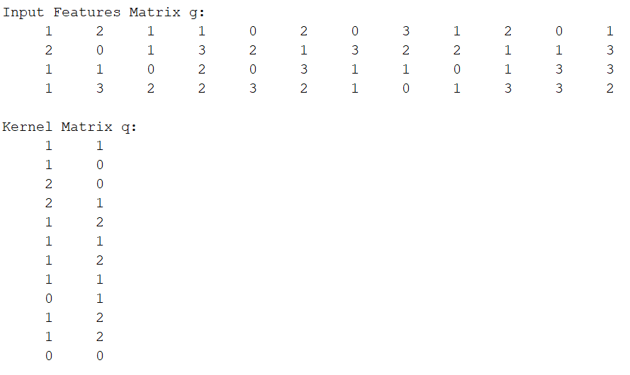
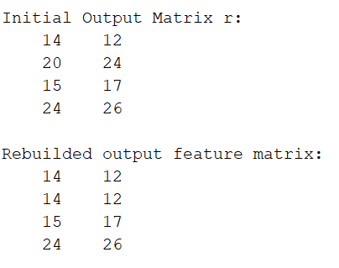
With image:
clc; clear all; close all;
img = imread('D:\brain_tumor_dataset\yes\Y11.jpg');
A = double(img);
kernel = ones(3, 3) / 9;
A1 = conv2(A, kernel, 'valid'); % 510x510
% Initialize inherited versions
A2_25 = A1;
A2_50 = A1;
A2_75 = A1;
[rows, cols] = size(A1);
% Apply inheritance logic
for i = 1:rows
for j = 1:cols
% 75% Inheritance
if mod(i, 4) == 0 && i - 3 > 0
A2_75(i, j) = A1(i - 3, j);
elseif mod(i, 4) == 2 && i - 1 > 0
A2_75(i, j) = A1(i - 1, j);
elseif mod(i, 4) == 3 && i - 2 > 0
A2_75(i, j) = A1(i - 2, j);
end
% 50% Inheritance
if mod(i, 2) == 0 && i - 1 > 0
A2_50(i, j) = A1(i - 1, j);
end
% 25% Inheritance
if mod(i, 4) == 0 && i - 1 > 0
A2_25(i, j) = A1(i - 1, j);
end
end
end
% Total patches = (510 - 2)^2 = 258064
num_patches = (rows - 2) * (cols - 2);
IDX = zeros(num_patches, 9);
index_matrix = reshape(1:rows * cols, rows, cols);
k = 1;
for j = 1:(cols - 2)
for i = 1:(rows - 2)
block = index_matrix(i:i+2, j:j+2);
IDX(k, :) = block(:)';
k = k + 1;
end
end
% Extract 3×3 patches from each matrix
patch25 = A2_25(IDX); % size: 258064 × 9
patch50 = A2_50(IDX);
patch75 = A2_75(IDX);
% Final concatenated output: 258064 × 27
G = [patch25, patch50, patch75];
disp("Final patch matrix G (258064 × 27):");
disp(G);
% Define kernels
k1 = [-1 -1 -1; -1 8 -1; -1 -1 -1];
k2 = [ 0 -1 0; -1 5 -1; 0 -1 0];
k3 = [0.11111111111 0.11111111111 0.11111111111;0.11111111111 0.11111111111 0.11111111111;0.11111111111 0.11111111111 0.11111111111];
col1 = [k1(:); k2(:); k3(:)];
col2 = col1(randperm(27));
col3 = col1(randperm(27));
kem = [col1, col2, col3];
disp("Kernel matrix")
disp(kem);
X= G*kem;
disp("Output feature matrix");
disp(X);
u = X; % Copy of X
for i = 1:size(X, 1)
if mod(i, 3) == 2 && i > 1
u(i, :) = X(i - 1, :);
end
end
disp("Rebuilded output feature matrix:")
disp(u);
u_img = reshape(mean(u, 2), [508, 508]); % Average over 3 features
imshow(mat2gray(u_img)); title('Rebuilded output Feature Image');

- Adaptive Threshold Algorithm:
Without image:
A = [1 5 8 2 3;1 5 4 9 2;7 4 3 6 8;1 4 5 6 2;1 6 4 5 4];
kernel = [-1 1 1;-2 2 2;-1 1 1];
A1 = conv2(A, kernel);
T = adaptthresh(A1, 0.2);
A2 = A1;
[rows, cols] = size(A1);
for i = 2:rows
for j = 2:cols
c = mod(A1(i,j) - A1(i-1,j), j);
if c < T(i,j)
A2(i,j) = A1(i, j-1);
else
A2(i,j) = A1(i,j);
end end end
disp("Original Matrix A:");disp(A);
disp("After Convolution (A1):");disp(A1);
disp("Adaptive Threshold Matrix (T):");disp(T);
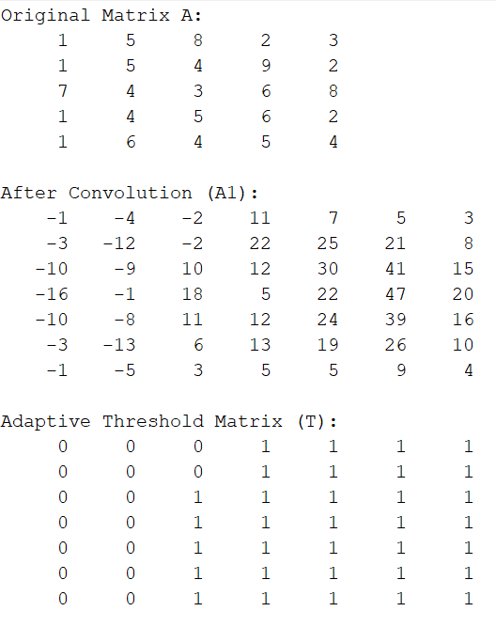
disp("Final Output Matrix (A2):");disp(A2);
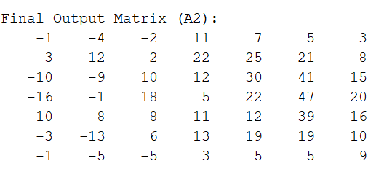
With image:
img = imread(‘D:/lena_gray.jpeg');
if size(img, 3) == 3
img = rgb2gray(img);
end
A = double(img);
kernel = [1 1 1;1 1 1;1 1 1];
kernel=kernel/sum(kernel(:));
A1 = conv2(A, kernel);
T = adaptthresh(A1, 0.2);
A2 = A1; [rows, cols] = size(A1);
for i = 2:rows
for j = 2:cols
c = mod(A1(i,j) - A1(i-1,j), j);
if c < T(i,j)
A2(i,j) = A1(i, j-1);
else
A2(i,j) = A1(i,j);
endendend
figure;
subplot(1,3,1); imshow(uint8(A)); title('Original Image');
subplot(1,3,2); imshow(uint8(A1)); title('After Convolution (A1)');
subplot(1,3,3); imshow(uint8(A2)); title('Final Output (A2)');

BRAIN TUMOR DETECTION CODES:
Sobel Operator Column Inheitance:
clc;clear all;close all;
img = imread('D:\brain_tumor_dataset\yes\Y11.jpg');
if size(img, 3) == 3
img = rgb2gray(img);
end
A = double(img);
kernel1 = [1 0 -1; 2 0 -2; 1 0 -1];
kernel2 = [1 2 1; 0 0 0; -1 -2 -1];
conv1 = conv2(A, kernel1, 'same');
conv2 = conv2(A, kernel2, 'same');
convolved_data_int = conv1.^2 + conv2.^2;
A1 = uint8(convolved_data_int > 4000) * 255;
A2_75 = A1;
A2_50 = A1;
A2_25 = A1;
[rows, cols] = size(A1);
for i = 1:rows
for j = 1:cols
if mod(j, 4) == 0 && j - 3 > 0
A2_75(i, j) = A1(i, j - 3);
elseif mod(j, 4) == 2 && j - 1 > 0
A2_75(i, j) = A1(i, j - 1);
elseif mod(j, 4) == 3 && j - 2 > 0
A2_75(i, j) = A1(i, j - 2);
end
if mod(j, 2) == 0 && j - 1 > 0
A2_50(i, j) = A1(i, j - 1);
end
if mod(j, 4) == 0 && j - 1 > 0
A2_25(i, j) = A1(i, j - 1);
end
end
end
figure;
sgtitle("Sobel Operator - Column Inheritance");
subplot(2,2,1); imshow(A1); title('Original Convolution (Thresholded)');
subplot(2,2,2); imshow(A2_75); title('75% Column Inheritance');
subplot(2,2,3); imshow(A2_50); title('50% Column Inheritance');
subplot(2,2,4); imshow(A2_25); title('25% Column Inheritance');

MORPHOLOGICAL DETECTION CODE:
img = imread('D:\brain_tumor_dataset\yes\Y1.jpg');
gray = rgb2gray(img);
% Enhance contrast
enhanced = imadjust(gray);
% Sharpening convolution
kernel = [-1 -1 -1; -1 9 -1; -1 -1 -1];
sharpened = imfilter(enhanced, kernel, 'same');
% Threshold
tumor_mask = imbinarize(sharpened, 0.72);
% Morphological cleanup
tumor_mask = imfill(tumor_mask, 'holes');
tumor_mask = bwareaopen(tumor_mask, 300);
tumor_mask = imclearborder(tumor_mask); %
CC = bwconncomp(tumor_mask);
if CC.NumObjects > 0
numPixels = cellfun(@numel, CC.PixelIdxList);
[~, idx] = max(numPixels);
tumor_mask(:) = 0; % reset
tumor_mask(CC.PixelIdxList{idx}) = 1;
end
% Get tumor boundary
boundaries = bwboundaries(tumor_mask);
figure;
subplot(1,4,1);
imshow(gray); title('(a) Source MRI');
subplot(1,4,2);
imshow(sharpened); title('(b) After Convolution');
subplot(1,4,3);
imshow(tumor_mask); title('(c) Segmented Tumor');
subplot(1,4,4);
imshow(gray); title('(d) Tumor Boundary Overlay');
hold on;
for k = 1:length(boundaries)
boundary = boundaries{k};
plot(boundary(:,2), boundary(:,1), 'y', 'LineWidth', 2);
end
  - VERILOG SOURCE CODES:

a)LineBuffer:
module lineBuffer(
input i_clk,
input i_rst,
input [7:0] i_data,
input i_data_valid,
output [23:0] o_data,
input i_rd_data
);
reg [7:0] line [511:0]; //line buffer
reg [8:0] wrPntr;
reg [8:0] rdPntr;
always @(posedge i_clk)
begin
if(i_data_valid)
line[wrPntr] <= i_data;
end
always @(posedge i_clk)
begin
if(i_rst)
wrPntr <= 'd0;
else if(i_data_valid)
wrPntr <= wrPntr + 'd1;
end
assign o_data = {line[rdPntr],line[rdPntr+1],line[rdPntr+2]};

always @(posedge i_clk)
begin
if(i_rst)
rdPntr <= 'd0;
else if(i_rd_data)
rdPntr <= rdPntr + 'd1;
end
endmodule

b) ImageControl:
module imageControl(
input i_clk,
input i_rst,
input [7:0] i_pixel_data,
input i_pixel_data_valid,
output reg [71:0] o_pixel_data,
output o_pixel_data_valid,
output reg o_intr);
reg [8:0] pixelCounter;
reg [1:0] currentWrLineBuffer;
reg [3:0] lineBuffDataValid;
reg [3:0] lineBuffRdData;
reg [1:0] currentRdLineBuffer;
wire [23:0] lb0data;
wire [23:0] lb1data;
wire [23:0] lb2data;
wire [23:0] lb3data;
reg [8:0] rdCounter;
reg rd_line_buffer;
reg [11:0] totalPixelCounter;
reg rdState;

localparam IDLE = 'b0,
RD_BUFFER = 'b1;

assign o_pixel_data_valid = rd_line_buffer;

always @(posedge i_clk)
begin
if(i_rst)
totalPixelCounter <= 0;
else
begin
if(i_pixel_data_valid & !rd_line_buffer)
totalPixelCounter <= totalPixelCounter + 1;
else if(!i_pixel_data_valid & rd_line_buffer)
totalPixelCounter <= totalPixelCounter - 1;
end
end

always @(posedge i_clk)
begin
if(i_rst)
begin
rdState <= IDLE;
rd_line_buffer <= 1'b0;
o_intr <= 1'b0;
end
else
begin
case(rdState)
IDLE:begin
o_intr <= 1'b0;
if(totalPixelCounter >= 1536)
begin
rd_line_buffer <= 1'b1;
rdState <= RD_BUFFER;
end
end
RD_BUFFER:begin
if(rdCounter == 511)
begin
rdState <= IDLE;
rd_line_buffer <= 1'b0;
o_intr <= 1'b1;
end
end
endcase
end
end

always @(posedge i_clk)
begin
if(i_rst)
pixelCounter <= 0;
else
begin
if(i_pixel_data_valid)
pixelCounter <= pixelCounter + 1;
end
end

always @(posedge i_clk)
begin
if(i_rst)
currentWrLineBuffer <= 0;
else
begin
if(pixelCounter == 511 & i_pixel_data_valid)
currentWrLineBuffer <= currentWrLineBuffer+1;
end
end

always @(*)
begin
lineBuffDataValid = 4'h0;
lineBuffDataValid[currentWrLineBuffer] = i_pixel_data_valid;
end
always @(posedge i_clk)
begin
if(i_rst)
rdCounter <= 0;
else
begin
if(rd_line_buffer)
rdCounter <= rdCounter + 1;
end
end

always @(posedge i_clk)
begin
if(i_rst)
begin
currentRdLineBuffer <= 0;
end
else
begin
if(rdCounter == 511 & rd_line_buffer)
currentRdLineBuffer <= currentRdLineBuffer + 1;
end
end

always @(*)
begin
case(currentRdLineBuffer)
0:begin
o_pixel_data = {lb2data,lb1data,lb0data};
end
1:begin
o_pixel_data = {lb3data,lb2data,lb1data};
end
2:begin
o_pixel_data = {lb0data,lb3data,lb2data};
end
3:begin
o_pixel_data = {lb1data,lb0data,lb3data};
end
endcase
end

always @(*)
begin
case(currentRdLineBuffer)
0:begin
lineBuffRdData[0] = rd_line_buffer;
lineBuffRdData[1] = rd_line_buffer;
lineBuffRdData[2] = rd_line_buffer;
lineBuffRdData[3] = 1'b0;
end
1:begin
lineBuffRdData[0] = 1'b0;
lineBuffRdData[1] = rd_line_buffer;
lineBuffRdData[2] = rd_line_buffer;
lineBuffRdData[3] = rd_line_buffer;
end
2:begin
lineBuffRdData[0] = rd_line_buffer;
lineBuffRdData[1] = 1'b0;
lineBuffRdData[2] = rd_line_buffer;
lineBuffRdData[3] = rd_line_buffer;
end
3:begin
lineBuffRdData[0] = rd_line_buffer;
lineBuffRdData[1] = rd_line_buffer;
lineBuffRdData[2] = 1'b0;
lineBuffRdData[3] = rd_line_buffer;
end
endcase
end

lineBuffer lB0(
.i_clk(i_clk),
.i_rst(i_rst),
.i_data(i_pixel_data),
.i_data_valid(lineBuffDataValid[0]),
.o_data(lb0data),
.i_rd_data(lineBuffRdData[0])
);

lineBuffer lB1(
.i_clk(i_clk),
.i_rst(i_rst),
.i_data(i_pixel_data),
.i_data_valid(lineBuffDataValid[1]),
.o_data(lb1data),
.i_rd_data(lineBuffRdData[1])
);

lineBuffer lB2(
.i_clk(i_clk),
.i_rst(i_rst),
.i_data(i_pixel_data),
.i_data_valid(lineBuffDataValid[2]),
.o_data(lb2data),
.i_rd_data(lineBuffRdData[2])
);

lineBuffer lB3(
.i_clk(i_clk),
.i_rst(i_rst),
.i_data(i_pixel_data),
.i_data_valid(lineBuffDataValid[3]),
.o_data(lb3data),
.i_rd_data(lineBuffRdData[3])
);

Endmodule

c)ImageProcessTop (top module):
module imageProcessTop1(
input axi_clk,
input axi_reset_n,
//slave interface
input i_data_valid,
input [7:0] i_data,
output o_data_ready,
//master interface
output o_data_valid,
output [7:0] o_data,
input i_data_ready,
//interrupt
output o_intr
);
wire [71:0] pixel_data;
wire pixel_data_valid;
wire axis_prog_full;
wire [7:0] convolved_data;
wire convolved_data_valid;

assign o_data_ready = !axis_prog_full;

imageControl IC(
.i_clk(axi_clk),
.i_rst(!axi_reset_n),
.i_pixel_data(i_data),
.i_pixel_data_valid(i_data_valid),
.o_pixel_data(pixel_data),
.o_pixel_data_valid(pixel_data_valid),
.o_intr(o_intr)
);

conv conv(
.i_clk(axi_clk),
.i_pixel_data(pixel_data),
.i_pixel_data_valid(pixel_data_valid),
.o_convolved_data(convolved_data),
.o_convolved_data_valid(convolved_data_valid)
);

outputBuffer OB (
.wr_rst_busy(), // output wire wr_rst_busy
.rd_rst_busy(), // output wire rd_rst_busy
.s_aclk(axi_clk), // input wire s_aclk
.s_aresetn(axi_reset_n), // input wire s_aresetn
.s_axis_tvalid(convolved_data_valid), // input wire s_axis_tvalid
.s_axis_tready(), // output wire s_axis_tready
.s_axis_tdata(convolved_data), // input wire [7 : 0] s_axis_tdata
.m_axis_tvalid(o_data_valid), // output wire m_axis_tvalid
.m_axis_tready(i_data_ready), // input wire m_axis_tready
.m_axis_tdata(o_data), // output wire [7 : 0] m_axis_tdata
.axis_prog_full(axis_prog_full) // output wire axis_prog_full
);

Endmodule

d)Convolution block:

i) blurred image
module conv(
input i_clk,
input [71:0] i_pixel_data,
input i_pixel_data_valid,
output reg [7:0] o_convolved_data,
output reg o_convolved_data_valid
);

integer i;
reg [7:0] kernel [8:0];
reg [15:0] multData[8:0];
reg [15:0] sumDataInt;
reg [15:0] sumData;
reg multDataValid;
reg sumDataValid;
reg convolved_data_valid;

initial
egin
for(i=0;i<9;i=i+1)
begin
kernel[i] = 1;
end
end

always @(posedge i_clk)
begin
for(i=0;i<9;i=i+1)
begin
multData[i] <= kernel[i]*i_pixel_data[i*8+:8];
end
multDataValid <= i_pixel_data_valid;
end

always @(*)
begin
sumDataInt = 0;
for(i=0;i<9;i=i+1)
begin
sumDataInt = sumDataInt + multData[i];
end
end

always @(posedge i_clk)
begin
sumData <= sumDataInt;
sumDataValid <= multDataValid;
end

always @(posedge i_clk)
begin
o_convolved_data <= sumData/9;
o_convolved_data_valid <= sumDataValid;
end

endmodule

ii) 75% Row Inheritance module: (altered to 50,25 according to algorithm)

module conv(//row
input i_clk,
input [71:0] i_pixel_data,
input i_pixel_data_valid,
output reg [7:0] o_convolved_data,
output reg o_convolved_data_valid
);
integer i;
reg [7:0] kernel [8:0];
reg [15:0] multData[8:0];
reg [15:0] sumDataInt;
reg [15:0] sumData;
reg multDataValid;
reg sumDataValid;

reg [9:0] row_counter = 0;
reg [9:0] col_counter = 0;
reg [18:0] current_index;
reg [18:0] prev_index_1, prev_index_2, prev_index_3;
reg [7:0] output_memory [0:262143];
reg [7:0] inherited_pixel;
reg [7:0] final_pixel;
reg write_enable;

initial begin
for (i = 0; i < 9; i = i + 1)
kernel[i] = 1;
end

always @(posedge i_clk) begin
for (i = 0; i < 9; i = i + 1)
multData[i] <= kernel[i] * i_pixel_data[i*8 +: 8];
multDataValid <= i_pixel_data_valid;
end

always @(*) begin
sumDataInt = 0;
for (i = 0; i < 9; i = i + 1)
sumDataInt = sumDataInt + multData[i];
end

always @(posedge i_clk) begin
sumData <= sumDataInt;
sumDataValid <= multDataValid;
end
always @(posedge i_clk) begin
if (i_pixel_data_valid) begin
if (col_counter == 511) begin
col_counter <= 0;
if (row_counter == 511)
row_counter <= 0;
else
row_counter <= row_counter + 1;
end else begin
col_counter <= col_counter + 1;
end
end
end

always @(posedge i_clk) begin
if (sumDataValid) begin

current_index = row_counter * 512 + col_counter;
prev_index_1 = (row_counter > 0) ? ((row_counter - 1) * 512 + col_counter) : 0;
prev_index_2 = (row_counter > 1) ? ((row_counter - 2) * 512 + col_counter) : 0;
prev_index_3 = (row_counter > 2) ? ((row_counter - 3) * 512 + col_counter) : 0;

inherited_pixel = sumData / 9;

if ((row_counter % 4 == 0) && row_counter >= 3)
final_pixel = output_memory[prev_index_3];
else if ((row_counter % 4 == 2) && row_counter >= 1)
final_pixel = output_memory[prev_index_1];
else if ((row_counter % 4 == 3) && row_counter >= 2)
final_pixel = output_memory[prev_index_2];
else
final_pixel = inherited_pixel;

o_convolved_data <= final_pixel;
o_convolved_data_valid <= 1;

output_memory[current_index] <= final_pixel;
end else begin
o_convolved_data_valid <= 0;
end
end
endmodule

iii) 75% Column Inheritance (altered to 50,25% according to algorithm)

module conv(//column
input i_clk,
input [71:0] i_pixel_data,
input i_pixel_data_valid,
output reg [7:0] o_convolved_data,
output reg o_convolved_data_valid
);
integer i;
reg [7:0] kernel [8:0];
reg [15:0] multData[8:0];
reg [15:0] sumDataInt;
reg [15:0] sumData;
reg multDataValid;
reg sumDataValid;

reg [9:0] row_counter = 0;
reg [9:0] col_counter = 0;
reg [18:0] current_index;
reg [18:0] prev_col_1, prev_col_2, prev_col_3;
reg [7:0] output_memory [0:262143];
reg [7:0] inherited_pixel;
reg [7:0] final_pixel;

initial begin
for (i = 0; i < 9; i = i + 1)
kernel[i] = 1;
end

// Multiply kernel with input pixels
always @(posedge i_clk) begin
for (i = 0; i < 9; i = i + 1)
multData[i] <= kernel[i] * i_pixel_data[i*8 +: 8];
multDataValid <= i_pixel_data_valid;
end

// Sum of all multiplied data
always @(*) begin
sumDataInt = 0;
for (i = 0; i < 9; i = i + 1)
sumDataInt = sumDataInt + multData[i];
end

always @(posedge i_clk) begin
sumData <= sumDataInt;
sumDataValid <= multDataValid;
end

// Update row and column counters
always @(posedge i_clk) begin
if (i_pixel_data_valid) begin
if (col_counter == 511) begin
col_counter <= 0;
if (row_counter == 511)
row_counter <= 0;
else
row_counter <= row_counter + 1;
end else begin
col_counter <= col_counter + 1;
end
end
end

// Column inheritance logic
always @(posedge i_clk) begin
if (sumDataValid) begin
current_index = row_counter * 512 + col_counter;
prev_col_1 = (col_counter > 0) ? (row_counter * 512 + (col_counter - 1)) : 0;
prev_col_2 = (col_counter > 1) ? (row_counter * 512 + (col_counter - 2)) : 0;
prev_col_3 = (col_counter > 2) ? (row_counter * 512 + (col_counter - 3)) : 0;

inherited_pixel = sumData / 9;

// Inherit from previous columns based on column_counter % 4
if ((col_counter % 4 == 0) && col_counter >= 3)
final_pixel = output_memory[prev_col_3];
else if ((col_counter % 4 == 2) && col_counter >= 1)
final_pixel = output_memory[prev_col_1];
else if ((col_counter % 4 == 3) && col_counter >= 2)
final_pixel = output_memory[prev_col_2];
else
final_pixel = inherited_pixel;

o_convolved_data <= final_pixel;
o_convolved_data_valid <= 1;

output_memory[current_index] <= final_pixel;
end else begin
o_convolved_data_valid <= 0;
end
end endmodule

iv) Adaptive Threshold Convolution:

module conv_adaptive_threshold (
input i_clk,
input [71:0] i_pixel_data,
input i_pixel_data_valid,
output reg [7:0] o_convolved_data,
output reg o_convolved_data_valid
);
integer i;
reg [7:0] kernel [0:8];
reg [15:0] multData [0:8];
reg [15:0] sumData;
reg [7:0] conv_pixel;

reg [9:0] row_counter = 0;
reg [9:0] col_counter = 0;
reg [18:0] current_index;

// Memory to hold intermediate and final output
reg [7:0] output_memory [0:262143]; // For 512x512 image
reg [7:0] previous_row_pixels [0:511];

// Adaptive logic
reg [7:0] pixel_ij, pixel_i1j, pixel_ij1;
reg [7:0] final_pixel;
parameter THRESHOLD = 20;

initial begin
for (i = 0; i < 9; i = i + 1)
kernel[i] = 1;
end

always @(posedge i_clk) begin
for (i = 0; i < 9; i = i + 1)
multData[i] <= kernel[i] * i_pixel_data[i*8 +: 8];
end
always @(*) begin
sumData = 0;
for (i = 0; i < 9; i = i + 1)
sumData = sumData + multData[i];
conv_pixel = sumData / 9; // Box blur average
end
always @(posedge i_clk) begin
if (i_pixel_data_valid) begin
if (col_counter == 511) begin
col_counter <= 0;
if (row_counter == 511)
row_counter <= 0;
else
row_counter <= row_counter + 1;
end else begin
col_counter <= col_counter + 1;
end
end
end
always @(posedge i_clk) begin
if (i_pixel_data_valid) begin
current_index = row_counter * 512 + col_counter;

pixel_ij = conv_pixel;
pixel_i1j = (row_counter > 0) ? previous_row_pixels[col_counter] : conv_pixel;
pixel_ij1 = (col_counter > 0) ? output_memory[current_index - 1] : conv_pixel;
if (((pixel_ij - pixel_i1j) % (col_counter + 1)) < THRESHOLD)
final_pixel = pixel_ij1; // Inherit from previous column
else
final_pixel = pixel_ij; // Use current convolved value
o_convolved_data <= final_pixel;
o_convolved_data_valid <= 1;

output_memory[current_index] <= final_pixel;
previous_row_pixels[col_counter] <= conv_pixel;
end else begin
o_convolved_data_valid <= 0;
end end endmodule

v) 75% Cross inheritance
module conv (
input i_clk,
input i_rst,
input [71:0] i_pixel_data,
input i_pixel_data_valid,
output reg [7:0] o_convolved_data,
output reg o_convolved_data_valid
);

integer i;

// 3x3 kernel weights (all ones for averaging)
reg [7:0] kernel[0:8];
initial begin
for (i = 0; i < 9; i = i + 1)
kernel[i] = 8'd1;
end

// Intermediate variables
reg [15:0] multData[0:8];
reg [15:0] sumDataInt;
reg [15:0] sumData;
reg multDataValid, sumDataValid;

// Inheritance state
reg [7:0] row_buffer[0:511]; // Buffer to store previous row values (for top inheritance)
reg [7:0] left_pixel; // Previous pixel value in current row (for left inheritance)

// Control counters
reg [9:0] row_counter = 0;
reg [9:0] col_counter = 0;

// Final inherited pixel logic
reg [7:0] conv_result;
reg [7:0] top_pixel;
reg [7:0] left_pixel_curr;

// Step 1: Multiply kernel with pixel data
always @(posedge i_clk) begin
for (i = 0; i < 9; i = i + 1)
multData[i] <= kernel[i] * i_pixel_data[i*8 +: 8];
multDataValid <= i_pixel_data_valid;
end

// Step 2: Sum the multiplied results (combinational)
always @(*) begin
sumDataInt = 0;
for (i = 0; i < 9; i = i + 1)
sumDataInt = sumDataInt + multData[i];
end

// Step 3: Store the final sum on clock edge
always @(posedge i_clk) begin
sumData <= sumDataInt;
sumDataValid <= multDataValid;
end

// Step 4: Update row and column counters
always @(posedge i_clk) begin
if (i_pixel_data_valid) begin
if (col_counter == 511) begin
col_counter <= 0;
if (row_counter == 511)
row_counter <= 0;
else
row_counter <= row_counter + 1;
end else begin
col_counter <= col_counter + 1;
end
end
end

// Step 5: Final output with 75% crossing inheritance logic
always @(posedge i_clk) begin
if (i_rst) begin
o_convolved_data <= 0;
o_convolved_data_valid <= 0;
left_pixel <= 0;
end else if (sumDataValid) begin
conv_result <= sumData / 9;
top_pixel <= row_buffer[col_counter];
left_pixel_curr <= left_pixel;

// 75% CROSSING INHERITANCE LOGIC
if ((row_counter % 2 == 0) && (col_counter % 2 == 1))
o_convolved_data <= top_pixel; // Inherit from top
else if ((row_counter % 2 == 1) && (col_counter % 2 == 0))
o_convolved_data <= left_pixel_curr; // Inherit from left
else if ((row_counter % 2 == 0) && (col_counter % 2 == 0))
o_convolved_data <= (top_pixel + left_pixel_curr) >> 1; // Average
else
o_convolved_data <= conv_result; // Use convolved result

o_convolved_data_valid <= 1;

// Update buffers
row_buffer[col_counter] <= conv_result;
left_pixel <= conv_result;
end else begin
o_convolved_data_valid <= 0;
end
end

endmodule

vi) 50% Cross Inheritance:
module conv (
input i_clk,
input i_rst,
input [71:0] i_pixel_data,
input i_pixel_data_valid,
output reg [7:0] o_convolved_data,
output reg o_convolved_data_valid
);

integer i;

reg [7:0] kernel[0:8];
initial begin
for (i = 0; i < 9; i = i + 1)
kernel[i] = 8'd1;
end

reg [15:0] multData[0:8];
reg [15:0] sumDataInt;
reg [15:0] sumData;
reg multDataValid, sumDataValid;

reg [7:0] row_buffer[0:511];
reg [7:0] left_pixel;

reg [9:0] row_counter = 0;
reg [9:0] col_counter = 0;

reg [7:0] conv_result;
reg [7:0] top_pixel;
reg [7:0] left_pixel_curr;

always @(posedge i_clk) begin
for (i = 0; i < 9; i = i + 1)
multData[i] <= kernel[i] * i_pixel_data[i*8 +: 8];
multDataValid <= i_pixel_data_valid;
end

always @(*) begin
sumDataInt = 0;
for (i = 0; i < 9; i = i + 1)
sumDataInt = sumDataInt + multData[i];
end

always @(posedge i_clk) begin
sumData <= sumDataInt;
sumDataValid <= multDataValid;
end

always @(posedge i_clk) begin
if (i_pixel_data_valid) begin
if (col_counter == 511) begin
col_counter <= 0;
if (row_counter == 511)
row_counter <= 0;
else
row_counter <= row_counter + 1;
end else begin
col_counter <= col_counter + 1;
end
end
end

always @(posedge i_clk) begin
if (i_rst) begin
o_convolved_data <= 0;
o_convolved_data_valid <= 0;
left_pixel <= 0;
end else if (sumDataValid) begin
conv_result <= sumData / 9;
top_pixel <= row_buffer[col_counter];
left_pixel_curr <= left_pixel;

if (((row_counter + col_counter) % 2) == 0)
o_convolved_data <= (top_pixel + left_pixel_curr) >> 1;
else
o_convolved_data <= conv_result;

o_convolved_data_valid <= 1;
row_buffer[col_counter] <= conv_result;
left_pixel <= conv_result;
end else begin
o_convolved_data_valid <= 0;
end
end

endmodule

vii) 25% Cross Inheritance:
module conv (
input i_clk,
input i_rst,
input [71:0] i_pixel_data,
input i_pixel_data_valid,
output reg [7:0] o_convolved_data,
output reg o_convolved_data_valid
);

integer i;
reg [7:0] kernel[0:8];
initial begin
for (i = 0; i < 9; i = i + 1)
kernel[i] = 8'd1;
end

reg [15:0] multData[0:8];
reg [15:0] sumDataInt;
reg [15:0] sumData;
reg multDataValid, sumDataValid;

reg [7:0] row_buffer[0:511];
reg [7:0] left_pixel;

reg [9:0] row_counter = 0;
reg [9:0] col_counter = 0;

reg [7:0] conv_result;
reg [7:0] top_pixel;
reg [7:0] left_pixel_curr;

always @(posedge i_clk) begin
for (i = 0; i < 9; i = i + 1)
multData[i] <= kernel[i] * i_pixel_data[i*8 +: 8];
multDataValid <= i_pixel_data_valid;
end

always @(*) begin
sumDataInt = 0;
for (i = 0; i < 9; i = i + 1)
sumDataInt = sumDataInt + multData[i];
end

always @(posedge i_clk) begin
sumData <= sumDataInt;
sumDataValid <= multDataValid;
end

always @(posedge i_clk) begin
if (i_pixel_data_valid) begin
if (col_counter == 511) begin
col_counter <= 0;
if (row_counter == 511)
row_counter <= 0;
else
row_counter <= row_counter + 1;
end else begin
col_counter <= col_counter + 1;
end
end
end

always @(posedge i_clk) begin
if (i_rst) begin
o_convolved_data <= 0;
o_convolved_data_valid <= 0;
left_pixel <= 0;
end else if (sumDataValid) begin
conv_result <= sumData / 9;
top_pixel <= row_buffer[col_counter];
left_pixel_curr <= left_pixel;

if ((row_counter % 2 == 0) && (col_counter % 2 == 0))
o_convolved_data <= (top_pixel + left_pixel_curr) >> 1;
else
o_convolved_data <= conv_result;

o_convolved_data_valid <= 1;
row_buffer[col_counter] <= conv_result;
left_pixel <= conv_result;
end else begin
o_convolved_data_valid <= 0;
end
end

endmodule

viii) Matrix Rebuild Algorithm (simplified form)

module conv (
input i_clk,
input i_rst,
input [71:0] i_pixel_data,
input i_pixel_data_valid,
output reg [7:0] o_convolved_data,
output reg o_convolved_data_valid
);

reg [7:0] p [0:8]; // 3x3 pixels
real G[0:26]; // 27-element feature vector
real F[0:2]; // Output features
real mean_out;

// Kernels
real k1[0:8]; // Edge
real k2[0:8]; // Sharpen
real k3[0:8]; // Blur

integer i;

initial begin
// Edge detection kernel
k1[0]=-1; k1[1]=-1; k1[2]=-1;
k1[3]=-1; k1[4]= 8; k1[5]=-1;
k1[6]=-1; k1[7]=-1; k1[8]=-1;

// Sharpen kernel
k2[0]= 0; k2[1]=-1; k2[2]= 0;
k2[3]=-1; k2[4]= 5; k2[5]=-1;
k2[6]= 0; k2[7]=-1; k2[8]= 0;

// Blur kernel (mean)
for (i = 0; i < 9; i = i + 1)
k3[i] = 1.0 / 9.0;
end

always @(posedge i_clk) begin
if (i_rst) begin
o_convolved_data <= 0;
o_convolved_data_valid <= 0;
end else if (i_pixel_data_valid) begin
// Extract pixels
for (i = 0; i < 9; i = i + 1)
p[i] = i_pixel_data[i*8 +: 8];

// Inheritance simulation
for (i = 0; i < 9; i = i + 1) begin
G[i] = p[i]; // 25%
G[i+9] = (i > 0) ? p[i-1] : p[i]; // 50%
G[i+18] = (i > 1) ? p[i-2] : p[i]; // 75%
end

// Feature fusion
F[0] = 0; F[1] = 0; F[2] = 0;
for (i = 0; i < 9; i = i + 1) begin
F[0] = F[0] + G[i] * k1[i];
F[1] = F[1] + G[i+9] * k2[i];
F[2] = F[2] + G[i+18] * k3[i];
end

mean_out = (F[0] + F[1] + F[2]) / 3.0;

// Clamp and assign output
if (mean_out > 255)
o_convolved_data <= 8'd255;
else if (mean_out < 0)
o_convolved_data <= 8'd0;
else
o_convolved_data <= mean_out;

o_convolved_data_valid <= 1'b1;
end else begin
o_convolved_data_valid <= 1'b0;
end
end
endmodule

TestBench Code:

`define headerSize 1080
`define imageSize 512*512

module tb(

);

reg clk;
reg reset;
reg [7:0] imgData;
integer file,file1,i;
reg imgDataValid;
integer sentSize;
wire intr;
wire [7:0] outData;
wire outDataValid;
integer receivedData=0;

initial
begin
clk = 1'b0;
forever
begin
#5 clk = ~clk;
end
end

initial
begin
reset = 0;
sentSize = 0;
imgDataValid = 0;
#100;
reset = 1;
#100;
file = $fopen("lena_gray.bmp","rb");
file1 = $fopen("blurred_lena.bmp","wb");
for(i=0;i<`headerSize;i=i+1)
begin
$fscanf(file,"%c",imgData);
$fwrite(file1,"%c",imgData);
end

for(i=0;i<4*512;i=i+1)
begin
@(posedge clk);
$fscanf(file,"%c",imgData);
imgDataValid <= 1'b1;
end
sentSize = 4*512;
@(posedge clk);
imgDataValid <= 1'b0;
while(sentSize < `imageSize)
begin
@(posedge intr);
for(i=0;i<512;i=i+1)
begin
@(posedge clk);
$fscanf(file,"%c",imgData);
imgDataValid <= 1'b1;
end
@(posedge clk);
imgDataValid <= 1'b0;
sentSize = sentSize+512;
end
@(posedge clk);
imgDataValid <= 1'b0;
@(posedge intr);
for(i=0;i<512;i=i+1)
begin
@(posedge clk);
imgData <= 0;
imgDataValid <= 1'b1;
end
@(posedge clk);
imgDataValid <= 1'b0;
@(posedge intr);
for(i=0;i<512;i=i+1)
begin
@(posedge clk);
imgData <= 0;
imgDataValid <= 1'b1;
end
@(posedge clk);
imgDataValid <= 1'b0;
$fclose(file);
end

always @(posedge clk)
begin
if(outDataValid)
begin
$fwrite(file1,"%c",outData);
receivedData = receivedData+1;
end
if(receivedData == `imageSize)
begin
$fclose(file1);
$stop;
end
end

imageProcessTop1 dut(
.axi_clk(clk),
.axi_reset_n(reset),
//slave interface
.i_data_valid(imgDataValid),
.i_data(imgData),
.o_data_ready(),
//master interface
.o_data_valid(outDataValid),
.o_data(outData),
.i_data_ready(1'b1),
//interrupt
.o_intr(intr)
);

endmodule

