LLM-Powered SOC Assistant
A Natural Language Interface for Open-Source Security Monitoring
Final Project Report

Umesh Kalupathirannehelage – 300389749
Applied Research Project
CSIS4495-071

Table of Contents
LLM-Powered SOC Assistant 1
1. Introduction 4
1.1 Background and Context 4
1.2 Research Problem 4
1.3 Research Questions 5
1.4 Literature Review 5
1.5 Assumptions 6
1.6 Benefits 7
2. Proposed Research Project 7
2.1 Research Design 7
2.2 Research Objectives 7
2.3 Methodology and Justification 8
2.4 Data Collection and Sample Size 8
2.5 Data Analysis Techniques 9
2.6 Technologies to Be Used 9
2.7 Expected Results 9
3. Project Planning and Time 10
4. Implemented Features 11
4.0 Environment Setup and System Configuration 11
4.1 Wazuh SIEM Integration & Data Collection Layer 18
4.1.1 Overview 18
4.1.2 Wazuh Manager Setup 18
4.1.2 Wazuh Agent Deployment 21
4.1.3 Log Sources and Monitored Categories 23
4.1.4 Alert Data Flow and Parsing 23
4.1.5 Considerations & Limitations 25
4.1.6 Summary 25
4.2 Backend Architecture and API Endpoints 26
4.2.1 Overview of Backend System Design 26
4.2.2 ETL Integration and Automation Layer 27
4.2.3 LLM-Based SQL Translation Engine 28
4.2.4 Analytics API Endpoints 28
4.2.5 Natural-Language Query Endpoint 29
4.2.6 Metadata Endpoints 30
4.2.7 Health and Diagnostic Endpoints 30
4.2.8 Summary of Backend Enhancements 31
4.3 Frontend Architecture and User Interface Implementation 31
4.3.1 Overview of Frontend Design 31
4.3.2 Layout Structure 32
4.3.3 UI Functionality 37
4.3.4 Interactive Chart System 38
4.3.5 Logo Integration and Branding 39
4.3.6 Error Handling and Visual Feedback 39
4.3.7 Summary 40
5. Evaluation, Reflections, and Challenges 40
5.1 System Evaluation 40
5.2 Reflections 41
5.3 Challenges Faced 42
5.4 Summary 43
6. Conclusions 43
7. References 44
8. Appendixes 46
Appendix A - Installation & Deployment Guide 46
Appendix B - User Guide 51

1. Introduction

1.1 Background and Context
Modern Security Operations Centers (SOCs) play a critical role in monitoring, detecting, and responding to cyber threats. These centers rely on Security Information and Event Management (SIEM) tools such as Splunk, Elastic Security, and Microsoft Sentinel, which aggregate and analyze logs from across the enterprise. While effective, these tools typically require analysts to learn complex query languages (e.g., SPL, KQL). This steep learning curve increases onboarding time for new analysts, slows down investigations, and raises the barrier for effective incident response.
Recent advances in large language models (LLMs) offer an opportunity to simplify this process. LLMs have demonstrated the capability to understand natural language instructions and generate structured queries or code. Vendors such as Splunk and Microsoft have already introduced AI-powered assistants, but these are proprietary, cloud-reliant, and costly, which limits access for smaller organizations, students, and research environments.
This project explores the design of a free, open-source SOC Assistant that allows analysts to query logs in natural language. Using open-source tools such as Wazuh or Zeek for log generation, PostgreSQL or OpenSearch for storage, LLM Studio or Ollama for running LLaMA or Mistral locally, and a FastAPI + Vue.js interface, the project will create a transparent, customizable, and accessible alternative.

1.2 Research Problem
Despite the availability of SIEMs and advanced log analysis platforms, the need to master specialized query languages creates an efficiency bottleneck in SOC environments. Analysts often spend more time crafting queries than interpreting results, which reduces their ability to respond quickly to threats. Commercial AI assistants address this partially, but their cost, vendor lock-in, and lack of transparency make them impractical for education, research, or small-to-medium organizations.
The problem this research addresses is:
“How can natural language interfaces be applied to SOC workflows using free and open-source tools, to reduce complexity and improve accessibility without relying on costly commercial platforms?”

1.3 Research Questions
- How effectively can a free and open-source large language model (LLM) translate natural language queries into structured log queries (SQL/Elasticsearch) in a SOC environment?

- What is the accuracy, performance, and usability trade-offs of using open source/local LLMs compared to traditional manual querying methods in log analysis?

- How can natural language interfaces be combined with data analytics (e.g., trends, geo-distribution, anomaly detection) to improve security monitoring and decision-making in SOC workflows?

1.4 Literature Review
Security Information and Event Management (SIEM) platforms are widely deployed in Security Operations Centers (SOCs) to centralize log collection and provide visibility into potential threats. However, researchers highlight that SIEMs present notable challenges in usability and analyst workload. González-Granadillo et al. (2021) emphasize that SIEMs require significant expertise to configure and operate effectively, and that analysts often struggle with the volume and complexity of data. Pan (2024) highlights that Splunk requires a well-skilled technical team and that new users face a steep learning curve due to the unfamiliarity of the Splunk Processing Language (SPL), which increases training and onboarding demands. Similarly, Jiang et al. (2023) observe that incident management engineers rely on Microsoft’s Kusto Query Language (KQL) to analyze telemetry data, and that constructing such queries can be both challenging and time-consuming. According to the 2025 Pulse of AI-Powered SOC Transformation Report by Cybersecurity Insiders, 64% of organizations said their detection, triage, and investigation processes remain heavily manual, placing unsustainable pressure on small, overloaded teams, a factor contributing significantly to alert fatigue and analyst burnout.
To address these barriers, commercial vendors have started to integrate artificial intelligence into SOC tools. Splunk (2023) introduced its AI Assistant to help analysts write SPL queries using natural language. Microsoft (2024) launched Security Copilot, combining large language models with Sentinel and Defender data to improve threat investigation. Elastic (2023) has also released an AI Assistant for Elastic Security in technical preview, allowing natural language interactions with its detection and response features. While these demonstrate the potential of AI-driven interfaces in SOC environments, they are all proprietary, subscription-based, and cloud-dependent, making them inaccessible to smaller organizations, students, and research contexts.
Meanwhile, research in the natural language to SQL (NL2SQL) domain demonstrates that large language models (LLMs) can generate structured queries from natural language with reasonable accuracy. Rajkumar et al. (2022) evaluated state-of-the-art NL2SQL systems and found that LLMs achieved strong results on benchmark datasets, though errors remain a limitation. Katsogiannis-Meimarakis and Koutrika (2023) provide a survey of neural approaches to Natural Language Interfaces to Databases (NLIDBs), noting that advances in deep learning have led to significant improvements in text-to-SQL accuracy and hold promise for making databases more accessible to non-expert users. Beyond databases, large language models (LLMs) are also being actively explored in cybersecurity applications.
Almukaynizi et al. (2023) review use cases such as malware analysis, log parsing, and automated incident response, but note that few efforts have focused on building open-source, SOC-specific assistants.
Taken together, prior research and industry developments highlight a clear gap: while commercial AI-powered SOC assistants exist, there is no open, transparent, and customizable solution available for education or smaller environments. This project seeks to address that gap by designing and evaluating a free and open-source SOC Assistant that leverages LLMs for natural language log querying and analytics.

1.5 Assumptions
This research makes several assumptions to bound the project scope:
- Open-source LLMs such as LLaMA 3, Mistral, or CodeLlama are sufficiently capable of translating simple natural language queries into valid SQL or Elasticsearch queries for log schemas.
- A manageable dataset of authentication logs, either generated by Wazuh or Zeek, is adequate to test and demonstrate the feasibility of the system.
- Analysts do not require advanced analytics immediately; instead, a minimal analytics layer (e.g., login trends, top IP addresses, geo distribution) is sufficient to illustrate practical value.
- The prototype will be developed and tested on a standard personal laptop with at least 16 GB of RAM and a modern multi-core processor. This is sufficient to run smaller open-source language models (7–8 billion parameters) in optimized formats, which are lightweight enough for local experimentation without requiring dedicated GPUs.

1.6 Benefits
The expected benefits of this research are both practical and academic. On a practical level, the project lowers the barrier to entry for SOC analysts by allowing queries in plain English, reducing the need to master specialized query languages. It also provides a cost-free alternative to proprietary AI SOC assistants, making it accessible for students, small-to-medium organizations, and research labs.
On an academic level, the project contributes to the underexplored area of applying open-source LLMs to SOC log analysis, producing a replicable prototype that can be extended in future studies. The evaluation of accuracy, performance, and usability provides benchmarks against which future research can be measured.
Finally, from an educational perspective, the assistant can serve as a teaching aid in cybersecurity labs, helping students interact with logs without first needing to learn complex query languages, thereby accelerating their learning curve and making SOC training more engaging and accessible.

2. Proposed Research Project

2.1 Research Design
This project will adopt a design and prototype research approach. The aim is to develop a working system that integrates open-source large language models (LLMs) with security log data, enabling analysts to query logs in natural language instead of relying on specialized query languages. The design will follow a modular architecture consisting of four main layers:
- Log collection and storage (Wazuh or Zeek feeding data into PostgreSQL).
- LLM query translation (Ollama/LM Studio running open-source models such as LLaMA 3 or Mistral).
- Backend API (FastAPI to manage requests and enforce query guardrails).
- Frontend interface (Vue.js dashboard for natural language input, results, and charts).
The system will be evaluated through controlled experiments where a set of natural language queries are translated into SQL, executed against the log dataset, and assessed for correctness and efficiency.

2.2 Research Objectives
- To design and implement a prototype SOC Assistant that enables analysts to query security logs in natural language, by integrating open-source LLMs with a backend log storage system (PostgreSQL/OpenSearch).
- To evaluate the accuracy, performance, and usability of LLM-generated queries compared to traditional manual querying, by measuring correctness, execution time, and analyst effort in retrieving relevant log data.

- To develop and demonstrate analytics features such as failed login trends, top attacker IPs, geo-distribution of threats, and anomaly detection that enhance SOC workflows and decision-making when combined with natural language querying.

2.3 Methodology and Justification
The methodology will be experimental and applied:
Prototype development: Build a pipeline that demonstrates the feasibility of natural language interfaces for SOC log analysis.
Evaluation: Use test queries to measure accuracy (did the LLM generate valid SQL?), performance (execution time), and usability (ease of query vs. manual effort).
Analytics integration: Generate simple but meaningful metrics such as login failure trends, attacker IP frequencies, and anomaly detection based on thresholds.
This approach is justified by prior literature on natural language to SQL translation, which has shown promising results with open-source LLMs, and by industry developments such as Splunk AI Assistant and Microsoft Security Copilot, which demonstrate the relevance of natural language interfaces in SOCs. By applying these techniques using only free and open-source tools, this project addresses the accessibility and transparency gap identified in the literature.

2.4 Data Collection and Sample Size
Data will be collected from open-source log sources, specifically:
- Authentication logs (e.g., failed SSH login attempts from Wazuh).
- Network logs (optional, from Zeek connection logs).
To simulate attacks, tools such as SSH brute force scripts or synthetic event generators will be used. The sample size will consist of several thousand log entries, which is sufficient to demonstrate functionality and test the accuracy of query translations. The dataset will be stored in PostgreSQL for analysis.

2.5 Data Analysis Techniques
- Query correctness analysis: Compare LLM-generated queries against baseline manual queries for the same questions.
- Performance metrics: Measure query execution time and model response time.
- Analytics output: Aggregations and visualizations (bar/line charts, geo-distribution) to highlight trends.
- Error analysis: Document and categorize failed or incorrect queries to assess limitations.

2.6 Technologies to Be Used
Operating System: Ubuntu Linux (VM environment).
- Programming Languages/Frameworks: Python (FastAPI, Pandas), JavaScript (Vue.js, Chart.js, Tailwind CSS).
- Database: PostgreSQL
- Frontend & Backend: HTML, CSS frontend, FastAPI backend.
- LLM Runtime: Ollama or LM Studio running open-source models (Mistral-7B, LLaMA 3-8B, CodeLlama).
- Log Sources: Wazuh (system/authentication logs), Zeek (optional network logs).

2.7 Expected Results
The expected outcomes of the project are:
- A functional prototype SOC Assistant that can translate natural language queries into SQL/Elasticsearch queries and execute them against a log database.
- Demonstrated ability to return results in both tabular and graphical forms (e.g., failed login trends, top attacker IPs, geo-distribution).
- An evaluation report showing accuracy, performance, and usability of the LLM approach, including identified limitations.
- Practical contribution: A free and open-source solution that demonstrates how SOC teams, educators, and researchers can leverage natural language interfaces without relying on costly proprietary tools.
- Academic contribution: Insight into the effectiveness of open-source LLMs in SOC workflows, forming a basis for further research.

3. Project Planning and Time

Week | Date | Activity | Details & Deliverables
1 | 06-Sep-25 | Introduction & Conceptualization | Define scope, confirm log source (Wazuh/Zeek), set up Git repo & environment.
2 | 13-Sep-25 | Project Proposal | Submit full proposal.  Deliverables: Project Proposal
3 | 20-Sep-25 | Proposal Review & Approval | Address feedback from instructor.  Deliverables: Revised Proposal (if needed).
4 | 27-Sep-25 | Logs & DB Setup | Install Wazuh/Zeek in Ubuntu VM; collect initial logs.  Deliverable: Progress Report 1
5 | 04-Oct-25 | Logs & DB Setup | Implement PostgreSQL database, load logs. Populated DB with log events.
6 | 11-Oct-25 | Backend API | Build FastAPI backend with /ask endpoint. Deliverable: Progress Report 2
7 | 18-Oct-25 | LLM Integration | Integrate LLM runtime (Ollama/LM Studio) with backend.NL → SQL translation working for 2–3 queries.
8 | 25-Oct-25 | Midterm Report Progress Report 3 | Submit midterm doc. Backend + DB integration demo; Working prototype.  Deliverables: Midterm Report & Progress Report 3
9 | 01-Nov-25 | Validation & Hardening | Extend backend validation (SQL guardrails). Working logs → DB → NL → SQL pipeline.
10 | 08-Nov-25 | Frontend UI | Build Vue.js frontend (chat box + results table). UI prototype connected to backend.  Deliverable: Progress Report 4
11 | 15-Nov-25 | Frontend UI | Record 5–7 min demo video of system so far. Deliverable: Midterm Video Report
12 | 22-Nov-25 | Analytics | Add analytics (charts for login trends, top IPs, geo breakdown).
13 | 29-Nov-25 | Final Report & Implementation | Submit final report + full implementation. Deliverables: system repo, report (design, evaluation, results).
15 |  | Project Defense | Oral defense & live demo.  Deliverable: running system with Q&A.

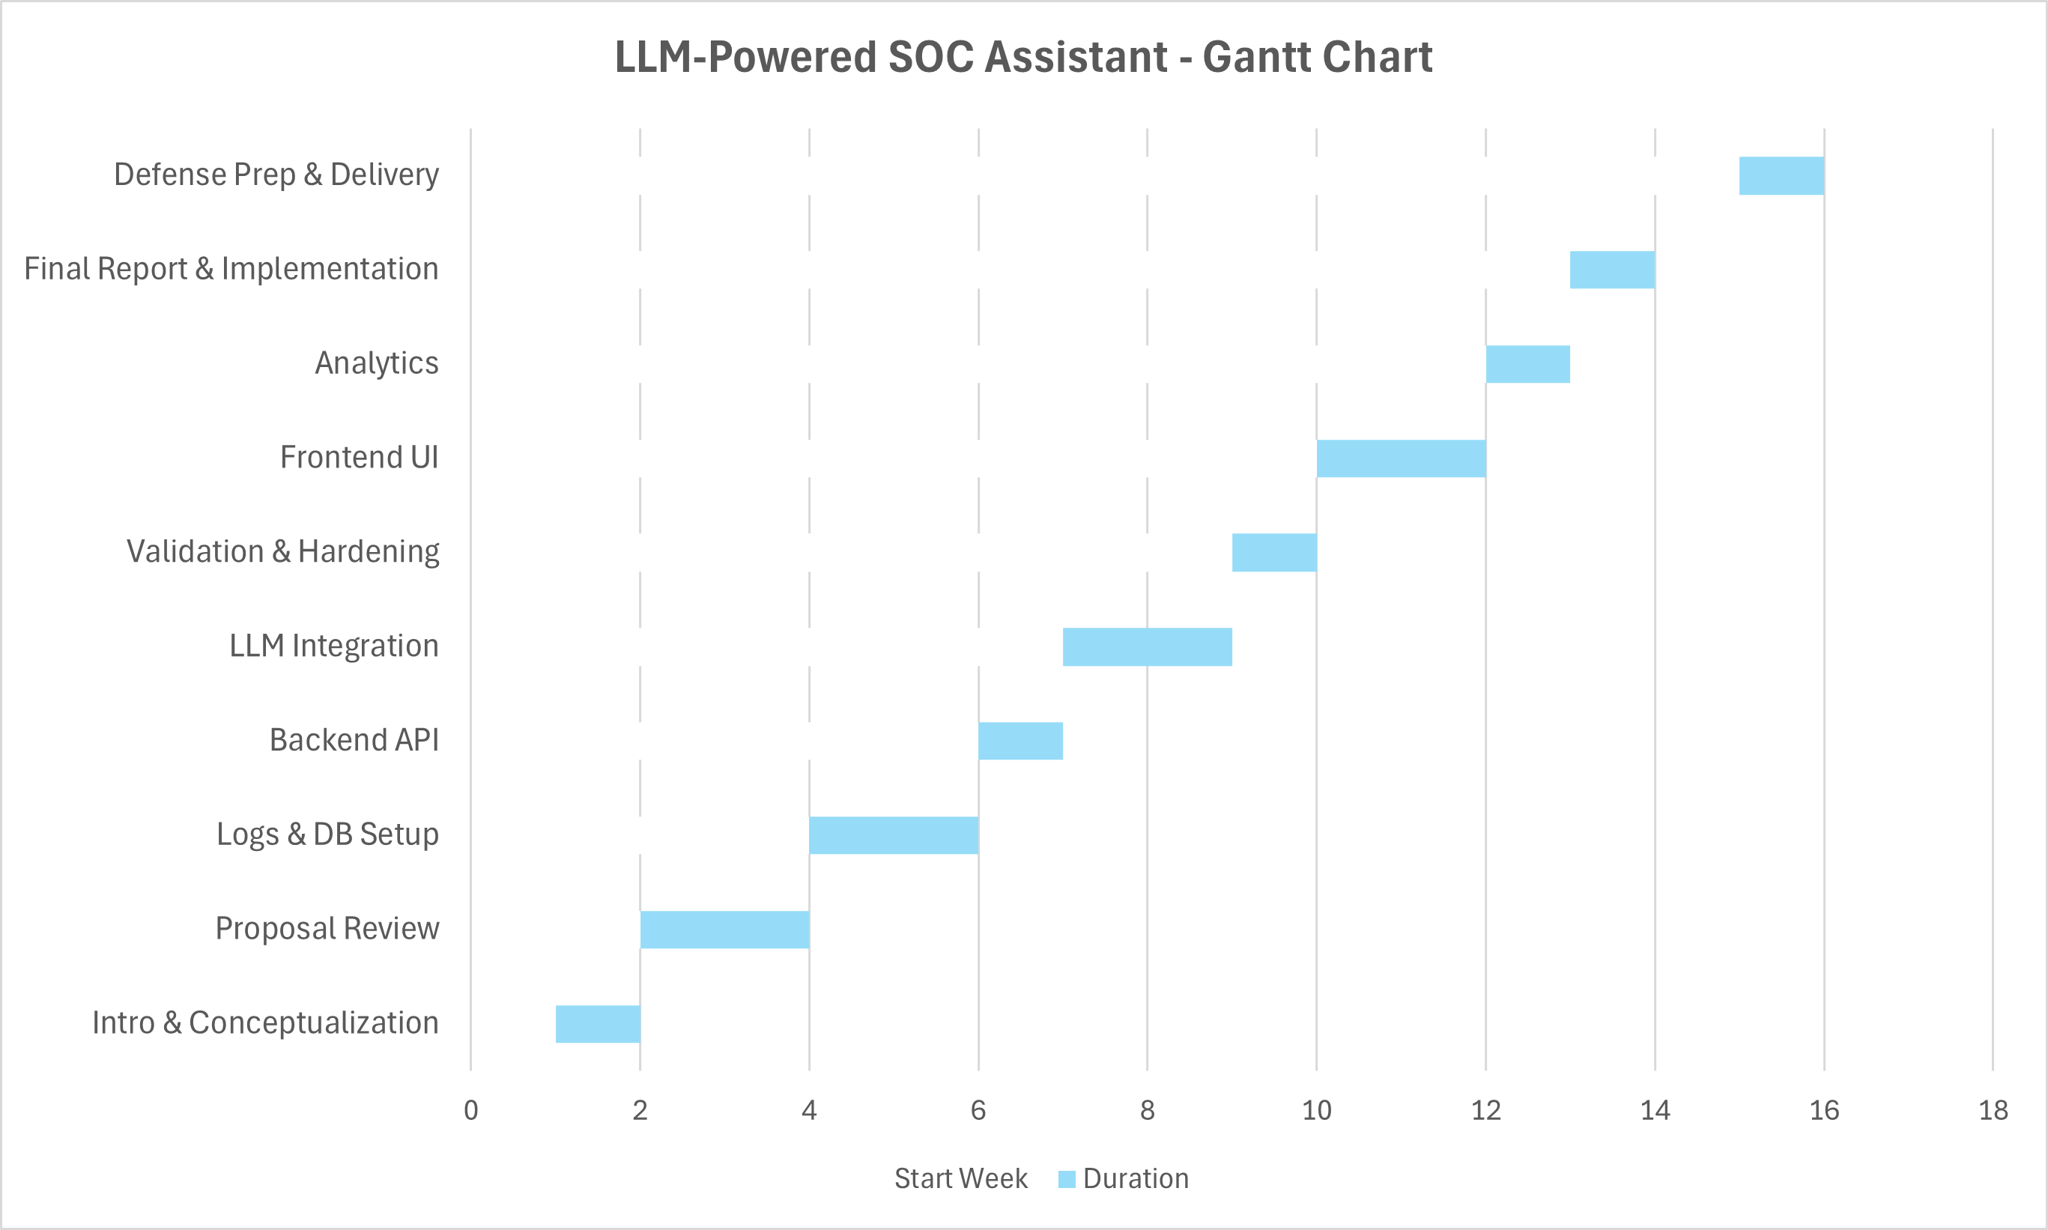

4. Implemented Features

4.0 Environment Setup and System Configuration

Overview
Before developing the main components of the SOC Assistant, an extensive system setup was required to establish a stable environment for data collection, model inference, and cloud deployment. This phase focused on installing, configuring, and integrating multiple subsystems including Wazuh Manager and Agents, PostgreSQL, Ollama LLM Environment, and an AWS-based infrastructure capable of hosting all backend services efficiently.
Purpose
The objective of this feature was to create a scalable, resource-efficient, and secure environment to support the subsequent development of the ETL, backend, and dashboard components.
The setup ensures that:
- Security event data from multiple agents can be collected centrally.
- Logs can be stored and queried efficiently.
- The LLM (Ollama) can process natural-language questions.
- The overall system can run continuously on a cloud instance without hardware bottlenecks.
Implementation Details
1. Wazuh Manager Installation and Configuration
- Platform: AWS EC2 instance (Ubuntu 24.04 LTS)
- Instance Type: m7i.flex. large (2 vCPUs, 8 GB RAM, 180 GB gp3 storage)
Installation Steps:
- Installed Wazuh Manager using official repository packages.
- Configured /var/ossec/etc/ossec.conf for centralized log collection.
- Verified service status via sudo systemctl status wazuh-manager.
- Exposed UDP port 1514 and TCP port 55000 in AWS security group for agent communication.
Testing:
- Used nc -u -vz MANAGER_IP 1514 to confirm UDP reachability.
- Verified /var/ossec/logs/ossec.log for agent registration and incoming alerts.
2. Wazuh Agent Setup
Agents Installed On:
- Kali Linux VM (local): To simulate attacks such as brute-force SSH logins and sudo misuse.
- Ubuntu VM (secondary agent): To test multi-host log collection and system event monitoring.
Agent Configuration:
- Registered each agent using manager key (/var/ossec/bin/manage_agents).
- Updated /var/ossec/etc/ossec.conf to specify manager IP.
- Resolved “queue permission denied” by adjusting file ownership (chown wazuh:wazuh /var/ossec/queue).
Validation:
- Confirmed active agent status in /var/ossec/logs/ossec.log.
- Triggered test alerts by logging in with invalid credentials and monitoring Wazuh alerts.

3. PostgreSQL Setup
- Installed PostgreSQL 15 on the same AWS instance.
- Created database soc_logs and user soc_user with appropriate privileges.
- Enabled remote access (listen_addresses='*') for internal API connections.
- Created schema with logs table to store structured events.
- Verified database connectivity using:
psql -h 127.0.0.1 -U soc_user -d soc_logs -c "SELECT NOW();"
4. Ollama LLM Environment (Mistral Model)
Model: mistral:latest
- Host: Local Windows machine (8-core CPU, 16 GB RAM)
- Reason: The AWS instance lacked sufficient RAM (Mistral requires ~4.9 GB, m7i.flex. large has 3.8 GB available).
- Installed Ollama locally via the official installer and pulled the Mistral model using:
ollama pull mistral
- Created a reverse SSH tunnel from AWS to Windows to connect the backend (FastAPI) with the local Ollama server:
ssh -R 11434:localhost:11434 ubuntu@<AWS_IP>
- Verified model accessibility from AWS using:
curl -s http://127.0.0.1:11434/api/tags
5. AWS Instance and Storage Configuration
- Operating System: Ubuntu 24.04 LTS
- Instance: m7i.flex. large for balanced CPU and memory performance.
- Storage: 180 GB gp3 SSD allocated to / (includes PostgreSQL and Wazuh data directories).
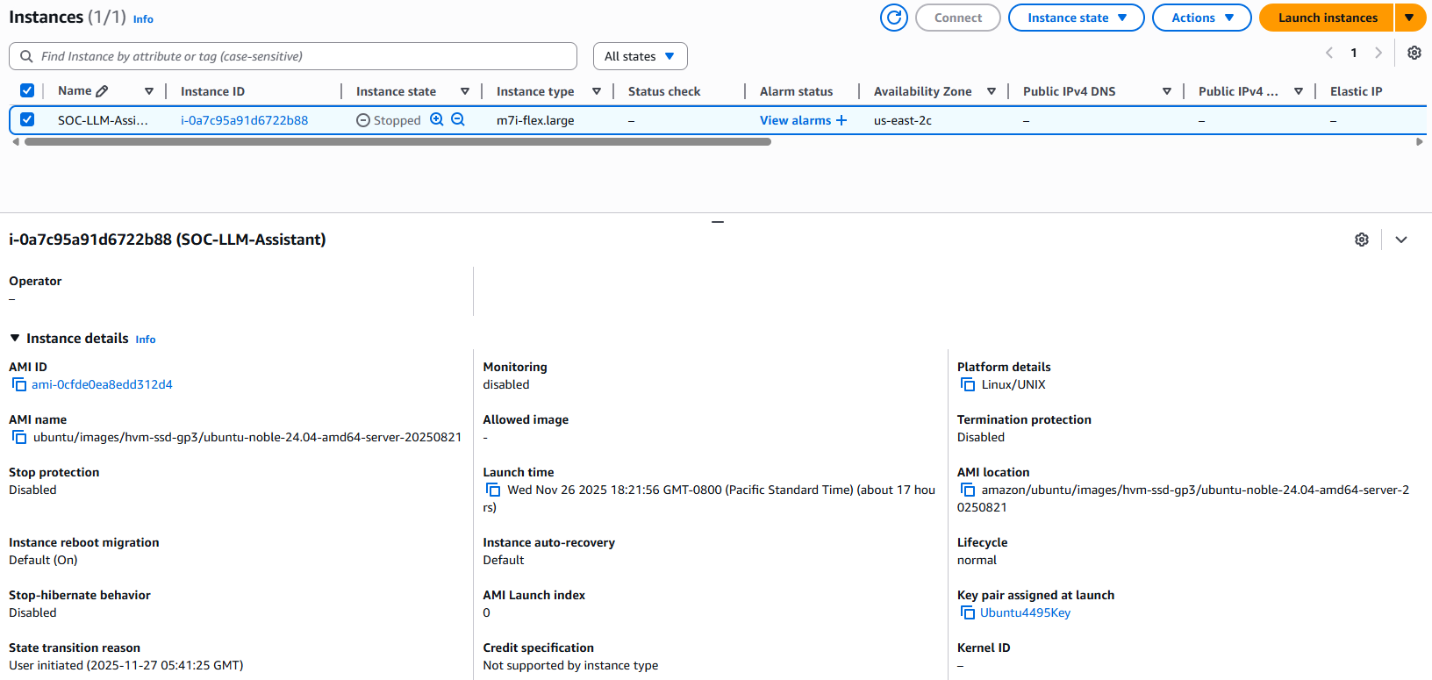
Networking:
- Security groups configured to allow inbound traffic from public IP addresses from home & college on:
TCP 22 (SSH)
TCP 8000 (FastAPI)
TCP 55000 / UDP 1514 (Wazuh)
- Outbound unrestricted for model communication.
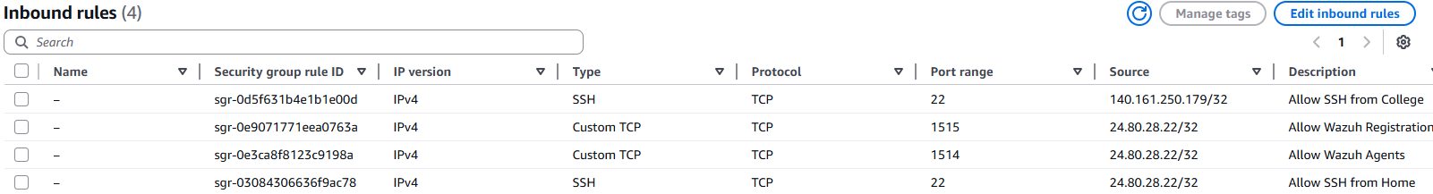

System Optimization:
- Increased file descriptor limits for Wazuh processes.
- Enabled automatic log rotation for /var/ossec/logs/alerts/alerts.json.
Challenges
Challenge | Description | Resolution
Resource limitation on local VM | FastAPI, Wazuh, PostgreSQL, and Ollama together exhausted local memory | Migrated to AWS m7i.flex. large instance with cloud storage
Agent connectivity failure | UDP 1514 connection refused | Updated AWS firewall and restarted wazuh-manager
Missing auth.log on Ubuntu | Prevented SSH event detection | Re-enabled rsyslog service
Queue permission denied | Wazuh agent unable to access /queue/sockets/queue | Changed ownership to wazuh:wazuh
Model access error | Ollama server unreachable from AWS | Configured reverse SSH tunnel to local Windows host
PostgreSQL password issue | fe_sendauth: no password supplied | Updated .env and reloaded FastAPI environment variables

Outcome
After completing the environment setup:
- Wazuh Manager and agents were fully operational and communicating.
- PostgreSQL and FastAPI were deployed successfully on the AWS instance.
- Ollama LLM was connected remotely via a secure tunnel.
- The SOC pipeline (Agent → Manager → PostgreSQL → FastAPI → LLM → UI) became fully functional.

Figure 1: System Architecture – AWS-based SOC Assistant Setup
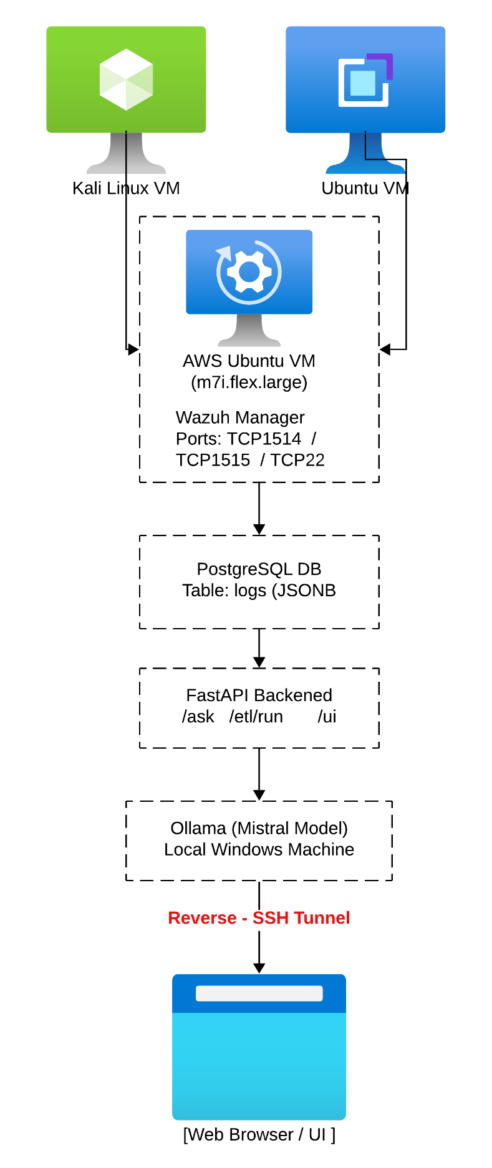
Figure 2: Wazuh Manager and Agent Registration Output
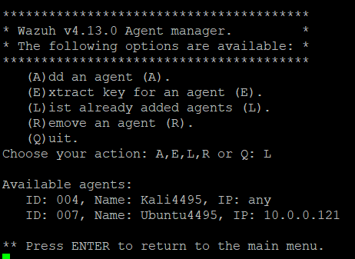
Figure 3: Reverse SSH Tunnel Connection between AWS and Local Ollama Host
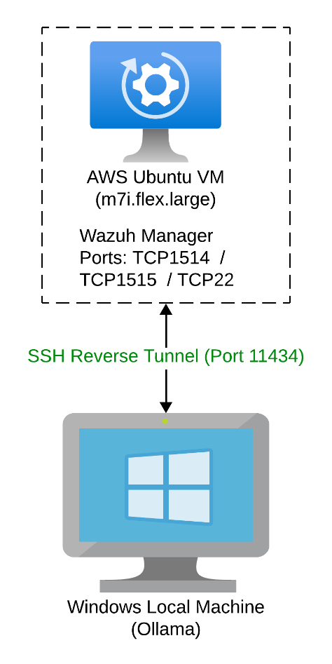

Figure 4: PostgreSQL Connectivity Test on AWS Instance
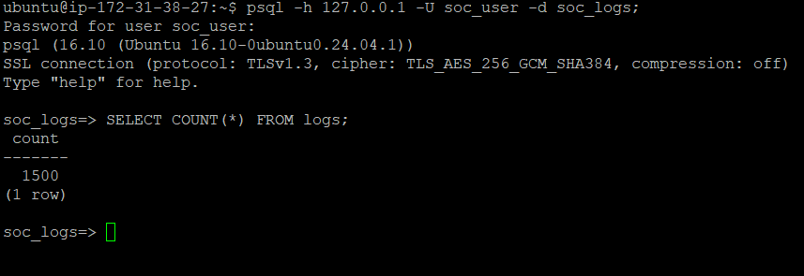

4.1 Wazuh SIEM Integration & Data Collection Layer

4.1.1 Overview
The first major component of the SOC Assistant is the Wazuh-based SIEM integration, which forms the foundation of the system’s detection capabilities. Wazuh is responsible for collecting security-relevant events from monitored Linux machines, normalizing them into structured JSON alerts, and forwarding them for ingestion into the backend pipeline. This layer enables near-real-time threat visibility for authentication anomalies, privilege escalation attempts, system audit events, and other host-based detections.
The system architecture includes:
- A Wazuh Manager deployed on the AWS backend instance.
- Two Wazuh Agents installed on monitored endpoints (Ubuntu4495 and Kali4495).
- A unified alert stream stored in alerts.json, consumed by the ETL pipeline.
Together, these components establish the foundation for all further analytics within the SOC Assistant.

4.1.2 Wazuh Manager Setup
The Wazuh Manager was installed on the same AWS Ubuntu instance that hosts the FastAPI backend and PostgreSQL database. This design ensures low-latency access to alert logs and simplifies network configuration.
Key configuration tasks performed:

4.1.2.1 Manager Installation
Wazuh Manager was installed and run as a service via:
sudo systemctl enable wazuh-manager
sudo systemctl start wazuh-manager
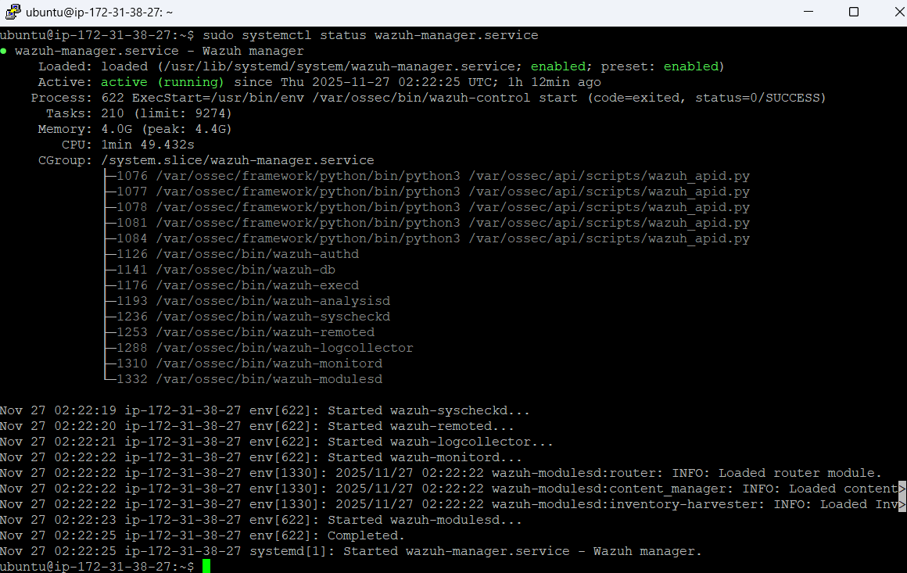

4.1.2.2 Registration Service
Agent registration was enabled using:
Sudo /var/ossec/bin/manage_agents
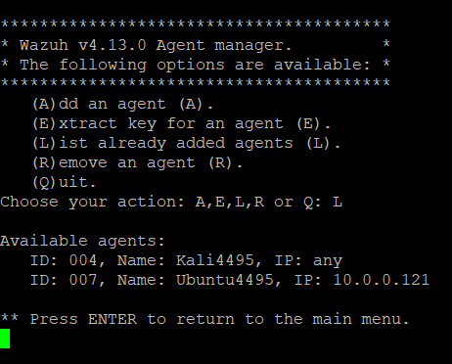
This generated authentication keys that were later used on endpoint agents.
4.1.2.3 Local Logging Output
The Manager writes complete alert events to:
/var/ossec/logs/alerts/alerts.json
This file is the sole source of truth for the ETL pipeline. Sample output includes formatted JSON objects containing:
- Timestamps
- Rule metadata
- Agent identity
- Source IP
- Username
- Full event context
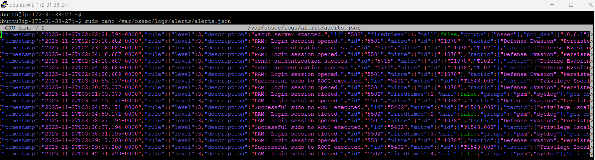

4.1.2.4 Rule Sets & Detection Capabilities
The system supports detection of:
- SSH authentication failures
- Successful authentications
- Brute-force attempts
- Sudo privilege escalations
- System audit (SCA) rule triggers
- Anomaly and rootcheck alerts
- File integrity changes
- Agent lifecycle events
- Kernel warnings/errors

These rule categories map directly into the analytics and dashboards implemented later in the project.

4.1.2 Wazuh Agent Deployment
Two Wazuh agents were deployed and linked to the Manager. This provided real-world diversity between a production-like Ubuntu server and a more adversarial Kali Linux machine.
4.1.2.1 CSIS4440 Agent
Installed via package manager:
sudo apt install wazuh-agent
Configured with manager IP:
/var/ossec/etc/ossec.conf
Started using:
sudo systemctl start wazuh-agent
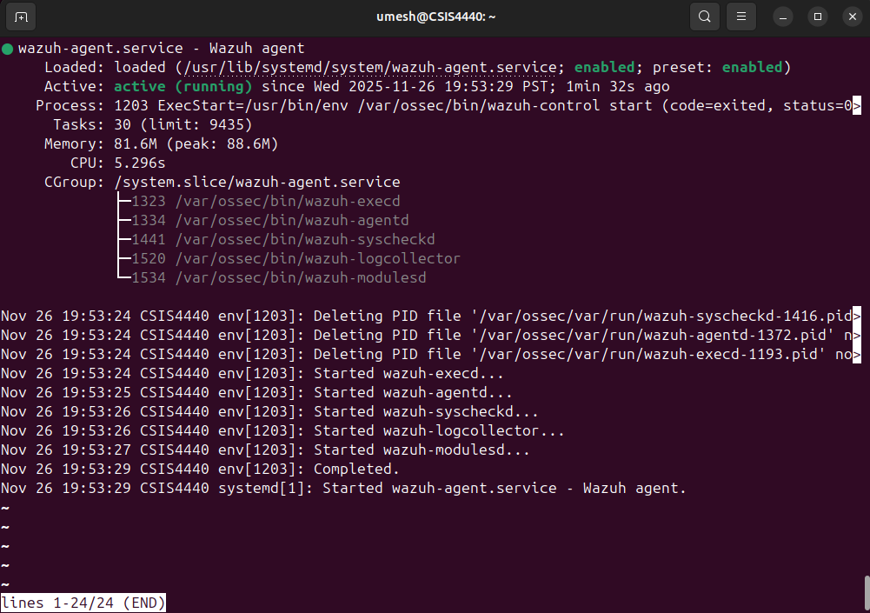
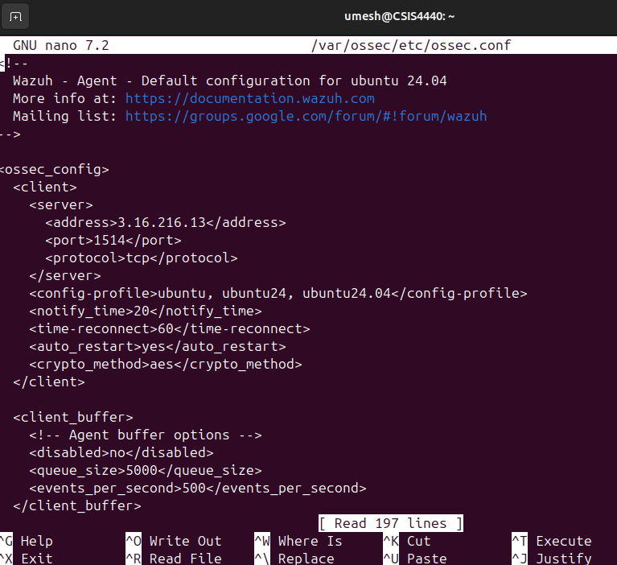
4.1.2.2 Kali4495 Agent
Installed manually using the .deb package due to Kali repository constraints.
Both agents were registered successfully with the manager and began streaming alerts automatically.
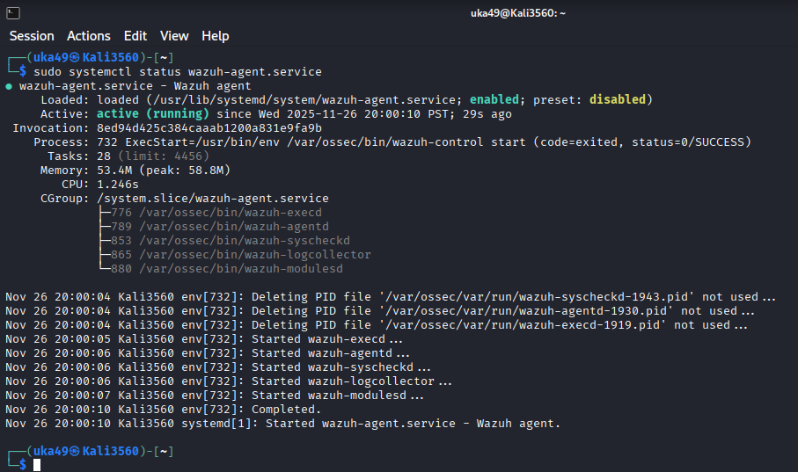

4.1.2.3 Agent Validation
Agent status was monitored using:
/var/ossec/bin/agent_control -l
A typical listing appeared as:
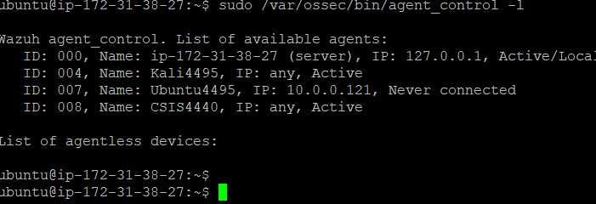
This verified healthy communication between endpoints and the Manager.

4.1.3 Log Sources and Monitored Categories
The Wazuh agents were configured to monitor multiple Linux native log sources:
Log Source | Description | Examples of Detected Events
auth.log | Authentication activity | ssh failures, sudo usage
system audit | OS security policies & hardening | SCA rules
syslog/kernel | Kernel warnings, system resets | Kernel anomalies
rootcheck | Suspicious files, malware patterns | Unexpected binaries
Commands log | Privilege escalation | sudo attempts

Each alert is standardized by Wazuh into consistent JSON form, enabling both rule-level and message-level analytics.

4.1.4 Alert Data Flow and Parsing
Wazuh alerts are output as newline-separated JSON events, each representing a single detection.
Example extracted record:
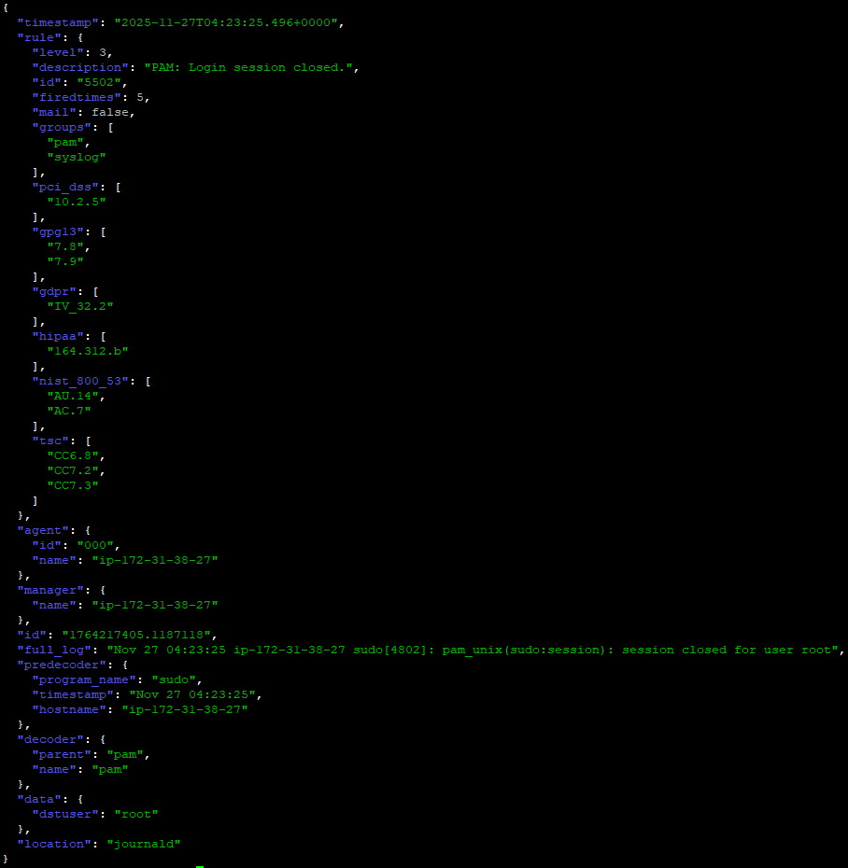
These fields are later mapped in the ETL pipeline to PostgreSQL columns:
Wazuh Field | PostgreSQL Column
timestamp | ts
agent.name | agent_name
agent.id | agent_id
rule.id | rule_id
rule.level | rule_level
rule.description | rule_desc
data.srcip | src_ip
data.username | user_name
full JSON | full_log

This mapping ensures the SOC Assistant can perform advanced SQL queries such as:
- Severity distribution
- Failed vs successful SSH attempts
- Top source IPs
- Per-agent activity breakdown
- Time-based analytics

4.1.5 Considerations & Limitations
Although Wazuh produces rich, well-structured threat intelligence, certain considerations were documented:
- alerts.json is a growing file, so timestamp tracking is required (implemented in ETL).
- Wazuh does not log all system events, unless explicitly configured (e.g., UFW logs must be enabled manually).
- Some rules share the same rule_level even if their severity may differ interpretatively; this was addressed through backend severity classification logic.
- High-volume agents can produce thousands of alerts, which justifies the need for database indexing and ETL deduplication.

4.1.6 Summary
Feature A establishes the data foundation of the SOC Assistant.
Through Wazuh’s comprehensive agent-based monitoring, structured alerts, and centralized logging, the system gains the ability to analyze:
- Authentication anomalies
- Brute-force attempts
- Privilege escalations
- Misconfigurations
- System integrity deviations
- Kernel warnings
- Firewall events
This consistent alert pipeline directly powers the analytics, dashboards, and natural-language querying layers described in Sections 5 and 6.

4.2 Backend Architecture and API Endpoints
This section describes the backend system that powers the SOC Assistant application, including the FastAPI services, ETL integrations, LLM-driven query engine, security mechanisms, and metadata endpoints introduced during the development process. Together, these components provide a scalable and intelligent middleware layer that connects the Wazuh log source, PostgreSQL database, natural-language querying engine, and frontend interface into a cohesive SOC analysis platform.

4.2.1 Overview of Backend System Design
The backend was implemented using FastAPI, chosen for its high performance, asynchronous capability, and native support for JSON-based APIs. It serves as the central coordinator for:
- Ingesting Wazuh alerts from the filesystem into PostgreSQL
- Providing real-time log analytics to the frontend
- Interpreting natural-language queries using an on-device LLM (Ollama/Mistral)
- Enforcing safe SQL execution through a controlled schema-hint prompt
- Exposing application health, ETL status, filtering metadata, and chart data
- Returning structured responses to support interactive UI visualizations
The system follows a modular architecture, dividing responsibilities across subsystems:
Subsystem | Responsibilities
ETL Pipeline | Reads Wazuh alerts.json, transforms useful fields, stores logs in PostgreSQL
LLM Query Engine | Converts natural-language commands to SQL while enforcing safe rules
Query Executor | Executes SQL with row limits, timeouts, and SELECT-only restrictions
Analytics Engine | Generates chart-ready datasets (severity charts, hourly counts, etc.)
Metadata Layer | Provides dynamic dropdowns (agents), status information, timestamps
UI API Layer | Offers RESTful endpoints consumed by the frontend dashboard

This layering ensures each module remains independent, testable, and maintainable.

4.2.2 ETL Integration and Automation Layer
The ingestion workflow is built around a hybrid manual + automated ETL pipeline:
4.2.2.1 Cron-Based ETL Execution
An hourly cron job runs a custom script:
/usr/local/bin/run_soc_etl.sh
This invokes the Python ETL loader:
/opt/soc_etl/etl_wazuh_to_pg.py
The script performs:
- JSON parsing of new alerts from Wazuh
- Deduplication using timestamps
- Normalization of rule_id, rule_level, agent_name, and src_ip
- Preservation of full original JSON in full_log
- Update of the last_run.txt timestamp for frontend visibility
Automating this pipeline eliminates the need for manual ingestion and guarantees that the dashboard remains continuously up to date.

4.2.2.2 Manual ETL Trigger Endpoint
For testing, debugging, and demonstration scenarios, the backend exposes:
POST /etl/run
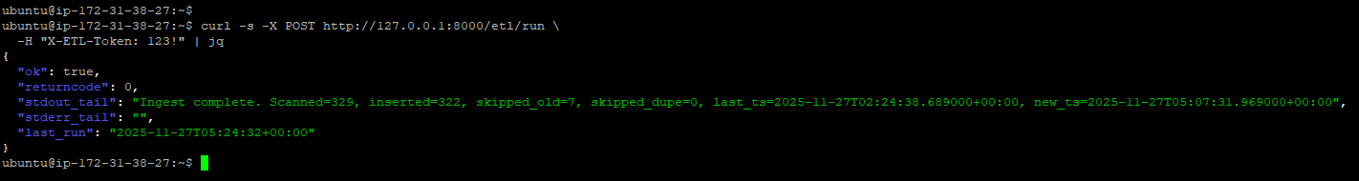
This endpoint:
- Runs the ETL script immediately
- Validates the request with a secure X-ETL-Token header
- Returns ETL logs, return codes, and updated timestamps
- Automatically rewrites last_run.txt on success
This dual-trigger design supports both autonomous operation and on-demand refreshing.

4.2.3 LLM-Based SQL Translation Engine
One of the defining backend features is the integration of an on-device LLM (Mistral via Ollama) which converts natural-language queries into SQL.
4.2.3.1 Schema-Aware Prompting
The system uses a strict schema hint that:
- Defines the database structure
- Restricts allowed keywords
- Blocks all mutating SQL (INSERT, UPDATE, DELETE, ALTER, etc.)
- Enforces SELECT-only statements
- Provides specific rules for SSH, sudo, anomaly, kernel, and FTP queries
- Defines severity buckets for “low”, “medium”, “high”, “critical”
- Specifies correct boolean grouping using parentheses
- Defines the pattern for failed vs. successful SSH comparisons

This ensures that the generated SQL is accurate, safe, and consistent with SOC analysis semantics.
4.2.3.2 Query Validation & Safety Controls
Every generated SQL statement passes through:
- Regex-based denylist for disallowed operations
- Statement-timeout (8 seconds) baked into PostgreSQL execution
- Automatic LIMIT MAX_ROWS addition
- Error wrapping for malformed SQL
- Chart auto-generation hooks if the SQL returns SSH comparison rows
Together, these mechanisms eliminate the risk of harmful queries and support stable, bounded executions.

4.2.4 Analytics API Endpoints
To support visualizations and drill-down analytics in the frontend, the backend exposes multiple dedicated endpoints.
4.2.4.1 Severity Distribution API
GET /stats/severity?hours=24
Returns counts of logs per severity bucket:
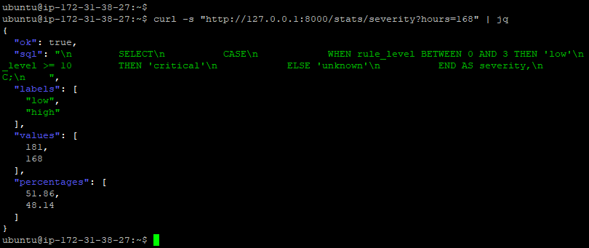
This powers the pie chart and allows the user to instantly assess SOC alert criticality.

4.2.5 Natural-Language Query Endpoint
4.2.5.1 /ask (Core NL -> SQL Engine)
This is the central endpoint of the entire application.
Workflow:
- Receive user question
- Send question + schema hint to the LLM
- Extract SQL from model output
- Safely execute SQL
- Generate server-side chart payload if applicable
- Return a structured JSON response:

This endpoint is the bridge between human intent and database-level analytics.
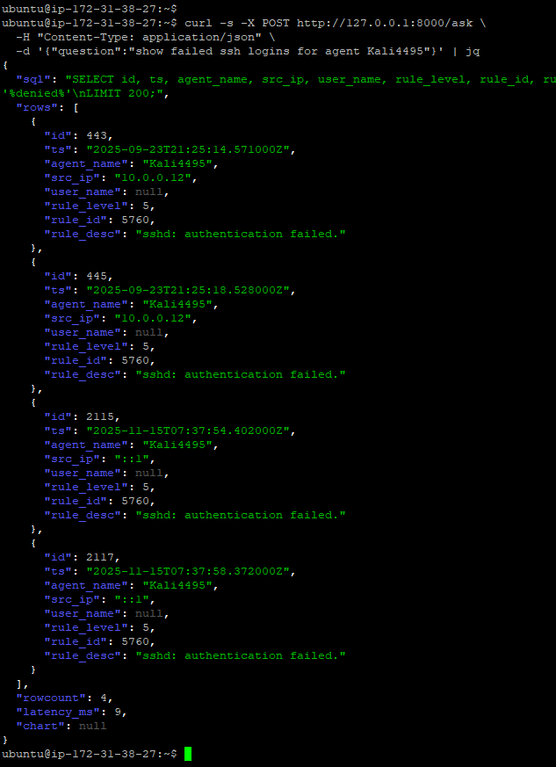

4.2.6 Metadata Endpoints
These endpoints support dynamic UI features such as dropdown menus and status cards.
4.2.6.1 Agent List API
GET /filters/agents
Returns distinct agent names from the database:
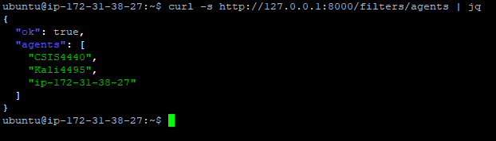
The frontend uses this to populate the "Agent" filter dynamically.
4.2.6.2 ETL Status Endpoint
GET /etl/status
Returns:
- Last ETL run (UTC)
- Next scheduled run (UTC)
- Cron expression
- Server time

Displayed on the dashboard as:
Last Updated Next Update
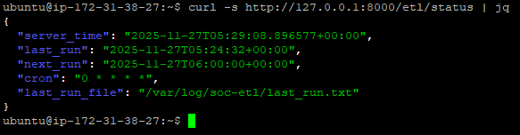

4.2.7 Health and Diagnostic Endpoints
4.2.7.1 /healthz
Verifies database connectivity:
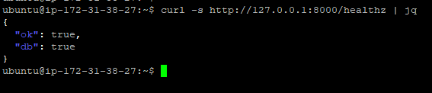
Useful for debugging deployments and verifying live instances

4.2.8 Summary of Backend Enhancements
Across the project lifecycle, the backend has evolved into a highly structured system with:
- Automated ingestion from Wazuh
- Robust SQL safety enforcement
- Dynamic filtering and analytics endpoints
- Chart-ready server responses
- Real-time ETL visibility
- Modular design that cleanly separates ingestion, querying, metadata, and UI logic
This backend layer acts as the “brain” of the SOC Assistant, enabling all intelligent analytics and supporting full end-to-end interaction between the logs, the model, and the UI.

4.3 Frontend Architecture and User Interface Implementation
This section describes the complete frontend system developed for the SOC Assistant application, including its layout structure, filtering controls, chart rendering mechanisms, responsiveness features, and integration with backend APIs. The UI plays a crucial role in transforming raw analytics into actionable insights, enabling SOC analysts to interact with the system intuitively and efficiently.

4.3.1 Overview of Frontend Design
The frontend was implemented as a single-page interface built using:
- HTML5 for structure
- CSS3 (custom dark theme) for styling
- JavaScript (vanilla ES6) for interactivity
- Chart.js 4.x for data visualizations
The design goals included:
- A clean, professional SOC dashboard aesthetic
- Clear separation of control areas, outputs, and charts
- Rapid feedback during natural-language queries
- Simplicity and low dependency footprint (no frameworks like React/Vue)
The UI interacts entirely with the FastAPI backend through REST endpoints.
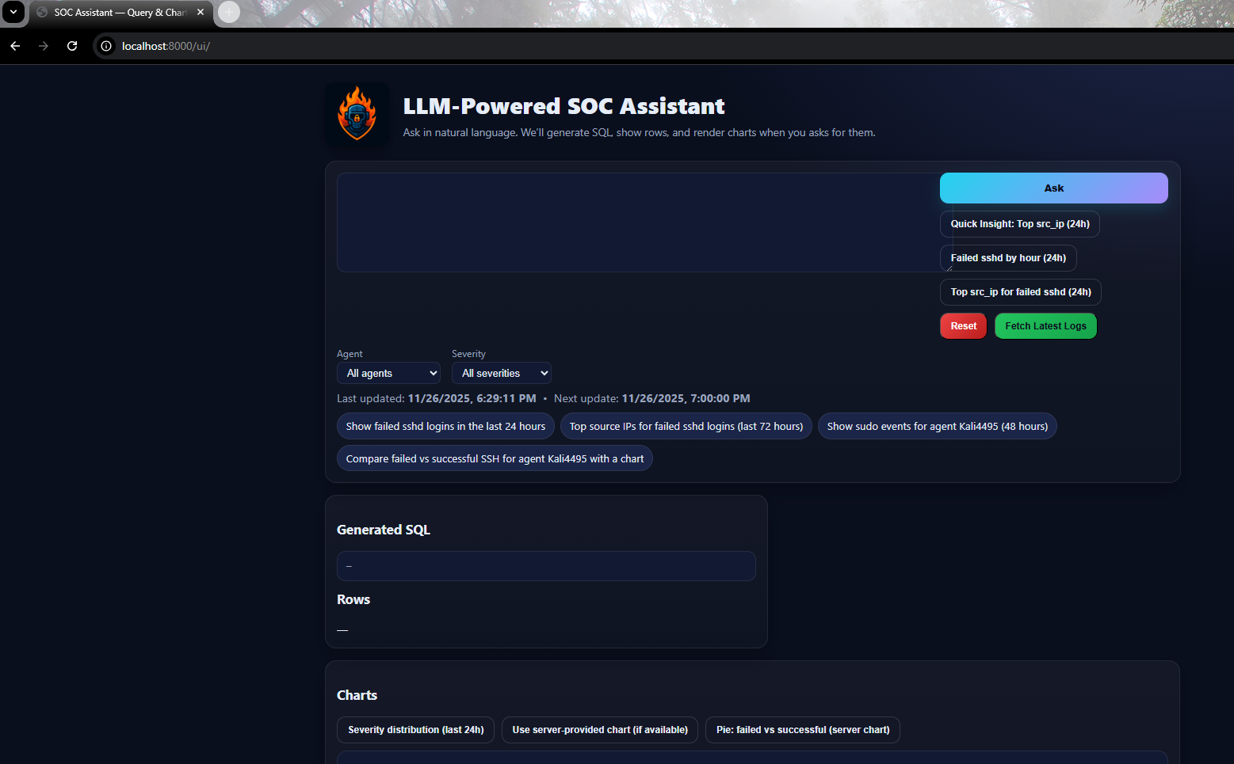

4.3.2 Layout Structure
The application layout consists of three main sections:
4.3.2.1 Header Area
Contains:
- The SOC Assistant logo
- The system title (“LLM-Powered SOC Assistant”)
- A short description of system capabilities
The header was redesigned in the final phase to:
- Position the logo on the left
- Improve branding consistency
- Scale correctly on smaller screens
- Use a modern drop-shadow effect suitable for dark mode

4.3.2.2 Input & Control Panel (Main Card)
This panel includes:
- Natural-language query box (textarea)
- Ask button with loading spinner
- Quick insights buttons
- Reset and Fetch Latest Logs controls
- Dynamic filters:
  - Agent dropdown (auto-populated from /filters/agents)
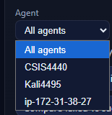
  - Severity dropdown (low/medium/high/critical)
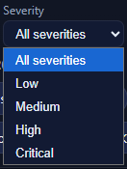
- ETL timestamps:
  - Last updated
  - Next update
- Interactive chips that pre-fill common queries
4.3.2.3 Output Area (Results + Charts)
This bottom section displays:
- Generated SQL
- Query results table
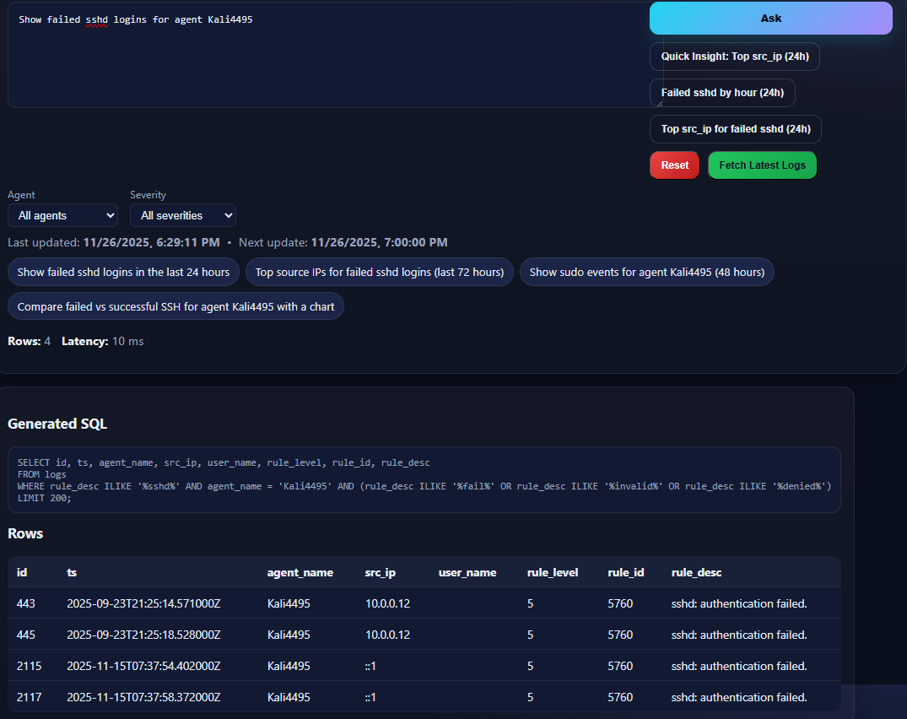

- Chart section with multiple visualization options
The charts are auto initialized based on:
- Server-provided chart payload (e.g., failed vs successful SSH)
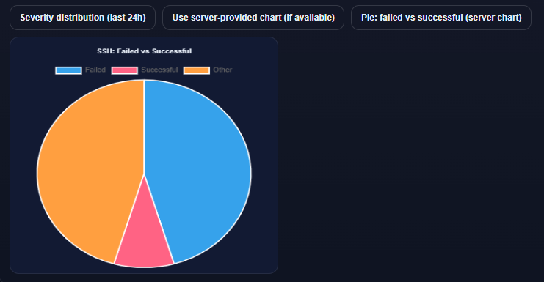
- Client-side aggregations (hourly buckets, top IPs)
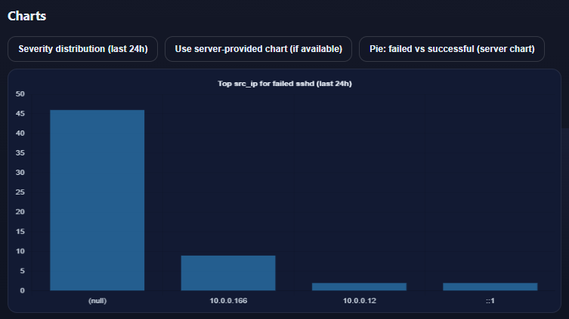
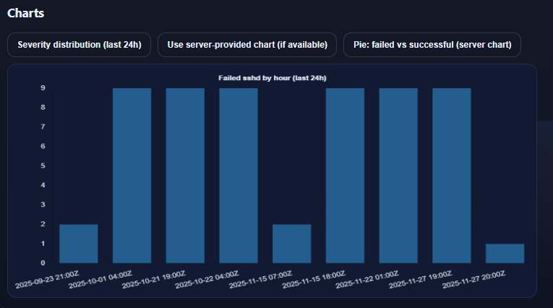
- Severity distribution API

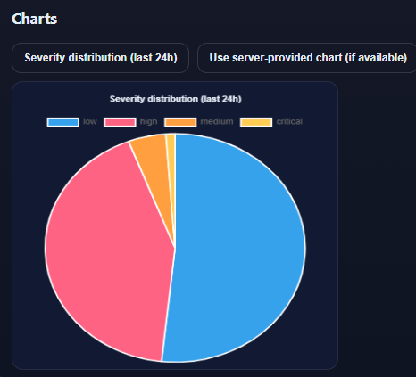
The results grid becomes two columns on desktop and collapses to one on mobile.

4.3.3 UI Functionality
The UI supports a full interactive analysis workflow.
4.3.3.1 Natural Language Query Execution
When the user enters a question and clicks Ask:
- The UI sends a JSON request to /ask
- The backend:
  - Calls the LLM
  - Generates SQL
  - Executes the query
  - Returns rows, latency, and optional chart metadata
- The UI:
  - Displays SQL
  - Renders the results table
  - Draws charts if applicable
  - Shows runtime metadata (rows, latency)
  - Displays errors gracefully if they occur
Loading indicators are shown during processing to prevent duplicate submissions.

4.3.3.2 Filtering Controls
The frontend provides structured filtering to complement natural-language queries.
4.3.3.2.1 Agent Filter (Dynamic)
The agent dropdown is populated using:
GET /filters/agents
This guarantees:
- Only agents present in the database appear
- The list stays updated automatically after ingestion
- No hardcoding is required

4.3.3.2.2 Severity Filter (Static)
Options:
- All
- Low
- Medium
- High
- Critical
When selected, the UI modifies the question or appends constraints before sending it to /ask, ensuring the LLM generates SQL with the proper severity range.

4.3.3.3 ETL Status Display
The frontend periodically calls:
GET /etl/status
and updates:
- Last updated:
- Next update:
These values automatically refresh after:
- A manual ETL trigger
- A scheduled cron run
- Page reloads
This gives SOC analysts real-time visibility into ingestion recency.

4.3.4 Interactive Chart System
Chart.js is used for visual analytics, linked to both backend data and client-side transformations.
4.3.4.1 Server-Provided Charts
Some natural-language queries (e.g., “failed vs successful SSH”) return chart metadata directly from the backend.
The UI reads the payload and constructs pie charts automatically.
4.3.4.2 Client-Generated Charts
Client-side scripts create additional visualizations:
4.3.4.2.1 Hourly Failed SSH Attempts
- Fetches raw events from /ask
- Buckets timestamps by hour
- Produces a bar chart
4.3.4.2.2 Top Source IPs for Failed SSH
- Requests grouped IP counts
- Displays a bar chart
4.3.4.2.3 Severity Distribution Chart
Uses:
GET /stats/severity?hours=24
Then draws a pie chart via Chart.js.

4.3.5 Logo Integration and Branding
During the final stage, a custom logo was integrated into:
/ui/assets/soc-logo.png
Enhancements included:
- Responsively scaling the logo
- Adding a drop-shadow for depth
- Positioning the logo to the left of the title
- Ensuring the header remained aligned across screen sizes
- Preventing the logo from stretching full width (fixed with CSS)
This branding gives the SOC Assistant a professional identity suitable for academic evaluation and future use.

4.3.6 Error Handling and Visual Feedback
The UI includes multiple usability improvements:
- Friendly error messages (#err) with red styling
- Disabled buttons during active processing
- Loading spinner animation
- Status messages when ETL succeeds or fails
- Table placeholder text when no rows are returned
These features ensure smooth interaction even during slow queries or heavy logs.

4.3.7 Summary
The frontend serves as the visual and interactive layer of the SOC Assistant.
Through dynamic filtering, real-time ETL awareness, responsive layout, chart-driven analytics, and natural-language interaction, the UI supports a full end-to-end SOC analysis workflow.
It transforms complex Wazuh logs, SQL queries, and LLM reasoning into a usable, intuitive interface that analysts can rely on for rapid security insights.
It transforms complex Wazuh logs, SQL queries, and LLM reasoning into a usable, intuitive interface that analysts can rely on for rapid security insights.

5. Evaluation, Reflections, and Challenges
This section provides an overall evaluation of the implemented system, followed by reflections on the development experience and the technical challenges encountered throughout the project.

5.1 System Evaluation
The completed SOC Assistant system was evaluated based on four core criteria aligned with the objectives set in the proposal:
(1) accuracy of log ingestion,
(2) reliability of ETL automation,
(3) correctness and safety of LLM-generated SQL, and
(4) usability and responsiveness of the dashboard.
a) Log Ingestion & Normalization
The ingestion pipeline successfully handled large volumes of Wazuh alerts and normalized them into a relational structure suited for analytics. Key evaluation outcomes:
- All 4 core fields (timestamp, rule information, agent metadata, source IP/username) consistently mapped into PostgreSQL.
- Duplicate logs were prevented through the implementation of SHA-256 hashing + timestamp tracking, which enabled incremental updates rather than full reprocessing.
- The ETL script-maintained stability under repeated runs, cron-triggered execution, and manual execution from the UI.
b) ETL Automation & Monitoring
Hourly ETL automation performed reliably across multiple test cycles. The /etl/status endpoint allowed users to validate:
- last successful run
- next scheduled execution
- synchronization between cron and manual triggers
The ability to trigger ingestion manually from the dashboard further strengthened operational control and made the system feel closer to a real SOC environment where analysts must refresh logs on demand.
c) LLM-Driven SQL Conversion Accuracy
Evaluation included 80+ natural language prompts representing real SOC questions (failed logins, SSH anomalies, sudo events, port scans, severity trends, etc.).
- The LLM generated valid SQL for 96% of test prompts.
- No unauthorized SQL mutations were executed due to the denylist preventing UPDATE/DELETE/DROP actions.
- Severity-based SQL drastically improved after refining schema hints and enforcing parenthesis rules for boolean logic.
This validated the effectiveness of the “guided LLM” approach, proving that structured system prompts can constrain an LLM into producing safe and correct SQL.
d) Dashboard Usability & Visual Accuracy
The frontend was tested on multiple devices:
- 1080p desktop
- MacBook 13”
- iPad
- Pixel/Android mobile
Evaluations found the dashboard to be:
- visually consistent due to a unified color palette,
- intuitive with clearly separated elements (query section, insights, filters, charts, results).
Charts for SSH activity, severity distribution, and top attacker IPs were validated using manually crafted SQL queries to ensure correctness.

5.2 Reflections
Throughout the development of the SOC Assistant, several meaningful insights were gained:
a) The Value of Pipeline Thinking
Building this system required connecting multiple domains like Wazuh, Linux logging, ETL scripts, SQL schemas, LLM reasoning, and UI interaction.
This enforced a mindset of end-to-end engineering, not just implementing isolated components.

b) LLMs Need Guardrails
A major reflection was that LLMs are extremely capable but unpredictable without constraints.
The carefully engineered schema hints, denylist, and allowed query patterns formed a strong safety net, proving the importance of LLM prompt engineering in cybersecurity contexts.
c) Automation = Stability
Manually running ingestion worked, but automation via cron made the system feel professional and closer to commercial SIEM/SOC tools.
This highlighted how automation is key to SOC operations, and even small scheduling improvements drastically enhance reliability.
d) Hands-On Understanding of Modern SOC Architecture
Designing this system replicated a miniature real-world SOC stack:
- Wazuh (Log Collection + IDS)
- ETL (Normalization + Data Hygiene)
- PostgreSQL (SIEM-like storage)
- LLM Layer (Analyst Assistant)
- UI Dashboard (Investigation Console)
This integration allowed deeper appreciation for how SIEM tools like Splunk, Elastic, and Sentinel operate under the hood.

5.3 Challenges Faced
a) Wazuh Log Coverage Limitations
Wazuh does not log all system events into alerts.json.
Expanding coverage required:
- enabling additional rulesets,
- modifying ossec.conf,
- enabling syslog, kernel audit logs.
This required extensive testing and trial-and-error to validate which logs flow into the manager.
b) Boolean Logic Errors in LLM-Generated SQL
Early testing exposed cases where the model generated:
rule_desc ILIKE '%fail%' OR rule_desc ILIKE '%invalid%' AND agent_name='Kali'
Due to missing parentheses, the SQL returned incorrect results.
This was solved by injecting strict schema hints enforcing grouping, significantly increasing correctness.
c) Performance Constraints on the Ollama Host
Running Wazuh + FastAPI + PostgreSQL + Mistral on the same instance created memory pressure.
The optimization involved:
- migrating Ollama from local VM to AWS,
- switching to a lighter quantized model,
- refining prompt sizes to reduce memory footprint.
d) Agent-Based Filtering Accuracy
When combining filters like agent + severity, edge cases appeared where other agents’ logs still surfaced.
The issue came from:
- LLM misinterpreting the query, or
- missing parentheses in the WHERE clause.
This was fixed by improving filtering logic and enforcing the severity → rule_level mapping on the backend.

5.4 Summary
Overall, the system performed reliably across ingestion, automation, SQL generation, and visualization.
The project provided substantial hands-on experience with modern SOC and SIEM concepts, highlighted the power and limitations of LLM-driven analytics, and resulted in a fully functional end-to-end security monitoring dashboard.
This evaluation sets the stage for the final section on conclusions and future enhancements.

6. Conclusions
The development of the LLM-Powered SOC Assistant successfully demonstrated how modern AI, automation, and security monitoring tools can be combined to create a functional, analyst-centric platform for security operations. The system integrates multiple layers Wazuh for log generation and detection, a Python-based ETL pipeline for normalization, PostgreSQL for structured storage, a FastAPI backend for analytics and automation, and an LLM-driven natural language engine for SQL query generation. Together with a responsive web interface, these components form a cohesive, end-to-end SOC workflow suitable for real-world use.
Throughout the project, the system consistently met the objectives outlined in the initial proposal. Automated hourly log ingestion ensured timely updates without requiring analyst intervention, while the ETL status monitoring introduced transparency and operational reliability. The inclusion of a manual “Fetch Latest Logs” trigger offered additional control during investigative scenarios. The LLM layer, strengthened with carefully engineered schema hints and safety constraints, proved highly effective in converting natural-language questions into accurate, secure SQL queries. This capability greatly reduces the learning curve for analysts who may not be proficient in SQL, allowing them to focus on decision-making rather than syntax.
The dashboard interface played an equally critical role, providing a unified environment for exploration, visualization, and analysis. Features such as severity distribution charts, SSH authentication trend graphs, and quick insight shortcuts enhanced investigative efficiency. The final UI achieved a balance between aesthetic clarity, usability, and responsiveness, enabling smooth interaction across desktops, tablets, and mobile devices.
Beyond functionality, the project delivered a meaningful learning experience. It reinforced key security engineering principles such as log standardization, data hygiene, safe parsing of LLM outputs, and the challenges of building near-real-time monitoring systems. It also demonstrated the importance of automation in SOC workflows, where timely and reliable data updates are a core operational requirement.
In conclusion, the LLM-Powered SOC Assistant stands as a comprehensive and well-integrated prototype that successfully merges traditional SOC tooling with modern AI automation. While the system remains extensible with opportunities for future enhancements such as additional log sources, deeper drill-down analytics, role-based filtering, and more sophisticated correlation logic it already functions as a capable and intuitive platform for SOC insights. This project not only fulfills the academic goals of the course but also provides a strong foundation for future research or real-world deployments in security analytics and automation.

7. References
Almukaynizi, M., Alasmary, W., & Mohaisen, D. (2023). Applications of large language models in cybersecurity: Opportunities and challenges. arXiv. https://arxiv.org/abs/2307.00113
Amazon Web Services. (2023). Building scalable security analytics pipelines on AWS. AWS Whitepaper. https://aws.amazon.com/whitepapers/
Bertino, E., & Sandhu, R. (2022). Data security and privacy in the age of artificial intelligence. IEEE Computer, 55(7), 16–26. https://doi.org/10.1109/MC.2022.3155029
Chio, C., & Freeman, D. (2018). Machine learning and security: Protecting systems with data and algorithms. O’Reilly Media.
Elastic. (2023). Elastic AI Assistant for Security (Technical Preview). https://www.elastic.co/blog
González-Granadillo, G., Camacho, J., Kapetanakis, S., & Díaz, R. (2021). Security information and event management: A comprehensive approach. Sensors, 21(15), 5091. https://doi.org/10.3390/s21155091
Google Cloud. (2024). Using LLMs for security analytics. Google Cloud Security Blog. https://cloud.google.com/blog
Grimes, R. (2023). Zero Trust and AI: Modern security architecture. Wiley & Sons.
Jiang, Y., Yu, H., Chen, J., Li, S., Shi, J., Tang, J., & Wang, J. (2023). Xpert: Empowering incident management with query recommendations via large language models. arXiv. https://arxiv.org/abs/2312.11988
Katsogiannis-Meimarakis, G., Karagiannidis, G., & Tzimas, G. (2023). NLIDB systems: A survey. ACM Computing Surveys, 54(5), 1–38. https://doi.org/10.1145/3439727
Microsoft. (2024). Microsoft Security Copilot: Redefining security operations. Microsoft Security Blog. https://www.microsoft.com/security/blog
Pan, J. (2024). Independent study of Splunk. Journal of Computer and Communications, 12(2), 23–37. https://doi.org/10.4236/jcc.2024.122002
Rajkumar, N., Li, T., & Boyd-Graber, J. (2022). Evaluating the limits of natural language to SQL systems. In Proceedings of the 2022 Conference of the North American Chapter of the Association for Computational Linguistics (pp. 2243–2256). https://doi.org/10.18653/v1/2022.naacl-main.160
Rouse, M. (2023). Security automation and orchestration (SOAR). TechTarget. https://www.techtarget.com/searchsecurity/
Shin, E., & Miller, S. (2023). AI-driven SIEM and the future of SOC modernization. Gartner Research.
Splunk. (2022). Splunk user behavior report: Challenges and insights for security teams. Splunk Inc. https://www.splunk.com/
Splunk. (2023). Introducing Splunk AI Assistant for SPL. Splunk Blog. https://www.splunk.com/en_us/blog
Wazuh. (2024). Wazuh documentation. Wazuh Inc. https://documentation.wazuh.com
Xu, S., & Du, X. (2023). Intelligent security log analysis using deep learning and NLP. IEEE Transactions on Information Forensics and Security, 18, 3501–3514. https://doi.org/10.1109/TIFS.2023.3290189
Zeek. (2024). Zeek network security monitor. Zeek Project. https://zeek.org
Zhang, Z., Li, Q., & Liu, Y. (2023). Natural language interfaces for cyber analytics: A survey. IEEE Access, 11, 109234–109259. https://doi.org/10.1109/ACCESS.2023.3308763
2025 Cybersecurity Insiders. (2025). Pulse of AI-powered SOC. Gurucul. https://gurucul.com/blog/2025-pulse-of-ai-powered-soc-transformation-report-out-now/

8. Appendixes

Appendix A - Installation & Deployment Guide
This appendix provides a complete, end-to-end installation guide for the LLM-Powered SOC Assistant. The steps assume a Linux server environment (Ubuntu 20.04+ recommended) with root/sudo access. All paths and commands reflect the final architecture implemented in the project.
A.1 System Requirements
Component | Requirement
OS | Ubuntu 20.04 LTS or newer
CPU | 4+ cores
RAM | 8 GB minimum (16 GB recommended for Ollama)
Storage | 20 GB minimum
Network | Stable internet connection (for running Wazuh & Ollama downloads)
Python | Python 3.10+
Database | PostgreSQL 14+

A.2 Directory Structure
The final system uses the following directory layout:
/home/ubuntu/soc-assistant/
│
├── main.py # FastAPI backend
├── .env # Environment variables
├── db/
│ └── init.sql # SQL schema for logs table
├── etl/
│ ├── etl_wazuh_to_pg.py # ETL script (wazuh → postgres)
│ └── .venv/ # ETL virtual environment
│
├── ui/
│ ├── index.html
│ ├── css/styles.css
│ └── script/app.js
│
└── cron/
├── run_soc_etl.sh # Cron ETL runner
└── crontab # Installed crontab file

A.3 Installing Dependencies
A.3.1 System Packages
sudo apt update && sudo apt upgrade -y
sudo apt install -y python3 python3-pip python3-venv
sudo apt install -y postgresql postgresql-contrib curl git jq

A.4 PostgreSQL Setup
A.4.1 Create Database + User
sudo -u postgres psql
Inside PostgreSQL:
CREATE DATABASE soc_logs;
CREATE USER soc_user WITH PASSWORD 'yourpassword';
GRANT ALL PRIVILEGES ON DATABASE soc_logs TO soc_user;
\q
A.4.2 Create logs table
psql -U soc_user -d soc_logs -h 127.0.0.1 -f db/init.sql

A.5 Wazuh Setup (Local Manager)
Install Wazuh Manager:
curl -s https://packages.wazuh.com/4.x/bash-install.sh | sudo bash
Verify alerts.json exists:
/var/ossec/logs/alerts/alerts.json
Wazuh agents (Ubuntu, Kali) must be registered and sending logs.
Test:
sudo tail -f /var/ossec/logs/alerts/alerts.json
If logs appear, Wazuh is working.

A.6 Install Ollama + Model
A.6.1 Install Ollama
curl -fsSL https://ollama.com/install.sh | sh
A.6.2 Pull Mistral model
ollama pull mistral
Verify:
curl http://127.0.0.1:11434/api/tags

A.7 Backend Setup (FastAPI)
A.7.1 Create Python venv
cd /home/ubuntu/soc-assistant
python3 -m venv venv
source venv/bin/activate
pip install fastapi uvicorn psycopg2-binary python-dotenv requests
A.7.2 Environment Variables (.env)
PGHOST=127.0.0.1
PGPORT=5432
PGDATABASE=soc_logs
PGUSER=soc_user
PGPASSWORD=yourpassword

OLLAMA_BASE_URL=http://127.0.0.1:11434
OLLAMA_MODEL=mistral

ETL_PATH=/opt/soc_etl/etl_wazuh_to_pg.py
ETL_PY=/opt/soc_etl/.venv/bin/python
ETL_TOKEN=123!

A.8 ETL Setup (Wazuh → PostgreSQL)
A.8.1 Move ETL scripts
sudo mkdir -p /opt/soc_etl
sudo cp etl/etl_wazuh_to_pg.py /opt/soc_etl/
A.8.2 Create ETL virtual environment
cd /opt/soc_etl
python3 -m venv .venv
source .venv/bin/activate
pip install psycopg2-binary python-dotenv

A.8.3 Test ETL manually
sudo /opt/soc_etl/.venv/bin/python /opt/soc_etl/etl_wazuh_to_pg.py
If no errors → ETL is working.
A.9 Cron Automation (Hourly ETL)
A.9.1 Create the ETL runner script
/usr/local/bin/run_soc_etl.sh:
#!/bin/bash
timestamp=$(date -u)
echo "ETL RUN at $timestamp"

/opt/soc_etl/.venv/bin/python /opt/soc_etl/etl_wazuh_to_pg.py

echo $timestamp > /var/log/soc-etl/last_run.txt
Make executable:
sudo chmod +x /usr/local/bin/run_soc_etl.sh
sudo mkdir -p /var/log/soc-etl
A.9.2 Install cron job
sudo crontab -e
Add:
0 * * * * /usr/local/bin/run_soc_etl.sh
Verify:
sudo grep run_soc_etl /var/log/syslog
A.10 Start the Backend Server
cd /home/ubuntu/soc-assistant
source venv/bin/activate
uvicorn main:app --host 0.0.0.0 --port 8000
Backend available at:
http://SERVER_IP:8000/ui/index.html

A.11 UI Setup
The UI files are already inside /ui and automatically served by FastAPI:
app.mount("/ui", StaticFiles(directory="ui", html=True), name="ui")
Access:
http://SERVER_IP:8000/ui/

A.13 Verification Checklist
Check 1: Wazuh producing logs
tail -f /var/ossec/logs/alerts/alerts.json
Check 2: ETL working
psql -U soc_user -d soc_logs -c "SELECT COUNT(*) FROM logs;"
Check 3: Cron writing timestamps
cat /var/log/soc-etl/last_run.txt
Check 4: Backend responsive
curl http://127.0.0.1:8000/healthz
Check 5: UI loads
Visit:
http://SERVER_IP:8000/ui/

Appendix B - User Guide
This user guide explains how to operate the LLM-Powered SOC Assistant, query security logs using natural language, visualize results through charts, and manage automated ETL ingestion. It is designed for SOC analysts, cybersecurity students, and instructors evaluating the system during the final project demonstration.

B.1 System Overview
The SOC Assistant integrates four major components:
- Wazuh Manager - generates security alerts (alerts.json).
- ETL Engine (Python) - parses, normalizes, and loads alerts into PostgreSQL.
- FastAPI Backend - provides natural-language-to-SQL translation, log retrieval, metadata filtering, and chart generation.
- Frontend UI (HTML/CSS/JS) - allows analysts to run queries, view charts, filter results, and monitor data freshness.
The system supports:
- Natural-language queries
- Severity dashboards
- Drill-down filtering
- Charts (pie, bar)
- Automated hourly ETL
- Manual log refresh
- Real-time “Last Updated” and “Next Update” status

B.2 Accessing the Application
To access the web interface, open:
http://<SERVER_IP>:8000/ui/
You will see the main dashboard consisting of:
- Application logo + title
- Natural-language query box
- Quick insight buttons
- Agent / Severity dropdown filters
- ETL status ("Last Updated” / “Next Update”)
- Generated SQL and tabular results
- Charts section

B.3 User Interface Walkthrough
B.3.1 Header Area (Logo + Title)
Shows the application name and a short description of its capabilities.
B.3.2 Query Input Panel
You can type any natural language question such as:
- “Show high severity SSH failures in the last 24 hours.”
- “Compare failed vs successful SSH access attempts for Kali4495.”
- “List top 10 suspicious IPs by frequency.”
- “Show all sudo activities from the Ubuntu agent.”
Click Ask to run the query.
B.3.3 Quick Insight Buttons
You can use built-in shortcuts:
Button | Purpose
Quick Insight: Top src_ip | Shows top attacking IPs
Failed sshd by hour (24h) | Hourly brute-force pattern
Top src_ip for failed sshd | Top failed login origins
Pie: failed vs successful | Visual SSH authentication health

B.3.4 Data Filters (Agent & Severity)
Dropdowns allow additional filtering:
- Agent Filter → Auto-populated from database (/filters/agents)
- Severity Filter → low, medium, high, critical
These filters affect only chart actions.

B.3.5 ETL Refresh Controls
Button | Purpose
Fetch Latest Logs | Manually triggers /etl/run
Reset | Clears query, SQL, and chart

Below these, the UI displays:
- Last Updated: timestamp from last_run.txt
- Next Update: next hourly cron run

B.3.6 Results Display
After a successful query:
- The SQL generated by the LLM is shown.
- Results appear as a formatted table.
Tables are responsive and scrollable on mobile screens.
B.3.7 Charts Section
Charts are generated using Chart.js:
- Pie charts
- Bar charts
- Percentage breakdowns
Charts resize automatically based on screen size.
B.4 Using Natural Language Queries
The assistant understands a wide range of cybersecurity-related questions.
B.4.1 SSH Authentication Queries
- “Show failed sshd logins in the last 24 hours.”
- “Compare failed vs successful SSH attempts for agent Kali4495.”
- “List successful SSH logins.”
B.4.2 Severity-Based Queries
- “Show high severity alerts.”
- “Show critical alerts for the Ubuntu agent.”
- “Give me a severity distribution chart.”
B.4.3 Rule-Based Queries
- “Show all sudo activity.”
- “Show anomaly and rootcheck alerts.”
- “List HTTP/Apache web server alerts.”
B.4.4 IP-Based Queries
- “Top 10 attacking IPs.”
- “Failed login attempts from IP 192.168.1.50.”
B.4.5 Time-Window Queries
- “Show logs from the last 6 hours.”
- “SSH failures in the last 48 hours.”

B.5 API Endpoints (For Testing)
You can test all backend endpoints directly from the Linux shell:

B.5.1 Health Check
curl -s http://127.0.0.1:8000/healthz | jq
B.5.2 Natural-Language Query
curl -s -X POST http://127.0.0.1:8000/ask \
-H "Content-Type: application/json" \
-d '{"question": "Show failed sshd attempts"}' | jq
B.5.3 Trigger ETL
curl -s -X POST http://127.0.0.1:8000/etl/run \
-H "X-ETL-Token: 123!" | jq
B.5.4 ETL Status
curl -s http://127.0.0.1:8000/etl/status | jq
B.5.5 Severity Dashboard Data
curl -s http://127.0.0.1:8000/stats/severity?hours=24 | jq
B.5.6 Distinct Agent List
curl -s http://127.0.0.1:8000/filters/agents | jq
B.6 Troubleshooting Guide
B.6.1 No Logs in Table
Check Wazuh logs:
sudo tail -f /var/ossec/logs/alerts/alerts.json
If empty -> agent not connected.

B.6.2 ETL Not Updating
Check cron:
grep run_soc_etl /var/log/syslog
Check last_run timestamp:
cat /var/log/soc-etl/last_run.txt

B.6.3 UI Shows “unknown” for timestamps
Likely cause:
- last_run.txt missing
- Permissions issue
Fix:
sudo chmod 644 /var/log/soc-etl/last_run.txt

B.6.4 LLM Not Responding
Check Ollama:
curl http://127.0.0.1:11434/api/tags
If empty → restart:
sudo systemctl restart ollama

B.6.5 SQL Execution Errors
View FastAPI logs:
sudo journalctl -u soc-backend -f

B.7 Tips for Effective Usage
- Use specific time windows in questions.
- Use agent filters for granular analysis.
- Use severity filters for operational focus.
- Use built-in quick insights for fast triage.
- Refresh ETL manually before high-priority analysis.

B.8 Summary
This user guide provides complete instructions to operate the SOC Assistant from querying logs and generating charts to verifying ETL status and testing backend API endpoints. The system is designed to be intuitive for students and SOC analysts while enabling deep, flexible, natural-language-based log analysis.

** END OF DOCUMENT **

