LLM-Powered SOC Assistant
A Natural Language Interface for Open-Source Security Monitoring

Umesh Kalupathirannehelage – 300389749
Applied Research Project
CSIS4495-071

Table of Contents
LLM-Powered SOC Assistant 1
1. Introduction 2
1.1 Background and Context 2
1.2 Research Problem 3
1.3 Research Questions 3
1.4 Literature Review 4
1.5 Assumptions 5
1.6 Benefits 5
2. Proposed Research Project 6
2.1 Research Design 6
2.2 Research Objectives 6
2.3 Methodology and Justification 7
2.4 Data Collection and Sample Size 7
2.5 Data Analysis Techniques 7
2.6 Technologies to Be Used 8
2.7 Expected Results 8
3. Project Planning and Time 8
4. Implemented Features 10
4.0 Environment Setup and System Configuration 10
4.1 Wazuh to PostgreSQL Integration (ETL Pipeline) 16
4.2 Natural Language to Query Language Conversion 18
4.3 Application Dashboard Frontend (Web Interface + Chart Visualization) 20
5. Conclusion 26
6. References 27

Introduction

1.1 Background and Context
Modern Security Operations Centers (SOCs) play a critical role in monitoring, detecting, and responding to cyber threats. These centers rely on Security Information and Event Management (SIEM) tools such as Splunk, Elastic Security, and Microsoft Sentinel, which aggregate and analyze logs from across the enterprise. While effective, these tools typically require analysts to learn complex query languages (e.g., SPL, KQL). This steep learning curve increases onboarding time for new analysts, slows down investigations, and raises the barrier for effective incident response.
Recent advances in large language models (LLMs) offer an opportunity to simplify this process. LLMs have demonstrated the capability to understand natural language instructions and generate structured queries or code. Vendors such as Splunk and Microsoft have already introduced AI-powered assistants, but these are proprietary, cloud-reliant, and costly, which limits access for smaller organizations, students, and research environments.
This project explores the design of a free, open-source SOC Assistant that allows analysts to query logs in natural language. Using open-source tools such as Wazuh or Zeek for log generation, PostgreSQL or OpenSearch for storage, LLM Studio or Ollama for running LLaMA or Mistral locally, and a FastAPI + Vue.js interface, the project will create a transparent, customizable, and accessible alternative.

1.2 Research Problem
Despite the availability of SIEMs and advanced log analysis platforms, the need to master specialized query languages creates an efficiency bottleneck in SOC environments. Analysts often spend more time crafting queries than interpreting results, which reduces their ability to respond quickly to threats. Commercial AI assistants address this partially, but their cost, vendor lock-in, and lack of transparency make them impractical for education, research, or small-to-medium organizations.
The problem this research addresses is:
“How can natural language interfaces be applied to SOC workflows using free and open-source tools, to reduce complexity and improve accessibility without relying on costly commercial platforms?”

1.3 Research Questions
- How effectively can a free and open-source large language model (LLM) translate natural language queries into structured log queries (SQL/Elasticsearch) in a SOC environment?

- What is the accuracy, performance, and usability trade-offs of using open source/local LLMs compared to traditional manual querying methods in log analysis?

- How can natural language interfaces be combined with data analytics (e.g., trends, geo-distribution, anomaly detection) to improve security monitoring and decision-making in SOC workflows?

1.4 Literature Review
Security Information and Event Management (SIEM) platforms are widely deployed in Security Operations Centers (SOCs) to centralize log collection and provide visibility into potential threats. However, researchers highlight that SIEMs present notable challenges in usability and analyst workload. González-Granadillo et al. (2021) emphasize that SIEMs require significant expertise to configure and operate effectively, and that analysts often struggle with the volume and complexity of data. Pan (2024) highlights that Splunk requires a well-skilled technical team and that new users face a steep learning curve due to the unfamiliarity of the Splunk Processing Language (SPL), which increases training and onboarding demands. Similarly, Jiang et al. (2023) observe that incident management engineers rely on Microsoft’s Kusto Query Language (KQL) to analyze telemetry data, and that constructing such queries can be both challenging and time-consuming. According to the 2025 Pulse of AI-Powered SOC Transformation Report by Cybersecurity Insiders, 64% of organizations said their detection, triage, and investigation processes remain heavily manual, placing unsustainable pressure on small, overloaded teams, a factor contributing significantly to alert fatigue and analyst burnout.
To address these barriers, commercial vendors have started to integrate artificial intelligence into SOC tools. Splunk (2023) introduced its AI Assistant to help analysts write SPL queries using natural language. Microsoft (2024) launched Security Copilot, combining large language models with Sentinel and Defender data to improve threat investigation. Elastic (2023) has also released an AI Assistant for Elastic Security in technical preview, allowing natural language interactions with its detection and response features. While these demonstrate the potential of AI-driven interfaces in SOC environments, they are all proprietary, subscription-based, and cloud-dependent, making them inaccessible to smaller organizations, students, and research contexts.
Meanwhile, research in the natural language to SQL (NL2SQL) domain demonstrates that large language models (LLMs) can generate structured queries from natural language with reasonable accuracy. Rajkumar et al. (2022) evaluated state-of-the-art NL2SQL systems and found that LLMs achieved strong results on benchmark datasets, though errors remain a limitation. Katsogiannis-Meimarakis and Koutrika (2023) provide a survey of neural approaches to Natural Language Interfaces to Databases (NLIDBs), noting that advances in deep learning have led to significant improvements in text-to-SQL accuracy and hold promise for making databases more accessible to non-expert users. Beyond databases, large language models (LLMs) are also being actively explored in cybersecurity applications.
Almukaynizi et al. (2023) review use cases such as malware analysis, log parsing, and automated incident response, but note that few efforts have focused on building open-source, SOC-specific assistants.
Taken together, prior research and industry developments highlight a clear gap: while commercial AI-powered SOC assistants exist, there is no open, transparent, and customizable solution available for education or smaller environments. This project seeks to address that gap by designing and evaluating a free and open-source SOC Assistant that leverages LLMs for natural language log querying and analytics.

1.5 Assumptions
This research makes several assumptions to bound the project scope:
- Open-source LLMs such as LLaMA 3, Mistral, or CodeLlama are sufficiently capable of translating simple natural language queries into valid SQL or Elasticsearch queries for log schemas.
- A manageable dataset of authentication logs, either generated by Wazuh or Zeek, is adequate to test and demonstrate the feasibility of the system.
- Analysts do not require advanced analytics immediately; instead, a minimal analytics layer (e.g., login trends, top IP addresses, geo distribution) is sufficient to illustrate practical value.
- The prototype will be developed and tested on a standard personal laptop with at least 16 GB of RAM and a modern multi-core processor. This is sufficient to run smaller open-source language models (7–8 billion parameters) in optimized formats, which are lightweight enough for local experimentation without requiring dedicated GPUs.

1.6 Benefits
The expected benefits of this research are both practical and academic. On a practical level, the project lowers the barrier to entry for SOC analysts by allowing queries in plain English, reducing the need to master specialized query languages. It also provides a cost-free alternative to proprietary AI SOC assistants, making it accessible for students, small-to-medium organizations, and research labs.
On an academic level, the project contributes to the underexplored area of applying open-source LLMs to SOC log analysis, producing a replicable prototype that can be extended in future studies. The evaluation of accuracy, performance, and usability provides benchmarks against which future research can be measured.
Finally, from an educational perspective, the assistant can serve as a teaching aid in cybersecurity labs, helping students interact with logs without first needing to learn complex query languages, thereby accelerating their learning curve and making SOC training more engaging and accessible.

Proposed Research Project

2.1 Research Design
This project will adopt a design and prototype research approach. The aim is to develop a working system that integrates open-source large language models (LLMs) with security log data, enabling analysts to query logs in natural language instead of relying on specialized query languages. The design will follow a modular architecture consisting of four main layers:
- Log collection and storage (Wazuh or Zeek feeding data into PostgreSQL).
- LLM query translation (Ollama/LM Studio running open-source models such as LLaMA 3 or Mistral).
- Backend API (FastAPI to manage requests and enforce query guardrails).
- Frontend interface (Vue.js dashboard for natural language input, results, and charts).
The system will be evaluated through controlled experiments where a set of natural language queries are translated into SQL, executed against the log dataset, and assessed for correctness and efficiency.

2.2 Research Objectives
- To design and implement a prototype SOC Assistant that enables analysts to query security logs in natural language, by integrating open-source LLMs with a backend log storage system (PostgreSQL/OpenSearch).
- To evaluate the accuracy, performance, and usability of LLM-generated queries compared to traditional manual querying, by measuring correctness, execution time, and analyst effort in retrieving relevant log data.

- To develop and demonstrate analytics features such as failed login trends, top attacker IPs, geo-distribution of threats, and anomaly detection that enhance SOC workflows and decision-making when combined with natural language querying.

2.3 Methodology and Justification
The methodology will be experimental and applied:
Prototype development: Build a pipeline that demonstrates the feasibility of natural language interfaces for SOC log analysis.
Evaluation: Use test queries to measure accuracy (did the LLM generate valid SQL?), performance (execution time), and usability (ease of query vs. manual effort).
Analytics integration: Generate simple but meaningful metrics such as login failure trends, attacker IP frequencies, and anomaly detection based on thresholds.
This approach is justified by prior literature on natural language to SQL translation, which has shown promising results with open-source LLMs, and by industry developments such as Splunk AI Assistant and Microsoft Security Copilot, which demonstrate the relevance of natural language interfaces in SOCs. By applying these techniques using only free and open-source tools, this project addresses the accessibility and transparency gap identified in the literature.

2.4 Data Collection and Sample Size
Data will be collected from open-source log sources, specifically:
- Authentication logs (e.g., failed SSH login attempts from Wazuh).
- Network logs (optional, from Zeek connection logs).
To simulate attacks, tools such as SSH brute force scripts or synthetic event generators will be used. The sample size will consist of several thousand log entries, which is sufficient to demonstrate functionality and test the accuracy of query translations. The dataset will be stored in PostgreSQL for analysis.

2.5 Data Analysis Techniques
- Query correctness analysis: Compare LLM-generated queries against baseline manual queries for the same questions.
- Performance metrics: Measure query execution time and model response time.
- Analytics output: Aggregations and visualizations (bar/line charts, geo-distribution) to highlight trends.
- Error analysis: Document and categorize failed or incorrect queries to assess limitations.

2.6 Technologies to Be Used
Operating System: Ubuntu Linux (VM environment).
- Programming Languages/Frameworks: Python (FastAPI, Pandas), JavaScript (Vue.js, Chart.js, Tailwind CSS).
- Database: PostgreSQL
- Frontend & Backend: Vue.js frontend, FastAPI backend.
- LLM Runtime: Ollama or LM Studio running open-source models (Mistral-7B, LLaMA 3-8B, CodeLlama).
- Log Sources: Wazuh (system/authentication logs), Zeek (optional network logs).

2.7 Expected Results
The expected outcomes of the project are:
- A functional prototype SOC Assistant that can translate natural language queries into SQL/Elasticsearch queries and execute them against a log database.
- Demonstrated ability to return results in both tabular and graphical forms (e.g., failed login trends, top attacker IPs, geo-distribution).
- An evaluation report showing accuracy, performance, and usability of the LLM approach, including identified limitations.
- Practical contribution: A free and open-source solution that demonstrates how SOC teams, educators, and researchers can leverage natural language interfaces without relying on costly proprietary tools.
- Academic contribution: Insight into the effectiveness of open-source LLMs in SOC workflows, forming a basis for further research.

Project Planning and Time

Week | Date | Activity | Details & Deliverables
1 | 06-Sep-25 | Introduction & Conceptualization | Define scope, confirm log source (Wazuh/Zeek), set up Git repo & environment.
2 | 13-Sep-25 | Project Proposal | Submit full proposal.  Deliverables: Project Proposal
3 | 20-Sep-25 | Proposal Review & Approval | Address feedback from instructor.  Deliverables: Revised Proposal (if needed).
4 | 27-Sep-25 | Logs & DB Setup | Install Wazuh/Zeek in Ubuntu VM; collect initial logs.  Deliverable: Progress Report 1
5 | 04-Oct-25 | Logs & DB Setup | Implement PostgreSQL database, load logs. Populated DB with log events.
6 | 11-Oct-25 | Backend API | Build FastAPI backend with /ask endpoint. Deliverable: Progress Report 2
7 | 18-Oct-25 | LLM Integration | Integrate LLM runtime (Ollama/LM Studio) with backend.NL → SQL translation working for 2–3 queries.
8 | 25-Oct-25 | Midterm Report Progress Report 3 | Submit midterm doc. Backend + DB integration demo; Working prototype.  Deliverables: Midterm Report & Progress Report 3
9 | 01-Nov-25 | Validation & Hardening | Extend backend validation (SQL guardrails). Working logs → DB → NL → SQL pipeline.
10 | 08-Nov-25 | Frontend UI | Build Vue.js frontend (chat box + results table). UI prototype connected to backend.  Deliverable: Progress Report 4
11 | 15-Nov-25 | Frontend UI | Record 5–7 min demo video of system so far. Deliverable: Midterm Video Report
12 | 22-Nov-25 | Analytics | Add analytics (charts for login trends, top IPs, geo breakdown).
13 | 29-Nov-25 | Final Report & Implementation | Submit final report + full implementation. Deliverables: system repo, report (design, evaluation, results).
15 |  | Project Defense | Oral defense & live demo.  Deliverable: running system with Q&A.

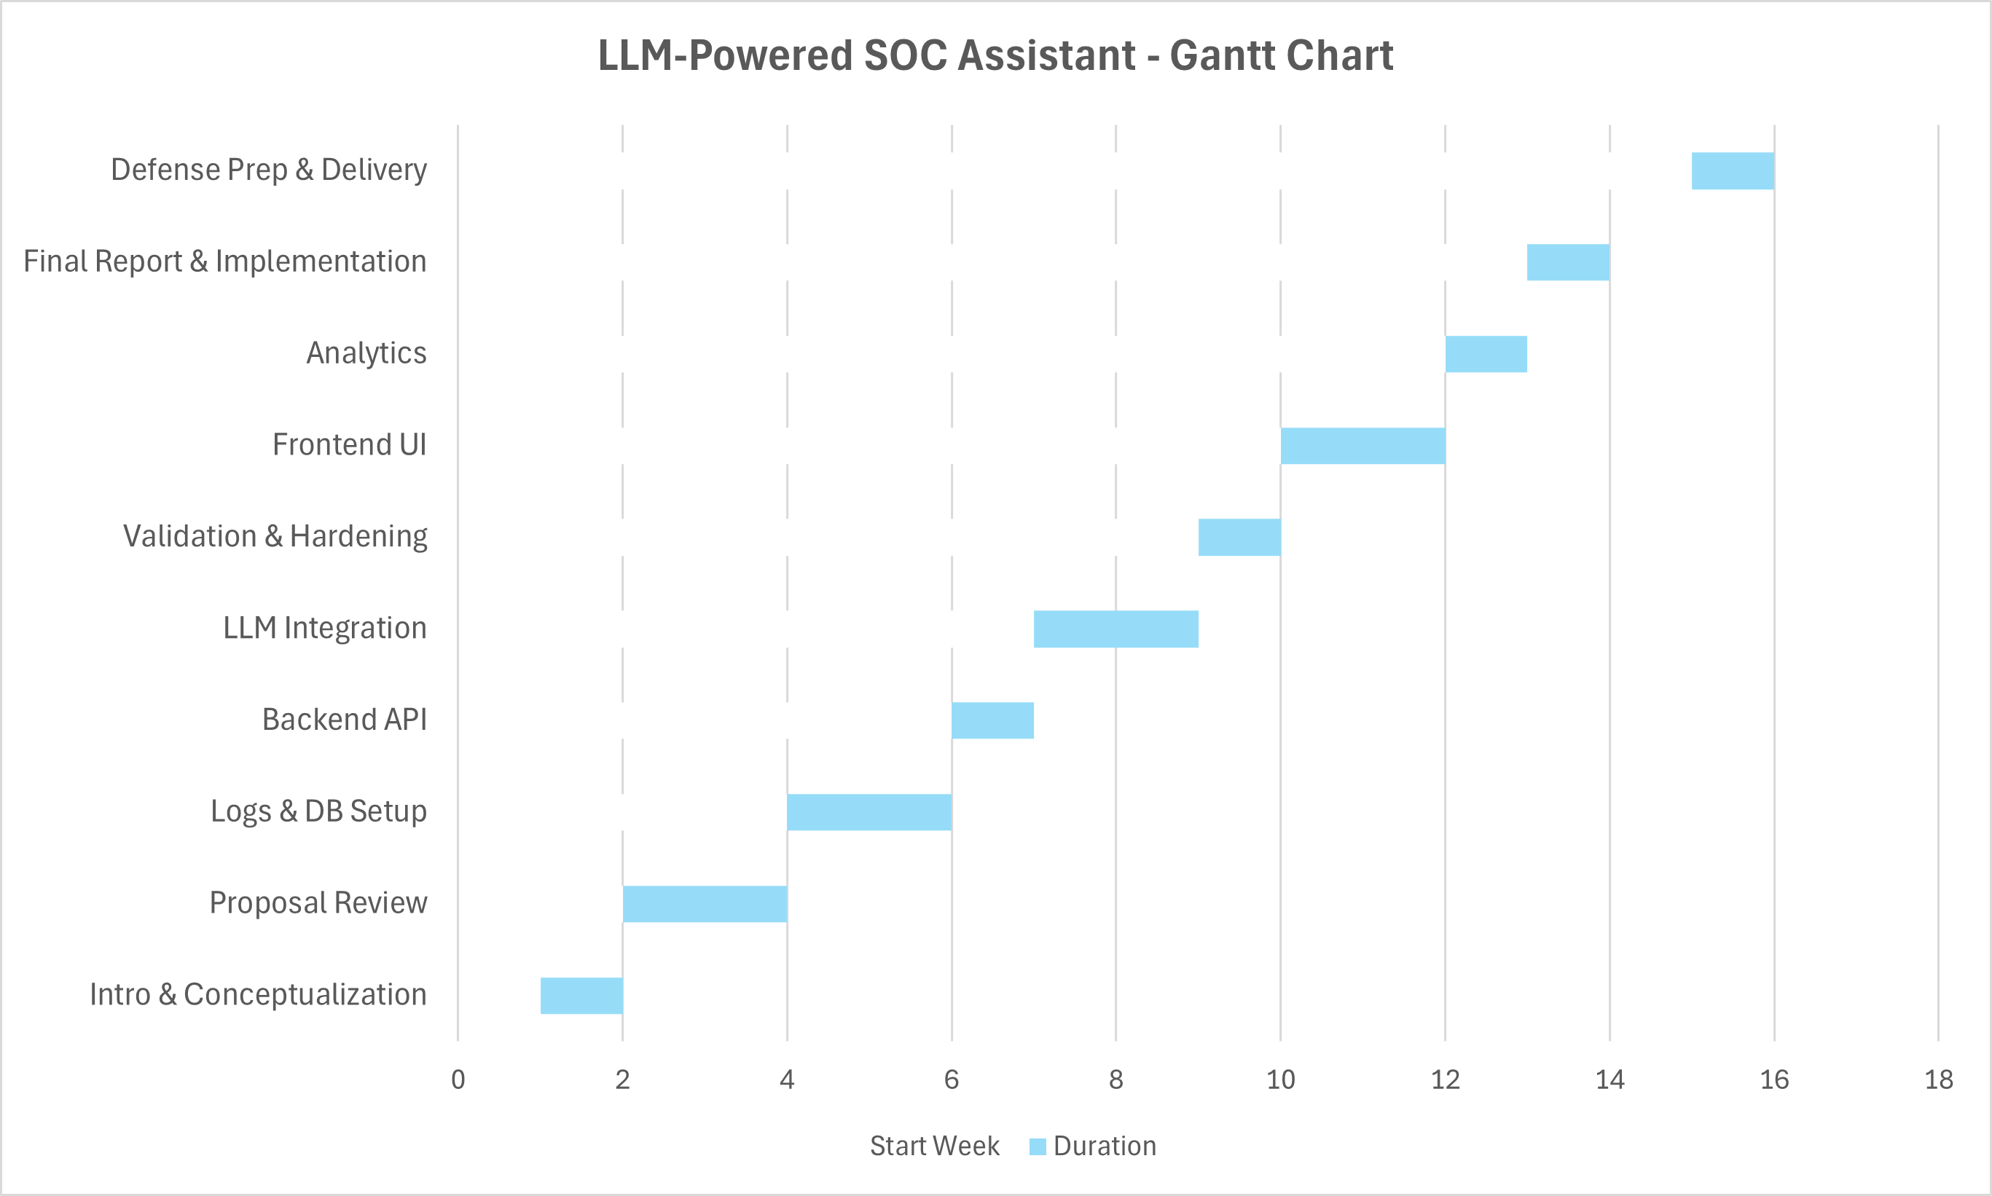

Implemented Features

4.0 Environment Setup and System Configuration

Overview
Before developing the main components of the SOC Assistant, an extensive system setup was required to establish a stable environment for data collection, model inference, and cloud deployment. This phase focused on installing, configuring, and integrating multiple subsystems including Wazuh Manager and Agents, PostgreSQL, Ollama LLM Environment, and an AWS-based infrastructure capable of hosting all backend services efficiently.
Purpose
The objective of this feature was to create a scalable, resource-efficient, and secure environment to support the subsequent development of the ETL, backend, and dashboard components.
The setup ensures that:
- Security event data from multiple agents can be collected centrally.
- Logs can be stored and queried efficiently.
- The LLM (Ollama) can process natural-language questions.
- The overall system can run continuously on a cloud instance without hardware bottlenecks.
Implementation Details
1. Wazuh Manager Installation and Configuration
- Platform: AWS EC2 instance (Ubuntu 24.04 LTS)
- Instance Type: m7i.flex. large (2 vCPUs, 8 GB RAM, 180 GB gp3 storage)
Installation Steps:
- Installed Wazuh Manager using official repository packages.
- Configured /var/ossec/etc/ossec.conf for centralized log collection.
- Verified service status via sudo systemctl status wazuh-manager.
- Exposed UDP port 1514 and TCP port 55000 in AWS security group for agent communication.
Testing:
- Used nc -u -vz MANAGER_IP 1514 to confirm UDP reachability.
- Verified /var/ossec/logs/ossec.log for agent registration and incoming alerts.
2. Wazuh Agent Setup
Agents Installed On:
- Kali Linux VM (local): To simulate attacks such as brute-force SSH logins and sudo misuse.
- Ubuntu VM (secondary agent): To test multi-host log collection and system event monitoring.
Agent Configuration:
- Registered each agent using manager key (/var/ossec/bin/manage_agents).
- Updated /var/ossec/etc/ossec.conf to specify manager IP.
- Resolved “queue permission denied” by adjusting file ownership (chown wazuh:wazuh /var/ossec/queue).
Validation:
- Confirmed active agent status in /var/ossec/logs/ossec.log.
- Triggered test alerts by logging in with invalid credentials and monitoring Wazuh alerts.

3. PostgreSQL Setup
- Installed PostgreSQL 15 on the same AWS instance.
- Created database soc_logs and user soc_user with appropriate privileges.
- Enabled remote access (listen_addresses='*') for internal API connections.
- Created schema with logs table to store structured events.
- Verified database connectivity using:
psql -h 127.0.0.1 -U soc_user -d soc_logs -c "SELECT NOW();"
4. Ollama LLM Environment (Mistral Model)
Model: mistral:latest
- Host: Local Windows machine (8-core CPU, 16 GB RAM)
- Reason: The AWS instance lacked sufficient RAM (Mistral requires ~4.9 GB, m7i.flex. large has 3.8 GB available).
- Installed Ollama locally via the official installer and pulled the Mistral model using:
ollama pull mistral
- Created a reverse SSH tunnel from AWS to Windows to connect the backend (FastAPI) with the local Ollama server:
ssh -R 11434:localhost:11434 ubuntu@<AWS_IP>
- Verified model accessibility from AWS using:
curl -s http://127.0.0.1:11434/api/tags
5. AWS Instance and Storage Configuration
- Operating System: Ubuntu 24.04 LTS
- Instance: m7i.flex. large for balanced CPU and memory performance.
- Storage: 180 GB gp3 SSD allocated to / (includes PostgreSQL and Wazuh data directories).
Networking:
- Security groups configured to allow inbound traffic from public IP addresses from home & college on:
TCP 22 (SSH)
TCP 8000 (FastAPI)
TCP 55000 / UDP 1514 (Wazuh)
- Outbound unrestricted for model communication.

System Optimization:
- Increased file descriptor limits for Wazuh processes.
- Enabled automatic log rotation for /var/ossec/logs/alerts/alerts.json.
Challenges
Challenge | Description | Resolution
Resource limitation on local VM | FastAPI, Wazuh, PostgreSQL, and Ollama together exhausted local memory | Migrated to AWS m7i.flex. large instance with cloud storage
Agent connectivity failure | UDP 1514 connection refused | Updated AWS firewall and restarted wazuh-manager
Missing auth.log on Ubuntu | Prevented SSH event detection | Re-enabled rsyslog service
Queue permission denied | Wazuh agent unable to access /queue/sockets/queue | Changed ownership to wazuh:wazuh
Model access error | Ollama server unreachable from AWS | Configured reverse SSH tunnel to local Windows host
PostgreSQL password issue | fe_sendauth: no password supplied | Updated .env and reloaded FastAPI environment variables

Outcome
After completing the environment setup:
- Wazuh Manager and agents were fully operational and communicating.
- PostgreSQL and FastAPI were deployed successfully on the AWS instance.
- Ollama LLM was connected remotely via a secure tunnel.
- The SOC pipeline (Agent → Manager → PostgreSQL → FastAPI → LLM → UI) became fully functional.

Figure 1: System Architecture – AWS-based SOC Assistant Setup
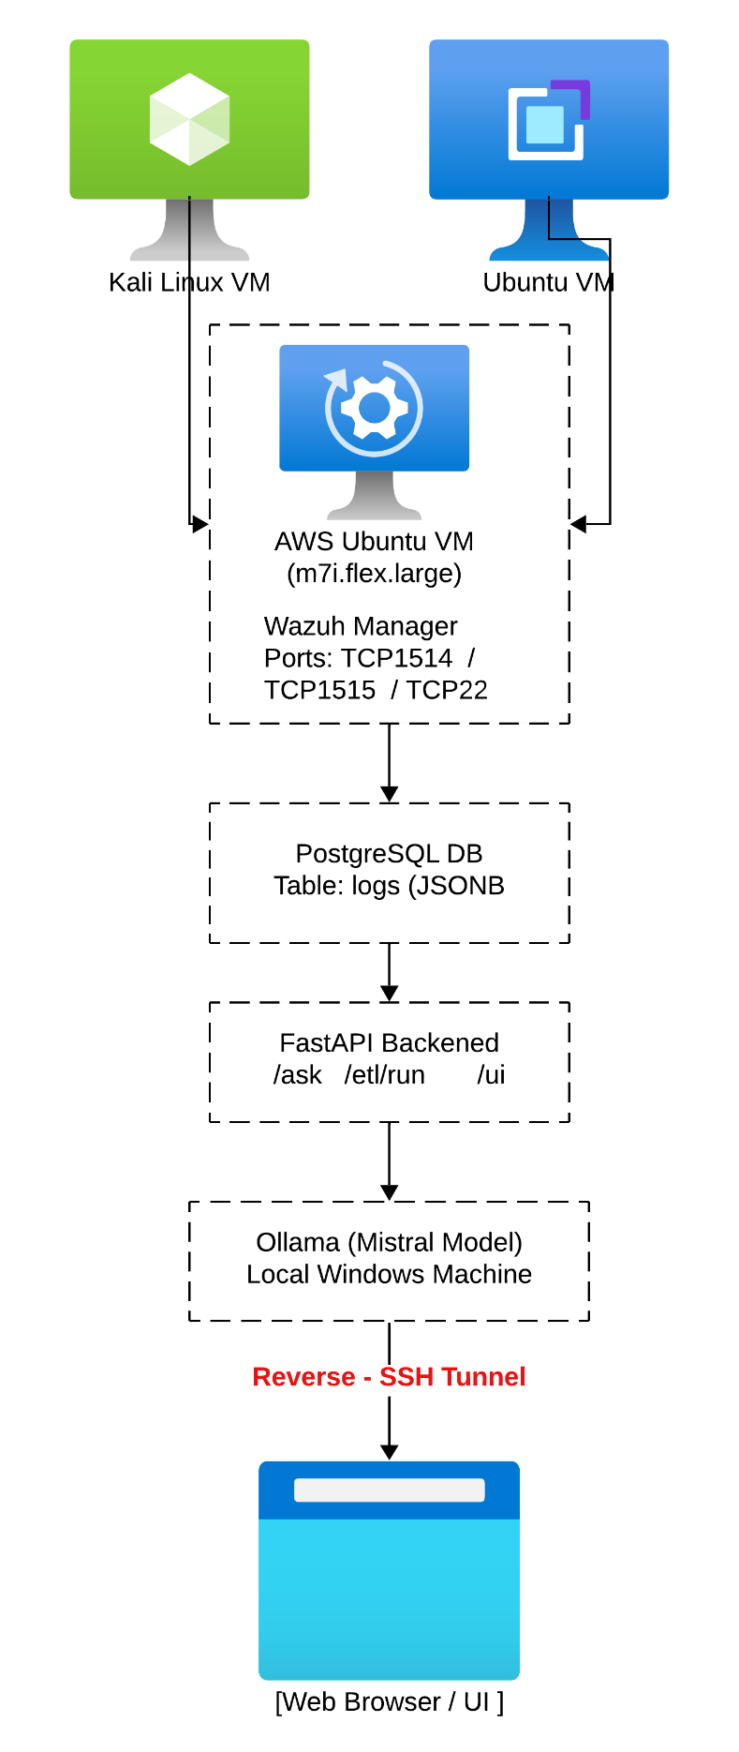
Figure 2: Wazuh Manager and Agent Registration Output
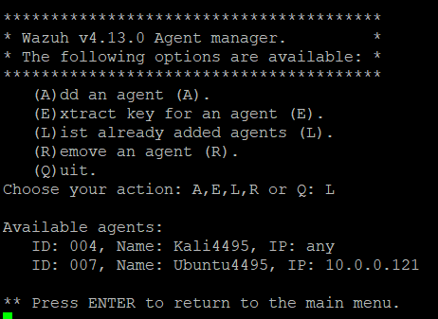
Figure 3: Reverse SSH Tunnel Connection between AWS and Local Ollama Host
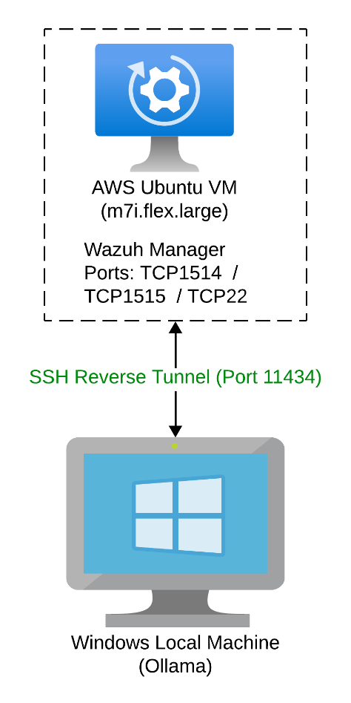

Figure 4: PostgreSQL Connectivity Test on AWS Instance
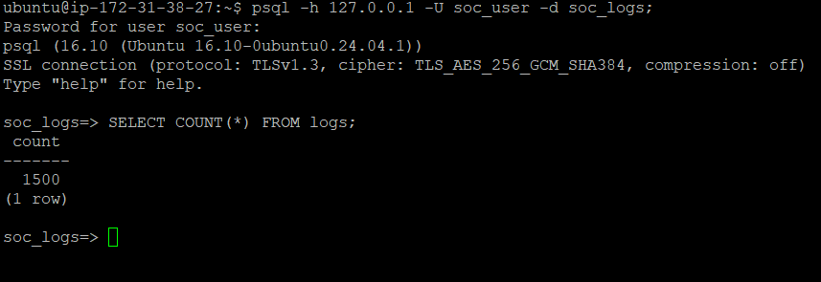

4.1 Wazuh to PostgreSQL Integration (ETL Pipeline)
Overview
The first major implemented feature focuses on building an ETL (Extract-Transform-Load) mechanism that collects alerts from Wazuh SIEM and stores them into a structured PostgreSQL database for further analysis.
This component is the foundation of the SOC Assistant system, it transforms raw JSON logs into a query-able, normalized dataset that the backend and LLM can later interpret.

Purpose
Wazuh’s alert data is stored as JSON lines in /var/ossec/logs/alerts/alerts.json, which is not directly searchable for complex analytical queries. By creating a Python-based ETL script, this data can be structured, deduplicated, and stored efficiently in a relational database, allowing analysts and the LLM to perform meaningful queries.
Implementation
- The ETL script (etl_wazuh_to_pg.py) reads Wazuh’s alerts.json line by line, parses each JSON event, and extracts relevant attributes such as:
  - timestamp, agent_name, agent_id, rule_id, rule_level, rule_desc, src_ip, user_name, and the full raw log (full_log JSONB).
- Each record is hashed using SHA-256 to generate a unique fingerprint (raw_sha256), preventing duplicate inserts.
- The table structure was defined as:
CREATE TABLE logs (
id BIGSERIAL PRIMARY KEY,
ts TIMESTAMPTZ,
agent_name TEXT,
agent_id TEXT,
rule_id INTEGER,
rule_level INTEGER,
rule_desc TEXT,
src_ip INET,
user_name TEXT,
full_log JSONB,
raw_sha256 TEXT UNIQUE
);

- A state tracking file (last_ts.txt) records the last ingested timestamp, ensuring that only new alerts are loaded on subsequent ETL runs.

- The ETL can be triggered manually or via the FastAPI endpoint /etl/run — and from the web UI using a “Fetch Latest Logs” button.

Testing & Validation
The ETL was verified using simulated events such as:
- Successful and failed SSH login attempts.
- Sudo command usage.
- Wazuh agent start/stop lifecycle events.
The results were confirmed through direct database queries and visualized in the web interface.
Challenges
- Encountered psycopg2 permission and authentication issues, resolved by adjusting PostgreSQL roles and. env credentials.
- Fixed a missing /var/log/auth.log on Ubuntu by re-enabling rsyslog.
- Managed Wazuh file permission issues (queue not accessible) by setting correct ownership.

Outcome
By the end of this phase, Wazuh alerts were successfully ingested into PostgreSQL, creating a reliable, structured foundation for LLM-based query processing.

4.2 Natural Language to Query Language Conversion
Overview
The second implemented feature integrates a Large Language Model (LLM), specifically Mistral served through Ollama into a FastAPI backend that converts natural language queries into SQL statements.
This transforms how SOC analysts interact with log data, enabling question-answering directly from plain English input.

Purpose
The goal was to make security log analysis accessible to non-SQL users by letting them type questions such as:
“Show the last 10 failed SSH logins from the Kali agent.”
The backend would then automatically translate that into SQL, execute it on PostgreSQL, and return structured results.
Implementation
The FastAPI app (main.py) includes three core endpoints:
- /ask → Accepts a user question, sends it to the Ollama API, extracts valid SQL, executes it on PostgreSQL, and returns results (rows, latency, row count).
- /etl/run → Executes the ETL ingestion process when manually triggered.
- /healthz → Tests DB connectivity for quick diagnostics.
A detailed SCHEMA_HINT prompt guides the LLM with database schema, rules, and keyword mappings:
“SSH → rule_desc ILIKE '%sshd%'”
“Failed logins → rule_desc ILIKE '%fail%' OR '%denied%'”
“Sudo → rule_desc ILIKE '%sudo%'”, etc.
The LLM ensures that only safe SELECT queries are executed by filtering out destructive SQL commands (INSERT, DELETE, ALTER, etc.).
A response example:
{
"sql": "SELECT ts, agent_name, src_ip, user_name, rule_desc FROM logs WHERE rule_desc ILIKE '%sshd%' AND rule_desc ILIKE '%fail%' ORDER BY ts DESC LIMIT 10;",
"rows": [...],
"rowcount": 10,
"latency_ms": 9
}

Integration Setup
Ollama is hosted on the local Windows machine for better performance (AWS m7i.flex. large didn’t have enough RAM for 7B models).
A reverse SSH tunnel connects the AWS backend to the local Ollama endpoint (127.0.0.1:11434).
Challenges
- Model memory limitation on AWS (4 GB RAM needed > available 3.8 GB).
- HTTP 500 errors when Ollama was unreachable — fixed via reverse tunnel.
- Adjusted schema prompt to remove the “default 24h window” constraint.
Outcome
This feature allows analysts to dynamically query logs conversationally, bridging traditional SIEM data with generative AI reasoning.
Figure 5: Application startup
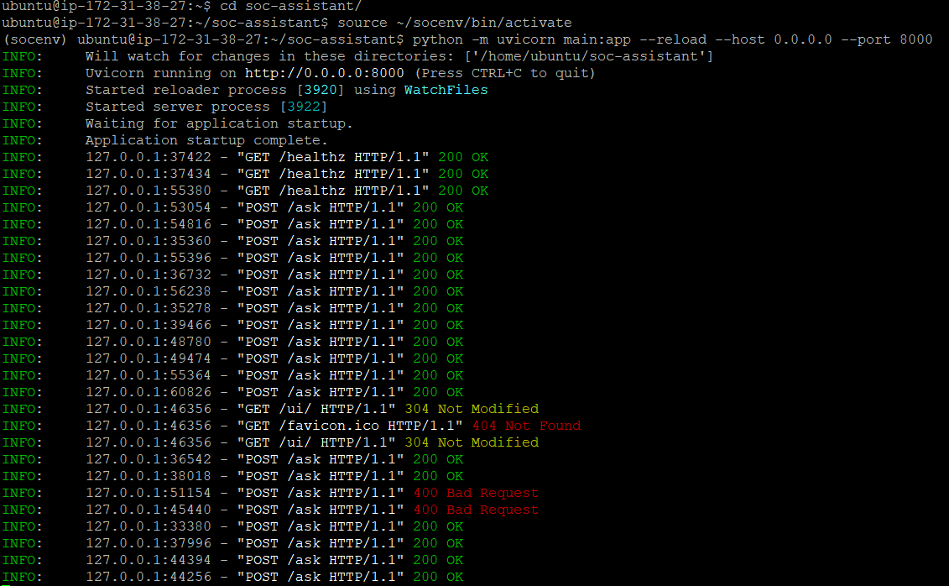
Figure 6: Getting alerts in backend using natural language
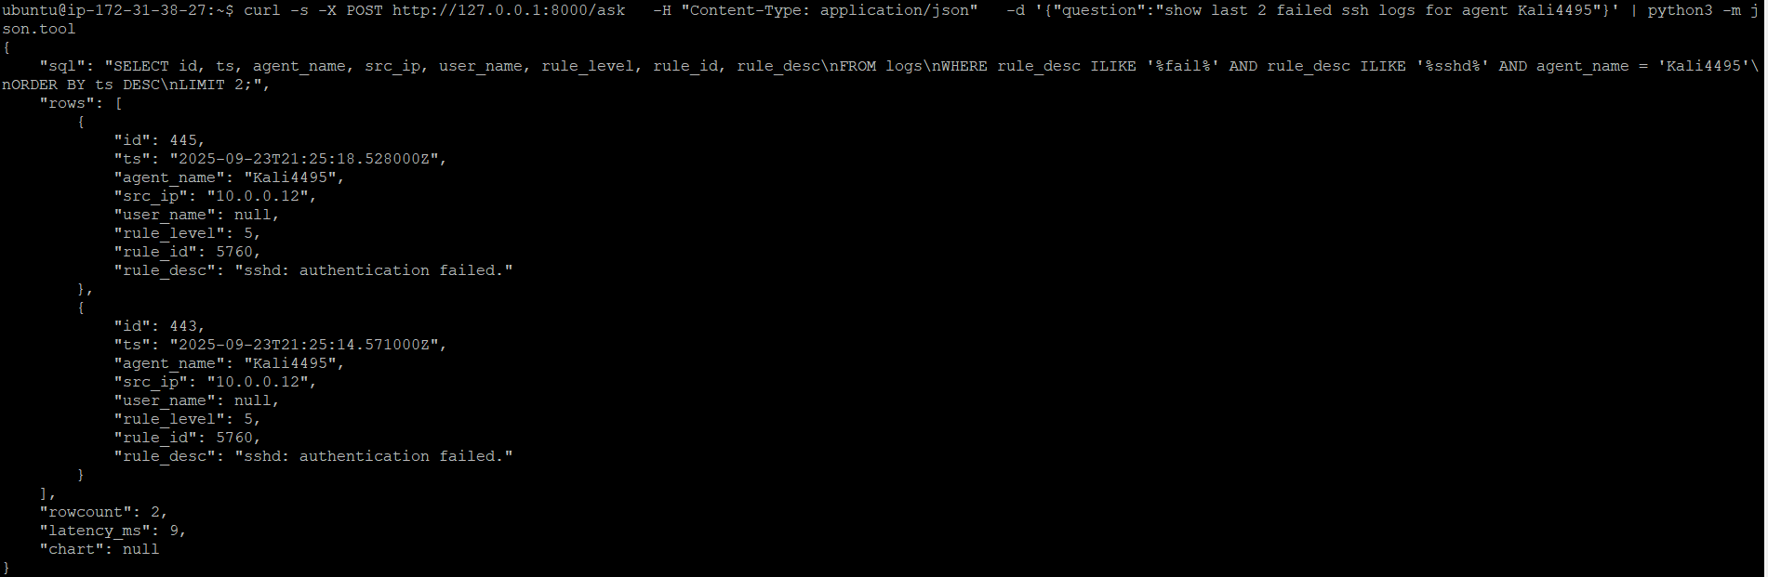
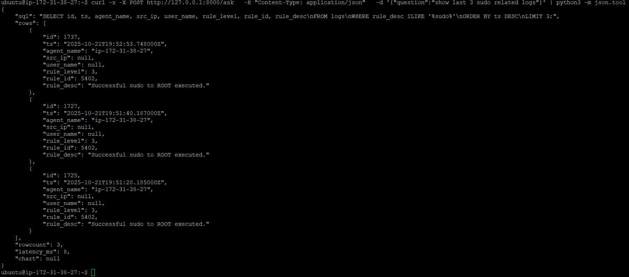

4.3 Application Dashboard Frontend (Web Interface + Chart Visualization)
Overview
The third implemented feature introduces a web-based dashboard that allows users to interact visually with the SOC Assistant backend.
The dashboard lets users enter natural language queries, view the generated SQL, examine tabular results, and render charts using Chart.js.
Purpose
To create an intuitive user interface that simplifies interaction with the SOC Assistant removing the need to use curl commands or APIs manually
Implementation
A static HTML/JS frontend (/ui/index.html) served by FastAPI.
Features include:
- A dark-themed responsive interface with a query text box and sample “chips” (quick examples).
- Buttons for Ask, Reset, Fetch Latest Logs, and Insights.
- Integration with /etl/run endpoint to trigger log ingestion directly from the browser.
- Chart.js visualizations for:
“Failed SSH attempts by hour (last 24h)”
“Top source IPs for failed SSH logins”
“Failed vs Successful SSH attempts (with percentage breakdown)” (in progress)
- The web app dynamically updates:
- The SQL generated by the LLM.
- The query results table.
- The chart area, auto populated from the API response.
Challenges
- Fixed overlapping buttons and icon misalignment by reworking the CSS grid and padding.
- Added responsive chart sizing and color contrast for readability.
- Implemented a live message banner (“ETL running… done”) for real-time feedback.
Outcome
The SOC Assistant dashboard now provides a seamless workflow:
Query → SQL Generation → Data Retrieval → Visualization
Users can perform end-to-end SOC analysis from data ingestion to chart-based insights entirely within a web browser.

Figure 7: LLM Powered SOC Assistant Application dashboard
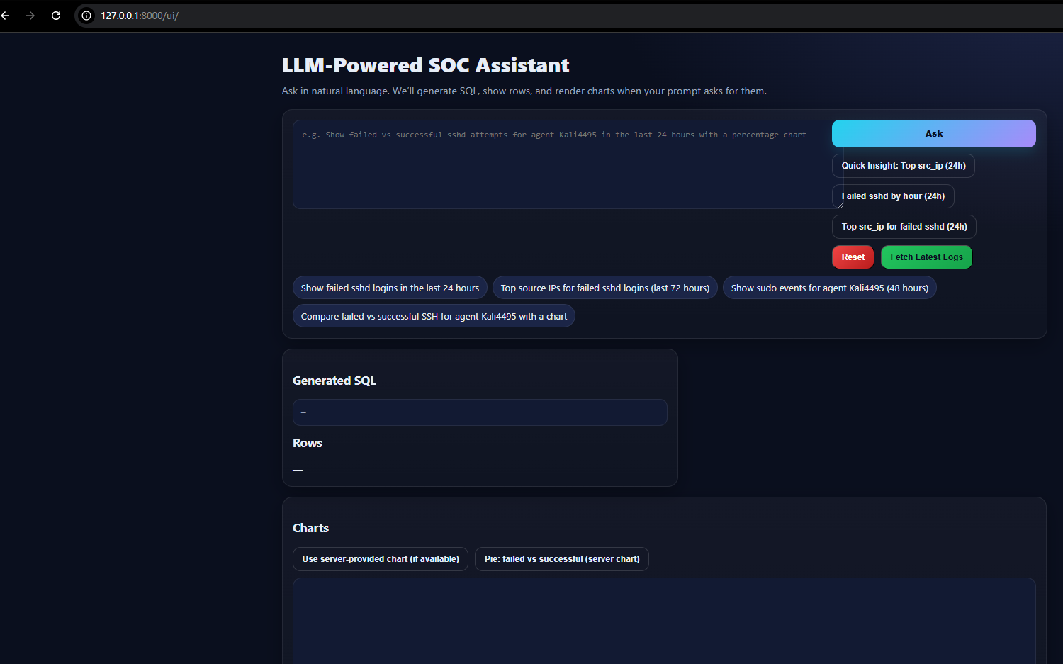

Figure 8: Basic log search query
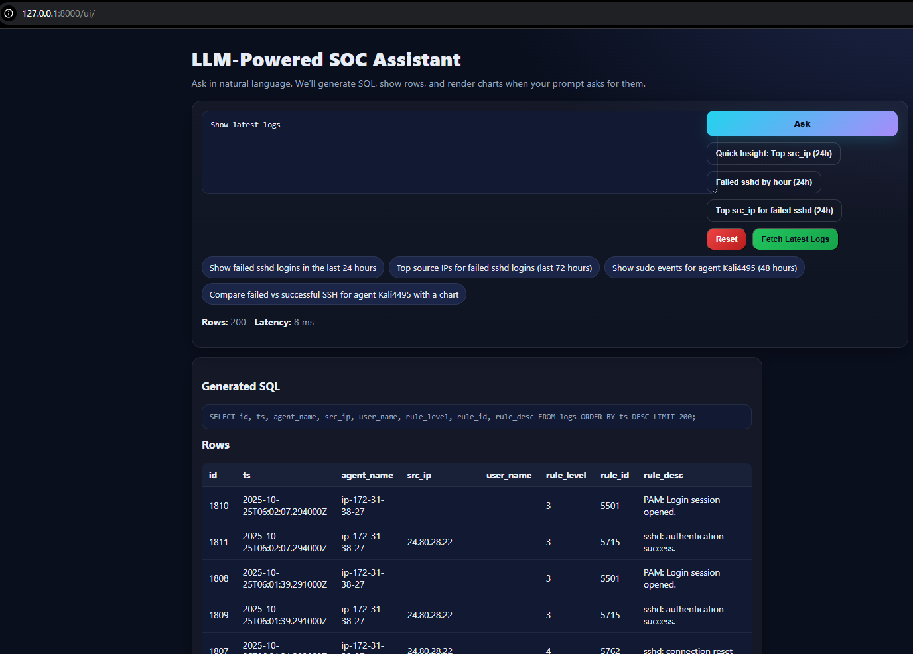

Figure 9: Basic log search query targeting a specific agent
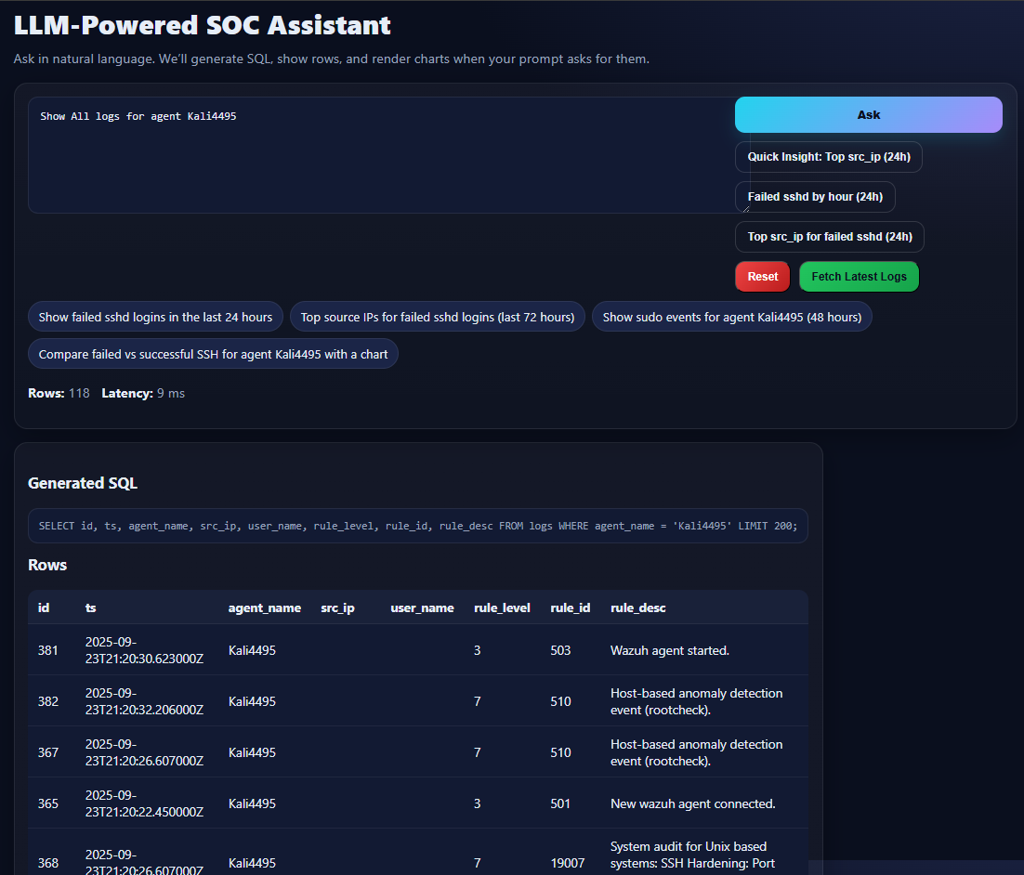

Figure 10: Comparison charts (Partially implemented)
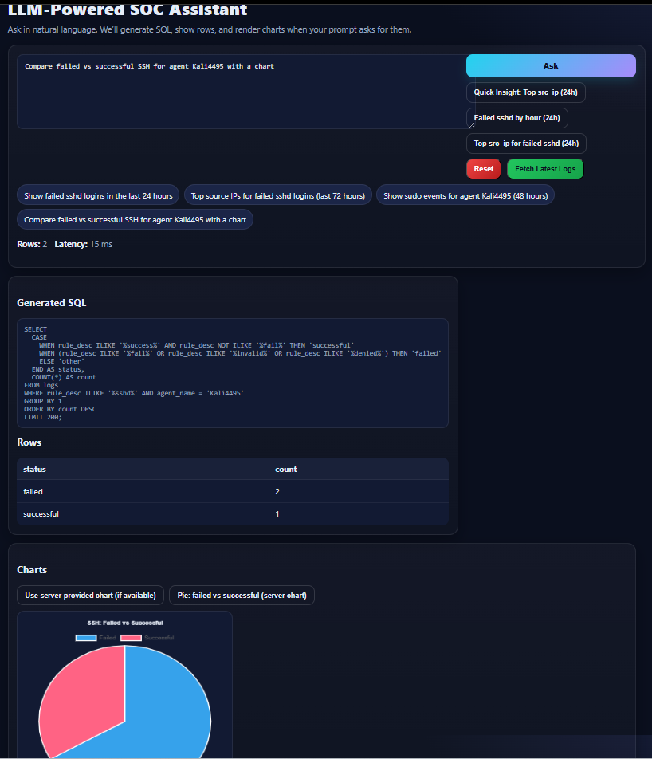

Conclusion

At the halfway stage, the SOC Assistant system successfully integrates SIEM log ingestion, AI-driven query translation, and visual analytics into a cohesive platform.
The project demonstrates that a lightweight, yet intelligent SOC tool can be achieved using open-source components (Wazuh, PostgreSQL, FastAPI, and Ollama) within a cloud-based environment.

Key Achievements
- Real-time ETL pipeline with deduplication and incremental loading.
- LLM-driven backend that safely converts natural-language input into SQL.
- Functional web dashboard for querying and visualizing logs interactively.
- Multi-agent setup tested (Ubuntu and Kali) with reliable ingestion.

Next Steps
For the final phase, the following improvements are planned:
- Automate ETL via scheduled jobs or triggers like cron jobs.
- Expand visualization capabilities for more dynamic inputs.
- Integrate alert classification (failed vs successful login trends).
- Evaluate model accuracy and response efficiency.
- More validation and hardening using rules to give more accurate results.
- Integrating Zeek for more comprehensive logs.

References

Almukaynizi, M., Alasmary, W., & Mohaisen, D. (2023). Applications of large language models in cybersecurity: Opportunities and challenges. arXiv preprint arXiv:2307.00113. https://arxiv.org/abs/2307.00113
Elastic. (2023). Elastic AI Assistant for Security (Technical Preview). Elastic. https://www.elastic.co/blog
González-Granadillo, G., Camacho, J., Kapetanakis, S., & Díaz, R. (2021). Security information and event management: A comprehensive approach. Sensors, 21(15), 5091. https://doi.org/10.3390/s21155091
Jiang, Y., Yu, H., Chen, J., Li, S., Shi, J., Tang, J., & Wang, J. (2023). Xpert: Empowering incident management with query recommendations via large language models. arXiv. https://arxiv.org/abs/2312.11988
Katsogiannis-Meimarakis, G., Karagiannidis, G., & Tzimas, G. (2023). NLIDB systems: A survey. ACM Computing Surveys, 54(5), 1–38.
Microsoft. (2024). Microsoft Security Copilot: Redefining security operations. Microsoft Security Blog. https://www.microsoft.com/security/blog
Pan, J. (2024). Independent study of Splunk. Journal of Computer and Communications, 12(2), 23–37. https://doi.org/10.4236/jcc.2024.122002
Rajkumar, N., Li, T., & Boyd-Graber, J. (2022). Evaluating the limits of natural language to SQL systems. In Proceedings of the 2022 Conference of the North American Chapter of the Association for Computational Linguistics (NAACL) (pp. 2243–2256).
Splunk. (2022). Splunk user behavior report: Challenges and insights for security teams. Splunk Inc. https://www.splunk.com/
Splunk. (2023). Introducing Splunk AI Assistant for SPL. Splunk Blog. https://www.splunk.com/en_us/blog
Wazuh. (2024). Wazuh documentation. Wazuh Inc. https://documentation.wazuh.com
Zeek. (2024). Zeek network security monitor. Zeek Project. https://zeek.org
2025 Cybersecurity Insiders Pulse of AI-Powered SOC https://gurucul.com/blog/2025-pulse-of-ai-powered-soc-transformation-report-out-now/

