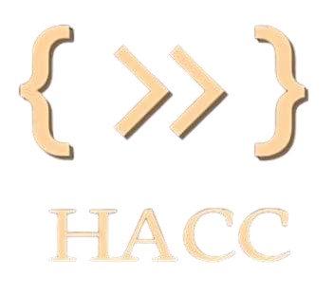

**HACCSchool of C&IT -IT 2.0**

**Innovation meets Collaboration**

**THEME : AI in Open Innovation Name : Think Minds**

# TEAM INFORMATION

**Name**

**SRN**

**Program / Branch**

**Mobile Number**

**Email**

Team member 1

Team member 2

Team member 3

Team member 4

**IDEA SUBMISSION**

**Domain:**

**Problem Statement:**

Metro stations in urban cities often face overcrowding during peak hours and special

events, leading to safety risks, delays, and mismanagement. Traditional CCTV systems

only record video and require manual monitoring, which is inefficient and error-prone.

There is a need for an AI-powered real-time monitoring system to ensure safe passenger

flow and timely alerts in metro stations.

**PROPOSED SOLUTION**

We propose MetroVision AI, an AI-based smart monitoring system for metro stations. It

uses computer vision (YOLOv8) to detect and count people from existing CCTV feeds. If

the passenger count exceeds a safe threshold, the system will: Raise instant alerts

(sound, SMS, or email). Log events for analysis of crowd patterns. (Optional) Provide a

dashboard for live monitoring by metro authorities. This helps ensure passenger safety,

efficient crowd management, and reduced risks of accidents.

**TECHNICAL APPROACH**

**Programming Language**: Python **Frameworks & Libraries**: YOLOv8 (Ultralytics),

OpenCV, Flask/Streamlit, SMTP/Twilio API **Database**: SQLite / MongoDB **Hardware**:

Standard CCTV camera + laptop/edge device for processing

# FEASIBILITY AND IMPACT

**Feasibility**: Uses existing CCTV infrastructure, runs on lightweight YOLO models, and is

easily scalable.

**Impact**: Enhances safety by preventing overcrowding and accidents, provides real-time

insights for metro authorities, and is scalable to airports, malls, stadiums, and other

crowded places. Improves public trust and efficiency in metro systems.