- The ratio of the lengths of two wires A and B of same material is 1 : 2 and the ratio of their diameter is 2 : 1. They are stretched by the same force, then the ratio of increase in length will be
(a) 2 : 1 (b) 1 : 4 (c) 1 : 8 (d) 8 : 1

- When a certain weight is suspended from a long uniform wire, its length increases by one cm. If the same weight is suspended from another wire of the same material and length but having a diameter half of the first one then the increase in length will be
(a) 0.5 cm (b) 2 cm (c) 4 cm (d) 8 cm

- On increasing the length by 0.5 mm in a steel wire of length 2 m and area of cross-section 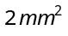, the force required is [Y for steel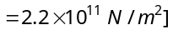]
(a) 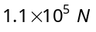 (b) 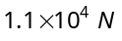 (c) 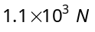 (d) 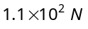

- The diameter of a brass rod is 4 mm and Young's modulus of brass is 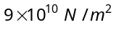. The force required to stretch by 0.1% of its length is
(a) 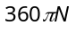 (b) 36 N (c)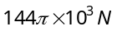 (d)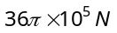

- If x longitudinal strain is produced in a wire of Young's modulus y, then energy stored in the material of the wire per unit volume is
(a) 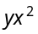 (b) 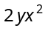 (c) 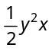 (d) 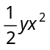

- The Young's modulus of a rubber string 8 cm long and density 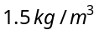 is 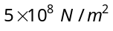, is suspended on the ceiling in a room. The increase in length due to its own weight will be
(a) 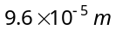 (b) 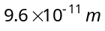 (c) 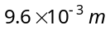 (d) 9.6 m

- A force of 200 N is applied at one end of a wire of length 2 m and having area of cross-section 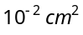. The other end of the wire is rigidly fixed. If coefficient of linear expansion of the wire 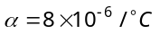 and Young's modulus 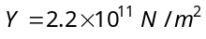 and its temperature is increased by 5°C, then the increase in the tension of the wire will be
(a) 4.2 N (b) 4.4 N (c) 2.4 N (d)8.8 N

- The length of a wire is 1.0 m and the area of cross-section is 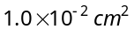. If the work done for increase in length by 0.2 cm is 0.4 joule, then Young's modulus of the material of the wire is
(a) 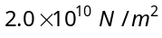 (b) 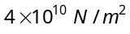 (c) 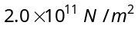 (d) 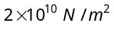

- Four identical rods are stretched by same force. Maximum extension is produced in
(a) 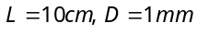 (b) 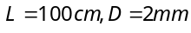 (c) 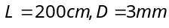 (d) 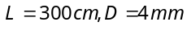

- If the volume of the given mass of a gas is increased four times, the temperature is raised from 27°C to 127°C. The elasticity will become
(a) 4 times (b) 1/4 times (c) 3 times (d) 1/3 times
- The compressibility of water is 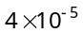 per unit atmospheric pressure. The decrease in volume of 100 cubic centimeter of water under a pressure of 100 atmosphere will be
(a) 0.4 cc (b) 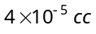 (c) 0.025 cc (d) 0.004 cc

- If a rubber ball is taken at the depth of 200 m in a pool, its volume decreases by 0.1%. If the density of the water is 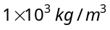 and 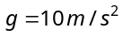, then the volume elasticity in 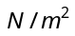 will be
(a) 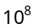 (b) 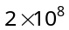 (c) 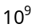 (d) 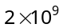

- The upper end of a wire of radius 4 mm and length 100 cm is clamped and its other end is twisted through an angle of 30°. Then angle of shear is
(a) 12° (b) 0.12° (c) 1.2° (d) 0.012°

- A 2 m long rod of radius 1 cm which is fixed from one end is given a twist of 0.8 radians. The shear strain developed will be
(a) 0.002 (b) 0.004 (c) 0.008 (d) 0.016

- A brass rod of cross-sectional area 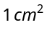 and length 0.2 m is compressed lengthwise by a weight of 5 kg. If Young's modulus of elasticity of brass is 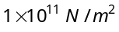 and 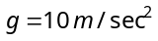, then increase in the energy of the rod will be
(a) 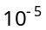J (b) 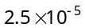J (c) 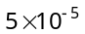J (d) 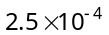J

- If one end of a wire is fixed with a rigid support and the other end is stretched by a force of 10 N, then the increase in length is 0.5 mm. The ratio of the energy of the wire and the work done in displacing it through 1.5 mm by the weight is
(a) (b) (c) (d) 1

- Equal masses of water and a liquid of density 2 are mixed together, then the mixture has a density of
(a) 2/3 (b) 4/3 (c) 3/2 (d) 3

- When a large bubble rises from the bottom of a lake to the surface. Its radius doubles. If atmospheric pressure is equal to that of column of water height H, then the depth of lake is
(a) H (b) 2H (c)7H (d)8H

- The volume of an air bubble becomes three times as it rises from the bottom of a lake to its surface. Assuming atmospheric pressure to be 75 cm of Hg and the density of water to be 1/10 of the density of mercury, the depth of the lake is
(a) 5 m (b) 10 m (c) 15 m (d) 20 m

- A solid sphere of density η ( > 1) times lighter than water is suspended in a water tank by a string tied to its base as shown in fig. If the mass of the sphere is m then the tension in the string is given by
(a) 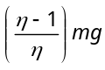
(b)
(c) 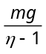
(d) 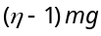

- A ball whose density is 0.4 × 10³ kg/m³ falls into water from a height of 9 cm . To what depth does the ball sink
(a) 9 cm (b) 6 cm (c) 4.5 cm (d) 2.25 cm

- An incompressible liquid flows through a horizontal tube as shown in the following fig. Then the velocity v of the fluid is
v₁ = 3 m/s
v₂ = 1.5 m/s
A
A
1.5 A
v

(a) 3.0 m/s (b) 1.5 m/s
(c) 1.0 m/s (d) 2.25 m/s

- A streamlined body falls through air from a height h on the surface of a liquid. If d and D(D > d) represents the densities of the material of the body and liquid respectively, then the time after which the body will be instantaneously at rest, is
(a) 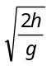 (b) 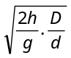 (c) 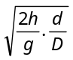 (d) 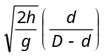

- Two capillary tubes of the same length but different radii r₁ and r₂ are fitted in parallel to the bottom of a vessel. The pressure head is P. What should be the radius of a single tube that can replace the two tubes so that the rate of flow is same as before
(a) 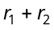 (b) 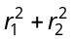 (c) 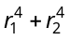 (d) None of these

- Two capillaries of same length and radii in the ratio 1 : 2 are connected in series. A liquid flows through them in streamlined condition. If the pressure across the two extreme ends of the combination is 1 m of water, the pressure difference across first capillary is
(a) 9.4 m (b) 4.9 m (c) 0.49 m (d) 0.94 m
- A homogeneous solid cylinder of length L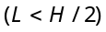. Cross-sectional area 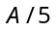 is immersed such that it floats with its axis vertical at the liquid-liquid interface with length 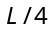 in the denser liquid as shown in the fig. The lower density liquid is open to atmosphere having pressure 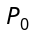. Then density D of solid is given by
(a) 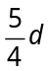
2d
H/2
H/2
d
3L/4
L
(b) 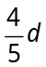
(c) (d) 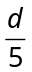
- The maximum force, in addition to the weight required to pull a wire of 5.0 cm long from the surface of water at temperature 20ºC, is 728 dynes. The surface tension of water is
(a) 7.28 N/cm (b) 7.28 dyne/cm (c)72.8 dyne/cm (d) 7.28×10² dyne/cm

- A thin metal disc of radius r floats on water surface and bends the surface downwards along the perimeter making an angle θ with vertical edge of the disc. If the disc displaces a weight of water W and surface tension of water is T, then the weight of metal disc is
(a) 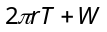 (b) 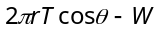 (c) 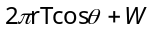 (d) 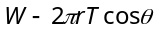

- A 10 cm long wire is placed horizontally on the surface of water and is gently pulled up with a force of 2 ×10⁻² N to keep the wire in equilibrium. The surface tension, in Nm⁻¹, of water is
(a) 0.1 (b) 0.2 (c) 0.001 (d) 0.002

- In a capillary tube experiment, a vertical 30 cm long capillary tube is dipped in water. The water rises up to a height of 10cm due to capillary action. If this experiment is conducted in a freely falling elevator, the length of the water column becomes
(a) 10 cm (b) 20 cm (c) 30 cm (d) Zero

- Radius of a capillary is 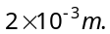 A liquid of weight 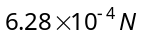 may remain in the capillary then the surface tension of liquid will be
(a) 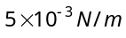 (b) 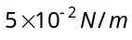 (c) 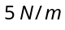 (d) 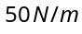

- When a capillary is dipped in water, water rises 0.015 m in it. If the surface tension of water is 75×10^{–3} N/m, the radius of capillary is
(a) 0.1 mm (b) 0.5 mm (c) 1 mm (d) 2 mm

- Two parallel glass plates are dipped partly in the liquid of density 'd' keeping them vertical. If the distance between the plates is 'x', surface tension for liquids is T and angle of contact is , then rise of liquid between the plates due to capillary will be
(a) 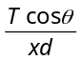 (b) 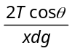 (c) 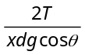 (d) 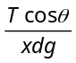

- Water rises in a capillary tube to a certain height such that the upward force due to surface tension is balanced by 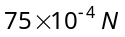 force due to the weight of the liquid. If the surface tension of water is 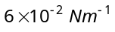, the inner circumference of the capillary must be
(a) 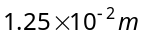 (b) 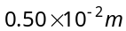 (c) 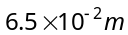 (d) 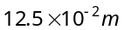

- Two capillary tubes P and Q are dipped in water. The height of water level in capillary P is 2/3 to the height in Q capillary. The ratio of their diameters is
(a) 2 : 3 (b) 3 : 2 (c) 3 : 4 (d) 4 : 3

