- In 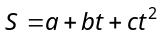. is measured in meters and in seconds. The unit of is
(a) None (b) (c) 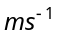 (d) 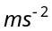

- Density of wood is 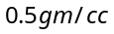 in the CGS system of units. The corresponding value in MKS units is
(a) 500 (b) 5 (c) 0.5 (d) 5000

- Which pair has the same dimensions
(a) Work and power (b) Density and relative density (c) Momentum and impulse (d) Stress and strain

- The dimensions of universal gravitational constant are
(a) 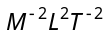 (b) 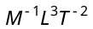 (c) 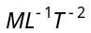 (d) 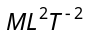

- The equation of state of some gases can be expressed as 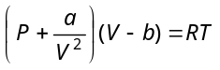. Here is the pressure, is the volume, is the absolute temperature and 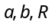 are constants. The dimensions of are
(a) 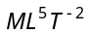 (b) 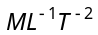 (c) 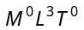 (d) 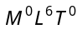

- The velocity of water waves may depend upon their wavelength , the density of water and the acceleration due to gravity . The method of dimensions gives the relation between these quantities as
(a) 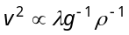 (b) 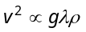 (c) 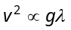 (d) 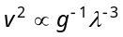

- The period of a body under SHM i.e. presented by 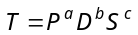; where is pressure, is density and is surface tension. The value of 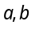 and are
(a) 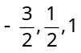 (b) 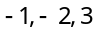 (c) 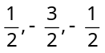 (d) 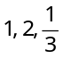

- A small steel ball of radius is allowed to fall under gravity through a column of a viscous liquid of coefficient of viscosity . After some time the velocity of the ball attains a constant value known as terminal velocity 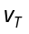. The terminal velocity depends on (i) the mass of the ball , (ii) , (iii) and (iv) acceleration due to gravity . Which of the following relations is dimensionally correct
(a) 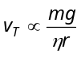 (b) 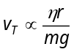 (c) 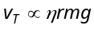 (d) 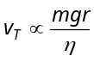

- If velocity , acceleration and force are chosen as fundamental quantities, then the dimensional formula of angular momentum in terms of 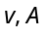 and would be
(a) 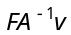 (b) 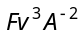 (c) 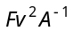 (d) 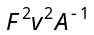

- If 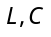 and denote the inductance, capacitance and resistance respectively, the dimensional formula for 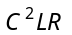 is
(a) 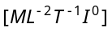 (b) 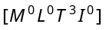 (c) 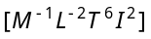 (d) 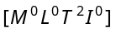

- The period of oscillation of a simple pendulum is given by 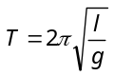where l is about 100 cm and is known to have 1mm accuracy. The period is about 2s. The time of 100 oscillations is measured by a stop watch of least count 0.1 s. The percentage error in g is
(a) 0.1% (b) 1% (c) 0.2% (d) 0.8%

- What is the number of significant figures in 0.310×10³
(a) 2 (b) 3 (c) 4 (d)6

- A body travels uniformly a distance of (13.8 ±0.2) m in a time (4.0 ± 0.3) s. The velocity of the body within error limits is
(a) (3.45 ± 0.2) ms⁻¹ (b) (3.45 ± 0.3) ms⁻¹ (c) (3.45 ± 0.4) ms⁻¹ (d) (3.45 ± 0.5) ms⁻¹

- A thin copper wire of length l metre increases in length by 2% when heated through 10ºC. What is the percentage increase in area when a square copper sheet of length l metre is heated through 10ºC
(a) 4% (b) 8% (c) 16% (d) None of the above

- A person moves 30 m north and then 20 m towards east and finally 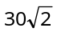 m in south-west direction. The displacement of the person from the origin will be
(a) 10 m along north (b) 10 m long south (c) 10 m along west (d) Zero

- A car travels the first half of a distance between two places at a speed of 30 km/hr and the second half of the distance at 50 km/hr. The average speed of the car for the whole journey is
(a) 42.5 km/hr (b) 40.0 km/hr (c) 37.5 km/hr (d) 35.0 km/hr

- One car moving on a straight road covers one third of the distance with 20 km/hr and the rest with 60 km/hr. The average speed is
(a) 40 km/hr (b) 80 km/hr (c) 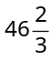 km/hr (d) 36 km/hr

- A 150 m long train is moving with a uniform velocity of 45 km/h. The time taken by the train to cross a bridge of length 850 meters is
(a) 56 sec (b) 68 sec (c) 80 sec (d) 92 sec

- Two cars and are travelling in the same direction with velocities and 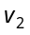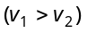. When the car is at a distance ahead of the car , the driver of the car applied the brake producing a uniform retardation There will be no collision when
(a) 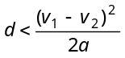 (b) 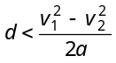 (c) 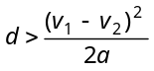 (d) 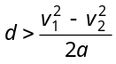

- A car moving with a speed of 40 km/h can be stopped by applying brakes after atleast 2 m. If the same car is moving with a speed of 80 km/h, what is the minimum stopping distance
(a) 8 m (b) 2 m (c) 4 m (d) 6 m

- An elevator car, whose floor to ceiling distance is equal to 2.7 m, starts ascending with constant acceleration of 1.2 ms^{–2}. 2 sec after the start, a bolt begins fallings from the ceiling of the car. The free fall time of the bolt is
(a) 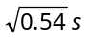 (b) 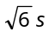 (c) 0.7 s (d) 1 s

- A student is standing at a distance of 50metres from the bus. As soon as the bus begins its motion with an acceleration of 1ms^{–2}, the student starts running towards the bus with a uniform velocity . Assuming the motion to be along a straight road, the minimum value of , so that the student is able to catch the bus is (a) 5 ms^{–1} (b)8 ms^{–1} (c) 10 ms^{–1} (d) 12 ms^{–1}

- A police jeep is chasing with, velocity of 45 km/h a thief in another jeep moving with velocity 153 km/h. Police fires a bullet with muzzle velocity of 180 m/s. The velocity it will strike the car of the thief is
(a) 150 m/s (b) 27 m/s (c) 450 m/s (d) 250 m/s

- A body falls freely from rest. It covers as much distance in the last second of its motion as covered in the first three seconds. The body has fallen for a time of
(a) 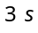 (b) 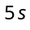 (c) 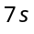 (d) 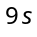

- A stone is dropped into water from a bridge above the water. Another stone is thrown vertically downward 1 sec later. Both strike the water simultaneously. What was the initial speed of the second stone
(a) 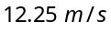 (b) 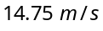 (c) 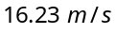 (d) 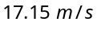

- A body is released from a great height and falls freely towards the earth. Another body is released from the same height exactly one second later. The separation between the two bodies, two seconds after the release of the second body is
(a) 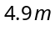 (b) 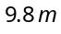 (c) 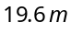 (d) 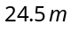

- A man in a balloon rising vertically with an acceleration of 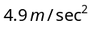 releases a ball 2 sec after the balloon is let go from the ground. The greatest height above the ground reached by the ball is 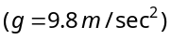
(a) 14.7 m (b) 19.6 m (c) 9.8 m (d) 24.5 m

- The variation of velocity of a particle with time moving along a straight line is illustrated in the following figure. The distance travelled by the particle in four seconds is
(a) 60
1
2
3
4
0
10
20
30
Velocity (m/s)
Time in second
(b) 55
(c) 25
(d) 30

- The graph of a moving object is given in figure. The maximum acceleration is
80
60
40
20
0
20
30
40
50
60
70
80
10
Velocity (cm/sec)
Time (sec.)

(a) 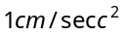 (b) 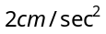
(c) 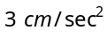 (d) 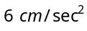

- The displacement versus time graph for a body moving in a straight line is shown in figure. Which of the following regions represents the motion when no force is acting on the body
X
a
b
c
d
e
Time
Y

(a) (b)
(c) (d)

- A lift is going up. The variation in the speed of the lift is as given in the graph. What is the height to which the lift takes the passengers
Time (sec)
Velocity (m/sec)
10
12
2
3.6
(a) 3.6
(b) 28.8
(c) 36.0
(d) Cannot be calculated from the above graph

- The velocity-time graph of a body moving in a straight line is shown in the figure. The displacement and distance travelled by the body in 6 sec are respectively
0
1
2
3
4
5
1
2
3
1
2
3
4
5
6
t(sec)
V(m/s)

(a) 8 m, 16 m (b) 16 m, 8 m
(c) 16 m, 16 m (d) 8 m, 8 m

- A hall has the dimensions 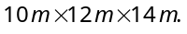A fly starting at one corner ends up at a diametrically opposite corner. What is the magnitude of its displacement
(a) 17 m (b) 26 m (c) 36 m (d) 20 m

- 100 coplanar forces each equal to 10 N act on a body. Each force makes angle 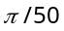with the preceding force. What is the resultant of the forces
(a) 1000 N (b) 500 N (c)250 N (d) Zero

- The unit vector parallel to the resultant of the vectors 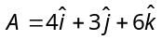 and 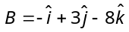 is
(a) 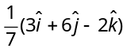 (b) 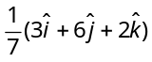 (c) 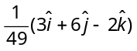 (d) 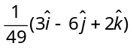

- Following sets of three forces act on a body. Whose resultant cannot be zero
(a) 10, 10, 10 (b) 10, 10, 20 (c) 10, 20, 23 (d) 10, 20, 40

- When three forces of 50 N, 30 N and 15 N act on a body, then the body is
(a) At rest (b) Moving with a uniform velocity
(c) In equilibrium (d) Moving with an acceleration

- The sum of two forces acting at a point is 16 N. If the resultant force is 8 N and its direction is perpendicular to minimum force then the forces are
(a) 6 N and 10 N (b) 8 N and 8 N (c) 4 N and 12 N (d) 2 N and 14 N

- If vectors P, Q and R have magnitude 5, 12 and 13 units and 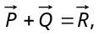 the angle between Q and R is
(a) 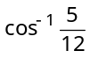 (b) 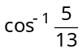 (c) 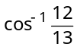 (d) 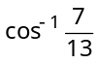

- If 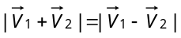and 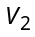 is finite, then
(a) 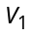 is parallel to (b) 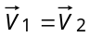
(c) and are mutually perpendicular (d) 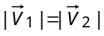

- A force 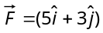Newton is applied over a particle which displaces it from its origin to the point 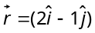 metres. The work done on the particle is
(a) – 7 J (b) +13 J (c)+7 J (d) +11 J

- The angle between two vectors 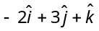 and 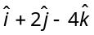 is
(a) 0° (b) 90° (c)180° (d) None of the above

- The area of the parallelogram represented by the vectors 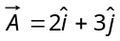 and 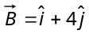 is
(a) 14 units (b) 7.5 units (c)10 units (d) 5 units

- P, Q and R are three coplanar forces acting at a point and are in equilibrium. Given P = 1.9318 kg wt, 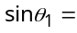0.9659, the value of R is ( in kg wt)
150º

P

Q

R

θ₁

θ₂

(a) 0.9659
(b) 2
(c) 1
(d)

