KEY

1 | 2 | 3 | 4 | 5 | 6 | 7 | 8 | 9 | 10 | 11 | 12 | 13 | 14 | 15
C | B | A | D | A | A | C | A | A | B | C | B | A | C | B
16 | 17 | 18 | 19 | 20 | 21 | 22 | 23 | 24 | 25 | 26 | 27 | 28 | 29 | 30
B | B | C | B | D | A | D | B | B | C | D | D | C | B | D

HINTS AND SOLUTIONS
- (c) Here and 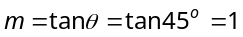 (Since the line is equally inclined to the axes, so 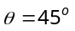)
Hence equation of straight line is 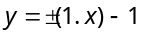
⇒ 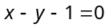and 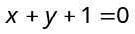.

- (b) Given 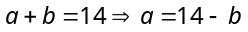
Hence the equation of straight line is 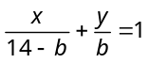.
Also, it passes through 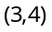
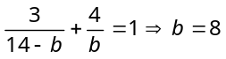or 7
Therefore equations are 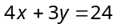and 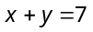.
Trick : This question can be checked with the options as the line passes through (3, 4) and also cuts the intercepts from the axes whose sum is 14.

- (a) 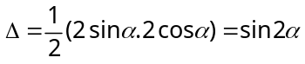
A
O
B
(0,2 sinα)
(2 cosα, 0)

- (d) Given form is 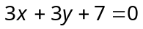 ⇒ 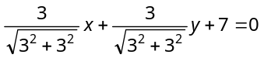
⇒ 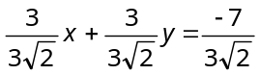, ∴ 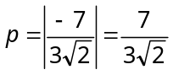.

- (a) As 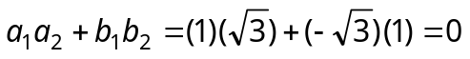
∴ Lines are perpendicular, ∴ 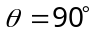.

- (a) The lines are concurrent, if 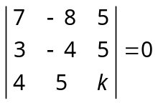
⇒.

- (c) Length of tangent = 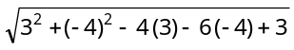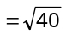
Square of length of tangent .

- (a) The point of intersection of 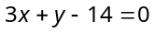 and 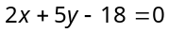 are
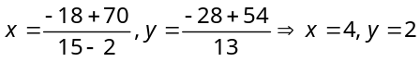i.e., point is (4, 2).
Therefore radius is 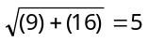 and equation is 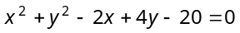.
Trick : The only circle is , whose centre is (1, –2).

- (a) The circle is 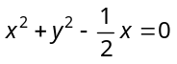. Centre 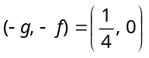 and 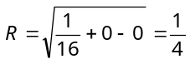

- (b) The equation of circle through points (0, 0), (1, 3) and (2, 4) is
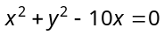
Point 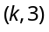 will be on the circle, if
or .

- (c) Centers of circles are 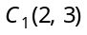 and 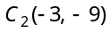 and their radii are 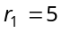 and 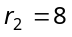.
Obviously 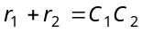 i.e., circles touch each other externally. Hence there are three common tangents.

- (b) Accordingly, 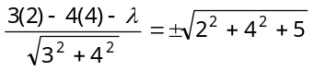
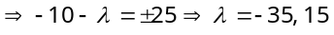.

- (a) 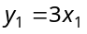. According to given condition 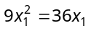⇒ 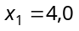⇒ 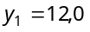
Hence the points are (0,0) and (4,12).

- (c) 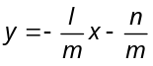 Condition for above line to be tangent to 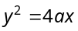 is 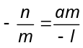or 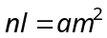.

- (b) Latus rectum 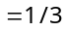(Major axis)
⇒ 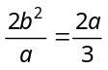⇒ 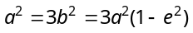⇒ 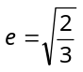.

- (b) 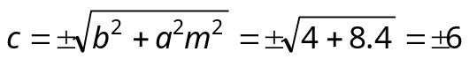.

- (b) 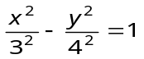. Therefore 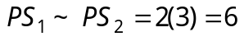.

- (c) Given equation of hyperbola, 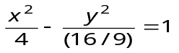,
∴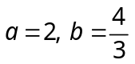. As we know, 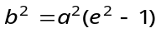
⇒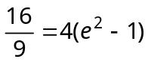⇒ 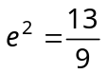, 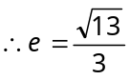.

- (b) We have 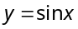
 | 0
 | 0 | 0.5 | 1 | 0 | –1 | 0
Join these points with a free hand to obtain a rough sketch
A
B
π
O
D
X
2π
C
Y

Required area = (area of ) + (area of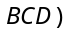
= 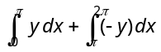,
( Area is below axis)
= 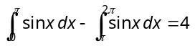 sq. unit.

- (d) Area 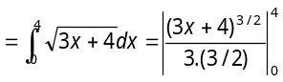
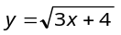
C
B
A
O
Y
X

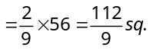unit.

- (a) The two curves 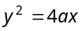 and intersect at 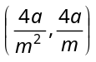 and the area enclosed by the two curves is given by 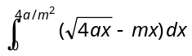.
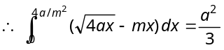
⇒ 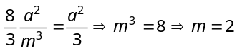.

- (d) 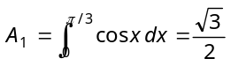, 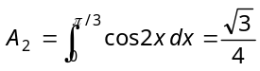 ∴ 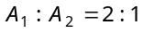.
- (b) Required area =

x =1
x = 4
D
C
X
B
A
D′
O
Y
C′

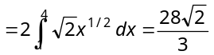 sq. unit.

- (b) Area of smaller part 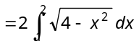
x = 1
X
(0,0)
Y
(2, 0)

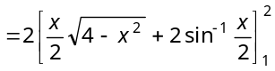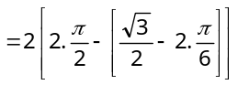
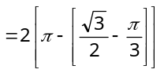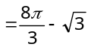.

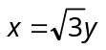
- (c) Required area 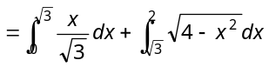
(2,0)
X
Y

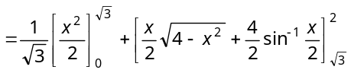
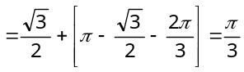.
Trick : Area of sector made by an arc = 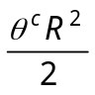 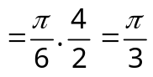.

- (d) Given parabolas are 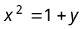, 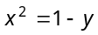
x² = 1 + y
(0, 1)
x² = 1 – y

(0, –1)
Y
X

Required area 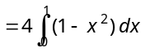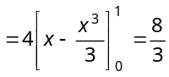.

- (d) Required area 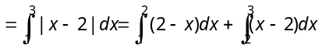
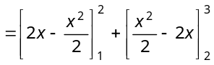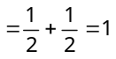.

- (c) Given equations of curves 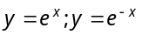 and straight line We know that area of the figure bounded by the curves and straight line
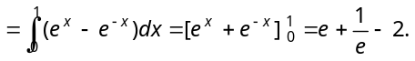

- (b) The x-coordinate of A is
According to the given condition, 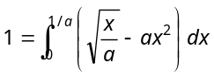
y²=
Y
X
O
A(1/a, 1/a)
y=ax²

⇒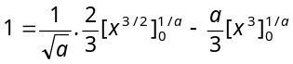⇒ 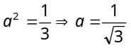.

- (d) 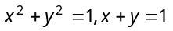meet when
B (0, 1)
x²+y² = 1²²
A (1, 0)
y = 1 – x
O

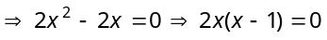
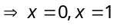 ⇒ 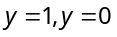, i.e., 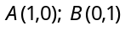
Required area 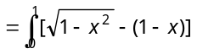dx


