- The equations of the lines which cuts off an intercept – 1 from y-axis are equally inclined to the axes are
(a) 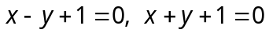 (b) 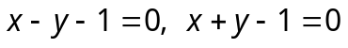
(c) 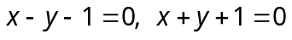 (d) None of these

- A line passes through the point (3, 4) and cuts off intercepts from the coordinates axes such that their sum is 14. The equation of the line is
- 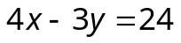 (b) 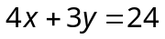 (c) 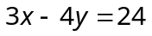 (d) 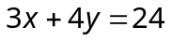

- The area of the triangle formed by the line 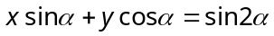and the coordinates axes is
(a) 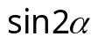 (b) 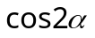 (c) 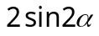 (d) 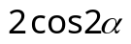

- If we reduce 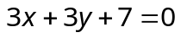 to the form 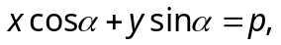 then the value of p is
(a) 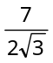 (b) (c) 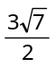 (d) 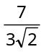

- The angle between the straight lines 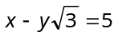 and 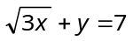is
(a) 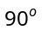 (b) 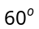 (c) 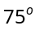 (d) 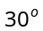

- The value of k for which the lines 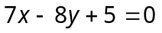, 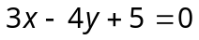 and 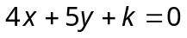 are concurrent is given by
(a) – 45 (b) 44 (c) 54 (d) – 54

- The square of the length of the tangent from (3, –4) on the circle 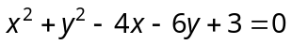is
(a) 20 (b) 30 (c) 40 (d) 50

- The equation of the circle having centre 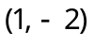 and passing through the point of intersection of lines 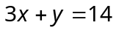, 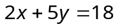 is
(a) 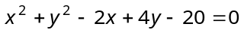 (b) 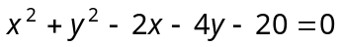
(c) 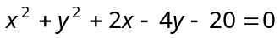 (d) 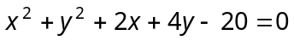

- The centre and radius of the circle 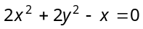 are
(a) 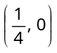 and (b) 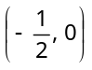 and
(c) 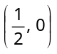 and (d) 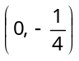 and

- For what value of k, the points (0, 0), (1, 3), (2, 4) and (k, 3) are con-cyclic
(a) 2 (b) 1 (c) 4 (d) 5

- The number of common tangents to the circles 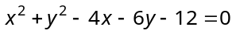and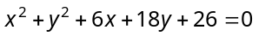is
(a) 1 (b) 2 (c) 3 (d) 4

- If the line 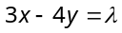touches the circle 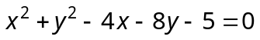, then is equal to
(a) – 35, –15 (b) – 35, 15 (c) 35, 15 (d) 35,– 15

- The points on the parabola 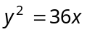 whose ordinate is three times the abscissa are
(a) (0, 0), (4, 12) (b) (1, 3), (4, 12) (c) (4, 12) (d) None of these

- The line 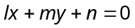 will touch the parabola 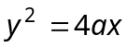, if
(a) 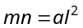 (b) 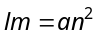 (c) 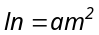 (d)

- The length of the latus rectum of an ellipse is of the major axis. Its eccentricity is
(a) (b) 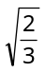 (c) 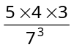 (d) 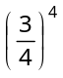

- If the line 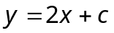 be a tangent to the ellipse 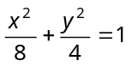, then
(a) (b) (c) (d)

- If P is a point on the hyperbola 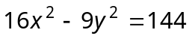 whose foci are 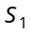 and 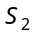, then 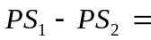
(a) 4 (b) 6 (c) 8 (d) 12

- The eccentricity of the hyperbola 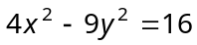, is
(a) (b) (c) 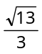 (d)

- Area bounded by the curve 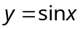 between and 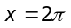 is
(a) 2 sq. unit (b) 4 sq. unit (c) 8 sq. unit (d) None of these

- Area under the curve 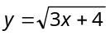 between and 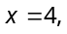 is
(a) 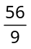 sq. unit (b) 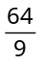 sq. unit (c) 8 sq. unit (d) None of these

- If area bounded by the curves 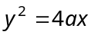 and is 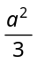, then the value of is
(a) 2 (b) (c) (d) None of these

- The ratio of the areas bounded by the curves 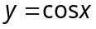 and 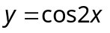 between 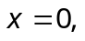 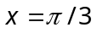 and axis, is
(a) 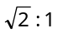 (b) (c) (d)

- Area bounded by the parabola 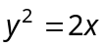 and the ordinates 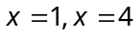 is
(a) 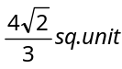 (b) 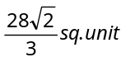 (c) 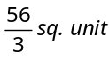 (d) None of these

- The area of smaller part between the circle 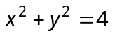and the line 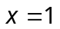 is
(a) 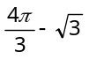 (b) 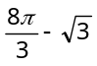 (c) 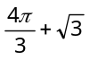 (d) 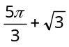

- The area bounded by the circle 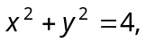 line 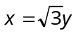 and axis lying in the first quadrant, is
(a) 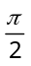 (b) 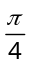 (c) 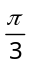 (d)

- The area enclosed by the parabolas 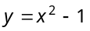 and 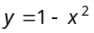 is
(a) 1/3 (b) 2/3 (c) 4/3 (d) 8/3

- The area of the region bounded by the curves 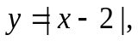 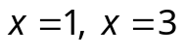and the x-axis is
(a) 4 (b) 2 (c) 3 (d) 1

- The area of figure bounded by 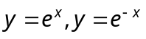 and the straight line 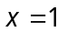 is
(a) 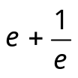 (b) 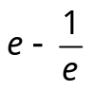 (c) 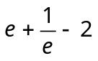 (d) 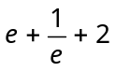

- If the area bounded by 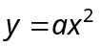and 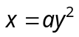, 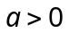, is 1, then
(a) 1 (b) 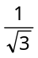 (c) (d) None of these

- The area of region 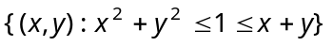 is
(a) 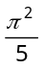 (b) 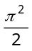 (c) 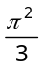 (d) 